Supplementary Materials
CONTENTS
Supplementary Text
Supplementary Text 1. Details of circadian imbalance related factors and construction of circadian imbalance index (CII).
Supplementary Text 2. Details of the definition of covariates.
Supplementary Text 3. Details of the methods of subgroup analyses and sensitivity analyses.
Supplementary Text 4. Details of method of Benjamini and Hochberg critical correction.

Supplementary Figures
Supplementary Figure 1. Flowchart for the selection of the analyzed study participant.
Supplementary Figure 2. Population distribution of CII.
Supplementary Figure 3. Cumulative incidence of psoriasis by CII groups and PRS groups.
Supplementary Figure 4. Association between PRS and psoriasis via RCS regression model.

Supplementary Tables
Supplementary Table 1. Exclusion table of participants in UK Biobank
Supplementary Table 2. Measurement methods for circadian imbalance related factors.
Supplementary Table 3. Assessment of multicollinearity of covariates using variance inflation factors (VIF).
Supplementary Table 4. Associations between each circadian imbalance factors and risk of incident psoriasis.
Supplementary Table 5. Associations between PRS and risk of incident psoriasis.
Supplementary Table 6. Subgroup analyses for the associations between circadian imbalance factors and risk of incident psoriasis.
Supplementary Table 7. Associations between CII and risk of psoriasis after excluding participants who developed psoriasis within the first 2 years of follow-up.
Supplementary Table 8. Associations between CII and risk of psoriasis after excluding participants who developed psoriasis within the first 5 years of follow-up.
Supplementary Table 9. Associations between CII and risk of psoriasis using inverse probability of treatment weighting (IPTW) method.
Supplementary Table 10. Associations between CII and risk of psoriasis after propensity score matching (PSM).
Supplementary Table 11. Associations between CII and risk of psoriasis using age as the time scale.
Supplementary Table 12. Associations between CII and risk of psoriasis after multiple imputation for missing data in covariates.
Supplementary Table 13. Associations between CII and risk of psoriasis after excluding participants without primary health records.
Supplementary Table 14. Associations between CII and risk of psoriasis after excluding participants missing polygenic risk point.
Supplementary Table 15. E-value for associations between CII and risk of psoriasis.
Supplementary Table 16. Associations between CII and risk of psoriasis after excluding participants with vitamin D deficiency.
Supplementary Table 17. Associations between CII score calculated via weighted scoring of each circadian imbalance factor and risk of incident psoriasis.
Supplementary Table 18. Association between CII and risk of incident psoriasis after reclassifying vitamin D from a CII component to a confounding variable.
Supplementary Table 19. Association between CII and risk of incident psoriasis after excluding retired or unemployed individuals.
Supplementary Table 20. Associations between CII and risk of psoriasis based on Fine-Gray hazard model.
Supplementary Table 21. Summary of mediation findings of blood biomarkers in the association between CII and risk of psoriasis.

Supplementary Text 1. Details of circadian imbalance related factors and construction of circadian imbalance index (CII).
Circadian imbalance related factors were assessed at baseline through a self-reported touchscreen questionnaire and peripheral blood samples collected at baseline by the UK Biobank. The circadian imbalance index was constructed based on the previous studies witch incorporate chronotype, sleep duration, neuroticism, caffeinated coffee intake, and serum vitamin D concentration. In detail, chronotype preference was assessed using the question, “Do you consider yourself to be?” with responses of 1. definitely a “morning” person; 2. more a “morning” than “evening” person; 3. more an “evening” person than a “morning” person; 4. definitely an “evening” person; 5. do not know/prefer not to answer. Sleep duration was self-reported through the question, “About how many hours sleep do you get in every 24 h? (Please include naps)”. Neuroticism was assessed using 12 questions (1. Does your mood often go up and down? 2. Do you ever feel “just miserable” for no reason? 3. Are you an irritable person? 4. Are your feelings easily hurt? 5. Do you often feel “fed-up”? 6. Would you call yourself a nervous person? 7. Are you a worrier? 8.Would you call yourself tense or “highly strung”? 9. Do you worry too long after an embarrassing experience? 10. Do you suffer from “nerves”? 11. Do you often feel lonely? 12. Are you often troubled by feelings of guilt?) from the Eysenck Personality Inventory Neuroticism Scale (EPIN-R). The neuroticism score was calculated by summing the number of “Yes” responses across these questions, resulting in a single integer score for each participant ranging 0–12. Consumption of caffeinated coffee was assessed using 2 dietary questions. Participants were first asked, “How many cups of coffee do you drink each DAY? (Include decaffeinated coffee)”. Response options included a specific number of cups, “< 1”, “do not know/prefer not to answer”. For those who reported drinking at least 1 cup of coffee per day, a follow-up question was asked: “What type of coffee do you usually drink?” with response options of “Decaffeinated coffee (any type)”, “Instant coffee”, “Ground coffee (include espresso, filter etc.)” or “other type of coffee”. For the present study, the caffeinated coffee consumption was categorized into the following groups: 0, 1, 2, 3, 4, ≥ 5 cups/day, with participants reporting decaffeinated coffee intake classified into the 0 group. Serum concentrations of 25(OH)D (nmol/L) were determined using the chemiluminescent immunoassay method (DiaSorin Liaison XL platform by DiaSorin S.p.A). For CII construction: 1. Chronotype: Morning chronotypes are generally associated with optimal circadian alignment, whereas evening types exhibit a higher predisposition to circadian misalignment; 2. Sleep Duration: Both short or long (≥ 9 h/day or ≤ 6 h/day) sleep durations are significant predictors of increased circadian imbalance; 3. Personality Traits: High neuroticism is linked to greater variability in sleep-wake cycles, rendering individuals more susceptible to desynchronization; 4. Caffeine Intake: Moderate caffeine consumption may facilitate circadian stability by enhancing the molecular clock’s responsiveness to environmental zeitgebers; 5. Vitamin D Status: Deficient serum 25(OH)D levels are associated with misalignment, potentially through the modulation of melatonin biosynthesis and signaling pathways regulating the sleep-wake cycle.

Supplementary Text 2. Details of the definition of covariates.
The covariates used in the present study including age, sex (male and female), body mass index (BMI), education levels (college or above, high school or equivalent, below high school), race and ethnicity (White and others), Townsend deprivation index (TDI), alcohol consumption status (current drinker, previous drinker, and never), smoking status (current smoker, previous smoker, and never), physical activity group (high level, moderate level, and low level), history of diabetes (yes and no), history of hypertension (yes and no). The TDI was derived from the postcode of residence using aggregated data on unemployment, car and house ownership, and household overcrowding. Physical activity was computed as metabolic equivalent (MET) hours per week, based on the short-form International Physical Activity Questionnaire (IPAQ) guidelines. The history of hypertension was obtained using touchscreen question “Has a doctor ever told you that you have had any of the following conditions?”, and the participants who answered “High blood pressure” was considered has a history of hypertension. The history of diabetes was obtained using touchscreen question “Has a doctor ever told you that you have diabetes?”, and the participants who answered “Yes” was considered has a history of diabetes.

Supplementary Text 3. Details of the methods of subgroup analyses and sensitivity analyses
In brief, we conducted subgroup analyses by age group, gender, race, smoking status, alcohol drinking status, history of hypertension, history of diabetes, and physical activity group. In addition, to increase the robustness of the results, several sensitivity analyses based on Model 3 were performed. 1. We repeated the main analyses after excluding the psoriasis cases with < 2 years and < 5 years of follow-up to minimize the effect of subclinical conditions on the observed associations; 2. We conducted inverse probability of treatment weighting (IPTW) analysis to reduce study bias; 3. We included all covariates in the propensity score model (PSM) to reduce the bias maybe cause by low proportion of patients with psoriasis in the overall sample; 4. We use age as the time scale in the model fitting; 5. To address the missing covariates which may risk bias, reanalyzed the associations using imputed datasets generated via multiple imputation by chained equations (MICE); 6. We excluding participants without primary health records to mitigate potential bias arising from incomplete health reporting; 7. We also excluded participants with missing data of PRS to reduce the potential bias; 8. We calculated E-values for our primary findings; 9. We excluded participants with vitamin D deficiency to isolate the specific association between CII and psoriasis; 10. We constructed a CII score which calculated as the weighted sum of each circadian imbalance factors, with weights corresponding to the estimated coefficients from the Cox model; 11. We reclassifying vitamin D from a CII component to a confounding variable to reduce the association driven by vitamin D; 12. We exclude retired or unemployed individuals to reduce the impact of employment status on circadian rhythms; 13. Since we focused on first psoriasis events, the death may act as competing risks, the Fine-Gray proportional sub-distribution hazards models were used to strengthen the robustness.

Supplementary Text 4. Details of method of Benjamini and Hochberg critical correction
To minimize the potential for Type I errors arising from multiple hypothesis testing, the Benjamini-Hochberg (BH) procedure was employed to control the False Discovery Rate (FDR). We applied this adjustment to the p-values derived from the primary exposure of interest across different modeling representations, including both continuous and categorical forms. Specifically, the raw p-values (P_{(i)}) were ranked in ascending order, and the adjusted p-values (q-values) were calculated based on the formula: q_{(i)} = min [q_{(i+1)}, $\frac{m}{i}$ × P_{(i)}], where m is the total number of tests and i is the rank. Statistical significance was maintained if the adjusted p-value was below the pre-specified threshold of 0.05. All analyses were performed using the p.adjust function in R software (version 4.3.3).

Supplementary Figure 1
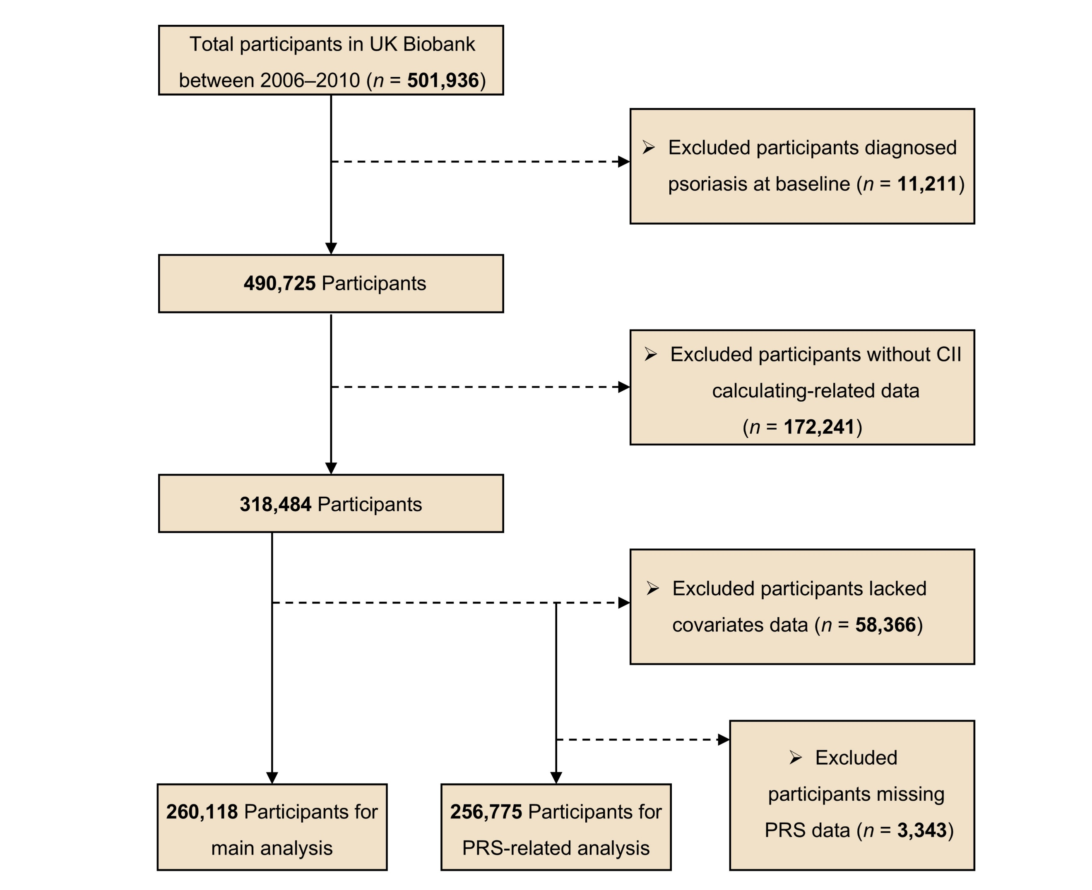
Supplementary Figure 1. Flowchart for the selection of the analyzed study participant
Abbreviations: CII, circadian imbalance index; PRS, polygenic risk score.

Supplementary Figure 2
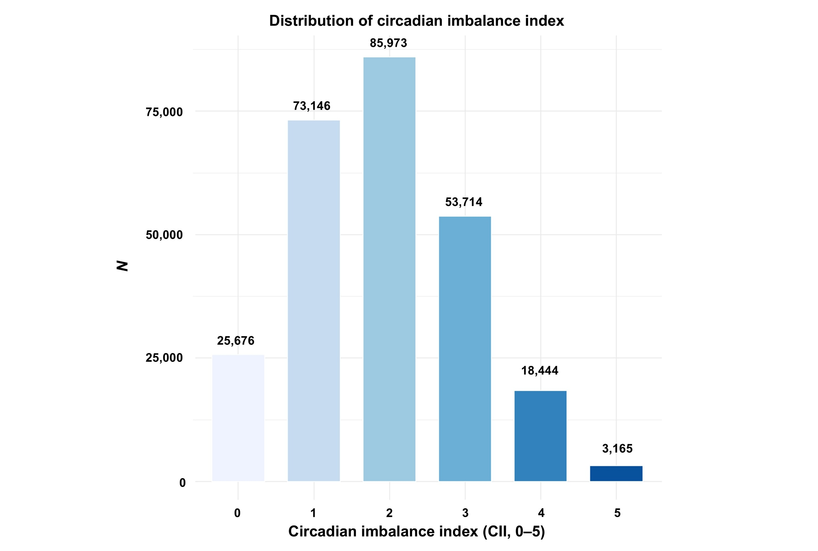
Supplementary Figure 2. Population distribution of CII
Abbreviations: CII, circadian imbalance index.

Supplementary Figure 3
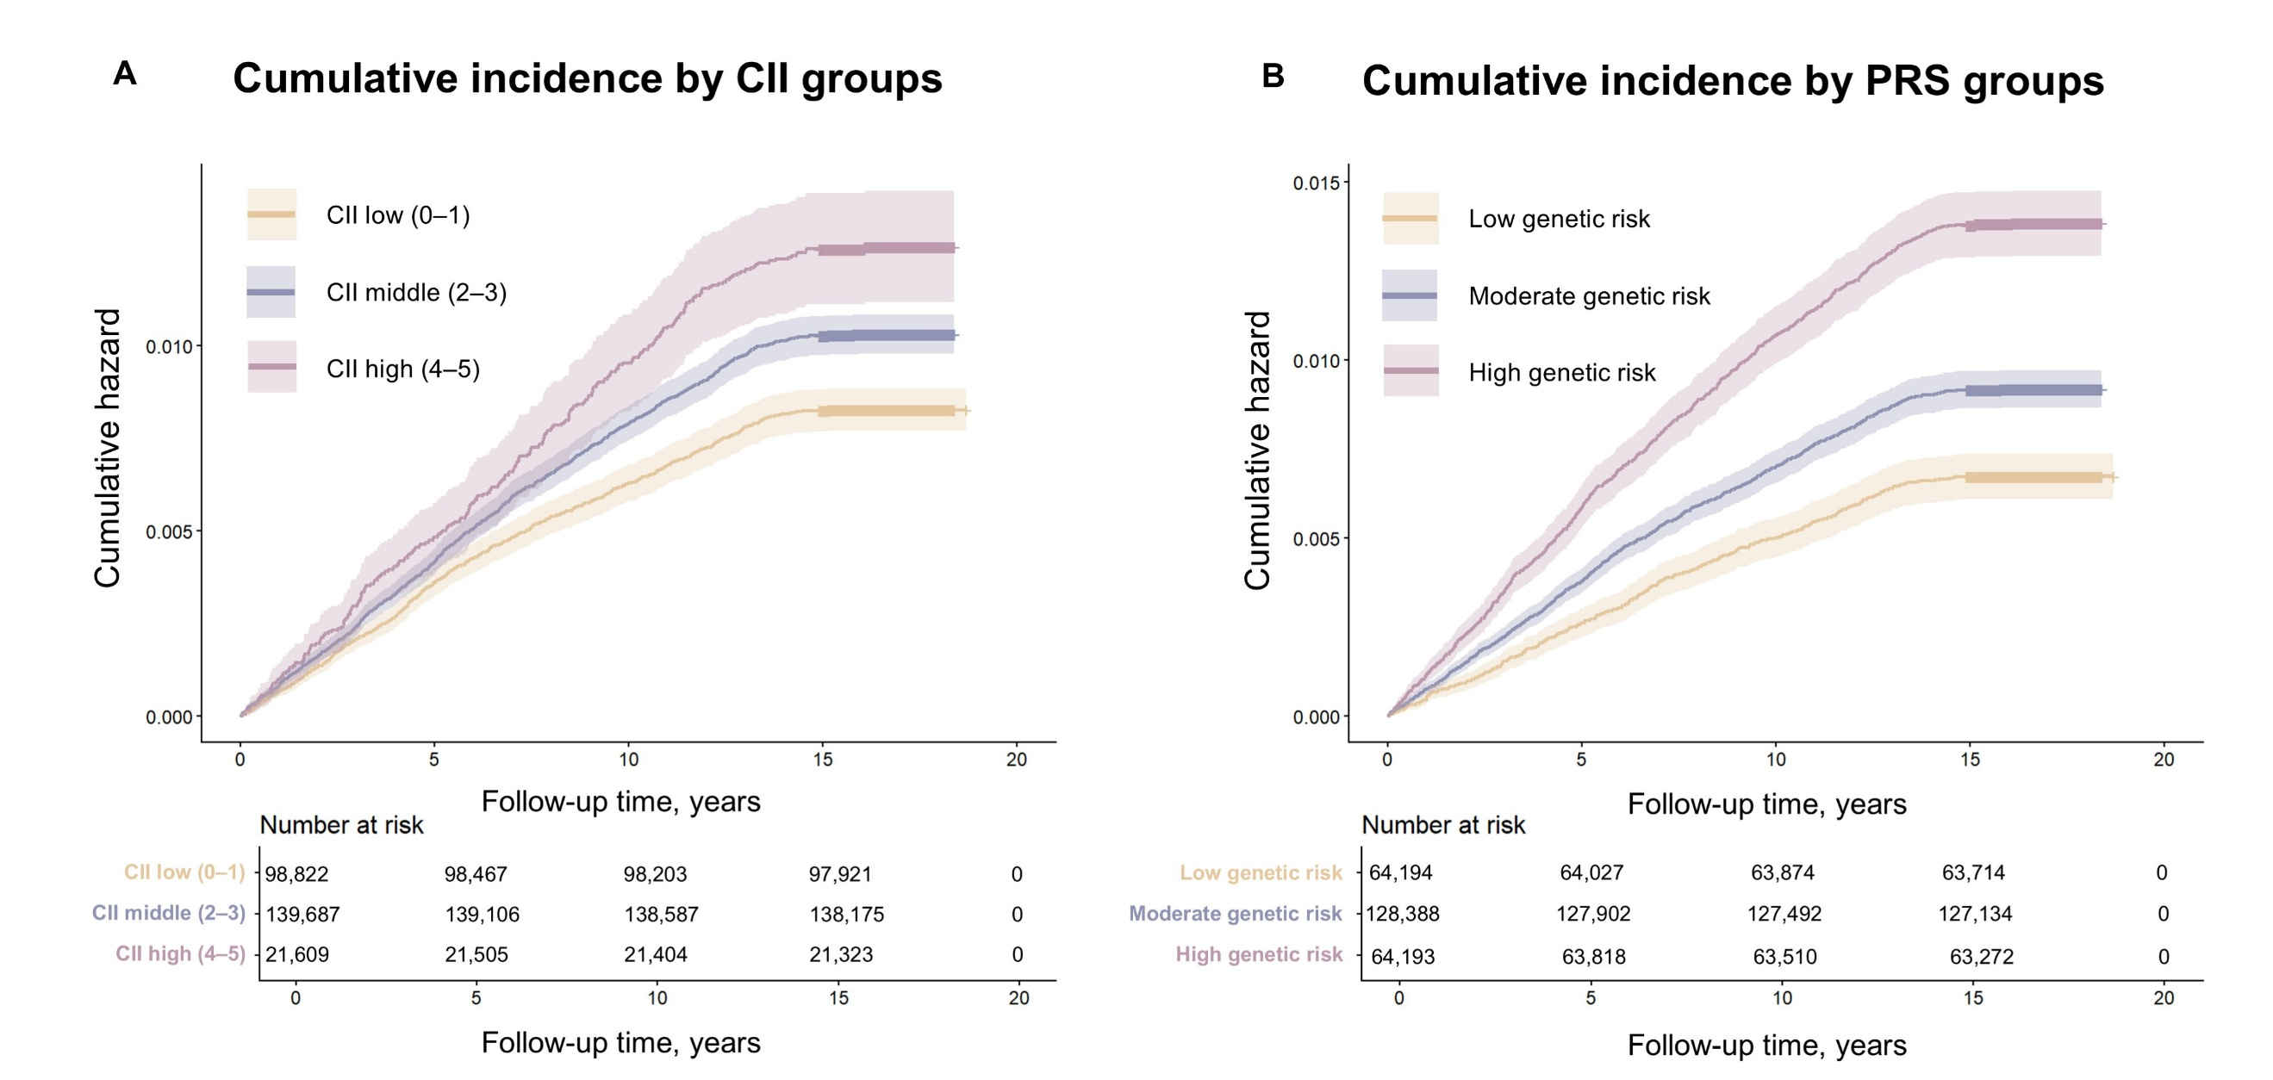
Supplementary Figure 3. Cumulative incidence of psoriasis by CII groups and PRS groups. The Kaplan-Meier curves demonstrate clinical progression over time for incident psoriasis across the CII groups, visualizing individuals with CII low group, CII middle group, and CII high group (All P_{log-rank} < 0.001) (A). The Kaplan-Meier curves showed clinical progression over time for incident psoriasis across the PRS groups, visualizing individuals with low genetic risk, moderate genetic risk, and high genetic risk (All P_{log-rank} < 0.001) (B). The shaded areas represent the 95% CIs.
Abbreviations: CI, confidence interval; CII, circadian imbalance index; PRS, polygenic risk score.

Supplementary Figure 4
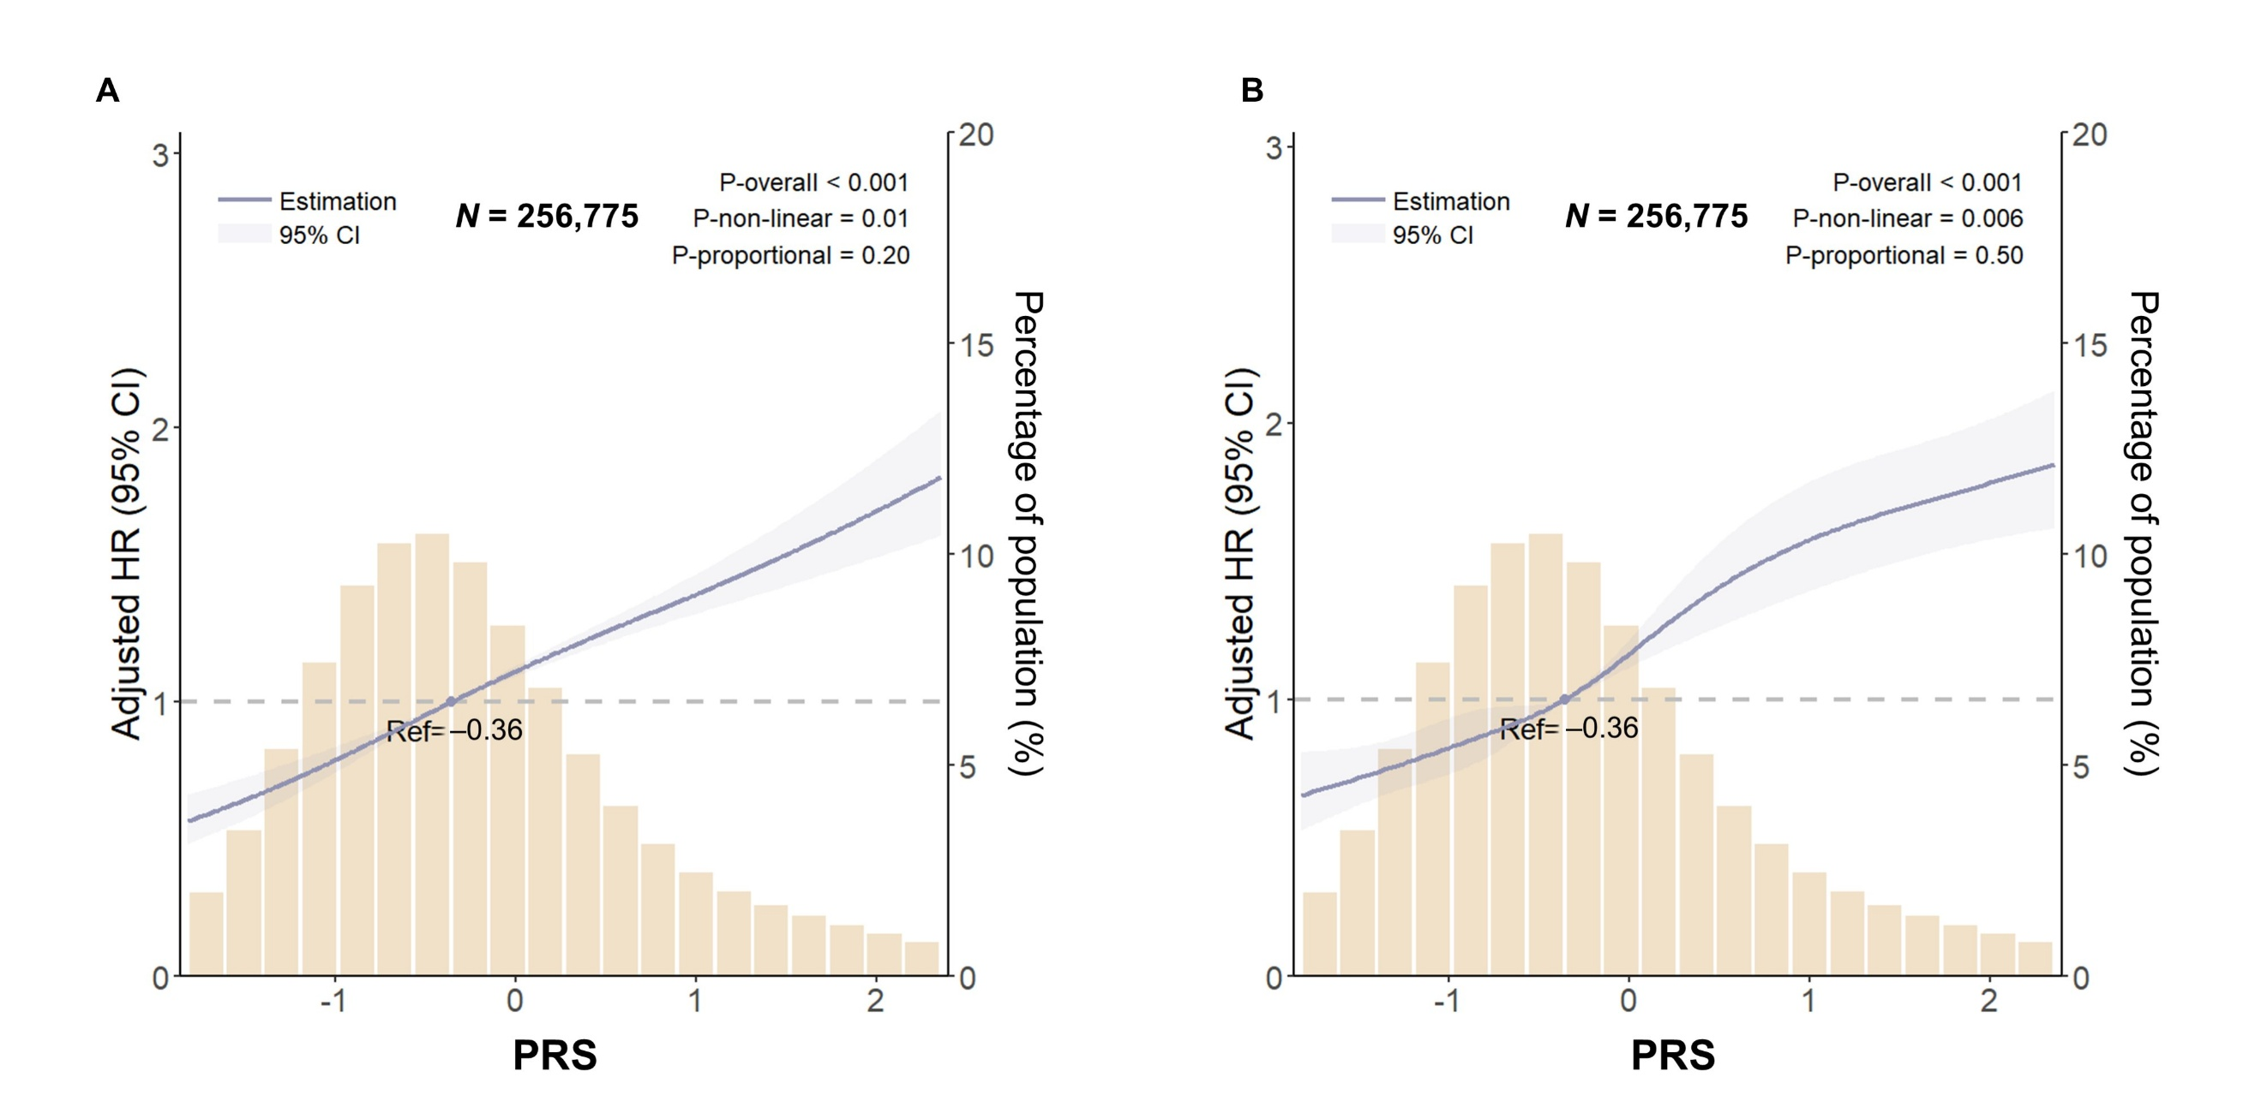
Supplementary Figure 4. Association between PRS and psoriasis via RCS regression model. RCS regression for evaluated PRS of psoriasis incidence after adjusted as Model 3. Data were fitted by a restricted cubic spline Cox proportional hazards regression model, and the model was conducted with 3 knots (10th, 50th, 90th percentiles of PRS) (A) and 5 knots (5th, 27.5th, 50th, 72.5th, and 95th percentiles of PRS) (B). Solid lines indicate HRs, and shadow shape indicate 95% CIs.
Abbreviations: HR, hazard ratio; CI, confidence interval; RCS, restricted cubic spline; PRS, polygenic risk score.

Supplementary Table 1. Exclusion table of participants in UK Biobank
 | Participants
Characteristic | Overall  (N = 501,936) | Included  (N = 260,118) | Excluded  (N = 241,818) | P  value
Age (y), mean ± SD | 56.5 ± 8.1 | 56.1 ± 8.1 | 57.0 ± 8.0 | < 0.001
TDI, mean ± SD | −1.3 ± 3.1 | −1.5 ± 3.0 | −1.1 ± 3.2 | < 0.001
Gender, N (%)
Male | 228,900 (45.6) | 124,401 (47.8) | 104,499 (43.2) | < 0.001
Female | 273,036 (54.4) | 135,717 (52.2) | 137,319 (56.8) | < 0.001
Race and ethnicityª, N (%)
White | 471,605 (94.0) | 248,715 (95.6) | 222,890 (92.2) | < 0.001
Others ª | 30,331 (6.0) | 11,403 (4.4) | 18,928 (7.8) | < 0.001
Educational level, N (%)
≥ College or above | 160,931 (32.0) | 94,259 (36.2) | 66,672 (27.6) | < 0.001
High school / equivalent | 255,785 (51.0) | 131,250 (50.5) | 124,535 (51.5) | < 0.001
< High school | 85,220 (17.0) | 34,609 (13.3) | 50,611 (20.9) | < 0.001

Abbreviations: SD, standard deviation; TDI, Townsend deprivation index.
ª In the UK Biobank, other included Asian or Asian British (including Bangladeshi, Indian, Pakistani, and any other Asian background), Black or Black British (including African, Caribbean, and any other Black background), Chinese, mixed race (including Black and White African, Black and White Caribbean, Asian and White, any other mixed background), or other ethnic group.

Supplementary Table 2. Measurement methods for circadian imbalance related factors.
Circadian imbalance related factors | Notes
Evening chronotype | Evening chronotype (including “definitely an ‘evening’ person” or “more an ‘evening’ person than a ‘morning’ person”)
Short or long sleep duration | Short or long sleep duration (≥ 9 h/day or ≤ 6 h/day)
High neuroticism score | High neuroticism score (≥ 7)
Low serum vitamin D concentration | Low serum vitamin D concentration (< 50 nmol/L)
Atypical caffeinated coffee intake | Atypical caffeinated coffee intake (none or ≥ 5 cups/day, approximately 400 mg caffeine)
Abbreviations: TDI, Townsend deprivation index; BMI, body mass index.
ª Given that approximately 80% of the global population consumes caffeine daily, complete avoidance of caffeinated coffee may reflect underlying caffeine sensitivity rather than a typical behavioral pattern. Participants with alternative expressions of these factors were assigned a zero for each respective category.

Supplementary Table 3. Assessment of multicollinearity of covariates using variance inflation factors (VIF).
Features | VIF
Age | 1.1
Race/ethnicity | 1.1
Gender | 1.0
Education level | 1.1
TDI | 1.1
Smoking status | 1.1
Alcohol drinking | 1.0
Diabetes | 1.1
Hypertension | 1.1
Physical activity group | 1.0
BMI | 1.1
Abbreviations: TDI, Townsend deprivation index; BMI, body mass index.

Supplementary Table 4. Associations between each circadian imbalance factors and risk of incident psoriasis.
 |  | Model 1ª |  | Model 2^{b} |  | Model 3^{c}
Circadian imbalance factors | N (%) | HR (95% CI) | P value | HR (95% CI) | P value | HR (95% CI) | P value | PAF% (95% CI)
Evening chronotype
No | 163,881 (63.0) | 1 (Reference) |  | 1 (Reference) |  | 1 (Reference)
Yes | 96,237 (37.0) | 1.15 (1.06–1.24) | < 0.001 | 1.17 (1.08–1.26) | < 0.001 | 1.10 (1.01–1.19) | 0.02 | 3.55 (0.52–6.63)
Short or long sleep duration
No | 180,326 (69.3) | 1 (Reference) |  | 1 (Reference) |  | 1 (Reference)
Yes | 79,792 (30.7) | 1.18 (1.09–1.28) | < 0.001 | 1.17 (1.08–1.28) | < 0.001 | 1.10 (1.01–1.20) | 0.02 | 2.99 (0.39–5.68)
High neuroticism score
No | 199,221 (76.6) | 1 (Reference) |  | 1 (Reference) |  | 1 (Reference)
Yes | 60,897 (23.4) | 1.25 (1.15–1.37) | < 0.001 | 1.30 (1.19–1.41) | < 0.001 | 1.22 (1.12–1.34) | < 0.001 | 4.99 (2.74–7.33)
Low serum vitamin D concentration
No | 119,589 (46.0) | 1 (Reference) |  | 1 (Reference) |  | 1 (Reference)
Yes | 140,529 (54.0) | 1.14 (1.05–1.23) | < 0.001 | 1.17 (1.08–1.27) | < 0.001 | 1.09 (1.00–1.18) | 0.04 | 4.41 (0.02–8.75)
Atypical caffeinated coffee intake
No | 141,738 (54.5) | 1 (Reference) |  | 1 (Reference) |  | 1 (Reference)
Yes | 118,380 (45.5) | 1.05 (0.98–1.14) | 0.18 | 1.07 (0.99–1.16) | 0.08 | 1.07 (0.99–1.16) | 0.26 | 2.10 (−1.51–5.72)

Abbreviations: PAF, population attributable fraction; CI, confidence interval; HR, hazard ratio; BMI, body mass index; TDI, Townsend deprivation index.
ª Model 1: Without adjustment.
^{b} Model 2: Adjusted for age, gender, and race/ethnicity.
^{c} Model 3: Adjusted for age, gender, and race/ethnicity, BMI, education level, TDI, smoking status, alcohol drinking, physical activity group, history of hypertension, history of diabetes.

Supplementary Table 5. Associations between PRS and risk of incident psoriasis.
 |  |  | Model 1ª |  | Model 2^{b} |  | Model 3^{c}
Exposure | Cases/N | PY | HR (95% CI) | P value | HR (95% CI) | P value | HR (95% CI) | P value | FDR
PRS
per SD increase | 2,487/256,775 | 4,236,730 | 1.30 (1.25–1.34) | < 0.001 | 1.30 (1.25–1.34) | < 0.001 | 1.29 (1.25–1.34) | < 0.001 | < 0.001
Tertiles
Low genetic risk | 431/64,194 | 1,060,262 | 1 (Reference) |  | 1 (Reference) |  | 1 (Reference)
Moderate genetic risk | 1,174/128,388 | 2,119,664 | 1.36 (1.21–1.52) | < 0.001 | 1.36 (1.22–1.52) | < 0.001 | 1.35 (1.21–1.51) | < 0.001 | < 0.001
High genetic risk | 882/64,193 | 1,056,804 | 2.07 (1.84–2.32) | < 0.001 | 2.07 (1.84–2.33) | < 0.001 | 2.06 (1.83–2.31) | < 0.001 | < 0.001
P for trend |  |  |  | < 0.001 |  | < 0.001 |  | < 0.001

Abbreviations: PRS, polygenic risk score; CI: confidence interval; HR, hazard ratio, BMI, body mass index; TDI, Townsend deprivation index; FDR, false discovery rate.
ª Model 1: , Adjusted for genotyping batch, and the first 10 genetic principal components.
^{b} Model 2: Adjusted for age, gender, and race/ethnicity, genotyping batch, and the first 10 genetic principal components.
^{c} Model 3: Adjusted for age, gender, and race/ethnicity, BMI, education level, TDI, smoking status, alcohol drinking, physical activity group, history of hypertension, history of diabetes, genotyping batch, and the first 10 genetic principal components.

Supplementary Table 6. Subgroup analyses for the associations between CII and risk of incident psoriasis.
 | CIIª
Subgroup | Low (0–1) | Middle (2–3) | High (4–5) | P for interaction
Age group |  |  |  | 0.90
< 60 | 1 (Reference) | 1.17 (1.04–1.32) | 1.29 (1.08–1.56)
≥ 60 | 1 (Reference) | 1.21 (1.07–1.38) | 1.46 (1.17–1.83)
Gender |  |  |  | 0.98
Male | 1 (Reference) | 1.21 (1.07–1.37) | 1.39 (1.14–1.71)
Female | 1 (Reference) | 1.17 (1.04–1.33) | 1.34 (1.10–1.64)
Race and ethnicity |  |  |  | 0.47
White | 1 (Reference) | 1.20 (1.10–1.31) | 1.36 (1.18–1.57)
Others | 1 (Reference) | 0.89 (0.51–1.55) | 1.30 (0.65–2.59)
BMI categories |  |  |  | 0.52
< 25 | 1 (Reference) | 1.11 (0.95–1.31) | 1.34 (1.01–1.78)
25–< 30 | 1 (Reference) | 1.25 (1.09–1.43) | 1.57 (1.27–1.96)
≥ 30 | 1 (Reference) | 1.20 (1.01–1.42) | 1.19 (0.92–1.52)
Smoking status |  |  |  | 0.80
Current | 1 (Reference) | 1.14 (0.89–1.46) | 1.46 (1.06–2.01)
Previous | 1 (Reference) | 1.25 (1.09–1.43) | 1.32 (1.05–1.65)
Never | 1 (Reference) | 1.16 (1.02–1.33) | 1.37 (1.09–1.71)
Alcohol drinking status |  |  |  | 0.84
Current | 1 (Reference) | 1.18 (1.08–1.30) | 1.38 (1.19–1.60)
Previous | 1 (Reference) | 1.48 (0.83–2.65) | 1.36 (0.64–2.88)
Never | 1 (Reference) | 1.20 (0.68–2.11) | 1.30 (0.58–2.90)
Hypertension |  |  |  | 0.40
No | 1 (Reference) | 1.20 (1.08–1.34) | 1.49 (1.25–1.76)
Yes | 1 (Reference) | 1.17 (1.00–1.37) | 1.15 (0.90–1.48)
Diabetes |  |  |  | 0.73
No | 1 (Reference) | 1.19 (1.09–1.30) | 1.38 (1.19–1.60)
Yes | 1 (Reference) | 1.24 (0.88–1.75) | 1.25 (0.75–2.08)
Physical activity group |  |  |  | 0.16
Low | 1 (Reference) | 0.94 (0.76–1.15) | 1.12 (0.84–1.49)
Moderate | 1 (Reference) | 1.32 (1.15–1.52) | 1.48 (1.18–1.85)
High | 1 (Reference) | 1.20 (1.05–1.37) | 1.39 (1.09–1.76)

Abbreviations: HR, hazard ratio; CI, confidence interval; HR, hazard ratio; BMI, body mass index; TDI, Townsend deprivation index.
ª Model: Adjusted for age, gender, and race/ethnicity, BMI, education level, TDI, smoking status, alcohol drinking, physical activity group, history of hypertension, history of diabetes (except the current stratified factor).

Supplementary Table 7. Associations between CII and risk of psoriasis after excluding participants who developed psoriasis within the first 2 years of follow-up.
 |  |  | Model 1ª |  | Model 2^{b} |  | Model 3^{c}
Exposure | Cases/N | PY | HR (95% CI) | P value | HR (95% CI) | P value | HR (95% CI) | P value | FDR
CII
Per 1 point | 2,118/259,717 | 4,290,287 | 1.13 (1.09–1.17) | < 0.001 | 1.15 (1.11–1.19) | < 0.001 | 1.10 (1.06–1.14) | < 0.001 | < 0.001
CII categories
Low (0–1) | 681/98,689 | 1,630,209 | 1 (Reference) |  | 1 (Reference) |  | 1 (Reference)
Middle (2–3) | 1,207/139,461 | 2,303,794 | 1.26 (1.14–1.38) | < 0.001 | 1.29 (1.17–1.42) | < 0.001 | 1.21 (1.10–1.33) | < 0.001 | < 0.001
High (4–5) | 230/21,567 | 356,284 | 1.55 (1.33–1.80) | < 0.001 | 1.63 (1.40–1.90) | < 0.001 | 1.40 (1.20–1.63) | < 0.001 | < 0.001

Abbreviations: CII, circadian imbalance index; CI, confidence interval; HR, hazard ratio; FDR, false discovery rate; BMI, body mass index; TDI, Townsend deprivation index.
ª Model 1: Without adjustment.
^{b} Model 2: Adjusted for age, gender, and race/ethnicity.
^{c} Model 3: Adjusted for age, gender, and race/ethnicity, BMI, education level, TDI, smoking status, alcohol drinking, physical activity group, history of hypertension, history of diabetes.

Supplementary Table 8. Associations between CII and risk of psoriasis after excluding participants who developed psoriasis within the first 5 years of follow-up.
 |  |  | Model 1ª |  | Model 2^{b} |  | Model 3^{c}
Exposure | Cases/N | PY | HR (95% CI) | P value | HR (95% CI) | P value | HR (95% CI) | P value | FDR
CII
Per 1 point | 1,479/259,078 | 4,288,046 | 1.14 (1.09–1.20) | < 0.001 | 1.16 (1.11–1.22) | < 0.001 | 1.11 (1.06–1.17) | < 0.001 | < 0.001
CII categories
Low (0–1) | 459/98,467 | 1,629,419 | 1 (Reference) |  | 1 (Reference) |  | 1 (Reference)
Middle (2–3) | 852/139,106 | 2,302,551 | 1.32 (1.17–1.47) | < 0.001 | 1.36 (1.21–1.52) | < 0.001 | 1.27 (1.13–1.42) | < 0.001 | < 0.001
High (4–5) | 168/21,505 | 356,076 | 1.68 (1.41–2.00) | < 0.001 | 1.78 (1.49–2.12) | < 0.001 | 1.52 (1.27–1.83) | < 0.001 | < 0.001

Abbreviations: CII, circadian imbalance index; CI, confidence interval; HR, hazard ratio; FDR, false discovery rate; BMI, body mass index; TDI, Townsend deprivation index.
ª Model 1: Without adjustment.
^{b} Model 2: Adjusted for age, gender, and race/ethnicity.
^{c} Model 3: Adjusted for age, gender, and race/ethnicity, BMI, education level, TDI, smoking status, alcohol drinking, physical activity group, history of hypertension, history of diabetes.

Supplementary Table 9. Associations between CII and risk of psoriasis using inverse probability of treatment weighting (IPTW) method.
 | Model 1ª |  | Model 2^{b} |  | Model 3^{c}
Exposure | HR (95% CI) | P value | HR (95% CI) | P value | HR (95% CI) | P value | FDR
CII
Per 1 point | 1.09 (1.04–1.14) | < 0.001 | 1.09 (1.04–1.14) | < 0.001 | 1.08 (1.03–1.13) | 0.002 | 0.002
CII categories
Low (0–1) | 1 (Reference) |  | 1 (Reference) |  | 1 (Reference)
Middle (2–3) | 1.18 (1.08–1.29) | < 0.001 | 1.18 (1.07–1.29) | < 0.001 | 1.18 (1.07–1.29) | < 0.001 | 0.002
High (4–5) | 1.37 (1.18–1.59) | < 0.001 | 1.38 (1.19–1.61) | < 0.001 | 1.36 (1.17–1.59) | < 0.001 | < 0.001

Abbreviations: CII, circadian imbalance index; CI, confidence interval; HR, hazard ratio; FDR, false discovery rate; BMI, body mass index; TDI, Townsend deprivation index.
ª Model 1: Without adjustment.
^{b} Model 2: Adjusted for age, gender, and race/ethnicity.
^{c} Model 3: Adjusted for age, gender, and race/ethnicity, BMI, education level, TDI, smoking status, alcohol drinking, physical activity group, history of hypertension, history of diabetes.

Supplementary Table 10. Associations between CII and risk of psoriasis after propensity score matching (PSM).
 | Model 1ª |  | Model 2^{b} |  | Model 3^{c}
Exposure | HR (95% CI) | P value | HR (95% CI) | P value | HR (95% CI) | P value | FDR
CII
Per 1 point | 1.05 (1.02–1.09) | 0.002 | 1.05 (1.02–1.09) | 0.002 | 1.06 (1.02–1.10) | < 0.001 | < 0.001
CII categories
Low (0–1) | 1 (Reference) |  | 1 (Reference) |  | 1 (Reference)
Middle (2–3) | 1.16 (1.06–1.26) | 0.001 | 1.15 (1.06–1.26) | 0.001 | 1.16 (1.06–1.27) | < 0.001 | < 0.001
High (4–5) | 1.23 (1.07–1.41) | 0.004 | 1.21 (1.06–1.40) | 0.005 | 1.23 (1.07–1.42) | < 0.001 | < 0.001

Abbreviations: PSM, propensity score matching; CII, circadian imbalance index; CI, confidence interval; HR, hazard ratio; FDR, false discovery rate; BMI, body mass index; TDI, Townsend deprivation index.
ª Model 1: Without adjustment.
^{b} Model 2: Adjusted for age, gender, and race/ethnicity.
^{c} Model 3: Adjusted for age, gender, and race/ethnicity, BMI, education level, TDI, smoking status, alcohol drinking, physical activity group, history of hypertension, history of diabetes.

Supplementary Table 11. Associations between CII and risk of psoriasis using age as the time scale.
 | Model 1ª |  | Model 2^{b} |  | Model 3^{c}
Exposure | HR (95% CI) | P value | HR (95% CI) | P value | HR (95% CI) | P value | FDR
CII
Per 1 point | 1.12 (1.08–1.16) | < 0.001 | 1.13 (1.09–1.17) | < 0.001 | 1.08 (1.05–1.12) | < 0.001 | < 0.001
CII categories
Low (0–1) | 1 (Reference) |  | 1 (Reference) |  | 1 (Reference)
Middle (2–3) | 1.23 (1.13–1.34) | < 0.001 | 1.25 (1.14–1.36) | < 0.001 | 1.16 (1.06–1.26) | < 0.001 | < 0.001
High (4–5) | 1.50 (1.30–1.72) | < 0.001 | 1.53 (1.33–1.75) | < 0.001 | 1.28 (1.11–1.47) | < 0.001 | < 0.001

Abbreviations: CII, circadian imbalance index; CI, confidence interval; HR, hazard ratio; FDR, false discovery rate; BMI, body mass index; TDI, Townsend deprivation index.
ª Model 1: Without adjustment.
^{b} Model 2: Adjusted for gender, and race/ethnicity.
^{c} Model 3: Adjusted for gender, and race/ethnicity, BMI, education level, TDI, smoking status, alcohol drinking, physical activity group, history of hypertension, history of diabetes.

Supplementary Table 12. Associations between CII and risk of psoriasis after multiple imputation for missing data in covariates.
 |  |  | Model 1ª |  | Model 2^{b} |  | Model 3^{c}
Exposure | Cases/N | PY | HR (95% CI) | P value | HR (95% CI) | P value | HR (95% CI) | P value | FDR
CII
Per 1 point | 3,172/318,484 | 5,253,745 | 1.34 (1.10–1.17) | < 0.001 | 1.15 (1.12–1.19) | < 0.001 | 1.10 (1.06–1.13) | < 0.001 | < 0.001
CII categories
Low (0–1) | 993/117,894 | 1,945,103 | 1 (Reference) |  | 1 (Reference) |  | 1 (Reference)
Middle (2–3) | 1,814/172,402 | 2,843,840 | 1.25 (1.16–1.35) | < 0.001 | 1.29 (1.19–1.39) | < 0.001 | 1.19 (1.10–1.29) | < 0.001 | < 0.001
High (4–5) | 365/28,188 | 464,802 | 1.54 (1.37–1.74) | < 0.001 | 1.62 (1.44–1.83) | < 0.001 | 1.36 (1.20–1.54) | < 0.001 | < 0.001

Abbreviations: CII, circadian imbalance index; CI, confidence interval; HR, hazard ratio; FDR, false discovery rate; BMI, body mass index; TDI, Townsend deprivation index.
ª Model 1: Without adjustment.
^{b} Model 2: Adjusted for age, gender, and race/ethnicity.
^{c} Model 3: Adjusted for age, gender, and race/ethnicity, BMI, education level, TDI, smoking status, alcohol drinking, physical activity group, history of hypertension, history of diabetes.

Supplementary Table 13. Associations between CII and risk of psoriasis after excluding participants without primary health records.
 |  |  | Model 1ª |  | Model 2^{b} |  | Model 3^{c}
Exposure | Cases/N | PY | HR (95% CI) | P value | HR (95% CI) | P value | HR (95% CI) | P value | FDR
CII
Per 1 point | 1,592/118,390 | 1,945,802 | 1.12 (1.07–1.16) | < 0.001 | 1.13 (1.08–1.18) | < 0.001 | 1.08 (1.04–1.13) | < 0.001 | 0.001
CII categories
Low (0–1) | 519/44,044 | 722,875 | 1 (Reference) |  | 1 (Reference) |  | 1 (Reference)
Middle (2–3) | 902/64,169 | 1,055,452 | 1.19 (1.07–1.33) | < 0.001 | 1.22 (1.09–1.36) | < 0.001 | 1.15 (1.03–1.28) | 0.02 | 0.02
High (4–5) | 171/10,177 | 167,475 | 1.43 (1.20–1.70) | < 0.001 | 1.49 (1.25–1.77) | < 0.001 | 1.28 (1.07–1.53) | 0.006 | 0.009

Abbreviations: CII, circadian imbalance index; CI, confidence interval; HR, hazard ratio; FDR, false discovery rate; BMI, body mass index; TDI, Townsend deprivation index.
ª Model 1: Without adjustment.
^{b} Model 2: Adjusted for age, gender, and race/ethnicity.
^{c} Model 3: Adjusted for age, gender, and race/ethnicity, BMI, education level, TDI, smoking status, alcohol drinking, physical activity group, history of hypertension, history of diabetes.

Supplementary Table 14. Associations between CII and risk of psoriasis after excluding participants missing polygenic risk point.
 |  |  | Model 1ª |  | Model 2^{b} |  | Model 3^{c}
Exposure | Cases/N | PY | HR (95% CI) | P value | HR (95% CI) | P value | HR (95% CI) | P value | FDR
CII
Per 1 point | 2,487/256,775 | 423,6,730 | 1.13 (1.09–1.17) | < 0.001 | 1.15 (1.11–1.19) | < 0.001 | 1.09 (1.06–1.13) | < 0.001 | < 0.001
CII categories
Low (0–1) | 807/97,615 | 1,610,801 | 1 (Reference) |  | 1 (Reference) |  | 1 (Reference)
Middle (2–3) | 1,414/137,851 | 2,274,418 | 1.24 (1.14–1.35) | < 0.001 | 1.30 (1.17–1.40) | < 0.001 | 1.18 (1.09–1.30) | < 0.001 | < 0.001
High (4–5) | 266/21,309 | 351,511 | 1.51 (1.32–1.74) | < 0.001 | 1.60 (1.39–1.84) | < 0.001 | 1.35 (1.17–1.56) | < 0.001 | < 0.001

Abbreviations: CII, circadian imbalance index; CI, confidence interval; HR, hazard ratio; FDR, false discovery rate; BMI, body mass index; TDI, Townsend deprivation index.
ª Model 1: Without adjustment.
^{b} Model 2: Adjusted for age, gender, and race/ethnicity.
^{c} Model 3: Adjusted for age, gender, and race/ethnicity, BMI, education level, TDI, smoking status, alcohol drinking, physical activity group, history of hypertension, history of diabetes.

Supplementary Table 15. E-value for associations between CII and risk of psoriasis.
 | Model 1ª |  |  | Model 2^{b} |  |  | Model 3^{c}
Exposure | HR (95% CI) | E-value | E-value (CI) | HR (95% CI) | E-value | E-value (CI) | HR (95% CI) | E-value | E-value (CI)
CII
Per 1 point | 1.13 (1.09–1.17) | 1.51 | 1.40 | 1.15 (1.11–1.19) | 1.57 | 1.46 | 1.10 (1.06–1.14) | 1.43 | 1.31
CII categories
Low (0–1) | 1 (Reference) |  |  | 1 (Reference) |  |  | 1 (Reference)
Middle (2–3) | 1.25 (1.14–1.36) | 1.81 | 1.54 | 1.28 (1.18–1.40) | 1.88 | 1.64 | 1.19 (1.09–1.30) | 1.67 | 1.40
High (4–5) | 1.53 (1.33–1.76) | 2.43 | 1.99 | 1.62 (1.41–1.86) | 2.62 | 2.17 | 1.37 (1.19–1.58) | 2.08 | 1.67

Abbreviations: CII, circadian imbalance index; CI, confidence interval; HR, hazard ratio; FDR, false discovery rate; BMI, body mass index; TDI, Townsend deprivation index.
ª Model 1: Without adjustment.
^{b} Model 2: Adjusted for age, gender, and race/ethnicity.
^{c} Model 3: Adjusted for age, gender, and race/ethnicity, BMI, education level, TDI, smoking status, alcohol drinking, physical activity group, history of hypertension, history of diabetes.

Supplementary Table 16. Associations between CII and risk of psoriasis after excluding participants with vitamin D deficiency.
 |  |  | Model 1ª |  | Model 2^{b} |  | Model 3^{c}
Exposure | Cases/N | PY | HR (95% CI) | P value | HR (95% CI) | P value | HR (95% CI) | P value | FDR
CII
Per 1 point | 1,077/119,589 | 1,972,523 | 1.14 (1.08–1.21) | < 0.001 | 1.16 (1.09–1.23) | < 0.001 | 1.19 (1.09–1.29) | < 0.001 | < 0.001
CII categories
Low (0–1) | 580/72,614 | 1,197,972 | 1 (Reference) |  | 1 (Reference) |  | 1 (Reference)
Middle (2) | 343/33,410 | 551,078 | 1.29 (1.13–1.47) | < 0.001 | 1.31 (1.15–1.50) | < 0.001 | 1.26 (1.10–1.44) | < 0.001 | < 0.001
High (3–4) | 154/13,565 | 223,473 | 1.42 (1.19–1.70) | < 0.001 | 1.47 (1.23–1.76) | < 0.001 | 1.36 (1.13–1.63) | < 0.001 | < 0.001

Abbreviations: CII, circadian imbalance index; CI, confidence interval; HR, hazard ratio; FDR, false discovery rate; BMI, body mass index; TDI, Townsend deprivation index.
ª Model 1: Without adjustment.
^{b} Model 2: Adjusted for age, gender, and race/ethnicity.
^{c} Model 3: Adjusted for age, gender, and race/ethnicity, BMI, education level, TDI, smoking status, alcohol drinking, physical activity group, history of hypertension, history of diabetes.

Supplementary Table 17. Associations between CII score calculated via weighted scoring of each circadian imbalance factor and risk of incident psoriasis.
 |  |  | Model 1ª |  | Model 2^{b} |  | Model 3^{c}
Exposure | Cases/N | PY | HR (95% CI) | P value | HR (95% CI) | P value | HR (95% CI) | P value | FDR
CII score
Per 1-SD increase | 2,519/260,118 | 4,290,680 | 1.16 (1.11–1.20) | < 0.001 | 1.18 (1.13–1.22) | < 0.001 | 1.12 (1.07–1.16) | < 0.001 | < 0.001
CII score tertiles
T1 | 711/86,706 | 1,430,612 | 1 (Reference) |  | 1 (Reference) |  | 1 (Reference)
T2 | 822/86,706 | 1,430,698 | 1.15 (1.04–1.27) | 0.008 | 1.17 (1.06–1.29) | 0.003 | 1.11 (1.00–1.23) | 0.04 | 0.04
T3 | 986/86,706 | 1,429,370 | 1.40 (1.27–1.54) | < 0.001 | 1.46 (1.32–1.61) | < 0.001 | 1.30 (1.18–1.44) | < 0.001 | < 0.001

Abbreviations: CII, circadian imbalance index; CI, confidence interval; HR, hazard ratio; FDR, false discovery rate; BMI, body mass index; TDI, Townsend deprivation index.
ª Model 1: Without adjustment.
^{b} Model 2: Adjusted for age, gender, and race/ethnicity.
^{c} Model 3: Adjusted for age, gender, and race/ethnicity, BMI, education level, TDI, smoking status, alcohol drinking, physical activity group, history of hypertension, history of diabetes.

Supplementary Table 18. Association between CII and risk of incident psoriasis after reclassifying vitamin D from a CII component to a confounding variable.
 |  |  | Model 1ª |  | Model 2^{b} |  | Model 3^{c}
Exposure | Cases/N | PY | HR (95% CI) | P value | HR (95% CI) | P value | HR (95% CI) | P value | FDR
CII
Per 1 point | 2,519/260,118 | 4,290,680 | 1.13 (1.09–1.18) | < 0.001 | 1.15 (1.10–1.19) | < 0.001 | 1.10 (1.06–1.14) | < 0.001 | < 0.001
CII categories
Low (0–1) | 814/98,822 | 1,630,345 | 1 (Reference) |  | 1 (Reference) |  | 1 (Reference)
Middle (2) | 837/85,973 | 1,418,536 | 1.23 (1.13–1.35) | < 0.001 | 1.26 (1.15–1.37) | < 0.001 | 1.19 (1.09–1.30) | < 0.001 | < 0.001
High (3–4) | 868/75,323 | 1,241,799 | 1.40 (1.24–1.56) | < 0.001 | 1.44 (1.29–1.62) | < 0.001 | 1.30 (1.16–1.46) | < 0.001 | < 0.001

Abbreviations: CII, circadian imbalance index; CI, confidence interval; HR, hazard ratio; FDR, false discovery rate; BMI, body mass index; TDI, Townsend deprivation index.
ª Model 1: Vitamin D
^{b} Model 2: Adjusted for age, gender, and race/ethnicity, and vitamin D.
^{c} Model 3: Adjusted for age, gender, and race/ethnicity, BMI, education level, TDI, smoking status, alcohol drinking, physical activity group, history of hypertension, history of diabetes, and vitamin D.

Supplementary Table 19. Association between CII and risk of incident psoriasis after excluding retired or unemployed individuals.
 |  |  | Model 1ª |  | Model 2^{b} |  | Model 3^{c}
Exposure | Cases/N | PY | HR (95% CI) | P value | HR (95% CI) | P value | HR (95% CI) | P value | FDR
CII
Per 1 point | 1,559/167,239 | 2,763,130 | 1.11 (1.07–1.16) | < 0.001 | 1.13 (1.08–1.18) | < 0.001 | 1.07 (1.02–1.12) | 0.004 | 0.006
CII categories
Low (0–1) | 464/58,999 | 975,239 | 1 (Reference) |  | 1 (Reference) |  | 1 (Reference)
Middle (2–3) | 920/92,980 | 1,535,783 | 1.26 (1.13–1.41) | < 0.001 | 1.29 (1.15–1.44) | < 0.001 | 1.19 (1.06–1.33) | 0.003 | 0.006
High (4–5) | 175/15,260 | 252,109 | 1.46 (1.23–1.74) | < 0.001 | 1.52 (1.28–1.81) | < 0.001 | 1.26 (1.05–1.51) | 0.01 | 0.01

Abbreviations: CII, circadian imbalance index; CI, confidence interval; HR, hazard ratio; FDR, false discovery rate; BMI, body mass index; TDI, Townsend deprivation index.
ª Model 1: Without adjustment.
^{b} Model 2: Adjusted for age, gender, and race/ethnicity.
^{c} Model 3: Adjusted for age, gender, and race/ethnicity, BMI, education level, TDI, smoking status, alcohol drinking, physical activity group, history of hypertension, history of diabetes.

Supplementary Table 20. Associations between CII and risk of psoriasis based on Fine-Gray hazard model.
 | Model 1ª |  | Model 2^{b} |  | Model 3^{c}
Exposure | HR (95% CI) | P value | HR (95% CI) | P value | HR (95% CI) | P value | FDR
CII
Per 1 point | 1.13 (1.09–1.17) | < 0.001 | 1.15 (1.11–1.19) | < 0.001 | 1.10 (1.06–1.14) | < 0.001 | < 0.001
CII categories
Low (0–1) | 1 (Reference) |  | 1 (Reference) |  | 1 (Reference)
Middle (2–3) | 1.25 (1.14–1.36) | < 0.001 | 1.28 (1.18–1.40) | < 0.001 | 1.19 (1.09–1.30) | < 0.001 | < 0.001
High (4–5) | 1.53 (1.33–1.76) | < 0.001 | 1.62 (1.41–1.86) | < 0.001 | 1.37 (1.19–1.58) | < 0.001 | < 0.001

Abbreviations: CII, circadian imbalance index; CI, confidence interval; HR, hazard ratio; FDR, false discovery rate; BMI, body mass index; TDI, Townsend deprivation index.
ª Model 1: Without adjustment.
^{b} Model 2: Adjusted for age, gender, and race/ethnicity.
^{c} Model 3: Adjusted for age, gender, and race/ethnicity, BMI, education level, TDI, smoking status, alcohol drinking, physical activity group, history of hypertension, history of diabetes.

Supplementary Table 21. Summary of mediation findings of blood biomarkers in the association between CII and risk of psoriasisª.
Mediators | Total effect | Direct effect | Indirect effect | Mediated proportion (%) | P values
Systematic inflammation
CRP | 1.0952 (1.0678–1.1216) | 1.0936 (1.0664–1.1205) | 1.0014 (1.0008–1.0019) | 1.66 (0.84–2.33) | < 2e-16
WBC | 1.0961 (1.0709–1.1275) | 1.0956 (1.0704–1.1268) | 1.0005 (1.0003–1.0011) | 0.53 (0.41–1.23) | < 2e-16
NEUT | 1.0950 (1.0837–1.1268) | 1.0930 (1.0814–1.1250) | 1.0018 (1.0012–1.0028) | 2.05 (1.22–3.20) | < 2e-16
MONO | 1.0955 (1.0841–1.1271) | 1.0954 (1.0841–1.1271) | 1.0001 (1.0000–1.0006) | 0.07 (0.01–0.68) | < 2e-16
LYM | 1.0954 (1.0840–1.1272) | 1.0954 (1.0840–1.1272) | 0.9999 (0.9998–1.0003) | −0.01 (−0.15–0.28) | 0.79
Liver function
ALP | 1.0957 (1.0405–1.1186) | 1.0932 (1.0386–1.1157) | 1.0023 (1.0012–1.0033) | 2.61 (1.34–4.81) | < 2e-16
GGT | 1.0956 (1.0699–1.1377) | 1.0939 (1.0684–1.1359) | 1.0015 (1.0007–1.0018) | 1.78 (0.73–2.45) | < 2e-16
Total bilirubin | 1.0950 (1.0727–1.1286) | 1.0948 (1.0717–1.1283) | 1.0001 (0.9994–1.0009) | 0.15 (−0.65–1.33) | 0.72
Total protein | 1.0900 (1.0696–1.1208) | 1.0902 (1.0698–1.1209) | 0.9999 (0.9996–1.0000) | −0.18 (−0.49–0.03) | 0.09
ALB | 1.0896 (1.0707–1.1037) | 1.0882 (1.0699–1.1024) | 1.0012 (1.0005–1.0014) | 1.50 (0.72–1.98) | < 2e-16
ALT | 1.0960 (1.0790–1.1164) | 1.0948 (1.0782–1.1151) | 1.0011 (1.0002–1.0015) | 1.26 (0.26–1.95) | < 2e-16
AST | 1.0956 (1.0699–1.1119) | 1.0949 (1.0692–1.1111) | 1.0006 (1.0003–1.0007) | 0.67 (0.38–0.96) | < 2e-16
Renal function
Cystatin C | 1.0960 (1.0747–1.1292) | 1.0949 (1.0742–1.1288) | 1.0011 (1.0001–1.0017) | 1.22 (0.17–1.67) | < 2e-16
Creatinine | 1.0959 (1.0541–1.1318) | 1.0960 (1.0540–1.1312) | 0.9999 (0.9996–1.0008) | −0.07 (−0.49–0.92) | 0.82
Urea | 1.0953 (1.0626–1.1412) | 1.0953 (1.0617–1.1408) | 0.9999 (0.9987–1.0013) | −0.02 (−1.63–2.12) | 0.60
Lipid/Glucose metabolism
TyG | 1.0885 (1.0603–1.1058) | 1.0867 (1.0585–1.1024) | 1.0016 (1.0007–1.0035) | 2.02 (0.82–4.65) | < 2e-16
HDL-C | 1.0905 (1.0486–1.1140) | 1.0897 (1.0477–1.1142) | 1.0008 (0.9998–1.0020) | 0.91 (−0.23–2.35) | 0.24
LDL-C | 1.0955 (1.0854–1.1112) | 1.0955 (1.0852–1.1113) | 1.0000 (0.9995–1.0010) | 0.05 (−0.55–1.21) | 0.93
TG | 1.0955 (1.0661–1.1173) | 1.0933 (1.0651–1.1149) | 1.0019 (0.9991–1.0037) | 2.23 (−1.07–4.23) | 0.09
Glucose | 1.0889 (1.0510–1.1306) | 1.0890 (1.0512–1.1306) | 0.9999 (0.9997–1.0003) | −0.11 (−0.47–0.38) | 0.61
HbA1c | 1.1064 (1.0806–1.1513) | 1.1068 (1.0810–1.1511) | 0.9996 (0.9989–1.0002) | −0.39 (−0.96–0.15) | 0.34

Abbreviations: CRP, C-reactive protein; WBC, white blood cell count; NEUT, neutrophil count; MONO, monocyte count; LYM, lymphocyte count; ALP, alkaline phosphatase; GGT, Gamma glutamyl-transferase; ALB, albumin; ALT, alanine aminotransferase; AST, aspartate aminotransferase; HDL-C, high-density lipoprotein cholesterol; LDL-C, low-density lipoprotein cholesterol; TG, triglycerides; HbA1c, glycated haemoglobin; TyG, triglyceride-glucose index; CI, confidence interval; HR, hazard ratio, BMI, body mass index; TDI, Townsend deprivation index.
ª All models were adjusted for age, gender, and race/ethnicity, BMI, education level, TDI, smoking status, alcohol drinking, physical activity group, history of hypertension, history of diabetes.

