Supporting Information for
Rhizosphere Cercozoa reflect the physiological response of wheat plants to salinity stress

This WORD file includes:
Details of soil and plant analyses
Supplementary figures S1–S7
Supplementary tables S1–S3
Details of soil and plant analyses:
Measurement of soil chemical properties
Water soluble salt content was measured using an extraction-weighing method (Bao, 2000). Briefly, soil was extracted in a soil:water ratio of 1:5 (w/v). The extract was filtered through a 0.45-μm Millipore filter, treated with 15% hydrogen peroxide to remove organic matter, oven dried at 105 °C, and then weighed. Electrical conductivity (EC) was determined in a soil:water extract [1:5 (w/v)] using an EC electrode (Mettler Toledo, Zurich, Switzerland). Soil organic C content was measured by a titrimetric method after oxidation with a mixture of concentrated sulfuric acid and potassium dichromate (Nelson & Sommers, 1982). Total N content was analyzed by the Kjeldahl method after digestion with concentrated sulfuric acid and catalyst (Bremner, 1965). Total P content was analyzed by molybdenum blue colorimetry after digestion with concentrated sulfuric acid–perchloric acid (Lu, 1999).
Determination of plant physiological traits
Aboveground plant biomass was determined after oven drying at 85 °C. Na⁺ and K⁺ contents of the oven-dried leaves were then determined as described by Li et al. (2021) with minor modifications. In brief, 100 mg of ground dry matter was extracted with 15 ml of 0.1 M nitric acid and then filtered through a Whatman quantitative filter. Na⁺ and K⁺ contents of the extract were determined using an inductively coupled plasma atomic emission spectrometer (Avio200, PerkinElmer, Waltham, MA, USA). The leaf Na⁺:K⁺ ratio was calculated as the ratio of Na⁺ to K⁺ content in leaves.
To comprehensively assess plant physiological response to salinity stress, we calculated a plant salinity stress index (PSSI) by integrating aboveground plant biomass and leaf Na⁺ and K⁺ contents and their ratio. First, the communality explained by each variable was calculated by factor analysis, and each variable was weighted based on the proportion of its communality within the total communalities of all variables (Andrews et al., 2004). The four variables were ranked in ascending order (i.e., leaf Na⁺ content and leaf Na⁺:K⁺ ratio, which responded positively to salinity stress) as well as descending order (i.e., plant biomass and leaf K⁺ content, which responded negatively to salinity stress) (Li et al., 2021). Each variable was normalized on a scale of 0 to 1 using the standard scoring function method (Guo et al., 2020). The corresponding indicator score (Y) was calculated according to the following equations:
Y = $(X-S)/(T-S)$
or
Y = $1-(X-S)/(T-S)$
where X is the measured value of each variable, and T and S represent the highest and lowest values within all samples, respectively. The first equation was chosen for the variables arranged in ascending order (“more is better”), and the second equation for the variables arranged in descending order (“less is better”).
Finally, the PSSI was calculated according to the following equation:
PSSI = $\sum_{i=1}^{n}{W_{i}Y_{i}}$
where W_{i} is the assigned weight of each variable, Y_{i} is the score of the corresponding variable, and n is the number of variables.
DNA isolation, amplicon sequencing, and bioinformatics
DNA was isolated from 500 mg freeze-dried soil using a Mobio Power Soil DNA Isolation kit (MoBio Laboratories, Carlsbad, CA, USA). The DNA was dissolved in Tris-EDTA buffer and then quantified using a NanoDrop spectrophotometer (NanoDrop Technologies, Wilmington, DE, USA). Fragments of eukaryotic 18S rRNA genes and bacterial 16S rRNA genes were amplified using primer pairs TAReuk454FWD1/TAReukREV3 and 515F/907R, respectively (Chen et al., 2016; Zhao et al., 2019). A barcode was embedded to distinguish amplicons from different samples. Each PCR mixture contained 20 ng DNA template, 2.5 mM dNTPs, 10 μM of each forward/reverse primer, 5× reaction buffer, and Taq polymerase (Takara, Dalian, China). The amplicons were purified and pooled in equimolar concentrations, and paired-end (2 × 300 bp) sequencing was performed on the Illumina MiSeq platform (Illumina, San Diego, CA, USA).
Raw sequences were processed as previously described (Chen et al., 2016; Zhao et al., 2019). Briefly, raw sequences were merged as paired-end sequences, barcodes and primers were removed, samples were demultiplexed, and low-quality sequences were discarded. After removing chimeras, the remaining sequences were clustered into operational taxonomic units (OTUs) with a 97% identity using the UPARSE pipeline (Edgar, 2013). Protistan and bacterial OTUs were then taxonomically assigned using the databases PR2 and SILVA, respectively (Guillou et al., 2013; Quast et al., 2013). Singletons and OTUs not assigned as protists or bacteria were filtered out. All samples were uniformly resampled to the same number of sequences. We categorized protists into different functional groups according to their feeding modes (i.e., parasites, phagotrophs, phototrophs, and saprotrophs) (Adl et al., 2019; Oliverio et al., 2020; Xiong et al., 2019) and further distinguished bacterivores, eukaryvores (feeding on fungi, microfauna, algae, or other protists), and omnivores (feeding on bacteria and eukaryotes) within Cercozoa (Dumack et al., 2020; Fiore-Donno et al., 2019; Sun et al., 2021).

References:
Adl, S.M., Bass, D., Lane, C.E., Lukes, J., Schoch, C.L., Smirnov, A., Agatha, S., Berney, C., Brown, M.W., Burki, F., Cardenas, P., Cepicka, I., Chistyakova, L., del Campo, J., Dunthorn, M., Edvardsen, B., Eglit, Y., Guillou, L., Hampl, V., Heiss, A.A., Hoppenrath, M., James, T.Y., Karnkowska, A., Karpov, S., Kim, E., Kolisko, M., Kudryavtsev, A., Lahr, D.J.G., Lara, E., Le Gall, L., Lynn, D.H., Mann, D.G., Massana, R., Mitchell, E.A.D., Morrow, C., Park, J.S., Pawlowski, J.W., Powell, M.J., Richter, D.J., Rueckert, S., Shadwick, L., Shimano, S., Spiegel, F.W., Torruella, G., Youssef, N., Zlatogursky, V., Zhang, Q.Q. (2019) Revisions to the classification, nomenclature, and diversity of eukaryotes. Journal of Eukaryotic Microbiology, 66, 4–119.
Andrews, S.S., Karlen, D.L. & Cambardella, C.A. (2004) The soil management assessment framework: A quantitative soil quality evaluation method. Soil Science Society of America Journal, 68, 1945–1962.
Bao, S.D. (2000) Soil and agricultural chemistry analysis. China, Beijing: China Agriculture Press.
Bremner, J.M. (1965) Chemical and microbiological properties. In: Black, C.A., Evans, D.D., Ensminger, L.E., White, J.L., Clark, F.E. & Dinauer, R.C. eds. Methods of soil analysis. USA, WI, Madison: American Society of Agronomy, 595–624.
Chen, L., Brookes, P.C., Xu, J.M., Zhang, J.B., Zhang, C.Z., Zhou, X.Y., Luo,Y. (2016) Structural and functional differentiation of the root-associated bacterial microbiomes of perennial ryegrass. Soil Biology and Biochemistry, 98, 1–10.
Dumack, K., Fiore-Donno, A.M., Bass, D. & Bonkowski, M. (2020) Making sense of environmental sequencing data: Ecologically important functional traits of the protistan groups Cercozoa and Endomyxa (Rhizaria). Molecular Ecology Resources, 20, 398–403.
Edgar, R.C. (2013) UPARSE: highly accurate OTU sequences from microbial amplicon reads. Nature Methods, 10, 996–998.
Fiore-Donno, A.M., Richter-Heitmann, T., Degrune, F., Dumack, K., Regan, K.M., Marhan, S., Boeddinghaus, R.S., Rillig, M.C., Friedrich, M.W., Kandeler, E., Bonkowski, M. (2019) Functional traits and spatio-temporal structure of a major group of soil protists (Rhizaria: Cercozoa) in a temperate grassland. Frontiers in Microbiology, 10, 1332.
Guillou, L., Bachar, D., Audic, S., Bass, D., Berney, C., Bittner, L., Boutte, C., Burgaud, G., de Vargas, C., Decelle, J., del Campo, J., Dolan, J.R., Dunthorn, M., Edvardsen, B., Holzmann, M., Kooistra, W.H.C.F., Lara, E., Le Bescot, N., Logares, R., Mahe, F., Massana, R., Montresor, M., Morard, R., Not, F., Pawlowski, J., Probert, I., Sauvadet, A.L., Siano, R., Stoeck, T., Vaulot, D., Zimmermann, P., Christen, R. (2013) The Protist Ribosomal Reference database (PR2): a catalog of unicellular eukaryote Small Sub-Unit rRNA sequences with curated taxonomy. Nucleic Acids Research, 41, D597–D604.
Guo, J.J., Ling, N., Chen, Z.J., Xue, C., Li, L., Liu, L.S., Gao, L.M., Wang, M., Ruan, J.Y., Guo, S.W., Vandenkoornhuyse, P., Shen, Q.R. 2020. Soil fungal assemblage complexity is dependent on soil fertility and dominated by deterministic processes. New Phytologist, 226, 232–243.
Li, H., La, S., Zhang, X., Gao, L. & Tian, Y. (2021) Salt-induced recruitment of specific root-associated bacterial consortium capable of enhancing plant adaptability to salt stress. The ISME Journal, 15, 2865–2882.
Lu, R.K. (1999) Methods of analysis on soil agricultural and chemical properties. China, Beijing: China Agricultural and Scientific Technology Press.
Nelson, D.W. & Sommers, L.E. (1982) Total carbon, organic carbon, and organic matter. In: Page, A.L., Miller, R.H. & Keeney, D.R. eds. Methods of soil analysis. Part 2. USA, WI, Madison: American Society of Agronomy, 539–580.
Oliverio, A.M., Geisen, S., Delgado-Baquerizo, M., Maestre, F.T., Turner, B.L. & Fierer, N. (2020) The global-scale distributions of soil protists and their contributions to belowground systems. Science Advances, 6, eaax8787.
Quast, C., Pruesse, E., Yilmaz, P., Gerken, J., Schweer, T., Yarza, P., Peplies, J., Glockner, F.O. (2013) The SILVA ribosomal RNA gene database project: improved data processing and web-based tools. Nucleic Acids Research, 41, D590–D596.
Sun, A., Jiao, X.Y., Chen, Q., Trivedi, P., Li, Z., Li, F., Zheng, Y., Lin, Y.X., Hu, H.W., He, J.Z. (2021) Fertilization alters protistan consumers and parasites in crop-associated microbiomes. Environmental Microbiology, 23, 2169–2183.
Xiong, W., Li, R., Guo, S., Karlsson, I., Jiao, Z., Xun, W., Kowalchuk, G.A., Shen, Q.R., Geisen, S. (2019) Microbial amendments alter protist communities within the soil microbiome. Soil Biology and Biochemistry, 135, 379–382.
Zhao, Z.B., He, J.Z., Geisen, S., Han, L.L., Wang, J.T., Shen, J.P., Wei, W.X., Fang, Y.T., Li, P.P., Zhang, L.M. (2019) Protist communities are more sensitive to nitrogen fertilization than other microorganisms in diverse agricultural soils. Microbiome, 7, 33.

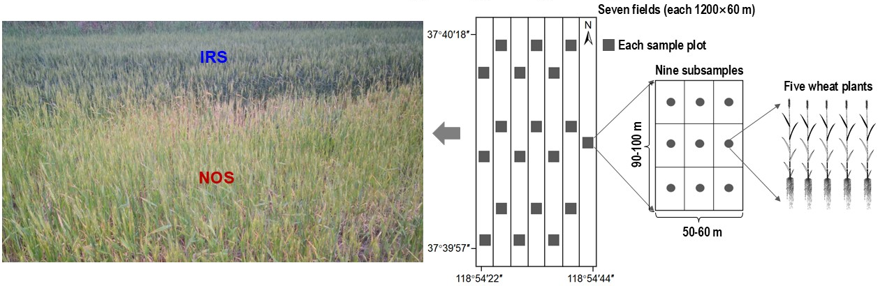
Fig.S1 Sample collection from wheat fields at the Shandong Dongying Institute of Geographic Sciences of the Chinese Academy of Sciences. The site is located in the Yellow River Delta, China, and the soil is a nontidal coastal saline soil. Seven fields, each 1,200 m long and 60 m wide, were planted in wheat (Triticum aestivum L., cultivar Xiaoyan_60). Nineteen samples under naturally occurring salinity (NOS) or irrigation-reduced salinity (IRS) were collected from the fields. For each of the 19 samples, nine subsamples from 90–100 m long × 50–60 m wide plots were aggregated into a single composite sample. In addition, five wheat plants were extracted from each 5-m diameter subsampling area.
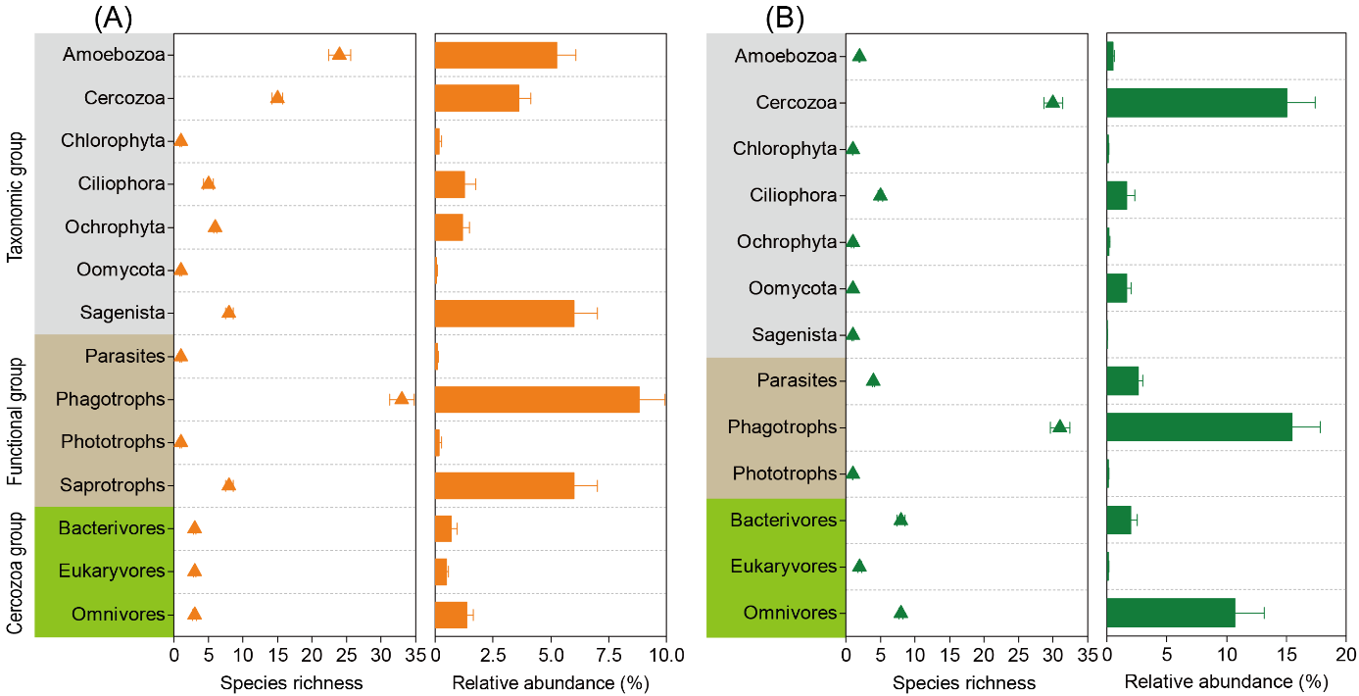
Fig.S2 (A–B) Species richness and relative abundance of specific protistan groups enriched in rhizospheres under naturally occurring salinity (A) and irrigation-reduced salinity (B). These taxa were identified by differential abundance analysis based on a likelihood ratio test (P < 0.01, false discovery rate corrected).
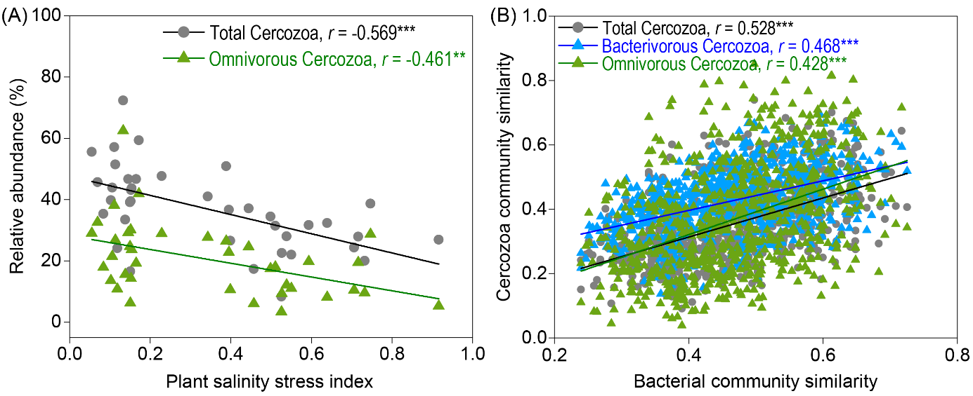
Fig.S3 (A–B) Spearman’s rank correlations between the plant salinity stress index and the relative abundance of total Cercozoa and omnivorous Cercozoa (A) and bacterial community similarity and the community similarity of total Cercozoa, bacterivorous Cercozoa, and omnivorous Cercozoa (B). Similarity = 1 – Bray-Curtis dissimilarity. ** and *** denote significant correlations at probability levels of 0.01 and 0.001, respectively.
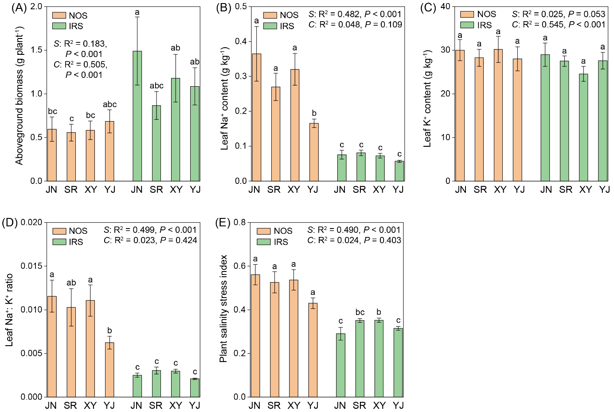
Fig.S4 (A–E) Aboveground biomass (A), leaf Na⁺ content (B), leaf K⁺ content (C), leaf Na⁺: K⁺ ratio (D), and plant salinity stress index (E) of wheat cultivars Jinan_177 (JN), Shanrong_3 (SR), Xiaoyan_6 (XY), and Yanjian_14 (YJ) under naturally occurring salinity (NOS) and irrigation-reduced salinity (IRS). Different lowercase letters above error bars indicate significant differences (P < 0.05) based on one-way analysis of variance (ANOVA). The effects of salinity (S) and cultivar (C) on plant physiological traits were tested by two-way ANOVA.
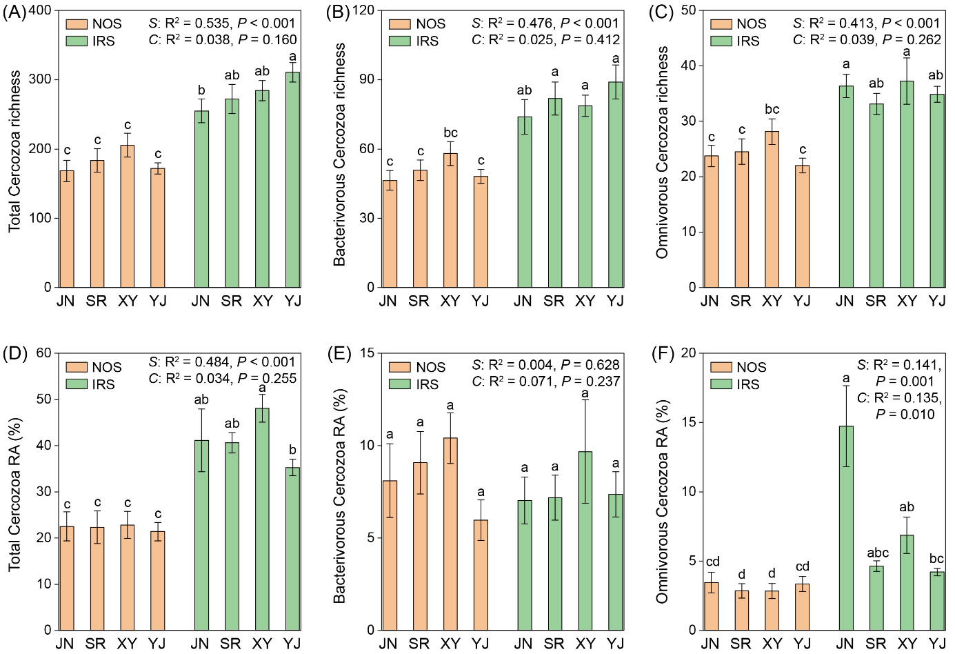
Fig.S5 (A–F) Richness of total Cercozoa (A), bacterivorous Cercozoa (B), and omnivorous Cercozoa (C) and relative abundance (RA) of total Cercozoa (D), bacterivorous Cercozoa (E), and omnivorous Cercozoa (F) in rhizospheres of wheat cultivars Jinan_177 (JN), Shanrong_3 (SR), Xiaoyan_6 (XY), and Yanjian_14 (YJ) under naturally occurring salinity (NOS) and irrigation-reduced salinity (IRS). Different lowercase letters above error bars indicate significant differences (P < 0.05) based on one-way analysis of variance (ANOVA). The effects of salinity (S) and cultivar (C) on the richness and relative abundance of these cercozoan groups were tested by two-way ANOVA.
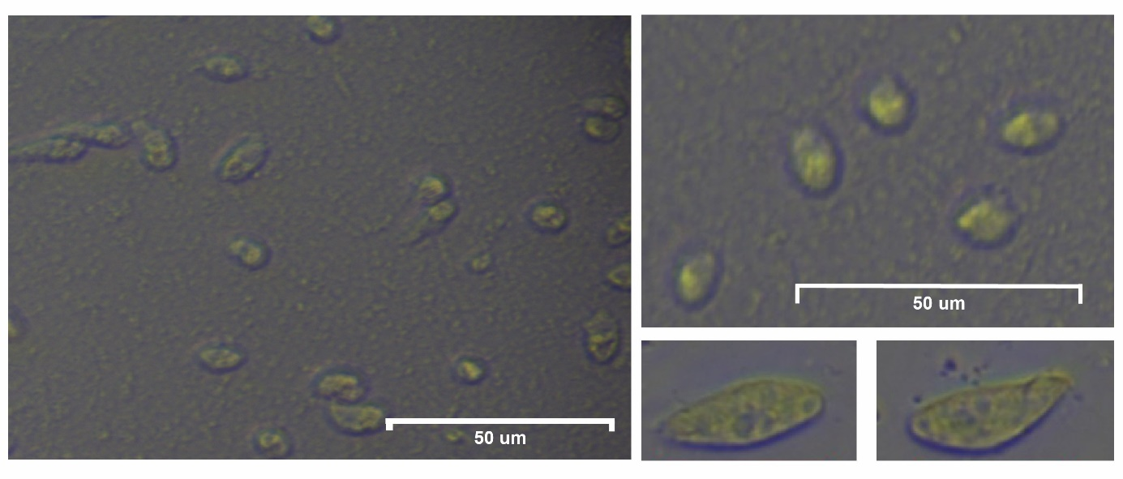
Fig.S6 Morphological observation of the Cercomonas directa strain.

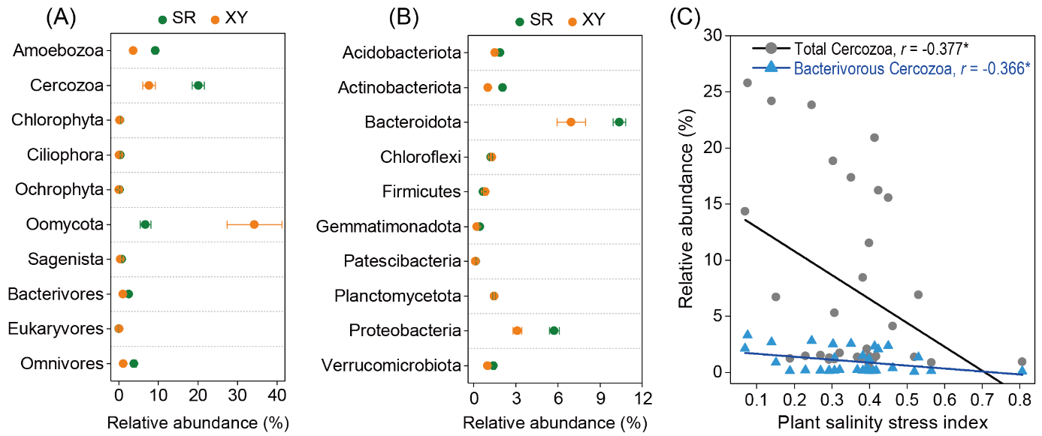
Fig.S7 (A–B) Relative abundance of specific protistan groups (A) and bacterial phyla (B) enriched by the Cercomonas directa inoculation in rhizospheres of wheat cultivars Shanrong_3 (SR) and Xiaoyan_6 (XY). These taxa were identified by differential abundance analysis based on a likelihood ratio test (P < 0.01, false discovery rate corrected). (C) Spearman’s rank correlations of the plant salinity stress index with the relative abundance of total Cercozoa and bacterivorous Cercozoa enriched by the Cercomonas directa inoculation. * denotes significant correlations at a probability level of 0.05.

Tab.S1 Soil and plant properties under naturally occurring salinity (NOS) and irrigation-reduced salinity (IRS). The plant salinity stress index was calculated by integrating aboveground biomass and leaf Na⁺ and K⁺ contents and their ratio. Results are means ± standard errors (n = 19). The significance (P) of differences was assessed by independent-sample t-tests; ns indicates non-significance (P > 0.05).
 | Property | NOS | IRS | P
Soil | pH | 8.24 ± 0.04 | 8.09 ± 0.04 | < 0.05
Soil | Electrical conductivity (dS m⁻¹) | 1.62 ± 0.15 | 0.52 ± 0.05 | < 0.001
Soil | Water soluble salt content (g kg⁻¹) | 3.44 ± 0.33 | 1.13 ± 0.13 | < 0.001
Soil | Organic C content (g kg⁻¹) | 6.97 ± 0.39 | 7.09 ± 0.41 | ns
Soil | Total N content (g kg⁻¹) | 0.62 ± 0.04 | 0.62 ± 0.04 | ns
Soil | Total P content (g kg⁻¹) | 0.72 ± 0.02 | 0.75 ± 0.03 | ns
Soil | Olsen P content (mg kg⁻¹) | 31.07 ± 3.42 | 38.25 ± 5.95 | ns
Plant | Aboveground biomass (g plant⁻¹) | 0.99 ± 0.05 | 2.47 ± 0.10 | < 0.001
Plant | Leaf Na⁺ content (g kg⁻¹) | 0.35 ± 0.03 | 0.10 ± 0.00 | < 0.001
Plant | Leaf K⁺ content (g kg⁻¹) | 12.67 ± 0.60 | 18.08 ± 0.49 | < 0.001
Plant | Leaf Na⁺: K⁺ ratio | 0.030 ± 0.003 | 0.005 ± 0.000 | < 0.001
Plant | Plant salinity stress index | 0.56 ± 0.03 | 0.13 ± 0.01 | < 0.001

Tab.S2 Community differentiation of major protist groups between naturally occurring salinity and irrigation-reduced salinity. Explanatory rate (R²) and significance (P) were calculated by permutational multivariate analysis of variance with 999 permutations; ns indicates non-significance (P > 0.05).
 |  | R² | P
Taxonomic group | Overall | 0.131 | < 0.01
Taxonomic group | Amoebozoa | 0.172 | < 0.01
 | Apicomplexa | 0.062 | ns
 | Cercozoa | 0.144 | < 0.01
 | Ciliophora | 0.034 | ns
Functional group | Parasites | 0.102 | < 0.01
 | Phagotrophs | 0.123 | < 0.01
Cercozoa group | Bacterivores | 0.129 | < 0.01
Cercozoa group | Eukaryvores | 0.152 | < 0.01
Cercozoa group | Omnivores | 0.143 | < 0.01

Tab.S3 Network topological characteristics of rhizosphere bacteria, bacterivorous Cercozoa, and omnivorous Cercozoa under naturally occurring salinity (NOS) and irrigation-reduced salinity (IRS).
Network topological characteristics ª | NOS | IRS
Network diameter | 11 | 7
Network density | 0.073 | 0.136
Network centralization | 0.201 | 0.228
Network heterogeneity | 0.777 | 0.775
Clustering coefficient | 0.476 | 0.523
Characteristic path length | 3.709 | 2.761
Average number of neighbors | 6.511 | 12.495
ª Network diameter refers to the longest distance between nodes, characteristic path length refers to average network distance between all pairs of nodes, and clustering coefficient is the average of clustering coefficients of all nodes. The more complex and connected network displays higher network density, clustering coefficient and average number of neighbors but lower network diameter and characteristic path length.

