Linking microbial nutrient limitation and community composition to nitrogen mineralization in bamboo forest soil with phosphorus addition
Running title: P supply enhances forest soil N mineralization

Tong-Tao Hu^{1,2a}, Dong Bu^{1,2a}, Yang Zhang¹, Fang-Chao Wang^{1,2}, Jian-Jun Li^{1,2}, Kui-Ling Zu¹, Ming-Hui Meng^{1,2}, Chao Liang³, Xiang-Min Fang^{1,2*}

¹ Key Laboratory of National Forestry and Grassland Administration on Forest Ecosystem Protection and Restoration of Poyang Lake Watershed, College of Forestry, Jiangxi Agricultural University, Nanchang 330045, China
² Long-term Research Base of National Forestry and Grassland Administration on Forest Vegetation Restoration in Degraded Red Soil Area of Jiangxi, College of Forestry, Jiangxi Agricultural University, Nanchang 330045, China
³ Institute of Applied Ecology, Chinese Academy of Sciences, Shenyang 110016, China

Table S1 Effects of phosphorus addition on the basic chemical properties of three soil types in moso bamboo forests.
Treatment |  | pH | NH₄⁺-N (mg kg⁻¹) | NO₃⁻-N (mg kg⁻¹) | Available P (mg kg⁻¹) | Mineral N (mg kg⁻¹) | Mineral N/Available P
BS | CK | 4.66±0.22 | 11.15±0.30 | 8.53±0.37 | 5.56±0.30 | 19.68±0.22 | 3.57±0.19
BS | PA | 4.80±0.20 | 12.77±0.32 | 8.80±0.49 | 8.24±0.40 | 21.56±0.19 | 2.64±0.14
RS | CK | 5.04±0.15 | 14.52±0.46 | 11.69±0.62 | 4.74±0.40 | 26.21±0.72 | 5.65±0.50
RS | PA | 5.16±0.16 | 17.54±0.84 | 11.69±0.71 | 8.72±0.27 | 29.23±1.42 | 3.37±0.24
RR | CK | 4.92±0.24 | 15.52±0.47 | 11.54±0.65 | 6.23±0.65 | 27.07±0.39 | 4.50±0.50
RR | PA | 5.03±0.21 | 17.62±0.49 | 11.93±0.77 | 10.00±0.31 | 29.56±0.62 | 2.96±0.07
Variance analysis of F-statistics
P |  | 0.57^{ns} | 28.99*** | 0.19^{ns} | 108.96*** | 17.37** | 36.21***
S |  | 1.80^{ns} | 48.77*** | 16.40*** | 6.89** | 69.83*** | 9.53**
P×S |  | 0.00^{ns} | 0.96^{ns} | 0.05^{ns} | 1.40^{ns} | 0.31^{ns} | 2.18^{ns}
Mean±1standard error. CK: control; PA: phosphorus addition treatment. BS: bulk soil; RS: rhizosphere soil of stump roots; RR: rhizosphere soil of rhizome roots. P: phosphorus addition effects; S: soil type effects.* p<0.05, **p<0.01, *** p<0.001, ns: not significant.

Table S2 Correlation coefficients between the variables of the soil microbial community and the soil N mineralization rate in moso bamboo forests.
 | Ammonification rate  (mg kg⁻¹ d⁻¹) | Nitrification rate  (mg kg⁻¹ d⁻¹) | Net N mineralization rate  (mg kg⁻¹ d⁻¹)
Total PLFAs (nmol g⁻¹) | 0.110 | 0.013 | 0.066
Bacteria (nmol g⁻¹) | 0.372# | 0.117 | 0.272
Fungi (nmol g⁻¹) | -0.126 | -0.111 | -0.144
Actinomycete (nmol g⁻¹) | -0.212 | -0.113 | -0.186
G+ (nmol g⁻¹) | 0.442* | 0.194 | 0.362#
G- (nmol g⁻¹) | 0.112 | -0.069 | 0.008
G+/G- | 0.315 | 0.26 | 0.342
Fungi/Bacteria | -0.389# | -0.225 | -0.357#
G+: Gram-positive bacteria. G-: Gram-negative bacteria. * p<0.05, #p<0.1.
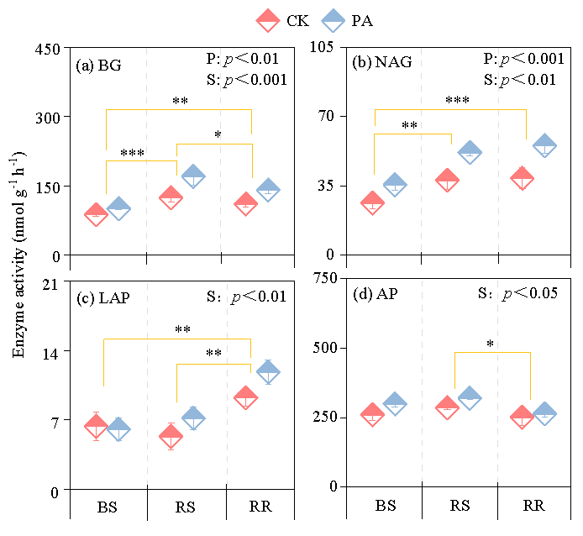
Fig. S1 Effects of phosphorus addition on the activities of extracellular enzymes in three soil types in moso bamboo forests. The bars indicate the standard error. CK: control; PA: phosphorus addition treatment. BS: bulk soil; RS: rhizosphere soil of stump roots; RR: rhizosphere soil of rhizome roots. BG: β-1,4-glucosidase, NAG: β-N-acetylglucosaminidase, LAP: leucine aminopeptidase, AP: acid phosphatase. The two-way ANOVA results are presented as an insert; P: phosphorus addition effects; S: soil type effects. The asterisks on the horizontal bars indicate significant differences between the two connected soil types. * p<0.05, **p<0.01, *** p<0.001.

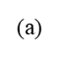
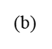
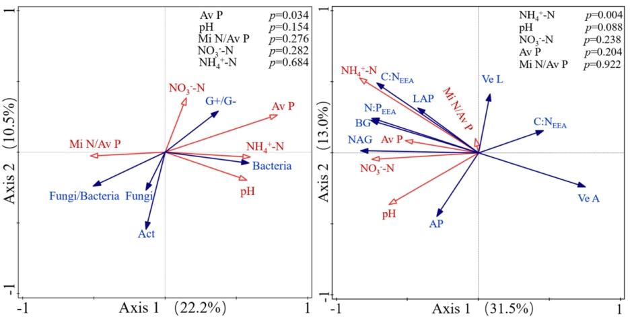

Fig. S2 Redundancy analysis (RDA) diagram illustrating the relationships among the characteristics of the soil microbial community (a), and extracellular enzymes (b), and soil chemical properties in moso bamboo forests. The soil chemical properties are represented by red arrows, and the blue arrows represent the microbial community characteristics or soil extracellular enzyme variables. Mi N: mineral nitrogen; Av P: available phosphorus; Mi N/Av P: the ratio of mineral nitrogen to available phosphorus. Act: Actinomycete. Ve A: enzyme vector angle, Ve L: enzyme vector length.

