Supplementary Information

Effects of straw management practices on soil organic carbon fraction dynamics and greenhouse gas emissions in a double-season rice cropping system
Chaoyun Ying ^{a,b,c}, Yue Li ^{a,b,c}, Xuechi Rong ^{a b,c}, Kailou Liu ^{d}, Yongfu Li ^{e}, Xianting Wang ^{f}, Guanjun Li ^{b,c}, Cuiyan Wu^{g}, Tida Ge ^{b,c}, Shuang Wang ^{b,c,*}
ª School of Geography and Remote sensing, Ningbo University, Ningbo 315211, China
^{b} State Key Laboratory for Quality and Safety of Agro-products, Key Laboratory of Biotechnology in Plant Protection of MARA, Zhejiang Key Laboratory of Green Plant Protection, Institute of Plant Virology, Ningbo University, Ningbo 315211, China
^{c} International Science and Technology Cooperation Base for the Regulation of Soil Biological Functions and One Health of Zhejiang Province, Ningbo University, Ningbo 315211, China
^{d} Jiangxi Institute of Red Soil and Germplasm Resources, Nanchang 330046, China
^{e} State Key Laboratory for Development and Utilization of Forest Food Resources, College of Environmental and Resource Sciences, Zhejiang A&F University, Hangzhou 311300, China
^{f} Yinzhou Station of Agricultural Technical Extension, Ningbo 315100, China
^{g} School of Materials and Chemical Engineering, Ningbo University of Technology, No. 201 Fenghua Road, Jiangbei District, Ningbo 315211, China

*Corresponding author
Shuang Wang
State Key Laboratory for Quality and Safety of Agro-products, Institute of Plant Virology, Ningbo University, Ningbo 315211, China
Phone number: 0574-87607537
E-mail address: wangshuang1@nbu.edu.cn
Table S1. Grain yield of different treatments across three rice seasons (kg ha⁻¹)
Rice season | SR  (Grain yield kg ha⁻¹) | GSR  (Grain yield kg ha⁻¹) | CSR  (Grain yield kg ha⁻¹) | ISB  (Grain yield kg ha⁻¹)
2024 early | 6704.07±264.13 | 6193.31±192.15 | 6561.14±346.26 | 6728.55±168.88
2024 late | 6348.88±273.99 | 6308.49±72.99 | 6901.46±246.02 | 6866.04±137.04
2025 early | 4828.18±61.00 | 4770.92±95.89 | 4924.14±43.73 | 4919.21±137.58

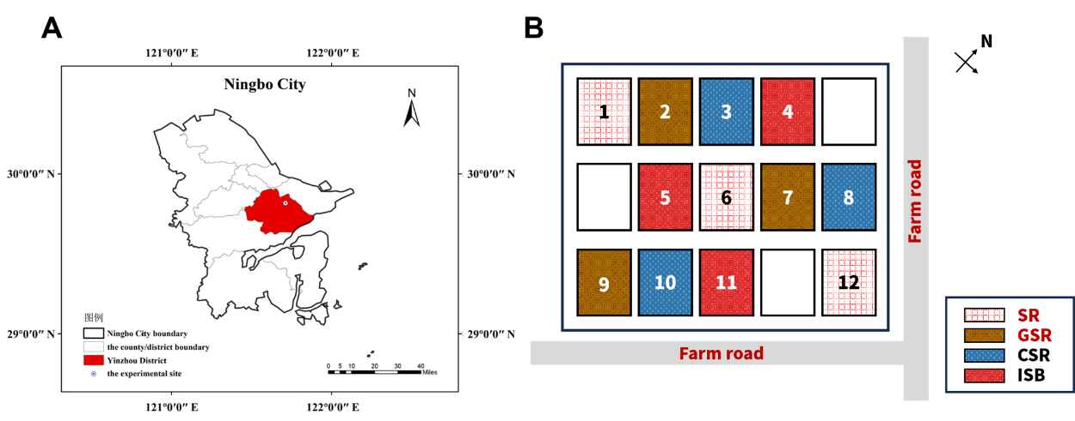
Fig. S1 Geographical location and experimental plot layout. (A) Geographical location of the study site in Ningbo City, Zhejiang Province, China. (B) Arrangement of the treatment plots in a randomized block design, i.e., straw removal (SR), granulated straw return (GSR), chopped straw return (CSR), and in-situ burning (ISB).

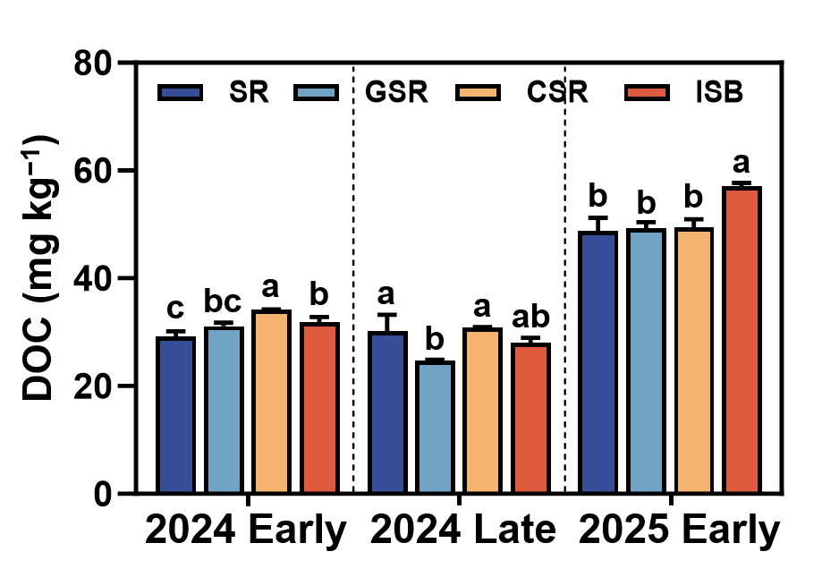
Fig. S2 Dynamics of dissolved organic carbon (DOC) under different straw management practices at rice maturity.​ Dissolved organic carbon content in the 2024 early rice, 2024 late rice, and 2025 early rice seasons. Data are presented as mean ± SD (n = 3). Different lowercase letters above bars within the same season indicate significant differences among treatments (SR, GSR, CSR, ISB) according to one-way ANOVA and Tukey’s HSD test (p < 0.05). Statistical results: F(3,8) = 22.81, p < 0.001 (2024 Early); F(3,8) = 8.71, p = 0.007 (2024 Late); F(3,8) = 18.96, p = 0.001 (2025 Early).

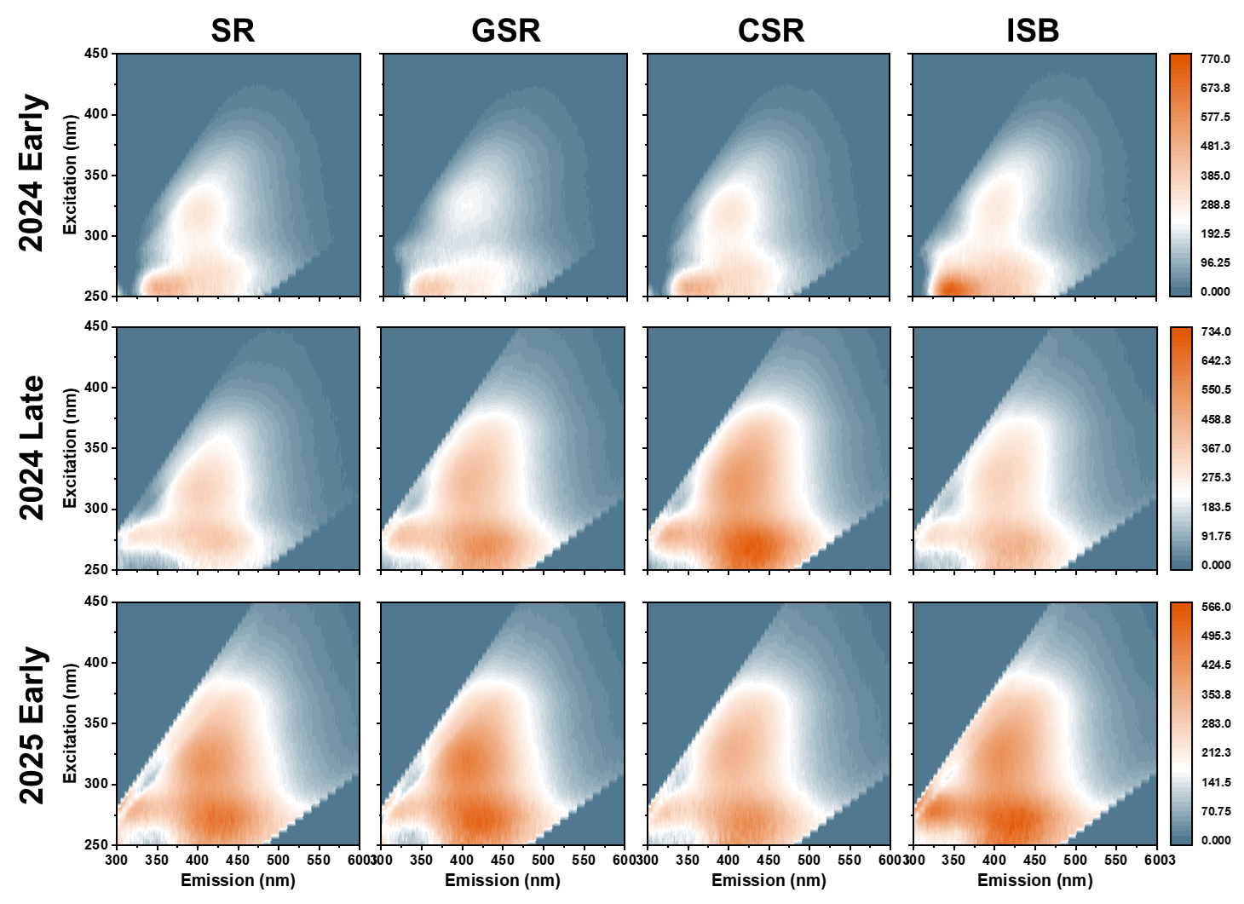
Fig. S3 Dynamics of dissolved organic matter fluorescence characteristics under different straw management practices at rice maturity.​ Representative excitation-emission matrix (EEM) fluorescence contour plots of typical samples in the 2024 early rice, 2024 late rice, and 2025 early rice seasons.

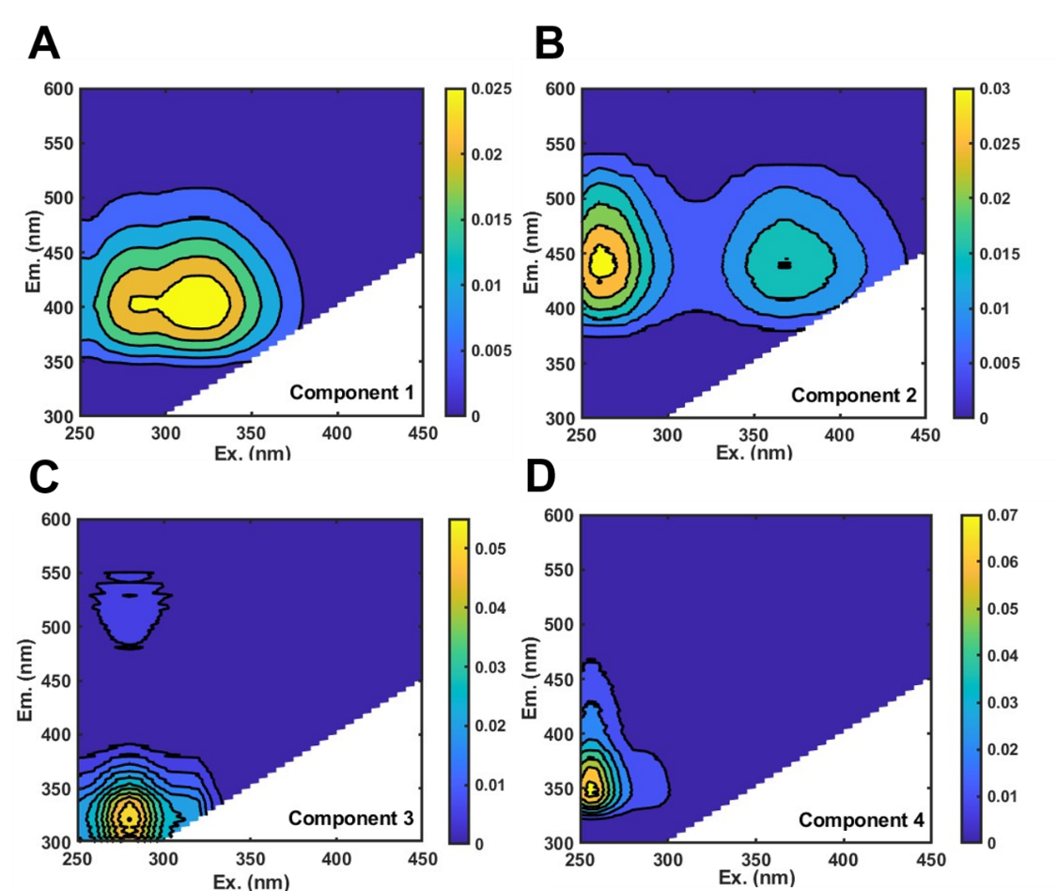
Fig. S4 Fluorescent components of dissolved organic matter identified by PARAFAC modeling.​ Four components identified from the fluorescence excitation-emission matrices under different straw management practices: (A) humic-like C1, (B) humic-like C2, (C) protein-like C3, and (D) tryptophan-like C4.

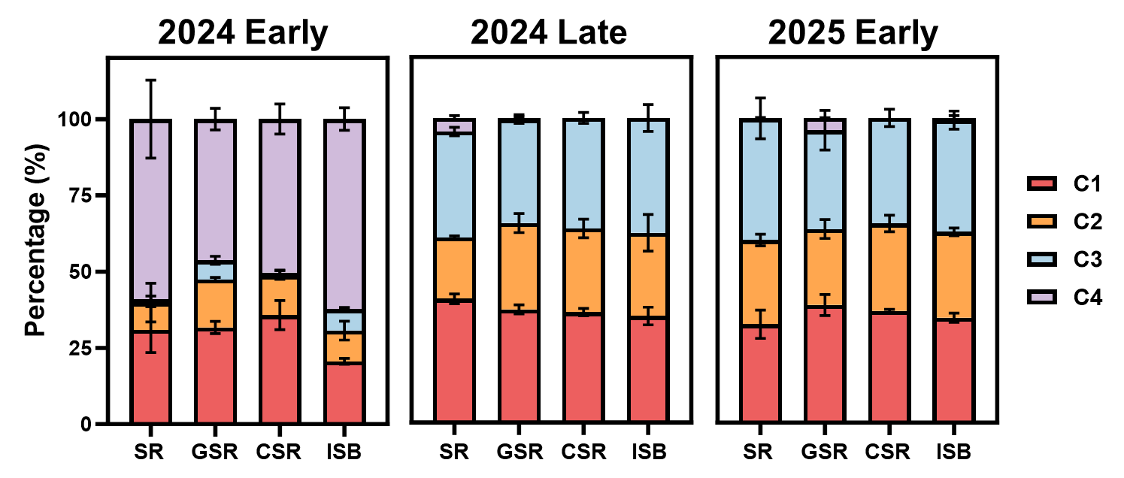
Fig. S5 Dynamics of the relative abundance of PARAFAC-derived fluorescent components under different straw management practices at rice maturity.​

