Supplementary information for Spatial dominance over temporal dynamics in urban soil bacterial communities and its implications for forensic geolocation
Running title: Spatial dominance in bacterial communities
Author Names: Qing Zhang ^{a,g}, Chang Zhao ª, Xiao Fu ª, Jiasheng Wu^{d}, Hengjun Zhang^{e}, Haiyan Chu^{a,b}, Meiqing Yuan^{f,*}, Teng Yang^{a,b,c,*}
ª State Key Laboratory of Soil and Sustainable Agriculture, Institute of Soil Science, Chinese Academy of Sciences, Nanjing 211135, China
^{b} University of Chinese Academy of Sciences, Beijing 100049, China
^{c} University of Chinese Academy of Sciences, Nanjing 211135, China
^{d} Liwan Branch of Guangzhou Public Security Bureau, Guangzhou 510140, China
^{e} Public Security Bureau of Bayingolin Mongolian Autonomous Prefecture, Xinjiang
^{f} Institute of Forensic Science, Ministry of Public Security (MPS), Beijing 100038, China
^{g} School of Ecology and Applied Meteorology, Nanjing University of Information Science and Technology, Nanjing 210044, China

* Corresponding author
Tel: +086-025-86881310; E-mail: tyang@issas.ac.cn
Tel: +086-010-66269473; E-mail: sequence17@163.com

Table S1 Detailed sampling schedule across the two-year time series, including all 16 sampling time points spanning spring 2019 to spring 2020.
Sampling interval | Sampling Date (2019) | Sampling Date (2020) | Season
1 day | 2019.03.19 | 2020.03.19 | Spring
2 days | 2019.03.20 | 2020.03.20 | Spring
3 days | 2019.03.21 | 2020.03.21 | Spring
1 week | 2019.03.26 | 2020.03.26 | Spring
2 weeks | 2019.04.02 | 2020.04.02 | Spring
4 weeks | 2019.04.16 | 2020.04.16 | Spring
2 months | 2019.05.21 |  | Spring
3 months | 2019.06.18 |  | Summer
6 months | 2019.09.17 |  | Autumn
9 months | 2019.12.17 |  | Winter

Table S2 Pairwise PERMANOVA comparisons of bacterial community composition among different soil sources within each city.
Comparison | Statistical Metric | Beijing | Nanjing | Guangzhou
In situ soil vs. Tool soil | R² | 0.012 | 0.010 | 0.008
 | P_{adj} | 0.054 | 0.136 | 0.713
In situ soil vs. Shoe-sole soil | R² | 0.016 | 0.016 | 0.010
 | P_{adj} | 0.015 | 0.021 | 0.306
Tool soil vs. Shoe-sole soil | R² | 0.021 | 0.020 | 0.012
 | P_{adj} | 0.107 | 0.136 | 0.829

Table S3 Comparison of seasonal and interannual variation in soil bacterial community composition within each city.
City | Mean seasonal difference in Bray-Curtis dissimilarity | Mean interannual difference in Bray-Curtis dissimilarity | P-value
Beijing | 0.804 | 0.744 | < 0.001
Nanjing | 0.861 | 0.853 | 0.031
Guangzhou | 0.814 | 0.736 | < 0.001

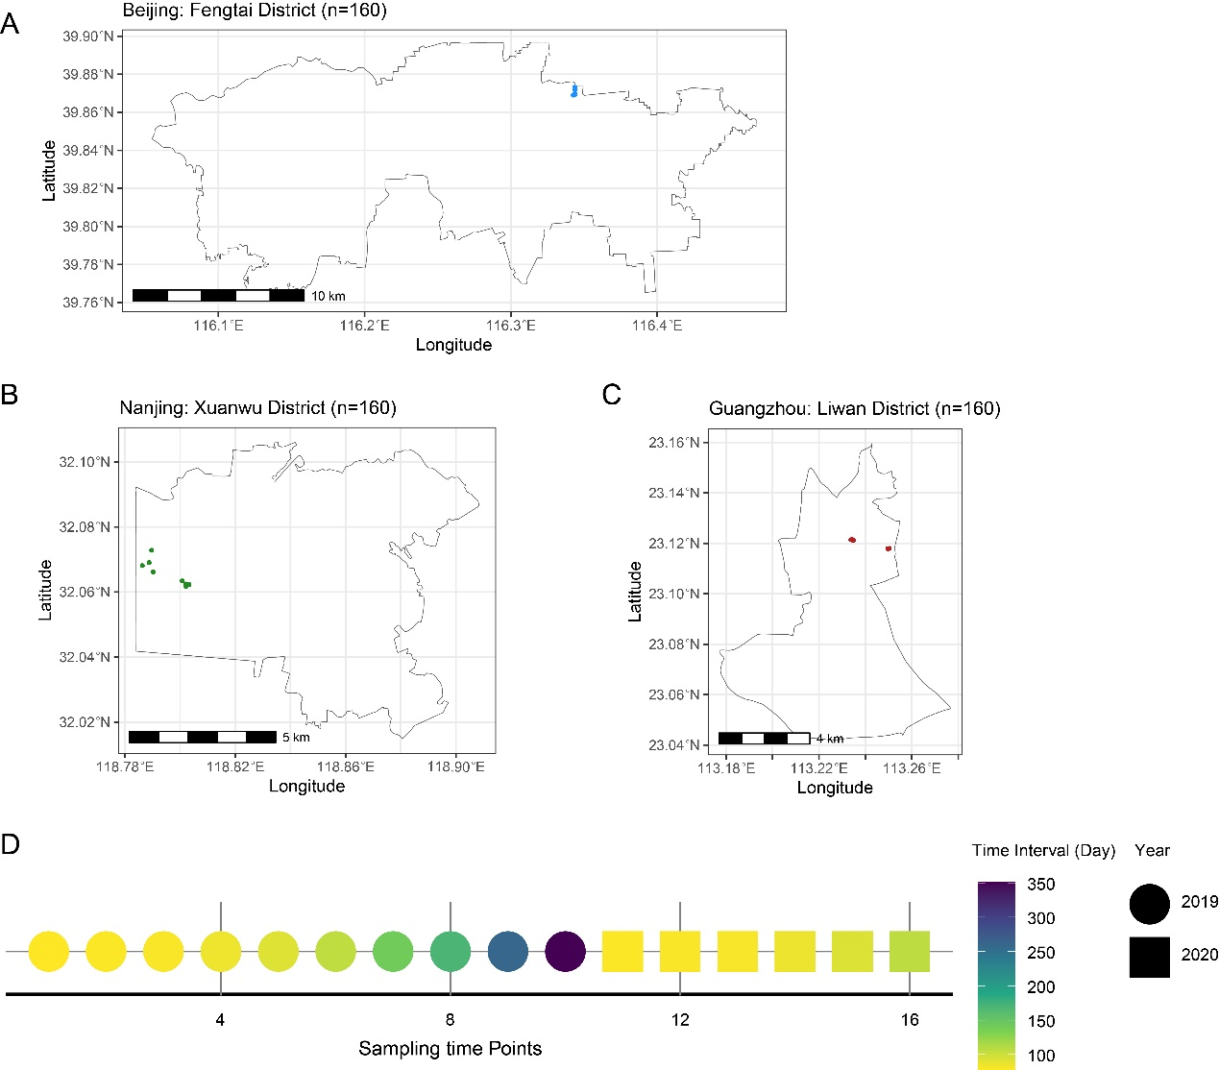
Fig. S1 Geographical distribution of the study area and the multi-scale spatiotemporal sampling design. (A-C) Locations of the six study sites in three major Chinese cities: Beijing (Fengtai District), Nanjing (Xuanwu District), and Guangzhou (Liwan District). Two independent sites were established within each city. (D) Temporal sampling design illustrating the 16 sampling time points spanning 2019–2020, encompassing short-term (days), medium-term (weeks), and long-term (months) intervals, with resampling of key time points to enable interannual comparisons.

Fig. S2 Relative abundances of the dominant bacterial phyla (relative abundance > 1%) across all samples. n=480.

Fig. S3 Venn diagram from variance partitioning analysis (VPA) illustrating the unique and shared contributions (adjusted R²) of spatial (“Space”), temporal (“Time”), and environmental (“Weather + Temperature”) factors to variation in soil bacterial community composition. n = 480.

Fig. S4 Drivers of soil bacterial community composition at the phylum level, showing the relative contributions (adjusted R²) of spatial, temporal, and soil source factors for the dominant bacterial phyla. n = 480.

Fig. S5 Spatial divergence of soil bacterial community composition at the urban scale. Panels illustrate bacterial community patterns within and between cities. (A-C) Non-metric multidimensional scaling (NMDS) ordinations based on Bray–Curtis dissimilarity for Beijing, Nanjing, and Guangzhou, respectively. Samples are colored by intra-city sampling site, and ellipses indicate 95% confidence intervals. (D) Boxplot comparing Bray–Curtis dissimilarities between inter-city and intra-city bacterial communities. n = 480.

Fig. S6 Drivers of soil bacterial community composition within each city. Panels show the relative contributions (adjusted R²) of spatial, temporal, and soil source factors to community composition for (A) Beijing, (B) Nanjing, and (C) Guangzhou. n = 160 for each city.

Fig. S7 Spatial distribution patterns of soil bacterial communities from different sources at the city scale. Non-metric multidimensional scaling (NMDS) ordinations based on Bray–Curtis dissimilarity for bacterial communities from in situ soil (green circles), tool soil (red triangles), and shoe-sole soil (blue squares) in (A) Beijing, (B) Nanjing, and (C) Guangzhou. Ellipses indicate 95% confidence intervals for each source group.
Fig. S8 Fast expectation-maximization microbial source tracking (FEAST) estimates of city-level source contributions for 12 randomly selected sink samples, including tool soil and shoe-sole soil, from three cities in China.
Fig. S9 Comparison of seasonal and interannual differences in soil bacterial community Bray–Curtis dissimilarity. Seasonal differences represent community dissimilarity among seasons within 2019, whereas interannual differences represent dissimilarity between corresponding months in 2019 and 2020.

