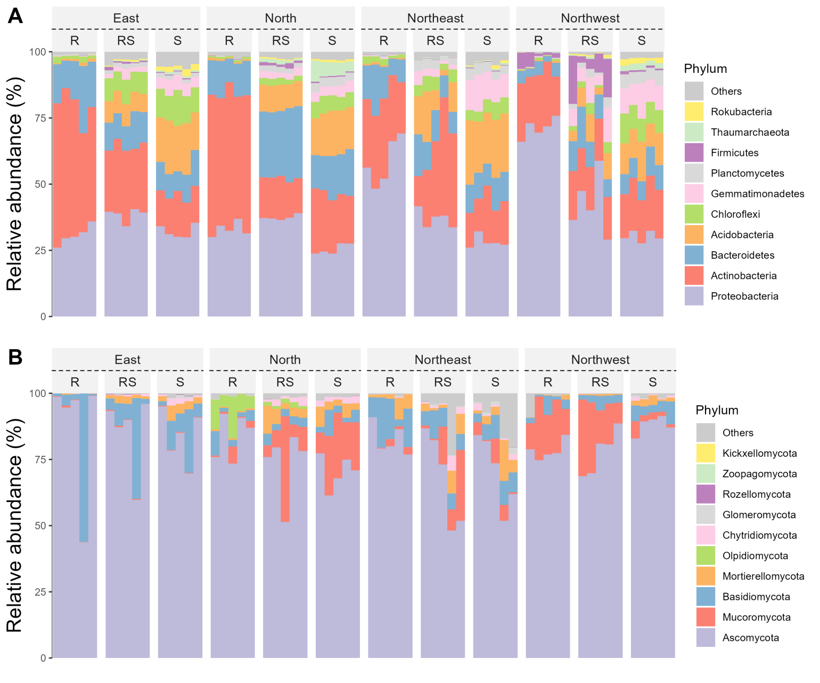
Figure S1: The abundances of representative phyla for prokaryotes (a) and fungi (b) in wheat samples. R: root endosphere; RS: rhizosphere; S: bulk soil.
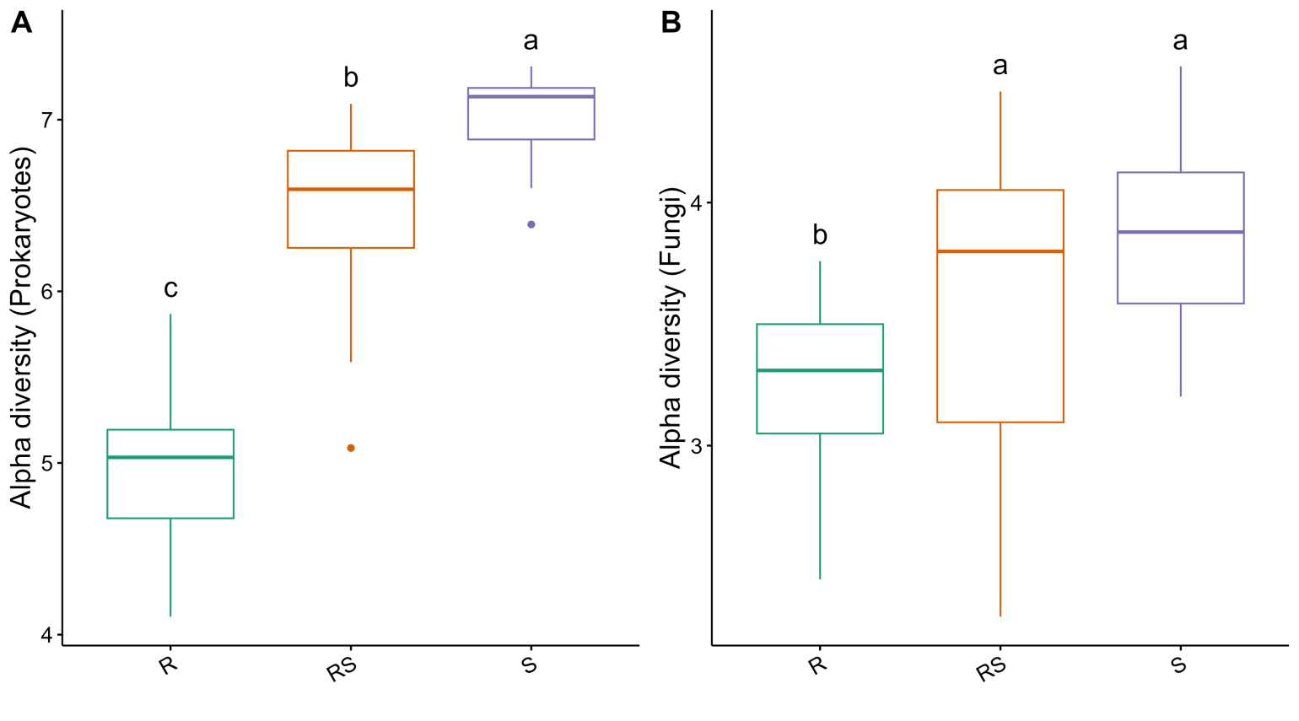
Figure S2: Shannon-Wiener index for the alpha diversity evaluation of different niches for prokaryotes (a) and fungi (b) of wheat samples.
Different lowercase letters denote significant differences among different groups in ANOVA analysis
with Duncan's new multiple range test using duncan.test function of agricolae package (**P** < 0.05).
R: root endosphere; RS: rhizosphere; S: bulk soil.

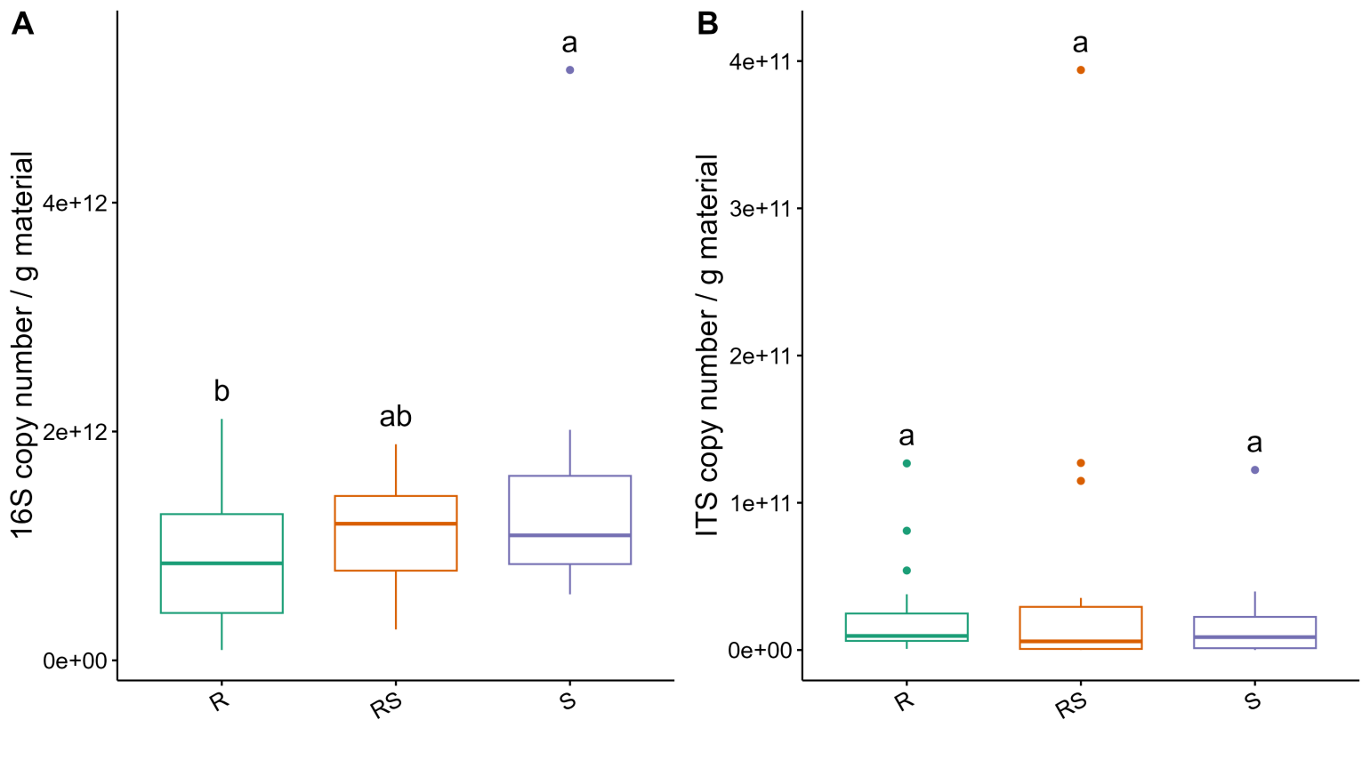
Figure S3: Copy numbers of 16S rRNA gene (a) and ITS fragment (b) of wheat samples.
Different lowercase letters denote significant differences among different groups in ANOVA analysis
with Duncan's new multiple range test using duncan.test function of agricolae package (P < 0.05).
R: root endosphere; RS: rhizosphere; S: bulk soil.
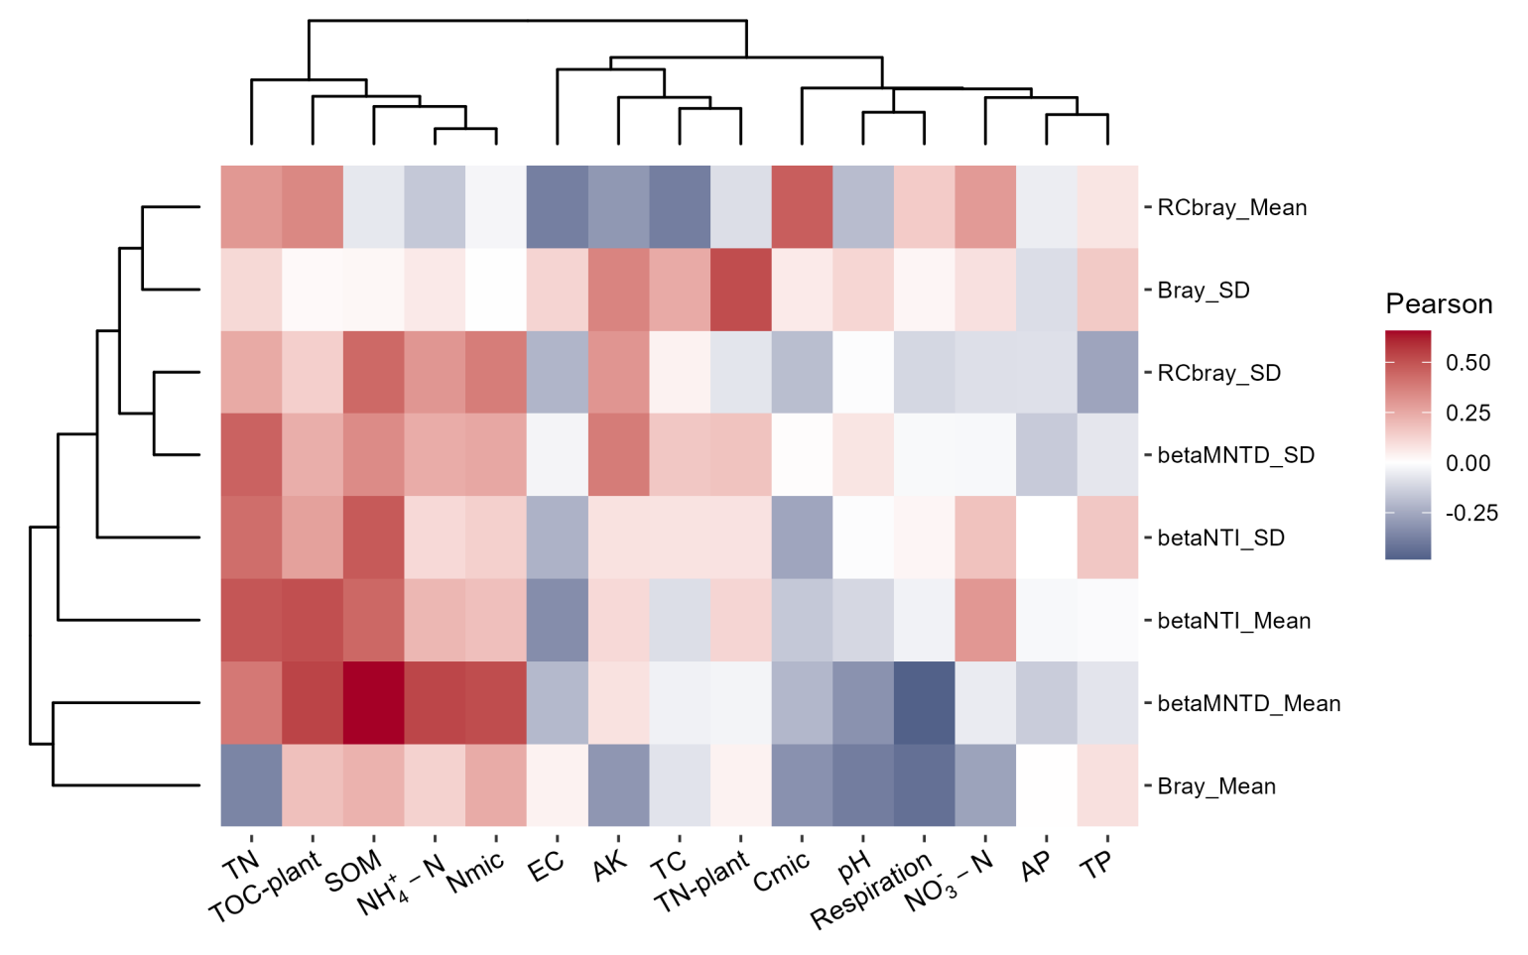
Figure S4: The correlations between soil/plant physicochemical factors and Mean/SD of beta diversity distances for the ITS data set of wheat.
P value was adjusted with the False Discovery Rate algorithm. *: p < 0.05; **: p < 0.01; ***: p < 0.001. AP: available phosphorus; TP: total phosphorus; AK: available potassium; TN: total nitrogen; TN-plant: total nitrogen of plant; EC: electronic conductivity; TC: total carbon; TOC-plant: total organic carbon of plant; SOM: soil organic matter; N_{mic}: soil microbial biomass nitrogen; C_{mic}: soil microbial biomass carbon.
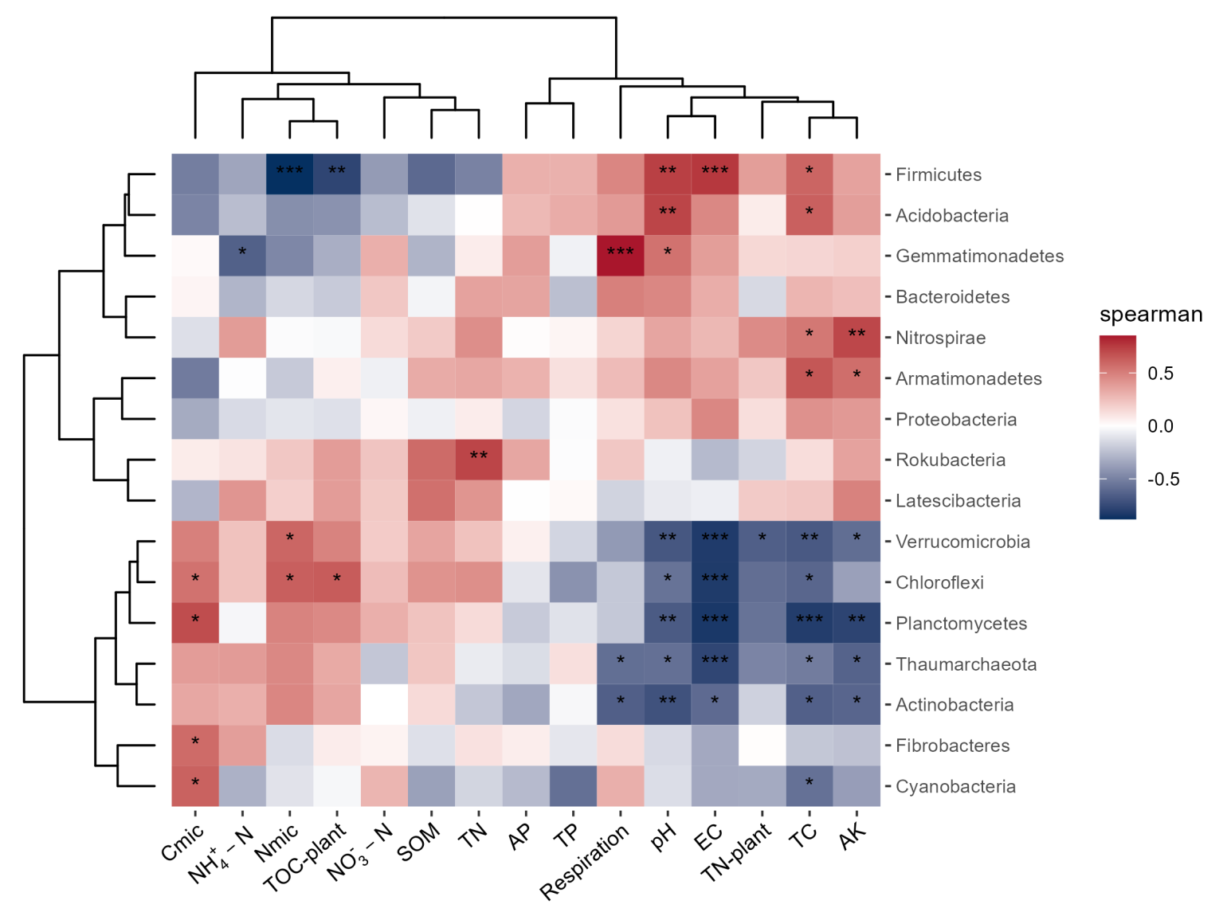
Figure S5: Spearman correlations between abundance difference values of fungal phyla and environmental factors in wheat data.
The abundance difference value means the abundance of rhizosphere soil minus that of bulk soil. P value was adjusted with the False Discovery Rate algorithm. *: p < 0.05; **: p < 0.01; ***: p < 0.001. AP: available phosphorus; TP: total phosphorus; AK: available potassium; TN: total nitrogen; TN-plant: total nitrogen of plant; EC: electronic conductivity; TC: total carbon; TOC-plant: total organic carbon of plant; SOM: soil organic matter; N_{mic}: soil microbial biomass nitrogen; C_{mic}: soil microbial biomass carbon.

