Supporting Information

Increasing microbial risks under co-contamination: View from virulence factor genes

Lijuan Ma^{a,b}, Fei Zhengª, Lu Wang^{b,c*}, Dong Zhu^{b,c*}
ªCollege of Life Science, Hebei University, Baoding 071002, China
^{b}State Key Laboratory of Regional and Urban Ecology, Ningbo Observation and Research Station, Institute of Urban Environment, Chinese Academy of Sciences, Xiamen 361021, China
^{c}Zhejiang Key Laboratory of Pollution Control for Port-Petrochemical Industry, CAS Haixi Industrial Technology Innovation Center in Beilun, Ningbo 315830, China
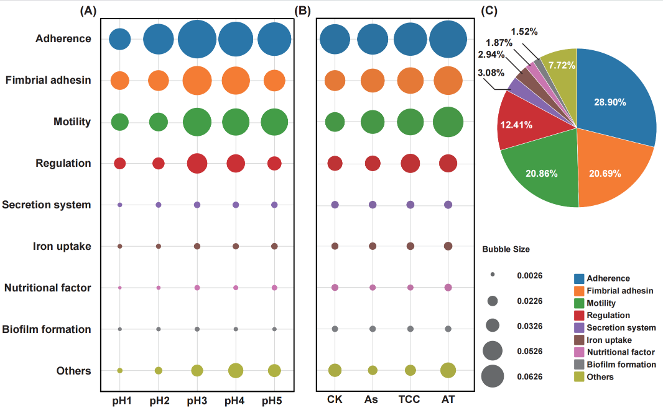
Fig. S1 Functional classification and abundance of virulence factor genes (VFGs) under different pH and pollutant treatments.（A and B）Bubble plots showing the relative abundance of major VFG functional categories across five pH levels (pH1-pH5) and four treatments (CK, As, TCC, AT). Bubble size corresponds to the relative abundance (copies per 16S rRNA gene) of each function. (C) Pie chart summarizing the overall functional distribution of VFGs. VFGs related to adherence, fimbrial adhesion, and motility dominated the profiles across all conditions, accounting for the majority of detected VFG abundance.
Fig. S2 Heat map showing the variation of dominant virulence factor genes (VFGs) under different treatments (CK, As, TCC, AT) and pH conditions (pH1-pH5). Colors represent normalized relative abundance of individual VFGs.
Fig. S3 Phylum-level composition of soil microbial communities under different pH conditions. The stacked bar chart illustrates the relative abundance of all bacterial phyla across five pH treatments (pH1-pH5).
Fig. S4 Random forest analysis showing phylum-level importance for predicting total VFG abundance. Bars represent the relative importance of each bacterial phylum in shaping the total abundance of VFGs, as determined by random forest modeling. Gray bars indicate low-abundance phyla (mean relative abundance < 0.02). Orange bars represent phyla with a positive correlation with pH. Blue bars represent phyla with a negative correlation with pH. Significant levels: * P < 0.05, ** P < 0.01 and *** P < 0.001.
Fig. S5 Relative abundance of α-Proteobacteria and γ-Proteobacteria across different pH conditions.

