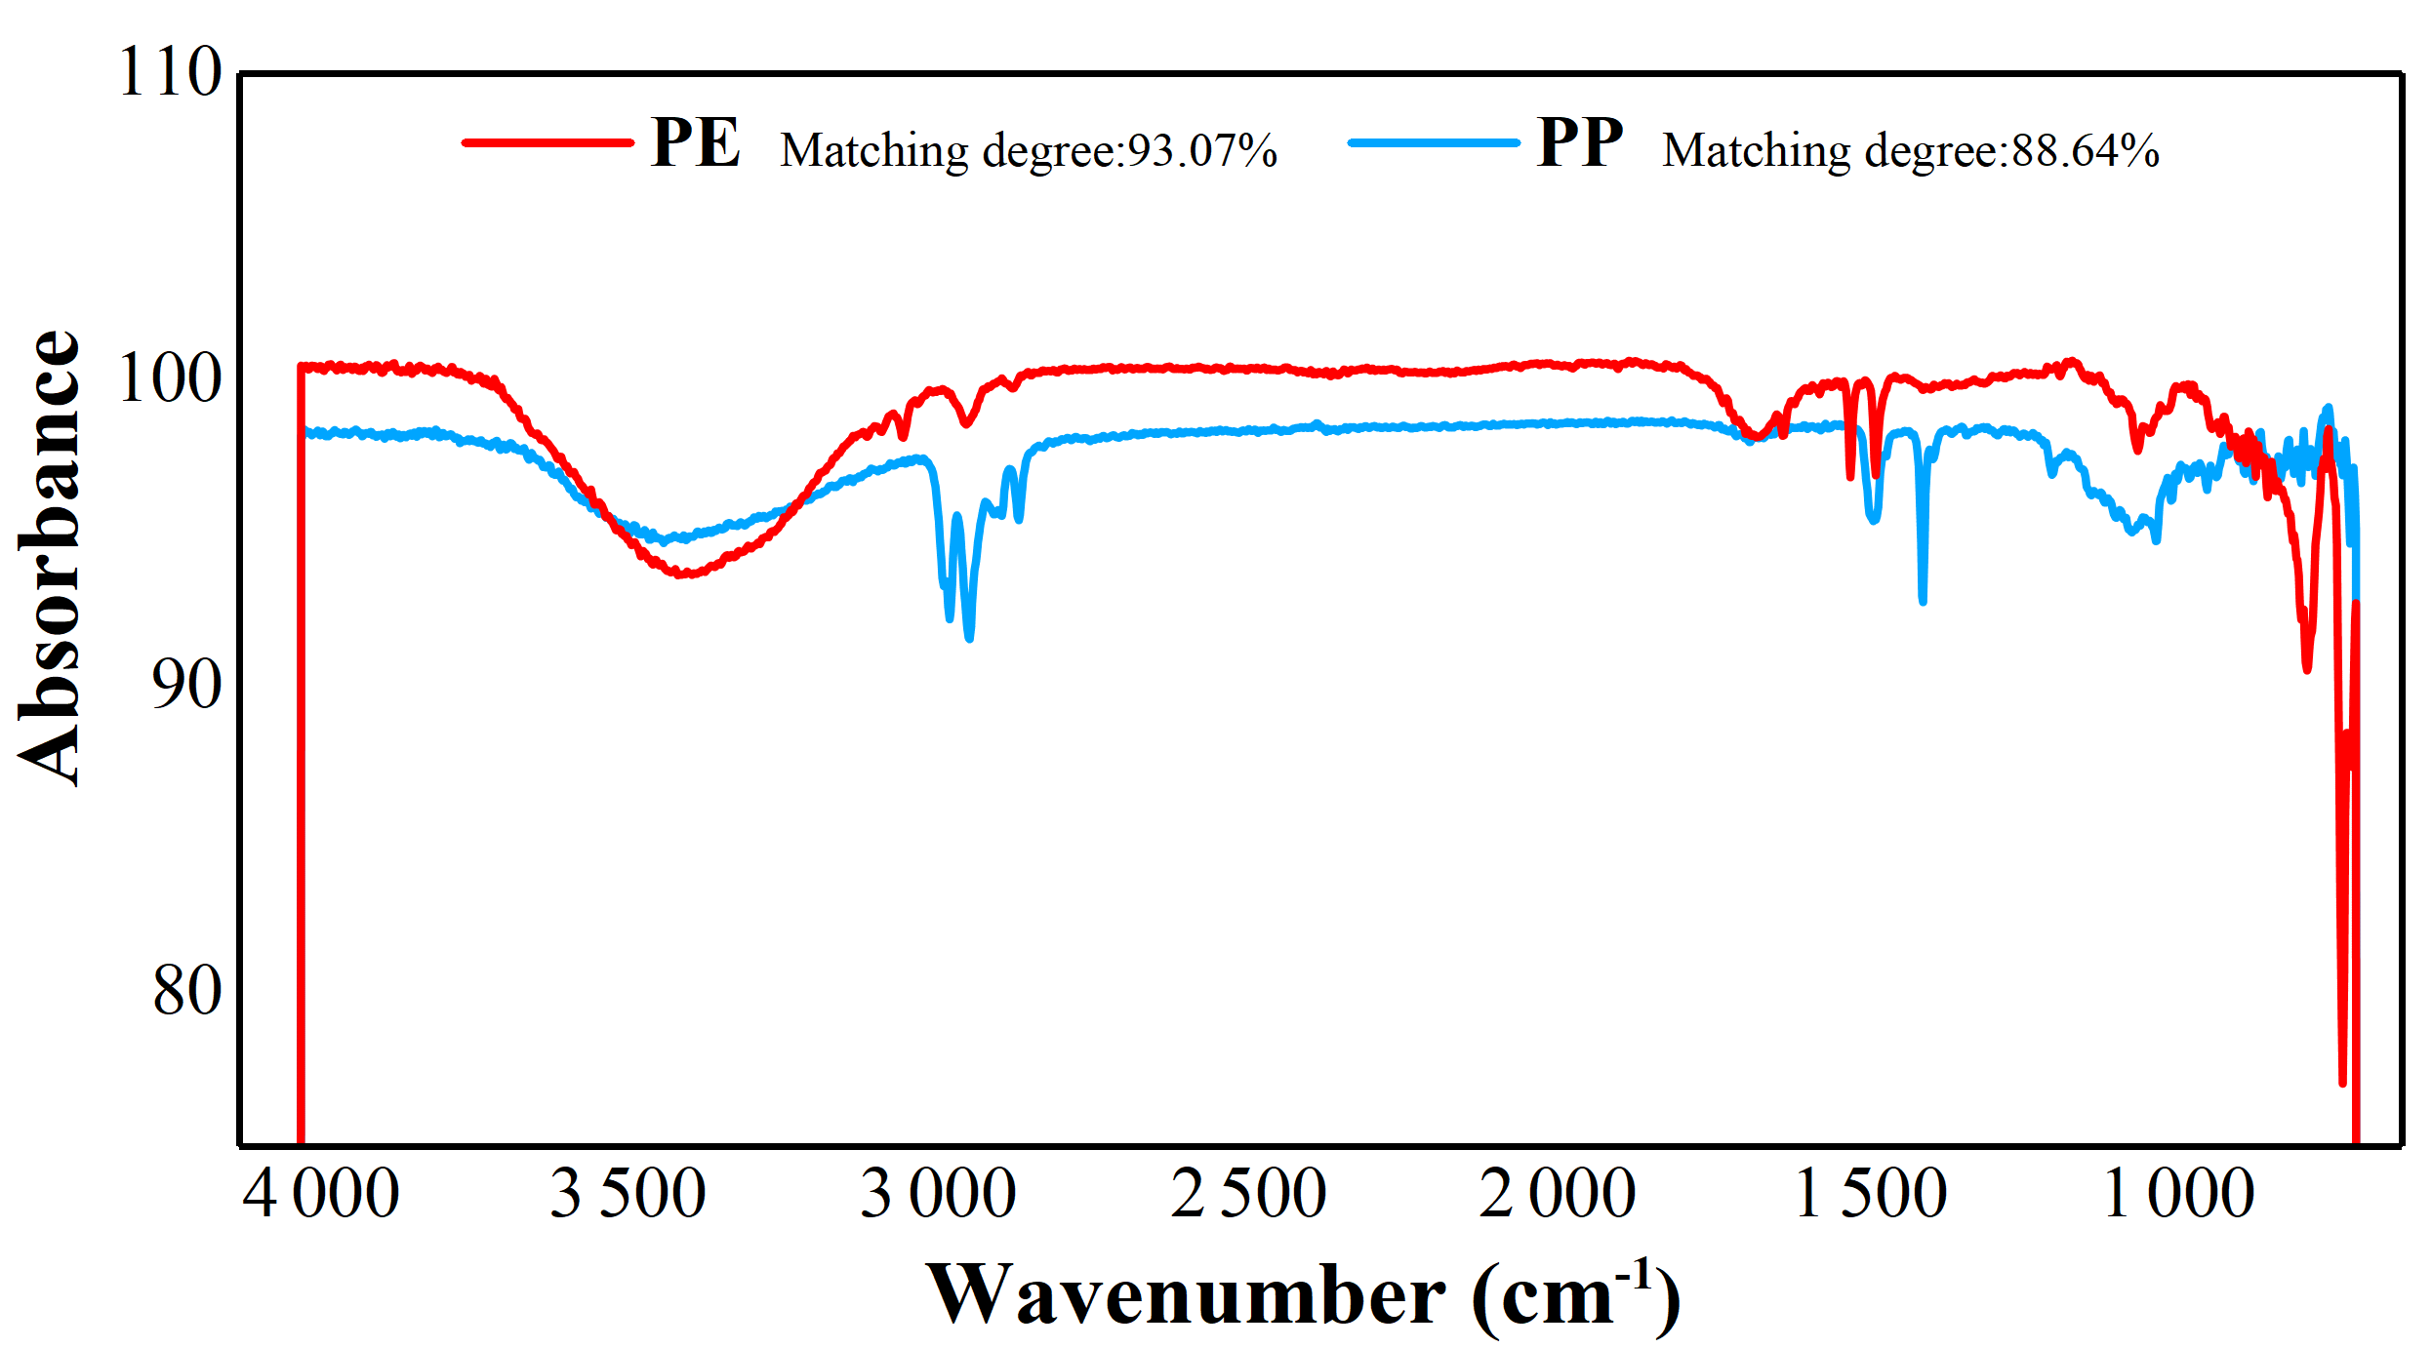
Supplementary Figure 1 Infrared spectra of different types of microplastics.

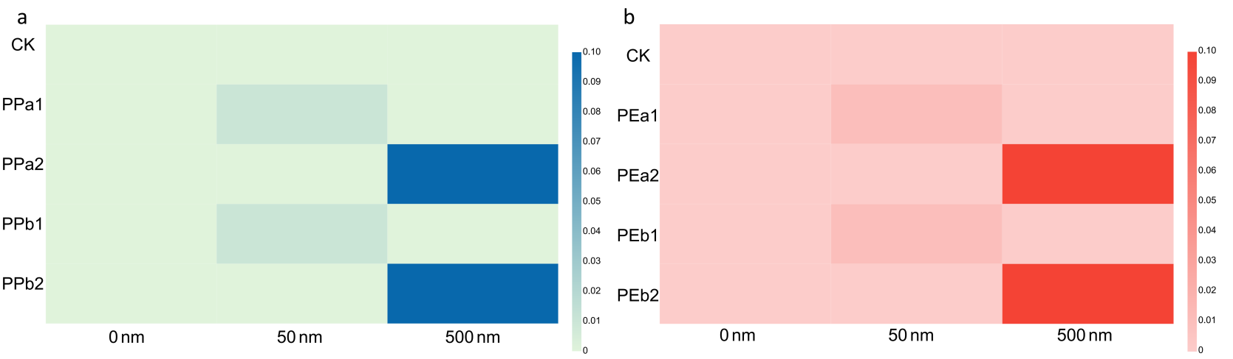
Supplementary Figure 2 Information about NPs compositions of experimental design.

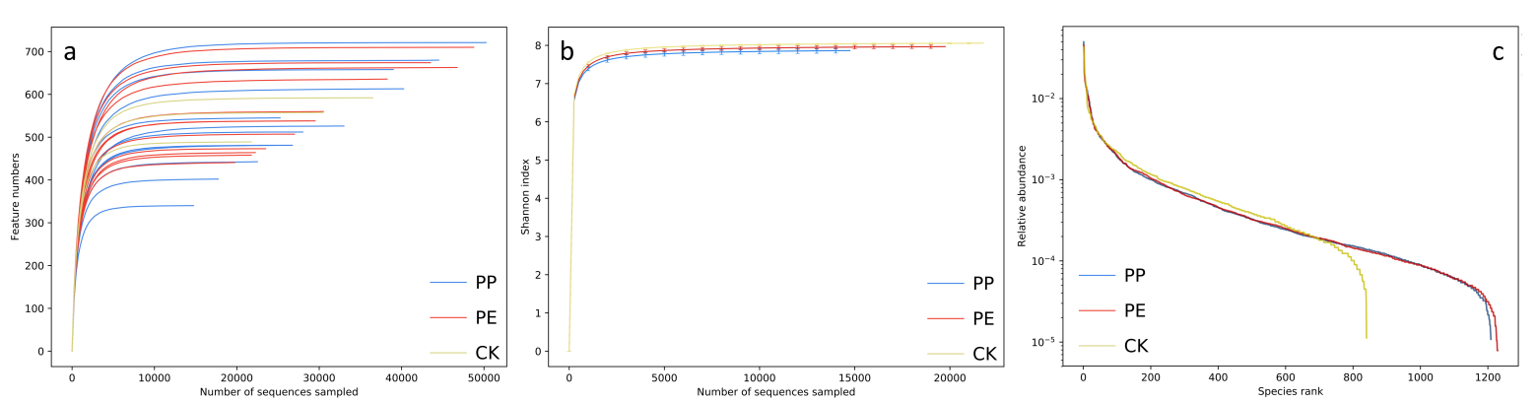
Supplementary Figure 3 (a) Dilution curve of the total sample; (b) Shannon curve; (c) Richness curve.
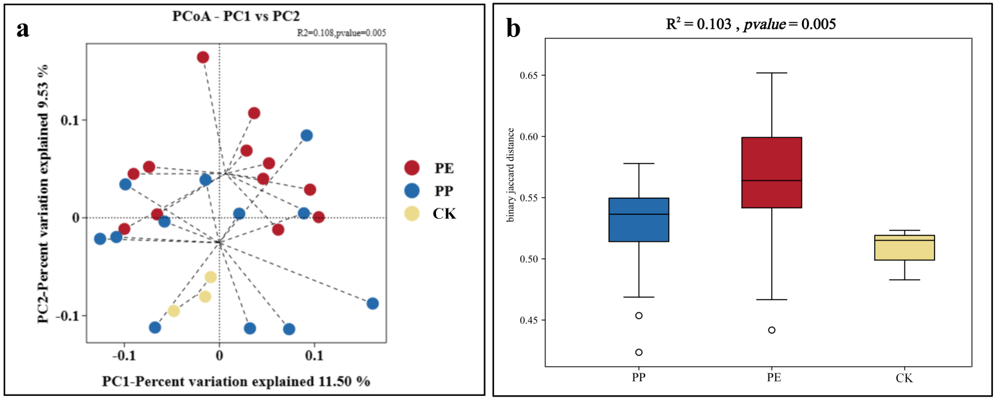
Supplementary Figure 4 (a) PCoA of the total samples; (b) PERMANOVA plot.

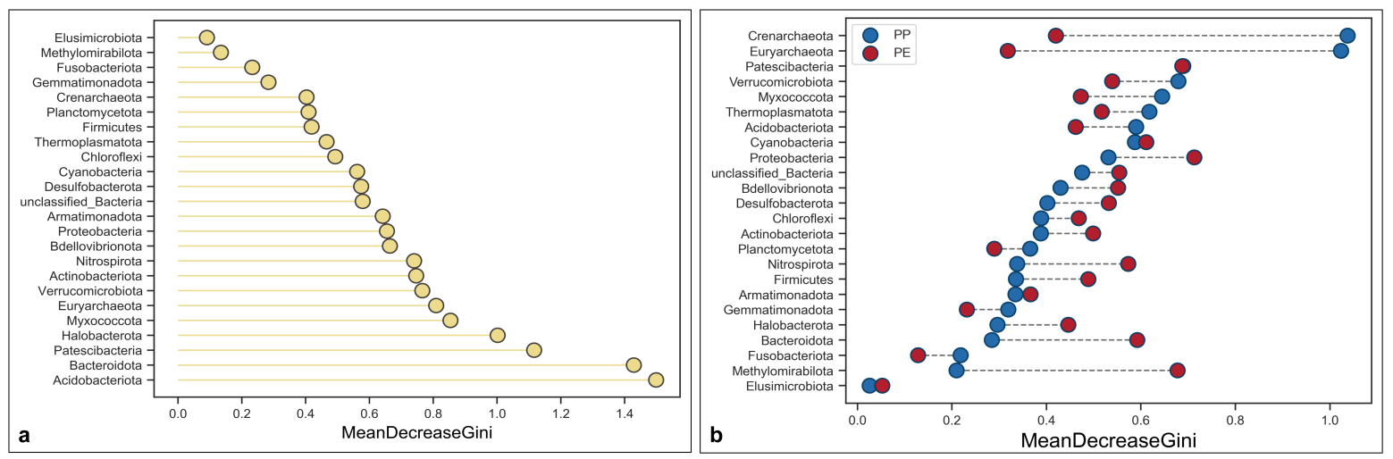
Supplementary Figure 5 (a) Random forest plot; (b) Bar chart of different microplastic microorganisms based on random forest.
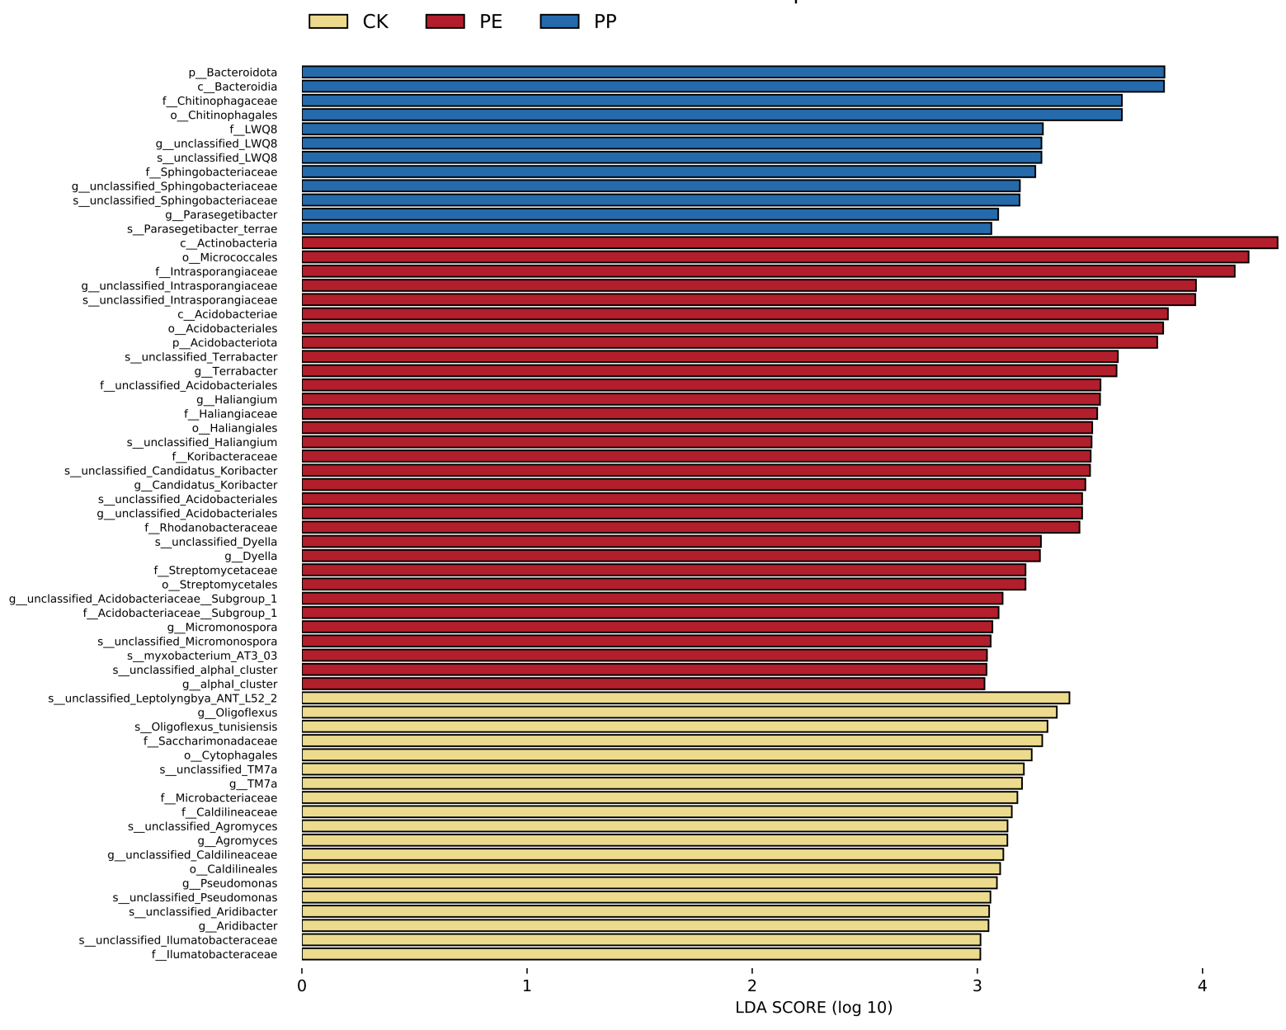
Supplementary Figure 6 Total LDA plot

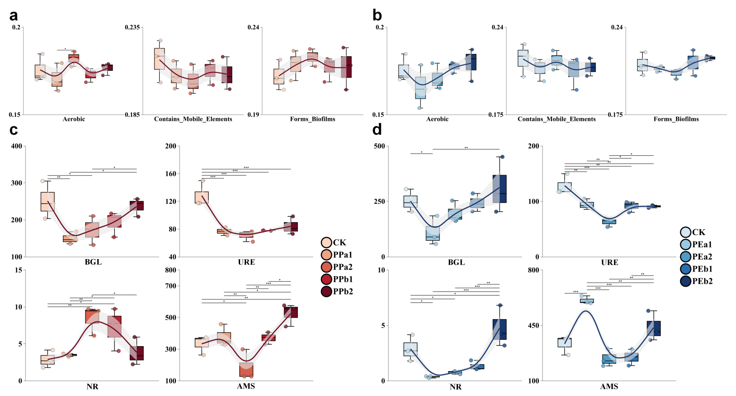
Supplementary Figure 7 (a) Differential histogram of the Bugbase gene function prediction matrix in PE; (b) Differential histogram of the Bugbase gene function prediction matrix in PP; (c) Different histogram of enzyme activity matrices in PE; (d) Different histogram of enzyme activity matrices in PP(*: P < 0.05, **: P < 0.01, ***: P < 0.001).

