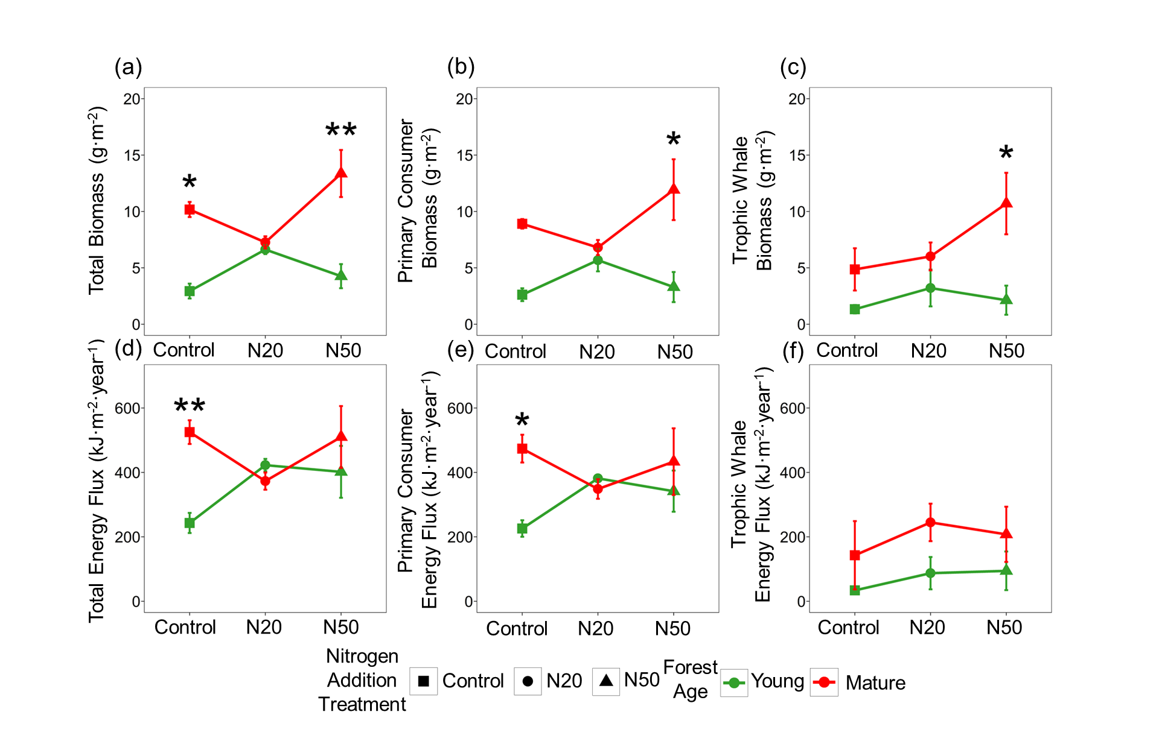Supplementary Fig. S1. Response of total biomass (a), primary consumer biomass (b), trophic whale biomass (c), total energy flux (d), primary consumer energy flux (e), trophic whale energy flux (f) under three nitrogen addition treatments (Control (no N addition), N20($20 kg N {ha}^{-1}∙{year}^{-1}$), and N50 (50 $kg N {ha}^{-1}∙{year}^{-1}$)) across different forest ages (young and mature). Shapes represent means ± standard error (SE) for different nitrogen addition treatments: squares for Control, circles for N20, and triangles for N50. Colors indicate two forest age: green for young forests and red for mature forests. Asterisks denote significant differences between young and mature forests (** (P < 0.01) and * (P < 0.05)). Data were analyzed using Tukey’s HSD test, followed by the Holm’s method to adjust P -values for multiple comparisons. ANOVA results refer to Table S3 and Table S5, and Table S6.

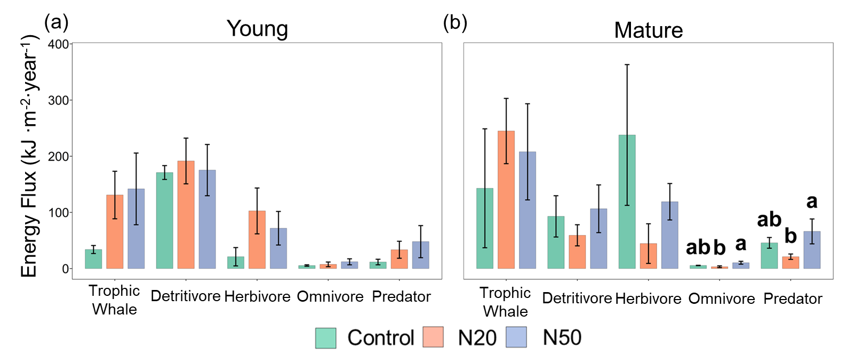
Supplementary Fig. S2. Response of energy flux ($kJ ∙m^{-2}∙{year}^{-1}$) to nitrogen addition (Control (no N addition), N20($20 kg N {ha}^{-1}∙{year}^{-1}$), and N50 (50 $kg N {ha}^{-1}∙{year}^{-1}$)) driven by five functional guilds (trophic whale, detritivore, herbivore, omnivore and predator) in young (a) and mature (b) forest. Bars represent means ± standard error (SE) (n = 3). Colors indicate different nitrogen addition treatments (Control, N20, N50). Letters in lower cases (e.g., "a", "b") indicate significant differences in summed values of all trophic groups between treatments. Data were analyzed using Tukey’s HSD test, followed by the Holm’s method to adjust P -values for multiple comparisons. ANOVA results refer to Table S6.

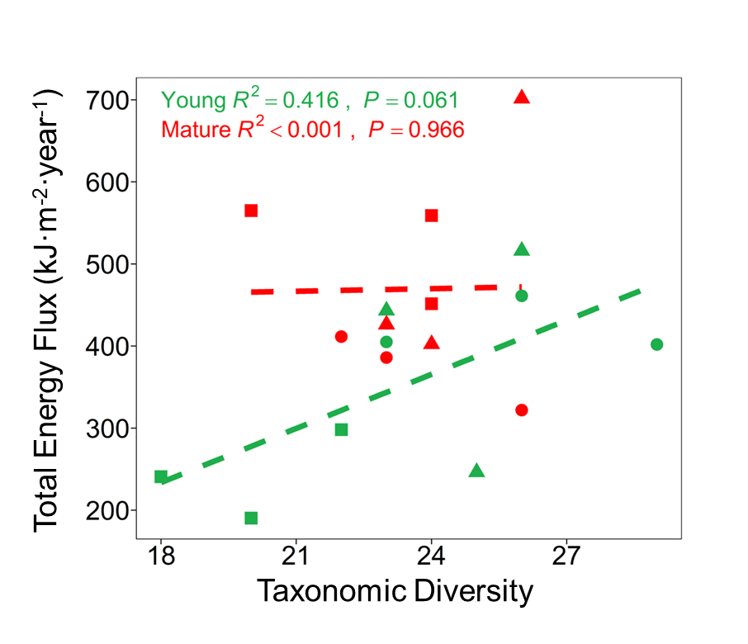
Supplementary Fig. S3. Relationships between energy flux ($kJ∙m^{-2}∙{year}^{-1}$) and taxonomic diversity across different forest ages were analyzed using three linear regression models, separately, for young forests (green, R² = 0.416, P = 0.061), mature forests (red, R² <0.001, P = 0.966). Different shapes represent the nitrogen addition treatments: square for control, circle for N20, and triangle for N50.

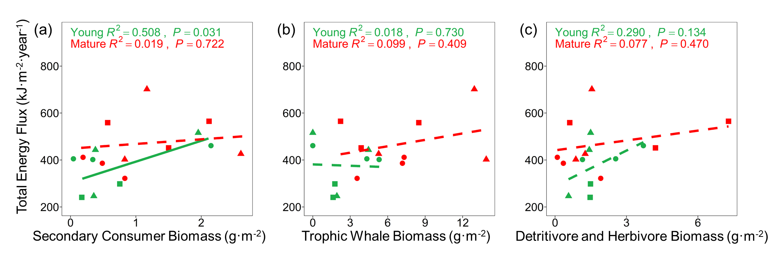Supplementary Fig. S4. Relationship between energy flux ($kJ∙m^{-2}∙{year}^{-1}$) and biomass of different trophic levels: secondary consumer biomass (a), trophic whale biomass (b) and detritivore and herbivore biomass (c) across different forest ages. Linear regression model was used to analyze how secondary consumer biomass affects energy flux in both young (green, R² = 0.508, P = 0.031) and mature forests (red, R² =0.019, P = 0.722). (a). And linear regression model was used to analyze how trophic whale biomass affects energy flux in both young and mature forests, respectively.

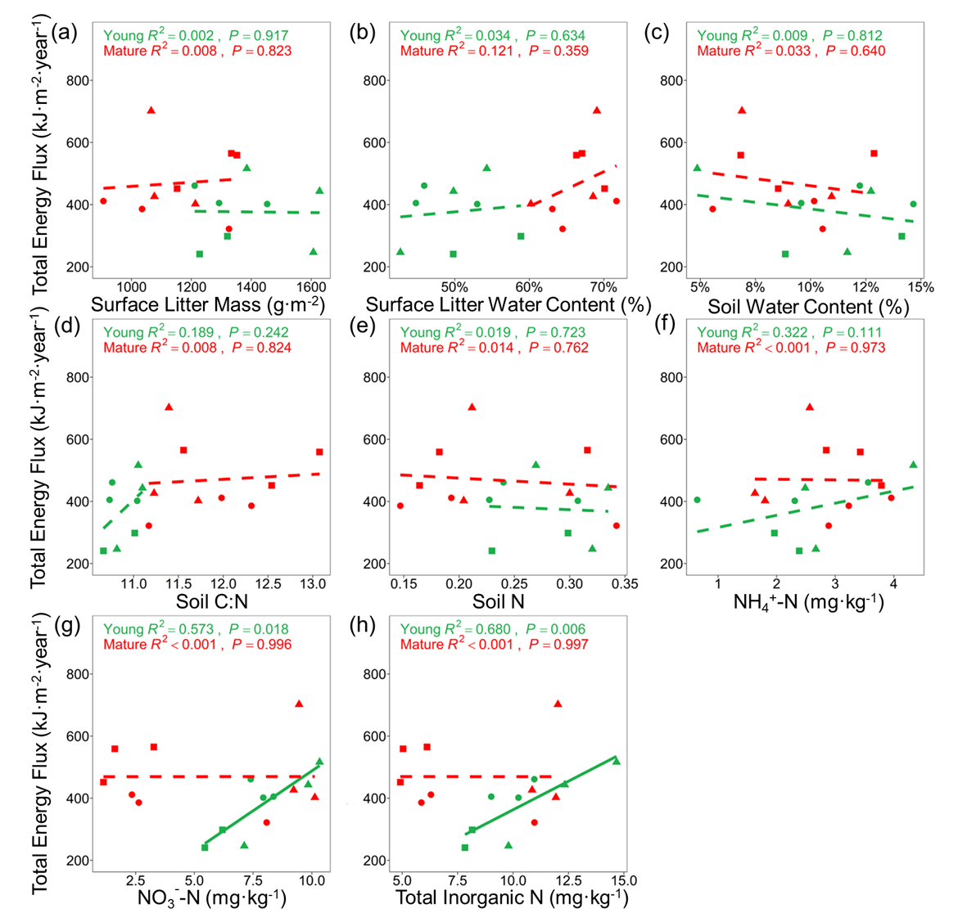
Supplementary Fig. S5. Relationship between energy flux ($kJ∙m^{-2}∙{year}^{-1}$) and surface litter biomass (a), surface litter water content (b), soil water content (c), soil C:N (d), soil N (e), NH₄⁺-N (f), NO₃⁻-N (g), and total inorganic N (h) across different forest ages. Linear regression model was used to analyze how energy flux was associated with the various factors in both young and mature forests, respectively.

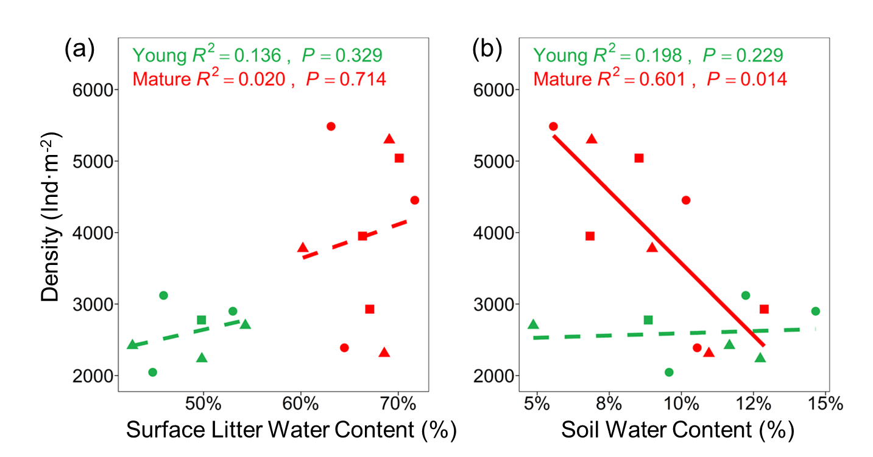
Supplementary Fig. S6. Relationship between density ($ind∙m^{-2}$) and surface litter water content (a) and soil water content (b) across different forest ages. Linear regression model was used to analyze how surface litter water content affects energy flux in both young and mature forests, respectively.

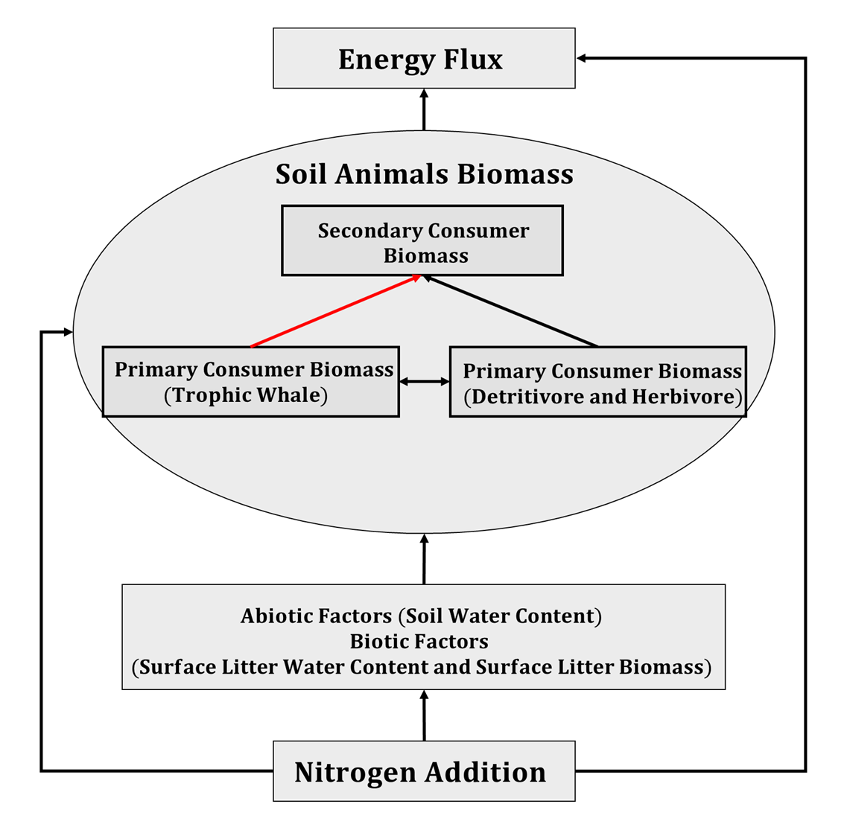
Supplementary Fig. S7. A hypothetical structural equation model (SEM) based on theoretical predictions, illustrating the relationships between energy flux and abiotic and biotic factors within the soil macro-food web. Black lines represent hypothesized positive relationships, while red lines represent hypothesized negative relationships.
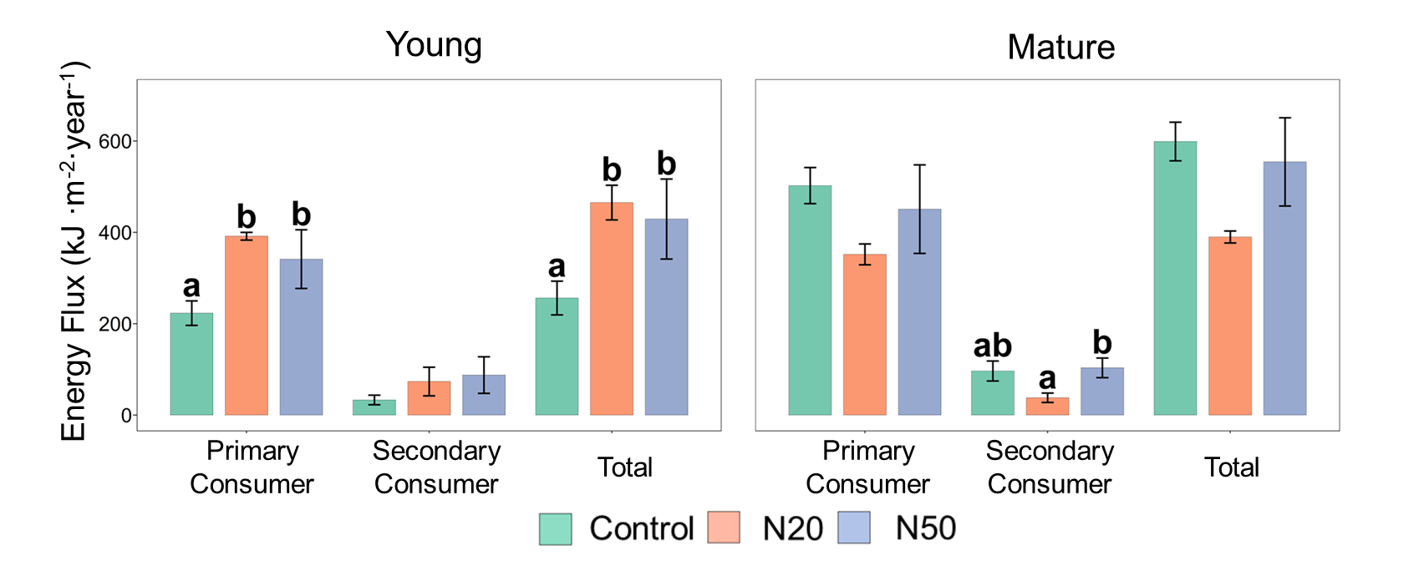
Supplementary Fig. S8. Energy flux distribution based on resource quantities (e.g., predators obtaining equal proportions of energy from herbivores and detritivores) within two trophic levels (primary and secondary consumers) and the entire food web in response to nitrogen addition (Control (no N addition), N20 (20 kg N ha^(-1)∙year^(-1)), and N50 (50 kg N ha^(-1)∙year^(-1))) in young (bottom-left panel) and mature forests (bottom-right panel). Bars represent means ± standard error (SE) (n = 3). The colors indicate different nitrogen addition treatments (Control, N20, N50). Letters in lowercase (e.g., "a", "b") indicate significant differences in summed values of all trophic groups between treatments. Data were analyzed using Tukey’s HSD test, followed by Holm’s method to adjust p-values for multiple comparisons. ANOVA results are presented in Table S8 and Table S9.
Supplementary Table S1. Soil fauna Identification List of Larch Plantations in Saihanba Nitrogen Addition Experiment Sites

Trophic Level | Functional Groups | Stage | Class | Order | Family (Suborder)
Secondary consumer | predator | mature | Arachnida | Araneida | Thomisidae
Secondary consumer | predator | mature | Arachnida | Araneida | Linyphiidae
Secondary consumer | predator | mature | Arachnida | Araneida | Liocranidae
Secondary consumer | predator | mature | Arachnida | Araneida | Lycosidae
Secondary consumer | predator | mature | Arachnida | Araneida | Pholcidae
Secondary consumer | predator | mature | Arachnida | Araneida | Theridiidae
Secondary consumer | predator | mature | Arachnida | Araneida | Thomisidae
Secondary consumer | predator | mature | Arachnida | Parasiformes | Mesostigmata(Suborder)
Secondary consumer | predator | mature | Chilopoda | Lithobiomorpha | Lithobiidae
Secondary consumer | predator | larvae | Insecta | Coleoptera | Cantharidae
Secondary consumer | predator | mature | Insecta | Coleoptera | Carabidae
Secondary consumer | predator | larvae | Insecta | Coleoptera | Carabidae
Secondary consumer | predator | mature | Insecta | Coleoptera | Staphylinidae
Secondary consumer | predator | larvae | Insecta | Coleoptera | Staphylinidae
Secondary consumer | predator | mature | Insecta | Neuroptera | Chrysopidae
Secondary consumer | omnivore | mature | Insecta | Hymenoptera | Formicidae
Secondary consumer | omnivore | mature | Insecta | Coleoptera | Tenebrionidae
Secondary consumer | omnivore | larvae | Insecta | Coleoptera | Tenebrionidae
Primary consumer | herbivore | mature | Insecta | Coleoptera | Cantharidae
Primary consumer | herbivore | mature | Insecta | Coleoptera | Curculionidae
Primary consumer | herbivore | mature | Insecta | Coleoptera | Chrysomelidae
Primary consumer | herbivore | larvae | Insecta | Coleoptera | Chrysomelidae
Primary consumer | herbivore | mature | Insecta | Coleoptera | Elateridae
Primary consumer | herbivore | larvae | Insecta | Coleoptera | Elateridae
Primary consumer | herbivore | mature | Insecta | Coleoptera | Melolonthidae
Primary consumer | herbivore | mature | Insecta | Coleoptera | Scarabaeidae
Primary consumer | herbivore | larvae | Insecta | Coleoptera | Scarabaeidae
Primary consumer | herbivore | mature | Insecta | Hemiptera | Cicadellidae
Primary consumer | herbivore | mature | Insecta | Hemiptera | Cydnidae
Primary consumer | herbivore | mature | Insecta | Hemiptera | Enicocephalidae
Primary consumer | herbivore | mature | Insecta | Hemiptera | Miridae
Primary consumer | herbivore | larvae | Insecta | Lepidoptera | Geometridae
Primary consumer | herbivore | larvae | Insecta | Lepidoptera | Noctuidae
Primary consumer | herbivore | mature | Insecta | Orthoptera | Tctrigoidea
Primary consumer | herbivore | mature | Insecta | Orthoptera | Trigonidiidae
Primary consumer | detritivore | mature | Arachnida | Acariformes | Prostigmata(Suborder)
Primary consumer | detritivore | mature | Arachnida | Acariformes | Oribatida(Suborder)
Primary consumer | detritivore | mature | Collembola | Collembola | Entomobryidae
Primary consumer | detritivore | mature | Collembola | Collembola | Isotomidae
Primary consumer | detritivore | mature | Collembola | Collembola | Neanridae
Primary consumer | detritivore | mature | Collembola | Collembola | Poduridae
Primary consumer | detritivore | mature | Collembola | Collembola | Sminthuridae
Primary consumer | detritivore | mature | Collembola | Collembola | Tomoceridae
Primary consumer | detritivore | mature | Gastropoda | Stylommatophora | Fruticicolidae
Primary consumer | detritivore | mature | Insecta | Coleoptera | Cryptophagidae
Primary consumer | detritivore | mature | Insecta | Coleoptera | Leiodidae
Primary consumer | detritivore | mature | Insecta | Coleoptera | Nitidulidae
Primary consumer | detritivore | mature | Insecta | Coleoptera | Ptiliidae
Primary consumer | detritivore | mature | Insecta | Coleoptera | Silphidae
Primary consumer | detritivore | larvae | Insecta | Diptera | Chironomidae
Primary consumer | detritivore | larvae | Insecta | Diptera | Dolichopodidae
Primary consumer | detritivore | larvae | Insecta | Diptera | Empididae
Primary consumer | detritivore | larvae | Insecta | Diptera | Muscidae
Primary consumer | detritivore | larvae | Insecta | Diptera | Psychodidae
Primary consumer | detritivore | larvae | Insecta | Diptera | Sarcophagidae
Primary consumer | detritivore | larvae | Insecta | Diptera | Scatopsidae
Primary consumer | detritivore | larvae | Insecta | Diptera | Sciaridae
Primary consumer | detritivore | larvae | Insecta | Diptera | Tabanidae
Primary consumer | detritivore | larvae | Insecta | Diptera | Tipulidae
Primary consumer | detritivore | mature | Diplopoda | Julida | Julidae
Primary consumer | detritivore | mature | Oligochaeta | Lumbricida | Lumbricidae
Primary consumer | detritivore | mature | Oligochaeta | Lumbricida | Enchytraeidae

Supplementary Table S2. Calculation of fresh mass based on body size measures (length, L [mm]) and (width, W [mm]) of the studied soil invertebrate groups. Fresh or dry body mass (M) [mg] were calculated using the power equation $M \left[mg\right]= a×{L\left[mm\right]}^{b1}$or $M \left[mg\right]= a×{L\left[mm\right]}^{b1}×{W[mm]}^{b2}$ and with a and b group-specific coefficients. Dry mass (DM) was converted into fresh mass (FM) using the following equation: $FM\left[mg\right]= c×{DM\left[mg\right]}^{d}$. LC – coefficient for conversion of size units.

Studied group | Measures | LC | Reference (Size-Mass) | a | b1 | b2 | c | d
Annelida | Length | 1 | (Hale et al, 2004) | 0.0068 | 2.29 |  | 8.48 | 1.09
Araneae (< 2.5mm) | Length | 1 | (Hoefer & Ott, 2009) | 0.085 | 3.29
Araneae (> 2.5mm) | Length | 1 | (Hoefer & Ott, 2009) | 0.17 | 2.9
Blattodea | Length | 1 | (Mercer et al, 2001) |  |  |  | 4.08 | 1.02
Chilopoda (Lithobiomorpha) | Length | 1 | (Sohlstroem et al, 2018) | 0.28 | 1.42 | 1.54
Coleoptera (Adult) | Length | 1 | (Mercer et al, 2001; Sohlstroem et al, 2018) | 0.52 | 0.84 | 1.95 | 4.08 | 1.02
Coleoptera (Larvae) | Length | 1 | (Johnson & Strong, 2000; Mercer et al, 2001) | 0.0032 | 2.26 |  | 4.08 | 1.02
Collembola | Length | 1 | (Mercer et al, 2001; Petersen, 1975) | 0.022 | 1.99 |  | 4.08 | 1.02
Dermaptera | Length | 1 | (Mercer et al, 2001; Sohlstroem et al, 2018) | 0.11 | 2.34 |  | 4.08 | 1.02
Diplopoda | Length | 1 | (Sohlstroem et al, 2018) | 0.04 | 2.44 | 0.22
Diptera (Larvae) | Length | 1 | (Johnson & Strong, 2000; Mercer et al, 2001) | 0.49 | 0.997 | 1.6 | 4.08 | 1.02
Formicidae | Length | 1 | (Johnson & Strong, 2000; Mercer et al, 2001) | 0.35 | 1.14 | 1.72 | 4.08 | 1.02
Hemiptera | Length | 1 | (Sohlstroem et al, 2018) | 0.38 | 1.18 | 1.43
Hymenoptera (other than Formicidae) | Length | 1 | (Gowing & Recher, 1984; Mercer et al, 2001) | 0.036 | 2.1 |  | 4.08 | 1.02
Lepidoptera (larvae) | Length | 1 | (Johnson & Strong, 2000; Mercer et al, 2001) | 0.0032 | 2.26 |  | 4.08 | 1.02
Mesostigmata | Length | 1000 | (Newton & Proctor, 2013) | 116.85 | 2.86
Neuroptera | Length | 1 | (Sohlstroem et al, 2018) | 3.76 | -0.042 | 2.54
Opiliones | Length | 1 | (Hoefer & Ott, 2009) | 0.15 | 3.62
Oribatida | Length | 1000 | (Newton & Proctor, 2013) | 140.8 | 2.77
Orthoptera | Length | 1 | (Mercer et al, 2001) |  |  |  | 4.08 | 1.02
Prostigmata | Length | 1000 | (Newton & Proctor, 2013) | 133.76 | 2.81
Pseudoscorpiones | Length | 1 | (Hoefer & Ott, 2009) | 0.16 | 2.45
Stylommatophora | Length | 1 | (Mercer et al, 2001) |  |  |  | 4.89 | 1.11

Supplementary Table S3. Effects of nitrogen addition on soil food web characteristics across different forest age. Linear regression model was used to analyze the effect of nitrogen addition treatments (Control (no N addition), N20($20 kg N {ha}^{-1}∙{year}^{-1}$), and N50 (50 $kg N {ha}^{-1}∙{year}^{-1}$)) on key soil food web metrics within each forest age (Young, Mature), with plot replication treated as a random effect. ANOVA was used to determine the statistical significance of each factor, with F-values and P -values presented for each metric to illustrate the influence of nitrogen addition across two forest age.

Forest age | Metrics of Food Web | Nitrogen Addition
Young | Biomass ($g∙m^{-2}$) | F_{2,6}=5.99, P =0.037
Young | Density ($ind∙m^{-2}$) | F_{2,6}=0.39, P =0.692
Young | Taxonomic Diversity | F_{2,6}=5.83, P =0.039
Young | Energy Flux ($kJ∙m^{-2}∙{year}^{-1}$) | F_{2,6}=3.7, P =0.090
Mature | Biomass ($g∙m^{-2}$) | F_{2,6}=5.49, P =0.044
Mature | Density ($ind∙m^{-2}$) | F_{2,6}=0.04, P =0.963
Mature | Taxonomic Diversity | F_{2,6}=0.53, P =0.615
Mature | Energy Flux ($kJ∙m^{-2}∙{year}^{-1}$) | F_{2,6}=1.87, P =0.234

Supplementary Table S4. Effects of nitrogen addition on abiotic factors across different forest age. Linear regression model was used to analyze the effect of nitrogen addition treatments (Control (no N addition), N20($20 kg N {ha}^{-1}∙{year}^{-1}$), and N50 (50 $kg N {ha}^{-1}∙{year}^{-1}$)) on abiotic factors within each forest age (Young, Mature), with plot replication treated as a random effect. ANOVA was used to determine the statistical significance of each factor, with F-values and P -values presented for each metric to illustrate the influence of nitrogen addition across two forest age.

Forest age | Abiotic Factors | Nitrogen Addition
Young | Surface Litter Biomass ($g∙m^{-2}$) | F_{2,6}=4.37, P =0.067
Young | Surface Litter Water Content | F_{2,6}=2.03, P =0.213
Young | Soil Water Content | F_{2,6}=0.39, P =0.692
Mature | Surface Litter Biomass ($g∙m^{-2}$) | F_{2,6}=1.45, P =0.306
Mature | Surface Litter Water Content | F_{2,6}=0.17, P =0.845
Mature | Soil Water Content | F_{2,6}=0.05, P =0.954

Supplementary Table S5. Effects of nitrogen addition on different trophic levels within soil food web characteristics across different forest age. Linear regression model was used to analyze the effect of nitrogen addition treatments (Control (no N addition), N20($20 kg N {ha}^{-1}∙{year}^{-1}$), and N50 (50 $kg N {ha}^{-1}∙{year}^{-1}$)) on different trophic levels within soil food web across two forest ages (Young, Mature), with plot replication treated as a random effect. ANOVA was used to determine the statistical significance of each factor, with F-values and P -values presented for each metric to illustrate the influence of nitrogen addition across two forest age.

Forest Age | Trophic Levels | Metrics of Food Web | Nitrogen Addition
Young | Primary Consumer | Biomass | F_{2,6}=2.52, P =0.160
Young | Secondary Consumer | Biomass | F_{2,6}=0.59, P =0.586
Young | Primary Consumer | Density | F_{2,6}=0.62, P =0.571
Young | Secondary Consumer | Density | F_{2,6}=0.05, P =0.956
Young | Primary Consumer | Taxonomic Diversity | F_{2,6}=6.24, P =0.034
Young | Secondary Consumer | Taxonomic Diversity | F_{2,6}=0.04, P =0.960
Young | Primary Consumer | Energy Flux | F_{2,6}=4.1, P =0.075
Young | Secondary Consumer | Energy Flux | F_{2,6}=0.95, P =0.437
Mature | Primary Consumer | Biomass | F_{2,6}=2.52, P =0.160
Mature | Secondary Consumer | Biomass | F_{2,6}=1.31, P =0.338
Mature | Primary Consumer | Density | F_{2,6}=0.15, P =0.860
Mature | Secondary Consumer | Density | F_{2,6}=1.37, P =0.323
Mature | Primary Consumer | Taxonomic Diversity | F_{2,6}=0.44, P =0.662
Mature | Secondary Consumer | Taxonomic Diversity | F_{2,6}=0.00, P =1.000
Mature | Primary Consumer | Energy Flux | F_{2,6}=0.91, P =0.453
Mature | Secondary Consumer | Energy Flux | F_{2,6}=3.7, P =0.090
Supplementary Table S6. Effects of nitrogen addition on different functional groups within soil food web characteristics across different forest age. Linear regression model was used to analyze the effect of nitrogen addition treatments (Control (no N addition), N20($20 kg N {ha}^{-1}∙{year}^{-1}$), and N50 (50 $kg N {ha}^{-1}∙{year}^{-1}$)) on different functional groups within soil food web across two forest ages (Young, Mature), with plot replication treated as a random effect. ANOVA was used to determine the statistical significance of each factor, with F-values and P -values presented for each metric to illustrate the influence of nitrogen addition across two forest age.

Forest age | Functional Groups | Metrics of Food Web | Nitrogen Addition
Young | Trophic Whale | Biomass | F_{2,6}=0.6,P =0.579
Young | Detritivore | Biomass | F_{2,6}=0.88, P =0.461
Young | Herbivore | Biomass | F_{2,6}=1.4, P =0.317
Young | Omnivore | Biomass | F_{2,6}=0.13, P =0.883
Young | Predator | Biomass | F_{2,6}=0.69, P =0.538
Young | Trophic Whale | Density | F_{2,6}=0.08, P =0.928
Young | Detritivore | Density | F_{2,6}=0.69, P =0.536
Young | Herbivore | Density | F_{2,6}=3.51, P =0.098
Young | Omnivore | Density | F_{2,6}=1.45, P =0.306
Young | Predator | Density | F_{2,6}=0.06, P =0.940
Young | Trophic Whale | Taxonomic Diversity | F_{2,6}=0.26, P =0.780
Young | Detritivore | Taxonomic Diversity | F_{2,6}=8.14, P =0.020
Young | Herbivore | Taxonomic Diversity | F_{2,6}=0.6, P =0.579
Young | Omnivore | Taxonomic Diversity | F_{2,6}=0.5, P =0.630
Young | Predator | Taxonomic Diversity | F_{2,6}=0.13, P =0.880
Young | Trophic Whale | Energy Flux | F_{2,6}=0.54, P =0.611
Young | Detritivore | Energy Flux | F_{2,6}=0.09, P =0.914
Young | Herbivore | Energy Flux | F_{2,6}=1.8, P =0.244
Young | Omnivore | Energy Flux | F_{2,6}=0.73, P =0.520
Young | Predator | Energy Flux | F_{2,6}=0.93, P =0.444
Mature | Trophic Whale | Biomass | F_{2,6}=2.3, P =0.181
Mature | Detritivore | Biomass | F_{2,6}=0.51, P =0.625
Mature | Herbivore | Biomass | F_{2,6}=1.91, P =0.229
Mature | Omnivore | Biomass | F_{2,6}=1.86, P =0.236
Mature | Predator | Biomass | F_{2,6}=1.03, P =0.414
Mature | Trophic Whale | Density | F_{2,6}=0.63, P =0.567
Mature | Detritivore | Density | F_{2,6}=0.18, P =0.841
Mature | Herbivore | Density | F_{2,6}=1.61, P =0.276
Mature | Omnivore | Density | F_{2,6}=8.14, P =0.020
Mature | Predator | Density | F_{2,6}=1.32, P =0.335
Mature | Trophic Whale | Taxonomic Diversity | F_{2,6}=2.63, P =0.152
Mature | Detritivore | Taxonomic Diversity | F_{2,6}=0.03, P =0.967
Mature | Herbivore | Taxonomic Diversity | F_{2,6}=4.43, P =0.066
Mature | Omnivore | Taxonomic Diversity | F_{2,6}=1.00, P =0.422
Mature | Predator | Taxonomic Diversity | F_{2,6}=0.06, P =0.946
Mature | Trophic Whale | Energy Flux | F_{2,6}=0.36, P =0.709
Mature | Detritivore | Energy Flux | F_{2,6}=0.51, P =0.626
Mature | Herbivore | Energy Flux | F_{2,6}=1.58, P =0.280
Mature | Omnivore | Energy Flux | F_{2,6}=4.36, P =0.068
Mature | Predator | Energy Flux | F_{2,6}=2.52, P =0.160

Supplementary Table S7. The estimated coefficients and its uncertainty in the structural equation model in Fig. 4. Sample size (n) is 9 for both young and mature forests. ** (P < 0.01), * (P < 0.05), and † (P < 0.1).

Forest Age | Response | Predicotr | df | Std_  Estimate | Std_  Error | P-Value
Young | Energy Flux | Secondary Consumer Biomass | 7 | 0.7130 | 38.5744 | 0.0311
Young | Secondary Consumer Biomass | Trophic Wahle Biomass Ratio | 6 | - 0.8571 | 0.4092 | 0.0018
Young | Secondary Consumer Biomass | Nitrogen Addition | 6 | 0.3580 | 0.0058 | 0.0689
Young | Trophic Wahle Biomass Ratio | Surface Litter Mass | 6 | 0.8382 | 0.0004 | 0.0072
Young | Trophic Wahle Biomass Ratio | Total Inorganic Nitrogen | 6 | -0.7096 | 0.0290 | 0.0149
Young | Surface Litter Mass | Nitrogen Addition | 7 | 0.7288 | 1.7934 | 0.0259
Young | Total Inorganic Nitrogen | Nitrogen Addition | 7 | 0.8077 | 0.0230 | 0.0085
Mature | Energy Flux | Secondary Consumer Biomass | 7 | 0.1388 | 53.3044 | 0.7218
Mature | Secondary Consumer Biomass | Trophic Wahle Biomass Ratio | 6 | -0.9053 | 0.9277 | 0.0213
Mature | Secondary Consumer Biomass | Nitrogen Addition | 6 | 0.6187 | 0.0111 | 0.0790
Mature | Trophic Wahle Biomass Ratio | Surface Litter Mass | 6 | -0.5000 | 0.0006 | 0.1908
Mature | Trophic Wahle Biomass Ratio | Total Inorganic Nitrogen | 6 | -0.2336 | 0.0283 | 0.5166
Mature | Surface Litter Mass | Nitrogen Addition | 7 | -0.4051 | 2.4626 | 0.2794
Mature | Total Inorganic Nitrogen | Nitrogen Addition | 7 | -0.8778 | 0.0258 | 0.0019

Supplementary Table S8. Energy flux distribution based on resource quantities (e.g., predators obtaining equal proportions of energy from herbivores and detritivores). The effects of nitrogen addition on soil food web characteristics across different forest ages are shown. A linear regression model was used to analyze the effect of nitrogen addition treatments (Control (no N addition), N20 (20 kg N ha^(-1)∙year^(-1)), and N50 (50 kg N ha^(-1)∙year^(-1))) on energy flux within each forest age (Young, Mature), with plot replication treated as a random effect. ANOVA was used to determine the statistical significance of each factor, with F-values and P-values presented for each metric to illustrate the influence of nitrogen addition across the two forest ages.
Forest age | Nitrogen Addition
Young | F_{2,6}=3.57, P =0.095
Mature | F_{2,6}=3.22, P =0.112

Supplementary Table S9. Energy flux distribution based on resource quantities. The effects of nitrogen addition on different trophic levels within soil food web characteristics across different forest ages are shown. A linear regression model was used to analyze the effect of nitrogen addition treatments (Control (no N addition), N20 (20 kg N ha^(-1)∙year^(-1)), and N50 (50 kg N ha^(-1)∙year^(-1))) on different trophic levels within the soil food web across two forest ages (Young, Mature), with plot replication treated as a random effect. ANOVA was used to determine the statistical significance of each factor, with F-values and P-values presented for each metric to illustrate the influence of nitrogen addition across the two forest ages.
Forest Age | Trophic Levels | Nitrogen Addition
Young | Primary Consumer | F_{2,6}=4.55, P =0.063
Young | Secondary Consumer | F_{2,6}=0.89, P =0.457
Mature | Primary Consumer | F_{2,6}=1.53, P =0.290
Mature | Secondary Consumer | F_{2,6}=3.69, P =0.090

Reference:
Gowing, G., Recher, H.F., 1984. Length‐weight relationships for invertebrates from forests in south‐eastern New South Wales. Australian Journal of Ecology 9(1), 5–8. DOI: 10.1111/j.1442-9993.1984.tb01612.x
Hale, C.M., Reich, P.B., Frelich, L.E., 2004. Allometric Equations for Estimation of Ash-free Dry Mass from Length Measurements for Selected European Earthworm Species (Lumbricidae) in the Western Great Lakes Region. The American Midland Naturalist 151(1), 179–185. DOI:10.1674/0003-0031(2004)151[0179:AEFEOA]2.0.CO;2
Hoefer, H., Ott, R., 2009. Estimating biomass of Neotropical spiders and other arachnids (Araneae, Opiliones, Pseudoscorpiones, Ricinulei) by mass-length regressions. Journal of Arachnology 37(2), 160–169.
Johnson, M.D., Strong, A.M., 2000. Length-weight relationships of Jamaican arthropods. Entomological News 111(4), 270–281.
Mercer, R.D., Gabriel, A.G.A., Barendse, J., Marshall, D.J., Chown, S.L., 2001. Invertebrate body sizes from Marion Island. Antarctic Science 13(2), 135–143. DOI:10.1017/S0954102001000219
Newton, J.S., Proctor, H.C., 2013. A fresh look at weight-estimation models for soil mites (Acari). International Journal of Acarology 39(1), 72–85. DOI:10.1080/01647954.2012.744351
Petersen, H., 1975. Estimation of Dry Weight, Fresh Weight, and Calorific Content of Various Collembolan Species. Pedobiologia 15(3), 222–243.
Sohlstroem, E.H., Marian, L., Barnes, A.D., Haneda, N.F., Scheu, S., Rall, B.C., Brose, U., Jochum, M., 2018. Applying generalized allometric regressions to predict live body mass of tropical and temperate arthropods. Ecology and Evolution 8(24), 12737–12749. DOI:10.1002/ece3.4702

