Supplementary Information
Title: Combined morphological, biomarker, and molecular approaches revealed linkages between AM fungi and Chinese fir growth across nine subtropical plantations

Wen Zhongª, Feihua Zhouª, Hanshuo Zhangª, Hao Yangª, Zhi-Jie Yang^{b}, Yong Zheng^{a,b,c,}*

ª Key Laboratory for Humid Subtropical Eco-geographical Processes of the Ministry of Education, Fujian Normal University, Fuzhou 350117, China.
^{b} Fujian Sanming Forest Ecosystem National Observation and Research Station, Fujian Normal University, Sanming 365002, China.
^{c} Shanghang Mountain Forest Carbon Sink Observation and Research Station of Fujian Province, Fujian Normal University, Longyan 364205, China.

*Corresponding author: Yong Zheng (ORCID: 0000-0001-5239-9824)
Tel: +86 (0)591 8346 5214; Fax: +86 (0)591 8346 5397; E-mail: zhengy@fjnu.edu.cn
Full postal address: School of Geographical Sciences, Qishan Campus, Fujian Normal University, No.8 South Xuefu Road, Minhou District, Fuzhou, Fujian Province, China, 350117.

Running title: Linking AM fungal community to tree growth

Figure legend

Fig. S1 The geographical distribution of the sampling sites in the Southeast China. Abbreviations: BS, Baisha State-Owned Forest Farm in Shanghang County; GZ, Guanzhuang State-owned Forest Farm in Sha County; JS, Jinshan State-owned Forest Farm in Hua'an County; QJS, Qiujiashan State-owned Forest Farm in Liancheng County; SM, Fujian Sanming Forest Ecosystem National Observation and Research Station; WY, Wuyi State-owned Forest Farm in Zhangping County; WYS, Wuyishan National Park; XP, Xiapu State-owned Forest Farm in Ningde City; XY, Xiayang State-owned Forest Farm in Nanping City.
Fig. S2 Environmental drivers and relationships of arbuscular mycorrhizal (AM) fungal biomass in Chinese fir plantations. Importance of environmental factors influencing AM fungal neutral lipid fatty acid (NLFA) content based on random forest analysis (A). Relationships between AM fungal NLFA and spore density (B), root colonization rate (C), and extraradical hyphal length (D) revealed by linear and polynomial regression analyses. Asterisks indicate the statistical significance of factor importance: * P < 0.05, ** P < 0.01.
Fig. S3 Arbuscular mycorrhizal (AM) fungal Shannon diversity index in root and rhizosphere soil habitats across nine sites. Boxplots show the AM fungal Shannon diversity index across the nine sampling sites. The center line of the boxplot indicates the mean value, the lower and upper hinges represent the standard deviation around the mean, and each whisker corresponds to the minimum and maximum values, respectively. Different lowercase and uppercase letters indicate significant differences in AM fungal Shannon diversity index among the nine sites (P < 0.05). Asterisks denote a significant difference between the root and rhizosphere soil habitats (***, P < 0.001).

Figure S1

Figure S2

Figure S3

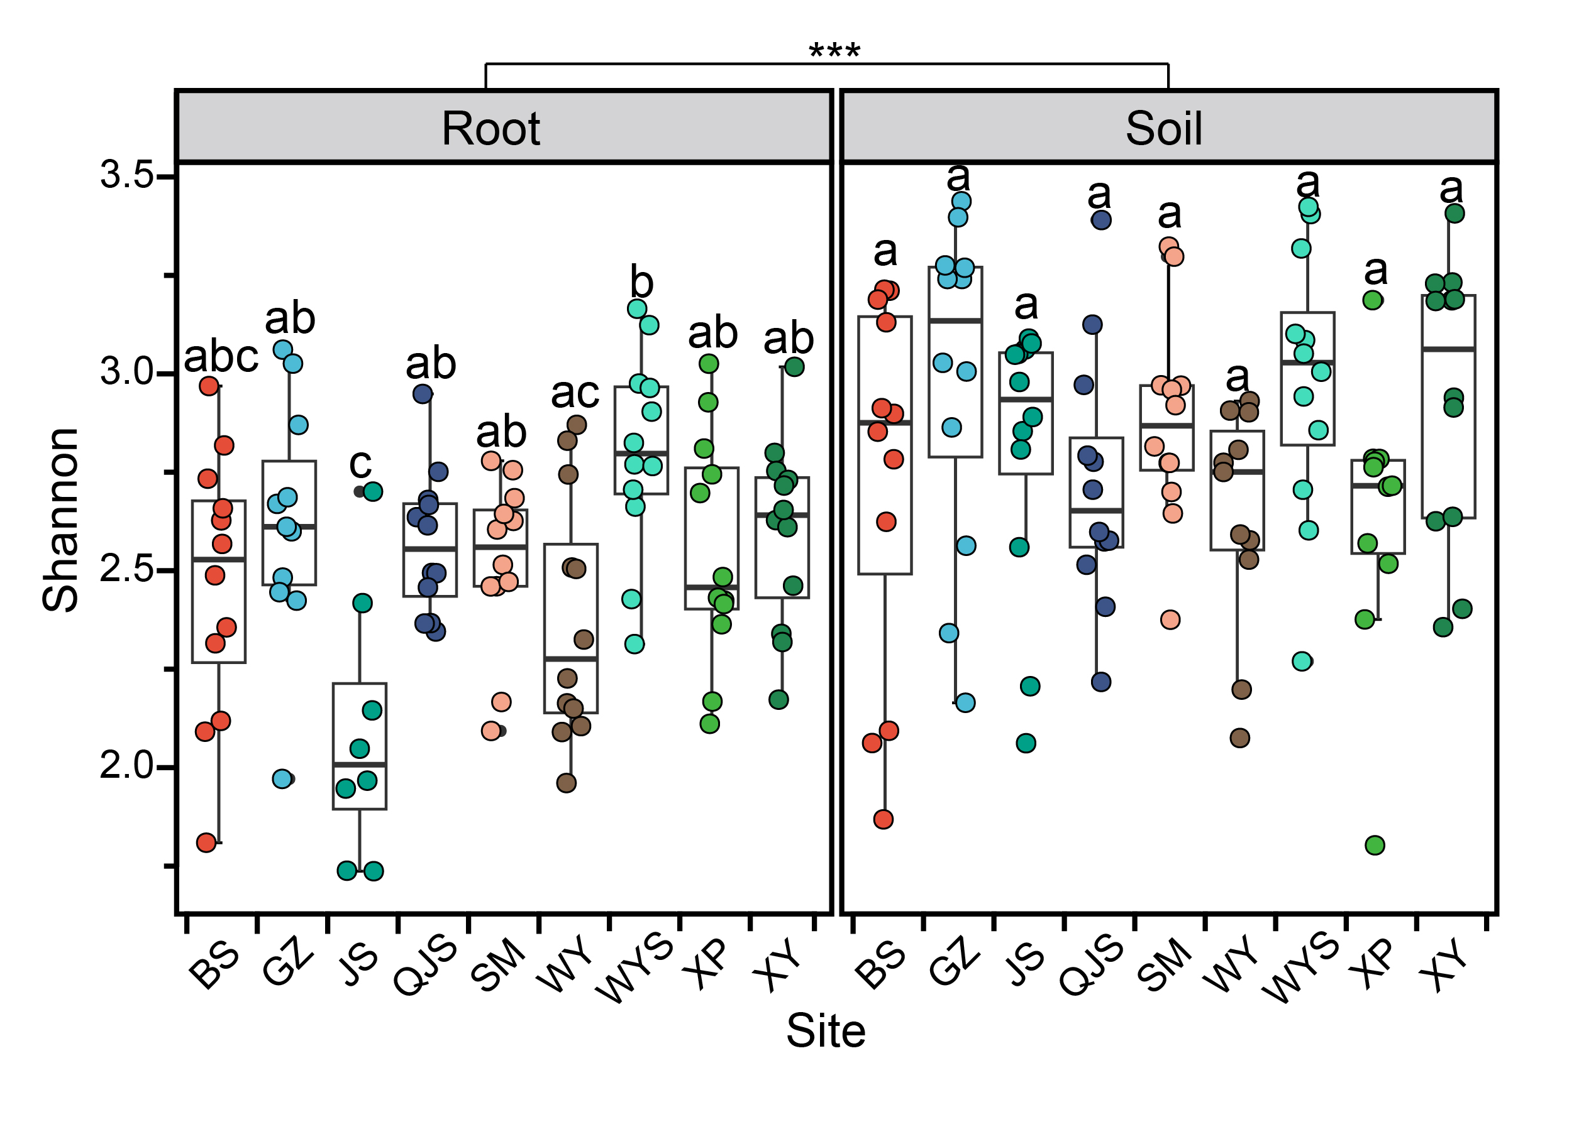

Table S1
The effects of sites and habitats on Arbuscular mycorrhizal (AM) fungal richness, Shannon (tested by two-way ANOVA), and community composition (PerMANOVA, permutational multivariate analysis of variance).
Source of variation | Richness |  | Shannon |  | Community composition
Source of variation | F | P | F | P | R² | F | P
Site | 13.39 | <0.001 | 4.503 | <0.001 | 0.145 | 4.242 | <0.001
Habitat | 47.88 | <0.001 | 46.95 | <0.001 | 0.186 | 47.38 | <0.001
Site×Habitat | 4.716 | <0.001 | 1.698 | 0.101 | 0.385 | 7.035 | <0.001

Table S2
Relationships between arbuscular mycorrhizal (AM) fungal community structure (family- and genus-level) and Chinese fir growth traits (basal area, growth increment) assessed by Spearman’s correlation.
Habitat | Taxonomy level | Taxa name | Basal area |  | Increment
Habitat | Taxonomy level | Taxa name | r | P | r | P
Root | Family | Acaulosporaceae | -0.035 | 0.729 | 0.11 | 0.27
Root | Family | Ambisporaceae | 0.058 | 0.560 | 0.226* | 0.022
Root | Family | Archaeosporaceae | -0.038 | 0.702 | 0.076 | 0.445
Root | Family | Claroideoglomeraceae | -0.018 | 0.857 | -0.086 | 0.387
Root | Family | Diversisporaceae | 0.013 | 0.895 | -0.103 | 0.301
Root | Family | Geosiphonaceae | 0.094 | 0.347 | 0.127 | 0.202
Root | Family | Gigasporaceae | 0.055 | 0.579 | 0.162 | 0.102
Root | Family | Glomeraceae | -0.176 | 0.076 | -0.257** | 0.009
Root | Family | Paraglomeraceae | 0.171 | 0.085 | 0.245* | 0.012
Root | Genus | Acaulospora | -0.035 | 0.729 | 0.110 | 0.270
Root | Genus | Ambispora | 0.058 | 0.560 | 0.226* | 0.022
Root | Genus | Archaeospora | -0.038 | 0.702 | 0.076 | 0.445
Root | Genus | Claroideoglomus | -0.018 | 0.857 | -0.086 | 0.387
Root | Genus | Diversispora | 0.013 | 0.895 | -0.103 | 0.301
Root | Genus | Geosiphon | 0.094 | 0.347 | 0.127 | 0.202
Root | Genus | Gigaspora | 0.117 | 0.239 | 0.329*** | 0.001
Root | Genus | Glomus | -0.176 | 0.076 | -0.257** | 0.009
Root | Genus | Kuklospora | / | / | / | /
Root | Genus | Paraglomus | 0.171 | 0.085 | 0.245* | 0.012
Root | Genus | Scutellospora | -0.130 | 0.192 | -0.174 | 0.079
Soil  Soil | Family | Acaulosporaceae | -0.268** | 0.006 | -0.199* | 0.040
Soil  Soil | Family | Ambisporaceae | -0.096 | 0.326 | 0.186 | 0.056
Soil  Soil | Family | Archaeosporaceae | -0.189 | 0.052 | 0.020 | 0.836
Soil  Soil | Family | Claroideoglomeraceae | -0.249** | 0.010 | -0.011 | 0.912
Soil  Soil | Family | Diversisporaceae | -0.324*** | 0.001 | -0.122 | 0.214
Soil  Soil | Family | Geosiphonaceae | 0.067 | 0.496 | 0.042 | 0.668
Soil  Soil | Family | Gigasporaceae | 0.086 | 0.380 | 0.247* | 0.011
Soil  Soil | Family | Glomeraceae | -0.217* | 0.026 | -0.084 | 0.394
Soil  Soil | Family | Paraglomeraceae | 0.240* | 0.013 | 0.051 | 0.606
Soil  Soil | Genus | Acaulospora | -0.271** | 0.005 | -0.201* | 0.039
Soil  Soil | Genus | Ambispora | -0.096 | 0.326 | 0.186 | 0.056
Soil  Soil | Genus | Archaeospora | -0.189 | 0.052 | 0.02 | 0.836
Soil  Soil | Genus | Claroideoglomus | -0.249** | 0.010 | -0.011 | 0.912
Soil  Soil | Genus | Diversispora | -0.324*** | 0.001 | -0.122 | 0.214
Soil  Soil | Genus | Geosiphon | 0.067 | 0.496 | 0.042 | 0.668
Soil  Soil | Genus | Gigaspora | 0.136 | 0.164 | 0.243* | 0.012
Soil  Soil | Genus | Glomus | -0.217* | 0.026 | -0.084 | 0.394
Soil  Soil | Genus | Kuklospora | 0.075 | 0.445 | 0.043 | 0.661
Soil  Soil | Genus | Paraglomus | 0.240* | 0.013 | 0.051 | 0.606
Soil  Soil | Genus | Scutellospora | -0.074 | 0.452 | -0.003 | 0.975

