Supplemental materials
Manuscript title:
Effects of nanoFe₃O₄ and carbon nanotubes on anaerobic decomposition of soil organic matter in paddy soil
Authors:
Bi Wang, Qian Wang, Debin Wu, Li Song, Quan Yuan

Table. S1 Physicochemical properties of paddy soils.
Sample names | Soil texture | OrgC  (%) | OrgN  (%) | OrgH (%) | OrgS  (%) | C/N ratio | pH | Density  (kg/m³)
GY | clay | 9.82 | 0.69 | 1.77 | 0.25 | 14.34 | 8.28 | 0.8
FY | loamy clay | 3 | 0.28 | 1.08 | 0.03 | 10.9 | 7.89 | 0.98

Table. S2 Main topological parameters of co-occurrence network diagram in GY and FY paddy soils.
soil | node | side | Average weighting | network diameter | modularization | Average clustering coefficient | average path length
GY | 212 | 757 | 4.95 | 8 | 0.578 | 0.339 | 3.652
FY | 155 | 336 | 3.188 | 13 | 0.738 | 0.369 | 5.063

Table. S3 The top 10 key species in the network graph based on weighted degree in GY and FY paddy soils.
GY | FY
BSV26 | Rhodomicrobiaceae
Pedosphaeraceae | Defluviicoccaceae
Ignavibacteriaceae | Ktedonobacteraceae
Bryobacteraceae | AKAU3564.sediment.group
WD2101.soil.group | Kineosporiaceae
Lachnospiraceae | Haliangiaceae
BSV40 | Mycobacteriaceae
Clostridiaceae | Rikenellaceae
Fimbriimonadaceae | Micromonosporaceae
Intrasporangiaceae | Christensenellaceae

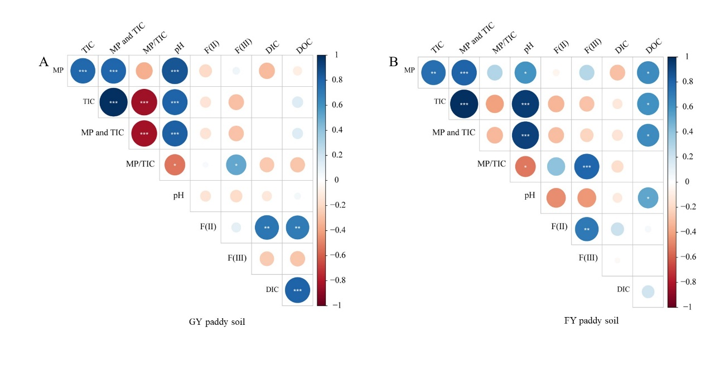
Fig. S1 The correlation analysis between soil methanogenic decomposition rates and environmental factors in GY (A) and FY (B) paddy soils.

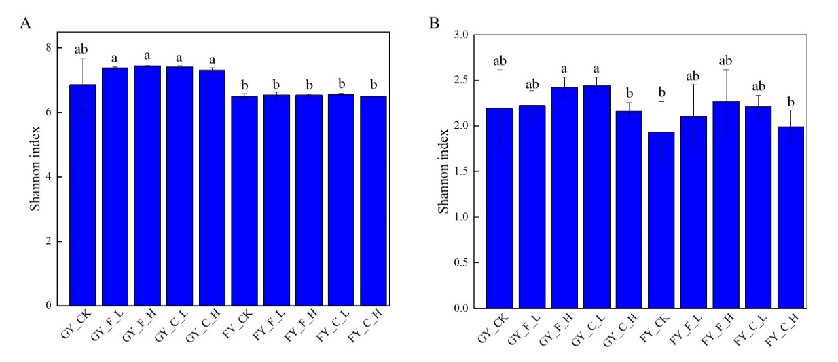
Fig. S2 Shannon index of the overall microbial community (A) and methanogenic archaea (B) in GY and FY paddy soils. For each soil, there are control (ck) and treatments with nanoparticles. F, nanoFe₃O₄; C, carbon nanotubes. L and H denote low and high concentrations of nanoparticles, respectively. Different letters on the top of the column indicate significant difference among the data (P<0.05).
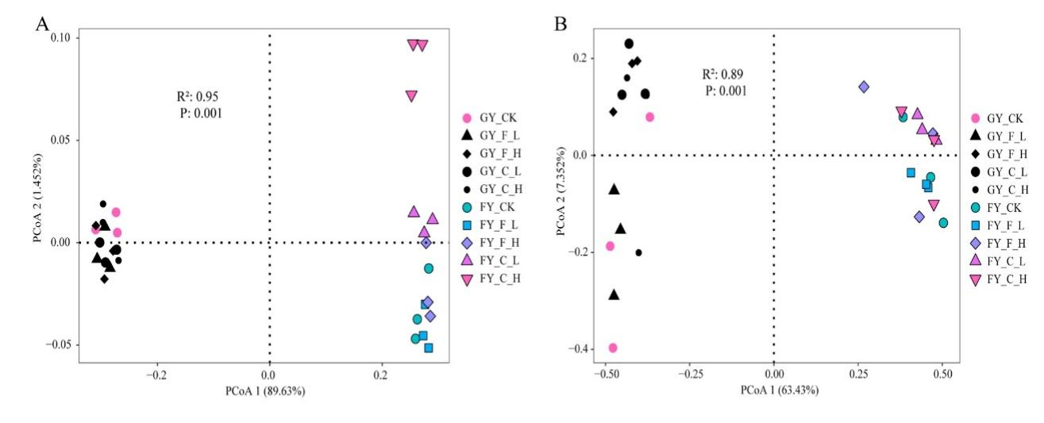
Fig. S3 Principal coordinate analysis (PCoA) of the overall microbial community (A) and methanogenic archaeal community (B) based on the unweighted UniFrac distance metric.

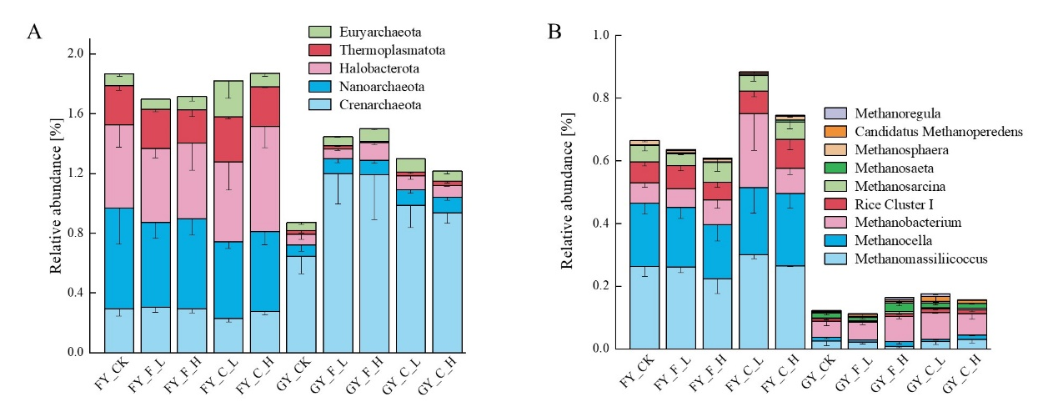
Fig. S4 Relative abundance of archaeal phylum (A) and methanogenic archaea (B) within the overall microbial community.

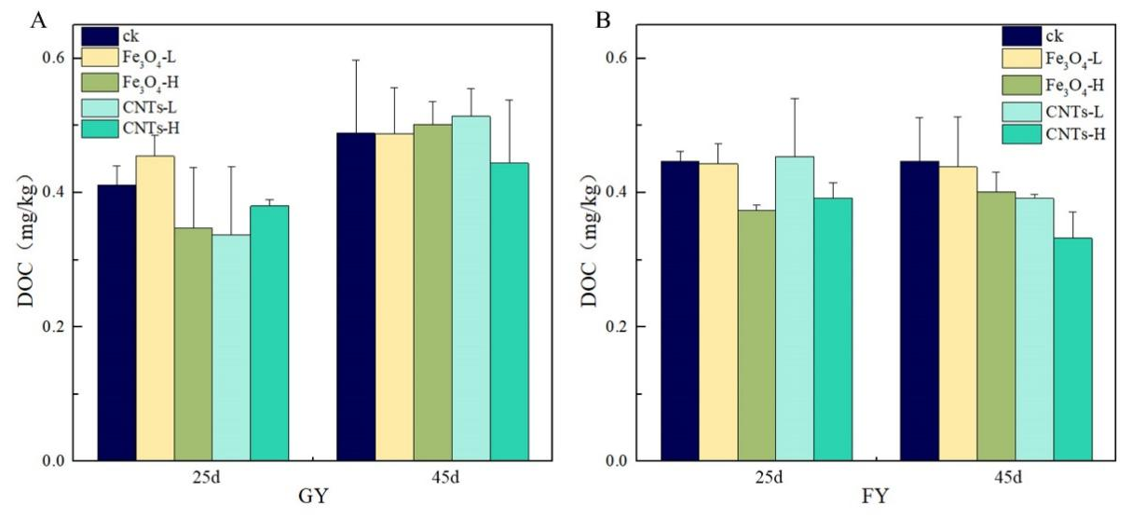
Fig. S5 DOC contents in GY (A) and FY (B) paddy soil after 25 and 45 days incubation.

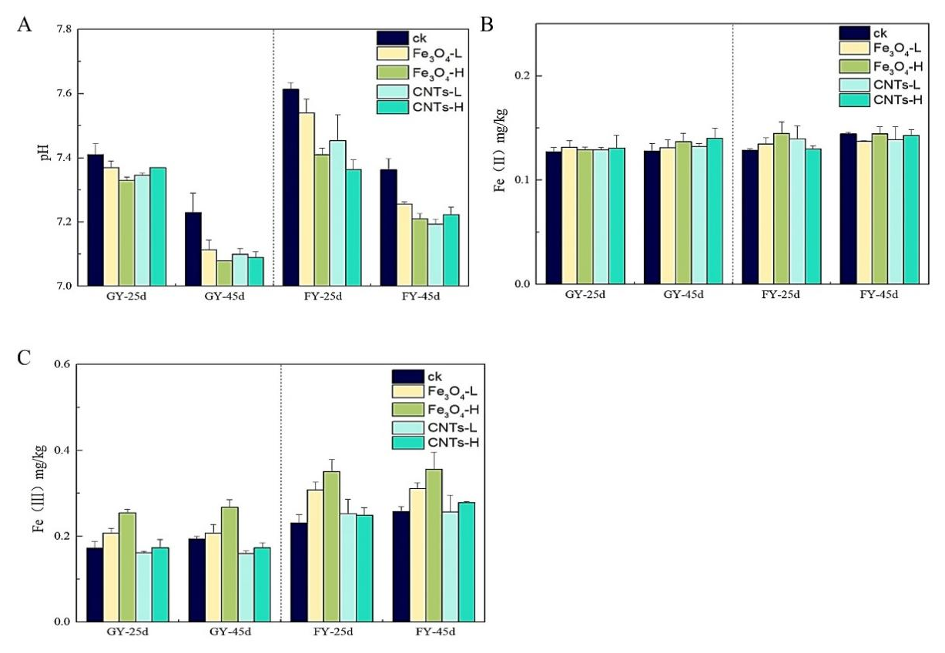
Fig. S6 The pH values, contents of Fe(II) and Fe(III) of the control soil (ck) and treatments with nanoparticles after incubation for 25 and 45 days.

