Slope aspect moderates soil nematode responses to converting subtropical forests into chestnut plantations during the early growing season
Wendi Geng ^{1, 2}, Jianqing Wang ^{1, 2,} *, Qing Yang ³, Josep Peñuelas ^{4, 5}, Roy Neilson ⁶, Ziyi Jiang ^{1, 2}, Minhui Xu ^{1, 2}, Yudie Lin ^{1, 2}, Liyuan Zou ^{1, 2}, Xiuzhen Shi ^{1, 2}
¹ Key Laboratory for Humid Subtropical Eco-geographical Processes of the Ministry of Education, Institute of Geography, Fujian Normal University, Fuzhou 350117, China
² Fujian Provincial Key Laboratory for Subtropical Resources and Environment, School of Geographical Sciences, Fujian Normal University, Fuzhou 350117, China
³ Fujian Provincial Center of Science and Technology Achievement Transformation, Fuzhou 350002, China
⁴ CREAF, Centre de Recerca Ecològica i Aplicacions Forestals, Cerdanyola del Vallès, Catalonia, Spain
⁵ CSIC. Global Ecology Unit CREAF-CSIC-UAB, Bellaterra, Catalonia, Spain
⁶ Ecological Sciences, The James Hutton Institute, Dundee, DD2 5DA, Scotland, UK
*Corresponding author
Email: jianqingwang@aliyun.com or jianqingwang@fjnu.edu.cn
Address: Key Laboratory for Humid Subtropical Eco-geographical Processes of the Ministry of Education, Institute of Geography, Fujian Normal University, Fuzhou 350117, China
Article Type: Research Paper
Running title: Changes in soil nematodes in chestnut plantations
Fig. S1 Soil nematode Maturity index (MI) (a), Enrichment index (EI) (b) and Structural index (SI) (c) in natural forests and managed chestnut plantations. Treatments with different letters differ significantly at P < 0.05. S-NF, south-facing (sunny) natural forests; S-CP, south-facing (sunny) chestnut plantations; N-NF, north-facing (shady) natural forests; N-CP, north-facing (shady) chestnut plantations.

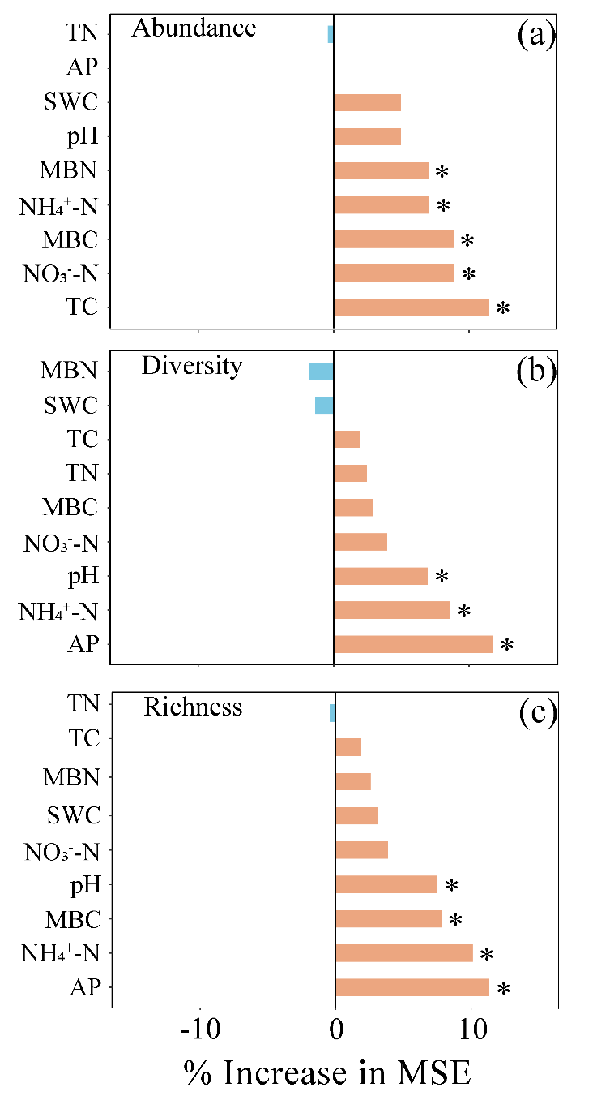
Fig. S2 Random Forest analyses highlighting the importance of environmental variables that explain variations in soil nematode abundance (a), alpha diversity (b) and richness (genus) (c). Variable importance is shown as the percent increase in mean squared error based on permutations. * represents that the contributions of environmental variables are statistically significant (P < 0.05). Environmental codes are: SWC, soil water content; MBN, soil microbial biomass nitrogen; MBC, soil microbial biomass carbon; TC, soil total carbon; TN, soil total nitrogen; AP, soil available phosphorus.

Fig. S3 Redundancy analysis (RDA) of soil nematode communities (a) and environmental variable contributions (b). * represents the contributions of environmental variables are statistically significant (P < 0.05). Treatment codes are described in Fig. S1. Environmental codes are described in Fig. S2.

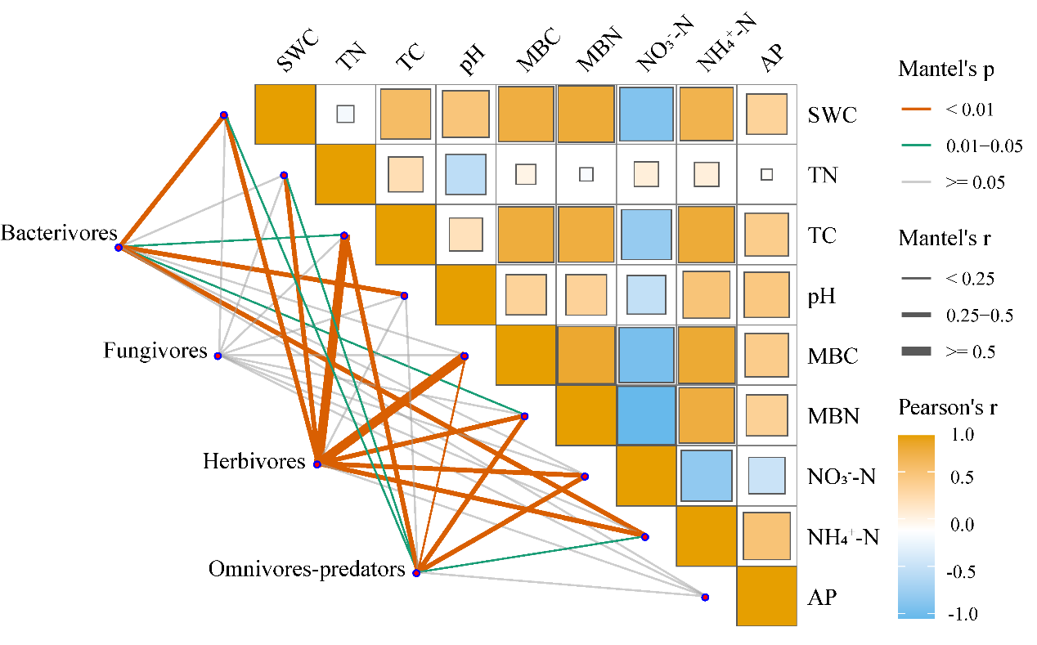
Fig. S4 Pairwise relationships between soil nematode trophic groups and environmental variables. Color intensity indicates Pearson correlation coefficients, with edge width representing correlation strength and color denoting statistical significance (Mantel tests, P < 0.05). Environmental codes are described in Fig. S2.
Table S1 Summary of general linear model analysis for soil nematode abundance, diversity and richness (genus), and relative abundance of nematode trophic groups in natural forests and managed chestnut plantations.
Source | Abundance | Diversity | Richness | Relative abundance
 |  |  |  | BF | FF | PF | OP
Effect of forest type | -67.60 | -12.16 | -24.43 | -37.74 | -32.07 | 20.34 | 18.99
Effect of slope aspect | 36.86 | 0.50 | -7.78 | -0.84 | 28.38 | -34.24 | 24.26
Forest type (F) | <0.001 | 0.001 | <0.001 | <0.001 | 0.121 | 0.101 | 0.021
Slope aspect (S) | 0.008 | 0.869 | 0.206 | 0.937 | 0.299 | 0.002 | 0.006
FS | 0.106 | 0.110 | 0.006 | <0.001 | 0.548 | <0.001 | 0.815
BF, bacterivores; FF, fungivores; PF, herbivores; OP, omnivores-predators.

Table S2 Changes in soil nematode richness (genus) in natural forests and managed chestnut plantations.
Treatments | Soil nematode richness
Treatments | BF | FF | PF | OP
S-NF | 1.61±0.55b | 0.62±0.24ab | 1.30±0.26a | 1.58±0.46a
S-CP | 1.50±0.44b | 0.34±0.20b | 1.30±0.47a | 1.56±0.25a
N-NF | 2.60±0.34a | 0.78±0.21a | 1.67±0.36a | 1.60±0.33a
N-CP | 0.84±0.57c | 0.40±0.43ab | 1.21±0.32a | 1.59±0.39a
Effect of forest type | -44.36 | -47.13 | -15.76 | -0.66
Effect of slope aspect | -9.38 | -19.08 | -9.52 | -1.50
Forest type (F) | 0.001 | 0.021 | 0.166 | 0.950
Slope aspect (S) | 0.466 | 0.393 | 0.409 | 0.886
FS | 0.002 | 0.715 | 0.179 | 0.971
BF, bacterivores; FF, fungivores; PF, herbivores; OP, omnivores-predators.
Different letters indicate significant differences between treatments at P < 0.05.
Treatment codes are described in Fig. S1.
Table S3 Changes in observed and null-model expected topological properties of soil nematode communities in natural forests and managed chestnut plantations.
Treatments |  | Total nodes | Positive correlation | Negative correlation | Total nodes | Average degree | Clustering coefficient
Natural forests | Observed | 119 | 81 | 38 | 60 | 3.97 | 0.52
Natural forests | Null expectation | 119 | - | - | 60 | 3.97 | 0.07
Natural forests | SES | - | - | - | - | - | 18.21
Chestnut plantations | Observed | 82 | 57 | 25 | 44 | 3.72 | 0.41
Chestnut plantations | Null expectation | 82 | - | - | 44 | 3.72 | 0.09
Chestnut plantations | SES | - | - | - | - | - | 9.59
SES, Standardized effect size.
Table S4 Changes in soil nematode Maturity index (MI), Enrichment index (EI) and Structural index (SI) in natural forests and managed chestnut plantations.
Treatments | MI | EI | SI
S-NF | 3.69±0.16a | 74.38±5.65a | 95.65±2.31ab
S-CP | 3.57±0.20a | 76.95±4.63a | 95.50±2.70ab
N-NF | 3.16±0.22b | 78.73±6.44a | 92.84±2.07b
N-CP | 3.79±0.16a | 54.71±12.76b | 97.16±1.57a
Effect of forest type | 7.46 | -14.01 | 2.21
Effect of slope aspect | 4.31 | 13.42 | 0.61
Forest type (F) | 0.008 | 0.106 | 0.054
Slope aspect (S) | 0.094 | 0.204 | 0.565
FS | <0.001 | 0.038 | 0.041
MI, Maturity index; EI, Enrichment index; SI, Structural index
Different letters indicate significant differences between treatments at P < 0.05.
Treatment codes are described in Fig. S1.

Table S5 Changes in environmental variables in natural forests and managed chestnut plantations.
 | pH | SWC  (%) | MBC  (mg/kg) | MBN (mg/kg) | NO₃⁻-N (mg/kg) | NH₄⁺-N (mg/kg) | TC  (g/kg) | TN  (g/kg) | AP (mg/Kg)
S-NF | 4.93±0.06c | 14.45±1.28b | 626.67±70.03a | 78.39±11.64a | 0.28±0.05d | 4.20±0.71b | 30.64±4.06a | 1.90±0.40b | 2.96±0.80b
S-CP | 4.93±0.04c | 11.87±0.48c | 348.85±95.03b | 28.28±4.81b | 4.79±0.29a | 3.16±0.33c | 22.20±1.22b | 2.17±0.11ab | 2.88±0.58b
N-NF | 5.41±0.04a | 15.66±0.84a | 645.25±16.55a | 79.56±4.97a | 0.78±0.13c | 5.08±0.21a | 30.62±1.78a | 2.28±0.14a | 5.42±2.90a
N-CP | 5.03±0.03b | 12.38±0.72c | 293.07±41.89b | 33.30±4.86b | 3.28±0.29b | 2.30±0.15d | 12.63±0.29c | 1.26±0.11c | 1.84±0.33b
Effect of forest type | -3.70 | -19.48 | -49.53 | -61.01 | 658.33 | -41.22 | -43.13 | -17.69 | -43.68
Effect of slope aspect | -5.58 | -6.11 | 3.97 | -5.49 | 24.56 | -0.18 | 22.18 | 15.20 | -19.56
Forest type (F) | <0.001 | <0.001 | <0.001 | <0.001 | <0.001 | <0.001 | <0.001 | 0.002 | 0.017
Slope aspect (S) | <0.001 | 0.045 | 0.520 | 0.350 | <0.001 | 0.971 | <0.001 | 0.018 | 0.318
FS | <0.001 | 0.390 | 0.207 | 0.559 | <0.001 | <0.001 | <0.001 | <0.001 | 0.022
Different letters indicate significant differences between treatments at P < 0.05. Treatment codes are described in Fig. S1. Environmental codes are described in Fig. S2. Data cited from Wang et al. (2026) were employed to evaluate the influence of environmental variables on soil nematode communities.
References
Wang, J.Q., Geng, W.D., Jiang, Z.Y., Brearley, F.Q., Xu, M.H., Shi, X.Z., 2026. Slope aspect alleviates the response of soil protistan functional structure to the conversion of natural forests to chestnut plantations in subtropical forests. Forest Ecology and Management 606, 123559.

