Supplementary Information

Distribution patterns and driving forces of soil fungal communities along elevational gradients on two snow mountains in the Hengduan Mountain Range

Shiqi Zhang^{1, 2}, Zhenjiao Cao¹, Wei Fu¹, Congcong Shen¹, Zhipeng Hao¹, Guoxin Sun^{1,2}, Yuan Ge^{1,2}, Limei Zhang^{1,2}, Xin Zhang^{1,2}, Baodong Chen^{1, 2, *}

¹ State Key Laboratory of Regional and Urban Ecology, Research Center for Eco-Environmental Sciences, Chinese Academy of Sciences, Beijing 100085, China
²University of Chinese Academy of Sciences, Beijing 100049, China

The supplementary materials contain 4 tables and 7 figures.

Table S1 Sampling sites in Meili and Baima Snow Mountain.
 | Latitude | Longitude | Elevation | MAT | MAP | NDVI | Vegetation type | Dominant species
 | (°E) | (°N） | (m) | (℃) | (mm) | NDVI | Vegetation type | Dominant species
ML-2382 | 28.496 | 98.794 | 2382 | 14.2 | 633.4 | 0.86 | Shrub | Aquilaria sinensis (Lour.) Spreng.
ML-2486 | 28.495 | 98.795 | 2486 | 14.1 | 634.2 | 0.87 | Shrub | Aquilaria sinensis (Lour.) Spreng.
ML-2566 | 28.495 | 98.796 | 2566 | 14.1 | 634 | 0.87 | Shrub | Magnolia liliflora Desr.
ML-2687 | 28.495 | 98.792 | 2687 | 13.2 | 648.1 | 0.84 | Shrub | Bauhinia purpurea L.
ML-2799 | 28.493 | 98.797 | 2799 | 13.8 | 639.4 | 0.84 | Mixed broadleaf-conifer forest | Quercus aquifolioides Rehder & E.H.Wilson
ML-3012 | 28.491 | 98.788 | 3012 | 11.3 | 675.9 | 0.9 | Mixed broadleaf-conifer forest | Pinus densata Mast.
ML-3122 | 28.49 | 98.785 | 3122 | 10.5 | 687.3 | 0.88 | Mixed broadleaf-conifer forest | Pinus densata Mast.
ML-3215 | 28.482 | 98.775 | 3215 | 9 | 714.1 | 0.88 | Mixed broadleaf-conifer forest | Pinus densata Mast.
ML-3325 | 28.48 | 98.772 | 3325 | 8.5 | 724 | 0.54 | Coniferous forest | Tsuga chinensis (Franch.) Pritz.
ML-3424 | 28.479 | 98.769 | 3424 | 7.9 | 733.5 | 0.39 | Coniferous forest | Tsuga chinensis (Franch.) Pritz.
ML-3636 | 28.476 | 98.765 | 3636 | 7 | 747.9 | 0.39 | Alpine shrub | Abies georgei Orr
ML-3926 | 28.473 | 98.761 | 3926 | 5.6 | 770.2 | 0.39 | Alpine shrub | Abies georgei Orr
ML-4185 | 28.47 | 98.754 | 4185 | 4.9 | 783.5 | 0.39 | Alpine shrub | Abies georgei Orr
BM-2066 | 28.252 | 99.281 | 2066 | 13.7 | 597.5 | 0.58 | Shrub | Mirabilis jalapa L.
BM-2276 | 28.257 | 99.269 | 2276 | 12.3 | 614.9 | 0.65 | Shrub | Mirabilis jalapa L. and Sophora davidii (Franch.) Skeels
BM-2516 | 28.263 | 99.289 | 2516 | 9.9 | 656.1 | 0.44 | Shrub | Sophora davidii (Franch.) Skeels
BM-2820 | 28.26 | 99.23 | 2820 | 15.2 | 575.6 | 0.82 | Mixed broadleaf-conifer forest | Quercus aquifolioides Rehder & E.H.Wilson
BM-3198 | 28.286 | 99.199 | 3198 | 8.6 | 669.2 | 0.9 | Mixed broadleaf-conifer forest | Pinus densata Mast.
BM-3477 | 28.308 | 99.157 | 3477 | 6.1 | 703.8 | 0.89 | Mixed broadleaf-conifer forest | Quercus spinosa David ex Franch.
BM-3681 | 28.309 | 99.124 | 3681 | 5.8 | 720.7 | 0.9 | Alpine shrub | Abies forrestii Orr
BM-3925 | 28.324 | 99.088 | 3925 | 3.6 | 754.5 | 0.7 | Alpine shrub | Abies georgei Orr
BM-4113 | 28.326 | 99.102 | 4113 | 3.4 | 749.8 | 0.63 | Alpine shrub | Abies georgei Orr
BM-4312 | 28.327 | 99.093 | 4312 | 3.4 | 753.6 | 0.67 | Alpine shrub | Abies georgei Orr
Table S2 Soil physicochemical properties of the sampling sites in Meili and Baima Snow Mountain
 | Sample | pH | SWC | TC | TN | C/N | SOC | SOM | AP | NH₄⁺-N | NO₃⁻-N | Sand | Silt | Clay
 | Sample | pH | (%) | (g/kg) | (g/kg) | C/N | (g/kg) | (g/kg) | (mg/kg) | (mg/kg) | (mg/kg) | (%) | (%) | (%)
Meili | ML-2382 | 6.52 ± 0.05 | 7.35 ± 0.09 | 26.20 ± 1.48 | 1.98 ± 0.14 | 13.26 ± 1.33 | 14.24 ± 1.46 | 24.55 ± 2.52 | 1.85 ± 0.42 | 3.65 ± 0.10 | 23.18 ± 2.63 | 8.63 ± 1.44 | 33.08 ± 5.94 | 58.29 ± 6.83
Meili | ML-2486 | 6.64 ± 0.12 | 10.52 ± 0.79 | 28.10 ± 4.00 | 2.52 ± 0.32 | 11.20 ± 1.44 | 24.63 ± 3.64 | 42.45 ± 6.27 | 3.00 ± 0.28 | 3.39 ± 0.13 | 54.73 ± 1.73 | 10.16 ± 1.09 | 44.83 ± 4.58 | 45.01 ± 5.60
Meili | ML-2566 | 6.66 ± 0.05 | 14.18 ± 1.89 | 35.53 ± 4.11 | 2.72 ± 0.17 | 13.05 ± 0.95 | 43.56 ± 6.67 | 75.09 ± 11.50 | 2.46 ± 0.04 | 4.19 ± 0.63 | 47.86 ± 1.63 | 7.29 ± 1.89 | 36.20 ± 6.33 | 56.51 ± 7.68
Meili | ML-2687 | 6.90 ± 0.07 | 10.06 ± 1.02 | 26.20 ± 1.95 | 2.98 ± 0.25 | 8.79 ± 0.21 | 36.99 ± 4.50 | 63.77 ± 7.77 | 2.44 ± 0.43 | 3.38 ± 0.05 | 38.57 ± 2.27 | 11.51 ± 3.12 | 40.59 ± 6.99 | 47.90 ± 10.11
Meili | ML-2799 | 6.93 ± 0.03 | 12.72 ± 2.64 | 23.50 ± 1.31 | 2.62 ± 0.18 | 8.96 ± 0.18 | 26.10 ± 0.45 | 45.00 ± 0.78 | 0.69 ± 0.15 | 3.50 ± 0.30 | 28.57 ± 2.78 | 11.91 ± 1.29 | 44.67 ± 4.43 | 43.42 ± 5.69
Meili | ML-3012 | 6.74 ± 0.07 | 20.66 ± 3.53 | 32.33 ± 4.05 | 2.15 ± 0.23 | 15.07 ± 1.70 | 40.67 ± 4.21 | 70.11 ± 7.25 | 7.91 ± 0.74 | 3.89 ± 0.03 | 121.06 ± 14.08 | 13.01 ± 2.52 | 43.76 ± 1.66 | 43.23 ± 4.15
Meili | ML-3122 | 6.87 ± 0.03 | 28.30 ± 2.32 | 39.60 ± 1.99 | 1.95 ± 0.11 | 20.36 ± 0.82 | 39.09 ± 5.44 | 67.40 ± 9.37 | 7.65 ± 0.41 | 11.47 ± 0.81 | 20.52 ± 0.54 | 10.65 ± 1.89 | 40.56 ± 9.43 | 48.80 ± 11.16
Meili | ML-3215 | 6.75 ± 0.15 | 29.45 ± 5.87 | 33.57 ± 2.51 | 2.32 ± 0.34 | 14.64 ± 1.72 | 40.05 ± 2.06 | 69.05 ± 3.56 | 8.61 ± 0.25 | 18.70 ± 1.18 | 6.46 ± 1.03 | 10.60 ± 1.32 | 45.31 ± 1.55 | 44.09 ± 2.86
Meili | ML-3325 | 6.70 ± 0.10 | 33.85 ± 3.34 | 57.67 ± 3.66 | 3.29 ± 0.05 | 17.55 ± 1.15 | 60.58 ± 1.05 | 104.45 ± 1.80 | 6.73 ± 0.14 | 13.81 ± 2.10 | 1.55 ± 0.25 | 13.43 ± 2.90 | 45.13 ± 2.86 | 41.43 ± 4.89
Meili | ML-3424 | 5.63 ± 0.06 | 47.78 ± 1.13 | 164.60 ± 10.54 | 9.25 ± 0.37 | 17.79 ± 0.51 | 126.05 ± 16.09 | 217.23 ± 27.74 | 4.09 ± 0.80 | 47.64 ± 5.08 | 2.25 ± 0.30 | 6.61 ± 1.54 | 34.17 ± 7.71 | 59.22 ± 9.20
Meili | ML-3636 | 4.71 ± 0.01 | 71.93 ± 0.89 | 396.80 ± 11.35 | 16.16 ± 0.51 | 24.56 ± 0.25 | 404.97 ± 20.48 | 698.17 ± 4.28 | 12.10 ± 1.26 | 250.36 ± 23.34 | 5.37 ± 0.14 | 2.72 ± 1.14 | 19.65 ± 2.99 | 77.63 ± 3.18
Meili | ML-3926 | 4.30 ± 0.01 | 73.62 ± 1.11 | 308.63 ± 19.89 | 13.56 ± 0.33 | 22.79 ± 2.01 | 287.60 ± 31.03 | 495.83 ± 53.50 | 9.99 ± 0.61 | 423.63 ± 30.25 | 5.65 ± 0.83 | 4.20 ± 1.44 | 22.21 ± 2.75 | 73.58 ± 4.18
Meili | ML-4185 | 4.58 ± 0.09 | 43.81 ± 1.21 | 88.20 ± 3.93 | 4.94 ± 0.02 | 17.85 ± 0.75 | 95.79 ± 2.61 | 165.14 ± 4.49 | 4.56 ± 0.31 | 48.30 ± 4.67 | 30.64 ± 3.2 | 8.86 ± 0.34 | 42.29 ± 2.26 | 48.85 ± 2.34
Baima | BM-2066 | 6.31 ± 0.08 | 6.52 ± 1.38 | 7.03 ± 0.95 | 0.57 ± 0.06 | 12.36 ± 0.75 | 15.32 ± 3.08 | 26.42 ± 5.31 | 1.73 ± 0.29 | 2.95 ± 0.23 | 7.00 ± 0.92 | 12.60 ± 1.83 | 54.74 ± 4.43 | 32.66 ± 2.60
Baima | BM-2276 | 6.13 ± 0.06 | 6.20 ± 0.13 | 42.47 ± 3.57 | 1.63 ± 0.09 | 26.05 ± 0.85 | 14.89 ± 1.21 | 25.67 ± 2.07 | 2.72 ± 0.30 | 4.85 ± 0.45 | 12.68 ± 1.18 | 5.81 ± 1.20 | 48.17 ± 4.06 | 46.02 ± 4.98
Baima | BM-2516 | 6.33 ± 0.07 | 7.61 ± 0.28 | 33.07 ± 3.12 | 2.34 ± 0.24 | 14.35 ± 2.93 | 21.87 ± 3.96 | 37.71 ± 6.83 | 1.27 ± 0.13 | 5.46 ± 0.73 | 1.50 ± 0.26 | 5.02 ± 0.77 | 46.26 ± 4.87 | 48.72 ± 5.64
Baima | BM-2820 | 6.01 ± 0.16 | 9.26 ± 0.57 | 54.87 ± 3.17 | 2.57 ± 0.07 | 21.38 ± 1.03 | 11.19 ± 1.22 | 19.29 ± 2.11 | 2.92 ± 0.31 | 5.01 ± 0.16 | 6.17 ± 1.55 | 16.53 ± 6.02 | 50.11 ± 7.48 | 33.36 ± 13.47
Baima | BM-3198 | 6.36 ± 0.14 | 8.28 ± 0.24 | 64.10 ± 2.72 | 2.85 ± 0.13 | 22.57 ± 1.97 | 50.61 ± 6.52 | 87.26 ± 11.24 | 6.52 ± 1.33 | 12.96 ± 1.87 | 10.49 ± 1.10 | 6.57 ± 2.30 | 40.63 ± 3.32 | 52.80 ± 5.32
Baima | BM-3477 | 5.62 ± 0.09 | 30.15 ± 3.36 | 138.47 ± 15.49 | 7.48 ± 0.77 | 18.50 ± 0.26 | 125.51 ± 25.89 | 216.38 ± 44.63 | 12.72 ± 1.05 | 20.21 ± 3.06 | 261.06 ± 9.28 | 5.61 ± 1.21 | 40.37 ± 2.85 | 54.02 ± 3.97
Baima | BM-3681 | 4.88 ± 0.08 | 42.59 ± 0.99 | 196.27 ± 16.86 | 8.65 ± 0.65 | 22.72 ± 1.69 | 179.01 ± 32.54 | 308.61 ± 56.10 | 14.13 ± 0.55 | 96.71 ± 14.49 | 5.65 ± 1.05 | 5.19 ± 0.61 | 35.62 ± 2.11 | 59.19 ± 2.72
Baima | BM-3925 | 4.37 ± 0.02 | 66.77 ± 4.61 | 401.30 ± 43.64 | 14.83 ± 0.62 | 27.10 ± 3.31 | 430.04 ± 35.80 | 741.40 ± 27.24 | 6.03 ± 0.34 | 849.58 ± 35.57 | 3.48 ± 0.38 | 1.19 ± 0.13 | 12.47 ± 0.77 | 86.35 ± 0.89
Baima | BM-4113 | 4.22 ± 0.10 | 67.52 ± 2.9 | 369.97 ± 27.12 | 10.66 ± 0.6 | 34.70 ± 1.26 | 423.52 ± 33.46 | 730.15 ± 57.69 | 2.73 ± 0.30 | 878.24 ± 60.17 | 4.30 ± 0.24 | 1.25 ± 0.66 | 12.21 ± 3.72 | 86.70 ± 4.62
Baima | BM-4312 | 4.43 ± 0.01 | 70.62 ± 3.72 | 41.84 ± 1.63 | 1.33 ± 0.09 | 31.56 ± 2.97 | 431.44 ± 12.89 | 743.8 ± 22.22 | 2.21 ± 0.06 | 1272.51 ± 81.95 | 7.68 ± 0.35 | 0.81 ± 0.19 | 10.89 ± 0.66 | 88.3 ± 0.59
Note: Soil samples are listed in ascending order of altitude. SWC: soil water content, TC: total carbon, TN: total nitrogen, C/N: total carbon-nitrogen ratio, SOC: soil organic carbon, SOM: soil organic matter, AP: available phosphorus, NH₄⁺-N: ammonium nitrogen, NO₃⁻-N: nitrate nitrogen.
Table S3 Pathways and hypothesized mechanisms for constructing the structural equation model (SEM) in Figure S3.
# | Pathway | Hypothesized mechanisms
a | Elevation → Fungal richness | Soil fungal diversity is influenced by elevation (Ping et al., 2017).
b | Elevation → MAT | The elevation gradient impacts the microclimate, especially air temperature, thereby shaping the soil physical, chemical, and biological functions (Banday et al., 2019).
c, d | Elevation → Soil | Elevation influences soil properties, including soil chemistry, soil structure, and nutrient availability (Yang et al., 2020).  Energy limitation and niche differentiation drive plant diversity changes along mountain elevations, often reducing species richness as altitude rises (Antonelli et al., 2018).
e | Elevation → Plant
f | MAT → Fungal richness | Globally, soil microbial diversity is significantly influenced by climatic factors. An elevation in temperature typically results in higher fungal diversity (Tang et al., 2019 , Delgado-Baquerizo et al., 2016).
g, h | MAT → Soil | Climate can influence soil texture and soil pH by weathering processes (Dixon et al., 2016). Warmer climates lengthen growing seasons, enhancing plant photosynthesis, but may also lower NDVI in certain regions (Piedallu et al., 2019).
i | MAT → Plant
j-l | Plant → Soil | Vegetation, a critical element of mountain ecosystems, significantly influences the biogeochemical cycles of carbon, nitrogen, and water, creating reciprocal effects on these ecosystems (Liu et al., 2019).
m | Plant → Fungal richness | Across a worldwide latitudinal spectrum, there's a positive correlation between plant and fungal α-diversity (Tedersoo et al., 2014).
n, o | Soil → Fungal richness | Elevation impacts fungal distribution and abundance by altering temperature, rainfall, and soil properties like pH, NH₄⁺-N, NO₃⁻-N, and P (Zhang et al., 2021).

Table S4 Topological roles and ecological affiliations of fungal ASVs.
ID | Zi | Pi | Type | site | group | Phylum
ASV_211 | 2.88 | 0.5 | Module Hub | ML | low | Ascomycota
ASV_821 | 0.31 | 0.67 | Connector | ML | low | Basidiomycota
ASV_1227 | 2.93 | 0.61 | Module Hub | ML | low | Ascomycota
ASV_1622 | -0.56 | 0.67 | Connector | ML | low | Ascomycota
ASV_1968 | 3.4 | 0.61 | Module Hub | ML | low | Ascomycota
ASV_1994 | -0.65 | 0.63 | Connector | ML | low | Ascomycota
ASV_2251 | 2.64 | 0.61 | Module Hub | ML | low | Ascomycota
ASV_2505 | -0.77 | 0.63 | Connector | ML | low | Basidiomycota
ASV_2781 | -0.7 | 0.63 | Connector | ML | low | Basidiomycota
ASV_1207 | 3.1 | 0.66 | Network Hub | ML | medium | Basidiomycota
ASV_1634 | 1.81 | 0.66 | Connector | ML | medium | Ascomycota
ASV_2040 | 1.15 | 0.67 | Connector | ML | high | Ascomycota
ASV_2062 | 4.19 | 0.75 | Network Hub | ML | high | Ascomycota
ASV_2243 | 0.85 | 0.71 | Connector | ML | high | Ascomycota
ASV_2278 | -0.53 | 0.67 | Connector | ML | high | Ascomycota
ASV_1150 | 1.01 | 0.67 | Connector | BM | low | Ascomycota
ASV_1165 | 1.72 | 0.69 | Connector | BM | low | Ascomycota
ASV_1197 | 2.76 | 0.44 | Module Hub | BM | low | Ascomycota
ASV_1219 | 0.41 | 0.73 | Connector | BM | low | Ascomycota
ASV_1308 | 1.95 | 0.76 | Connector | BM | low | Ascomycota
ASV_1425 | -0.19 | 0.67 | Connector | BM | low | Ascomycota
ASV_1436 | 0.42 | 0.63 | Connector | BM | low | Ascomycota
ASV_1473 | 2.84 | 0.81 | Network Hub | BM | low | Ascomycota
ASV_1572 | 1.95 | 0.65 | Connector | BM | low | Ascomycota
ASV_2026 | 1.75 | 0.63 | Connector | BM | low | Ascomycota
ASV_2071 | 1.01 | 0.78 | Connector | BM | low | Ascomycota
ASV_2232 | 1.01 | 0.72 | Connector | BM | low | Ascomycota
ASV_2298 | 1.14 | 0.69 | Connector | BM | low | Ascomycota
ASV_2938 | -0.36 | 0.8 | Connector | BM | low | Ascomycota
ASV_3173 | 1.4 | 0.7 | Connector | BM | low | Glomeromycota
ASV_3643 | 1.46 | 0.67 | Connector | BM | low | Ascomycota
ASV_3844 | 2 | 0.65 | Connector | BM | low | Glomeromycota
ASV_4792 | -0.88 | 0.67 | Connector | BM | low | Ascomycota
ASV_286 | 1 | 0.67 | Connector | BM | medium | Ascomycota
ASV_1147 | 4.97 | 0.71 | Network Hub | BM | medium | Ascomycota
ASV_1497 | 2.63 | 0.5 | Module Hub | BM | medium | Ascomycota
ASV_1862 | 2.63 | 0.45 | Module Hub | BM | medium | Ascomycota
ASV_099 | 1.84 | 0.75 | Connector | BM | high | Ascomycota
ASV_340 | 0.98 | 0.64 | Connector | BM | high | Ascomycota
ASV_1173 | 1.95 | 0.76 | Connector | BM | high | Ascomycota
ASV_1198 | -0.49 | 0.67 | Connector | BM | high | Ascomycota
ASV_1209 | 0.79 | 0.65 | Connector | BM | high | Ascomycota
ASV_1290 | -0.69 | 0.67 | Connector | BM | high | Mortierellomycota
ASV_1364 | 3.12 | 0.56 | Module Hub | BM | high | Ascomycota
ASV_1386 | 1.88 | 0.74 | Connector | BM | high | Ascomycota
ASV_1431 | 4.49 | 0.87 | Network Hub | BM | high | Basidiomycota
ASV_1471 | 2.03 | 0.73 | Connector | BM | high | Ascomycota
ASV_1488 | 2.14 | 0.74 | Connector | BM | high | Ascomycota
ASV_1539 | 1.84 | 0.78 | Connector | BM | high | Ascomycota
ASV_1556 | -0.82 | 0.67 | Connector | BM | high | Mortierellomycota
ASV_1614 | 1.39 | 0.73 | Connector | BM | high | Ascomycota
ASV_1770 | 2.03 | 0.75 | Connector | BM | high | Basidiomycota
ASV_3032 | 2.69 | 0.46 | Module Hub | BM | high | Ascomycota

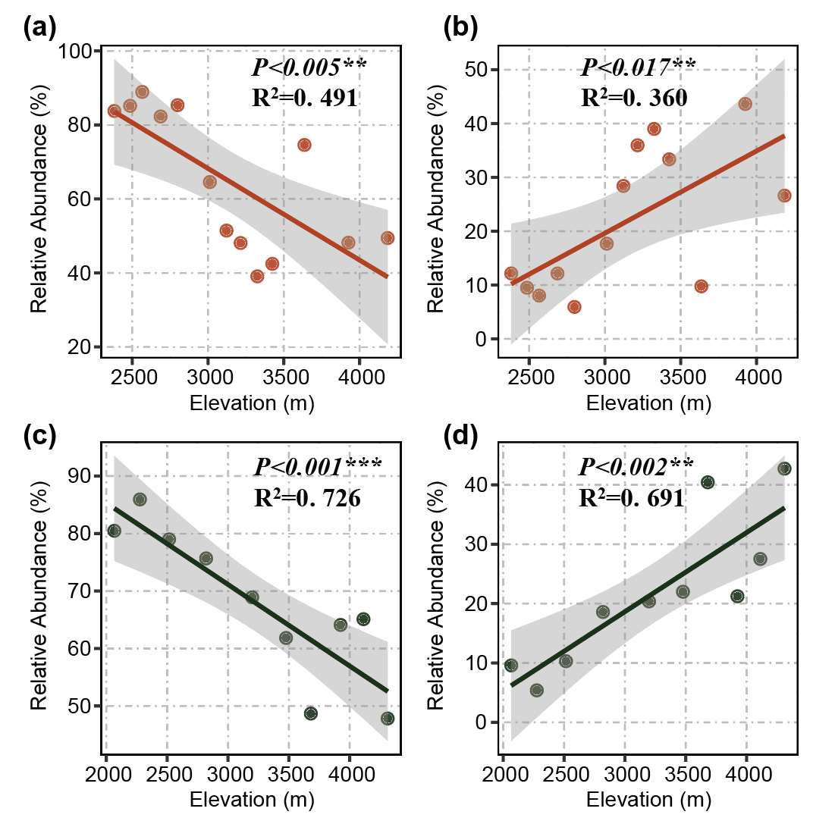
Fig. S1 Relationships between the relative abundance of dominant phyla of soil fungi with elevation. Response of the relative abundance of Ascomycota (a) and Basidiomycota (b) to elevation in Meili Snow Mountain. Response of the relative abundance of Ascomycota (c) and Basidiomycota (d) to elevation in Baima Snow Mountain. Statistical significance is notated as follows: *, p < 0.05; **, p < 0.01; ***, p < 0.001. The choice between linear and curved model fittings was guided by the AICs (Akaike's Information Criterion).

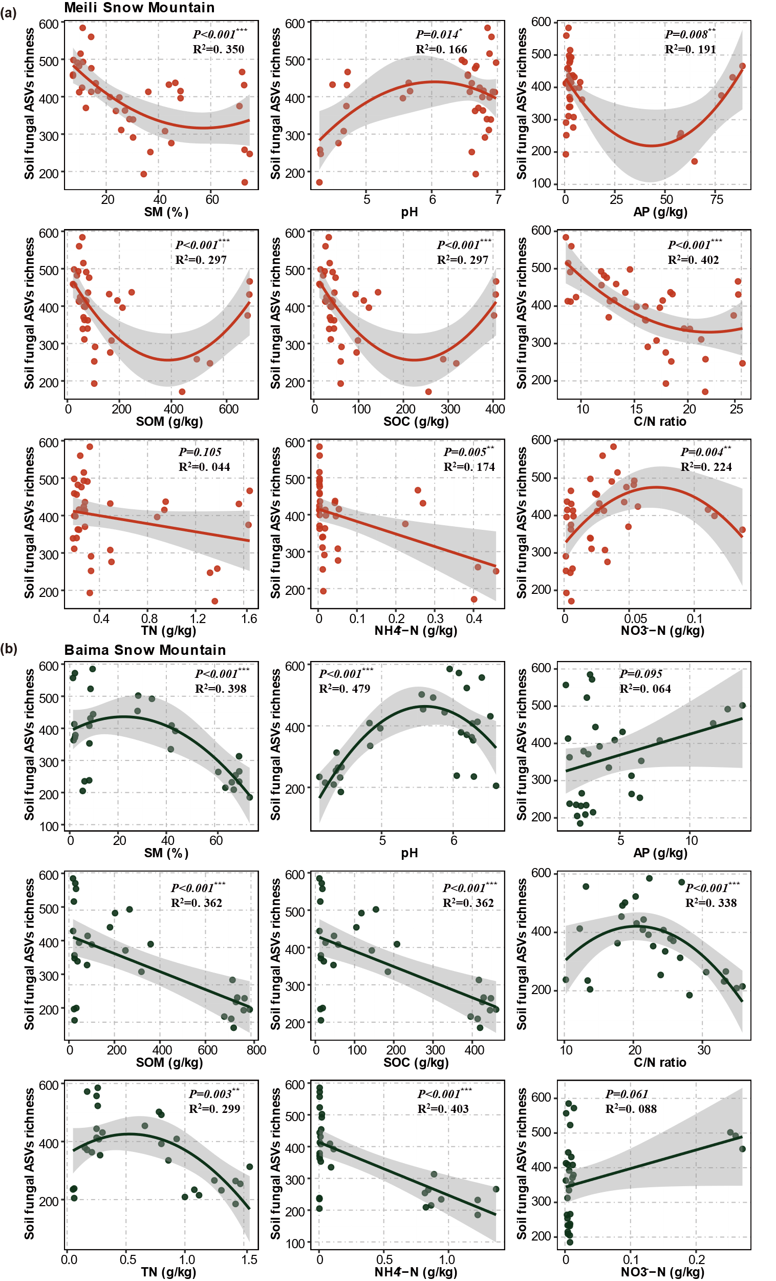
Fig. S2 Relationship between soil fungal richness and soil physicochemical properties. Correlations of soil fungal richness with environmental factors in Meili Snow Mountain (a) and Baima Snow Mountain (b). SM, soil moisture; TC, soil total carbon content; TN, soil total nitrogen content; SOC, soil organic carbon content; C/N ratio, soil organic carbon/total nitrogen ratio; NH₄⁺-N, soil ammonium-nitrogen content; NO₃⁻-N, soil nitrate-nitrogen content; AP, soil available phosphorus content. Statistical significance is notated as follows: *, p < 0.05; **, p < 0.01; ***, p < 0. 001. The choice between linear and curved model fittings was guided by the AICc (Akaike's Information Criterion).
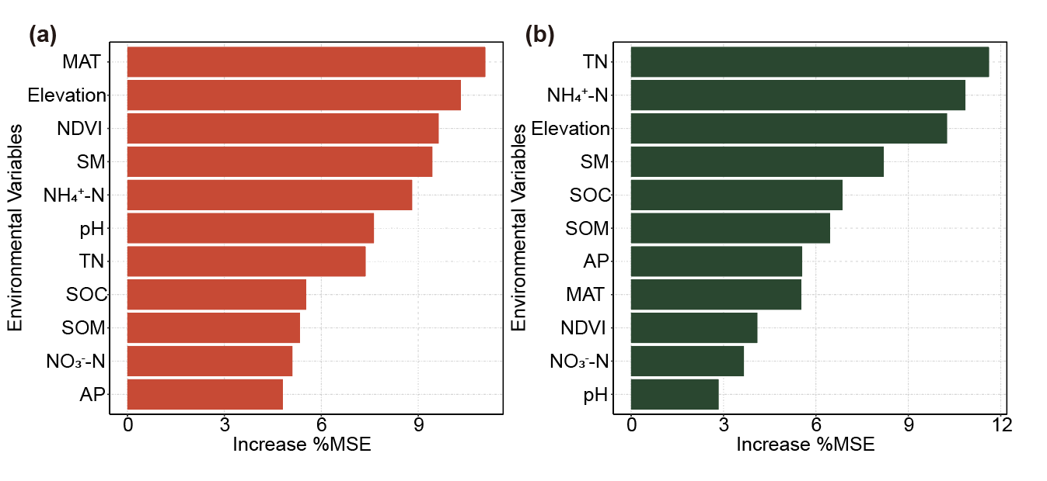
Fig. S3 Random Forest analysis predicting the relationship between fungal richness and environmental factors on (a) Meili Snow Mountain and (b) Baima Snow Mountain. SM, soil moisture; TC, soil total carbon content; TN, soil total nitrogen content; SOC, soil organic carbon content; C/N ratio, soil organic carbon / total nitrogen ratio; NH₄⁺-N, soil ammonium-nitrogen content; NO₃⁻-N, soil nitrate-nitrogen content; AP, soil available phosphorus content. Statistical significance is notated as follows: *, p < 0.05; **, p < 0.01; ***, p < 0. 001.

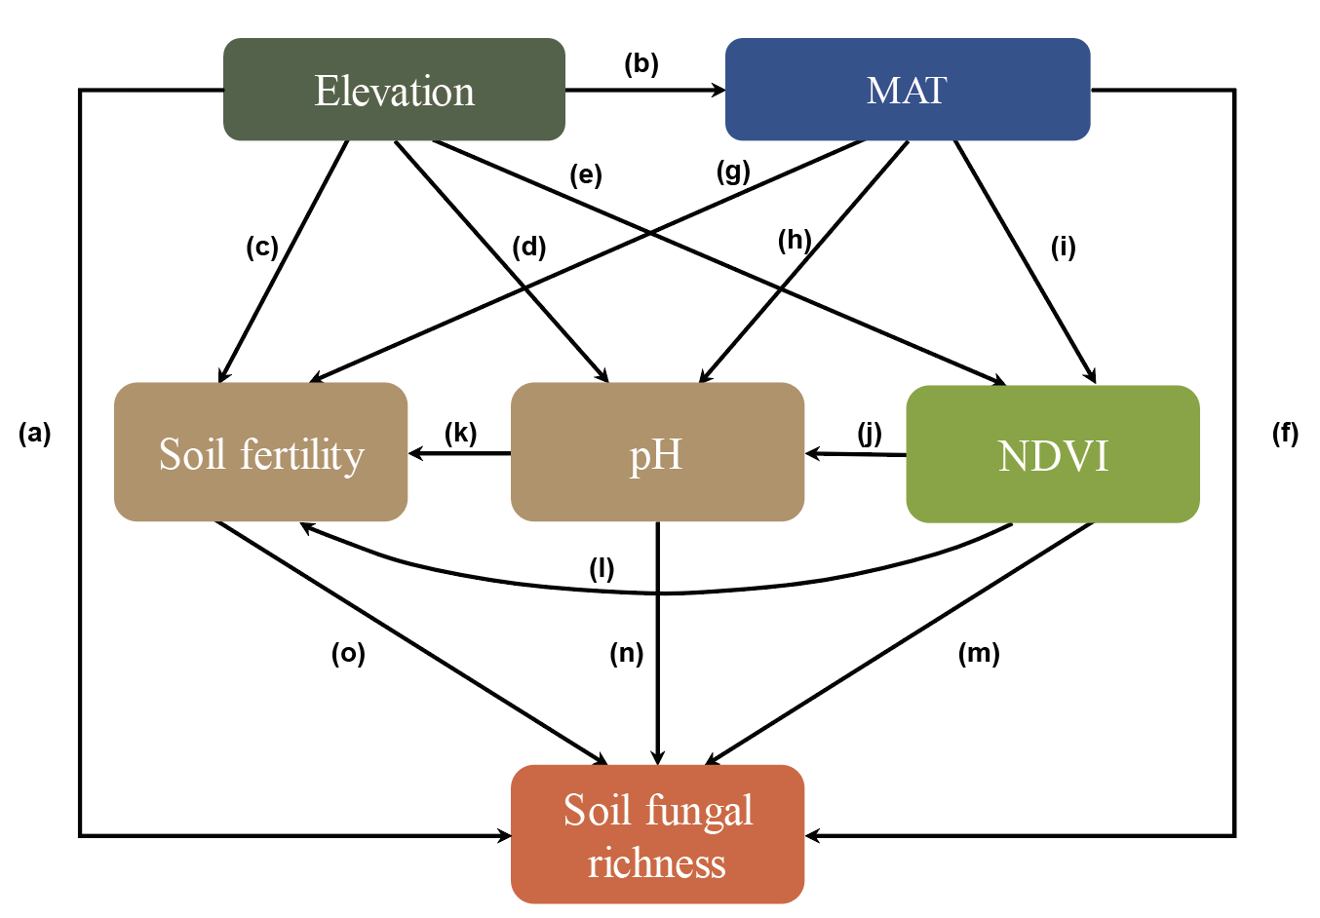
Fig. S4 Conceptual model for how elevation affects soil fungal diversity. A priori generic SEM depicting pathways through which elevation, climate (MAT), plants (NDVI), and soil (soil fertility, pH) may influence the soil fungal richness. The pathways in the predefined SEM model are labelled with letters, which correspond to the detailed explanations in Table S2 used to validate the hypotheses. Abbreviations: MAT: mean annual temperature; NDVI, normalized difference vegetation index; pH, soil pH.
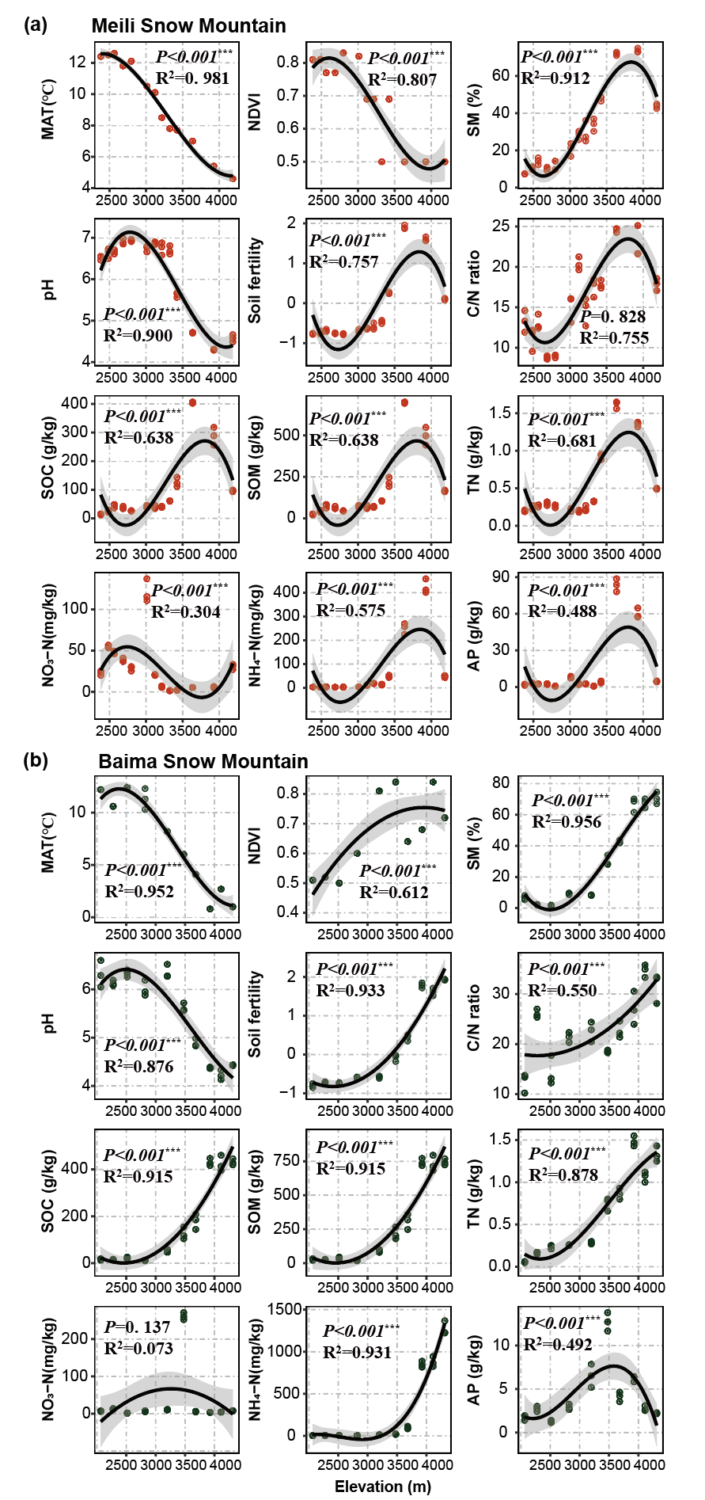
Fig. S5 Relationship between soil physicochemical properties and elevation. The gray shaded area around the fitted line represents the 95% confidence interval. Significance is indicated by p < 0.05. MAT, mean annual temperature; NDVI, normalized difference vegetation index; SM, soil moisture; TN, soil total nitrogen content; SOC, soil organic carbon content; SOM, Soil organic matter content; C/N ratio, soil organic carbon/total nitrogen ratio; NO₃⁻-N, soil nitrate-nitrogen content; NH₄⁺-N, soil ammonium-nitrogen content; AP, soil available phosphorus content. Statistical significance is notated as follows: *, p < 0.05; **, p < 0.01; ***, p < 0. 001.
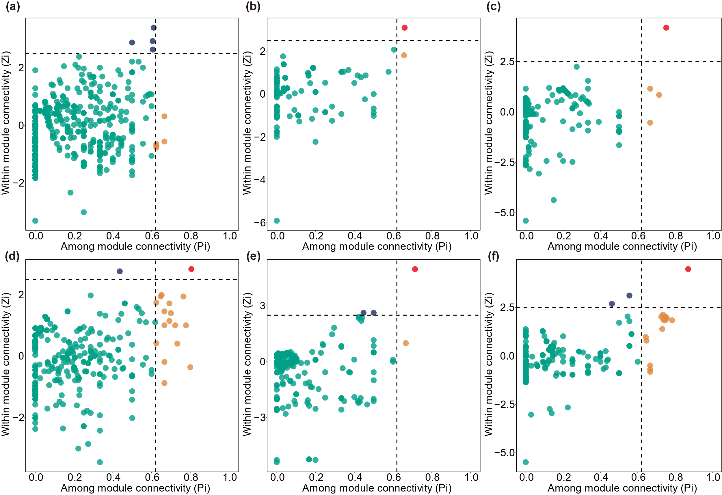
Fig S6. Key biological species in co-occurrence networks. Key biological species were analyzed at (a) low-altitude region, (b) mid-altitude region, and (c) high-altitude region of Meili Snow Mountain, and (d) low- altitude region, (e) mid- altitude region, and (f) high-altitude region of Baima Snow Mountain. Based on Zi (within-module connectivity) and Pi (among-module connectivity) values, network nodes are classified into four categories: network hubs (Zi > 2.5, Pi > 0.62) are ASVs highly connected both overall and within modules; module hubs (Zi > 2.5, Pi < 0.62) are highly connected only within one module; ASVs linking modules are connectors (Zi < 2.5, Pi > 0.62); and peripherals (Zi < 2.5, Pi < 0.62) exhibit few connections with other species.

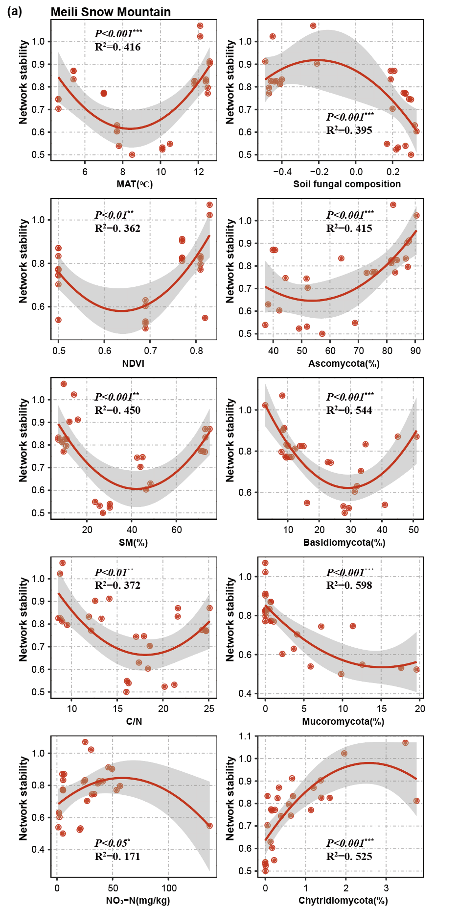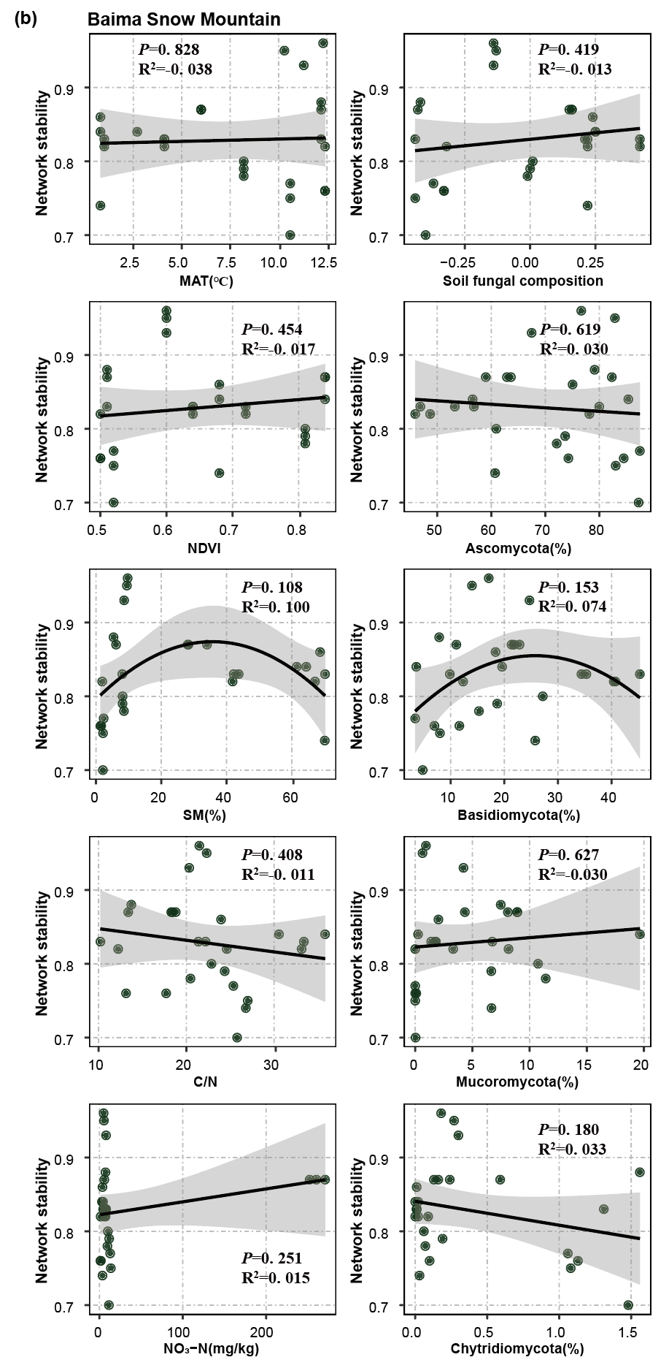
Fig. S7. Network stability of the soil fungal community. Relationship between network stability with MAT; NDVI; SM; C:N ratio; NO₃⁻-N; soil fungal composition; relative abundance of Ascomycota; relative abundance of Basidiomycota; relative abundance of Mucoromycota; relative abundance of Chytridiomycota in Meili Snow Mountain (a) and Baima Snow Mountain (b). Network stability was calculated by absolute negative: positive cohesion. MAT, mean annual temperature; NDVI, normalized difference vegetation index; SM, soil moisture; C/N ratio, soil organic carbon / total nitrogen ratio; NO₃⁻-N, soil nitrate-nitrogen content; Soil fungal composition, the first axis of the principal coordinate analysis (PCoA).

Supplementary references:

Antonelli A, Kissling W D, Flantua S G A, et al. Geological and climatic influences on mountain biodiversity . Nature Geoscience, 2018, 11: 718-725.
Banday M, Bhardwaj D R, Pala N A. Influence of forest type, altitude and NDVI on soil properties in forests of North Western Himalaya, India. Acta Ecologica Sinica, 2019, 39: 50-55.
Delgado-Baquerizo M, Maestre F T, Reich P B, et al. Microbial diversity drives multifunctionality in terrestrial ecosystems. Nature Communications, 2016, 7: 10541.
Dixon J L, Chadwick O A, Vitousek P M. Climate-driven thresholds for chemical weathering in postglacial soils of New Zealand. Journal of Geophysical Research: Earth Surface, 2016, 121: 1619-1634.
Liu L, Wang Y, Wang Z, et al. Elevation-dependent decline in vegetation greening rate driven by increasing dryness based on three satellite NDVI datasets on the Tibetan Plateau. Ecological Indicators, 2019, 107.
Neina D. The Role of Soil pH in Plant Nutrition and Soil Remediation. Applied and Environmental Soil Science, 2019, 2019: 1-9.
Piedallu C, Cheret V, Denux J P, et al. Soil and climate differently impact NDVI patterns according to the season and the stand type. Science of the Total Environment, 2019, 651: 2874-2885.
Ping Y, Han D, Wang N, et al. Vertical zonation of soil fungal community structure in a Korean pine forest on Changbai Mountain, China. World Journal of Microbiology and Biotechnology, 2017, 33: 1-10.
Tang L, Zhong L, Xue K, et al. Warming counteracts grazing effects on the functional structure of the soil microbial community in a Tibetan grassland. Soil Biology & Biochemistry, 2019, 134: 113-121.
Tedersoo L, Bahram M, Põlme S, et al. Global diversity and geography of soil fungi. Science, 2014, 346: 1256688.
Yang Y, Cheng H, Liu L, et al. Comparison of soil microbial community between planted woodland and natural grass vegetation on the Loess Plateau. Forest Ecology and Management, 2020, 460.
Zhang P, Luan M, Li X, et al. The distribution of soil fungal communities along an altitudinal gradient in an alpine meadow. Global Ecology and Conservation, 2021, 31.

