Supplementary figures and tables
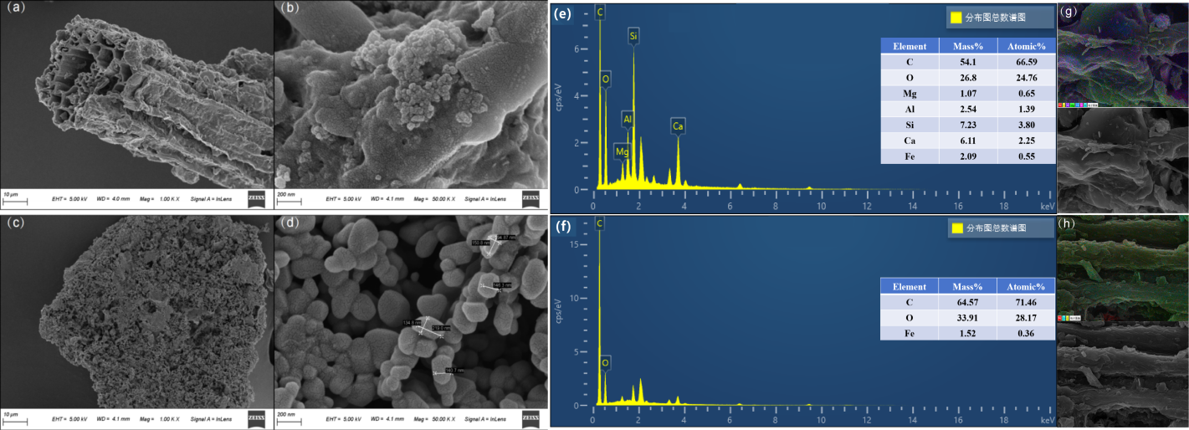
Fig. S1. Scanning electron microscope (SEM) images of (a, b) yak dung biochar (BC) and (c, d) biochar-supported nanoscale zero-valent iron (nZVI-BC) pyrolyzed at 500 ℃. Similarly, energy dispersive spectroscopy (EDS) in spectra of yak dung biochar and nanoscale zero-valent iron-modified biochar. Energy-dispersive spectroscopy (EDS) analysis and elemental composition of (e, g) BC and (f, h) nZVI-BC.

Table S1. Physicochemical properties topsoil and subsoil of degraded grassland. Soil microbial community (SMC), bulk density (BD), water content (WC), potenz Hydrogen (pH), electrical conductivity (EC), cation exchange capacity (CEC), soil amine nitrogen (NH₄-N), nitrate nitrogen (NO₃-N), total carbon (TC), soil organic carbon (SOC), soil hygroscopic water (SHW), annual precipitation (AP), dissolved organic carbon (DOC), readily oxidizable carbon (ROC), amine nitrogen (NH₄-N), total phosphorous (TP), particulate organic carbon and mineral-associated organic carbon (POC: MAOC), total dissolved nitrogen (TDN).
Properties | Topsoil（0-10 cm） | Subsoil（10-20 cm）
SMC (%) | 16.0±1.01^{b} | 18.1±0.11ª
BD (g∙cm-3) | 0.91±0.05 | 0.92±0.01
WC (%) | 76.3±7.17ª | 53.1±8.54^{b}
pH | 8.15±0.01 | 8.12±0.02
EC (cmol∙kg-1) | 76.4±3.06 | 76.6±5.79
CEC (cmol∙kg-1) | 24.9±3.85 | 23.9±4.10
NH4⁺-N (g∙kg-1) | 3.54±0.16^{b} | 3.90±0.06ª
NO3⁻-N (g∙kg-1) | 40.9±4.23 | 39.2±3.24
SOC (g·kg-1) | 39.4±6.72 | 36.5±8.45
SHW (%) | 3.96±0.34 | 3.92±0.30
AP (mg·kg-1) | 4.17±0.87 | 5.02±2.13
DOC (mg·kg-1) | 151±9.86 | 167±26.6
ROC (g·kg-1) | 7.42±0.98 | 6.84±1.54
TP (g·kg-1) | 0.77±0.06 | 0.81±0.09
TN (g·kg-1) | 3.68±0.50 | 3.70±0.72
TC (g·kg-1) | 46.0±6.73 | 45.4±7.49
SC:N | 12.8±3.00 | 12.7±3.13
POC (g·kg-1) | 2.64±0.50 | 1.83±0.81
MAOC (g·kg-1) | 30.7±2.24 | 29.5±2.99
TDN (g·kg-1) | 11.5±1.46 | 11.1±1.51

Table S2. Relative changes (RC) over incubation time in soil organic carbon mineralization with nano zero-valent iron-modified biochar (nZVI-BC) and yak dung biochar (BC) in three aggregate soil sizes in topsoil and subsoil at 5 ℃.
Aggregate soil size Biochar |  |  | 5 ℃ incubation time（day）
 |  |  | 3 | 7 | 10 | 14 | 21 | 28
Topsoil | <0.25mm | RC_{nZVI-BC1%} | 0.55±3.63 | 23.8±2.77 | 15.5±3.71 | 21.6±3.22 | 27.7±3.22 | 31.3±5.07
Topsoil | <0.25mm | RC_{nZVI-BC5%} | 15.6±3.03 | 50.1±6.73 | 24.4±5.20 | 21.4±1.92 | 17.2±4.22 | 11.2±3.44
Topsoil | 0.25-2mm | RC_{nZVI-BC1%} | -33.6±8.32 | -12.6±5.85 | -10.9±1.56 | -0.30±2.43 | -2.62±2.76 | -0.89±3.81
Topsoil | 0.25-2mm | RC_{nZVI-BC5%} | 0.54±9.00 | 34.6±10.6 | 17.0±4.04 | 9.80±2.50 | 9.67±1.02 | 13.3±1.84
Topsoil | >2mm | RC_{nZVI-BC1%} | 32.8±5.27 | 6.29±2.46 | -2.39±1.67 | 3.97±3.02 | 18.2±4.18 | 22.7±4.98
Topsoil | >2mm | RC_{nZVI-BC5%} | 4.79±11.6 | 11.4±5.78 | 3.51±0.72 | 3.23±1.44 | 5.95±0.47 | 19.6±0.84
Subsoil | <0.25mm | RC_{nZVI-BC1%} | 65.9±21.5 | 79.0±11.3 | 65.9±5.69 | 49.1±6.61 | 43.7±1.65 | 41.5±0.79
Subsoil | <0.25mm | RC_{nZVI-BC5%} | 2.53±0.52 | 14.3±2.76 | 14.7±3.54 | 15.0±5.29 | 16.0±3.45 | 23.1±3.48
Subsoil | 0.25-2mm | RC_{nZVI-BC1%} | 29.4±33.6 | 7.96±14.8 | -6.99±9.96 | 6.08±7.22 | 0.67±3.76 | -0.61±1.83
Subsoil | 0.25-2mm | RC_{nZVI-BC5%} | -9.72±6.88 | 0.50±8.61 | 7.07±5.39 | 17.6±6.30 | 12.0±3.97 | 14.1±3.22
Subsoil | >2mm | RC_{nZVI-BC1%} | -18.9±5.80 | 22.2±7.04 | 7.72±4.33 | 2.47±5.65 | 2.60±1.76 | -6.49±2.00
Subsoil | >2mm | RC_{nZVI-BC5%} | -36.1±4.51 | 3.65±5.75 | 10.3±3.65 | 11.3±3.57 | 16.4±5.72 | 16.7±4.82

Table S3. Relative changes (RC) over incubation time in soil organic carbon mineralization with the addition of nanoscale zerovalent iron-modified biochar (nZVI-BC) compared to the addition of yak dung biochar (BC) at three aggregate sizes in topsoil and subsoil at 15 ℃.
Aggregate soil size Biochar |  |  | 15 ℃ incubation time（day）
 |  |  | 3 | 7 | 10 | 14 | 21 | 28
Topsoil | <0.25mm | RC_{nZVI-BC1%} | 36.4±1.17 | 16.4±4.36 | -0.22±2.16 | 1.47±1.62 | 4.64±2.56 | 15.5±2.58
Topsoil | <0.25mm | RC_{nZVI-BC5%} | 10.8±0.64 | 9.88±3.13 | 26.6±3.06 | 24.9±1.62 | 19.9±1.20 | 14.8±0.85
Topsoil | 0.25-2mm | RC_{nZVI-BC1%} | 6.92±1.59 | 7.74±5.83 | 14.5±3.11 | 9.64±4.91 | 10.7±3.08 | 11.1±1.07
Topsoil | 0.25-2mm | RC_{nZVI-BC5%} | 28.3±2.39 | 10.3±2.80 | 22.0±3.49 | 32.3±3.13 | 21.3±1.54 | 21.4±0.77
Topsoil | >2mm | RC_{nZVI-BC1%} | 6.22±2.01 | -10.4±1.53 | 16.1±1.28 | 56.4±2.71 | 46.5±3.45 | 33.7±1.32
Topsoil | >2mm | RC_{nZVI-BC5%} | 26.9±6.74 | -3.78±4.46 | -9.39±4.03 | -14.4±3.58 | -10.5±2.43 | -8.93±1.96
Subsoil | <0.25mm | RC_{nZVI-BC1%} | -38.1±1.66 | -21.1±1.58 | -16.3±1.59 | -6.42±2.46 | -11.5±2.08 | -15.2±2.06
Subsoil | <0.25mm | RC_{nZVI-BC5%} | 42.5±2.50 | 23.9±1.18 | 33.7±1.51 | 22.0±2.37 | 8.10±2.44 | 7.96±1.89
Subsoil | 0.25-2mm | RC_{nZVI-BC1%} | -1.64±3.9 | -9.88±0.88 | -8.92±1.75 | -6.83±2.16 | -7.06±2.54 | -3.48±1.68
Subsoil | 0.25-2mm | RC_{nZVI-BC5%} | 14.7±1.45 | 15.0±0.83 | 2.44±1.36 | 8.36±1.84 | 6.60±2.51 | 20.3±1.64
Subsoil | >2mm | RC_{nZVI-BC1%} | -28.8±4.11 | -32.6±2.95 | -39.7±0.97 | -40.4±1.00 | -37.4±1.18 | -32.3±1.21
Subsoil | >2mm | RC_{nZVI-BC5%} | 17.0±3.66 | 17.4±0.84 | 11.4±0.05 | 15.1±0.43 | 3.51±0.93 | -1.24±0.94

