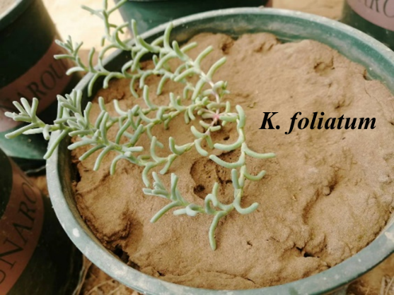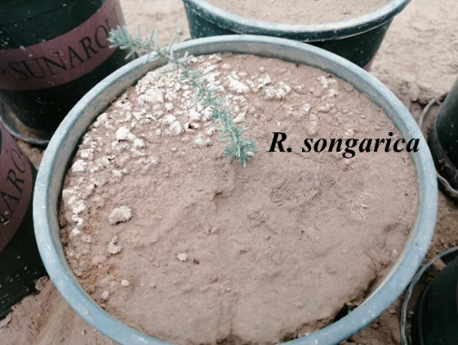
Fig S1 Picture of K. foliatum and R. songarica
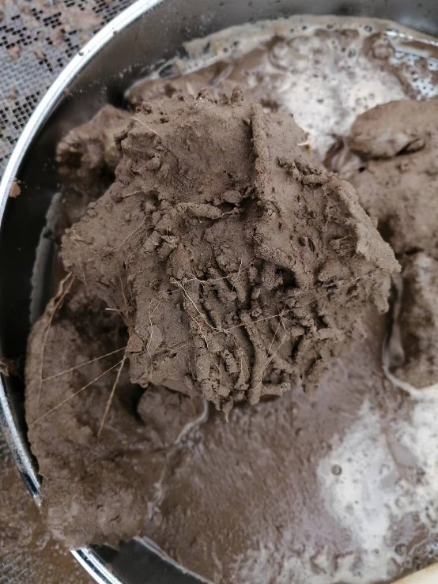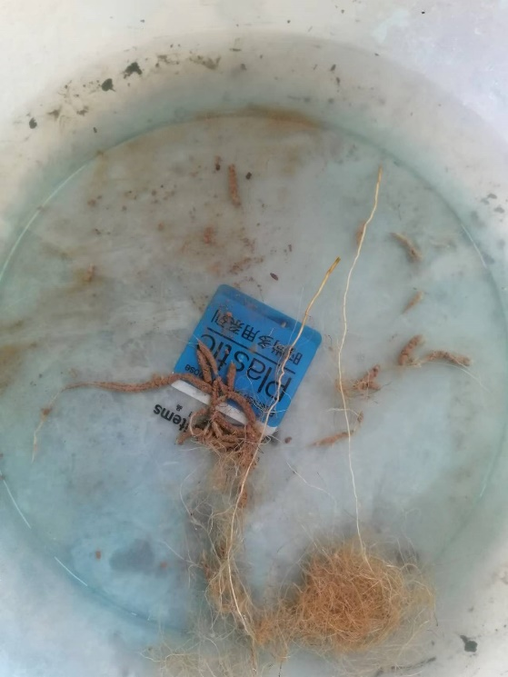
Fig S2 Picture of rhizosheath of R. songarica

Table S1, Soil organic carbon (SOC), total nitrogen (TN), total phosphorus (TP), available nitrogen (AN) and phosphorus (AP), and pH of soil collected for a plant-soil feedback experiment
SOC  (g•kg⁻¹) | TN  (g•kg⁻¹) | TP  (g•kg⁻¹) | AN  (mg•kg⁻¹) | AP  (mg•kg⁻¹) | pH
1.44±0.21 | 0.17±0.02 | 0.15±0.03 | 9.5±1.0 | 16.8±2.4 | 8.6±0.2

Table S2 Result of independent T-test between B-PSF_{of} and B-PSF of K. foliatum and R. songarica on conspecific and heterospecific soils
Conditioning | Species | Mean difference | SD | df | p
Conspecific | K. foliatum | -1.006 | 0.107 | 8 | <0.001
Conspecific | R. songarica | -0.004 | -0.028 | 8 | 0.888
Heterospecific | K. foliatum | -1.285 | 0.103 | 8 | <0.001
Heterospecific | R. songarica | -0.017 | 0.059 | 8 | 0.778

Table S3 Result of independent T-test between K. foliatum and R. songarica of B-PSF_{of} and B-PSF_{c} on conspecific and heterospecific soils
Conditioning | Type | Mean difference | SD | df |  |  | p
Conspecific | Pˊ-Biotic | -1.222 | 0.093 |  | 8 | <0.001
Conspecific | P-Biotic | -0.160 | 0.059 |  | 8 | 0.026
Heterospecific | Pˊ-Biotic | -0.697 | 0.093 |  | 8 | <0.001
Heterospecific | P-Biotic | 0.572 | 0.073 |  | 8 | <0.001

Table S4 The conspecific and the heterospecific SS_{nutrient} and SS_{uc} of R.songarica and K. foliatum
Species | SS_{nutrient} |  | SS_{uc}
Species | Conspecific | Heterospecific | SS_{uc}
K. foliatum | 7.45E-02±1.67 E-02 A | 1.91 E-02±0.55 E-02 B | -1.23±0.10
R. songarica | 0.03 E-02±0.01 E-02 b | 0.06 E-02±0.01 E-02 a | -0.02±0.03
* The values presented in the table represent the mean ± SE (n = 5). There were significant differences among different letters (P=0.05).

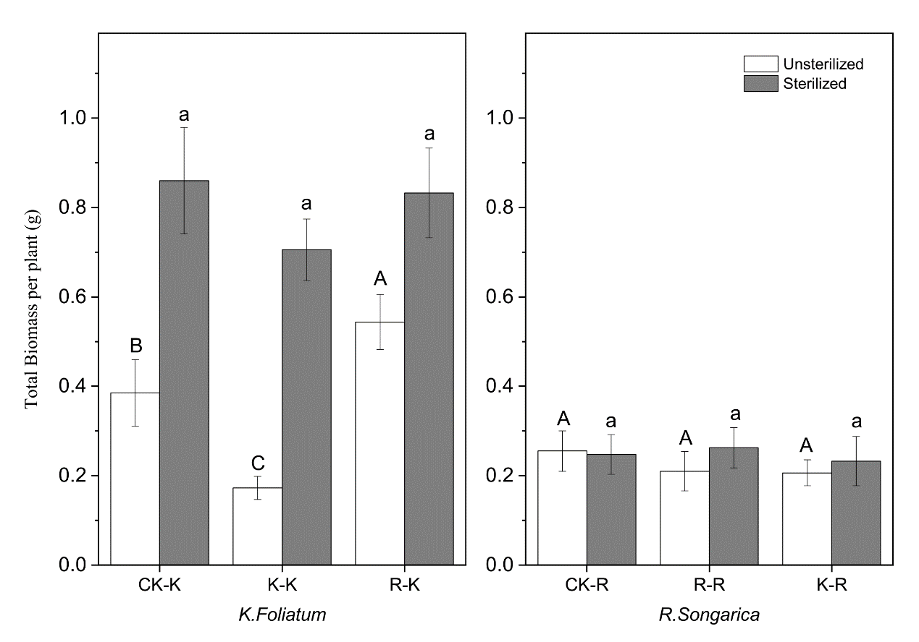
Fig S3 The biomass of K. foliatum (a) and R. songarica (b) under sterilized (filled columns) and unsterilized (unfilled columns) soil on different conditioning soils. Each value represents the mean ± SE (n = 5). CK-K refers to K. foliatum planted on control soil (no planting), and so on. Where CK, K and R refer to controlled soil (no planting), K. foliatum and R. songarica, respectively. There were significant differences among different letters (P=0.05).

