Supplementary Materials for
Microplastics mineralization accelerates soil organic carbon decomposition by positive priming effects: A meta-analysis

Shuotian Lai, Changlin Xu, Wenao Wu, Xudong Wang, Yongxiang Yu, Biao Zhu*

*Corresponding author: biaozhu@pku.edu.cn.

This file includes:
Figures S1-S5
Tables S1-S2
Text S1
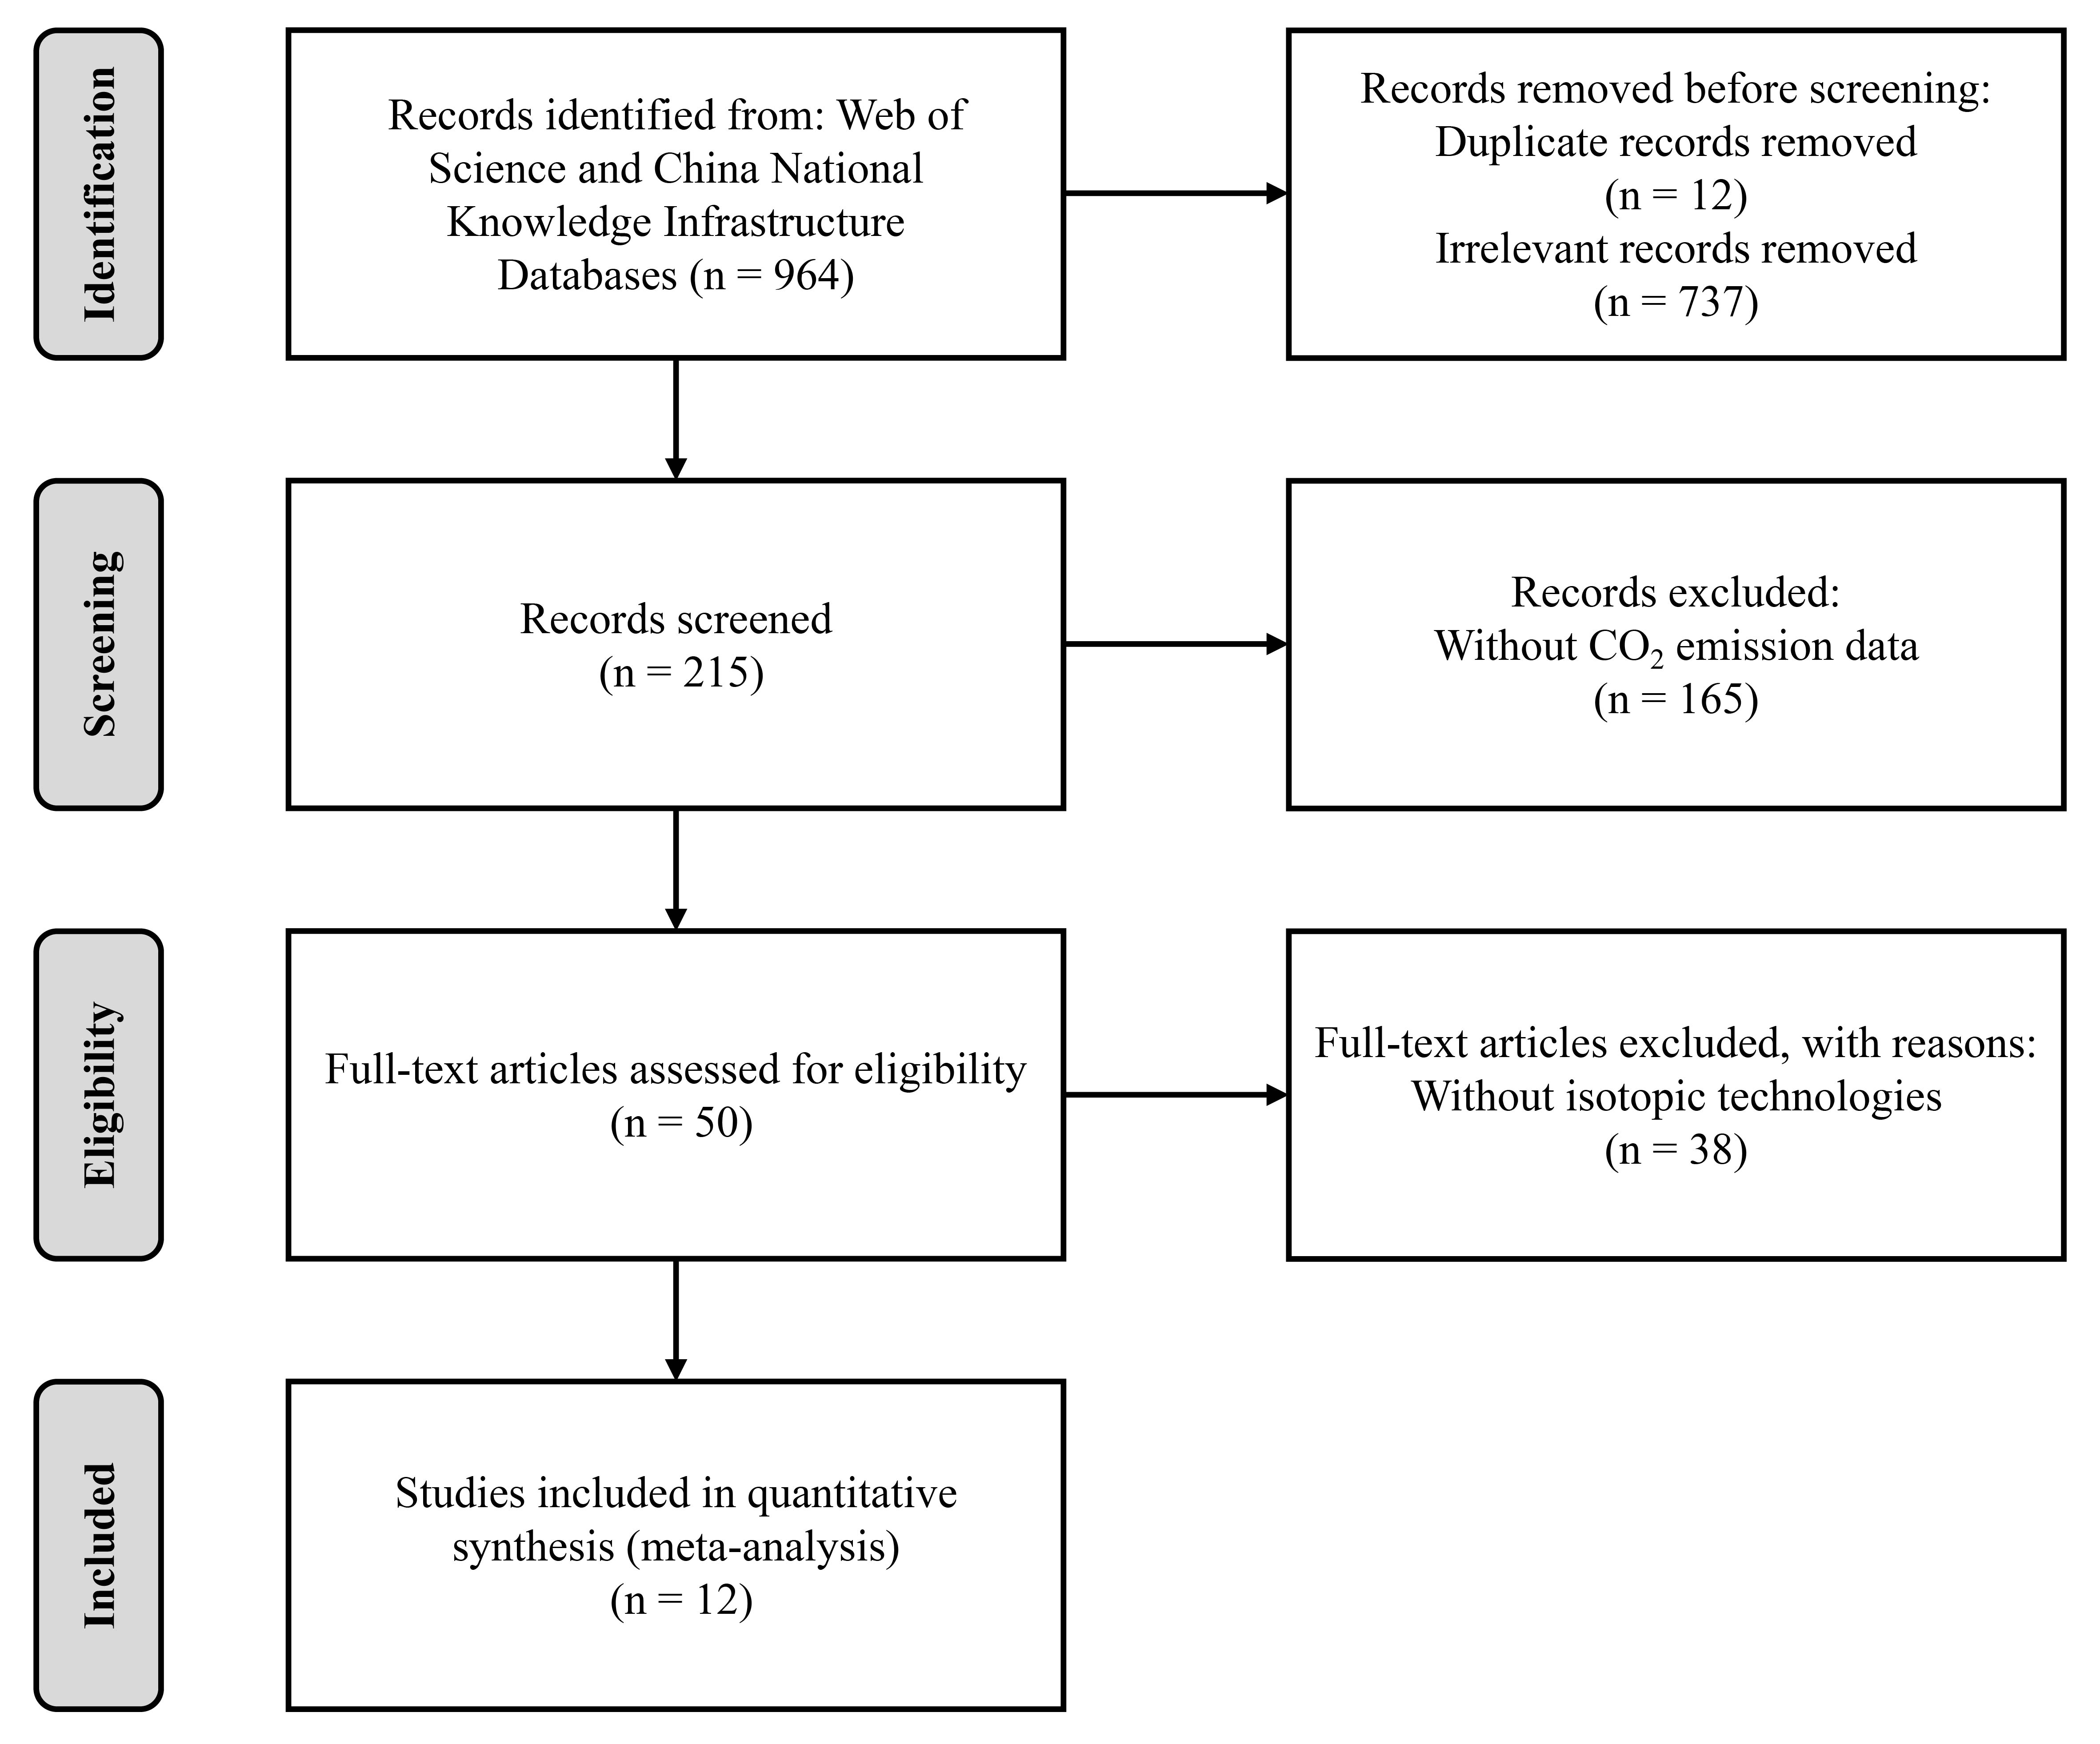

Fig. S1 PRISMA 2020 Flow Diagram showing the procedure of study selection in this meta-analysis.
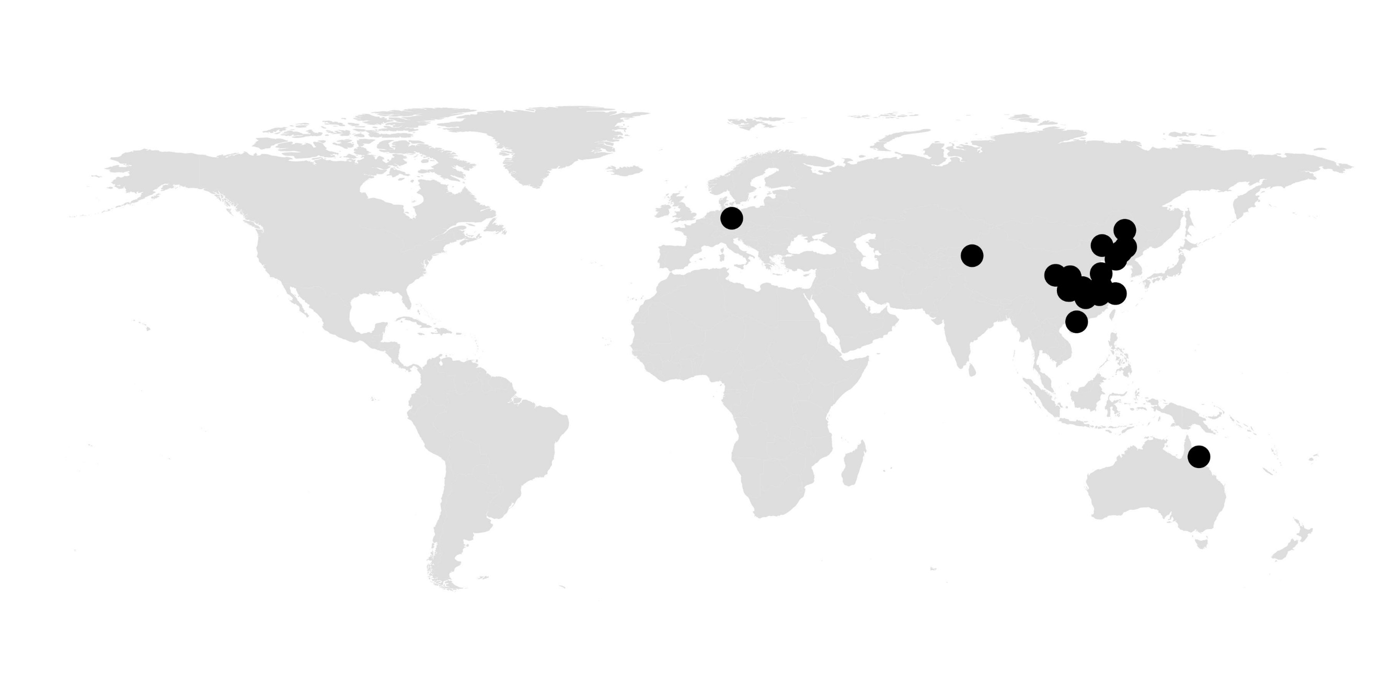

Fig. S2 Global distributions of current microplastics priming effect experiments included in this study. A total of 103 observations were collected at 20 sites obtained from 12 peer-reviewed journal articles published before May 2025.
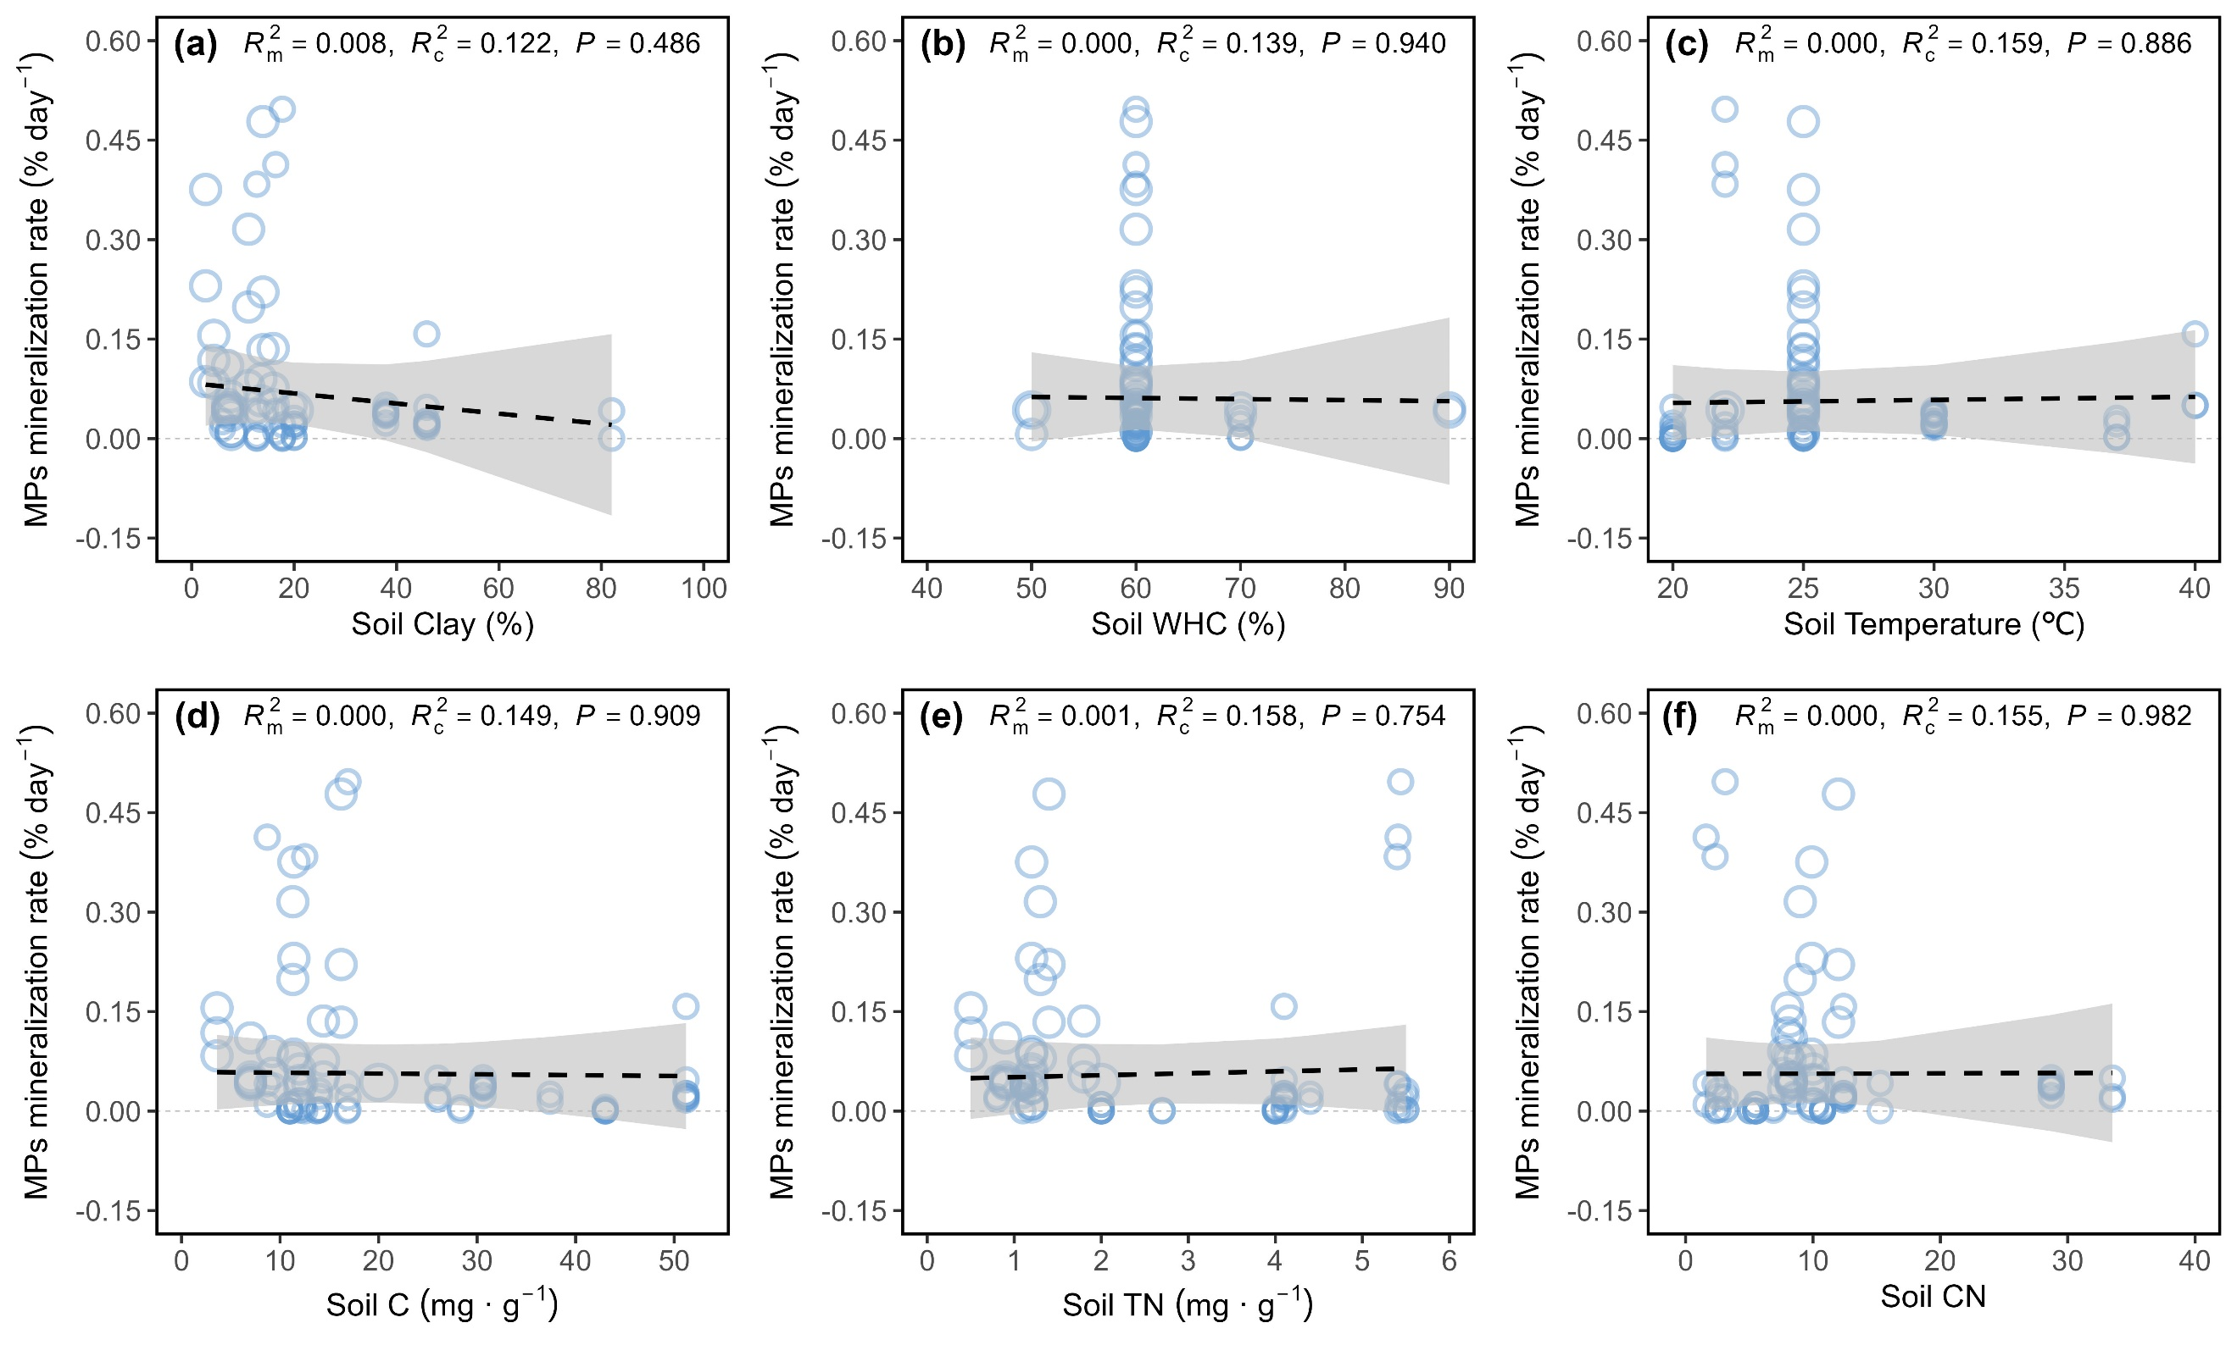

Fig. S3 The relationships between microplastics mineralization rate and soil variables. The dashed line denotes non-significant fitted results (P > 0.05). Gray shadow shows 95% confidence intervals. The marginal (m) and conditional (c) R² represent the degree of explanation by fixed effects and by both fixed and random effects (study), respectively. Soil Clay, soil clay concentration; Soil WHC, soil water holding capacity; Soil Temperature, incubation temperature; Soil C, soil organic carbon concentration; Soil TN, soil total nitrogen concentration; Soil CN, soil carbon and nitrogen ratio.
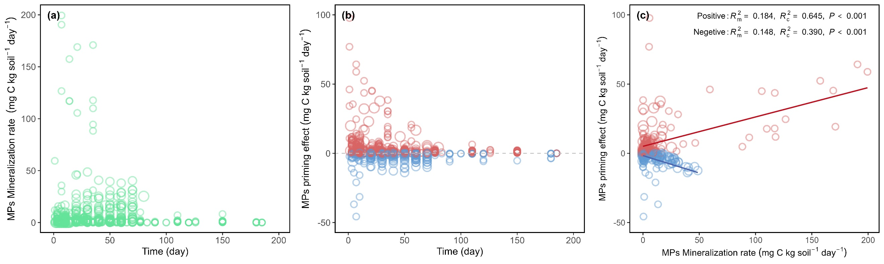

Fig. S4 Changes in microplastics daily mineralization rate (a) and priming effect (b) with incubation time as well as the relationships between microplastics mineralization rate and priming effect (c). The red and blue points in panels b and c represent positive and negative priming effect, respectively. The red and blue lines in panel c indicate the correlation between MPs mineralization rate and positive and negative MPs priming effect, respectively. The marginal (m) and conditional (c) R² in panel c represent the degree of explanation by fixed effects and by both fixed and random effects (study), respectively.
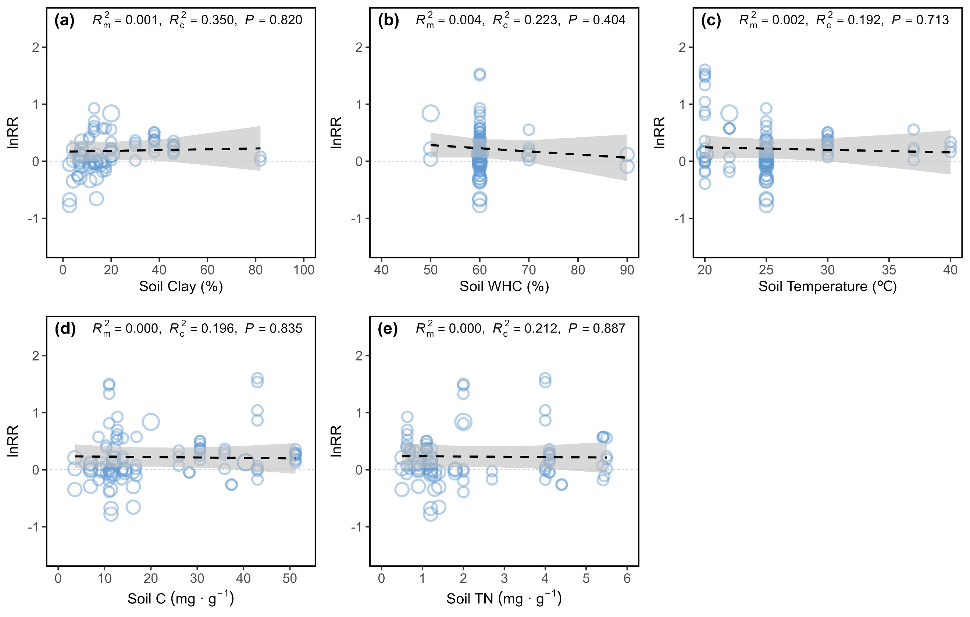

Fig. S5 The relationships between the natural logarithm of response ratio (lnRR) and soil variables. The dashed line denotes non-significant fitted results (P > 0.05). Gray shadow shows 95% confidence intervals. The marginal (m) and conditional (c) R² represent the degree of explanation by fixed effects and by both fixed and random effects (study), respectively. Soil Clay, soil clay concentration; Soil WHC, soil water holding capacity; Soil Temperature, incubation temperature; Soil C, soil organic carbon concentration; Soil TN, soil total nitrogen concentration.

Tabel S1 Examinations for publication bias using the Egger’s test. Results indicated that there was no publication bias.
 | MPs priming effect
Sample size (n) | 103
z | -1.403
P value | 0.161

Tabel S2 The microplastics mineralization rate and the weighted response ratio of microplastics priming effect after excluding outliers. Results indicate that outliers removal have no significant impact on the direction and magnitude of effect sizes, confidence intervals and significance levels.
Outliers removal | Variable |  | Total | Subgroup
 |  |  |  | MPs type |  | MPs size |  |  | MPs concentration
 |  |  |  | Bio | Con | ≤1mm | >1mm | Others | <1% | 1%-3% | >3%
Before removal | Microplastics mineralization rate | Sample size (n) | 89 | 77 | 12 | 41 | 8 | 40 | 37 | 43 | 9
Before removal | Microplastics mineralization rate | Mean | 0.114 | 0.131 | 0.004 | 0.148 | 0.021 | 0.097 | 0.071 | 0.161 | 0.063
Before removal | Microplastics mineralization rate | CI₁ | 0.064 | 0.074 | -0.003 | 0.044 | 0.010 | 0.065 | 0.036 | 0.063 | 0.035
Before removal | Microplastics mineralization rate | CI₂ | 0.163 | 0.187 | 0.012 | 0.252 | 0.032 | 0.130 | 0.106 | 0.259 | 0.091
Before removal | Microplastics mineralization rate | ANOVA P-values | —— | P < 0.001 |  | P < 0.001 |  |  | P = 0.204
Before removal | Microplastics priming effect | Sample size (n) | 103 | 85 | 18 | 53 | 8 | 42 | 38 | 56 | 9
Before removal | Microplastics priming effect | Response ratio | 0.290 | 0.302 | 0.398 | 0.404 | 0.318 | 0.200 | 0.112 | 0.297 | 0.253
Before removal | Microplastics priming effect | CI₁ | 0.078 | 0.073 | 0.033 | 0.110 | 0.181 | -0.077 | -0.020 | 0.007 | -0.805
Before removal | Microplastics priming effect | CI₂ | 0.502 | 0.530 | 0.763 | 0.698 | 0.456 | 0.477 | 0.243 | 0.588 | 1.310
Before removal | Microplastics priming effect | ANOVA P-values | —— | P = 0.139 |  | P < 0.001 |  |  | P = 0.017
After removal | Microplastics mineralization rate | Sample size (n) | 85 | 73 | 12 | 37 | 8 | 40 | 37 | 39 | 9
After removal | Microplastics mineralization rate | Mean | 0.069 | 0.079 | 0.004 | 0.048 | 0.021 | 0.097 | 0.071 | 0.068 | 0.063
After removal | Microplastics mineralization rate | CI₁ | 0.046 | 0.053 | -0.003 | 0.009 | 0.010 | 0.065 | 0.036 | 0.028 | 0.035
After removal | Microplastics mineralization rate | CI₂ | 0.092 | 0.106 | 0.012 | 0.087 | 0.032 | 0.130 | 0.106 | 0.107 | 0.091
After removal | Microplastics mineralization rate | ANOVA P-values | —— | P < 0.001 |  | P < 0.001 |  |  | P = 0.035
After removal | Microplastics priming effect | Sample size (n) | 100 | 82 | 18 | 50 | 8 | 42 | 38 | 53 | 9
After removal | Microplastics priming effect | Response ratio | 0.221 | 0.228 | 0.398 | 0.287 | 0.318 | 0.200 | 0.112 | 0.199 | 0.253
After removal | Microplastics priming effect | CI₁ | 0.060 | 0.061 | 0.033 | 0.073 | 0.181 | -0.077 | -0.020 | -0.013 | -0.805
After removal | Microplastics priming effect | CI₂ | 0.383 | 0.396 | 0.763 | 0.501 | 0.456 | 0.477 | 0.243 | 0.410 | 1.310
After removal | Microplastics priming effect | ANOVA P-values | —— | P = 0.074 |  | P = 0.001 |  |  | P = 0.031
CI₁, lower confidence interval; CI₂, upper confidence interval; Bio, biodegradable microplastics; Con, conventional microplastics.

Text S1 All 12 studies included in the presented meta-analysis
- Xiao, M.L., Shahbaz, M., Liang, Y., Yang, J., Wang, S., Chadwicka, D.R., Jones, D., Chen, J.P., Ge, T.D., 2021. Effect of microplastics on organic matter decomposition in paddy soil amended with crop residues and labile C: A three-source-partitioning study. Journal of Hazardous Materials 416, 126221.
- Guliyev, V., Tanunchai, B., Udovenko, M., Menyailo, O., Glaser, B., Purahong, W., Blagodatskaya, E., 2023. Degradation of bio-based and biodegradable plastic and its contribution to soil organic carbon stock. Polymers 15, 660.
- Huo, Y.X., Dijkstra, F.A., Possell, M., Dong, A.Z., Singh, B., 2023. Degradation of conventional, biodegradable and oxo-degradable microplastics in a soil using a δ13C technique. Soil Research 61, 755-765.
- Zhang, G.H., Liu, D., Lin, J.J., Kumar, A., Jia, K.T., Tian, X.X., Yu, Z.G., Zhu, B., 2023. Priming effects induced by degradable microplastics in agricultural soils. Soil Biology and Biochemistry 180, 109006.
- Hink, L., Rohrbach, S., Rehkopf, J., Sehl, E., Agarwal, S., Feldhaar, H., Horn, M.A., 2024. Poly(L-lactide) mineralisation under environmental conditions is enhanced in earthworm guts. Soil Biology and Biochemistry 196, 109485.
- Huo, Y.X., Dijkstra, F.A., Possell, M., Singh, B., 2024. Mineralisation and priming effects of a biodegradable plastic mulch film in soils: Influence of soil type, temperature and plastic particle size. Soil Biology and Biochemistry 189, 109257.
- Jia, K.T., Nie, S.M, Tian, M.F., Sun, W.X., Gao, Y., Zhang, Y.R., Xie, X.F., Xu, Z.Q., Zhao, C.J., Li, C.Y., 2024. Biodegradable microplastics can cause more serious loss of soil organic carbon by priming effect than conventional microplastics in farmland shelterbelts. Functional Ecology 38, 2447-2458.
- Yu, Y.X., Lin, S.Y., Sarkar, B., Wang, J., Liu, X.H., Wang, D.N., Ge, T.D., Li, Y.Y., Zhu, B., Yao, H.Y., 2024. Mineralization and microbial utilization of poly(lactic acid) microplastic in soil. Journal of Hazardous Materials 476, 135080.
- Xiao, C.L., Liu, X.H., Wang, D.D., Xue, J.T., Liu, L.H., Yu, Y.X., Yao, H.Y., 2024. Impact of moisture on the degradation and priming effects of poly(lactic acid) microplastic. Land Degradation & Development 35, 4623-4636.
- Chen, L.Y., Han, L.F., Wang, F.Y., Chen, Q., Huang, H.K., Wang, J., Ma, C.X., Sun, K., Rillig, M.C., Kuzyakov, Y., Yang, Z.F., 2025. Polylactic acid microplastics induced negative priming and improved carbon sequestration via microbial processes in different paddy soils. Soil Biology and Biochemistry 201, 109653.
- Lin, J.J., Chen, B.B., Dong, H.X., Zhang, W.L., Kumar, A., Hui, D.F., Zhang, C.A., Shan, S.D., Zhu, B., 2025. Effects of soil moisture fluctuation and microplastics types on soil organic matter decomposition and carbon dynamics. Soil Biology and Biochemistry 205, 109781.
- Wu, Y., Wang, Z.H., Yu, Y.X., Liu, X.H., Wang, D.N., Wang, J., Li, Y.Y., Zhu, B., Whalen, J.K., Yao, H.Y., 2025. Degrading poly(lactic acid) microplastic induces priming in agricultural soils. Applied Soil Ecology 206, 105911.

