Supplementary Material of:
Decadal litter addition mitigates nitrogen enrichment-induced declines of soil microbial biomass in Mongolian pine plantations

Zhanhe Cheng¹, Nianpeng He^{1,2}, Yizhen Li¹, De-Hui Zeng³, Songfei Cheng¹, Weiqi Xu¹, Guigang Lin^{1,2,*}

¹Institute of Carbon Neutrality, School of Ecology, Northeast Forestry University, Harbin 150040, China
²Key Laboratory of Boreal Forest Ecosystem Conservation and Restoration, National Forestry and Grassland Administration, Harbin, 150040, China
³Daqinggou Ecological Station, Institute of Applied Ecology, Chinese Academy of Sciences, Shenyang 110016, China

*Corresponding author: Guigang Lin.
E-mail: linguigang@126.com.
Tel.: +86 451 82192454.
Fax: +86 451 82192455.
Postal address: School of Ecology, Northeast Forestry University, Harbin 150040, China.

Table S1 Stand characteristics, needle litter chemical properties, and soil physicochemical properties (0–10 cm) measured in April 2011 prior to treatment initiation.
Variable subset | Variable | Mean (standard error)
Stand characteristics | Diameter at breast height (cm) | 7.0 (0.4)
 | Height (m) | 3.9 (0.3)
 | Stand density (trees ha⁻¹) | 974 (13)
Needle litter chemical properties | C (mg g⁻¹) | 551 (5)
 | N (mg g⁻¹) | 4.03 (0.07)
 | Lignin (mg g⁻¹) | 306 (1)
 | C:N ratio | 137 (4)
 | Lignin:N ratio | 76 (3)
Soil physicochemical properties | Soil pH | 6.87 (0.69)
 | Soil organic C (mg g⁻¹) | 4.82 (1.28)
 | Soil total N (mg g⁻¹) | 0.37 (0.05)
 | Soil inorganic N (mg kg⁻¹) | 4.90 (0.99)
 | Bulk density (g cm⁻³) | 1.51 (0.10)

Table S2 Classifying phospholipid fatty acids (PLFAs) into microbial functional guilds.
Functional guild | PLFAs | References
Fungi | 18:2ω6c, 18:1ω9c | Frostegård and Bååth, 1996; Joergensen, 2022
Bacteria | 13:0 iso, 13:0 anteiso, 14:0 iso, 14:0 anteiso, 15:1 iso ω6c, 15:0 iso, 15:0 anteiso, 16:0 iso, 16:0anteiso, 17:1 iso ω9c, 17:0 iso, 17:0 anteiso, 18:0 iso, 19:0 anteiso, 10:0 3OH, 10:0 2OH, 14:1ω8c, 14:1ω5c, 15:1ω7c, 16:1ω7c, 16:1ω7c DMA, 17:1ω8c, 17:0 cyclo ω7c, 18:1ω7c, 18:1ω5c, 19:0 cyclo ω7c, 17:1ω7c 10-methyl, 17:0 10-methyl, 18:1ω7c 10-methyl, 18:0 10-methyl | Zelles, 1999; Midgley and Phillips, 2019; DeForest et al., 2021
Actinomycetes | 17:1ω7c 10-methyl, 17:0 10-methyl, 18:1ω7c 10-methyl, 18:0 10-methyl | Zelles, 1999; Midgley and Phillips, 2019; DeForest et al., 2021
Gram-positive bacteria | 13:0 iso, 13:0 anteiso, 14:0 iso, 14:0 anteiso, 15:1 iso ω6c, 15:0 iso, 15:0 anteiso, 16:0 iso, 16:0 anteiso, 17:1 iso ω9c, 17:0 iso, 17:0 anteiso, 18:0 iso, 19:0 anteiso | Willers et al., 2015; Midgley and Phillips, 2019
Gram-negative bacteria | 10:0 3OH, 10:0 2OH, 14:1ω8c, 14:1ω5c, 15:1ω7c, 16:1ω7c, 16:1ω7c DMA, 17:1ω8c, 17:0 cyclo ω7c, 18:1ω7c, 18:1ω5c, 19:0 cyclo ω7c | Zelles, 1999; DeForest et al., 2021
References
DeForest, J.L., Dorkoski, R., Freedman, Z.B., Smemo, K.A., 2021. Multi-year soil microbial and extracellular phosphorus enzyme response to lime and phosphate addition in temperate hardwood forests. Plant and Soil 464, 391–404.
Frostegård, A., Bååth, E., 1996. The use of phospholipid fatty acid analysis to estimate bacterial and fungal biomass in soil. Biology and Fertility of Soils 22, 59–65.
Joergensen, R.G., 2022. Phospholipid fatty acids in soil–drawbacks and future prospects. Biology and Fertility of Soils 58, 1–6.
Midgley, M.G., Phillips, R.P., 2019. Spatio-temporal heterogeneity in extracellular enzyme activities tracks variation in saprotrophic fungal biomass in a temperate hardwood forest. Soil Biology and Biochemistry 138, 107600.
Willers, C., Jansen van Rensburg, P.J., Claassens, S., 2015. Phospholipid fatty acid profiling of microbial communities–a review of interpretations and recent applications. Journal of Applied Microbiology 119, 1207–1218.
Zelles, L., 1999. Fatty acid patterns of phospholipids and lipopolysaccharides in the characterisation of microbial communities in soil: a review. Biology and Fertility of Soils 29, 111–129.

Table S3 Results of linear mixed models identifying soil chemical properties that significantly affect soil microbial biomass and community composition. Significant positive and negative relationships are shown by the signs of (+) and (–), respectively. *, p <0.05; **, p <0.01; ***, p <0.001. Nmin, net N mineralization rate; Nitri, net nitrification rate; Exch., exchangeable; F:B ratio, the ratio of fungal phospholipid fatty acids (PLFAs) to bacterial PLFAs; G+:G– ratio, the ratio of Gram-positive to Gram-negative bacterial PLFAs; iso:anteiso ratio, the ratio of iso- to anteiso-branched PLFAs; cy:pre ratio, the ratio of cyclopropyl to monounsaturated PLFAs.
Response variable | Soil chemical property
Response variable | Total N | Nmin | Nitri | NO₃–-N | NH₄⁺-N | pH | Exch. Ca²⁺ | Exch. Mg²⁺ | Exch. K⁺ | Exch. Na⁺
Fungi |  |  |  |  |  | (+)** |  |  |  | (+)*
Bacteria |  |  |  |  |  | (+)* | (+)* |  |  | (+)*
Actinomycetes |  |  |  | (–)** |  | (+)*** |  |  | (+)* | (+)*
G+ |  |  |  |  |  | (+)*** | (+)**
G |  |  |  |  |  | (+)*** |  |  |  | (+)*
F:B ratio
G+:G– ratio
cy:pre ratio |  |  |  |  | (+)* | (–)*** |  |  | (–)*
iso:anteiso ratio |  |  | (–)* | (+)*
Total PLFAs |  |  |  |  |  |  | (+)** |  |  | (+)*

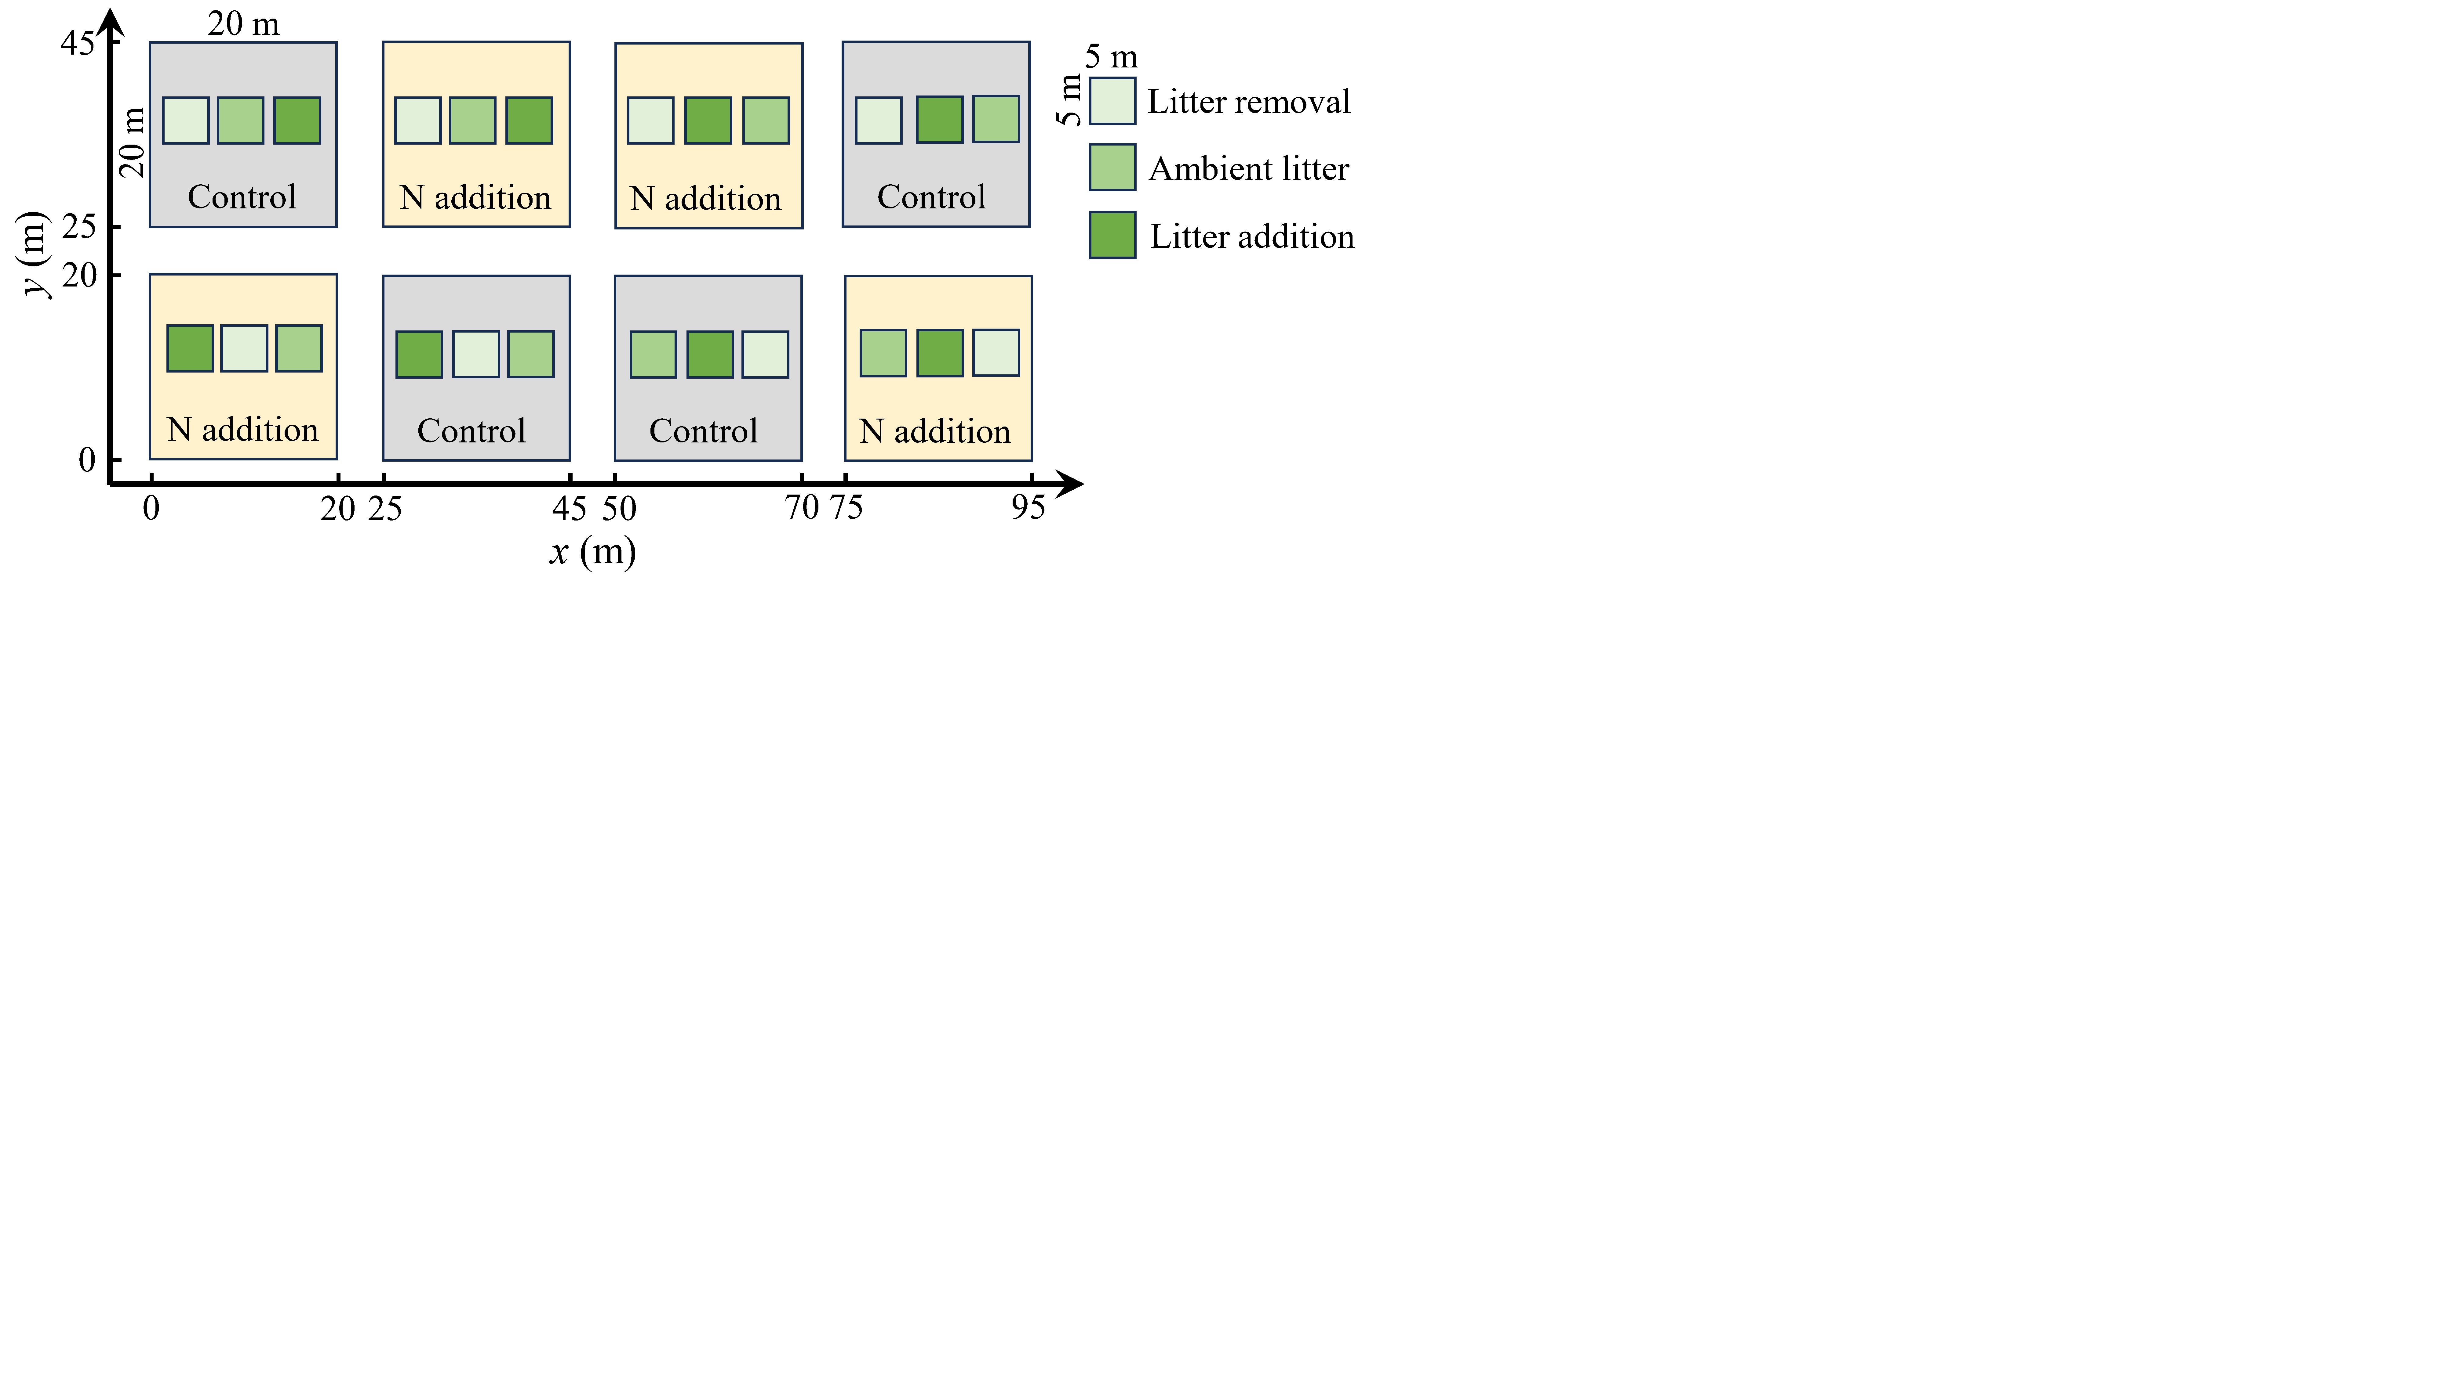
Fig. S1 Schematic diagram showing the layout of main plots and subplots in the split-plot experimental design.

Fig. S2 Linear relationships between soil chemical properties and bacterial phospholipid fatty acids (PLFAs) (a–c), Gram-positive (G+) bacterial PLFAs (d–e), Gram-negative (G–) bacterial PLFAs (f–g), actinomycetes PLFAs (h–k), fungal PLFAs (l–m) and total PLFAs (n–o). Statistical results are shown in the Table S3. Shaded areas around regression lines represent 95% confidence intervals. Exch., exchangeable; 2L, litter addition; 1L, ambient litter; 0L, litter removal.

Fig. S3 Linear relationships between soil chemical properties and cy:pre (a–c) and iso:anteiso ratios (d–e). Statistical results are shown in the Table S3. Shaded areas around regression lines represent 95% confidence intervals. Exch., exchangeable; net nitri, net nitrification rate; cy:pre ratio, the ratio of cyclopropyl phospholipid fatty acids (PLFAs) to monounsaturated PLFAs; iso:anteiso, the ratio of iso- to anteiso-branched PLFAs; 2L, litter addition; 1L, ambient litter; 0L, litter removal.

