Supplementary Materials
Differential responses of soil organic carbon pools to warming: a global meta-analysis

Zehong Yao^{1,2}, Qiufang Zhang^{1,2*}, Jiguang Feng³, Hao Sun^{1,2}, Yaping Lin^{1,2}, Huizhi Pi^{1,2}, Chenxing Lian^{1,2}, Quanxin Zeng^{1,4}, Yuehmin Chen^{1,2*}

¹ Key Laboratory of Humid subtropical Eco-geographical Process of Ministry of Education, School of Geographical Sciences, Fujian Normal University, Fuzhou 350117, China
² Fujian Sanming Forest Ecosystem National Observation and Research Station, Fujian Normal University, Fuzhou 350117, China
³ Ministry of Education Key Laboratory of Ecology and Resource Use of the Mongolian Plateau, Inner Mongolia Key Laboratory of Grassland Ecology, and School of Ecology and Environment, Inner Mongolia University, Huhhot 010021, China
⁴ State Key Laboratory of Vegetation Structure, Function and Construction (VegLab), Ministry of Education Key Laboratory of Earth Surface Processes, and College of Urban and Environmental Sciences, Peking University, Beijing 100871, China

*Corresponding author: Qiufang Zhang and Yuehmin Chen
E-mail: qiufangzh@fjnu.edu.cn (Qiufang Zhang); ymchen@fjnu.edu.cn (Yuehmin Chen)

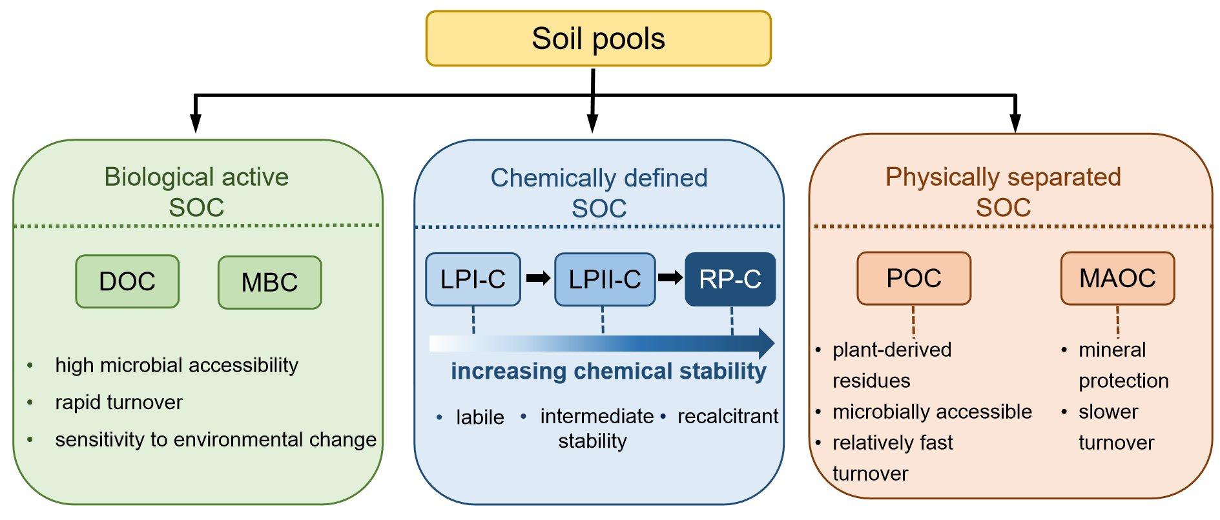
Figure S1. Conceptual framework for classifying soil organic carbon (SOC) pools based on biological, chemical, and physical properties. DOC, dissolved organic carbon; MBC, microbial biomass carbon; LPI-C, labile pool I carbon; LPII-C, labile pool II carbon; RP-C, recalcitrant pool carbon; POC, particulate organic carbon; MAOC, mineral-associated organic carbon.

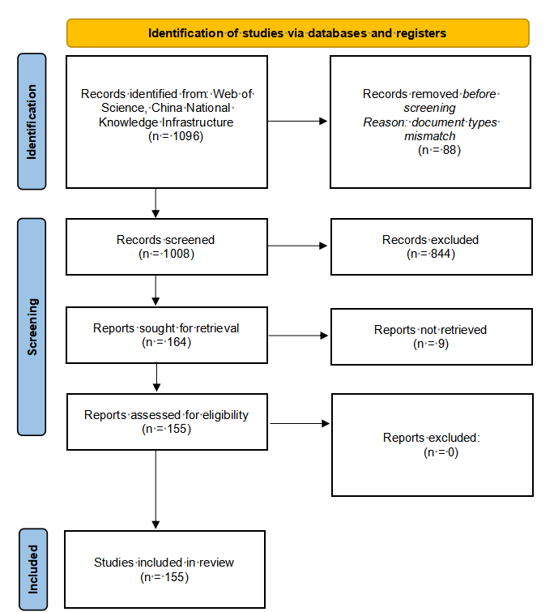
Figure S2. PRISMA 2020 Flow Diagram showing the process of study selection in this meta-analysis. This official template is from: Page, M.J., McKenzie, J.E., Bossuyt, P.M., Boutron, I., Hoffmann, T.C., Mulrow, C.D., ... Moher, D., 2021. The PRISMA 2020 statement: an updated guideline for reporting systematic reviews. Journal of Clinical Epidemiology 134, 178–179. http://doi.org/10.1016/j.jclinepi.2021.03.001

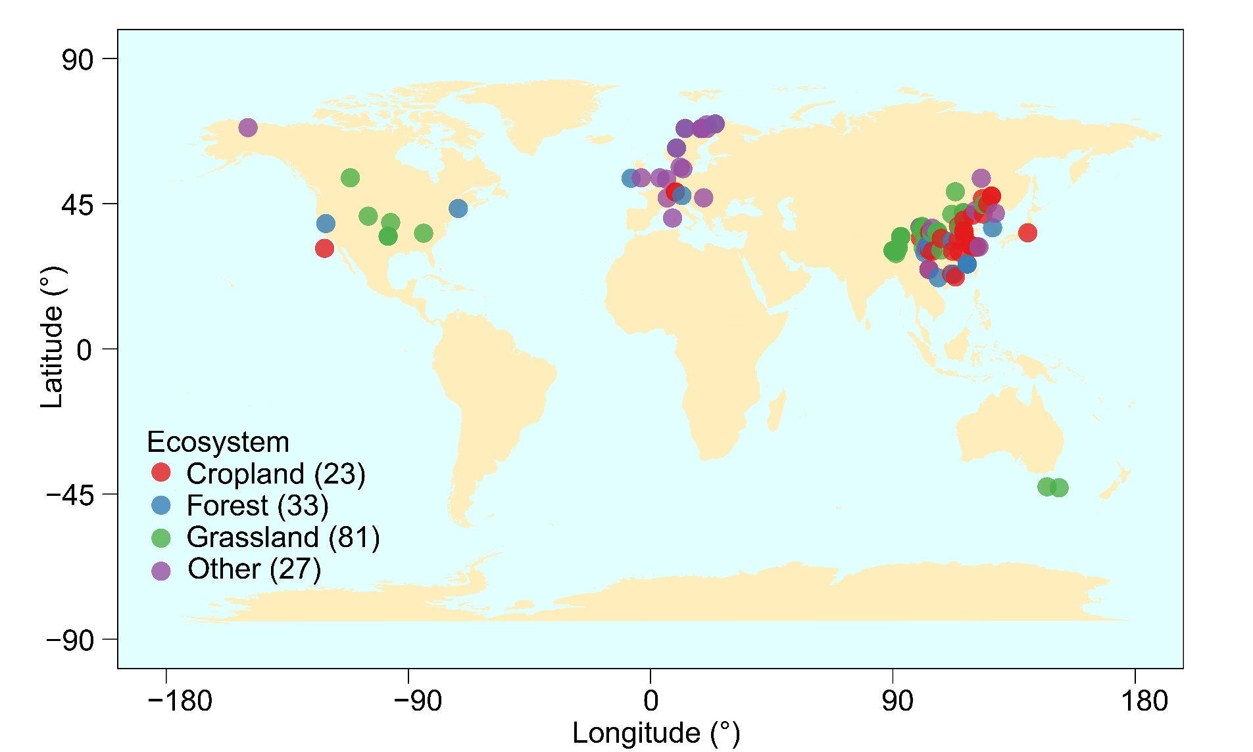
Figure S3. Global site distribution of field-warming experiments included in this meta-analysis. The others in the figure including shrublands (n = 18), tundra (n = 5), and wetlands (n = 4). The n here represents the number of independent observations. The base map boundaries are for reference only and do not imply official recognition or acknowledgement of national boundaries.

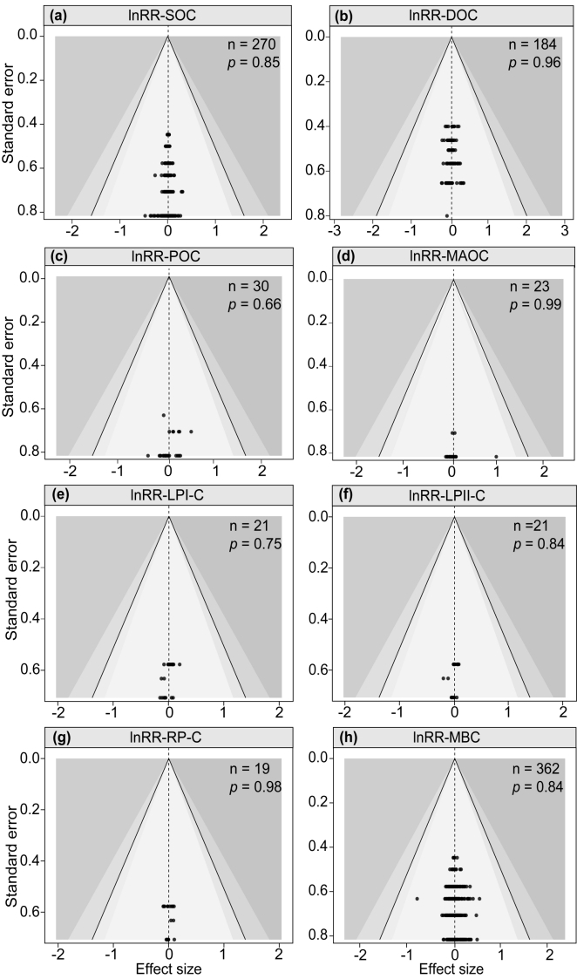
Figure S4. Funnel plots showed the publication bias of responses (lnRR) of soil organic carbon and its pools to field warming using Egger’s test. The publication bias was generally considered to exist when p < 0.05. n: observations. Soil organic carbon, SOC (a); dissolved organic carbon, DOC (b); particulate organic carbon, POC (c); mineral-associated organic carbon, MAOC (d); labile pool I carbon, LPI-C (e); labile pool II carbon, LPII-C (f); recalcitrant pool carbon, RP-C (g); microbial biomass carbon, MBC (h).

Reference list of articles included in this meta-analysis (155 publications).
- Bai, H., Yang, Z., Zheng, Y., Xiong, D., Zhou, J., 2020. Effects of soil warming on water extractable organic carbon in subtropical forest (in Chinese with English Abstract). Chinese Journal of Ecology 39, 1436–1444. https://doi.org/10.13292/j.1000-4890.202005.023
- Bai, T., Wang, P., Hall, S.J., Wang, F., Ye, C., Li, Z., Li, S., Zhou, L., Qiu, Y., Guo, H., Wang, Y., Hu, S., 2020b. Interactive global change factors mitigate soil aggregation and carbon change in a semi-arid grassland. Global Change Biology 26, 5320–5332. https://doi.org/10.1111/gcb.15220
- Bai, W., Wang, G., Xi, J., Liu, Y., Yin, P., 2019. Short-term responses of ecosystem respiration to warming and nitrogen addition in an alpine swamp meadow. European Journal of Soil Biology 92, 16–23. https://doi.org/10.1016/j.ejsobi.2019.04.003
- Bao, X., Zhu, X., Chang, X., Wang, S., Xu, B., Luo, C., Zhang, Z., Wang, Q., Rui, Y., Cui, X., 2016. Effects of soil temperature and moisture on soil respiration on the Tibetan Plateau. PLoS ONE 11, e0165212. https://doi.org/10.1371/journal.pone.0165212
- Belay-Tedla, A., Zhou, X., Su, B., Wan, S., Luo, Y., 2009. Labile, recalcitrant, and microbial carbon and nitrogen pools of a tallgrass prairie soil in the US Great Plains subjected to experimental warming and clipping. Soil Biology and Biochemistry 41, 110–116. https://doi.org/10.1016/j.soilbio.2008.10.003
- Bork, E.W., Attaeian, B., Cahill, J.F., Chang, S.X., 2019. Soil nitrogen and greenhouse gas dynamics in a temperate grassland under experimental warming and defoliation. Soil Science Society of America Journal 83, 780–790. https://doi.org/10.2136/sssaj2018.04.0150
- Chang, R., Liu, S., Chen, L., Li, N., Bing, H., Wang, T., Chen, X., Li, Y., Wang, G., 2021. Soil organic carbon becomes newer under warming at a permafrost site on the Tibetan Plateau. Soil Biology and Biochemistry 152, 108074. https://doi.org/10.1016/j.soilbio.2020.108074
- Che, R., Deng, Y., Wang, W., Rui, Y., Zhang, J., Tahmasbian, I., Tang, L., Wang, S., Wang, Y., Xu, Z., Cui, X., 2018. Long-term warming rather than grazing significantly changed total and active soil procaryotic community structures. Geoderma 316, 1–10. https://doi.org/10.1016/j.geoderma.2017.12.005
- Chen, D., Zhao, L., Li, Q., Cai, H., Li, J., Xu, S., Zhao, X., 2016a. Response of soil carbon and nitrogen to 15-year experimental warming in two alpine habitats (Kobresia meadow and Potentilla shrubland) on the Qinghai-Tibetan Plateau. Polish Journal of Environmental Studies 25, 2305–2313. https://doi.org/10.15244/pjoes/64325
- Chen, J.I., Luo, Y., Xia, J., Shi, Z., Jiang, L., Niu, S., Zhou, X., Cao, J., 2016b. Differential responses of ecosystem respiration components to experimental warming in a meadow grassland on the Tibetan Plateau. Agricultural and Forest Meteorology 220, 21–29.
- Chen, X., Wang, G., Zhang, T., Mao, T., Wei, D.A., Song, C., Hu, Z., Huang, K., 2017a. Effects of warming and nitrogen fertilization on GHG flux in an alpine swamp meadow of a permafrost region. Science of the Total Environment 601, 1389–1399. https://doi.org/10.1016/j.scitotenv.2017.06.028
- Chen, X., Wang, G., Zhang, T., Mao, T., Wei, D., Hu, Z., Song, C., 2017b. Effects of warming and nitrogen fertilization on GHG flux in the permafrost region of an alpine meadow. Atmospheric Environment 157, 111–124. https://doi.org/10.1016/j.atmosenv.2017.03.024
- Chen, Y., Han, M., Yuan, X., Hou, Y., Qin, W., Zhou, H., Zhao, X., Klein, J.A., Zhu, B., 2021. Warming has a minor effect on surface soil organic carbon in alpine meadow ecosystems on the Qinghai–Tibetan Plateau. Global Change Biology 28, 1618–1629. https://doi.org/10.1111/gcb.15984
- Chen, Z., Yin, H., Wei, Y., Liu, Q., 2010. Short-term effects of night warming and nitrogen addition on soil available nitrogen and microbial properties in subalpine coniferous forest, Western Sichuan, China (in Chinese with English Abstract). Chinese Journal of Plant Ecology 34, 1254. https://doi.org/10.3773/j.issn.1005-264x.2010.11.002
- Ding, X., Chen, S., Zhang, B., He, H., Filley, T.R., Horwath, W.R., 2020. Warming yields distinct accumulation patterns of microbial residues in dry and wet alpine grasslands on the Qinghai-Tibetan Plateau. Biology and Fertility of Soils 56, 881–892. https://doi.org/10.1007/s00374-020-01474-9
- Domínguez, M.T., Holthof, E., Smith, A.R., Koller, E., Emmett, B.A., 2017. Contrasting response of summer soil respiration and enzyme activities to long-term warming and drought in a wet shrubland (NE Wales, UK). Applied Soil Ecology 110, 151–155. https://doi.org/10.1016/j.apsoil.2016.11.003
- Dong, L., Zeng, W., Wang, A., Tang, J., Yao, X., Wang, W., 2020. Response of soil respiration and its components to warming and dominant species removal along an elevation gradient in alpine meadow of the Qinghai–Tibetan Plateau. Environmental Science & Technology 54, 10472–10482. https://doi.org/10.1021/acs.est.0c01545
- Fang, C., Ke, W., Campioli, M., Pei, J., Yuan, Z., Song, X., Ye, J.S., Li, F., Janssens, I.A., 2020. Unaltered soil microbial community composition, but decreased metabolic activity in a semiarid grassland after two years of passive experimental warming. Ecology and Evolution 10, 12327–12340. https://doi.org/10.1002/ece3.6862
- Fang, X., Zhou, G., Li, Y., Liu, S., Chu, G., Xu, Z., Liu, J., 2016. Warming effects on biomass and composition of microbial communities and enzyme activities within soil aggregates in subtropical forest. Biology and Fertility of Soils 52, 353–365. https://doi.org/10.1007/s00374-015-1081-5
- Fang, X., Zhou, G., Qu, C., Huang, W., Zhang, D., Li, Y., Yi, Z., Liu, J., 2020a. Translocating subtropical forest soils to a warmer region alters microbial communities and increases the decomposition of mineral-associated organic carbon. Soil Biology and Biochemistry 142, 107707. https://doi.org/10.1016/j.soilbio.2020.107707
- Fu, G., Shen, Z., Zhang, X., Zhou, Y., 2012. Response of soil microbial biomass to short-term experimental warming in alpine meadow on the Tibetan Plateau. Applied Soil Ecology 61, 158–160. https://doi.org/10.1016/j.apsoil.2012.05.002
- Gao, J., Wang, E., Ren, W., Liu, X., Chen, Y., Shi, Y., Yang, Y., 2017. Effects of simulated climate change on soil microbial biomass and enzyme activities in young Chinese fir (Cunninghamia lanceolata) in subtropical China. Acta Ecologica Sinica 37, 272–278. https://doi.org/10.1016/j.chnaes.2017.02.007
- Graham, S.L., Hunt, J.E., Millard, P., McSeveny, T., Tylianakis, J.M., Whitehead, D., 2014. Effects of soil warming and nitrogen addition on soil respiration in a New Zealand tussock grassland. PLoS ONE 9, e91204. https://doi.org/10.1371/journal.pone.0091204
- Haugwitz, M.S., Bergmark, L., Priemé, A., Christensen, S., Beier, C., Michelsen, A., 2014. Soil microorganisms respond to five years of climate change manipulations and elevated atmospheric CO₂ in a temperate heath ecosystem. Plant and Soil 374, 211–222. https://doi.org/10.1007/s11104-013-1855-1
- Heng, T., Wu, J., Xie, S., Wu, M., 2011. The responses of soil C and N, microbial biomass C or N under alpine meadow of Qinghai-Tibet Plateau to the change of temperature and precipitation (in Chinese with English Abstract). Chinese Agricultural Science Bulletin 27, 425–430. https://doi.org/10.7666/d.y1882759
- Huang, Y., Li, Y., Fan, L., Zhang, Z., Ma, Z., Zhang, L., Zhao, C., 2019. Response of carbon and nitrogen processes to warming as mediated by ectomycorrhizae of Picea asperata (in Chinese with English Abstract). Chinese Journal of Applied and Environmental Biology 25, 1319–1326. https://doi.org/10.19675/j.cnki.1006-687x.2019.03019
- Jassey, V.E., Chiapusio, G., Binet, P., Buttler, A., Laggoun-Défarge, F., Delarue, F., Bernard, N., Mitchell, E.A.D., Toussaint, M.L., Francez, A.-J., Gilbert, D., 2013. Above- and belowground linkages in Sphagnum peatland: climate warming affects plant-microbial interactions. Global Change Biology 19, 811–823. https://doi.org/10.1111/gcb.12075
- Jia, J., Feng, X., He, J.-S., He, H., Lin, L., Liu, Z., 2017. Comparing microbial carbon sequestration and priming in the subsoil versus topsoil of a Qinghai-Tibetan alpine grassland. Soil Biology and Biochemistry 104, 141–151. https://doi.org/10.1016/j.soilbio.2016.10.018
- Jiang, M., Ni, M., Zhou, J., Chen, Y., Yang, Y., 2018. Effects of warming and precipitation reduction on soil enzyme activity in a young Cunninghamia lanceolata plantation (in Chinese with English Abstract). Chinese Journal of Ecology 37, 3210–3219.
- Jing, X., Chen, X., Xiao, W., Lin, L., Wang, C., He, J. S., Zhu, B. 2018. Soil enzymatic responses to multiple environmental drivers in the Tibetan grasslands: Insights from two manipulative field experiments and a meta-analysis. Pedobiologia 71, 50–58. https://doi.org/10.1016/j.pedobi.2018.10.001
- Jing, Y., Wang, Y., Liu, S., Zhang, X., Wang, Q., Liu, K., Yin, Y., Deng, J., 2019. Interactive effects of soil warming, throughfall reduction, and root exclusion on soil microbial community and residues in warm-temperate oak forests. Applied Soil Ecology 142, 52–58. https://doi.org/10.1016/j.apsoil.2019.05.020
- Jonasson, S., Michelsen, A., Schmidt, I.K., Nielsen, E.V., 1999. Responses in microbes and plants to changed temperature, nutrient, and light regimes in the arctic. Ecology 80, 1828–1843. https://doi.org/10.1890/0012-9658(1999)080[1828:RIMAPT]2.0.CO;2
- Li, F., Peng, Y., Chen, L., Yang, G., Abbott, B.W., Zhang, D., Fang, K., Wang, G., Wang, J., Yu, J., Liu, L., Zhang, Q., Chen, K., Mohammat, A., Yang, Y., 2020. Warming alters surface soil organic matter composition despite unchanged carbon stocks in a Tibetan permafrost ecosystem. Functional Ecology 34, 911–922. https://doi.org/10.1111/1365-2435.13489
- Li, F., Peng, Y., Natali, S.M., Chen, K., Han, T., Yang, G., Ding, J., Zhang, D., Wang, G., Wang, J., Yu, J., Liu, F., Yang, Y., 2017. Warming effects on permafrost ecosystem carbon fluxes associated with plant nutrients. Ecology 98, 2851–2859. https://doi.org/10.1002/ecy.1975
- Li, H., Yang, Y., Si, Y., Lin, W., Xiong, D., Liu, X., 2018b. Effects of experimental soil warming and precipitation reduction on the quantity and structure of soil dissolved organic matter of Cunninghamia lanceolata plantations in subtropical China (in Chinese with English Abstract). Acta Ecologica Sinica 38, 2884–2895. https://doi.org/10.5846/stxb201704250749
- Li, N., Wang, G., Yang, Y., Gao, Y., Liu, G., 2011. Plant production, and carbon and nitrogen source pools, are strongly intensified by experimental warming in alpine ecosystems in the Qinghai-Tibet Plateau. Soil Biology and Biochemistry 43, 942–953. https://doi.org/10.1016/j.soilbio.2011.01.009
- Li, Q., Bai, H., Liang, W., Xia, J., Wan, S., van der Putten, W.H., 2013. Nitrogen addition and warming independently influence the belowground micro-food web in a temperate steppe. PLoS ONE 8, e60441. https://doi.org/10.1371/journal.pone.0060441
- Li, Y., Qing, Y., Lyu, M., Chen, S., Yang, Z., Lin, C., Yang, Y., 2018. Effects of artificial warming on different soil organic carbon and nitrogen pools in a subtropical plantation. Soil Biology and Biochemistry 124, 161–167. https://doi.org/10.1016/j.soilbio.2018.06.007
- Liu, F., Zhang, Y., Luo, J., 2018. The effects of experimental warming and CO₂ concentration doubling on soil organic carbon fractions of a montane coniferous forest on the eastern Qinghai-Tibetan Plateau. European Journal of Forest Research 137, 211–221. https://doi.org/10.1007/s10342-018-1100-9
- Liu, L., Hu, C., Yang, P., Ju, Z., Olesen, J.E., Tang, J., 2015. Effects of experimental warming and nitrogen addition on soil respiration and CH₄ fluxes from crop rotations of winter wheat–soybean/fallow. Agricultural and Forest Meteorology 207, 38–47. https://doi.org/10.1016/j.agrformet.2015.03.013
- Liu, W., Allison, S.D., Xia, J., Liu, L., Wan, S., 2016. Precipitation regime drives warming responses of microbial biomass and activity in temperate steppe soils. Biology and Fertility of Soils 52, 469–477. https://doi.org/10.1007/s00374-016-1087-7
- Liu, W., Zhang, Z.H.E., Wan, S., 2009. Predominant role of water in regulating soil and microbial respiration and their responses to climate change in a semiarid grassland. Global Change Biology 15, 184–195. https://doi.org/10.1111/j.1365-2486.2008.01728.x
- Liu, X., Chen, S., Yang, Z., Lin, C., Xiong, D., Lin, W., Xu, C., Chen, G., Xie, J., Li, Y., Yang, Y., 2018. Will heterotrophic soil respiration be more sensitive to warming than autotrophic respiration in subtropical forests? European Journal of Soil Science 70, 655–663. https://doi.org/10.1111/ejss.12758
- Ma, C., Li, H., Zheng, H., Chen, Y., Yang, L., Wang, L., Zhang, J., Liu, Y. 2019. Responses of soil active carbon and nitrogen to short-term warming in alpine treeline of west Sichuan, China (in Chinese with English Abstract). Chinese Journal of Applied Ecology 30, 718–726. https://doi.org/10.13287/j.1001-9332.201903.006
- Ma, Z., Zhao, W., Liu, M., Liu, Q., 2018. Responses of soil respiration and its components to experimental warming in an alpine scrub ecosystem on the eastern Qinghai-Tibet Plateau. Science of the Total Environment 643, 1427–1435.
- Mao, J., Duo, Y., Deng, J., Cheng, J., Cheng, J., Peng, C., Guo, L., 2021. Influences of warming and snow reduction in winter on soil nutrients and bacterial communities composition in a typical grassland of the Loess Plateau (in Chinese with English Abstract). Chinese Journal of Plant Ecology 45, 891–902. https://doi.org/10.17521/cjpe.2021.0085
- Miao, Y., Liu, M., Xuan, J., Xu, W., Wang, S., Miao, R., Wang, D., Wu, W., Liu, Y., Han, S., 2020. Effects of warming on soil respiration during the non-growing seasons in a semiarid temperate steppe. Journal of Plant Ecology 13, 288–294. https://doi.org/10.1093/jpe/rtaa013
- Noh, N.J., Kuribayashi, M., Saitoh, T.M., Muraoka, H., 2017. Different responses of soil, heterotrophic and autotrophic respirations to a 4-year soil warming experiment in a cool-temperate deciduous broadleaved forest in central Japan. Agricultural and Forest Meteorology 247, 560–570. https://doi.org/10.1016/j.agrformet.2017.09.002
- Noh, N.J., Kuribayashi, M., Saitoh, T.M., Nakaji, T., Nakamura, M., Hiura, T., Muraoka, H. 2016. Responses of soil, heterotrophic, and autotrophic respiration to experimental open-field soil warming in a cool-temperate deciduous forest. Ecosystems 19, 504-520. https://doi.org/ 10.1007/s10021-015-9948-8
- Peng, F., Zhang, W., Li, C., Lai, C., Zhou, J., Xue, X., Tsunekawa, A. 2020. Sustained increase in soil respiration after nine years of warming in an alpine meadow on the Tibetan Plateau. Geoderma 379, 114641. https://doi.org/10.1016/j.geoderma.2020.114641
- Phillips, C.A., Elberling, B., Michelsen, A. 2019. Soil carbon and nitrogen stocks and turnover following 16 years of warming and litter addition. Ecosystems 22, 110–124. https://doi.org/10.1007/s10021-018-0256-y
- Poll, C., Marhan, S., Back, F., Niklaus, P.A., Kandeler, E., 2013. Field-scale manipulation of soil temperature and precipitation change soil CO₂ flux in a temperate agricultural ecosystem. Agriculture, Ecosystems & Environment 165, 88–97. https://doi.org/10.1016/j.agee.2012.12.012
- Reinsch, S., Michelsen, A., Sárossy, Z., Egsgaard, H., Schmidt, I.K., Jakobsen, I., Ambus, P., 2014. Short-term utilization of carbon by the soil microbial community under future climatic conditions in a temperate heathland. Soil Biology and Biochemistry 68, 9–19. https://doi.org/10.1016/j.soilbio.2013.09.014
- Rinnan, R., Michelsen, A., Bååth, E., Jonasson, S., 2007. Fifteen years of climate change manipulations alter soil microbial communities in a subarctic heath ecosystem. Global Change Biology 13, 28–39. https://doi.org/10.1111/j.1365-2486.2006.01263.x
- Rinnan, R., Michelsen, A., Jonasson, S., 2008. Effects of litter addition and warming on soil carbon, nutrient pools and microbial communities in a subarctic heath ecosystem. Applied Soil Ecology 39, 271–281. https://doi.org/10.1016/j.apsoil.2007.12.014
- Rinnan, R., Stark, S., Tolvanen, A., 2009. Responses of vegetation and soil microbial communities to warming and simulated herbivory in a subarctic heath. Journal of Ecology 97, 788–800. https://doi.org/10.1111/j.1365-2745.2009.01506.x
- Rousk, J., Smith, A.R., Jones, D.L., 2013. Investigating the long-term legacy of drought and warming on the soil microbial community across five European shrubland ecosystems. Global Change Biology 19, 3872–3884. https://doi.org/10.1111/gcb.12338
- Rui, Y., Wang, S., Xu, Z., Wang, Y., Chen, C., Zhou, X., Kang, X., Lu, S., Hu, Y., Lin, Q., Luo, C., 2011. Warming and grazing affect soil labile carbon and nitrogen pools differently in an alpine meadow of the Qinghai–Tibet Plateau in China. Journal of Soils and Sediments 11, 903. https://doi.org/10.1007/s11368-011-0388-6
- Schindlbacher, A., Schnecker, J., Takriti, M., Borken, W., Wanek, W., 2015. Microbial physiology and soil CO₂ efflux after 9 years of soil warming in a temperate forest—no indications for thermal adaptations. Global Change Biology 21, 4265–4277. https://doi.org/10.1111/gcb.12996
- Schmidt, I.K., Jonasson, S., Shaver, G.R., Michelsen, A., Nordin, A., 2002. Mineralization and distribution of nutrients in plants and microbes in four arctic ecosystems: responses to warming. Plant and Soil 242, 93–106. https://doi.org/10.1023/A:1019642007929
- Shao, P., He, H., Zhang, X., Xie, H., Bao, X., Liang, C., 2018. Responses of microbial residues to simulated climate change in a semiarid grassland. Science of the Total Environment 644, 1286–1291. https://doi.org/10.1016/j.scitotenv.2018.07.055
- Shen, R., Xu, M., Chi, Y., Yu, S., Wan, S., 2014. Soil microbial responses to experimental warming and nitrogen addition in a temperate steppe of northern China. Pedosphere 24, 427–436. https://doi.org/10.1016/S1002-0160(14)60029-1
- Shen, R., Xu, M., Chi, Y., Yu, S., Wan, S., He, N., 2020. Microbial membranes related to the thermal acclimation of soil heterotrophic respiration in a temperate steppe in northern China. European Journal of Soil Science 71, 484–494. https://doi.org/10.1111/ejss.12872
- Sistla, S.A., Moore, J.C., Simpson, R.T., Gough, L., Shaver, G.R., Schimel, J.P. 2013. Long-term warming restructures Arctic tundra without changing net soil carbon storage. Nature 497, 615–618. https://doi.org/10.1038/nature12129
- Song, B., Niu, S., Zhang, Z., Yang, H., Li, L., Wan, S., 2012. Light and heavy fractions of soil organic matter in response to climate warming and increased precipitation in a temperate steppe. PLoS ONE 7, e33217. https://doi.org/10.1371/journal.pone.0033217
- Song, X., Chen, Q., Wang, K., Zhu, X., Zhang, T., Sun, B., Wang, G., Yin, H., Wang, X., Guo, S., 2022. Nonlinear response of ecosystem respiration to gradient warming in paddy field in Northeast China. Agricultural and Forest Meteorology 312, 108721. https://doi.org/10.1016/j.agrformet.2021.108721
- Song, Y., Song, C., Ren, J., Ma, X., Tan, W., Wang, X., Gao, J., Hou, A. 2019. Short-term response of the soil microbial abundances and enzyme activities to experimental warming in a boreal peatland in Northeast China. Sustainability 11, 590. https://doi.org/10.3390/su11030590
- Sorensen, P.O., Finzi, A.C., Giasson, M.A., Reinmann, A.B., Sanders-DeMott, R., Templer, P.H., 2018. Winter soil freeze-thaw cycles lead to reductions in soil microbial biomass and activity not compensated for by soil warming. Soil Biology and Biochemistry 116, 39–47. https://doi.org/10.1016/j.soilbio.2017.09.026
- Sun, D., Li, Y., Zhao, W., Zhang, Z., Li, D., Zhao, C., Liu, Q., 2016. Effects of experimental warming on soil microbial communities in two contrasting subalpine forest ecosystems, eastern Tibetan Plateau, China. Journal of Mountain Science 13, 1442–1452. https://doi.org/10.1007/s11629-015-3733-1
- Sun, S., Wu, Y., Zhang, J., Wang, G., DeLuca, T. H., Zhu, W., Li, A., Duan, M., He, L. 2019. Soil warming and nitrogen deposition alter soil respiration, microbial community structure and organic carbon composition in a coniferous forest on eastern Tibetan Plateau. Geoderma 353, 283–292. https://doi.org/10.1016/j.geoderma.2019.07.023
- Weedon, J.T., Kowalchuk, G.A., Aerts, R., van Hal, J., van Logtestijn, R., Taş, N., Roling, W.F.M., van Bodegom, P.M., 2012. Summer warming accelerates sub-arctic peatland nitrogen cycling without changing enzyme pools or microbial community structure. Global Change Biology 18, 138–150. https://doi.org/10.1111/j.1365-2486.2011.02548.x
- Tang, S., Cheng, W., Hu, R., Guigue, J., Hattori, S., Tawaraya, K., Tokida, T., Fukuoka, M., Yoshimoto, M., Sakai, H., Usui, Y., Xu, X., Hasegawa, T., 2021. Five-year soil warming changes soil C and N dynamics in a single rice paddy field in Japan. Science of the Total Environment 756, 143845. https://doi.org/10.1016/j.scitotenv.2020.143845
- Tu, C., Li, F., 2016. Responses of soil CH₄ fluxes to simulated warming in conventional tillage and no-tillage systems (in Chinese with English Abstract). Journal of Agro-Environment Science 35, 1788–1796. https://doi.org/10.11654/jaes.2016-0182
- Wang, B., Sun, G., Luo, P., Wang, M., Wu, N., 2011. Labile and recalcitrant carbon and nitrogen pools of an alpine meadow soil from the eastern Qinghai-Tibetan Plateau subjected to experimental warming and grazing (in Chinese with English Abstract). Acta Ecologica Sinica 31, 1506–1514. https://doi.org/10.20103/j.stxb.2011.06.004
- Wang, C., Zhao, X., Zi, H., Hu, L., Ade, L., Wang, G., Lerdau, M., 2017. The effect of simulated warming on root dynamics and soil microbial community in an alpine meadow of the Qinghai-Tibet Plateau. Applied Soil Ecology 116, 30–41. https://doi.org/10.1016/j.apsoil.2017.03.005
- Wang, H., Huang, W., He, Y., Niu, Y., Zhu, Y., 2022. Effects of short-term warming and precipitation reduction on soil microbial biomass carbon, nitrogen and enzyme activity in sandy grassland (in Chinese with English Abstract). Journal of Desert Research 42, 274–281. https://doi.org/10.7522/j.issn.1000-694X.2021.00135
- Wang, H., Liu, S., Wang, J., Li, D., Shi, Z., Liu, Y., Xu, J., Hong, P., Yu, H., Zhao, Z., Ming, A., Lu, L., Cai, D., 2017. Contrasting responses of heterotrophic and root-dependent respiration to soil warming in a subtropical plantation. Agricultural and Forest Meteorology 247, 221–228. https://doi.org/10.1016/j.agrformet.2017.07.025
- Wang, J., Luo, Y., Quan, Q., Ma, F., Tian, D., Chen, W., Wang, S., Yang, L., Meng, C., Niu, S., 2021. Effects of warming and clipping on CH₄ and N₂O fluxes in an alpine meadow. Agricultural and Forest Meteorology 297, 108278. https://doi.org/10.1016/j.agrformet.2020.108278
- Wang, J., Shi, X., Li, L., Zhang, X., 2021. Changes in soil nematodes in rhizosphere and non-rhizosphere soils following combined elevated CO₂ and canopy warming in a winter wheat field. Geoderma 386, 114907. https://doi.org/10.1016/j.geoderma.2020.114907
- Wang, J., Wang, G., Li, F., Peng, Y., Yang, G., Yu, J., Zhou, G., Yang, Y., 2018a. Effects of short-term experimental warming on soil microbes in a typical alpine steppe (in Chinese with English Abstract). Chinese Journal of Plant Ecology 42, 116–125. https://doi.org/10.17521/cjpe.2017.0297
- Wang, X., Dong, S., Gao, Q., Zhou, H., Liu, S., Su, X., Li, Y., 2014. Effects of short-term and long-term warming on soil nutrients, microbial biomass and enzyme activities in an alpine meadow on the Qinghai-Tibet Plateau of China. Soil Biology and Biochemistry 76, 140–142. https://doi.org/10.1016/j.soilbio.2014.05.014
- Wang, X., Gao, Q. 2018. Response of greenhouse gases emission fluxes to long-term warming in alpine meadow of Northern Tibet (in Chinese with English Abstract). Chinese Journal of Agrometeorology. 39, 152–161. https://doi.org/10.3969/j.issn.1000-6362.2018.03.002
- Wang, X., Zhou, Y., Wang, X., Jiang, X., Han, S., 2014. Responses of soil enzymes in activity and soil microbes in biomass to warming in tundra ecosystem on Changbai Mountain (in Chinese with English Abstract). Acta Pedologica Sinica 51, 166–175. https://doi.org/10.11766 /trxb201303120112
- Wang, Y. 2015. Effects of simulated warming and throughfall reduction on soil respiration and microbial response in Warm-temperate oak (Quercus aliens var. acuteserrata) forest (in Chinese with English Abstract). Chinese Academy of Forestry. https://doi.org/10.7666/d.Y2903793
- Wang, Y., Song, C., Liu, H., Wang, S., Zeng, H., Luo, C., He, J.-S., 2021. Precipitation determines the magnitude and direction of interannual responses of soil respiration to experimental warming. Plant and Soil 458, 75–91. https://doi.org/10.1007/s11104-020-04438-y
- Wei, Y., Yin, H., Liu, Q., Li, Y., 2011. Responses on rhizosphere effect of two subalpine coniferous species to night-time warming and nitrogen fertilization in western Sichuan, China (in Chinese with English Abstract). Acta Ecologica Sinica 31, 698–708. https://doi.org/10.20103/j.stxb.2011.03.013
- Wild, B., Ambus, P., Reinsch, S., Richter, A., 2018. Resistance of soil protein depolymerization rates to eight years of elevated CO₂, warming, and summer drought in a temperate heathland. Biogeochemistry 140, 255–267. https://doi.org/10.1007/s10533-018-0487-1
- Williams, M.A., Rice, C.W., Owensby, C.E., 2000. Carbon dynamics and microbial activity in tallgrass prairie exposed to elevated CO2 for 8 years. Plant and Soil 227, 127–137. https://doi.org/10.1023/A:1026590001307
- Xi, J., Bai, W., Yin, P., Liu, Y., 2019. Effects of simulated warming on soil organic carbon composition and biomass in alpine swamp meadow in the headwaters region of the Yangtze River (in Chinese with English Abstract). Ecological Science 38, 92–101. https://doi.org/10.14108/j.cnki.1008-8873.2019.01.013
- Xiong, L., Liu, X., Vinci, G., Spaccini, R., Drosos, M., Li, L., Piccolo, A., Pan, G., 2019. Molecular changes of soil organic matter induced by root exudates in a rice paddy under CO2 enrichment and warming of canopy air. Soil Biology and Biochemistry 137, 107544. https://doi.org/10.1016/j.soilbio.2019.107544
- Xiong, Q., Pan, K., Zhang, L., Wang, Y., Li, W., He, X., Luo, H., 2016. Warming and nitrogen deposition are interactive in shaping surface soil microbial communities near the alpine timberline zone on the eastern Qinghai–Tibet Plateau, southwestern China. Applied Soil Ecology 101, 72–83. https://doi.org/10.1016/j.apsoil.2016.01.011
- Xu, G., Chen, J., Berninger, F., Pumpanen, J., Bai, J., Yu, L., Duan, B., 2015. Labile, recalcitrant, microbial carbon and nitrogen and the microbial community composition at two Abies faxoniana forest elevations under elevated temperatures. Soil Biology and Biochemistry 91, 1–13. https://doi.org/10.1016/j.soilbio.2015.08.016
- Xu, G., Jiang, H., Zhang, Y., Korpelainen, H., Li, C., 2013. Effect of warming on extracted soil carbon pools of Abies faxoniana forest at two elevations. Forest Ecology and Management 310, 357–365. https://doi.org/10.1016/j.foreco.2013.08.038
- Xu, J., Su, X., Jia, Z., Du, M., 2021. Effects of warming on soil nitrogen transformation rates, microbial biomass carbon and nitrogen and enzyme activity in crust-covered soil system (in Chinese with English Abstract). Acta Pedologica Sinica 58, 788–797. https://doi.org/10.11766/trxb201911080393
- Xu, M., Peng, F., You, Q., Guo, J., Tian, X., Liu, M., Xue, X., 2015. Effects of warming and clipping on plant–soil properties of an alpine meadow in the Qinghai-Tibetan Plateau, China. Journal of Arid Land 7, 189–204. https://doi.org/10.1007/s40333-014-0010-z
- Xu, Z., Hu, R., Xiong, P., Wan, C., Cao, G., Liu, Q., 2010. Initial soil responses to experimental warming in two contrasting forest ecosystems, Eastern Tibetan Plateau, China: nutrient availabilities, microbial properties and enzyme activities. Applied Soil Ecology 46, 291–299. https://doi.org/10.1016/j.apsoil.2010.07.005
- Xu, Z., Zhao, C., Yin, H., Liu, Q., 2015. Warming and forest management interactively affect the decomposition of subalpine forests on the eastern Tibetan Plateau: a four-year experiment. Geoderma 239, 223–228.
- Yan, Y., Wang, J., Tian, D., Zhang, R., Song, L., Li, Z., Niu, S., 2022. Heterotrophic respiration and its proportion to total soil respiration decrease with warming but increase with clipping. Catena 215, 106321. https://doi.org/10.1016/j.catena.2022.106321
- Yang, X., Lin, L., Li, Y., He, J., 2017. Effects of warming and altered precipitation on soil physical properties and carbon pools in a Tibetan alpine grassland (in Chinese with English Abstract). Acta Scientiarum Naturalium Universitatis Pekinensis 53, 765–774. https://doi.org/10.13209/j.0479-8023.2017.086
- Yang, Y., Shi, G., Liu, Y., Ma, L., Zhang, Z., Jiang, S., Pan, J., Zhang, Q., Yao, B., Zhou, H., Feng, H., 2022. Experimental warming has not affected the changes in soil organic carbon during the growing season in an alpine meadow ecosystem on the Qinghai–Tibet Plateau. Frontiers in Plant Science 13, 847680. https://doi.org/10.3389/fpls.2022.847680
- Yin, H., Chen, Z., Liu, Q., 2012. Effects of experimental warming on soil N transformations of two coniferous species, Eastern Tibetan Plateau, China. Soil Biology and Biochemistry 50, 77–84. https://doi.org/10.1016/j.soilbio.2012.03.004
- Yu, C., 2016. Soil microbial responses to global change in a semi-arid steppe in Northern China (in Chinese with English Abstract). Thesis, Henan University. https://doi.org/10.7666/d.D01052769
- Yuan, X., Chen, Y., Qin, W., Xu, T., Mao, Y., Wang, Q., Chen, K., Zhu, B., 2021. Plant and microbial regulations of soil carbon dynamics under warming in two alpine swamp meadow ecosystems on the Tibetan Plateau. Science of the Total Environment 790, 148072. https://doi.org/10.1016/j.scitotenv.2021.148072
- Zeng, H., Bai, W., Fang, J., Xu, L., Shang, G., 2022. Effects of simulated warming on soil bacterial communities of alpine swamp meadow in the Qinghai-Tibet Plateau (in Chinese with English Abstract). Environmental Science & Technology 45, 164–172. https://doi.org/10.19672/j.cnki.1003-6504.1640.21.338
- Zhang, B., Chen, S.Y., Zhang, J.F., He, X.Y., Liu, W.J., Zhao, Q., Zhao, L., Tian, C.J., 2015. Depth-related responses of soil microbial communities to experimental warming in an alpine meadow on the Qinghai-Tibet Plateau. European Journal of Soil Science 66, 496–504. https://doi.org/10.1111/ejss.12240
- Zhang, B., Chen, S., He, X., Liu, W., Zhao, Q., Zhao, L., Tian, C., 2014. Responses of soil microbial communities to experimental warming in alpine grasslands on the Qinghai-Tibet Plateau. PLoS ONE 9, e103859. https://doi.org/10.1371/journal.pone.0103859
- Zhang, C., Tang, G., Sun, Y., 2019. Asymmetric and symmetric warming-induced stability of organic carbon in a calcareous soil. Soil Science Society of America Journal 83, 1200–1208. https://doi.org/10.2136/sssaj2018.11.0444
- Zhang, H., Li, S., Zhang, G., Fu, G., 2020. Response of soil microbial communities to warming and clipping in alpine meadows in Northern Tibet. Sustainability 12, 5617. https://doi.org/10.3390/su12145617
- Zhang, M., Chen, S., Ding, S., Yao, X., Wang, Z., Sang, L., 2022. Effects of 7 years of warming and straw application on soil bacterial, fungal, and archaeal community compositions and diversities in a crop field. Journal of Soil Science and Plant Nutrition 22, 1–16. https://doi.org/10.1007/s42729-022-00807-x
- Zhang, M., Han, Z., Chen, J., Guo, J., Tian, Y., Zhang, B., Yang, B., Zhang, W., 2012. Impact of nighttime warming on soil microbial biomass carbon/nitrogen and activity in main winter wheat cropping areas in China (in Chinese with English Abstract). Chinese Journal of Eco-Agriculture 20, 1464–1470. https://doi.org/10.3724/SP.J.1011.2012.01464
- Zhang, N., Liu, W., Yang, H., Yu, X., Gutknecht, J.L.M., Zhang, Z., Wan, S., Ma, K., 2013. Soil microbial responses to warming and increased precipitation and their implications for ecosystem C cycling. Oecologia 173, 1125–1142. https://doi.org/10.1007/s00442-013-2685-9
- Zhang, W., Parker, K.M., Luo, Y., Wan, S., Wallace, L.L., Hu, S., 2005. Soil microbial responses to experimental warming and clipping in a tallgrass prairie. Global Change Biology 11, 266–277. https://doi.org/10.1111/j.1365-2486.2005.00902.x
- Zhang, Y., Zhang, N., Yin, J., Yang, F., Zhao, Y., Jiang, Z., Tao, J., Yan, X., Qiu, Y., Guo, H., Hu, S., 2020. Combination of warming and N inputs increases the temperature sensitivity of soil N₂O emission in a Tibetan alpine meadow. Science of the Total Environment 704, 135450. https://doi.org/10.1016/j.scitotenv.2019.135450
- Zhao, C., Zhu, L., Liang, J., Yin, H., Yin, C., Li, D., Zhang, N., Liu, Q., 2014. Effects of experimental warming and nitrogen fertilization on soil microbial communities and processes of two subalpine coniferous species in Eastern Tibetan Plateau, China. Plant and Soil 382, 189–201. https://doi.org/10.1007/s11104-014-2153-2
- Zhao, J., Tian, L., Wei, H., Sun, F., Li, R., 2019. Negative responses of ecosystem autotrophic and heterotrophic respiration to experimental warming in a Tibetan semi-arid alpine steppe. Catena 179, 98–106. https://doi.org/10.1016/j.catena.2019.04.002
- Zhao, J., Wu, J., Zhang, H., Xiong, X., Zhao, M., Chu, G., Meng, Z., Zhou, G., Zhang, D., 2019. Effects of warming on soil microbial communities of a subtropical monsoon evergreen broad-leaved forest in southern China (in Chinese with English Abstract). Ecology and Environmental Sciences 28, 881–889. https://doi.org/10.16258/j.cnki.1674-5906.2019.05.004
- Zheng, W., Zhou, J., Lin, W., Zheng, Y., Li, C., Li, X., Ji, Y., Yang, Z., 2019. Effects of soil warming on soil microbial extracellular enzyme activities with different depths in a young Chinese fir (Cunninghamia lanceolata) plantation of subtropics (in Chinese with English Abstract). Chinese Journal of Applied Ecology 30, 832–840. https://doi.org/10.13287/j.1001-9332.201903.025
- Zheng, Y., Yang, W., Sun, X., Wang, S.P., Rui, Y.C., Luo, C.Y., Guo, L.D., 2012. Methanotrophic community structure and activity under warming and grazing of alpine meadow on the Tibetan Plateau. Applied Microbiology and Biotechnology 93, 2193–2203. https://doi.org/10.1007/s00253-011-3535-5
- Zhong, Q., Wang, K., Nie, M., Zhang, G., Zhang, W., Zhu, Y., Fu, Y., Zhang, Q., Gao, Y., 2019. Responses of wetland soil carbon and nutrient pools and microbial activities after 7 years of experimental warming in the Yangtze Estuary. Ecological Engineering 136, 68–78. https://doi.org/10.1016/j.ecoleng.2019.06.010
- Zhou, J., Xue, K., Xie, J., Deng, Y., Wu, L., Cheng, X., Fei, S., Deng, S., He, Z., Van Nostrand, J.D., Luo, Y., 2012. Microbial mediation of carbon-cycle feedbacks to climate warming. Nature Climate Change 2, 106–110. https://doi.org/10.1038/NCLIMATE1331
- Zhu, E., Cao, Z., Jia, J., Liu, C., Zhang, Z., Wang, H., Dai, G., He, J.-S., Feng, X., 2021. Inactive and inefficient: warming and drought effect on microbial carbon processing in alpine grassland at depth. Global Change Biology 27, 2241–2253. https://doi.org/10.1111/gcb.15541
- Zong, N., Geng, S., Duan, C., Shi, P., Chai, X., Zhang, X., 2018. The effects of warming and nitrogen addition on ecosystem respiration in a Tibetan alpine meadow: the significance of winter warming. Ecology and Evolution 8, 10113–10125. https://doi.org/10.1002/ece3.4484
- Zosso, C.U., Ofiti, N.O., Soong, J.L., Solly, E.F., Torn, M.S., Huguet, A., Wiesenberg, G.L.B., Schmidt, M.W.I., 2021. Whole-soil warming decreases abundance and modifies the community structure of microorganisms in the subsoil but not in surface soil. SOIL 7, 477–494. https://doi.org/10.5194/soil-7-477-2021
- Zou, J., Tobin, B., Luo, Y., Osborne, B., 2018. Response of soil respiration and its components to experimental warming and water addition in a temperate Sitka spruce forest ecosystem. Agricultural and Forest Meteorology 260, 204–215. https://doi.org/10.1016/j.agrformet.2018.06.020
- Chen, S., Zhang, X., Sang, L., Sun, L., Wu, J., 2021. Simulated acid rain offset a warming-induced increase in soil respiration but did not impact the temperature sensitivity of soil respiration in a cropland. Applied Soil Ecology 164, 103936. https://doi.org/10.1016/j.apsoil.2021.103936
- Cheng, H., Ren, W., Ding, L., Liu, Z., Fang, C., 2013. Responses of a rice–wheat rotation agroecosystem to experimental warming. Ecological Research 28, 959–967. https://doi.org/10.1007/s11284-013-1078-1
- He, N., Chen, Q., Han, X., Yu, G., Li, L., 2012. Warming and increased precipitation individually influence soil carbon sequestration of Inner Mongolian grasslands, China. Agriculture, Ecosystems & Environment 158, 184–191. https://doi.org/10.1016/j.agee.2012.06.010
- Guan, S., Zhang, J., An, N., He, N., Zong, N., Shi, P., He, Y., 2018. Climate warming impacts on soil organic carbon fractions and aggregate stability in a Tibetan alpine meadow. Soil Biology and Biochemistry 116, 224–236. https://doi.org/10.1016/j.soilbio.2017.10.011
- Garten, C.T., Classen, A.T., Norby, R.J., 2009. Soil moisture surpasses elevated CO₂ and temperature as a control on soil carbon dynamics in a multi-factor climate change experiment. Plant and Soil 319, 85–94. https://doi.org/10.1007/s11104-008-9851-6
- Pendall, E., Osanai, Y., Williams, A.L., Hovenden, M.J., 2011. Soil carbon storage under simulated climate change is mediated by plant functional type. Global Change Biology 17, 505–514. https://doi.org/10.1111/j.1365-2486.2010.02296.x
- Dunleavy, H.R., Mack, M.C., 2021. Long-term experimental warming and fertilization have opposing effects on ectomycorrhizal root enzyme activity and fungal community composition in Arctic tundra. Soil Biology and Biochemistry 154, 108151. https://doi.org/10.1016/j.soilbio.2020.108151
- Fu, G., Zhang, Y., Zhang, X., Shi, P., Zhou, Y., Li, Y., Shen, Z., 2013. Response of ecosystem respiration to experimental warming and clipping in Tibetan alpine meadow at three elevations. Biogeosciences Discussions 10, 13015–13047. https://doi.org/10.1007/s11629-013-2360-y
- Gong, S., Zhang, T., Guo, J., 2019. Warming and nitrogen addition change the soil and soil microbial biomass C:N:P stoichiometry of a meadow steppe. International Journal of Environmental Research and Public Health 16, 2705. https://doi.org/10.3390/ijerph16152705
- Li, F., Peng, Y., Chen, L., Yang, G., Abbott, B.W., Zhang, D., et al., 2020. Warming alters surface soil organic matter composition despite unchanged carbon stocks in a Tibetan permafrost ecosystem. Functional Ecology 34, 911–922. https://doi.org/10.1111/1365-2435.13489
- Li, G., Kim, S., Han, S.H., Chang, H., Du, D., Son, Y., 2018. Precipitation affects soil microbial and extracellular enzymatic responses to warming. Soil Biology and Biochemistry 120, 212–221. https://doi.org/10.1016/j.soilbio.2018.02.008
- Liu, X., Yang, Z., Lin, C., Giardina, C.P., Xiong, D., Lin, W., et al., 2017. Will nitrogen deposition mitigate warming-increased soil respiration in a young subtropical plantation? Agricultural and Forest Meteorology 246, 78–85. https://doi.org/10.1016/j.agrformet.2017.05.025
- Liu, Z., Liu, X., Wu, X., Bian, R., Liu, X., Zheng, J., et al., 2021. Long-term elevated CO₂ and warming enhance microbial necromass carbon accumulation in a paddy soil. Biology and Fertility of Soils 57, 673–684. https://doi.org/10.1007/s00374-021-01565-7
- Miao, S., Qiao, Y., Jin, J., Wang, Y., Tang, C., 2021. Greater variation of bacterial community structure in soybean-than maize-grown Mollisol soils in responses to seven-year elevated CO₂ and temperature. Science of the Total Environment 764, 142836. https://doi.org/10.1016/j.scitotenv.2020.142836
- Shi, G., Yao, B., Liu, Y., Pan, J., Jiang, S., Wang, Y., Wang, Z., Feng, H., Zhou, H., 2021. The effects of long-term warming on arbuscular mycorrhizal fungal communities depend on habitat type on the Qinghai-Tibet Plateau. Applied Soil Ecology 167, 104030. https://doi.org/10.1016/j.apsoil.2021.104030
- Sjögersten, S., Turner, B.L., Mahieu, N., Condron, L.M., Wookey, P.A., 2003. Soil organic matter biochemistry and potential susceptibility to climatic change across the forest-tundra ecotone in the Fennoscandian mountains. Global Change Biology 9, 759–772. https://doi.org/10.1046/j.1365-2486.2003.00632.x
- Waqas, M.A., Ashraf, M.N., Ahmed, W., Wang, B., Sardar, M.F., Ma, P., et al., 2021. Long-term warming and elevated CO₂ increase ammonia-oxidizing microbial communities and accelerate nitrification in paddy soil. Applied Soil Ecology 166, 104063.
- Wu, H., Wang, X., Ganjurjav, H., Hu, G., Qin, X., Gao, Q., 2020. Effects of increased precipitation combined with nitrogen addition and increased temperature on methane fluxes in alpine meadows of the Tibetan Plateau. Science of the Total Environment 705, 135818. https://doi.org/10.1016/j.scitotenv.2019.135818
- Xu, Z., Wan, C., Xiong, P., Tang, Z., Hu, R., Cao, G., Liu, Q., 2010. Initial responses of soil CO₂ efflux and C, N pools to experimental warming in two contrasting forest ecosystems, Eastern Tibetan Plateau, China. Plant and Soil 336, 183–195.
- Yu, Y., Liu, L., Wang, J., Zhang, Y., Xiao, C., 2021. Effects of warming on the bacterial community and its function in a temperate steppe. Science of the Total Environment 792, 148409. https://doi.org/10.1016/j.scitotenv.2021.148409
- Zhang, C., Dong, W., Manevski, K., Hu, W., Timilsina, A., Chen, X., Zhang, X., Hu, C., 2021. Long-term warming and nitrogen fertilization affect C-, N- and P-acquiring hydrolase and oxidase activities in winter wheat monocropping soil. Scientific Reports 11, 18542. https://doi.org/10.1038/s41598-021-97231-5
- Fu, W., Zhang, X., Zhao, X., Du, S., Hou, M., 2017. Effects of experimental warming on soil respiration during growing period in cropland in the black soil region of Northeast China. Chinese Journal of Ecology 36, 601–608. https://doi.org/10.13292/j.1000-4890.201703.014
- Guo, W., Xu, X., Lu, L., Hu, R., Yang, Z., 2021. Effects of warming and biochar addition on soil nutrients and microbial biomass in a wheat field (in Chinese with English Abstract). Journal of Ecology and Rural Environment 37, 611–618. https://doi.org/10.19741/j.issn.1673-4831.2020.0794
- Tang, G., Zhang, C., Liu, F., Ma, Y., 2018. Temperature-driven mechanisms of short-term stabilization of soil organic carbon in plateau karst soils (in Chinese with English Abstract). Environmental Science 39, 3391–3399. https://doi.org/10.13227/j.hjkx.201710068
- Heng, T., Wu, J., Xie, S., Wu, M., 2011. Responses of soil carbon and nitrogen and microbial biomass carbon and nitrogen to changes in temperature and precipitation in an alpine meadow. Chinese Agricultural Science Bulletin 27, 425–430.
- Zhang, Q., Zhou, J., Li, X., Zheng, Y., Xie, L., Yang, Z., Liu, X., Xu, C., Lin, H., Yuan, X., Liu, C., Zhu, B., Chen, Y., Yang, Y., 2022. Contrasting effects of warming and N deposition on soil microbial functional genes in a subtropical forest. Geoderma 408, 115588. https://doi.org/10.1016/j.geoderma.2021.115588
- Carrillo, Y., Pendall, E., Dijkstra, F.A., Jack, A.M., Joanne, M.N., 2011. Response of soil organic matter pools to elevated CO₂ and warming in a semi-arid grassland. Plant and Soil 347, 339–350. https://doi.org/10.1007/s11104-011-0853-4
- Li, J., Zhang, J., Ma, T., Lv, W., Shen, Y., Yang, Q., Wang, X., Wang, R., Xiang, Q., Lv, L., et al., 2023. Responses of soil respiration to the interactive effects of warming and drought in alfalfa grassland on the Loess Plateau. Agronomy 13, 2992. https://doi.org/10.3390/agronomy13122992
- Zhao, J., Yang, W., Tian, L., Qu, G., Wu, G.-L., 2024. Warming differentially affects above- and belowground ecosystem functioning of the semi-arid alpine grasslands. Science of the Total Environment 914, 170061. https://doi.org/10.1016/j.scitotenv.2024.170061
- Gao, Y., Huang, D., Zhang, Y., McLaughlin, N., Zhang, Y., Wang, Y., Chen, X., Zhang, S., Lu, Y., Liang, A., 2024. Precipitation increment reinforced warming-induced increases in soil mineral-associated and particulate organic matter under agricultural ecosystem. Applied Soil Ecology 196, 105301. https://doi.org/10.1016/j.apsoil.2024.10530
- Zhang, Z., Gao, H., Gao, X., Huang, S., Niu, S., Lugato, E., Xia, X., 2025. Short-term warming supports mineral-associated carbon accrual in abandoned croplands. Nature Communications 16, 344. doi:10.1038/s41467-024-55765-y

