Supporting Information

Distinct responses of rare and abundant microbial taxa to long-term soil acidification
Weibing Liu^{1,2#}, Rui Yan^{3#}, Linfa Fang^{1,2}, Hailin Zhang^{1,2}, Haixia Zeng^{1,2}, Wengao Shangguan^{1,2}, Yue Deng^{1,2}, Xiaoxuan Su^{1,2}*

¹ Interdisciplinary Research Center for Agriculture Green Development in Yangtze River Basin, College of Resources and Environment, Southwest University, Chongqing 400715, China
² Key Laboratory of Low-carbon Green Agriculture in Southwestern China, Ministry of Agriculture and Rural Affairs, Chongqing 400715, China
³ Sugarcane Research Institute, Guangxi Academy of Agricultural Sciences; Key Laboratory of Sugarcane Genetic Improvement, Guangxi Academy of Agricultural Sciences, Nanning 530007, China
# These authors contributed equally to this study.
*Corresponding author:
Xiaoxuan Su (xuangood@swu.edu.cn); Phone: 023-68251249; Fax: 023-68251249; Address: 2rd, Tiansheng Road, Chongqing 400715, China

Table S1. Physical and chemical properties of the soils prior to experiment (2007).
Soil properties | Ac | Ne | Ca
pH | 5.81±0.12c | 6.82±0.15b | 8.35±0.09a
SOC (g·kg⁻¹) | 10.06±1.45a | 10.43±0.87a | 10.73±1.23a
TN (g·kg⁻¹) | 1.04±0.09ab | 1.16±0.11a | 0.99±0.09b
TP (g·kg⁻¹) | 0.23±0.10b | 0.44±0.07a | 0.43±0.03a
TK (g·kg⁻¹) | 18.70±1.87b | 19.40±1.65b | 23.40±2.02a
AN (mg·kg⁻¹) | 81.20±8.76b | 111.01±10.21a | 78.5±4.32c
AP (mg·kg⁻¹) | 17.30±2.98a | 18.90±3.08a | 15.00±2.31a
AK (mg·kg⁻¹) | 133.00±6.30a | 97.01±8.10b | 126.04±5.10a
Data are presented as the mean ± standard error. Different letters denote significant differences among soil samples (one-way ANOVA, P < 0.05).

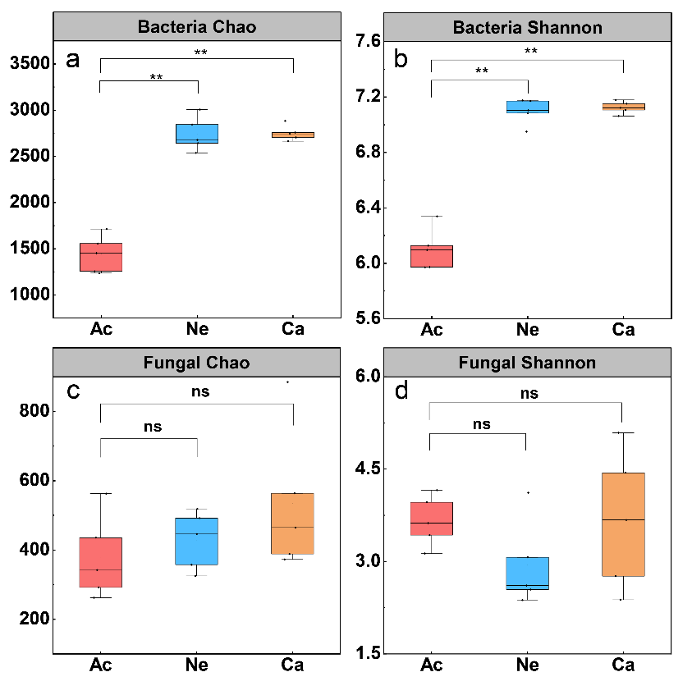
Fig. S1. Alpha diversity of soil bacterial and fungal communities in acidic soil, neutral soil and calcareous soil. Bacterial chao index (a), Bacterial Shannon index (b) and Fungal chao index (c), Fungal Shannon index (d). ** indicate that the alpha diversity of different soil microorganisms is significantly different (P < 0.05).
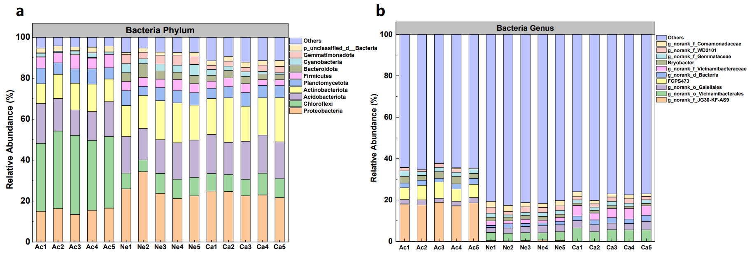
Fig. S2. Bacterial community composition. The relative abundance (a) of the major phyla (top 10) in bacterial communities; as well as the relative abundance (b) of the major genera (top 10) in bacterial communities.

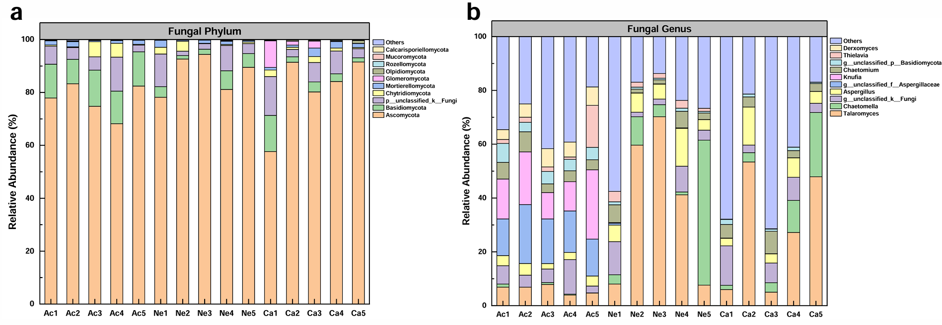
Fig. S3. Fungal community composition. The relative abundance (a) of the major phyla (top 10) in fungal communities; as well as the relative abundance (b) of the major genera (top 10) in fungal communities.

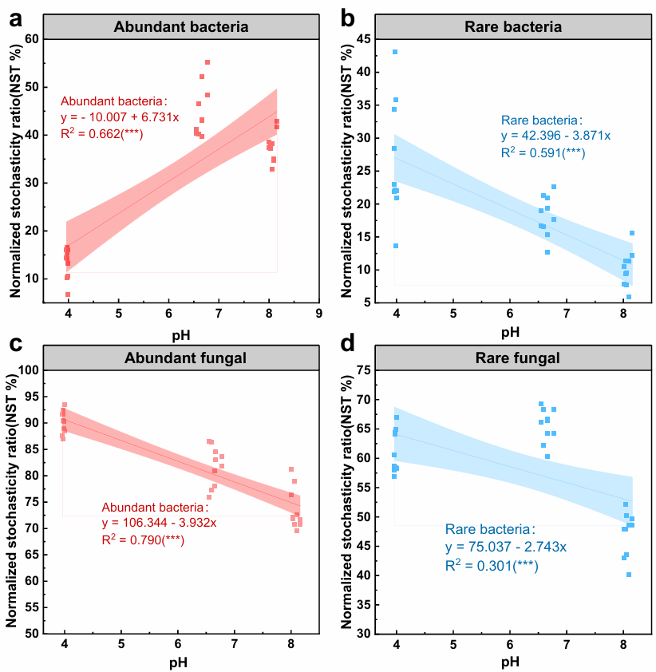Fig. S4. The regression analysis of standardized random ratio (NST) of abundant bacteria (a), rare bacteria (b), abundant fungi (c), and rare fungi (d) communities under different treatments with pH. The NST index has a boundary of 50% to distinguish between more deterministic (<50%) and more stochastic (>50%) assembly.

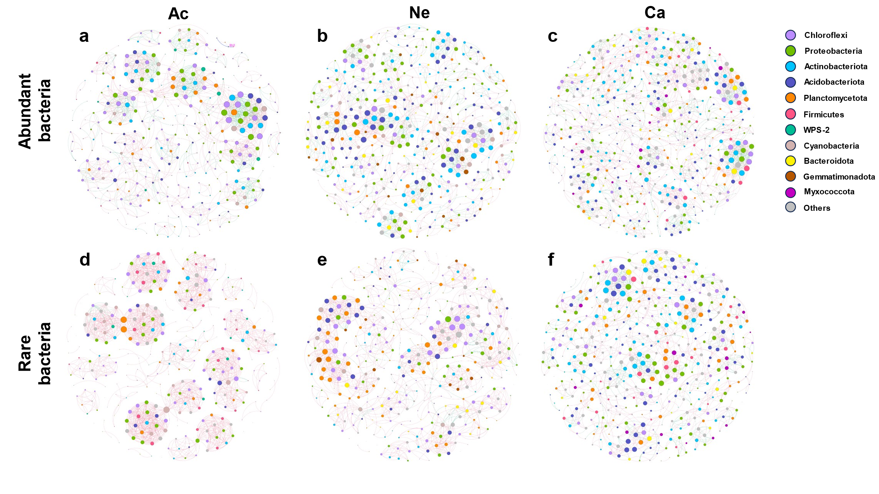
Fig. S5. Co-occurrence networks of the abundant(a-c) and rare(d-f) soil bacterial community in acidic soil (Ac), neutral soil (Ne), and Calcareous soil (Ca). The nodes represent the operational taxonomic units (ASVs), and the size of each node is proportional to the degree of the ASVs. The links indicate significant co-occurrence relationships with a significant correlation (P < 0.05), the red line indicates positive relation, and the green line indicates negative relation.

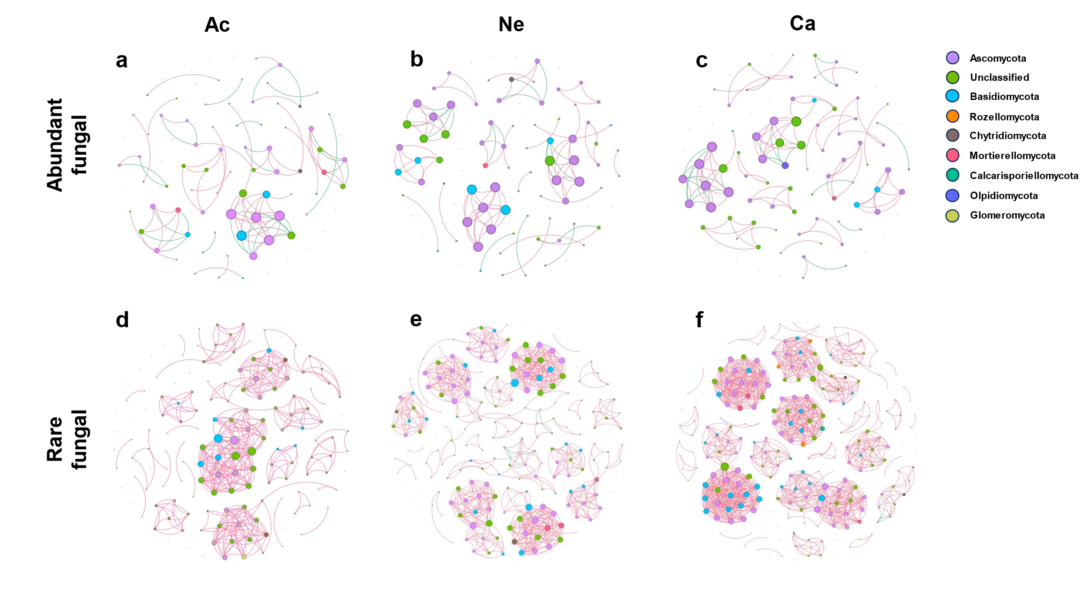
Fig. S6. Co-occurrence networks of the abundant(a-c) and rare(d-f) soil fungal community in acidic soil (Ac), neutral soil (Ne), and Calcareous soil (Ca). The nodes represent the operational taxonomic units (ASVs), and the size of each node is proportional to the degree of the ASVs. The links indicate significant co-occurrence relationships with a significant correlation (P < 0.05), the red line indicates positive relation, and the green line indicates negative relation.

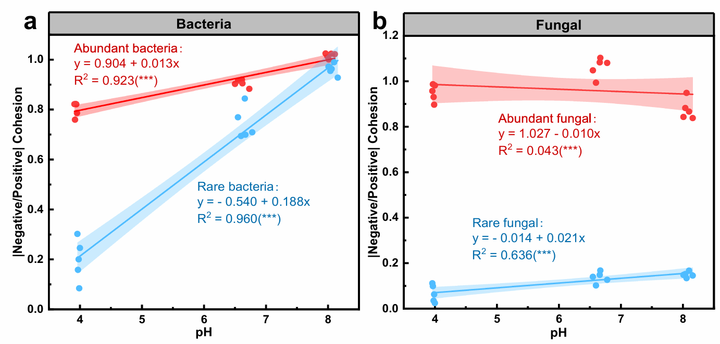
Fig. S7. Variation in ratio of |negative/positive| cohesion across the pH gradient. (a): bacteria, (b): fungi. red: abundance, blue: rare.

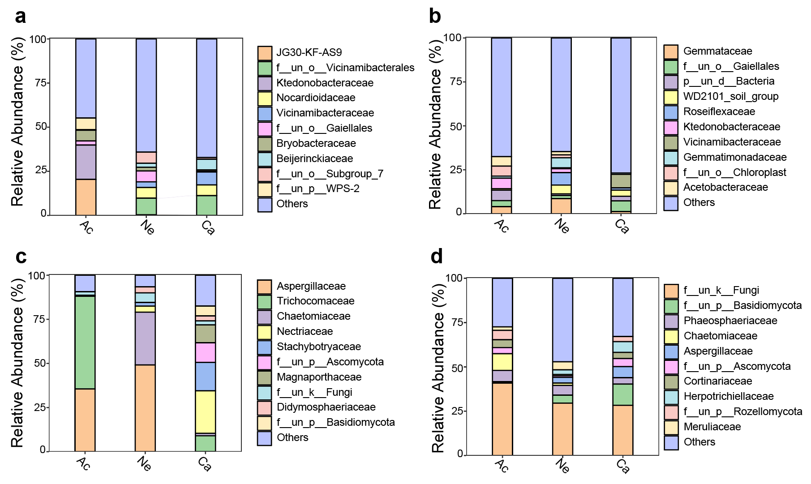
Fig. S8. Proportions of key taxa families (connectors) across different networks, calculated from the 12 empirical networks under various treatments. Abundant bacteria (a); Rare bacteria (b); Abundant fungal (c); Rare fungal (d).
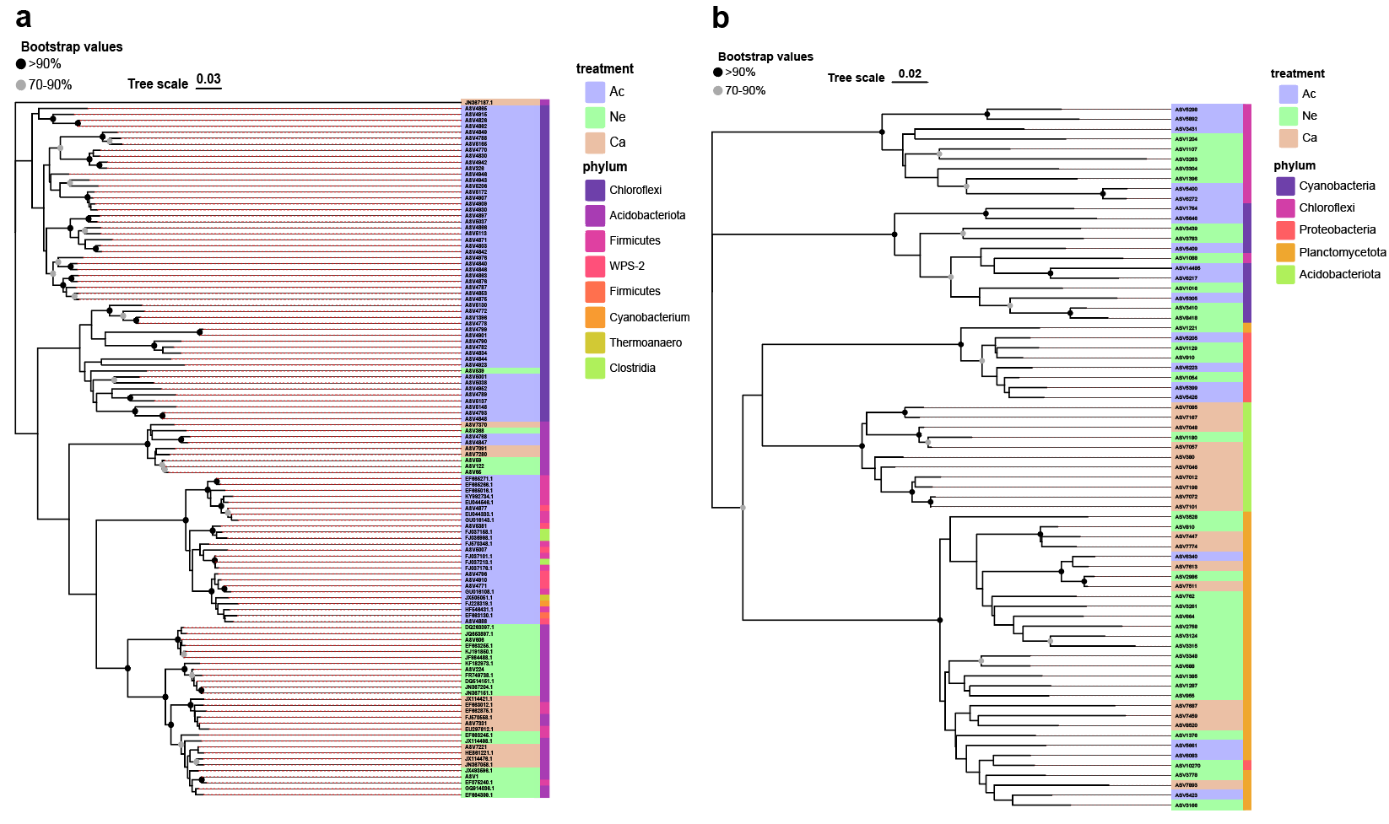
Fig. S9. The neighbor-joining phylogenetic tree constructed based on 16S rRNA gene sequences of abundant and rare bacterial network connectors. Abundant bacteria (a); Rare bacteria (b).

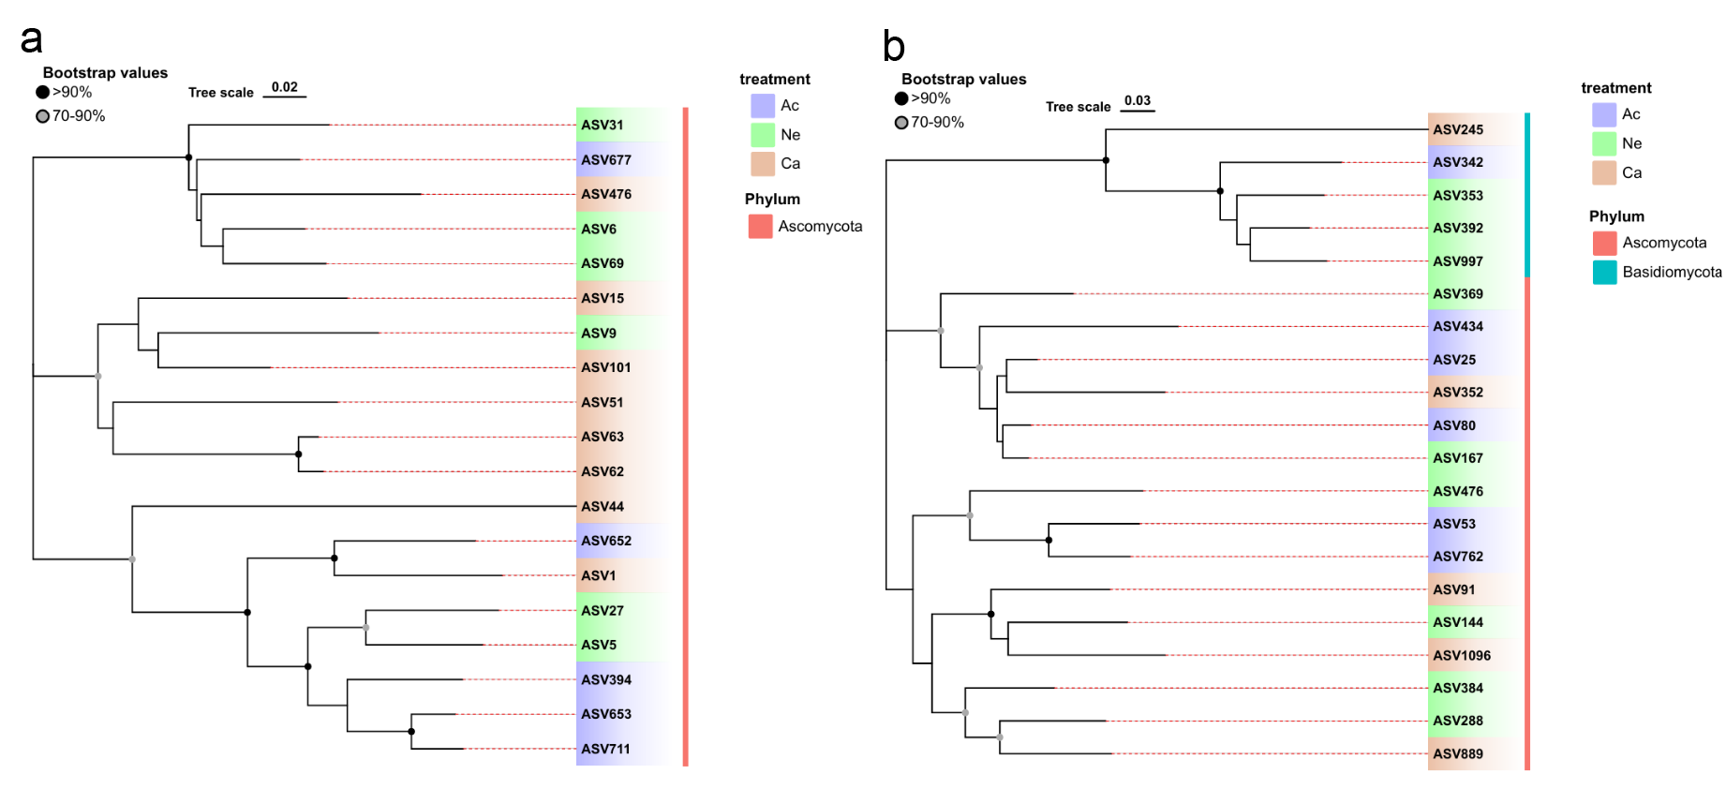Fig. S10. The neighbor-joining phylogenetic tree constructed based on ITS gene sequences of abundant and rare fungal network connectors. Abundant fungal (a); Rare fungal (b).

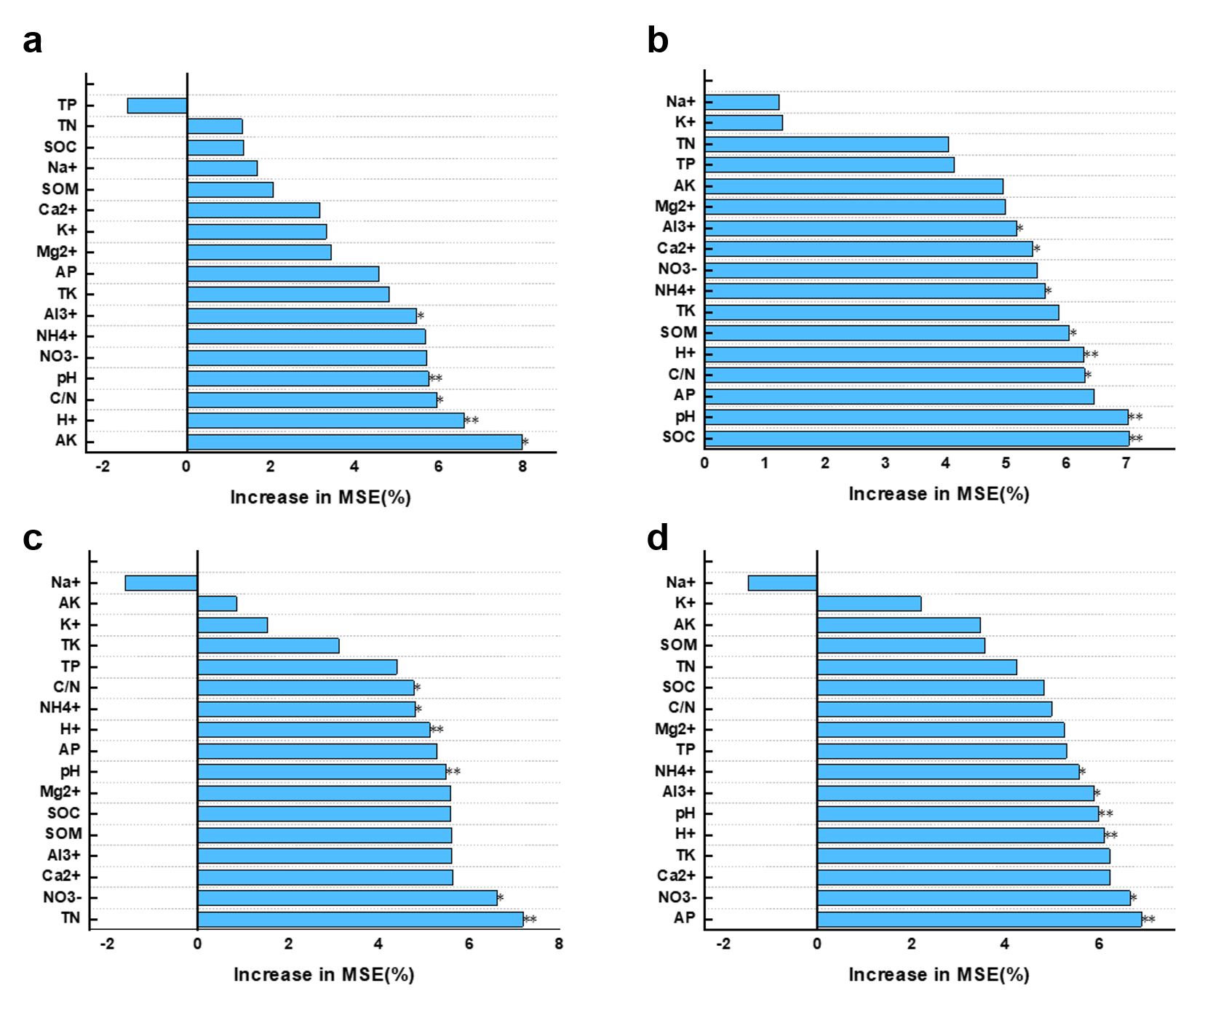
Fig. S11. Random Forest (RF) identified the role of environmental factors in bacterial and fungal keystone species. (a): abundant bacteria, (b): rare bacteria, (c): abundant fungal, (d): rare fungal. ** indicates P < 0.01, * indicates P < 0.05.

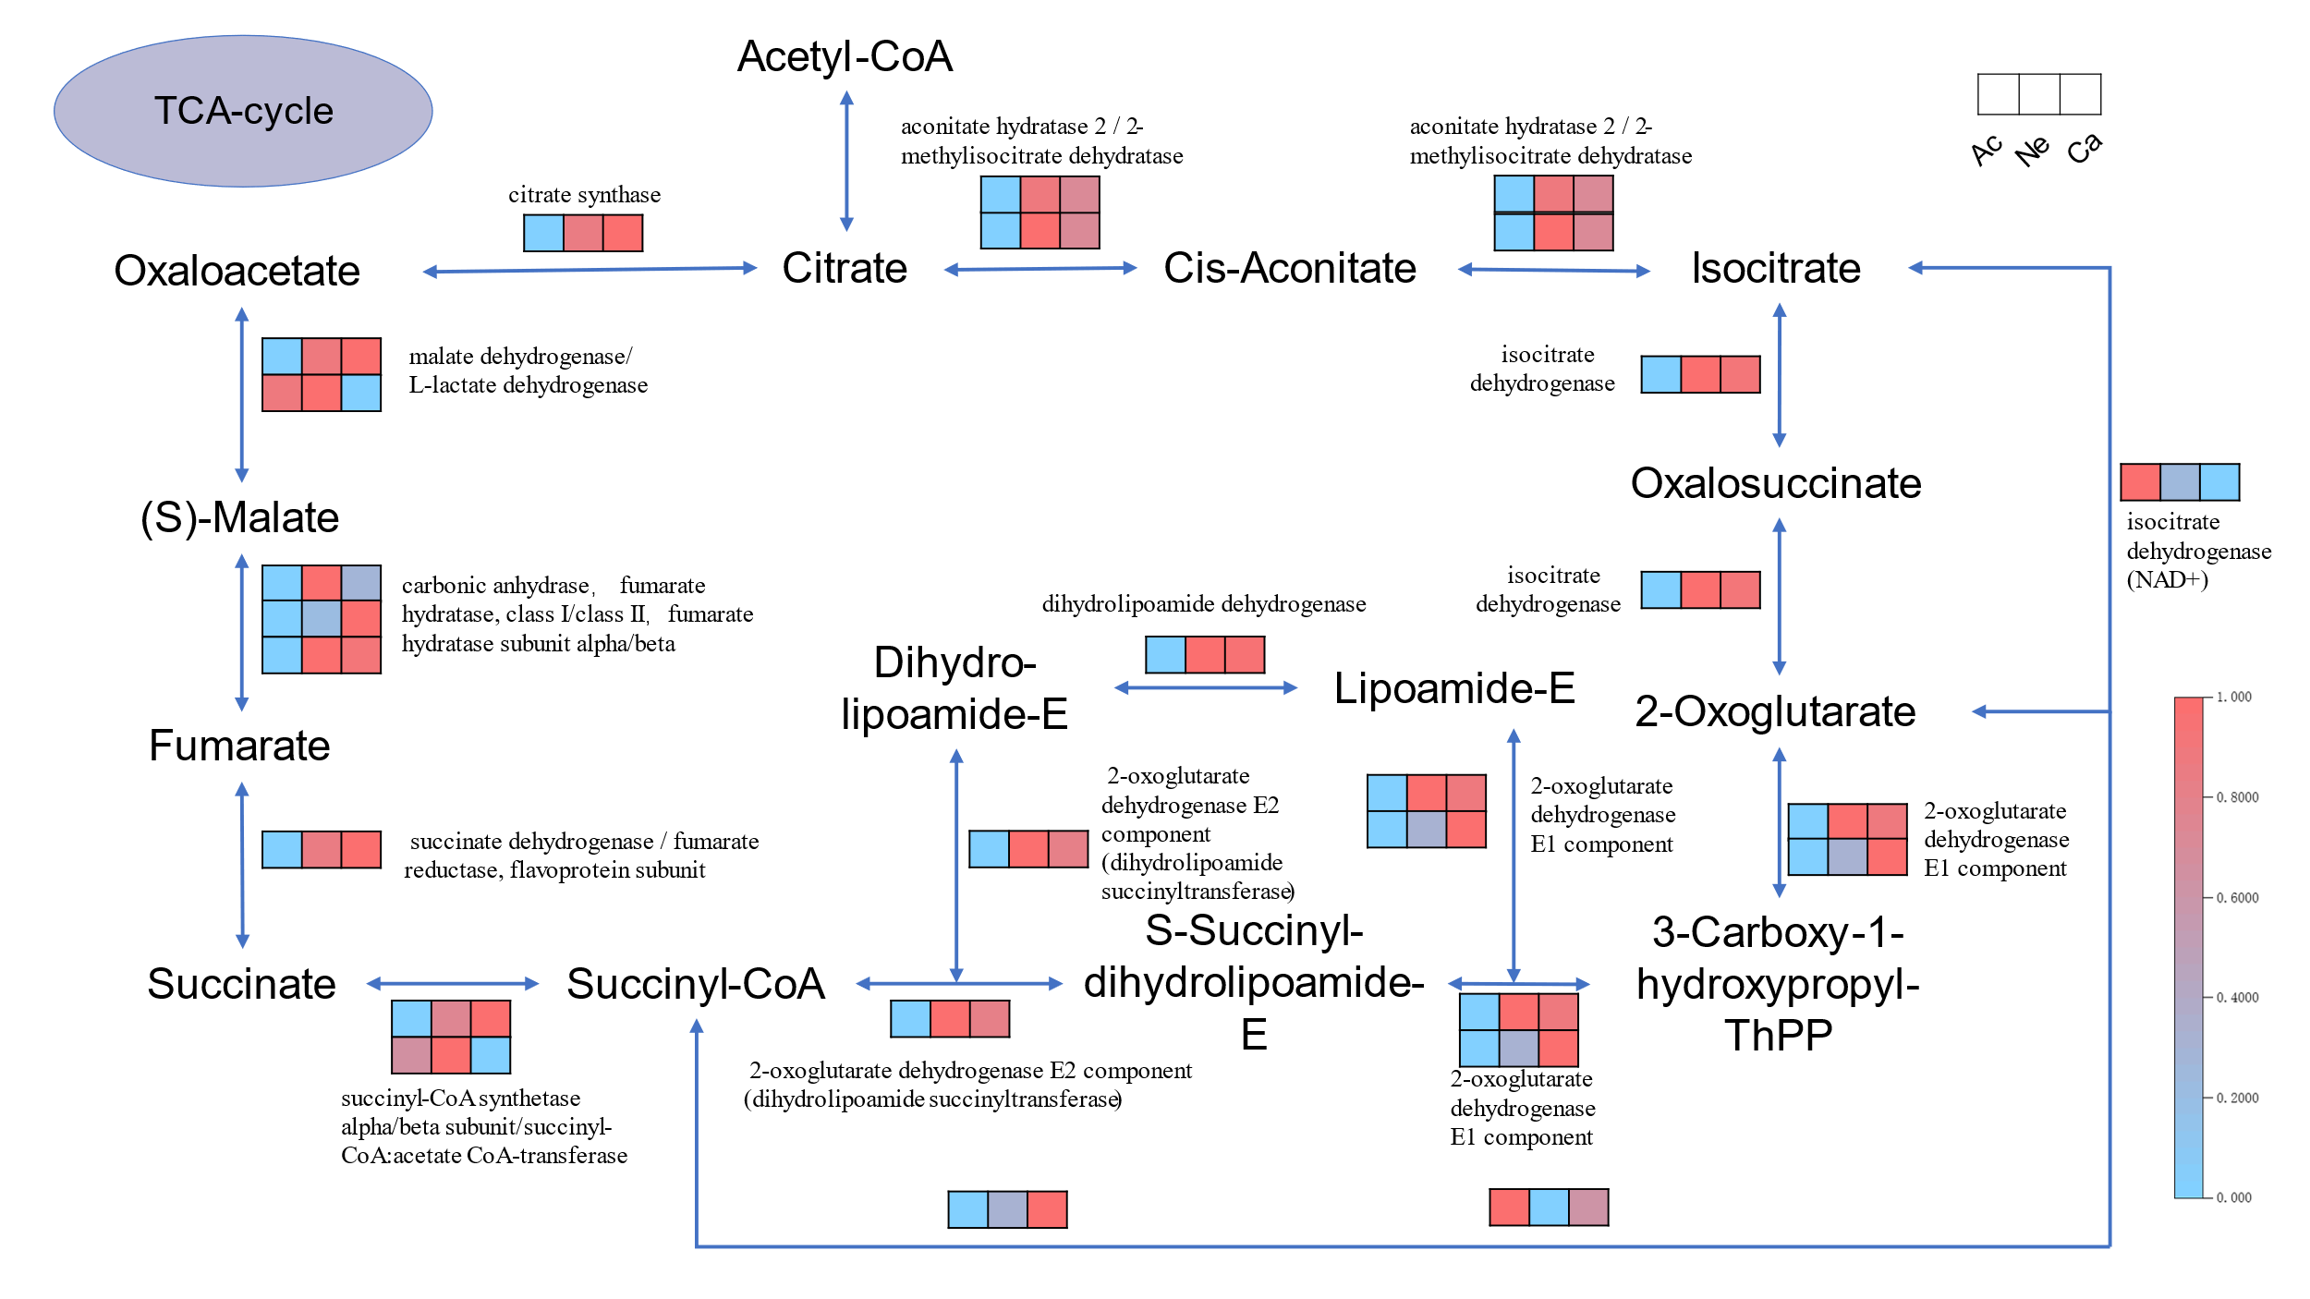
Fig. S12. Schematic diagram of the TCA cycle pathway. The up- and down-regulated genes of the enzyme are indicated in red and blue, respectively.

