Supplementary materials
S1. Detailed introduction of rice cultivars.
Taichung Native 1 (TN) is an indica rice cultivar without resistance gene. It is susceptible to any biotype of N. lugens, bacterial leaf blight and sheath blight, and intermediately resistant to rice blast (Shi et al., 2008). Now, this cultivar is not grown by farmers, but it is widely used as a model cultivar in scientific research, usually as a susceptible control (Cuong et al., 1997; Alagar et al., 2007).
IR36 (IR) is an indica rice cultivar with resistance gene Bph2. It is also resistant to rice blast, bacterial leaf blight and sheath blight (IRRI, 1991; Shi et al., 2008). This high resistant cultivar was bred by the International Rice Research Institute (IRRI) at Luzon, Philippines. It was widely grown earlier but now is replaced by other cultivars which have both high resistance and yield. However, it is usually used as a model resistant cultivar in scientific research.

References
Alagar, M., Suresh, S., Samiyappan, R., Saravanakumar, D., 2007. Reaction of resistant and susceptible rice genotypes against brown planthopper (Nilaparvata lugens). Phytoparasitica 35, 346–356.
Cuong, N.L., Ben, P.T., Phuong, L.T., Chau, L.M., Cohen, M.B., 1997. Effect of host plant resistance and insecticide on brown planthopper Nilaparvata lugens (Stål) and predator population development in the Mekong, Vietnam. Crop Protection 16, 707–715.
IRRI, 1991. IRRI germplasm: collecting, preservation, use. Proceedings of Third International Workshop 10–12.

Table. S1. Summary of the three-way ANOVA results (F values and Probability level) for the effects of rice cultivar (R), fertilizer (F) and brown planthopper (BP) on shoot height, root length and soluble sugar and amino acid in shoot, root and soil.
Source | df | Shoot height |  |  | Root length |  |  | Soluble sugar  (shoot) |  |  | Soluble sugar  (root)
 |  | F | P |  | F | P |  | F | P |  | F | P
R: Rice cultivar | 1 | 93.01 | <0.001 |  | 0.15 | 0.700 |  | 2.39 | 0.136 |  | 83.15 | <0.001
F: Fertilizer | 1 | 0.77 | 0.390 |  | 71.08 | <0.001 |  | 36.73 | <0.001 |  | 239.53 | <0.001
BP: Brown planthopper | 1 | 160.66 | <0.001 |  | 45.70 | <0.001 |  | 220.64 | <0.001 |  | 13.33 | 0.001
R×F | 1 | 4.92 | 0.036 |  | 4.06 | 0.055 |  | 0.36 | 0.557 |  | 0.26 | 0.613
R×BP | 1 | 29.80 | <0.001 |  | 8.16 | 0.009 |  | 54.37 | <0.001 |  | 5.92 | 0.023
F×BP | 1 | 60.24 | <0.001 |  | 15.89 | 0.001 |  | 43.43 | <0.001 |  | 36.93 | <0.001
R×F×BP | 1 | 5.05 | 0.034 |  | 0.12 | 0.730 |  | 4.85 | 0.038 |  | 4.32 | 0.049
Error | 24
Source |  | Soluble amino acid (shoot) |  |  | Soluble amino acid (root) |  |  | Soluble  sugar (soil) |  |  | Soluble amino acid (soil)
 |  | F | P |  | F | P |  | F | P |  | F | P
R: Rice cultivar | 1 | 0.74 | 0.399 |  | 20.26 | <0.001 |  | 20.80 | <0.001 |  | 36.93 | <0.001
F: Fertilizer | 1 | 43.61 | <0.001 |  | 34.36 | <0.001 |  | 47.12 | <0.001 |  | 99.01 | <0.001
BP: Brown planthopper | 1 | 45,13 | <0.001 |  | 12.87 | 0.001 |  | 5.09 | 0.033 |  | 74.40 | <0.001
R×F | 1 | 7.89 | 0.010 |  | 0.35 | 0.559 |  | 3.18 | 0.087 |  | 45.85 | <0.001
R×BP | 1 | 35.20 | <0.001 |  | 1.63 | 0.214 |  | 37.07 | <0.001 |  | 55.77 | <0.001
F×BP | 1 | 52.22 | <0.001 |  | 2.76 | 0.110 |  | 2.54 | 0.124 |  | 22.27 | <0.001
R×F×BP | 1 | 1.74 | 0.200 |  | 0.83 | 0.371 |  | 2.44 | 0.131 |  | 44.06 | <0.001
Error | 24

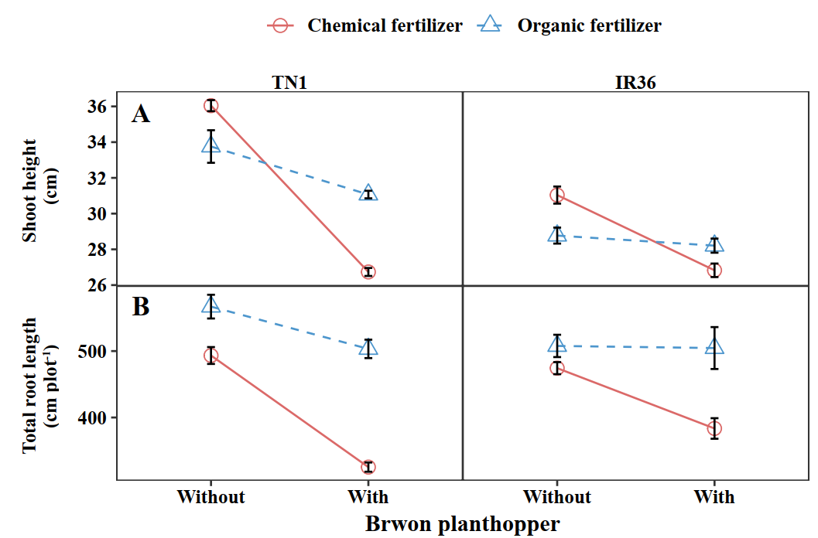Fig. S1. Plant performance such as shoot height (A) and root length (B) of two rice cultivars: susceptible rice cultivar Taichung Native1 (TN1) and resistant rice cultivar IR36 (IR36), without (CK) and with (BP) brown planthopper (mean ± SE) in chemical (CF) and organic fertilizer (OF) treatments.

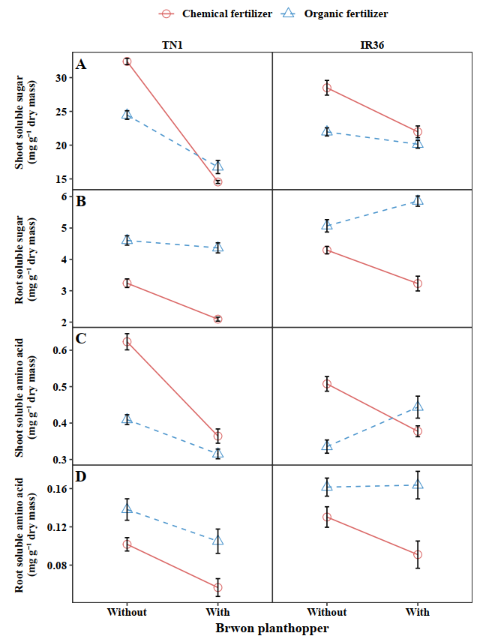
Fig.S2 The shoot and root concentrations of soluble sugar (A, B) and amino acid (C, D) of two rice cultivars: susceptible rice cultivar Taichung Native1 (TN1) and resistant rice cultivar IR36 (IR36), without (CK) and with brown planthopper (BP) (mean ± SE) in chemical (CF) and organic fertilizer (OF) treatments.

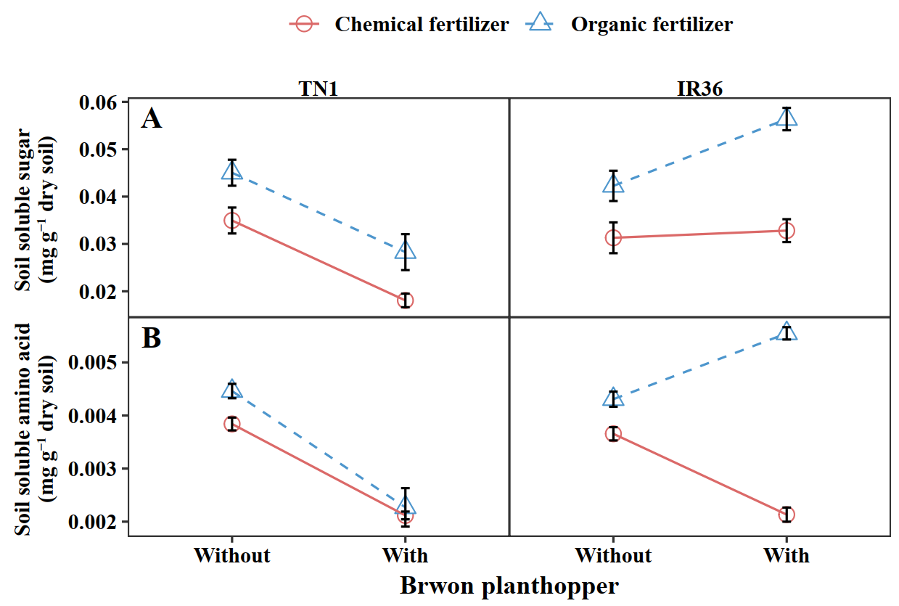
Fig. S3. The concentrations of soluble sugar (A) and soluble amino acid (B) in soil under two rice cultivars: susceptible rice cultivar Taichung Native1 (TN1) and resistant rice cultivar IR36 (IR36), without (CK) and with brown planthopper (BP) (mean ± SE) in chemical (CF) and organic fertilizer (OF) treatments.

