Supplementary data for
Metagenomic evidence for adaptive P-acquisition strategies to sustain elevated soil microbial biomass P under swine manure fertilization

Yunbin Jiang^{1,2}, Yijie Zhao¹, Cheng Han^{1,2}, Huan Deng^{2,4}, Kailou Liu³, Shangshu Huang³, Wenhui Zhong^{1,2,*}

1 State Key Laboratory of Climate System Prediction and Risk Management, Jiangsu Provincial Key Laboratory of Materials Cycling and Pollution Control, School of Geography, Nanjing Normal University, Nanjing 210023, China
2 Jiangsu Center for Collaborative Innovation in Geographical Information Resource Development and Application, Nanjing 210023, China
3 National Engineering and Technology Research Center for Red Soil Improvement, Jiangxi Institute of Red Soil and Germplasm Resources, Nanchang 331717, China
4 School of Environment, Nanjing Normal University, Nanjing 210023, China

* Corresponding author. E-mail: zhongwenhui@njnu.edu.cn (W. Zhong)

This file contains Tables S1 ~ S5 and Figures S1 ~ S2.
Table S1 Physicochemical properties of the collected soil samples.
 | Fertilization treatment |  |  |  | Two-way ANOVA
 | CK | NPK | M | NPKM | Manure | Mineral | Ma. × Mi.
Moisture (%) | 19.9 ± 0.50 | 18.7 ± 2.1 | 19.8 ± 0.85 | 19.5 ± 1.3 | n.s. | n.s. | n.s.
pH | 5.10 ± 0.16 | 4.23 ± 0.16 | 6.10 ± 0.16 | 5.75 ± 0.15 | *** | *** | *
TOC (g kg⁻¹) | 8.57 ± 0.10 | 9.78 ± 0.41 | 13.6 ± 1.3 | 13.7 ± 0.72 | *** | n.s. | n.s.
TN (g kg⁻¹) | 0.882 ± 0.028 | 1.02 ± 0.016 | 1.27 ± 0.088 | 1.34 ± 0.037 | *** | ** | n.s.
TP (g kg⁻¹) | 0.522 ± 0.025 | 0.775 ± 0.10 | 1.90 ± 0.13 | 2.07 ± 0.060 | *** | ** | n.s.
DOC (mg kg⁻¹) | 26.7 ± 1.7 | 42.2 ± 5.0 | 77.1 ± 3.4 | 85.3 ± 1.7 | *** | *** | n.s.
TDN (mg kg⁻¹) | 14.1 ± 0.36 | 42.1 ± 4.9 | 42.7 ± 4.0 | 55.7 ± 0.92 | *** | *** | **
AP (mg kg⁻¹) | 3.79 ± 0.99 | 25.1 ± 17 | 284 ± 39 | 375 ± 27 | *** | ** | *
TOC:TP | 16.4 ± 0.72 | 12.8 ± 1.7 | 7.10 ± 0.24 | 6.60 ± 0.24 | *** | ** | *
TN:TP | 1.69 ± 0.039 | 1.33 ± 0.15 | 0.665 ± 0.020 | 0.647 ± 0.0071 | *** | ** | **
DOC:AP | 7.37 ± 1.9 | 2.06 ± 0.86 | 0.276 ± 0.051 | 0.228 ± 0.020 | *** | ** | **
TDN:AP | 3.88 ± 0.84 | 2.19 ± 1.2 | 0.151 ± 0.0073 | 0.149 ± 0.0094 | *** | n.s. | n.s.
Note: Data are presented as means ± standard deviations (n = 3). *, P < 0.05; **, P < 0.01; ***, P < 0.001; n.s., not significant.

Table S2 Two-way ANOVA for the effects of manure fertilization, mineral fertilization, and their interactions on the abundances of P-transformation gene classes.
 | Manure | Mineral | Manure × Mineral
Two-component system | * | n.s. | *
Transporters | *** | ** | **
Organic phosphoester hydrolysis | *** | *** | ***
Oxidative phosphorylation | *** | ** | n.s.
Pyruvate metabolism | *** | * | n.s.
Phosphotransferase system | *** | ** | **
Phosphonate metabolism | *** | * | **
Pentose phosphate pathway | *** | n.s. | *
Purine metabolism | *** | * | n.s.
Pyrimidine metabolism | ** | ** | n.s.
Others | *** | n.s. | n.s.
Note: *, P < 0.05; **, P < 0.01; ***, P < 0.001; n.s., not significant.

Table S3 Two-way ANOVA for the effects of manure fertilization, mineral fertilization, and their interactions on the abundances of individual P-transformation genes.
 |  | Manure | Mineral | Manure × Mineral
Two-component system | phoU | n.s. | ** | n.s.
Two-component system | phoR | ** | n.s. | n.s.
Two-component system | phoB | * | n.s. | **
Two-component system | phoP | *** | * | n.s.
Two-component system | SenX3 | *** | n.s. | n.s.
Two-component system | RegX3 | *** | ** | n.s.
Two-component system | pgtC | n.s. | n.s. | *
Two-component system | pgtB | *** | n.s. | n.s.
Two-component system | pgtA | *** | * | *
Transporters | pgtP | * | *** | *
Transporters | pstS | *** | n.s. | *
Transporters | pstC | n.s. | *** | *
Transporters | pstA | n.s. | ** | n.s.
Transporters | pstB | n.s. | ** | *
Transporters | pit | *** | n.s. | n.s.
Transporters | htxB | n.s. | n.s. | *
Transporters | ptxB | n.s. | n.s. | n.s.
Transporters | ptxC | *** | * | **
Transporters | phnD  _phosphite | *** | ** | **
Transporters | phnD | n.s. | * | ***
Transporters | phnE | n.s. | * | ***
Transporters | phnC | *** | ** | n.s.
Transporters | ugpB | * | n.s. | n.s.
Transporters | ugpA | ** | ** | **
Transporters | ugpE | ** | ** | *
Transporters | ugpC | *** | ** | n.s.
Transporters | phnS | *** | ** | n.s.
Transporters | phnV | *** | *** | n.s.
Transporters | phnU | *** | * | n.s.
Transporters | phnT | n.s. | n.s. | n.s.
Transporters | glpT | n.s. | * | n.s.
Transporters | aepX | *** | n.s. | n.s.
Transporters | aepW | ** | n.s. | n.s.
Transporters | aepP | n.s. | n.s. | *
Organic phosphoester hydrolysis | opd | n.s. | *** | *
Organic phosphoester hydrolysis | pafA | *** | n.s. | n.s.
Organic phosphoester hydrolysis | phoA | ** | n.s. | n.s.
Organic phosphoester hydrolysis | phoD | *** | *** | *
Organic phosphoester hydrolysis | phoX | *** | *** | ***
Organic phosphoester hydrolysis | phoN | ** | * | n.s.
Organic phosphoester hydrolysis | aphA | *** | * | *
Organic phosphoester hydrolysis | phoC | n.s. | * | n.s.
Organic phosphoester hydrolysis | olpA | n.s. | n.s. | n.s.
Organic phosphoester hydrolysis | phy | *** | *** | ***
Organic phosphoester hydrolysis | appA | n.s. | n.s. | n.s.
Organic phosphoester hydrolysis | ugpQ | ** | ** | n.s.
Organic phosphoester hydrolysis | glpQ | *** | *** | **
Oxidative phosphorylation | ppk | *** | ** | n.s.
Oxidative phosphorylation | ppa | n.s. | *** | n.s.
Pyruvate metabolism | pps | ** | n.s. | n.s.
Pyruvate metabolism | ppdK | *** | * | n.s.
Pyruvate metabolism | pyk | *** | n.s. | n.s.
Pyruvate metabolism | pckG | *** | *** | n.s.
Pyruvate metabolism | ppc | *** | n.s. | n.s.
Pyruvate metabolism | pckA | *** | * | *
Phosphotransferase system | ptsI | *** | *** | **
Phosphotransferase system | ptsH | n.s. | n.s. | n.s.
Phosphonate metabolism | pepM | ** | n.s. | **
Phosphonate metabolism | pphA | n.s. | ** | n.s.
Phosphonate metabolism | ppd | *** | n.s. | *
Phosphonate metabolism | phnX | n.s. | n.s. | n.s.
Phosphonate metabolism | fomC | n.s. | n.s. | *
Phosphonate metabolism | phpC | *** | *** | n.s.
Phosphonate metabolism | mpnS | ** | n.s. | *
Phosphonate metabolism | phnG | * | n.s. | n.s.
Phosphonate metabolism | phnH | n.s. | n.s. | n.s.
Phosphonate metabolism | phnI | *** | n.s. | *
Phosphonate metabolism | phnK | ** | n.s. | n.s.
Phosphonate metabolism | phnL | ** | n.s. | n.s.
Phosphonate metabolism | phnM | *** | n.s. | n.s.
Phosphonate metabolism | phnJ | *** | n.s. | **
Phosphonate metabolism | phnP | *** | n.s. | **
Phosphonate metabolism | phnN | n.s. | n.s. | n.s.
Phosphonate metabolism | phnPP | *** | n.s. | n.s.
Phosphonate metabolism | phny | *** | * | n.s.
Phosphonate metabolism | phnA | *** | n.s. | ***
Phosphonate metabolism | phnW | *** | n.s. | **
Phosphonate metabolism | phnO | ** | n.s. | n.s.
Phosphonate metabolism | pbfA | ** | n.s. | n.s.
Phosphonate metabolism | phnY | n.s. | n.s. | *
Phosphonate metabolism | phnZ | n.s. | n.s. | n.s.
Pentose phosphate pathway | gdh | n.s. | n.s. | n.s.
Pentose phosphate pathway | gcd | *** | n.s. | *
Pentose phosphate pathway | gnl | *** | n.s. | *
Pentose phosphate pathway | gntK | *** | n.s. | n.s.
Pentose phosphate pathway | gnd | *** | n.s. | **
Pentose phosphate pathway | rpiA | *** | n.s. | n.s.
Pentose phosphate pathway | prsA | *** | * | n.s.
Pentose phosphate pathway | deoB | *** | n.s. | n.s.
Purine metabolism | purF | *** | ** | n.s.
Purine metabolism | purD | *** | n.s. | **
Purine metabolism | purN | *** | * | **
Purine metabolism | purT | *** | n.s. | n.s.
Purine metabolism | purL | *** | ** | n.s.
Purine metabolism | purS | ** | *** | n.s.
Purine metabolism | purQ | *** | ** | n.s.
Purine metabolism | purM | *** | n.s. | n.s.
Purine metabolism | purK | ** | n.s. | n.s.
Purine metabolism | purE | n.s. | * | *
Purine metabolism | ADE2 | ** | n.s. | n.s.
Purine metabolism | purC | *** | ** | n.s.
Purine metabolism | purB | *** | * | **
Purine metabolism | purH | *** | n.s. | n.s.
Purine metabolism | purP | n.s. | * | n.s.
Purine metabolism | guaB | *** | n.s. | n.s.
Purine metabolism | guaA | *** | ** | n.s.
Purine metabolism | gmk | ** | n.s. | n.s.
Purine metabolism | ushA | *** | * | ***
Purine metabolism | ndk | n.s. | * | ***
Purine metabolism | spoT | *** | * | n.s.
Purine metabolism | ppx | ** | ** | n.s.
Purine metabolism | purA | *** | n.s. | n.s.
Purine metabolism | adk | *** | * | n.s.
Pyrimidine metabolism | pyrE | ** | ** | n.s.
Pyrimidine metabolism | pyrF | *** | n.s. | n.s.
Pyrimidine metabolism | cmk | n.s. | ** | n.s.
Pyrimidine metabolism | pyrH | *** | *** | n.s.
Pyrimidine metabolism | pyrG | *** | n.s. | n.s.
Pyrimidine metabolism | rtpR | n.s. | n.s. | n.s.
Pyrimidine metabolism | nrdD | *** | ** | n.s.
Pyrimidine metabolism | nrdA | *** | *** | n.s.
Pyrimidine metabolism | nrdE | * | n.s. | n.s.
Pyrimidine metabolism | nrdB | *** | *** | n.s.
Pyrimidine metabolism | nrdF | *** | *** | **
Pyrimidine metabolism | nrdJ | *** | ** | n.s.
 | dcd | *** | n.s. | n.s.
 | dut | n.s. | n.s. | n.s.
 | thyA | * | * | n.s.
 | tmk | *** | * | n.s.
Others | htxA | n.s. | n.s. | **
Others | ptxD | *** | n.s. | **
Others | lysR | ** | n.s. | n.s.
Others | phnR | n.s. | n.s. | n.s.
Others | phnF | ** | n.s. | n.s.
Others | phoH | *** | * | n.s.
Note: *, P < 0.05; **, P < 0.01; ***, P < 0.001; n.s., not significant.

Table S4 Topological properties of soil bacterial communities harboring key genes responsible for P-transformation processes associated with MBP enhancement.
 | pstS | pit | ugpB | phy | phnW | phny | phnA | ptxD
Number of nodes | 57 | 42 | 73 | 28 | 37 | 68 | 20 | 42
Number of edges | 315 | 103 | 491 | 46 | 146 | 315 | 39 | 137
Number of positive correlations | 176 | 71 | 284 | 27 | 66 | 165 | 18 | 78
Number of negative correlations | 139 | 32 | 207 | 19 | 80 | 150 | 21 | 59
Ratio of negative  to positive correlations | 0.79 | 0.45 | 0.73 | 0.70 | 1.2 | 0.91 | 1.2 | 0.76
Average degree | 11.1 | 4.91 | 13.5 | 3.29 | 7.89 | 9.27 | 3.90 | 6.52
Average path length | 3.30 | 3.37 | 2.43 | 2.39 | 1.81 | 3.19 | 2.00 | 2.43
Average clustering coefficient | 0.62 | 0.49 | 0.55 | 0.52 | 0.65 | 0.52 | 0.63 | 0.63
Modularity | 0.30 | 0.50 | 0.28 | 0.45 | 0.32 | 0.39 | 0.30 | 0.41

Table S5 Degree of the key P-transformation gene-harboring bacterial genera (relative abundance >1%, significantly enriched in the long-term swine manure fertilization treatments) in their corresponding co-occurrence networks.
 | pstS | pit | ugpB | phy | phnW | phny | phnA | ptxD
Achromobacter | - | - | - | - | - | - | 6 | -
Baekduia | - | - | - | - | - | 16 | - | -
Bradyrhizobium | - | - | 4 | - | 6 | 6 | 1 | 6
Conexibacter | - | 11 | - | - | - | - | - | -
Cupriavidus | - | - | - | - | - | - | 1 | -
Gaiella | - | - | - | - | 14 | - | - | -
Kouleothrix | - | - | - | - | 14 | - | - | -
Marmoricola | - | 7 | 32 | 3 | - | - | - | -
Nitrospira | - | - | - | - | - | 9 | - | -
Nocardioides | 22 | 6 | 18 | - | 10 | 21 | - | 8
Nonomuraea | - | - | 5 | - | - | - | - | -
Povalibacter | - | - | - | 8 | - | - | - | -
Ramlibacter | - | - | - | - | - | - | 6 | -
Reyranella | - | - | - | - | - | - | 2 | -
Rhizobacter | - | - | - | - | - | - | 7 | -
Solirubrobacter | 22 | 8 | 28 | 2 | 13 | 17 | 4 | 15
Sphingomonas | - | - | - | - | - | 3 | - | -
Steroidobacter | - | - | - | 5 | - | - | - | -
Streptomyces | - | - | 9 | - | - | - | - | -
Terrabacter | - | - | - | - | - | - | 6 | -
Note: -, not applicable.

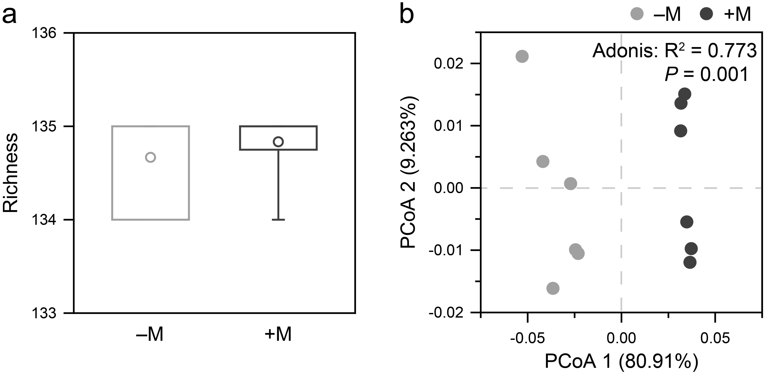
Fig. S1 Diversity of soil microbial P-transformation genes in the long-term swine manure fertilization treatments (+M) and their corresponding controls (–M). (a) Box plot of the richness of microbial P-transformation genes. The circle dots, lower and upper bounds of box, and vertical bars denote means, the first and third quartiles, and 1.5 × interquartile ranges, respectively (n = 6). (b) PCoA plot of the composition of microbial P-transformation genes.

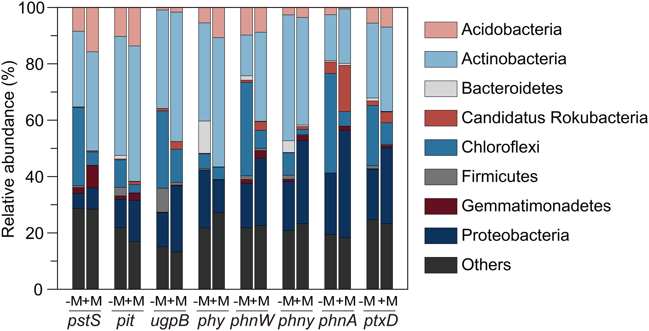
Fig. S2 Phylum-level taxonomic composition of soil bacterial communities harboring key genes responsible for P-transformation processes associated with MBP enhancement in the long-term swine manure fertilization treatments (+M) and their corresponding controls (–M).

