Supplementary for:

Grazing intensity is associated with shifts in nutrient status, metabolite profiles, and selected bacterial taxa in biological soil crusts

Author names and affiliations: Jiangping Gao ^{1,2,3,4} ǀ Zengru Wang ^{1,2,3,4} ǀ Yubing Liu ^{1,2,3,4}
¹ College of Pastoral Agriculture Science and Technology, Lanzhou University, Lanzhou 730020, PR China ǀ ² State Key Laboratory of Herbage Improvement and Grassland Agro-ecosystems, Lanzhou, 730020, China ǀ ³Key Laboratory of Grassland Livestock Industry Innovation, Ministry of Agriculture and Rural Affairs, Lanzhou, 730020, China ǀ ⁴ Engineering Research Center of Grassland Industry, Ministry of Education, Lanzhou, 730020, China

Corresponding author: Zengru Wang; Yubing Liu
Present Address: 768 Jiayuguan West Road, Chengguan District, Lanzhou, 730020, China
- mail address: wangzengru@lzu.edu.cn, liuyb@lzu.edu.cn
Table S1. Total reads of 16S rRNA gene and OTU numbers in the samples.
Sample name | Total reads | Quality-filtered contigs | Base numbers | Mean length | Min length | Max length | OTU numbers
YD | 69323 | 35731 | 23804966 | 411.4307 | 203 | 504 | 323
WY2 | 65413 | 35215 | 22298192 | 413.1896 | 232 | 464 | 302
WY3 | 67105 | 35127 | 24577148 | 413.2766 | 212 | 459 | 339
AYL | 68497 | 34582 | 22937269 | 411.8223 | 244 | 450 | 288
ARL | 71131 | 33719 | 23877965 | 411.824 | 247 | 495 | 296
AJL | 56757 | 37592 | 18907039 | 412.0348 | 246 | 447 | 298
ZS1 | 63903 | 30913 | 21115263 | 413.3601 | 238 | 466 | 317
ZS2 | 66187 | 31202 | 22381604 | 412.9219 | 203 | 493 | 323
ZSL | 67255 | 31531 | 22308207 | 413.4518 | 231 | 506 | 344
PK1 | 56720 | 27515 | 18759278 | 413.6646 | 232 | 503 | 341
PK2 | 55886 | 28329 | 18523216 | 413.5016 | 245 | 521 | 294
PKL | 56823 | 29755 | 18797485 | 412.9137 | 239 | 449 | 278
BJ1 | 65745 | 31555 | 22048547 | 413.2579 | 203 | 525 | 283
BJ3 | 65201 | 28141 | 22407717 | 414.6429 | 203 | 508 | 338
BJL | 88430 | 38355 | 29266668 | 413.8445 | 232 | 482 | 334
DA2 | 59145 | 26554 | 19864484 | 413.344 | 245 | 477 | 241
DA3 | 58734 | 30279 | 20034152 | 412.6074 | 241 | 453 | 218
BH | 54123 | 26174 | 18140752 | 414.4468 | 246 | 523 | 358
GPL | 52782 | 28684 | 17511193 | 412.4065 | 262 | 466 | 387
QZL | 56552 | 30364 | 18567857 | 414.2207 | 230 | 525 | 356
QHL | 63022 | 35527 | 21300494 | 414.4146 | 245 | 514 | 302
Total | 1328734 | 666844 |  |  |  |  | 6560

Table S2 Peak table after metabolite processing.
Ion mode | All peaks | Identified metabolites | Metabolites in KEGG
pos | 5337 | 453 | 150
neg | 4766 | 303 | 89
mix | 10103 | 756 | 239

Table S3 Annotation information of differential metabolites between EN and LG groups.
Metab ID | Mode | Metabolite | HMDB Superclass
metab_43 | pos | Starch acetate | Organic acids and derivatives
metab_66 | pos | 2-(1,3-dihydroxy-4-oxocyclohexa-2,5-dien-1-yl)-5-hydroxy-3,6,7-trimethoxy-4H-chromen-4-one | Organoheterocyclic compounds
metab_140 | pos | (R)-Serine | -
metab_159 | pos | 3,4,5-trihydroxy-6-[(3-methylbut-2-enoyl)oxy]oxane-2-carboxylic acid | Organic oxygen compounds
metab_262 | pos | [3-hydroxy-4-(7-methoxy-2-oxo-2H-chromen-8-yl)-2-methylidenebutoxy]sulfonic acid | Phenylpropanoids and polyketides
metab_373 | pos | Zedoarondiol | Lipids and lipid-like molecules
metab_646 | pos | 6-{[2-({4,5-dihydroxy-6-methyl-2-[(3,4,5,6-tetrahydroxyoxan-2-yl)methoxy]oxan-3-yl}oxy)-4,5-dihydroxy-6-methyloxan-3-yl]oxy}-3,4,5-trihydroxyoxane-2-carboxylic acid | Organic oxygen compounds
metab_767 | pos | Galactosyl 4-hydroxyproline | Alkaloids and derivatives
metab_838 | pos | 6-O-Oleuropeoylsucrose | Lipids and lipid-like molecules
metab_1252 | pos | DG(18:3(9Z,12Z,15Z)/18:2(9Z,12Z)/0:0) | Lipids and lipid-like molecules
metab_1487 | pos | 6,8,10,12-pentadecatetraenal | -
metab_1678 | pos | Tricetinidin | Phenylpropanoids and polyketides
metab_1799 | pos | 3-Hydroxymandelic acid | Benzenoids
metab_2046 | pos | Inosine | Nucleosides, nucleotides, and analogues
metab_2486 | pos | Asp-Phe-OH | -
metab_2675 | pos | 2-Pyrrolidinone | Organoheterocyclic compounds
metab_2676 | pos | D-2-Aminobutyric acid | Organic acids and derivatives
metab_2690 | pos | 6-(3-{8-[1-(2,4-dihydroxyphenyl)-3-(3,4-dihydroxyphenyl)-2-hydroxypropyl]-3,5,7-trihydroxy-3,4-dihydro-2H-1-benzopyran-2-yl}phenoxy)-3,4,5-trihydroxyoxane-2-carboxylic acid | Phenylpropanoids and polyketides
metab_2847 | pos | 1-Kestose | Organic oxygen compounds
metab_2929 | pos | 6b-Hydroxy-8a-methoxy-7(11)-eremophilen-12,8-olide | Lipids and lipid-like molecules
metab_3083 | pos | Dihyroxy-1H-indole glucuronide I | Organic oxygen compounds
metab_3108 | pos | Trifucosyllacto-N-hexaose | Organic oxygen compounds
metab_3166 | pos | N-Carboxyethyl-gamma-aminobutyric acid | Organic acids and derivatives
metab_3196 | pos | 6-beta-Hydroxy-mometasone furoate | Lipids and lipid-like molecules
metab_3298 | pos | Glandulone C | Lipids and lipid-like molecules
metab_3355 | pos | 3-(1,2,4-trihydroxybutyl)-1H-isochromen-1-one | Phenylpropanoids and polyketides
metab_3511 | pos | N-(4-guanidinobutyl)-3-(4-hydroxyphenyl)acrylamide | -
metab_3548 | pos | Trans-2,3-Dihydroxycinnamate | Phenylpropanoids and polyketides
metab_3557 | pos | Trp-P-1 | Organoheterocyclic compounds
metab_3562 | pos | Lactodifucotetraose | Lipids and lipid-like molecules
metab_3632 | pos | Malonylcarnitine | Lipids and lipid-like molecules
metab_3690 | pos | 4-(4-amino-3-chlorophenyl)-2-chloroaniline | -
metab_3727 | pos | (4S)-Dihydrocurcumenone | Lipids and lipid-like molecules
metab_3776 | pos | Blumealactone C | Lipids and lipid-like molecules
metab_3795 | pos | ANHYDROBRAZILIC ACID | -
metab_3800 | pos | 3,3',4',7-Tetrahydroxyflavone | -
metab_3816 | pos | N-(2-Phenylethyl)-acetamide | -
metab_3845 | pos | 3-Hydroxydodecanedioic acid | Organic acids and derivatives
metab_4039 | pos | S-Adenosylhomocysteine | Nucleosides, nucleotides, and analogues
metab_4464 | pos | MGDG(18:3/18:3) | -
metab_5404 | pos | MGDG(18:3/20:4) | -
metab_5529 | pos | 2-Hydroxy-3-methoxyestrone | Lipids and lipid-like molecules
metab_5661 | pos | Paeonol | -
metab_5998 | pos | 3,4,5-trihydroxy-6-{3-[2-(2-hydroxyphenyl)ethyl]-5-methoxyphenoxy}oxane-2-carboxylic acid | Phenylpropanoids and polyketides
metab_6014 | pos | 2-amino-4-({1-[(carboxymethyl)-C-hydroxycarbonimidoyl]-2-[(1-{2,6-dihydroxy-4-[(E)-2-(4-hydroxyphenyl)ethenyl]phenyl}-2-hydroxy-3-methylbutyl)sulfanyl]ethyl}-C-hydroxycarbonimidoyl)butanoic acid | Organic acids and derivatives
metab_6125 | pos | 3-Isochromanone | -
metab_6206 | pos | Asteltoxin | Organoheterocyclic compounds
metab_6266 | pos | Flavoyadorigenin b | -
metab_6377 | pos | Epijasminoside A | Organic oxygen compounds
metab_6416 | pos | Allenolic acid | -
metab_6435 | pos | Rhamnalpinogenin | Benzenoids
metab_6438 | pos | 2-amino-4-({1-[(carboxymethyl)-C-hydroxycarbonimidoyl]-2-[(1-{2,6-dihydroxy-4-[(E)-2-(4-hydroxyphenyl)ethenyl]phenyl}-1-hydroxy-3-methylbutan-2-yl)sulfanyl]ethyl}-C-hydroxycarbonimidoyl)butanoic acid | Organic acids and derivatives
metab_6508 | pos | HYMECROMONE METHYL ETHER | -
metab_6618 | pos | 3,7,8,15-Scirpenetetrol | Lipids and lipid-like molecules
metab_6751 | pos | 1,4,6-Trihydroxy-5-methoxy-7-prenylxanthone | Organoheterocyclic compounds
metab_7033 | pos | Isoscopoletin | -
metab_7063 | pos | Propanoic acid, 2-hydroxy-3-[(4-hydroxy-1-naphthalenyl)oxy]- | -
metab_7168 | pos | Eruberin C | -
metab_7235 | pos | Trans-Zeatin-O-glucoside riboside | Nucleosides, nucleotides, and analogues
metab_7286 | pos | NNAL-N-glucuronide | Organic oxygen compounds
metab_7399 | pos | 5-Hydroxyindoleacetic acid | Organoheterocyclic compounds
metab_7636 | pos | 1-(beta-D-Ribofuranosyl)-1,4-dihydronicotinamide | Organic oxygen compounds
metab_7688 | pos | Prenyl glucoside | Lipids and lipid-like molecules
metab_7838 | pos | 6-{2-[(E)-2-(3,5-dihydroxyphenyl)ethenyl]-5-{[3,4,5-trihydroxy-6-(hydroxymethyl)oxan-2-yl]oxy}phenoxy}-3,4,5-trihydroxyoxane-2-carboxylic acid | Phenylpropanoids and polyketides
metab_8005 | pos | Vanillylamine | Benzenoids
metab_8077 | pos | R-(-)-Mandelic acid | -
metab_8098 | pos | Dioscoretine | Lipids and lipid-like molecules
metab_8219 | pos | 3,4,5-trihydroxy-6-(3-{3,5,7-trihydroxy-4-[3,5,7-trihydroxy-2-(3-hydroxyphenyl)-3,4-dihydro-2H-1-benzopyran-8-yl]-6-[3,4,5-trihydroxy-6-(hydroxymethyl)oxan-2-yl]-3,4-dihydro-2H-1-benzopyran-2-yl}phenoxy)oxane-2-carboxylic acid | Phenylpropanoids and polyketides
metab_8251 | pos | 3-hydroxy-4-methoxymandelate | Benzenoids
metab_8347 | pos | Sialyllacto-N-tetraose b | Organic oxygen compounds
metab_8503 | pos | Allomaltol | -
metab_8505 | pos | 2-Cyclopentene-1,4-dione | -
metab_8937 | pos | Homoarginine | Organic acids and derivatives
metab_9144 | pos | Maltotriose | Organic oxygen compounds
metab_9145 | pos | Quinone | Organic oxygen compounds
metab_9255 | neg | Neohesperidose | Organic oxygen compounds
metab_9288 | neg | Cerebroside B | Lipids and lipid-like molecules
metab_9323 | neg | Uridine | Nucleosides, nucleotides, and analogues
metab_9474 | neg | L-Asparagine | Organic acids and derivatives
metab_9552 | neg | 3-Deoxy-D-glycero-D-galacto-2-nonulosonic acid | Organic oxygen compounds
metab_9623 | neg | Acetoacetic acid | Organic acids and derivatives
metab_9692 | neg | [3,4,5-trihydroxy-6-(hydroxymethyl)oxan-2-yl] 3,4,5-trihydroxybenzoate | -
metab_9883 | neg | FAPy-adenine | Organoheterocyclic compounds
metab_9971 | neg | Coriandrone E | Organoheterocyclic compounds
metab_10163 | neg | 3,4,5-trihydroxy-6-{[4-oxo-2-(2,3,4-trihydroxyphenyl)-4H-chromen-7-yl]oxy}oxane-2-carboxylic acid | Phenylpropanoids and polyketides
metab_10854 | neg | Adenosine 2',3'-cyclic phosphate | Nucleosides, nucleotides, and analogues
metab_10957 | neg | 1-Methylinosine | Nucleosides, nucleotides, and analogues
metab_11061 | neg | Formiminoglutamic acid | Organic acids and derivatives
metab_11086 | neg | 6-{3,5-dihydroxy-2-[3-(3-hydroxyphenyl)propanoyl]-6-[3,4,5-trihydroxy-6-(hydroxymethyl)oxan-2-yl]phenoxy}-3,4,5-trihydroxyoxane-2-carboxylic acid | Phenylpropanoids and polyketides
metab_11117 | neg | Pentadecanoyl Coenzyme A | Lipids and lipid-like molecules
metab_11562 | neg | 6-({2-[({4,5-dihydroxy-6-methyl-3-[(3,4,5-trihydroxy-6-methyloxan-2-yl)oxy]oxan-2-yl}oxy)methyl]-3,5,6-trihydroxyoxan-4-yl}oxy)-3,4,5-trihydroxyoxane-2-carboxylic acid | Organic oxygen compounds
metab_11735 | neg | Furaneol 4-(6-malonylglucoside) | Organic oxygen compounds
metab_11774 | neg | Np-006989(12) | -
metab_11822 | neg | 3,4,5-trihydroxy-6-{[7-hydroxy-2-(4-hydroxy-3-methoxyphenyl)-3-{[3,4,5-trihydroxy-6-(hydroxymethyl)oxan-2-yl]oxy}-8aH-chromen-5-yl]oxy}oxane-2-carboxylic acid | Organic oxygen compounds
metab_11905 | neg | 3,4,5-trihydroxy-6-{[2-(3-hydroxyphenyl)-7-methoxy-4-oxo-6-[3,4,5-trihydroxy-6-(hydroxymethyl)oxan-2-yl]-4H-chromen-5-yl]oxy}oxane-2-carboxylic acid | Phenylpropanoids and polyketides
metab_12233 | neg | 8-Hydroxy-2-methoxy-6-methyl-1,4-naphthoquinone | Benzenoids
metab_12331 | neg | Genkwanin | -
metab_12389 | neg | Hydroxygaleon | Organoheterocyclic compounds
metab_12451 | neg | NORSTICTIC ACID | -
metab_12529 | neg | 7-hydroxy-6-(3-oxobutyl)-2H-chromen-2-one | Phenylpropanoids and polyketides
metab_12708 | neg | 6-[5-(5,7-dihydroxy-4-oxo-3,4-dihydro-2H-1-benzopyran-2-yl)-2-hydroxyphenoxy]-3,4,5-trihydroxyoxane-2-carboxylic acid | Phenylpropanoids and polyketides
metab_12857 | neg | 1-(11Z-eicosenoyl)-glycero-3-phosphate | Lipids and lipid-like molecules
metab_13802 | neg | PG(16:0/0:0)[U] | -
metab_14054 | neg | 3,5,6,7-tetrahydroxy-2-(4-hydroxy-3-methoxyphenyl)-8aH-chromen-8a-yl | Benzenoids
metab_14075 | neg | 3,4,5-trihydroxy-6-{[4-(hydroxymethyl)-2-oxo-2H-chromen-7-yl]oxy}oxane-2-carboxylic acid | Phenylpropanoids and polyketides
metab_14124 | neg | 3-(3,4-dihydroxy-5-methoxyphenyl)oxirane-2-carboxylic acid | Benzenoids
metab_14252 | neg | 2-Phenylethyl butanoate | Lipids and lipid-like molecules
metab_14258 | neg | 2-(3,4-dihydroxyphenyl)-7-hydroxy-4H-chromen-4-one | Phenylpropanoids and polyketides
metab_14298 | neg | FUMARPROTOCETRARIC ACID | -
metab_14307 | neg | 3,4,5-trihydroxy-6-{[3-hydroxy-2-(2-hydroxypropan-2-yl)-7-oxo-2H,3H,7H-furo[3,2-g]chromen-9-yl]oxy}oxane-2-carboxylic acid | Phenylpropanoids and polyketides
metab_14386 | neg | 2,3,7,9-tetrahydroxy-1-methyl-6H-benzo[c]chromen-6-one | Phenylpropanoids and polyketides
metab_14393 | neg | 2-(3,4-dihydroxyphenyl)-3,5-dihydroxy-7-methoxy-4H-chromen-4-one | Phenylpropanoids and polyketides
metab_14397 | neg | 3,5,7-trihydroxy-8-methoxy-2-phenyl-4H-chromen-4-one | Phenylpropanoids and polyketides
metab_14629 | neg | 1-(4-methoxyphenyl)-4-methylpenta-1,4-dien-3-one | Benzenoids
metab_14835 | neg | (+/-)-Taxifolin | Phenylpropanoids and polyketides
metab_14840 | neg | Apigenin-7-O-Glucoside | -
metab_14883 | neg | 3-(3,4-dimethoxyphenyl)-5-hydroxy-7-methoxy-8-methyl-3,4-dihydro-2H-1-benzopyran-4-one | Phenylpropanoids and polyketides
metab_15054 | neg | 1-(6-hydroxy-2H-1,3-benzodioxol-5-yl)-3-(4-methoxy-1-benzofuran-5-yl)propane-1,3-dione | Phenylpropanoids and polyketides
metab_15263 | neg | Trans-Caffeic acid [apiosyl-(1->6)-glucosyl] ester | Phenylpropanoids and polyketides
metab_15489 | neg | [(16R)-5,6,7-trihydroxy-8,8,10,12,16-pentamethyl-3-[1-(2-methyl-1,3-thiazol-4-yl)prop-1-en-2-yl]-9-oxo-17-oxa-4-azabicyclo[14.1.0]heptadec-4-en-11-yl]oxidanesulfonic acid | Organoheterocyclic compounds
metab_15511 | neg | 1-(3-Methylbutanoyl)-6-apiosylglucose | Lipids and lipid-like molecules
metab_15608 | neg | Xanthosine | Nucleosides, nucleotides, and analogues
metab_15716 | neg | 2-(hydroxymethyl)-6-(2,4,6-trihydroxyphenyl)oxane-3,4,5-triol | Organic oxygen compounds
metab_15786 | neg | Estriol 3-sulfate 16-glucuronide | Lipids and lipid-like molecules
metab_15843 | neg | 1,4-b-D-Mannan | Organic oxygen compounds
metab_15857 | neg | Maltononaose | Organic oxygen compounds
metab_15992 | neg | 6-{4-[(E)-2-(4-{6-[2,4-dihydroxy-3-(3-methylbut-2-en-1-yl)benzoyl]-5-(2,4-dihydroxyphenyl)-4-hydroxy-3-methylcyclohex-2-en-1-yl}-3,5-dihydroxyphenyl)ethenyl]-3-hydroxyphenoxy}-3,4,5-trihydroxyoxane-2-carboxylic acid | Phenylpropanoids and polyketides
metab_16121 | neg | Nalpha-Acetyl-L-glutamine | -
metab_16153 | neg | Oxoadipic acid | Organic acids and derivatives
metab_16212 | neg | A-L-Arabinofuranosyl-(1->2)-[a-D-mannopyranosyl-(1->6)]-D-mannose | Organic oxygen compounds
metab_16557 | neg | 3,4,5-trihydroxy-6-{[2-oxo-3-(2,3,4,5-tetrahydroxyphenyl)propanoyl]oxy}oxane-2-carboxylic acid | Organic oxygen compounds
metab_16683 | neg | 1,4-Benzothiazine-O-quinonimine | Organoheterocyclic compounds
metab_16689 | neg | Alpha-(1,2-Dihydroxyethyl)-1,2,3,4-tetrahydro-7-hydroxy-9-methoxy-3,4-dioxocyclopenta[c][1]benzopyran-6-acetaldehyde | Phenylpropanoids and polyketides
metab_16698 | neg | [2-(dimethylamino)ethoxy]sulfonic acid | Organic acids and derivatives
metab_17097 | neg | N-Acetylneuraminic acid | Organic oxygen compounds

Table S4 Annotation information of differential metabolites between EN and HG groups.
Metab ID | Mode | Metabolite | HMDB Subclass
metab_29 | pos | Maltotetraose | Carbohydrates and carbohydrate conjugates
metab_43 | pos | Starch acetate | Tricarboxylic acids and derivatives
metab_132 | pos | Cyanidin 3-O-(6''-acetyl-arabinoside) | Flavonoid glycosides
metab_141 | pos | Sucrose | Carbohydrates and carbohydrate conjugates
metab_159 | pos | 3,4,5-trihydroxy-6-[(3-methylbut-2-enoyl)oxy]oxane-2-carboxylic acid | Carbohydrates and carbohydrate conjugates
metab_210 | pos | 7-Methylinosine | Not Available
metab_311 | pos | Ganolucidic acid D | Not Available
metab_373 | pos | Zedoarondiol | Sesquiterpenoids
metab_646 | pos | 6-{[2-({4,5-dihydroxy-6-methyl-2-[(3,4,5,6-tetrahydroxyoxan-2-yl)methoxy]oxan-3-yl}oxy)-4,5-dihydroxy-6-methyloxan-3-yl]oxy}-3,4,5-trihydroxyoxane-2-carboxylic acid | Carbohydrates and carbohydrate conjugates
metab_767 | pos | Galactosyl 4-hydroxyproline | Not Available
metab_804 | pos | Apocynin | -
metab_838 | pos | 6-O-Oleuropeoylsucrose | Not Available
metab_843 | pos | 5-Methylthioribose | Carbohydrates and carbohydrate conjugates
metab_1129 | pos | Dinor-PGE2 | -
metab_1252 | pos | DG(18:3(9Z,12Z,15Z)/18:2(9Z,12Z)/0:0) | Lineolic acids and derivatives
metab_1334 | pos | PC(18:2/0:0) | -
metab_1487 | pos | 6,8,10,12-pentadecatetraenal | -
metab_1920 | pos | 3-(4-hydroxy-3-methoxy-phenyl)-N-[2-(3-hydroxy-4-methoxy-phenyl)ethyl]acrylamide | -
metab_1944 | pos | Chitobiose | Carbohydrates and carbohydrate conjugates
metab_2047 | pos | Neuraminic acid | Carbohydrates and carbohydrate conjugates
metab_2133 | pos | Betaine | Amino acids, peptides, and analogues
metab_2486 | pos | Asp-Phe-OH | -
metab_2675 | pos | 2-Pyrrolidinone | Pyrrolidones
metab_2676 | pos | D-2-Aminobutyric acid | Amino acids, peptides, and analogues
metab_2690 | pos | 6-(3-{8-[1-(2,4-dihydroxyphenyl)-3-(3,4-dihydroxyphenyl)-2-hydroxypropyl]-3,5,7-trihydroxy-3,4-dihydro-2H-1-benzopyran-2-yl}phenoxy)-3,4,5-trihydroxyoxane-2-carboxylic acid | Flavonoid glycosides
metab_2769 | pos | 4-Guanidinobutanoic acid | Not Available
metab_2808 | pos | Propofol glucuronide | Carbohydrates and carbohydrate conjugates
metab_2847 | pos | 1-Kestose | Carbohydrates and carbohydrate conjugates
metab_2922 | pos | Serylphenylalanine | Amino acids, peptides, and analogues
metab_2929 | pos | 6b-Hydroxy-8a-methoxy-7(11)-eremophilen-12,8-olide | Terpene lactones
metab_3083 | pos | Dihyroxy-1H-indole glucuronide I | Carbohydrates and carbohydrate conjugates
metab_3091 | pos | Disialyllacto-N-hexaose II | Carbohydrates and carbohydrate conjugates
metab_3108 | pos | Trifucosyllacto-N-hexaose | Carbohydrates and carbohydrate conjugates
metab_3166 | pos | N-Carboxyethyl-gamma-aminobutyric acid | Amino acids, peptides, and analogues
metab_3196 | pos | 6-beta-Hydroxy-mometasone furoate | Pregnane steroids
metab_3298 | pos | Glandulone C | Sesquiterpenoids
metab_3314 | pos | 3-hydroxy-3-[4-hydroxy-3-(3-methylbut-2-en-1-yl)phenyl]propanoic acid | Not Available
metab_3328 | pos | Cis-zeatin-9-N-glucoside | Carbohydrates and carbohydrate conjugates
metab_3355 | pos | 3-(1,2,4-trihydroxybutyl)-1H-isochromen-1-one | Not Available
metab_3562 | pos | Lactodifucotetraose | Fatty acyl glycosides
metab_3568 | pos | N-Deschlorobenzoyl indomethacin | Indolyl carboxylic acids and derivatives
metab_3654 | pos | Allosamidine | -
metab_3690 | pos | 4-(4-amino-3-chlorophenyl)-2-chloroaniline | -
metab_3727 | pos | (4S)-Dihydrocurcumenone | Sesquiterpenoids
metab_3776 | pos | Blumealactone C | Terpene lactones
metab_3816 | pos | N-(2-Phenylethyl)-acetamide | -
metab_3845 | pos | 3-Hydroxydodecanedioic acid | Medium-chain hydroxy acids and derivatives
metab_3937 | pos | Alpha-Santonin | -
metab_4464 | pos | MGDG(18:3/18:3) | -
metab_5404 | pos | MGDG(18:3/20:4) | -
metab_5529 | pos | 2-Hydroxy-3-methoxyestrone | Estrane steroids
metab_6055 | pos | 1-Linoleoylglycerophosphocholine | Glycerophosphocholines
metab_6439 | pos | 9H-Carbazole-3-carboxaldehyde | Carbazoles
metab_6508 | pos | HYMECROMONE METHYL ETHER | -
metab_6751 | pos | 1,4,6-Trihydroxy-5-methoxy-7-prenylxanthone | 1-benzopyrans
metab_6814 | pos | (6E,8E,12E,14E)-hexadeca-6,8,12,14-tetraen-10-ynoic acid | -
metab_7075 | pos | (7b,10a)-3-Hydroxy-1,3,5-cadinatrien-9-one | Sesquiterpenoids
metab_7168 | pos | Eruberin C | -
metab_7235 | pos | Trans-Zeatin-O-glucoside riboside | Not Available
metab_7286 | pos | NNAL-N-glucuronide | Carbohydrates and carbohydrate conjugates
metab_7294 | pos | Stachyoside A | Terpene glycosides
metab_7349 | pos | 6-Methylthioguanine | -
metab_7399 | pos | 5-Hydroxyindoleacetic acid | Indolyl carboxylic acids and derivatives
metab_7441 | pos | Gamma-Glutamyl-beta-aminopropiononitrile | Amino acids, peptides, and analogues
metab_7582 | pos | 2-Phenylaminoadenosine | Not Available
metab_7636 | pos | 1-(beta-D-Ribofuranosyl)-1,4-dihydronicotinamide | Carbohydrates and carbohydrate conjugates
metab_7688 | pos | Prenyl glucoside | Fatty acyl glycosides
metab_7838 | pos | 6-{2-[(E)-2-(3,5-dihydroxyphenyl)ethenyl]-5-{[3,4,5-trihydroxy-6-(hydroxymethyl)oxan-2-yl]oxy}phenoxy}-3,4,5-trihydroxyoxane-2-carboxylic acid | Stilbene glycosides
metab_7907 | pos | Aesculin | Coumarin glycosides
metab_7908 | pos | Cassiachromone | 1-benzopyrans
metab_8065 | pos | Monotropein | Terpene glycosides
metab_8086 | pos | Pipecolic Acid | Amino acids, peptides, and analogues
metab_8098 | pos | Dioscoretine | Fatty acids and conjugates
metab_8219 | pos | 3,4,5-trihydroxy-6-(3-{3,5,7-trihydroxy-4-[3,5,7-trihydroxy-2-(3-hydroxyphenyl)-3,4-dihydro-2H-1-benzopyran-8-yl]-6-[3,4,5-trihydroxy-6-(hydroxymethyl)oxan-2-yl]-3,4-dihydro-2H-1-benzopyran-2-yl}phenoxy)oxane-2-carboxylic acid | Biflavonoids and polyflavonoids
metab_8251 | pos | 3-hydroxy-4-methoxymandelate | Methoxyphenols
metab_8422 | pos | 2-Methylfuran | Not Available
metab_8462 | pos | Oxolan-3-one | Furanones
metab_8503 | pos | Allomaltol | -
metab_8505 | pos | 2-Cyclopentene-1,4-dione | -
metab_8937 | pos | Homoarginine | Amino acids, peptides, and analogues
metab_9144 | pos | Maltotriose | Carbohydrates and carbohydrate conjugates
metab_9145 | pos | Quinone | Carbonyl compounds
metab_9218 | neg | D-Sorbitol | Carbohydrates and carbohydrate conjugates
metab_9348 | neg | Saligenin-Beta-D-Glucopyranoside | Carbohydrates and carbohydrate conjugates
metab_9589 | neg | 6-{4-[(E)-2-(4-{6-[2,4-dihydroxy-3-(4-hydroxy-3-methylbut-2-en-1-yl)benzoyl]-5-(2,4-dihydroxyphenyl)-3-methylcyclohex-2-en-1-yl}-3,5-dihydroxyphenyl)ethenyl]-3-hydroxyphenoxy}-3,4,5-trihydroxyoxane-2-carboxylic acid | Stilbene glycosides
metab_9692 | neg | [3,4,5-trihydroxy-6-(hydroxymethyl)oxan-2-yl] 3,4,5-trihydroxybenzoate | -
metab_9718 | neg | Sarmentosin | Fatty acyl glycosides
metab_9883 | neg | FAPy-adenine | Pyrimidines and pyrimidine derivatives
metab_10043 | neg | Cibaric acid | Lineolic acids and derivatives
metab_10813 | neg | 6-[4-(2-{[3-(3,4-dimethoxyphenyl)-1-hydroxypropylidene]amino}ethyl)-2-methoxyphenoxy]-3,4,5-trihydroxyoxane-2-carboxylic acid | Carbohydrates and carbohydrate conjugates
metab_10854 | neg | Adenosine 2',3'-cyclic phosphate | Cyclic purine nucleotides
metab_10946 | neg | 3,4,5-trihydroxy-6-[(2-{9-[(3-methylbut-2-enoyl)oxy]-2-oxo-2H,8H,9H-furo[2,3-h]chromen-8-yl}propan-2-yl)oxy]oxane-2-carboxylic acid | Furanocoumarins
metab_10992 | neg | 6-Hydroxymelatonin glucuronide | Carbohydrates and carbohydrate conjugates
metab_11051 | neg | 3,4,5-trihydroxy-6-(2-hydroxyethoxy)oxane-2-carboxylic acid | Carbohydrates and carbohydrate conjugates
metab_11098 | neg | Neohesperidin dihydrochalcone | Flavonoid glycosides
metab_11562 | neg | 6-({2-[({4,5-dihydroxy-6-methyl-3-[(3,4,5-trihydroxy-6-methyloxan-2-yl)oxy]oxan-2-yl}oxy)methyl]-3,5,6-trihydroxyoxan-4-yl}oxy)-3,4,5-trihydroxyoxane-2-carboxylic acid | Carbohydrates and carbohydrate conjugates
metab_11618 | neg | 2-hydroxy-5-[3,4,5-trihydroxy-6-(hydroxymethyl)oxan-2-yl]oxybenzoic acid | -
metab_11646 | neg | 6-[(3-{3-[(3,3-dimethyloxiran-2-yl)methyl]-4-hydroxyphenyl}-2-hydroxypropanoyl)oxy]-3,4,5-trihydroxyoxane-2-carboxylic acid | Carbohydrates and carbohydrate conjugates
metab_11774 | neg | Np-006989(12) | -
metab_11785 | neg | 5'-((Z)-Feruloyl) 3-(2'-methylarabinosylxylose) | Hydroxycinnamic acids and derivatives
metab_11822 | neg | 3,4,5-trihydroxy-6-{[7-hydroxy-2-(4-hydroxy-3-methoxyphenyl)-3-{[3,4,5-trihydroxy-6-(hydroxymethyl)oxan-2-yl]oxy}-8aH-chromen-5-yl]oxy}oxane-2-carboxylic acid | Carbohydrates and carbohydrate conjugates
metab_11905 | neg | 3,4,5-trihydroxy-6-{[2-(3-hydroxyphenyl)-7-methoxy-4-oxo-6-[3,4,5-trihydroxy-6-(hydroxymethyl)oxan-2-yl]-4H-chromen-5-yl]oxy}oxane-2-carboxylic acid | Flavonoid glycosides
metab_11956 | neg | Isovitexin | -
metab_11968 | neg | Eq-4''-Hydroxymaysin | Flavonoid glycosides
metab_12221 | neg | Kiwiionoside | Terpene glycosides
metab_13464 | neg | LysoPC(18:2(9Z,12Z)) | Glycerophosphocholines
metab_13471 | neg | PE(18:2/0:0) | -
metab_14629 | neg | 1-(4-methoxyphenyl)-4-methylpenta-1,4-dien-3-one | Anisoles
metab_14840 | neg | Apigenin-7-O-Glucoside | -
metab_14883 | neg | 3-(3,4-dimethoxyphenyl)-5-hydroxy-7-methoxy-8-methyl-3,4-dihydro-2H-1-benzopyran-4-one | O-methylated isoflavonoids
metab_15054 | neg | 1-(6-hydroxy-2H-1,3-benzodioxol-5-yl)-3-(4-methoxy-1-benzofuran-5-yl)propane-1,3-dione | Chalcones and dihydrochalcones
metab_15079 | neg | Np-000062(6) | -
metab_15134 | neg | (3,4,5,6-tetrahydroxyoxan-2-yl)methyl (2E)-3-(3,4-dihydroxyphenyl)prop-2-enoate | Hydroxycinnamic acids and derivatives
metab_15263 | neg | Trans-Caffeic acid [apiosyl-(1->6)-glucosyl] ester | Furanoisoflavonoids
metab_15363 | neg | Cis-Ferulic acid [arabinosyl-(1->3)-[glucosyl-(1->6)]-glucosyl] ester | Carbohydrates and carbohydrate conjugates
metab_15489 | neg | [(16R)-5,6,7-trihydroxy-8,8,10,12,16-pentamethyl-3-[1-(2-methyl-1,3-thiazol-4-yl)prop-1-en-2-yl]-9-oxo-17-oxa-4-azabicyclo[14.1.0]heptadec-4-en-11-yl]oxidanesulfonic acid | Thiazoles
metab_15511 | neg | 1-(3-Methylbutanoyl)-6-apiosylglucose | Fatty acyl glycosides
metab_15716 | neg | 2-(hydroxymethyl)-6-(2,4,6-trihydroxyphenyl)oxane-3,4,5-triol | Carbohydrates and carbohydrate conjugates
metab_15767 | neg | Crispolide | Terpene lactones
metab_15786 | neg | Estriol 3-sulfate 16-glucuronide | Steroidal glycosides
metab_15843 | neg | 1,4-b-D-Mannan | Carbohydrates and carbohydrate conjugates
metab_15857 | neg | Maltononaose | Carbohydrates and carbohydrate conjugates
metab_15992 | neg | 6-{4-[(E)-2-(4-{6-[2,4-dihydroxy-3-(3-methylbut-2-en-1-yl)benzoyl]-5-(2,4-dihydroxyphenyl)-4-hydroxy-3-methylcyclohex-2-en-1-yl}-3,5-dihydroxyphenyl)ethenyl]-3-hydroxyphenoxy}-3,4,5-trihydroxyoxane-2-carboxylic acid | Stilbene glycosides
metab_16143 | neg | Acaciabiuronic acid | Carbohydrates and carbohydrate conjugates
metab_16179 | neg | Stachyose | Carbohydrates and carbohydrate conjugates
metab_16212 | neg | A-L-Arabinofuranosyl-(1->2)-[a-D-mannopyranosyl-(1->6)]-D-mannose | Carbohydrates and carbohydrate conjugates
metab_16303 | neg | Uridine diphosphate-N-acetylglucosamine | Pyrimidine nucleotide sugars
metab_16557 | neg | 3,4,5-trihydroxy-6-{[2-oxo-3-(2,3,4,5-tetrahydroxyphenyl)propanoyl]oxy}oxane-2-carboxylic acid | Carbohydrates and carbohydrate conjugates
metab_16683 | neg | 1,4-Benzothiazine-O-quinonimine | Not Available
metab_16689 | neg | Alpha-(1,2-Dihydroxyethyl)-1,2,3,4-tetrahydro-7-hydroxy-9-methoxy-3,4-dioxocyclopenta[c][1]benzopyran-6-acetaldehyde | Not Available
metab_16698 | neg | [2-(dimethylamino)ethoxy]sulfonic acid | Sulfuric acid esters

Table S5 Annotation information of differential metabolites between LG and HG groups.
Metab ID | Mode | Metabolite | HMDB Subclass
metab_29 | pos | Maltotetraose | Carbohydrates and carbohydrate conjugates
metab_48 | pos | {2-hydroxy-2-[6-(2-methylbut-3-en-2-yl)-7-oxo-2H,3H,7H-furo[3,2-g]chromen-2-yl]propoxy}sulfonic acid | Furanocoumarins
metab_66 | pos | 2-(1,3-dihydroxy-4-oxocyclohexa-2,5-dien-1-yl)-5-hydroxy-3,6,7-trimethoxy-4H-chromen-4-one | 1-benzopyrans
metab_132 | pos | Cyanidin 3-O-(6''-acetyl-arabinoside) | Flavonoid glycosides
metab_140 | pos | (R)-Serine | -
metab_141 | pos | Sucrose | Carbohydrates and carbohydrate conjugates
metab_235 | pos | 2,6,7-Trihydroxy-9-methylxanthen-3-one | -
metab_262 | pos | [3-hydroxy-4-(7-methoxy-2-oxo-2H-chromen-8-yl)-2-methylidenebutoxy]sulfonic acid | Not Available
metab_390 | pos | 7,10-Hexadecadiynoic acid | -
metab_646 | pos | 6-{[2-({4,5-dihydroxy-6-methyl-2-[(3,4,5,6-tetrahydroxyoxan-2-yl)methoxy]oxan-3-yl}oxy)-4,5-dihydroxy-6-methyloxan-3-yl]oxy}-3,4,5-trihydroxyoxane-2-carboxylic acid | Carbohydrates and carbohydrate conjugates
metab_767 | pos | Galactosyl 4-hydroxyproline | Not Available
metab_966 | pos | 6-(3-ethenylphenoxy)-3,4,5-trihydroxyoxane-2-carboxylic acid | Carbohydrates and carbohydrate conjugates
metab_1122 | pos | Notoginsenoside R10 | Steroidal glycosides
metab_1141 | pos | 7-hydroxy-2-(4-hydroxyphenyl)-5-methoxy-6,8-dimethyl-3,4-dihydro-2H-1-benzopyran-4-one | O-methylated flavonoids
metab_1334 | pos | PC(18:2/0:0) | -
metab_1618 | pos | 3-hydroxy-3-(3-methoxyphenyl)propanoic acid | Not Available
metab_1678 | pos | Tricetinidin | Hydroxyflavonoids
metab_1799 | pos | 3-Hydroxymandelic acid | 1-hydroxy-4-unsubstituted benzenoids
metab_2047 | pos | Neuraminic acid | Carbohydrates and carbohydrate conjugates
metab_2078 | pos | Glutamylalanine | Amino acids, peptides, and analogues
metab_2486 | pos | Asp-Phe-OH | -
metab_2690 | pos | 6-(3-{8-[1-(2,4-dihydroxyphenyl)-3-(3,4-dihydroxyphenyl)-2-hydroxypropyl]-3,5,7-trihydroxy-3,4-dihydro-2H-1-benzopyran-2-yl}phenoxy)-3,4,5-trihydroxyoxane-2-carboxylic acid | Flavonoid glycosides
metab_2769 | pos | 4-Guanidinobutanoic acid | Not Available
metab_2929 | pos | 6b-Hydroxy-8a-methoxy-7(11)-eremophilen-12,8-olide | Terpene lactones
metab_3150 | pos | 6-Amino-9H-purine-9-propanoic acid | Purines and purine derivatives
metab_3321 | pos | N-ACETYLPROLINE | Amino acids, peptides, and analogues
metab_3511 | pos | N-(4-guanidinobutyl)-3-(4-hydroxyphenyl)acrylamide | -
metab_3557 | pos | Trp-P-1 | Pyridoindoles
metab_3584 | pos | Cysteinyl-Glutamine | Amino acids, peptides, and analogues
metab_3632 | pos | Malonylcarnitine | Fatty acid esters
metab_3753 | pos | 7,8 Dihydrokawain | -
metab_3795 | pos | ANHYDROBRAZILIC ACID | -
metab_3816 | pos | N-(2-Phenylethyl)-acetamide | -
metab_3958 | pos | 3,5,7-trihydroxy-2-(1-hydroxy-5-methoxy-4-oxocyclohex-2-en-1-yl)-6-methoxy-4H-chromen-4-one | 1-benzopyrans
metab_3966 | pos | 3,4,5-trihydroxy-6-[2-(3-oxoprop-1-en-1-yl)phenoxy]oxane-2-carboxylic acid | Carbohydrates and carbohydrate conjugates
metab_3981 | pos | Tyramine glucuronide | Carbohydrates and carbohydrate conjugates
metab_4039 | pos | S-Adenosylhomocysteine | 5'-deoxy-5'-thionucleosides
metab_4429 | pos | 7,8-Dehydroastaxanthianthin | Triterpenoids
metab_5401 | pos | DGDG(18:2/18:2) | -
metab_5997 | pos | Pregnanediol-3-glucuronide | Glycerophosphoethanolamines
metab_5998 | pos | 3,4,5-trihydroxy-6-{3-[2-(2-hydroxyphenyl)ethyl]-5-methoxyphenoxy}oxane-2-carboxylic acid | Not Available
metab_6055 | pos | 1-Linoleoylglycerophosphocholine | Glycerophosphocholines
metab_6206 | pos | Asteltoxin | Not Available
metab_6322 | pos | Tricetin 4'-methyl ether | O-methylated flavonoids
metab_6323 | pos | Dehydrocyanaropicrin | Terpene lactones
metab_6341 | pos | Vulgaxanthin I | Amino acids, peptides, and analogues
metab_6435 | pos | Rhamnalpinogenin | Anthracenecarboxylic acids and derivatives
metab_6539 | pos | 2-(1,3-dihydroxy-4-oxocyclohex-2-en-1-yl)-5-hydroxy-3,6,7-trimethoxy-4H-chromen-4-one | 1-benzopyrans
metab_6618 | pos | 3,7,8,15-Scirpenetetrol | Sesquiterpenoids
metab_6647 | pos | 3-benzoyl-6-phenyl-2H-pyran-2,4(3H)-dione | -
metab_6653 | pos | 3-(2,5-dihydroxy-4-methoxyphenyl)-6-methoxy-3,4-dihydro-2H-1-benzopyran-4,7,8-triol | O-methylated isoflavonoids
metab_6686 | pos | Thysanone | -
metab_6751 | pos | 1,4,6-Trihydroxy-5-methoxy-7-prenylxanthone | 1-benzopyrans
metab_6806 | pos | (1S,2S,4R)-p-Menth-8-ene-1,2,10-triol 2-glucoside | Terpene glycosides
metab_6893 | pos | 5,7,3',4',5'-Pentahydroxyflavanone | Flavans
metab_6961 | pos | 6-(4-ethyl-3-hydroxyphenoxy)-3,4,5-trihydroxyoxane-2-carboxylic acid | Carbohydrates and carbohydrate conjugates
metab_7033 | pos | Isoscopoletin | -
metab_7063 | pos | Propanoic acid, 2-hydroxy-3-[(4-hydroxy-1-naphthalenyl)oxy]- | -
metab_7286 | pos | NNAL-N-glucuronide | Carbohydrates and carbohydrate conjugates
metab_7292 | pos | Noradrenochrome | Not Available
metab_7299 | pos | Genipic acid | Not Available
metab_7556 | pos | 5-Methoxy-DL-tryptophan | -
metab_7736 | pos | Hydroxysepiapterin | Pterins and derivatives
metab_7838 | pos | 6-{2-[(E)-2-(3,5-dihydroxyphenyl)ethenyl]-5-{[3,4,5-trihydroxy-6-(hydroxymethyl)oxan-2-yl]oxy}phenoxy}-3,4,5-trihydroxyoxane-2-carboxylic acid | Stilbene glycosides
metab_7907 | pos | Aesculin | Coumarin glycosides
metab_8086 | pos | Pipecolic Acid | Amino acids, peptides, and analogues
metab_9142 | pos | Inulobiose | Carbohydrates and carbohydrate conjugates
metab_9156 | neg | Turanose | Fatty acyl glycosides
metab_9255 | neg | Neohesperidose | Carbohydrates and carbohydrate conjugates
metab_9474 | neg | L-Asparagine | Amino acids, peptides, and analogues
metab_9589 | neg | 6-{4-[(E)-2-(4-{6-[2,4-dihydroxy-3-(4-hydroxy-3-methylbut-2-en-1-yl)benzoyl]-5-(2,4-dihydroxyphenyl)-3-methylcyclohex-2-en-1-yl}-3,5-dihydroxyphenyl)ethenyl]-3-hydroxyphenoxy}-3,4,5-trihydroxyoxane-2-carboxylic acid | Stilbene glycosides
metab_9718 | neg | Sarmentosin | Fatty acyl glycosides
metab_9886 | neg | 4-p-Coumaroyl-1,5-quinolactone | Hydroxycinnamic acids and derivatives
metab_10043 | neg | Cibaric acid | Lineolic acids and derivatives
metab_10163 | neg | 3,4,5-trihydroxy-6-{[4-oxo-2-(2,3,4-trihydroxyphenyl)-4H-chromen-7-yl]oxy}oxane-2-carboxylic acid | Flavonoid glycosides
metab_10823 | neg | L-Aspartic Acid | Amino acids, peptides, and analogues
metab_10854 | neg | Adenosine 2',3'-cyclic phosphate | Cyclic purine nucleotides
metab_10877 | neg | Allantoic acid | Amino acids, peptides, and analogues
metab_10946 | neg | 3,4,5-trihydroxy-6-[(2-{9-[(3-methylbut-2-enoyl)oxy]-2-oxo-2H,8H,9H-furo[2,3-h]chromen-8-yl}propan-2-yl)oxy]oxane-2-carboxylic acid | Furanocoumarins
metab_11051 | neg | 3,4,5-trihydroxy-6-(2-hydroxyethoxy)oxane-2-carboxylic acid | Carbohydrates and carbohydrate conjugates
metab_11061 | neg | Formiminoglutamic acid | Amino acids, peptides, and analogues
metab_11086 | neg | 6-{3,5-dihydroxy-2-[3-(3-hydroxyphenyl)propanoyl]-6-[3,4,5-trihydroxy-6-(hydroxymethyl)oxan-2-yl]phenoxy}-3,4,5-trihydroxyoxane-2-carboxylic acid | Flavonoid glycosides
metab_11098 | neg | Neohesperidin dihydrochalcone | Flavonoid glycosides
metab_11117 | neg | Pentadecanoyl Coenzyme A | Fatty acyl thioesters
metab_11480 | neg | Adenosylcobinamide-GDP | Amines
metab_11517 | neg | Crocin 4 | Diterpenoids
metab_11820 | neg | Gamma-Glutamyltryptophan | Amino acids, peptides, and analogues
metab_11905 | neg | 3,4,5-trihydroxy-6-{[2-(3-hydroxyphenyl)-7-methoxy-4-oxo-6-[3,4,5-trihydroxy-6-(hydroxymethyl)oxan-2-yl]-4H-chromen-5-yl]oxy}oxane-2-carboxylic acid | Flavonoid glycosides
metab_12032 | neg | 3,4,5-trihydroxy-6-({7-oxo-7H-furo[3,2-g]chromen-4-yl}oxy)oxane-2-carboxylic acid | Carbohydrates and carbohydrate conjugates
metab_12233 | neg | 8-Hydroxy-2-methoxy-6-methyl-1,4-naphthoquinone | Naphthoquinones
metab_12577 | neg | 4-Hydroxybenzyl isothiocyanate 4''-acetylrhamnoside | -
metab_12708 | neg | 6-[5-(5,7-dihydroxy-4-oxo-3,4-dihydro-2H-1-benzopyran-2-yl)-2-hydroxyphenoxy]-3,4,5-trihydroxyoxane-2-carboxylic acid | Flavonoid glycosides
metab_12858 | neg | Phenylglucuronide | Carbohydrates and carbohydrate conjugates
metab_14075 | neg | 3,4,5-trihydroxy-6-{[4-(hydroxymethyl)-2-oxo-2H-chromen-7-yl]oxy}oxane-2-carboxylic acid | Coumarin glycosides
metab_14101 | neg | Retinyl beta-glucuronide | Terpene glycosides
metab_14174 | neg | Glycyrrhetinic Acid | Triterpenoids
metab_14181 | neg | 2-hydroxyhexadecanoic acid | Fatty acids and conjugates
metab_14216 | neg | 7alpha-Hydroxy-3-oxo-4-cholestenoate | Bile acids, alcohols and derivatives
metab_14386 | neg | 2,3,7,9-tetrahydroxy-1-methyl-6H-benzo[c]chromen-6-one | Hydroxycoumarins
metab_14393 | neg | 2-(3,4-dihydroxyphenyl)-3,5-dihydroxy-7-methoxy-4H-chromen-4-one | Flavones
metab_14397 | neg | 3,5,7-trihydroxy-8-methoxy-2-phenyl-4H-chromen-4-one | Flavones
metab_14472 | neg | Glycitein 4'-O-glucuronide | Isoflavonoid O-glycosides
metab_14501 | neg | Lecanoric acid | -
metab_14594 | neg | 5,6,7-trihydroxy-2-(3-hydroxy-5-methoxyphenyl)-3,4-dihydro-2H-1-benzopyran-4-one | O-methylated flavonoids
metab_14769 | neg | Eriodictyol | Flavans
metab_14790 | neg | Basellasaponin A | Terpene glycosides
metab_14835 | neg | (+/-)-Taxifolin | Not Available
metab_14968 | neg | Swertiajaponin | Flavonoid glycosides
metab_15134 | neg | (3,4,5,6-tetrahydroxyoxan-2-yl)methyl (2E)-3-(3,4-dihydroxyphenyl)prop-2-enoate | Hydroxycinnamic acids and derivatives
metab_15324 | neg | 6-(4-ethenyl-2-hydroxyphenoxy)-3,4,5-trihydroxyoxane-2-carboxylic acid | Carbohydrates and carbohydrate conjugates
metab_15439 | neg | 3-[[(2R)-2,4-dihydroxy-3,3-dimethylbutanoyl]amino]propanoic acidPantothenic acid | -
metab_15489 | neg | [(16R)-5,6,7-trihydroxy-8,8,10,12,16-pentamethyl-3-[1-(2-methyl-1,3-thiazol-4-yl)prop-1-en-2-yl]-9-oxo-17-oxa-4-azabicyclo[14.1.0]heptadec-4-en-11-yl]oxidanesulfonic acid | Thiazoles
metab_15608 | neg | Xanthosine | Not Available
metab_15786 | neg | Estriol 3-sulfate 16-glucuronide | Steroidal glycosides
metab_15857 | neg | Maltononaose | Carbohydrates and carbohydrate conjugates
metab_15992 | neg | 6-{4-[(E)-2-(4-{6-[2,4-dihydroxy-3-(3-methylbut-2-en-1-yl)benzoyl]-5-(2,4-dihydroxyphenyl)-4-hydroxy-3-methylcyclohex-2-en-1-yl}-3,5-dihydroxyphenyl)ethenyl]-3-hydroxyphenoxy}-3,4,5-trihydroxyoxane-2-carboxylic acid | Stilbene glycosides
metab_16143 | neg | Acaciabiuronic acid | Carbohydrates and carbohydrate conjugates
metab_16179 | neg | Stachyose | Carbohydrates and carbohydrate conjugates
metab_16212 | neg | A-L-Arabinofuranosyl-(1->2)-[a-D-mannopyranosyl-(1->6)]-D-mannose | Carbohydrates and carbohydrate conjugates
metab_16346 | neg | 2-amino-4-({1-[(carboxymethyl)-C-hydroxycarbonimidoyl]-2-{[5,10-dihydroxy-8,8-dimethyl-6-(2-methylpropanoyl)-2-oxo-4-phenyl-2H,8H,9H,10H-pyrano[2,3-h]chromen-9-yl]sulfanyl}ethyl}-C-hydroxycarbonimidoyl)butanoic acid | Amino acids, peptides, and analogues
metab_16424 | neg | {[3,4-dihydroxy-5-(hydroxymethyl)-5-{[3,4,5-trihydroxy-6-(hydroxymethyl)oxan-2-yl]oxy}oxolan-2-yl]methoxy}sulfonic acid | Carbohydrates and carbohydrate conjugates
metab_16557 | neg | 3,4,5-trihydroxy-6-{[2-oxo-3-(2,3,4,5-tetrahydroxyphenyl)propanoyl]oxy}oxane-2-carboxylic acid | Carbohydrates and carbohydrate conjugates
metab_16559 | neg | L-Arginine | Amino acids, peptides, and analogues
metab_17097 | neg | N-Acetylneuraminic acid | Carbohydrates and carbohydrate conjugates

Table S6 Mixed‑linear models for responses of BSC physicochemical properties and bacterial community diversity to grazing intensity and region.
BSC physicochemical properties | Grazing intensity |  | Region
BSC physicochemical properties | F | p | F | p
pH | 3.117 | 0.098 | 2.689 | 0.061
SOC | 6.554 | 0.001 | 1.249 | 0.289
TN | 3.131 | 0.101 | 3.431 | 1
TP | 1.485 | 0.246 | 12.311 | 0.003
NH₄⁺-N | 3.187 | 0.004 | 6.47 | 0.024
NO₃⁻-N | 6.99 | 0.002 | 4.604 | 0.055
NO₂⁻-N | 0.476 | 0.501 | 0.14 | 0.716
AP | 2.056 | 0.027 | 0.595 | 1
Shannon index | 0.009 | 0.926 | 0.028 | 0.87

Table S7 Linear mixed‑effects models for responses of bacterial phyla to grazing intensity and region.
Phylum | Grazing intensity |  | Region
Phylum | F | p | F | p
Proteobacteria | 0.331 | 0.573 | 0 | 1
Actinobacteriota | 0.468 | 0.505 | 1.717 | 0.221
Chloroflexi | 0.461 | 0.508 | 0.07 | 1
Acidobacteriota | 0.059 | 0.812 | 0.429 | 0.528
Bacteroidota | 0 | 1 | 0 | 1
Cyanobacteria | 2.339 | 0.16 | 0.467 | 1
Myxococcota | 1.009 | 0.331 | 0.627 | 0.446
Gemmatimonadota | 4.392 | 0.002 | 0.192 | 0.671
Patescibacteria | 3.133 | 0.1 | 6.294 | 1
Others | 2.009 | 0.034 | 0.445 | 0.518

Table S8 Linear mixed‑effects models for responses of bacterial genera to grazing intensity and region.
Genus | Grazing intensity |  | Region
Genus | F | p | F | p
Rubrobacter | 4.39 | 0.044 | 0.098 | 0.759
RB41 | 1.723 | 0.21 | 0.792 | 0.396
Microvirga | 0.282 | 0.605 | 0.264 | 0.725
Blastococcus | 2.084 | 0.171 | 8.986 | 0.015
Ellin6055 | 2.366 | 0.148 | 2.599 | 0.127
Pseudonocardia | 4.4 | 0.026 | 1.541 | 0.135
Psychroglaciecola | 2.719 | 0.123 | 0.043 | 0.841
Bryobacter | 0.011 | 0.917 | 0.005 | 0.943
Rubellimicrobium | 1.242 | 0.283 | 0.676 | 0.427
Solirubrobacter | 0.571 | 0.462 | 3.182 | 0.102
Nocardioides | 6.132 | 0.025 | 12.381 | 0.003
Sphingomonas | 0.823 | 0.383 | 0.083 | 0.774
Blastocatella | 1.564 | 0.232 | 6.654 | 0.021
Geodermatophilus | 0.001 | 0.98 | 2.592 | 0.371
Friedmanniella | 0.165 | 0.69 | 0.789 | 0.39

Table S9 BSC physicochemical properties and characteristics of bacterial community co-occurrence networks.
Nodes | Edges | Positive_edges | Average clustering coefficient | Average path length | Network density | Average degrees
187 | 1556 | 1272 | 0.479 | 2.794 | 0.089 | 16.642

Table S10 Statistical parameters associated with the orthogonal partial least‑squares discriminant analysis (OPLS‑DA) model.
Group | principal components | R2X | R2X(cum) | R2Y | R2Y(cum) | Q2 | Q2(cum)
EN vs LG | p1 | 0.221 | 0.221 | 0.842 | 0.842 | 0.645 | 0.645
EN vs LG | p2 | 0.15 | 0.371 | 0.11 | 0.952 | 0.146 | 0.697
EN vs HG | p1 | 0.37 | 0.37 | 0.985 | 0.985 | 0.92 | 0.92
EN vs HG | p2 | 0.12 | 0.49 | 0.0125 | 0.998 | 0.102 | 0.928
LG vs HG | p1 | 0.3 | 0.3 | 0.957 | 0.957 | 0.895 | 0.895
LG vs HG | p2 | 0.0785 | 0.379 | 0.035 | 0.992 | 0.208 | 0.916
Note: R2X and R2Y indicate the proportions of variance in the X and Y matrices explained by the model, respectively; R2X(cum) and R2Y(cum) indicate the cumulative explained variances. Q2 indicates the predictive ability of the model. The closer these three indices are to 1, the more stable and reliable the model is. A Q2 value > 0.5 indicates good predictive ability, whereas a Q2 value < 0.5 indicates poor predictive ability. p1 and p2 represent the first and second principal components, respectively.
Table S11 Characteristics of co-occurrence networks between BSCs differential metabolites and bacterial communities.
Parameters | EN vs LG | EN vs HG | LG vs HG
Nodes | 130 | 135 | 140
Edges | 396 | 786 | 565
Positive_edges | 325 | 643 | 390
Average clustering coefficient | 0.462 | 0.564 | 0.438
Average path length | 4.485 | 3.266 | 3.386
Network density | 0.047 | 0.087 | 0.058
Average degrees | 6.092 | 11.644 | 8.071
Note:EN (Enclosure), LG (Light grazing), and HG (Heavy grazing).
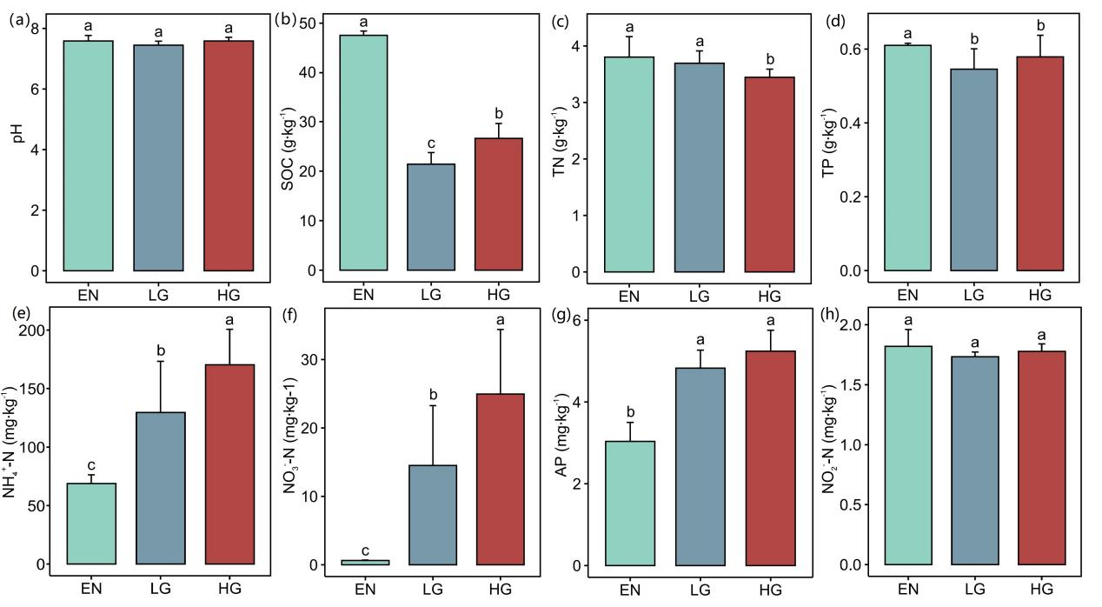
Fig. S1 Response of pH (a), SOC (b), TN (c), TP (d), NH₄⁺-N (e), NO₃⁻-N (f), AP (g) and NO₂⁻-N (h) in BSCs to grazing intensity (Tukey's HSD test, p < 0.05). Abbreviations: SOC, soil organic carbon; TN, total nitrogen; TP, total phosphorus; NH₄⁺-N, ammonium nitrogen; NO₃⁻-N, nitrate nitrogen; AP, available phosphorus; NO₂⁻-N, nitrite nitrogen. EN (Enclosure), LG (Light grazing), and HG (Heavy grazing).
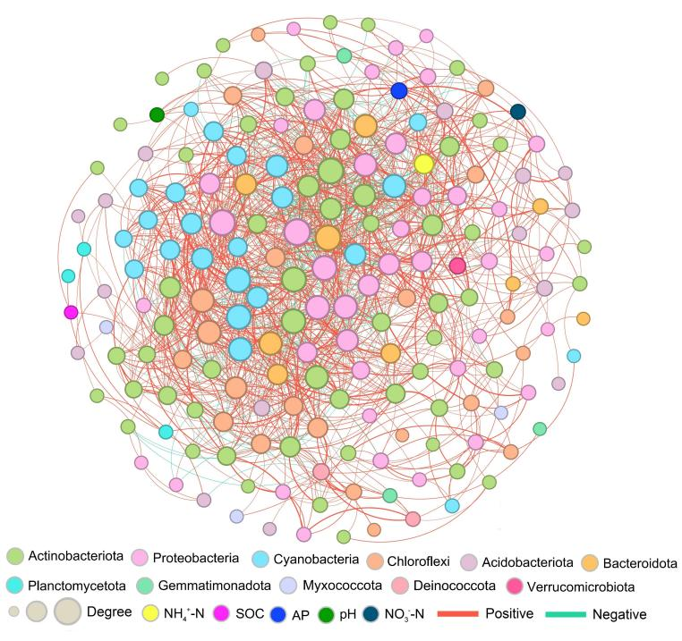
Fig. S2 Co-occurrence network of BSC physicochemical properties and bacterial communities. A connection represents a strong correlation (Spearman’s |r| ≥ 0.7) and significant correlation (p < 0.01). The size of each node indicates its connectivity with other components.
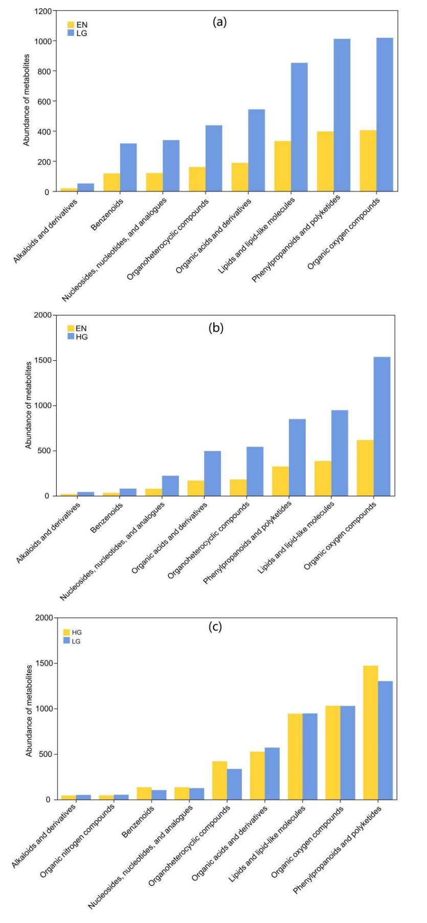
Fig. S3 Abundance of differential metabolites under different grazing intensities. EN (Enclosure), LG (Light grazing), and HG (Heavy grazing).
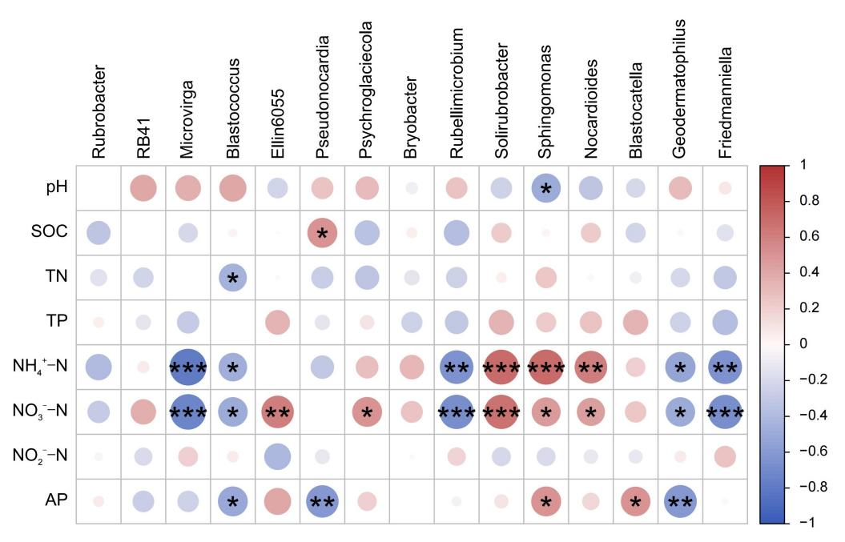
Fig. S4 Pearson correlation between physicochemical properties of BSCs and the top 15 bacterial genera. Abbreviations: SOC, soil organic carbon; TN, total nitrogen; TP, total phosphorus; NH₄⁺-N, ammonium nitrogen; NO₃⁻-N, nitrate nitrogen; AP, available phosphorus; NO₂⁻-N, nitrite nitrogen. *p < 0.05, **p < 0.01, ***p < 0.001.

