Supporting Information for

A regional distribution of soil alkaline phosphatase (phoD) gene harbouring bacteria across Qinghai-Tibet Plateau
Lin Xu^{1 #}, Jiabao Li^{2 #}, Chaonan Li³, Yongping Kou², Minjie Yao¹, Changting Wang^{4*}, Weidong Kong⁵, Junming Wang⁶, Xiangzhen Li^{1*}
¹ Engineering Research Center of Soil Remediation of Fujian Province University, College of Resources and Environment, Fujian Agriculture and Forestry University, Fuzhou 350002, China
²Key Laboratory of Environmental and Applied Microbiology, CAS; Environmental Microbiology Key Laboratory of Sichuan Province, Chengdu Institute of Biology, Chinese Academy of Sciences, Chengdu 610041, China
³ Ecological Security and Protection Key Laboratory of Sichuan Province, Mianyang Normal University, Mianyang, 621000, PR China;
⁴Institute of Qinghai-Tibet Plateau, Southwest Minzu University, Chengdu 610041, China
⁵Key Laboratory of Alpine Ecology, Institute of Tibetan Plateau Research, Chinese Academy of Sciences, Beijing, 100101, China
⁶Section of Climate Science, Illinois State Water Survey, Prairie Research Institute, University of Illinois at Urbana-Champaign, Champaign, IL 61802, USA
*Correspondence:
Changting Wang, E-mail:wangct@swun.edu.cn
Xiangzhen Li, E-mail: lixz@fafu.edu.cn
# Both authors contributed equally to this work
Post address: Fujian Agriculture and Forestry University, 15 Shangxiadian Road, Cangshan district, Fuzhou, 35002, P.R. China
Telephone: +86–13550130410, E–mail: lixz@fafu.edu.cn

This file includes:
Appendix S1: Extended Figures S1−S13
Appendix S2: Extended Tables S1−S2

S1 Extended Figures
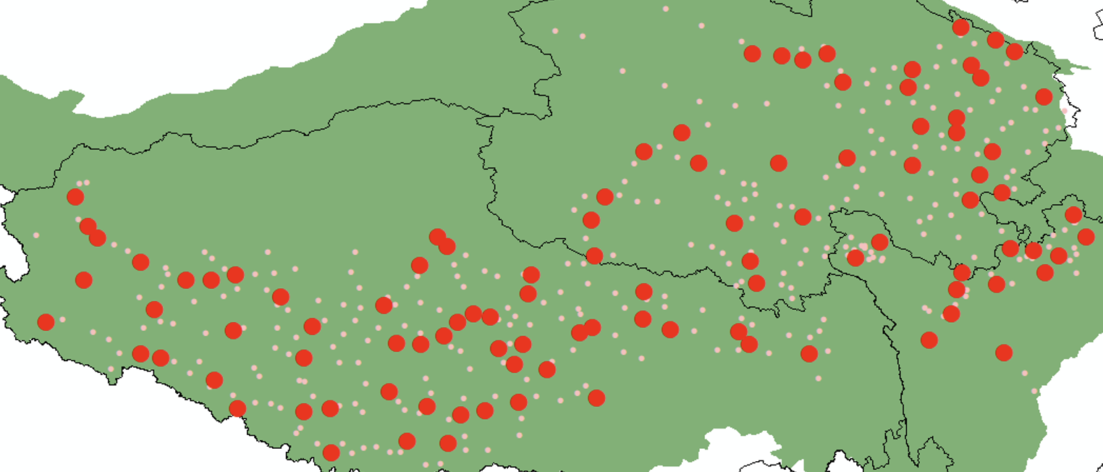
FIGURE S1 Locations of sampling sites across Qinghai-Tibet Plateau. Small pink points represent all samples, and large red points represent those samples selected for organic P and alkaline phosphatase activity measuring. For detailed location of the sampling area, please refer to Fig. 1 of our previous study (Li et al., 2024).

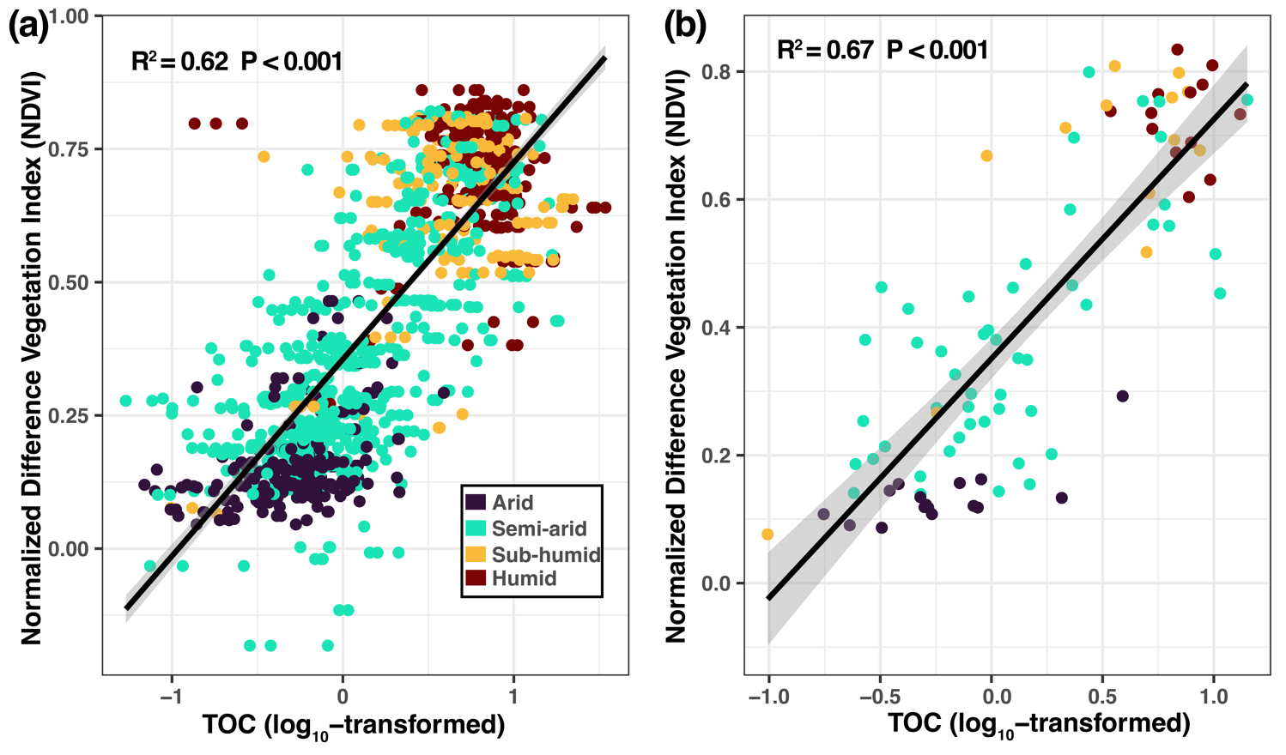
FIGURE S2 Similar explanation power of soil total organic C (TOC) to normalized difference vegetation index (NDVI) using all (a) and selected samples (b). Arid, AI ≤ 0.2; semi-arid, 0.2 < AI ≤ 0.5; sub-humid, 0.5 < AI ≤ 0.65; humid, AI > 0.65.

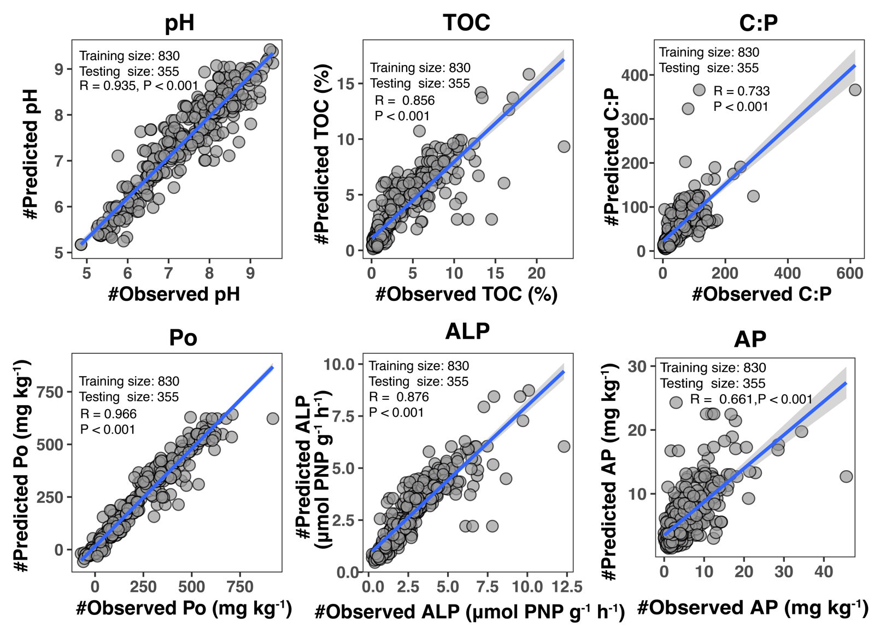
FIGURE S3 Performances of the random forest models in predicting the geographic distribution of major soil properties. The R (Pearson correlation rho) and P values indicate the strength of the correlation and its significance between the real values in the testing dataset and the predicted values generated by the random forest models. TOC, total organic C; C:P, soil C to P ratio; Po, organic P; ALP, alkaline phosphatase activity; AP, available P.
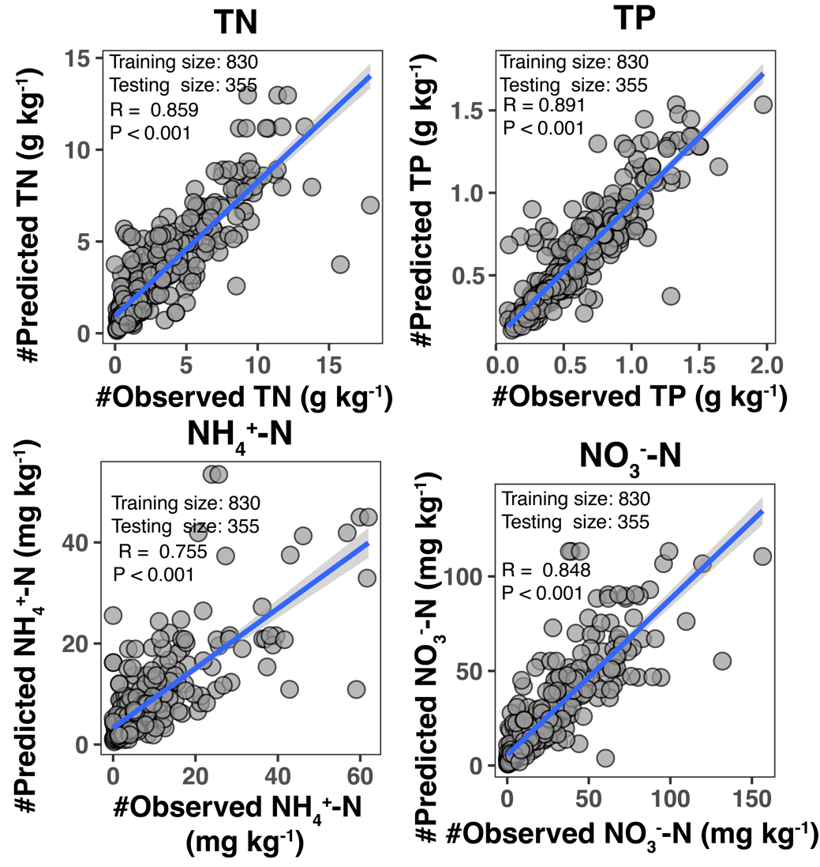
FIGURE S4 Performances of the random forest models in predicting the geographic distribution of other soil properties. The R (Pearson correlation rho) and P values indicate the strength of the correlation and its significance between the real values in the testing dataset and the predicted values generated by the random forest models. TN, total N; TP, total P; NH₄⁺-N, ammonium N; NO₃⁻-N, nitrate N.

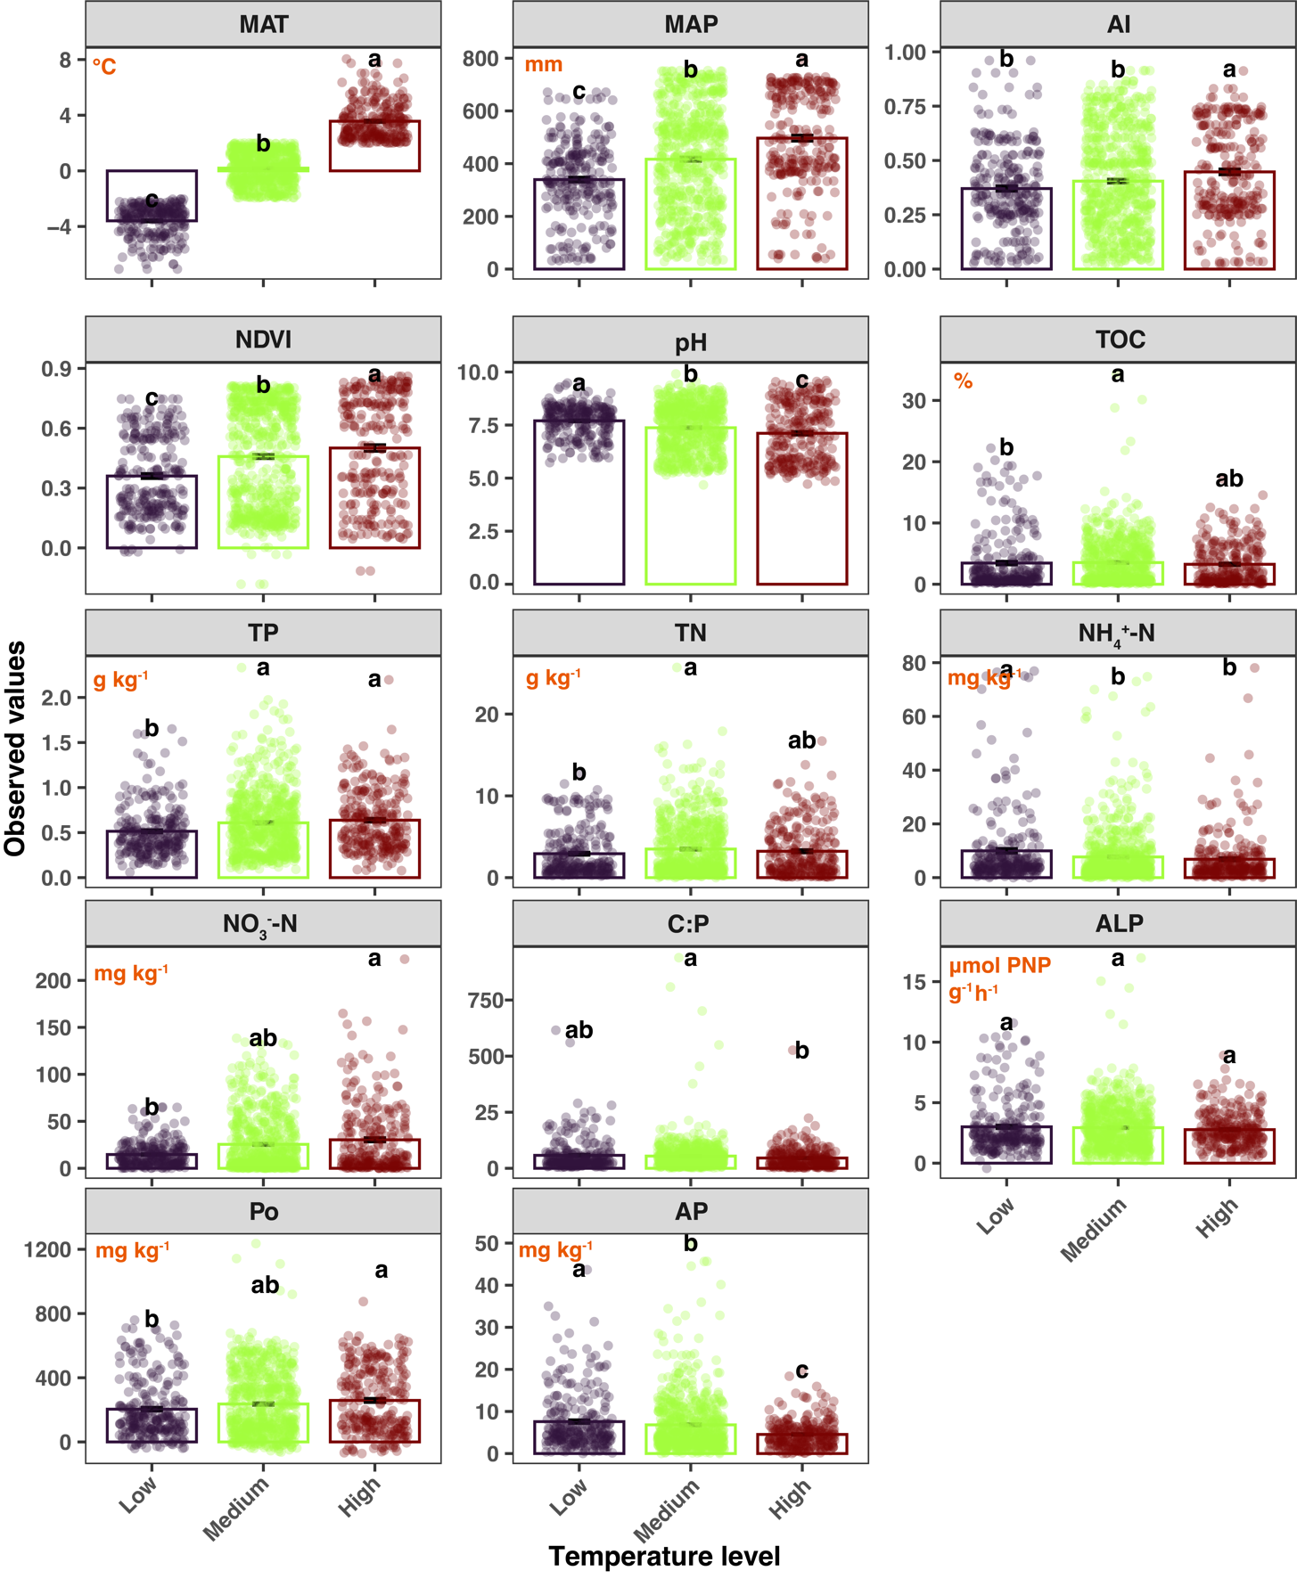
FIGURE S5 Differences of climate, vegetation and soil properties among temperature levels. Different lowercase letters denote significant differences determined by the Kruskal-Wallis test at a significance level of P < 0.05. MAT, mean annual temperature; MAP, mean annual precipitation; AI, aridity index; NDVI, normalized difference vegetation index; TOC, total organic C; TN, total N; TP, total P; NH₄⁺-N, ammonium N; NO₃⁻-N, nitrate N; C:P, soil C to P ratio; Po, organic P; ALP, alkaline phosphatase activity; Po, organic P; AP, available P.
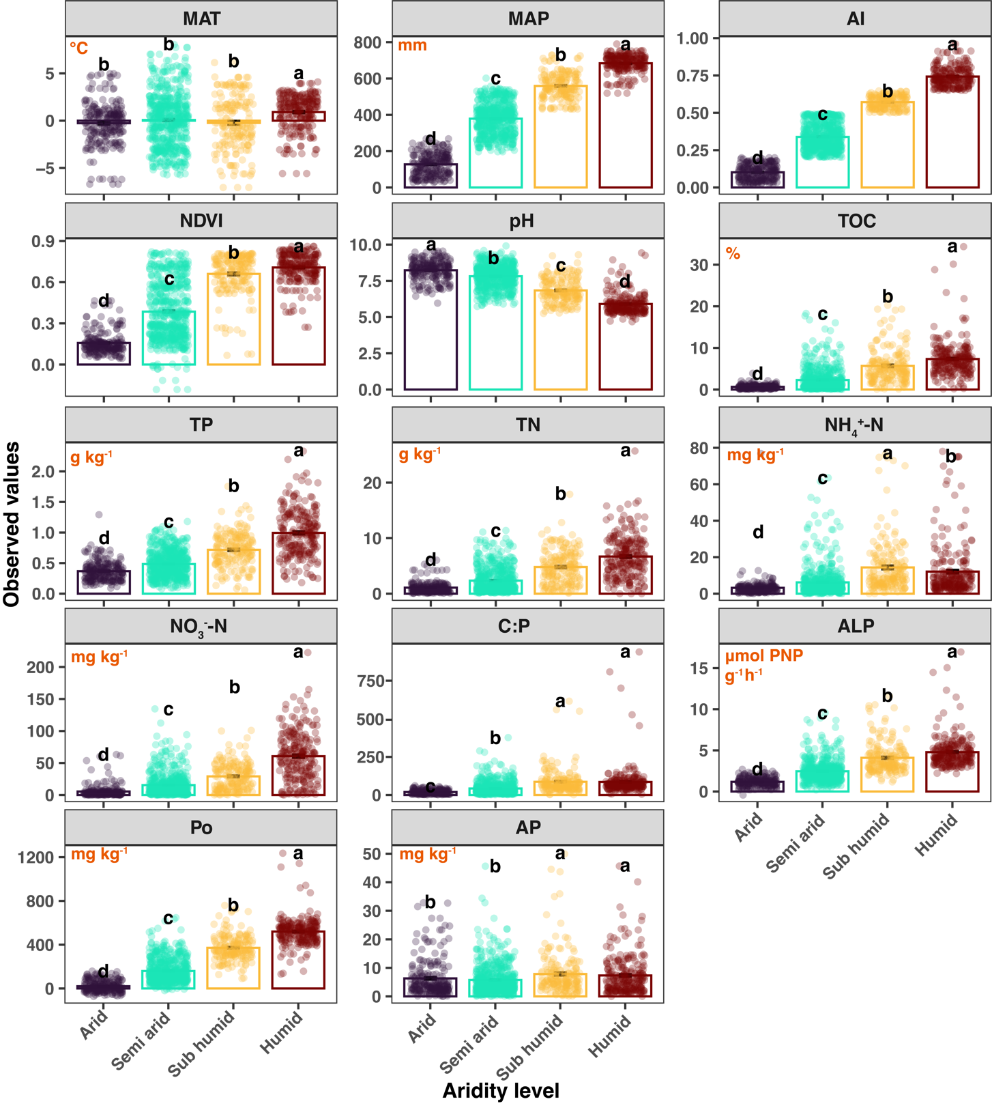
FIGURE S6 Differences of climate, vegetation and soil properties among aridity levels. Different lowercase letters denote significant differences determined by the Kruskal-Wallis test at a significance level of P < 0.05. MAT, mean annual temperature; MAP, mean annual precipitation; AI, aridity index; NDVI, normalized difference vegetation index; TOC, total organic C; TN, total N; TP, total P; NH₄⁺-N, ammonium N; NO₃⁻-N, nitrate N; C:P, soil C to P ratio; Po, organic P; ALP, alkaline phosphatase activity; Po, organic P; AP, available P.

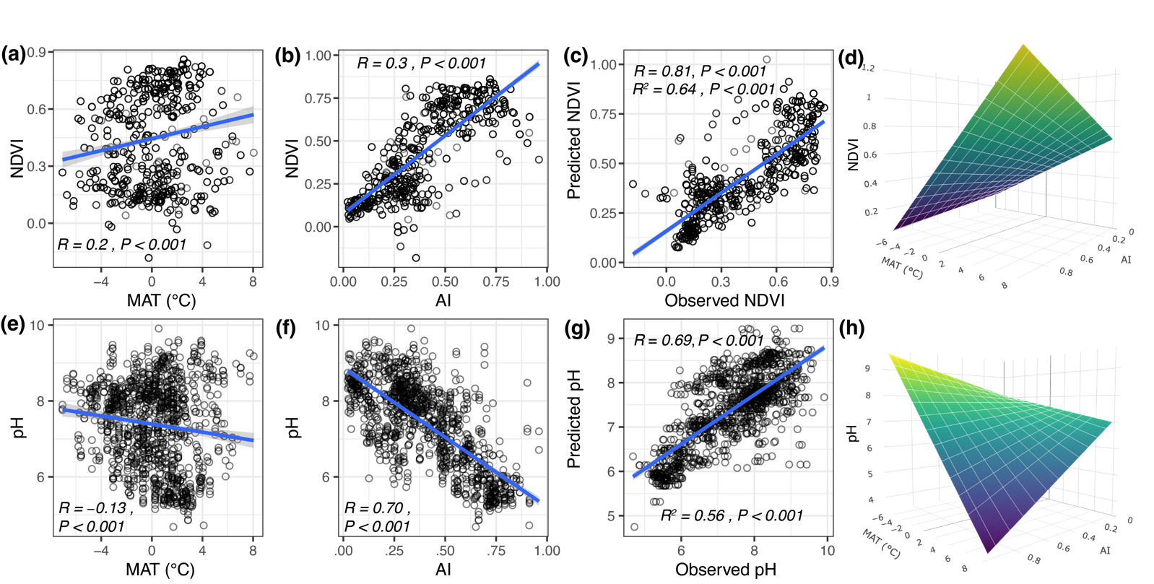
FIGURE S7 Relationships between mean annual temperature (MAT) and normalised difference vegetation index (NDVI) (a), NDVI and aridity index (AI) (b). The conjunction effects of increasing MAT and AI on NDVI (c) and (d) ((c) indicates the performance of 3D-surface model illustrated by (d)). Relationships between MAT and soil pH, AI and soil pH and the conjunction effects of increasing MAT and AI on soil pH are shown in (e) to (h), respectively. The R values represent the spearman correlation rho, and the R² values in (d) and (h) panels represent the goodness of regression model (“NDVI ~ MAT + AI + MAT:AI” and “pH ~ MAT + AI + MAT:AI”) used for the 3D-surface diagram in panel (d) and (h), respectively. The yellow colour means a higher NDVI (for panel (d)) or soil pH (for panel (h)) and the blue colour represents lower ones. P values in figure (d) and (h) represent the significance of MAT-AI interactions on NDVI and soil pH, respectively.

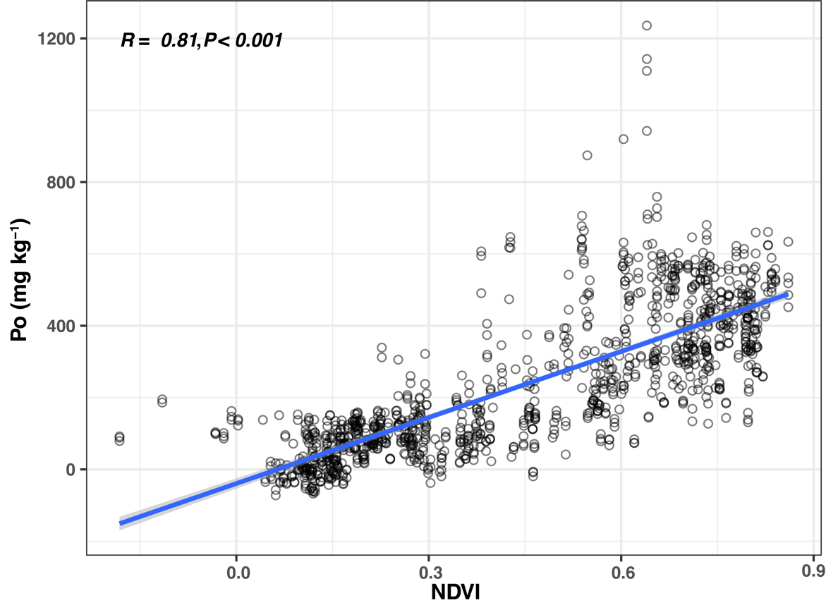
FIGURE S8 Highly positive correlation between normalised difference vegetation index (NDVI) and organic P (Po) content.
FIGURE S9 Mantel correlations between beta diversity of soil phoD-harbouring community and P-mineralisation parameters. Significance level ***, P < 0.001.

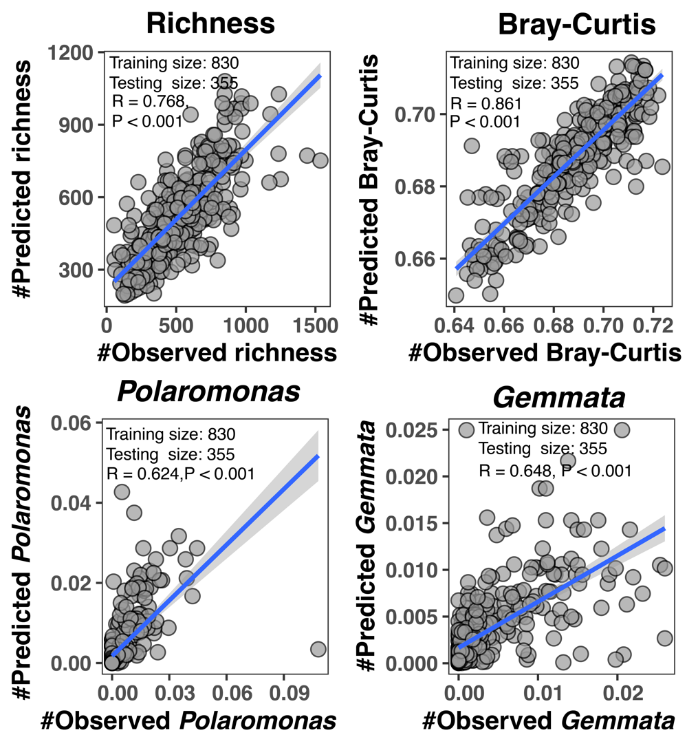
FIGURE S10 Performances of the random forest models in predicting the geographic distribution of richness, Bray-Curtis dissimilarity and relative abundances of key phoD-harbouring genera relating to organic P mineralisation. The R (Pearson correlation rho) and P values indicate the strength of the correlation and its significance between the real values in the testing dataset and the predicted values generated by the random forest models.

FIGURE S11 The performance of 3D-surface models illustrated in Figure 5. The R values represent the spearman correlation rho, and the R² values represent the goodness of regression model (“richness (or Bray-Curtis dissimilarity or Polaromonas/Gemmata abundance) ~ MAT + AI + MAT:AI” and “pH ~ MAT + AI + MAT:AI”) used for the 3D-surface diagrams. The yellow colour means a higher richness (or Bray-Curtis dissimilarity or Polaromonas/Gemmata abundance) and blue colour represents lower ones. P values represent the significance of MAT-AI interactions on richness (or Bray-Curtis dissimilarity or Polaromonas/Gemmata abundance).

FIGURE S12 Correlations between community parameters (including richness and relative abundances of key phoD-harbouring genera) of soil phoD-harbouring taxa and environmental (including climate, vegetation and soil properties) variables and mantel tests for the correlation between Bray-Curtis dissimilarity metric and the explanatory variable (a) and (b). The number in each block indicates Spearman’s correlation rho. All correlations are significant (P < 0.001) in case they are labelled with ns. For simplicity, only positive correlations with rho ≥ 0.60 are shown in panel (b).

FIGURE S13. Non-metric multidimensional scaling (NMDS) plot of phoD-harbouring bacterial communities coloured by soil organic P (Po) contents.

S2 Extended Tables
Table S1. Prediction of alkaline phosphatase activity (ALP) and organic P (Po) content using stepwise regression.
Models | R² | P
Po = 321.932 AI – 58.915 pH + 23.324 TOC + 457.861 | 0.810 | < 0.001
ALP = 3.591AI + 0.710 pH +0 .442 TOC –5 .321 | 0.607 | < 0.001
Climatic and edaphic factors are considered in each model. The initial model is Po/ALP ~MAT+AI+pH+TOC. P_{o}, Organic P (mg kg⁻¹); ALP (μmol PNP g⁻¹ h⁻¹), MAT, mean annual temperature (℃); AI, aridity index (unitless); OC, organic C content (%).

Table S2. Spearman’s correlations between P-mineralization parameters and the relative abundances of phoD-harbouring genera
Genera | C:P | ALP | Organic P | Bioavailable P
Polaromonas | 0.51*** | 0.55*** | 0.73*** | 0.17***
Gemmata | 0.55*** | 0.55*** | 0.71*** | 0.17***
Gemmatimonas | 0.46*** | 0.55*** | 0.59*** | 0.15***
Streptomyces | 0.53*** | 0.50*** | 0.58*** | 0.14***
Rhodoplanes | 0.54*** | 0.51*** | 0.69*** | 0.12***
Gimesia | 0.56*** | 0.56*** | 0.67*** | 0.11***
Phenylobacterium | 0.45*** | 0.42*** | 0.61*** | 0.10***
Methylobacterium | 0.51*** | 0.47*** | 0.70*** | 0.09**
Variovorax | 0.39*** | 0.41*** | 0.54*** | 0.09**
Pseudolabrys | 0.41*** | 0.40*** | 0.50*** | 0.09**
Notes:
1. Significance codes, ** , P < 0.01, ***, P < 0.001.
2. Only the top ten genera with relative abundances significantly (P < 0.01) correlated with all P-mineralization parameters are shown because we treated them as the key taxa detecting P limitation, secreting ALPs, transforming organic P into bioavailable P.
3. Bold fonts indicate relatively high correlation coefficients.

References
Li, C., Wang, C., Zou, P., Xu, L., Liao, H., Lan, N., . . . Li, X. (2024). Warming and wetting-induced soil acidification triggers methanotrophic diversity loss and species turnover in an alpine ecosystem. CATENA, 235, 107700. doi:https://doi.org/10.1016/j.catena.2023.107700

