Title: The role of local environmental heterogeneity in shaping soil mesofauna communities of Argentine high Andean wetlands
Authors: M. Fernanda Chiappero^{a,b*}, María V. Vaierettiª, Pablo A. Martínez^{c}, Andrea E. Izquierdoª
ªInstituto Multidisciplinario de Biología Vegetal (IMBIV), National University of Córdoba -CONICET, Vélez Sársfield Avenue 1666, 5016 Córdoba, Argentina
^{b}Instituto de Investigaciones en Biodiversidad y Medioambiente (INIBIOMA), National University of Comahue - CONICET, Quintral 1250, Bariloche, Argentina
^{c}National University of Mar del Plata

*Corresponding author at: Instituto de Investigaciones en Biodiversidad y Medioambiente (INIBIOMA)
Postal address: 8400, Bariloche, Argentina
Email-address: fernanda.chiappero@mi.unc.edu.ar
M. Fernanda Chiappero https://orcid.org/0000-0002-7769-7980
María V. Vaieretti https://orcid.org/0000-0003-4714-3183
Pablo A. Martinez https://orcid.org/0000-0002-3421-7676
Andrea E. Izquierdo https://orcid.org/0000-0003-0520-3248

Vega´s name | Name’s  code | Latitude (S) | Longitude (W) | Mean elevation  (m a.s.l.) | Area (ha)
Las Cuevas | VLC | -24.34951 | -66.02571 | 3323 | 1.4
Pozo Bravo | VPB | -25.51507 | -67.57711 | 3324 | 13.7
Las Quinuas | VLQ | -25.84924 | -67.91640 | 3437 | 6.6
Antofalla | VAT | -25.49578 | -67.62943 | 3503 | 34.0
San Antonio | VSA | -24.21049 | -66.31874 | 3749 | 6.9
Pasto Ventura | VPV | -26.68877 | -67.17905 | 3813 | 47.6
Tocomar abajo | VTA | -24.23909 | -66.41565 | 3960 | 0.8
Real Grande | VRG | -25.98766 | -25.98766 | 4192 | 25.5
Tocomar | VTO | -24.19967 | -66.54539 | 4323 | 82.9
Acay abajo | VAA | -24.44097 | -66.23323 | 4748 | 5.7
Table S1. Geographical location, mean elevation and size of the studied vegas.

Table S2. Mean relative abundance (standard error) of soil mesofauna taxa in vegas of the Argentine Puna. The feeding guild of each taxa (FG) is also showed. Vegas’ names: Las Cuevas (VLC), Pozo Bravo (VPB), Las Quinuas (VLQ), Antofalla (VAT), San Antonio (VSA), Pasto Ventura (VPV), Tocomar Abajo (VTA), Real Grande (VRG), Tocomar (VTO), Acay Abajo (VAA). D= detritivores, P=predators, H= herbivores, PA=parasites, PD=parasitoids. NI= no identified. n=5.
Taxa |  | FG | Vega
 |  | FG | VLC | VPB | VLQ | VAT | VSA | VPV | VTA | VRG | VTO | VAA
Oribatida | Banksinoma monoceros | D | 0 | 0 | 0 | 0 | 0.40(0.40) | 0 | 1(0) | 0 | 0 | 0
Oribatida | Cosmochthonius lanatus foveolatus | D | 0.40(0.40) | 0 | 0 | 0 | 0.20(0.20) | 0 | 0 | 0 | 0 | 0.40(0.24)
Oribatida | Hemileius suramericanus | D | 0 | 0 | 0 | 0 | 19(8.07) | 0 | 0 | 0.60(0.60) | 0.20(0.20) | 0
Oribatida | Hydrozetes sp. | D | 0 | 0 | 5.40(5.40) | 0 | 0 | 0 | 0 | 0 | 0 | 0
Oribatida | Jugatala montana | D | 0 | 0 | 0 | 0 | 0 | 0 | 0 | 1(1) | 0.40(0.40) | 0.40(0.40)
Oribatida | Mainothrus cf. aquaticus | D | 0 | 0 | 1.20(0.97) | 0 | 0 | 0 | 0 | 0 | 0 | 0
Oribatida | Malaconothrus aff. angulatus | D | 0 | 0 | 6.80(4.62) | 0 | 0 | 0 | 0 | 2(1.76) | 30.60(30.60) | 4(4)
Oribatida | Malaconothrus translamellatus | D | 3.40(3.40) | 0 | 13.20(13.20) | 0 | 8.20(8.20) | 2.60(2.36) | 0 | 1.20(1.20) | 90.60(76.62) | 7.20(2.96)
Oribatida | Mucronothrus nasalis | D | 0 | 0 | 1.60(1.60) | 0 | 0 | 0 | 0 | 0 | 0 | 0
Oribatida | Nothrus suramericanus | D | 0 | 0 | 0 | 0 | 0 | 0 | 0 | 0 | 4.40(4.40) | 4.20(4.20)
Oribatida | Oxyoppia (Oxyoppiella) suramericana | D | 0 | 0.20(0.20) | 0 | 0 | 6.60(5.63) | 0.60(0.24) | 0 | 0.40(0.40) | 3.80(2.37) | 0.80(0.58)
Oribatida | Platynothrus sp. | D | 0 | 0 | 0 | 0 | 0 | 0 | 0 | 0 | 0.20(0.20) | 0.20(0.20)
Oribatida | Podoribates foveolatus | D | 0 | 0 | 0 | 0 | 0 | 0.8(0.58) | 0 | 0 | 0 | 0
Oribatida | Tectocepheus velatus | D | 0 | 0 | 0 | 0 | 0 | 0.6(0.4) | 0 | 0 | 55(28.85) | 1.80(1.20)
Oribatida | Thrypochthonius breviclava | D | 0 | 0 | 1.60(1.36) | 0.20(0.2) | 0 | 0 | 0.20(0.20) | 5(2.53) | 17.20(14.39) | 0 0
Oribatida | Trimalaconothrus novus | D | 0 | 0 | 4.80(3.43) | 0 | 0 | 0 | 0 | 0 | 18.60(9.77) | 0.60(0.40)
Oribatida | Williamszetes elsosneadensis | D | 0 | 0 | 0 | 0 | 0 | 0 | 0 | 0 | 33.80  (19.29) | 0
Oribatida | Malaconothridae immatures | D | 3.40(2.91) | 0 | 0 0 | 0 | 0 | 0 | 0 | 0 | 0 | 0
Oribatida | No identified immatures | D | 0 | 0 | 21.80(9.99) | 0.80(0.37) | 56.80(32.3) | 2.40(1.94) | 0.80(0.58) | 2(0.95) | 135(64.94) | 22.40(17.97)
Astigmata |  | D | 1.20(0.49) | 1.40(0.51) | 1.20( 0.80) | 2.2(0.97) | 4.60(1.03) | 2.40(1.94) | 0.80(0.58) | 2(0.95) | 135(64.94) | 22.40(17.97)
Prostigmata | Eryophidae | H | 0 | 0 | 0 | 0 | 0.20(0.20) | 0 | 0 | 0 | 0 | 0
Prostigmata | Penthaleidae | H | 0 | 0 | 0 | 0 | 0 | 0 | 0 | 0 | 0.20(0.20) | 0.20(0.20)
Prostigmata | Tetranychidae | H | 0 | 0 | 0 | 0 | 2.80(2.56) | 0 | 0 | 0.20(0.20) | 0.20(0.20) | 0
Prostigmata | Hidracarid immatures | NI | 0.20(0.20) | 0 | 0 | 0 | 0 | 0 | 0 | 0 | 0 | 0
Prostigmata | Parasitengona larvae | PA | 0.80(0.58) | 0 | 0.20(0.20) | 0.40(0.40) | 0 | 0 | 0 | 0 | 4(2.12) | 0.20(0.20)
Prostigmata | Pyemotidae | PA | 0 | 0 | 0 | 0 | 3.40(1.36) | 0 | 0 | 0.60(0.60) | 0 | 0
Prostigmata | Trombellidae | P | 0 | 0 | 0 | 0 | 0 | 0 | 0 | 0 | 0.40(0.40) | 0
Prostigmata | Bdellidae | P | 0.40(0.24) | 0 | 0 | 0 | 0 | 0 | 0 | 0 | 0 | 0
Prostigmata | Cheyletidae | P | 0 | 0 | 0.20( 0.20) | 0.20(0.20) | 0 | 0 | 0 | 0 | 0 | 0
Prostigmata | Cunaxidae | P | 0.20(0.20) | 0 | 0.40(0.40) | 0.20(0.20) | 2.60(1.17) | 0.20(0.20) | 0.20(0.20) | 0 | 0.40(0.24) | 0.40(0.40)
Prostigmata | Erythraeidae | P | 0 | 0 | 0 | 0 | 0 | 0 | 0 | 0 | 0.6(0.6) | 0.20(0.20)
Prostigmata | Eupodidae | P | 0 | 0 | 0.20(0.20) | 0.20(0.20) | 0.40(0.24) | 0 | 0.20(0.20) | 0 | 0.6(0.24) | 0.20(0.20)
Prostigmata | Hidracarids | P | 1.20(0.97) | 0 | 0.40(0.40) | 0.20(0.20) | 0 0 | 0 | 0 | 0 | 0 | 0
Prostigmata | Pomerantziidae | P | 0 | 0 | 0 | 0 | 4.20(1.74) | 0 | 0 | 0 | 0 | 0
Prostigmata | Raghidiidae | P | 0 | 0 | 0 | 0 | 0 0 | 0 | 0.20(0.20) | 0.60(0.60) | 0 | 0.40(0.24)
Prostigmata | Raphignathidae | P | 0 | 0 | 0 | 0 | 0 0 | 0 | 0 | 0 | 0.20(0.20) | 0
Prostigmata | Scutacaridae | P | 0 | 0 | 0 | 0 | 0.8(0.58) | 0 | 0 | 2.80(2.80) | 0 | 0
Prostigmata | Stigmaeidae | P | 3.20(2.24) | 0 | 0.20(0.20) | 0 | 0.20(0.20) | 0.60(0.60) | 0 | 3(2.32) | 0.60(0.40) | 3.20(1.74)
Prostigmata | Tarsonemidae | P | 3(1.55) | 0.20(0.20) | 8.40(7.91) | 0 | 6.80(3.31) | 0 | 0 | 0 | 0.40(0.40) | 0 0
Prostigmata | Trombiculidae | P | 0 | 0 | 0 | 0 | 0 | 0 | 0 | 1.20(0.97) | 0.60(0.24) | 0.20(0.20)
Prostigmata | Tydeidae | P | 0 | 0 | 0.20(0.20) | 0 | 3.60(1.81) | 0 | 0 | 0 | 5.60(3.76) | 0
Prostigmata | No identified | NI | 0.20(0.20) | 0 | 0 0 | 0 | 1(0.77) | 0 | 0 | 0 | 0.20(0.20) | 0
Mesostigmata |  | P | 9.60(2.84) | 1.2(0.58) | 8.8(2.82) | 5.2(2.06) | 22(6.49) | 5.6(4.61) | 11(8.51) | 7.8(4.25) | 20.4(2.46) | 3(1.82)
Collembola |  | D | 81.4(26.89) | 0 | 1.4(0.68) | 0 | 45.4(5.61) | 4(2.76) | 2(1.05) | 1.4(1.4) | 27.8(11.73) | 17.4(3.72)
 | Diptera | D | 3.6(0.98) | 0.20(0.20) | 1.20(0.58) | 1(0.32) | 4.6(0.81) | 4.40(3.67) | 3.60(1.29) | 4.40(2.77) | 12(2.02) | 0.40(0.24)
 | Psocoptera | D | 1.20(0.37) | 0.40(0.24) | 0.40(0.24) | 0 | 0.40(0.40) | 0.20(0.20) | 0.60(0.40) | 0 | 1(0.55) | 0.80(0.58)
Insecta | Thysanoptera | D | 0 | 0.20(0.20) | 0 | 0 | 0.40(0.24) | 0 | 0 | 0.40(0.40) | 0.40(0.24) | 0.40(0.24)
 | Hemiptera | H | 0.20(0.20) | 0.60(0.40) | 0.20(0.20) | 0 | 4.60(1.96) | 0 | 0.20(0.20) | 0.20(0.20) | 16.40(10.20) | 1.20(0.97)
 | Hymenoptera | PD | 0 | 0 | 0 | 0 | 0.80(0.58) | 0 | 0 | 0 | 0 | 0
 | Coleoptera | NI | 0 | 0.60(0.40) | 0.20(0.20) | 0.20(0.20) | 2.40(0.87) | 0 | 0.20(0.20) | 0.20(0.20) | 0.40(0.24) | 0
Araneae |  | P | 0 | 0 | 0 | 0 | 0 | 0 | 0 | 0.20(0.20) | 1(0.32) | 0.20(0.20)
No identified |  | NI | 0 | 0 | 0 | 0.20(0.20) | 0 | 0 | 0 | 0 | 0 | 0

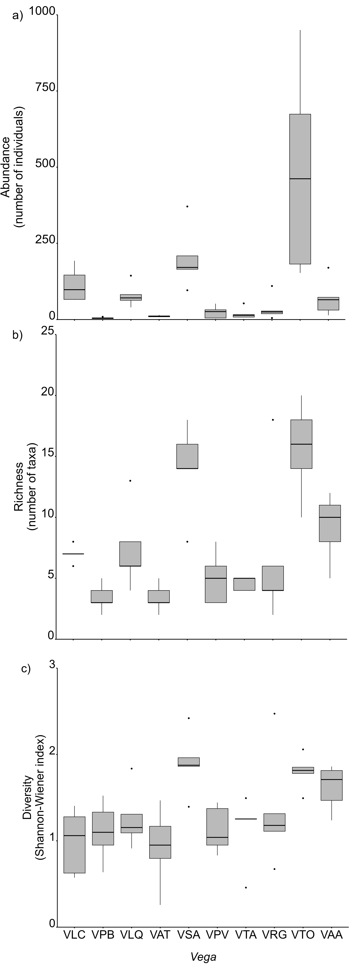
Figure S1. Boxplot graphics showing the variation in abundance (a), richness (b) and diversity (c) of soil mesofauna taxa in vegas of the Argentine Puna. Vegas’ names: Las Cuevas (VLC), Pozo Bravo (VPB), Las Quinuas (VLQ), Antofalla (VAT), San Antonio (VSA), Pasto Ventura (VPV), Tocomar Abajo (VTA), Real Grande (VRG), Tocomar (VTO), Acay Abajo (VAA).

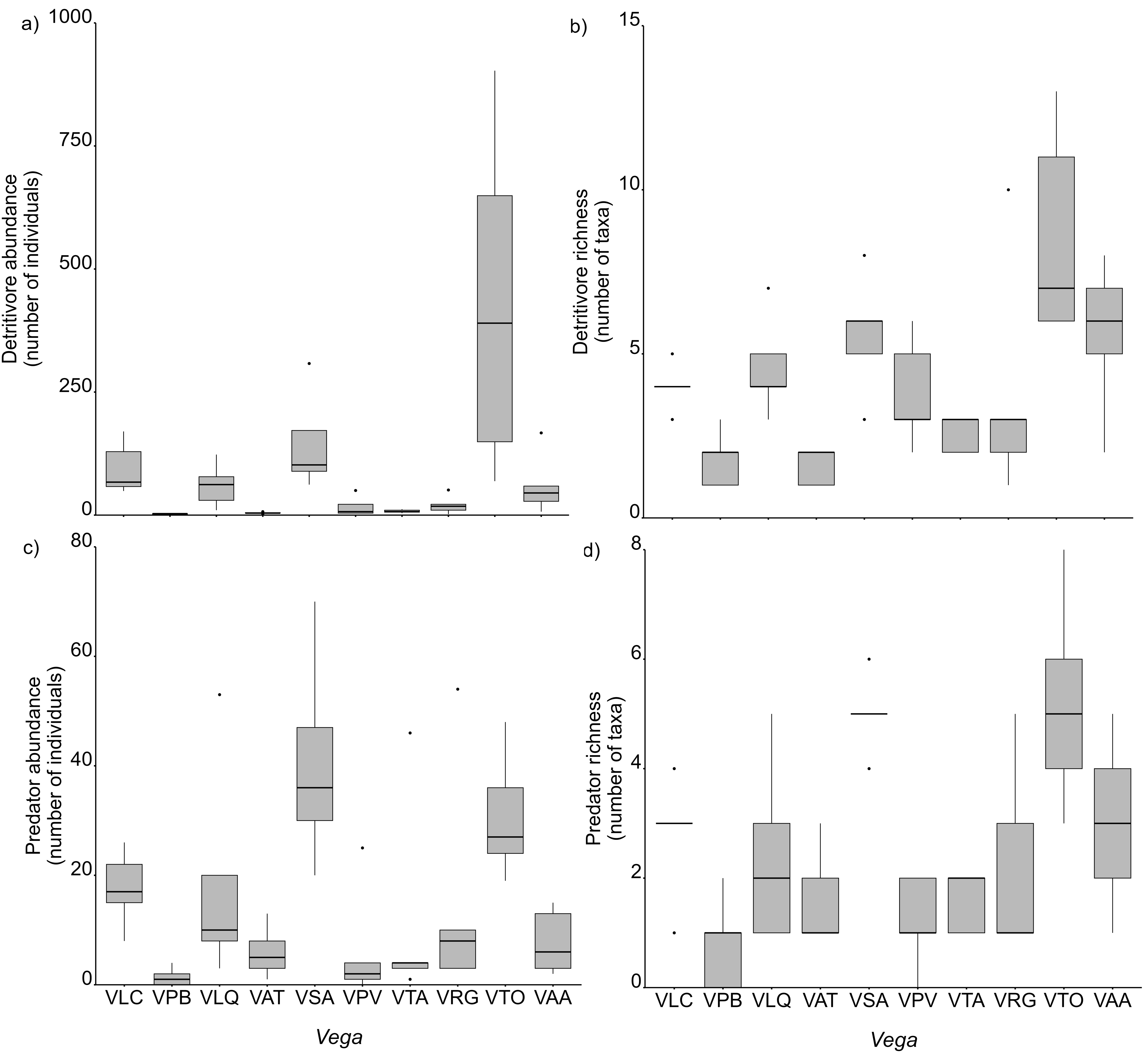
Figure S2. Boxplot graphics showing the variation in the abundance (a), richness (b) of detritivores and the abundance (c) and richness (d) of predators of soil mesofauna in vegas of the Argentine Puna. Vegas’ names: Las Cuevas (VLC), Pozo Bravo (VPB), Las Quinuas (VLQ), Antofalla (VAT), San Antonio (VSA), Pasto Ventura (VPV), Tocomar Abajo (VTA), Real Grande (VRG), Tocomar (VTO), Acay Abajo (VAA).

Table S3. Soil properties of the selected vegas of the Argentine Puna. Means (±standard error) are given (n=5). Vegas’ names: Las Cuevas (VLC), Pozo Bravo (VPB), Las Quinuas (VLQ), Antofalla (VAT), San Antonio (VSA), Pasto Ventura (VPV), Tocomar Abajo (VTA), Real Grande (VRG), Tocomar (VTO), Acay Abajo (VAA). EC= electrical conductivity; CEC= cation exchange capacity; OM=organic matter; C:N= carbon to nitrogen ratio.
Soil properties | Vega
Soil properties | VLC | VPB | VLQ | VAT | VSA | VPV | VTA | VRG | VTO | VAA
pH | 6.2(0.09) | 8.3(0.08) | 7.6(0.23) | 7.2(0.39) | 8.9(0.37) | 8.5(0.26) | 6.3(0.34) | 7.0(0.40) | 6.9(0.12) | 6.6(0.04)
EC (µS cm⁻¹) | 2949.4(817.5) | 19850.0(4032.6) | 850.4(132.9) | 1731.6(665.6) | 1467.2(168.0) | 1395.6(550.7) | 210.4(11.2) | 948.4(432.2) | 497.4(41.6) | 312.6(43.5)
N (%) | 1.3(0.05) | 0.2(0.04) | 0.5(0.08) | 0.4(0.08) | 0.4(0.04) | 0.3(0.02) | 0.1(0.01) | 0.6(0.13) | 0.6(0.10) | 0.5(0.11)
P (mg kg⁻¹) | 0.3(0.10) | 0.2(0.00) | 11.8(5.15) | 15.9(10.33) | 0.2(0.00) | 0.3(0.08) | 7.5(2.35) | 3.8(1.47) | 72.4(16.10) | 3.1(2.37)
CEC (mg kg⁻¹) | 53.1(2.11) | 10.8(0.97) | 16.8(2.15) | 29.4(5.92) | 17.3(2.87) | 17.86(1.15) | 8.8(1.11) | 21.2(3.98) | 55.3(9.58) | 34.8(5.38)
K (mg kg⁻¹) | 1.9(0.49) | 1.6(0.27) | 1.1(0.24) | 1.9(0.37) | 1.6(0.35) | 1.7(0.17) | 0.5(0.04) | 0.7(0.24) | 5.2(0.91) | 1.2(0.11)
Ca (mg kg⁻¹) | 36.5(4.10) | 42.7(12.61) | 17.1(2.43) | 20.9(1.99) | 28.3(2.99) | 28.8(3.52) | 13.6(2.83) | 19.8(6.33) | 16.6(2.47) | 18.9(3.49)
Mg (mg kg⁻¹) | 12.6(2.74) | 8.9(1.33) | 3.2(1.40) | 4.5(1.47) | 9.1(1.69) | 2.8(2.71) | 3.7(1.19) | 0.5(0.24) | 5.4(1.46) | 8.2(2.45)
OM (%) | 40.7(5.96) | 6.7(0.53) | 11.1(1.42) | 16.6(7.37) | 9.7(2.03) | 11.1(0.99) | 2.2(0.20) | 17.5(5.55) | 84.9(0.92) | 20.3(4.49)
C:N | 18.8(2.55) | 16.5(1.31) | 15.4(1.78) | 23.4(7.18) | 14.4(2.14) | 18.9(2.26) | 21.2(2.54) | 17.0(1.73) | 87.3(11.29) | 20.8(1.13)
Water content (%) | 79.26(79.26) | 37.51(2.11) | 62.22(3.74) | 57.10(9.50) | 34.0(6.60) | 41.93(4.31) | 25.95(1.07) | 51.80(5.25) | 87.31(1.08) | 58.33(9.55)

Table S4. Percentage (%) of plant total cover, bare soil and different life forms cover of the selected vegas of the Argentine Puna. Means (±standard error) are given (n=5). Vegas’ names: Las Cuevas (VLC), Pozo Bravo (VPB), Las Quinuas (VLQ), Antofalla (VAT), San Antonio (VSA), Pasto Ventura (VPV), Tocomar Abajo (VTA), Real Grande (VRG), Tocomar (VTO), Acay Abajo (VAA).

Variable | Vega
Variable | VLC | VPB | VLQ | VAT | VSA | VPV | VTA | VRG | VTO | VAA
Total plant cover | 118.4(7.10) | 78.9(8.61) | 96.2(2.13) | 84.4(8.40) | 115(8.82) | 92.8(3.22) | 125.3(10.26) | 89.7(8.28) | 117.0(6.82) | 107.2(7.91)
Bare soil cover | 0 | 19.0(7.40) | 0 | 0 | 3.4(1.44) | 4.4(1.03) | 0 | 9.8(8.35) | 0 | 0.1(0.10)
Algae | 0 | 0 | 0 | 0 | 0 | 0 | 1.2(0.97) | 0 | 0 | 0
Bryophytes | 0 | 0 | 0 | 0 | 0 | 0 | 0 | 0 | 0 | 2.8(1.85)
Shrubs | 0 | 19(8.1) | 0.2(0.2) | 0 | 0 | 0 | 0 | 0 | 0 | 0
Forbs | 7.6(2.01) | 4.8(3.09) | 33.8(3.34) | 20.2(6.05) | 49.4(14.74) | 3(2.14) | 72.1(9.61) | 23.6(12.08) | 4(4.0) | 10.8(3.18)
Cushions | 0 | 0 | 0 | 0 | 0 | 39.2(12.2) | 0 | 11.2(5.72) | 71(5.01) | 36(9.31)
Grasses | 44.8(11.38) | 0.2(0.2) | 16.2(2.24) | 25.2(9.63) | 27.2(12.45) | 24.8(9.50) | 0 | 10.8(6.60) | 20.8(6.26) | 53.8(12.54)
Graminoids | 66.0(12.19) | 54.9(14.76) | 46.0(3.18) | 39.0(8.53) | 38.4(5.87) | 25.8(7.30) | 52.0(11.57) | 44.1(13.41) | 21.2(9.95) | 3.8(1.85)

