Supplementary materials

Vermicompost enhances the amendment efficacy of biochar in severely saline-alkaline soil through biological reinforcement

2.7 Statistical analysis supplementary materials.
Statistical analyses such as Principal Component Analysis (PCA) and membership function analysis.
Dividing each principal component load vector by the arithmetic square root of its corresponding eigenvalue yields the coefficients for each indicator in the two principal components (F1 and F2).
Following dimensionality reduction via factor analysis in SPSS, the comprehensive score model F is derived:
F = (r1/r) × F1 + (r2/r) × F2
where F denotes the comprehensive indicator value, r1 and r2 represent the contribution rates of Principal Components 1 and 2, respectively, and r is the cumulative eigenvalue of both components.
Membership Function Analysis: For each treatment, compute the membership function values based on the comprehensive indicator values (F). Subsequently, determine the weights using the contribution rates of each comprehensive indicator. Ultimately, derive the comprehensive evaluation value from these membership function values and weights. The membership function value is expressed as:
μ(Fi) = (Fi - Fmin) / (Fmax - Fmin)
where denotes the i-th comprehensive indicator (i=1, 2, 3, …, n), Fmax is the maximum value of Fi, and Fmin is the minimum value of Fi.
The weight calculation is given by:
Wi = Pi / ΣPi, i = 1, 2, 3, …, n.
where Pi denotes the contribution rate of the i-th comprehensive indicator for various lettuce varieties.
The comprehensive evaluation index D is calculated as:
D = Σ[μ(Fi) × Wi], i = 1, 2, 3, …, n.

Table S1
Table S1 Principal component score coefficient list, contribution rate and cumulative contribution
Index variables | Print 1 | Print 2
K⁺ | 0.099 | 0.028
Ca²⁺ | -0.08 | 0.204
Mg²⁺ | -0.095 | 0.099
Organic matter | 0.099 | -0.01
Total-N | 0.099 | 0.031
Olsen-P | 0.097 | 0.061
Large-macroaggregeta (>2 mm) | 0.099 | 0.005
Small-macroaggregeta (>0.25 mm) | 0.086 | 0.168
Na⁺ | -0.097 | 0.076
pH | -0.094 | 0.107
Proteobacteria | 0.08 | 0.204
Firmicutes | 0.037 | -0.32
Only species_num | 0.041 | 0.314

Table S2
Table S2. Effects of different treatments on 10-20cm and 20-30cm soil pH, water-soluble Na⁺, water-soluble K⁺, water-soluble Mg²⁺, water-soluble Ca²⁺, CI⁻, HCO₃⁻ and SO₄²⁺.
 | Treatment | pH | Cation content (mg kg⁻¹) |  |  |  | Anion content (mg kg⁻¹)
 | Treatment | pH | Na⁺ | K⁺ | Mg²⁺ | Ca²⁺ | Cl⁻ | HCO₃⁻ | SO₄²⁻
10-20cm | CK | 8.65 ± 0.04a | 4.36 ± 0.11a | 49.34 ± 1.76d | 141.00 ± 6.50a | 170.07 ± 4.65a | 3.53 ± 0.14a | 41.68 ± 2.29a | 276.32 ± 9.85b
10-20cm | B | 8.51 ± 0.06b | 4.32 ± 0.44a | 179.17 ± 4.05a | 124.80 ± 5.60b | 165.43 ± 2.75a | 3.86 ± 0.14a | 35.58 ± 0.98b | 335.65 ± 23.16a
10-20cm | VB | 8.50 ± 0.05b | 4.20 ± 0.69a | 169.40 ± 7.45a | 106.43 ± 8.65c | 171.07 ± 11.37a | 3.58 ± 0.35a | 41.67 ± 1.13a | 309.89 ± 4.28a
20-30cm | CK | 8.72 ± 0.05a | 8.56 ± 0.34b | 81.88 ± 1.65c | 312.03 ± 8.53c | 332.77 ± 10.44c | 6.84 ± 0.11b | 41.38 ± 0.47b | 658.77 ± 10.99b
20-30cm | B | 8.48 ± 0.03c | 10.14 ± 0.54a | 268.13 ± 1.12b | 349.60 ± 13.39b | 367.17 ± 22.74b | 6.45 ± 0.29b | 57.54 ± 2.08a | 682.65 ± 23.19ab
20-30cm | VB | 8.58 ± 0.02b | 8.22 ± 0.41b | 310.50 ± 15.44a | 398.50 ± 7.36a | 564.80 ± 9.80a | 8.11 ± 0.23a | 44.84 ± 4.23b | 726.61 ± 28.88a

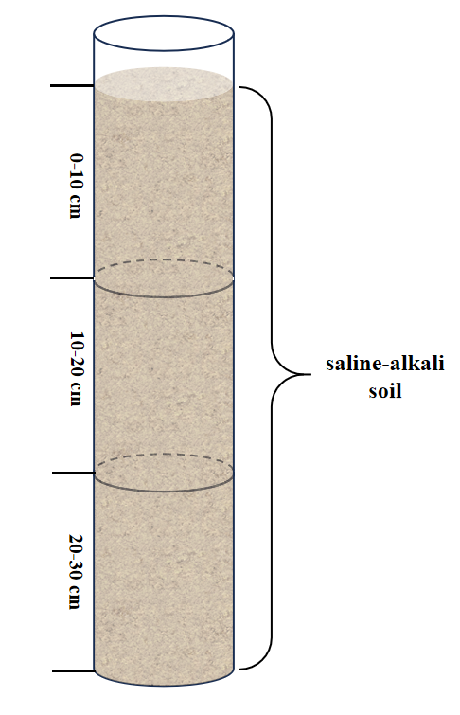
Figure S1. Equipment schematic diagram of soil column test.

