Supplementary material

Linking Microbial Diversity and Network Complexity to Soil Multifunctions in Tianshan Mountains
Ning Wang^{a,b}, Junhui Chengª, Yunhua Liuª, Xuewei Wangª, Ye Deng^{c}, Gang Wang^{a,d}, Jiandong Sheng^{a,} *

ª Xinjiang Key Laboratory of Soil and Plant Ecological Processes, College of Resources and Environment, Xinjiang Agricultural University, 311 Nongda East Road, Urumqi, 830052, Xinjiang, China
^{b} Institute of Food Science and Technology, Xinjiang Academy of Agricultural Sciences, Urumqi, Xinjiang Uygur Autonomous Region 830091, China
^{c} State Key Laboratory of Regional Environment and Sustainability, Research Center for Eco-Environmental Sciences, Chinese Academy of Sciences, Beijing, China
^{d} Department of Soil and Water Sciences, China Agricultural University, Beijing 100193, China

*Corresponding author: Jiandong Sheng,
E-mail address: sjd@xjau.edu.cn
Supplementary Fingers and Table List
Finger S1 Relationships between soil multifunctionality and microbial β-diversity across bacterial and fungal communities.
Finger S2 Relationships between soil multifunctionality and network complexity.
Figure S3. Rarefaction curves for bacterial and fungal communities are based on the observed OTUs.
Table S1 Key topological properties of bacterial-fungal co-occurrence networks in the soil among the grassland type.

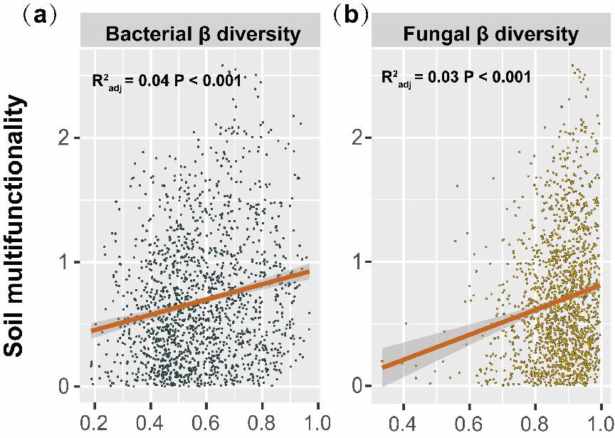

Finger S1. Relationships between soil multifunctionality and microbial β-diversity across (a) bacterial and (b) fungal communities.
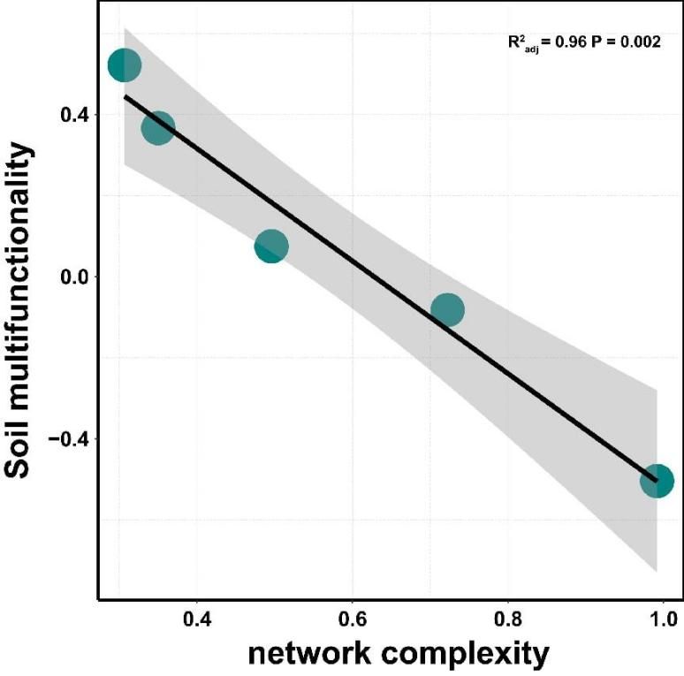
Finger S2. Relationships between soil multifunctionality and network complexity.

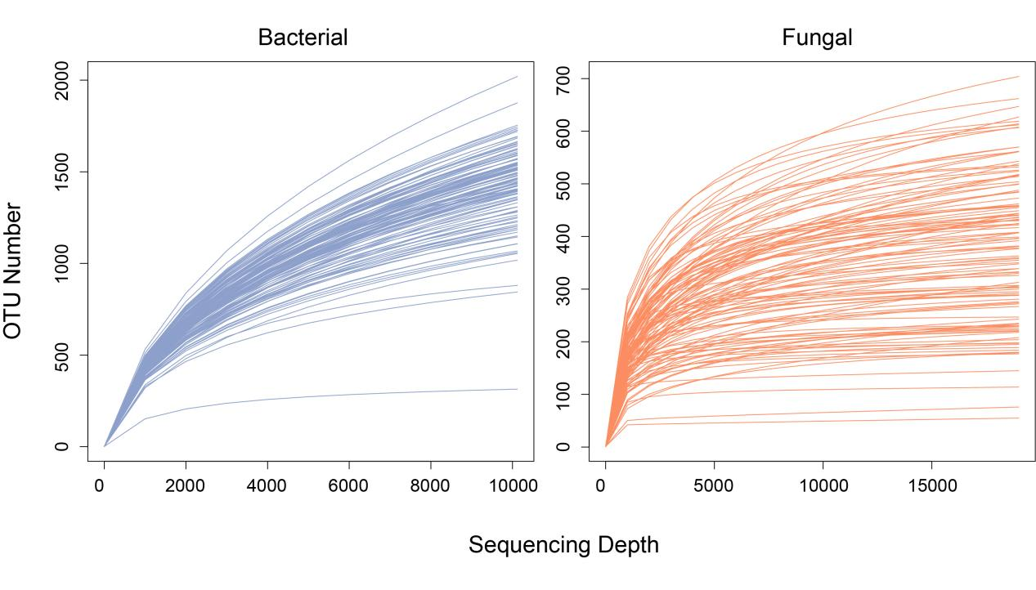

Figure S3. Rarefaction curves for bacterial and fungal communities are based on the observed OTUs.

Table S1 Key topological properties of bacterial-fungal co-occurrence networks in the soil among the grassland type

 | Topological properties | Temperate desert  (TD) | Temperate steppe  (TS) |  | Temperate meadow steppe  (TMS) | Mountain meadow  (MM) | Alpine meadow  (AM)
Empirical networks | Nodes  (Bacteria and Fungi nodes /%) | 759  (80.76, 19.24) | 878  (78.59, 21.41) |  | 539  (81.26, 18.74) | 541  (77.63, 17.38) | 732  (83.61, 16.39)
Empirical networks | Total links  (Positive and Negative links /%) | 9878  (49.46, 50.54) | 9331  (45.90, 54.10) |  | 2008  (48.16,51.84) | 1697  (51.68, 48.32) | 4199  (52.51, 47.49)
Empirical networks | Linkage density | 81.743 | 85.206 |  | 24.607 | 29.777 | 31.392
Empirical networks | Connectance | 0.11 | 0.072 |  | 0.045 | 0.043 | 0.057
Empirical networks | Average degree (avgD) | 26.029 | 21.255 |  | 7.451 | 6.603 | 11.437
Empirical networks | Average path length (APL) | 3.095 | 3.262 |  | 3.754 | 3.792 | 3.465
Empirical networks | Average clustering coefficient (avgCC) | 0.063 | 0.060 |  | 0.055 | 0.063 | 0.075
Empirical networks | Modularity (MOD) | 0.288 | 0.266 |  | 0.454 | 0.413 | 0.405
Empirical networks | Module number | 4 | 13 |  | 14 | 18 | 5
Empirical networks | Niche overlap (Bacteria and Fungi) | 0.110, 0.142 | 0.057, 0.130 |  | 0.044, 0.067 | 0.033, 0.082 | 0.064, 0.065
Empirical networks | Robustness (Bacteria and Fungi) | 0.855, 0.926 | 0.830, 0.866 |  | 0.736, 0.867 | 0.710, 0.816 | 0.811, 0.957
Empirical networks | Functional complementarity  (Bacteria and Fungi) | 891, 1613 | 983, 1802 |  | 435, 712 | 360, 604 | 706, 1278
Random networks | Modularity (MOD) | 0.121 ± 0.002 | 0.135 ± 0.002 |  | 0.302 ± 0.003 | 0.316 ± 0.003 | 0.233 ± 0.003
Random networks | Average clustering coefficient (avgCC) | 0.062 ± 0.000 | 0.020 ± 0.000 | 0.030 ± 0.000 |  | 0.018 ± 0.000 | 0.044 ± 0.000
Mean and S.E. based on 100 randomized networks results.

