SUPPLEMENTARY INFORMATION
Spatiotemporal Dynamics and Driving Factors of Soil Organic Carbon Storage in the Yangtze River Basin Under Climate Change and Land Use Scenarios

Yangtze Basin SOC under Land-Use/Climate Scenarios

Yu-Qian Liu^{a,b}, Xiao Tan^{b}, Gui-Lan Duan^{b,c*}

ªHenan Institute of Advanced Technology, Zhengzhou University, Zhengzhou 450052, China
^{b}State Key Lab of Urban and Regional Ecology, Research Center for Eco-Environmental Sciences, Chinese Academy of Sciences, Beijing 100085, China
^{c}University of Chinese Academy of Sciences, Beijing 100049, China

*Corresponding author:
Gui-Lan Duan, email: duangl@rcees.ac.cn, ORCID: 0000-0002-2880-5017,
postal address: 18 Shuangqing Road, Haidian District, Beijing, China (100085), Research Center for Eco-Environmental Sciences, Chinese Academy of Sciences.
Appendix S1 AI models
Random Forest (RF): RF is an ensemble learning method that improves model accuracy and stability by constructing multiple decision trees and combining their predictions. Each tree is trained using different subsets of data and features. Advantages include high accuracy and robustness, the ability to handle high-dimensional data and missing values, and reduced risk of overfitting (Biau, 2012; Schonlau & Zou, 2020).
Support Vector Machine (SVM): SVM is a supervised learning algorithm that finds an optimal hyperplane in a high-dimensional space to maximize the margin between different classes for classification. Advantages include effectiveness in high-dimensional spaces, the ability to handle non-linear classification problems, and good generalization performance (Mosaid et al., 2024; Wang, Zhang et al., 2023)
Gradient Boosting Regression Trees (GBRT): GBRT is an ensemble method that sequentially builds multiple weak predictive models (such as shallow decision trees), with each model attempting to correct the errors of the previous one. Advantages include high predictive accuracy, the ability to handle complex non-linear relationships, and strong performance in many tasks (Huang et al., 2019; Yang et al., 2022).
Long Short-Term Memory networks (LSTM): LSTM is a type of recurrent neural network (RNN) capable of learning and remembering long-term dependencies in sequential data, making it particularly suitable for time series prediction and natural language processing. Advantages include effective handling of long sequences, avoidance of the vanishing gradient problem in traditional RNNs, and strong performance in sequence data tasks (Tian & Chen, 2022).
Extra Trees Regressor (ETR): ETR is an extremely randomized trees regressor that reduces model variance by randomly selecting features and split points when constructing decision trees (Nasseri et al., 2023). Advantages include fast training speed, the ability to handle large datasets, and potentially greater robustness compared to traditional random forests in some cases (Almuhammadi et al., 2023).
Appendix S2 Model Integration Methodology Using RMSE and R²
We selected the three prediction models (denoted as M₁, M₂, and M₃) with the best predictive performance through model evaluation. These three models were integrated into a final ensemble prediction model using a weighted combination of root mean square error (RMSE) and coefficient of determination (R²). The specific steps are as follows:
- Base Model Weight Calculation
Calculate the root mean square error (RMSE) and coefficient of determination (R²) of each model on the test set, and normalize them to generate initial weights:
$w_{RMSE,i}=\frac{1/{RMSE}_{i}}{\sum_{j=1}^{3}{1/{RMSE}_{j}}}$ （Eq. 1）
$w_{R^{2},i}=\frac{R_{i}^{2}}{\sum_{j=1}^{3}{R_{j}^{2}}}$ （Eq. 2）
Where $i$ϵ {M₁, M₂, M₃} is the index of the base model, and ${RMSE}_{i}$ and${ R}_{i}^{2}$ represent the performance metrics of the $i$-th model, respectively.
- Weight Integration and Balance
Introduce a balancing coefficient α∈[0,1] to adjust the contribution of RMSE and R2, generating the comprehensive weight for each prediction model:
$w_{i}=α∙w_{RMSE,i}+(1-α)∙w_{R^{2},i}$ (Eq. 3)
In this study, α = 0.5 , indicating equal contributions from both metrics.
Weight Normalization
Normalize the comprehensive weights to ensure the sum of weights is 1:
${\hat{w}}_{i}=\frac{w_{i}}{\sum_{j=1}^{3}{w_{j}}}$ (Eq. 4)
- Ensemble Model Prediction
The final predicted value is the weighted sum of the predictions from each base model:
${\hat{y}}_{ensemble}=\sum_{i=1}^{3}{{\hat{w}}_{i}∙{\hat{y}}_{i}}$ (Eq. 5)
Where ${\hat{y}}_{i}$ represents the prediction of the $i$-th base model.
- Implementation Example
TableS1 Weight calculation demonstration
Model | RMSE | R² | $$w_{RMSE,i}$$ | $$w_{R^{2},i}$$ | $w_{i}$ª | $${\hat{w}}_{i}$$
M₁ | 2.11 | 0.83 | 0.350 | 0.341 | 0.346 | 0.346
M₂ | 1.83 | 0.87 | 0.403 | 0.357 | 0.380 | 0.380
M₃ | 2.52 | 0.79 | 0.247 | 0.302 | 0.274 | 0.274
ªAbbreviations: α = 0.5; ∑${\hat{w}}_{i}$ = 1 .
Appendix S3 Space-for-time substitution method
The space-for-time substitution method is a technique that utilizes spatial statistical patterns to predict temporal changes (Pickett, 1989). Specifically, this method assumes that different locations in space can represent different stages in time, thereby inferring temporal changes by studying spatial variations. The advantage of this method is that it allows for the prediction of future temporal changes using existing spatial data, reducing the reliance on long-term monitoring data (Negassa et al., 2023). This method has been widely applied to predict the spatiotemporal variations of soil organic carbon (SOC) stocks in the United States and China. When using the space-for-time substitution method to predict the spatiotemporal variations of SOC stocks, researchers typically reference the SCORPAN equation, which considers the formation process of soil organic carbon. They assume that certain influencing factors remain relatively stable over time, such as topographic variables and soil types, to study the effects of major driving factors like climate variables and land use types on the target variable (Wang, Zhang et al., 2023).
TableS2 Linear correlation between soil organic carbon density and environmental factors
Factors | Correlation coefficients | p value
Precipitation | 0.314** | 0.000
Temperature | -0.374** | 0.000
Landtype | -0.101** | 0.000
Clay | -0.100** | 0.000
Silt  Sand | -0.037  0.093** | 0.106  0.000
Soil_pH | -0.006 | 0.804
Soil hydration | -0.155** | 0.000
TWI | -0.144** | 0.000
Slope | 0.214** | 0.000
Dem | 0.395** | 0.000
Aspect | 0.013 | 0.580
Fertilization | -0.114** | 0.000
Nighttime brightness | -0.071** | 0.002
Meat production | -0.209** | 0.000
Land use | 0.155** | 0.000
Population density | -0.041* | 0.048
TNª | 0.444** | 0.000
NEP | 0.096** | 0.000
NDVI_max | 0.070** | 0.002
ªAbbreviations:TN , total soil nitrogen content ; Dem , elevation; TWI , topographic wetness index; NEP , net ecosystem productivity; NDVI_max,annual maximum normalized difference vegetation. index
TableS3 Prediction Performance of Soil Organic Carbon (SOC) Stock Models for Topsoil (0–20 cm) in the Yangtze River Basin in Testing Sets
Modelª | R² | RMSE
RF | 0.703 | 2.740
GBRT | 0.682 | 2.860
SVM | 0.295 | 3.015
LSTM | 0.386 | 2.928
ETR | 0.708 | 2.664
Weighted Ensemble Model | 0.713 | 2.234
ªAbbreviations: RF, Random Forest; GBRT , Gradient Boosting Regression Trees; SVM , Support Vector Machine; LSTM , Long Short-Term Memory networks; ETR, Extra Trees Regressor.

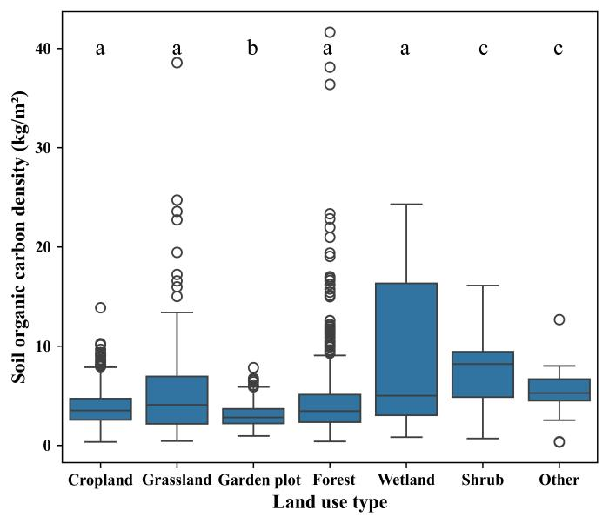
Figure S1 Results of the Kruskal-Wallis test for the soil organic carbon storage in the 0-20 cm topsoil of the Yangtze River Basin under different land use types
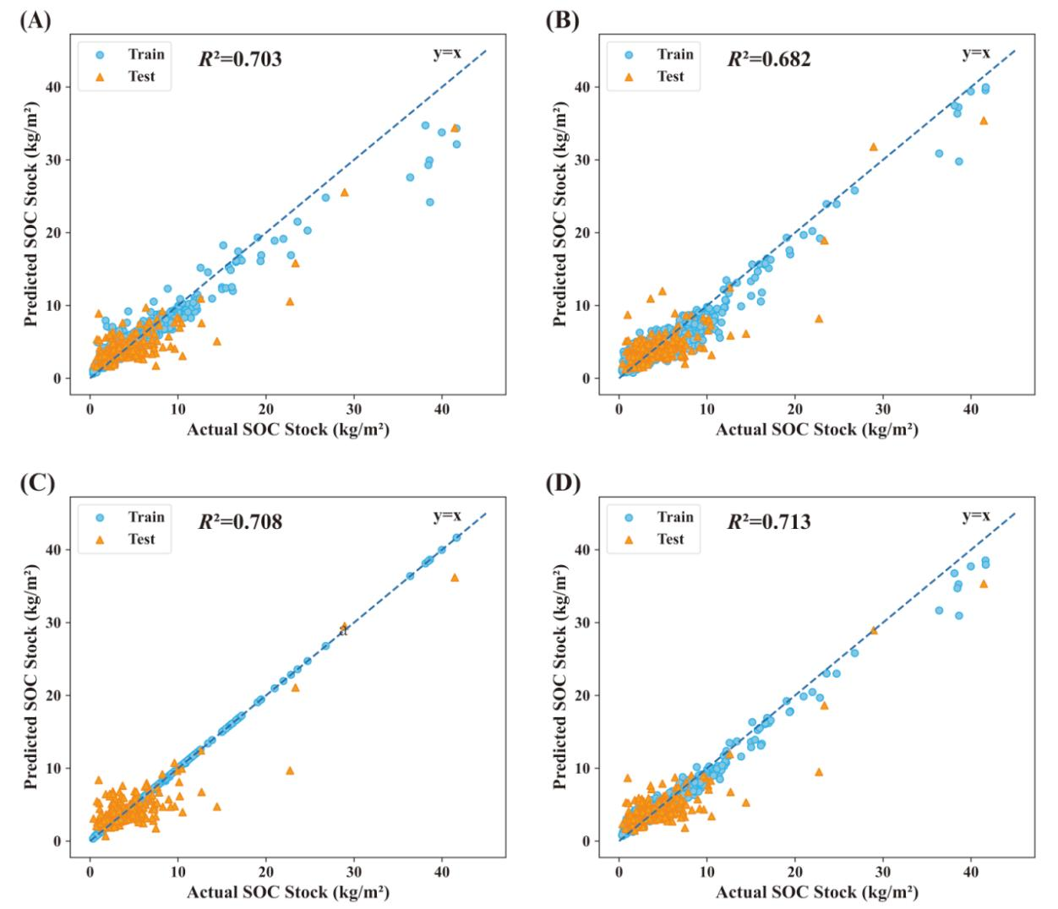
Figure S2 Scatter Plots of Predicted vs. Actual Soil SOC Stocks Using Different Models (a) Random Forest (RF) (b) Gradient Boosting Regression Tree (GBRT) (c) Extra Trees Regressor (ETR) (d) Weighted Ensemble Model

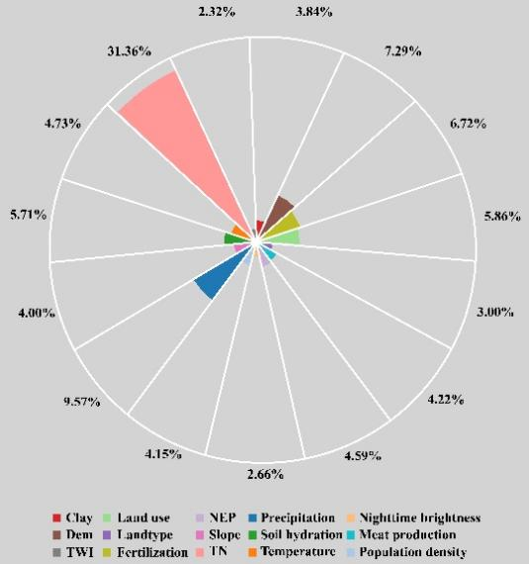
Figure S3 Relative Importance of 15 Environmental Variables (Weighted by Absolute SHAP Values to 100%)

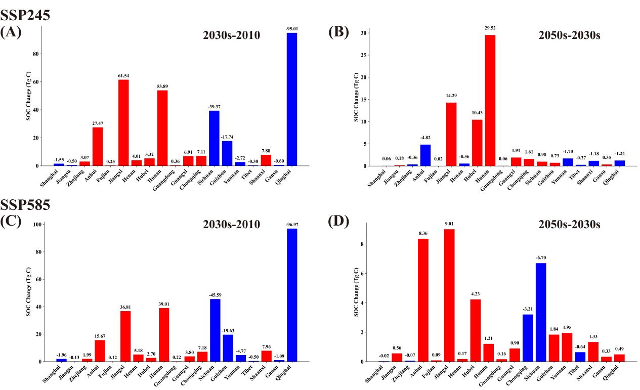

Figure S4 Prediction of changes in surface soil organic carbon stocks (0-20 cm) in provinces of the Yangtze River basin.Panels (A)–(D) show differences under SSP245 (2030s vs. 2010: A; 2050s vs. 2030s: B) and SSP585 (2030s vs. 2010: C; 2050s vs. 2030s: D). Red = increase; blue = decrease.

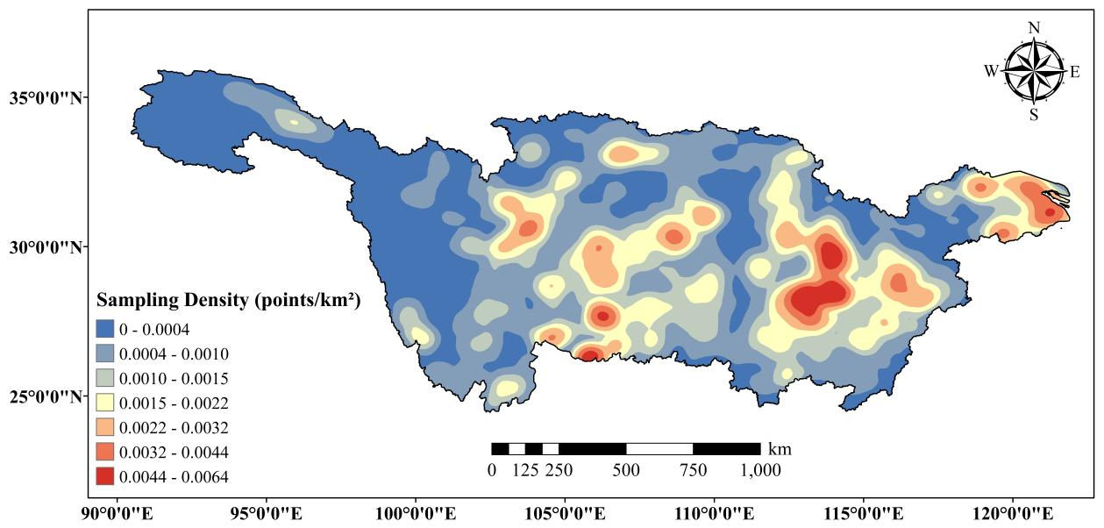
Figure S5 Spatial Uncertainty Proxy Based on Sampling Density
Note: Low density = high uncertainty, units: points/km²

References
Almuhammadi, S., Alnajim, A., & Ayub, M. (2023). QUIC Network Traffic Classification Using Ensemble Machine Learning Techniques. Applied Sciences, 13(8), 4725.
Biau, G. (2012). Analysis of a random forests model. J. Mach. Learn. Res., 13(null), 1063–1095. JMLR.org.
Huang, Y., Liu, Y., Li, C., & Wang, C. (2019). GBRTVis: Online analysis of gradient boosting regression tree. Journal of Visualization, 22(1), 125–140.
Mosaid, H., Barakat, A., John, K., Faouzi, E., Bustillo, V., El Garnaoui, M., & Heung, B. (2024). Improved soil carbon stock spatial prediction in a Mediterranean soil erosion site through robust machine learning techniques. Environmental Monitoring and Assessment, 196(2), 130.
Nasseri, M., Falatouri, T., Brandtner, P., & Darbanian, F. (2023). Applying Machine Learning in Retail Demand Prediction—A Comparison of Tree-Based Ensembles and Long Short-Term Memory-Based Deep Learning. Applied Sciences, 13(19), 11112.
Negassa, M. K., Haile, M., Feyisa, G. L., Wogi, L., & Liben, F. M. (2023). Soil Organic Carbon Stock Prediction: Fate under 2050 Climate Scenarios, the Case of Eastern Ethiopia. Sustainability, 15(8), 6495.
Pickett, S. T. A. (1989). Space-for-Time Substitution as an Alternative to Long-Term Studies. In G. E. Likens (Ed.), Long-Term Studies in Ecology (pp. 110–135). New York, NY: Springer New York. Retrieved November 19, 2024, from http://link.springer.com/10.1007/978-1-4615-7358-6_5
Schonlau, M., & Zou, R. Y. (2020). The random forest algorithm for statistical learning. The Stata Journal: Promoting communications on statistics and Stata, 20(1), 3–29.
Tian, H., & Chen, J. (2022). Deep Learning with Spatial Attention-Based CONV-LSTM for SOC Estimation of Lithium-Ion Batteries. Processes, 10(11), 2185.
Wang, S., Zhang, X., Adhikari, K., Roland, B., Zhuang, Q., Wang, Z., Shi, D., et al. (2023). Predicting soil organic carbon stocks under future land use and climate change conditions in Northeast China. Environmental Impact Assessment Review, 103, 107278.
Wang, T., Zhou, W., Xiao, J., Li, H., Yao, L., Xie, L., & Wang, K. (2023). Soil Organic Carbon Prediction Using Sentinel-2 Data and Environmental Variables in a Karst Trough Valley Area of Southwest China. Remote Sensing, 15(8). Retrieved from https://www.mdpi.com/2072-4292/15/8/2118
Yang, H., Liu, X., & Song, K. (2022). A novel gradient boosting regression tree technique optimized by improved sparrow search algorithm for predicting TBM penetration rate. Arabian Journal of Geosciences, 15(6), 461.

