Supplementary materials

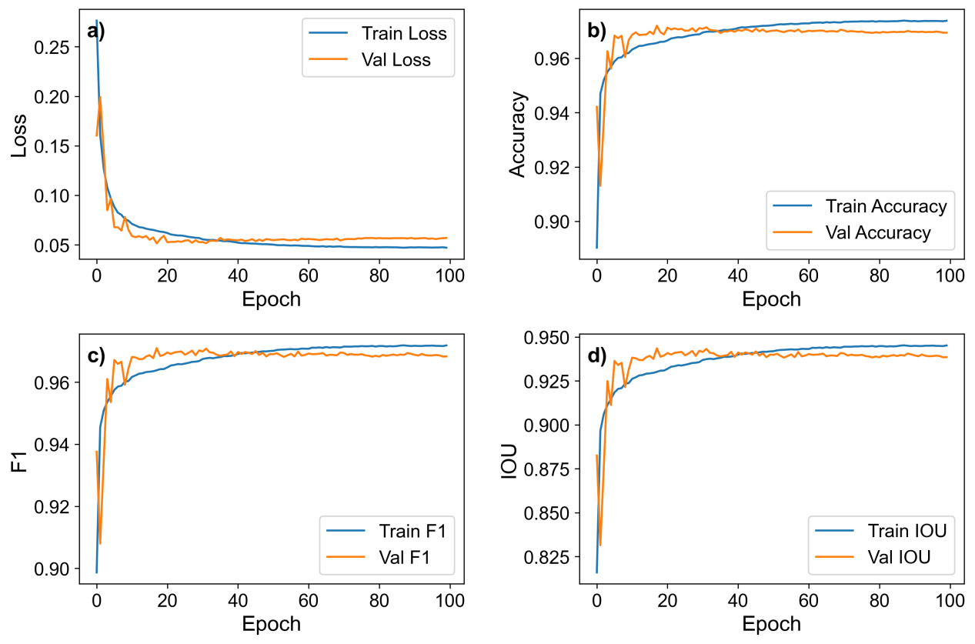
Fig. S1 Training curves of the Att-U-Net model.
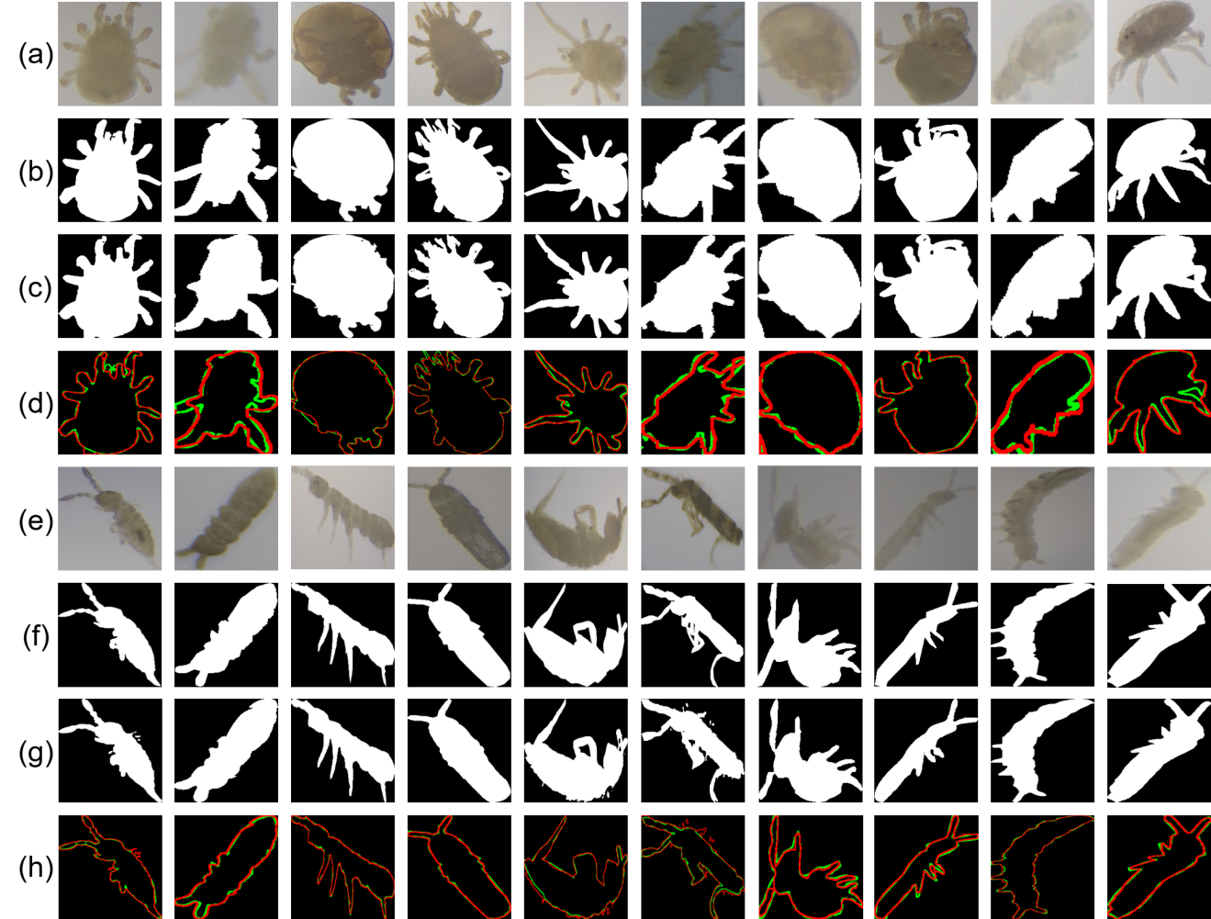
Fig. S2 The segmentation results for different types of Collembola and mites. (a) (e), Original image; (b) (f), Ground truth; (c) (g), Att-U-Net model extraction results; (d) (h), contours comparison between ground truth and model extraction, with green for ground truth while red for model segmentation.
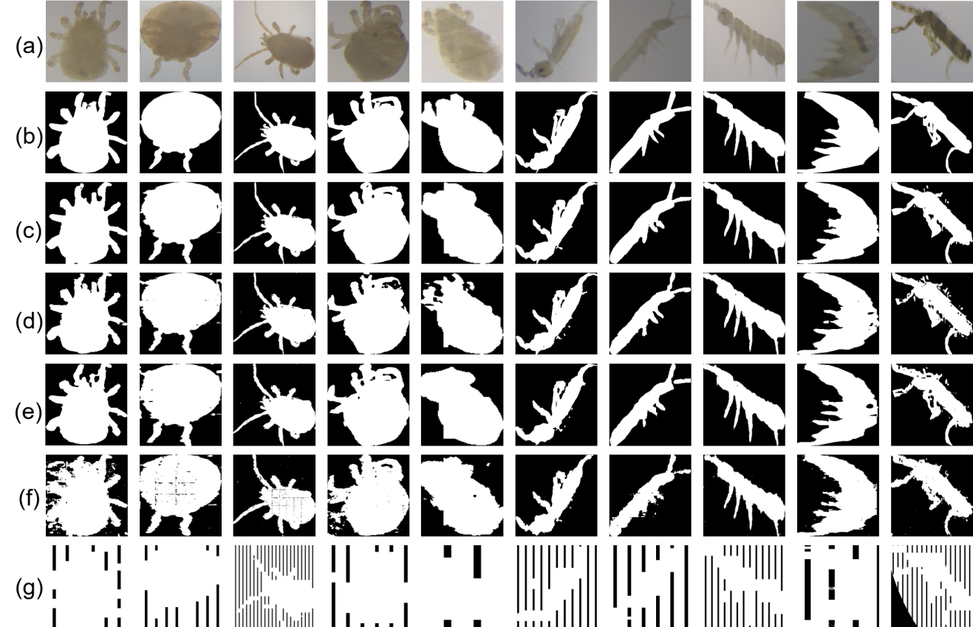
Fig. S3 Comparison of segmentation results among different semantic segmentation models. (a), Original images; (b), Ground truth; (c), Att-U-Net model; (d), U-Net model; (e), DeepLab V3 model; (f), SegNet model; (g), FCN model.
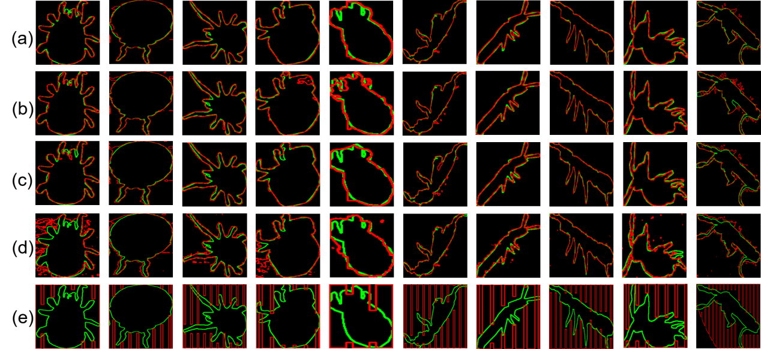
Fig. S4 Contours comparison between ground truth and model extraction, with green for ground truth while red for model segmentation. (a), Att-U-Net model; (b), U-Net model; (c), DeepLab V3 model; (d), SegNet model; (e), FCN model.
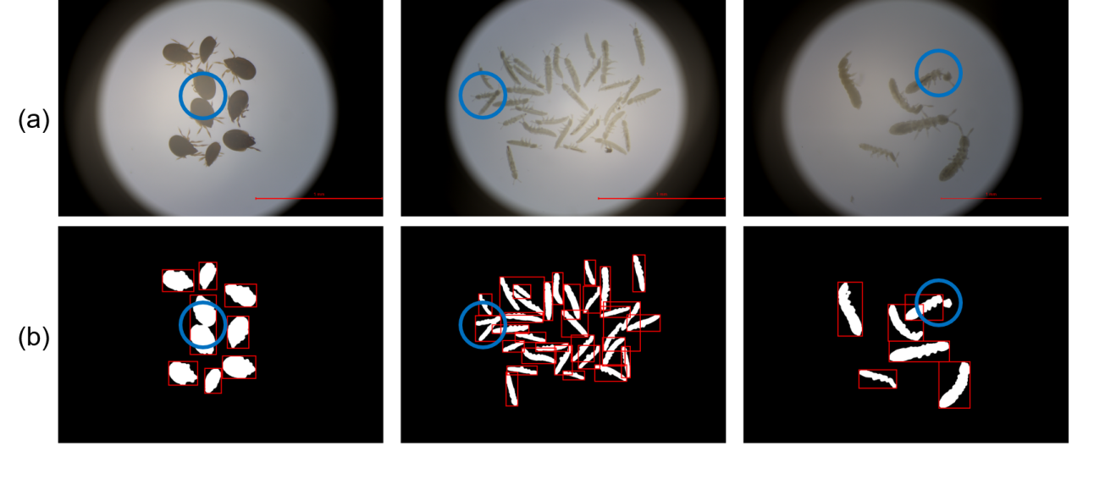
Fig. S5 Examples of major sources of errors in soil fauna detection and measurement. a) RGB images, b) labeled binary images.

