Title Page:
Plant invasion alters latitudinal patterns of soil microbial diversity in coastal wetlands
Authors: Xin Xin ^{a,b,c}, Jiasui Li ^{d}, Chuancheng Fu ^{e}, Teng Yang ^{a,c}, Yu Shi ^{f}, Xu Liu ^{g}, Hai-Lei Zheng ^{h}, Haiyan Chu ^{a,c*}, Gui-Feng Gao ^{a,c*}

Affiliations:
ª State Key Laboratory of Soil and Sustainable Agriculture, Institute of Soil Science, Chinese Academy of Sciences, Nanjing, 211135, China
^{b} School of Biological Sciences, Nanjing Normal University, Nanjing, 210023, China
^{c} University of Chinese Academy of Sciences, Beijing, 100049, China
^{d} School of Life and Environmental Sciences, Faculty of Science, The University of Sydney, Sydney NSW, 2006, Australia
^{e} Marine Science Program, Biological and Environmental Science and Engineering Division (BESE), King Abdullah University of Science and Technology, Thuwal, 23955-6900, Saudi Arabia
^{f} State Key Laboratory of Crop Stress Adaptation and Improvement, School of Life Sciences, Henan University, Kaifeng, 475004, China
^{g} Department of Microbiology, College of Life Sciences, Nanjing Agricultural University, Key Laboratory of Agricultural and Environmental Microbiology, Ministry of Agriculture and Rural Affairs, Nanjing, 210095, China
^{h} College of the Environment and Ecology (CEE), Xiamen University, Xiamen, 361102, China

Corresponding authors
Gui-Feng Gao
E-mail: gfgao@issas.ac.cn

Haiyan Chu
E-mail: hychu@issas.ac.cn
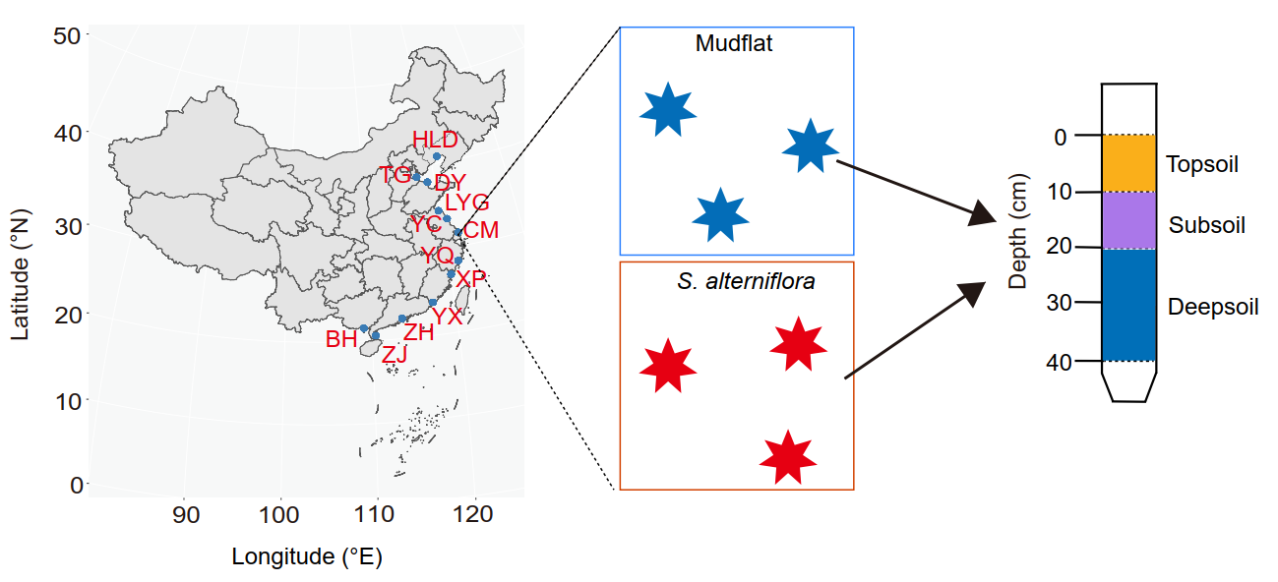
Figure S1. Distribution of sampling sites in paired mudflat and S. alterniflora habitats across China’s coast. HLD: Huludao; TG: Tanggu; DY: Dongying; LYG: Lianyungang; YC: Yancheng; CM: Chongming; YQ: Yueqing; XP: Xiapu; YX: Yunxiao; ZH: Zhuhai; BH: Beihai; ZJ: Zhanjiang.

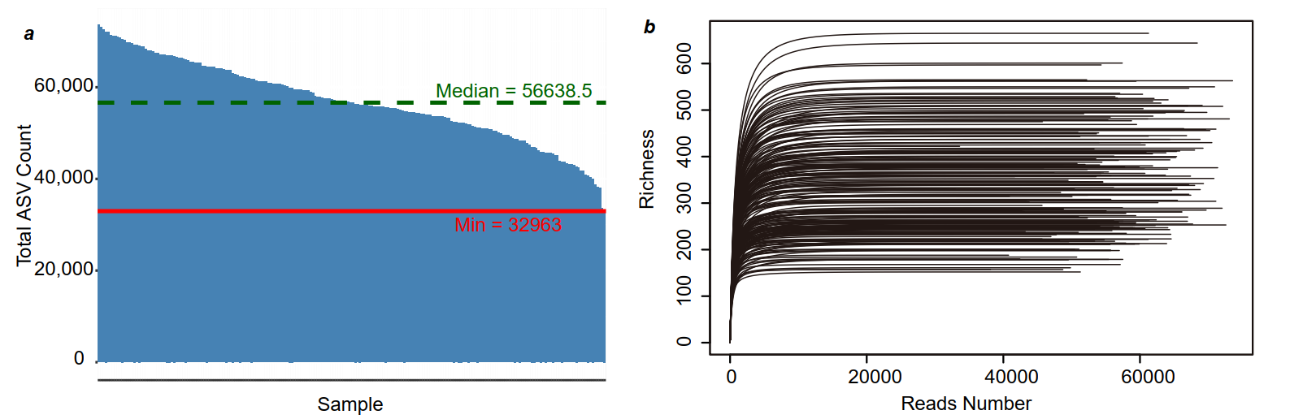
Figure S2. (a) ASV distribution map of samples; (b) dilution curve of bacterial richness.
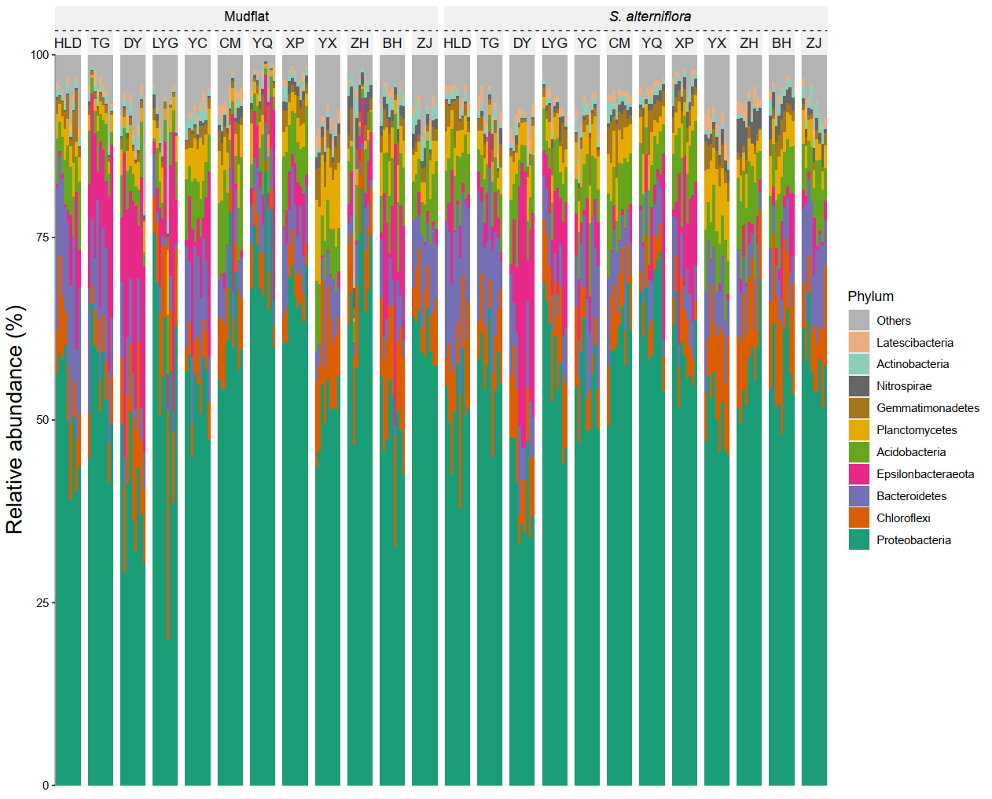
Figure S3. Relative abundance of the top 10 bacterial phyla for both mudflat and S. alterniflora habitats across the coastlines of China. HLD: Huludao; TG: Tanggu; DY: Dongying; LYG: Lianyungang; YC: Yancheng; CM: Chongming; YQ: Yueqing; XP: Xiapu; YX: Yunxiao; ZH: Zhuhai; BH: Beihai; ZJ: Zhanjiang.

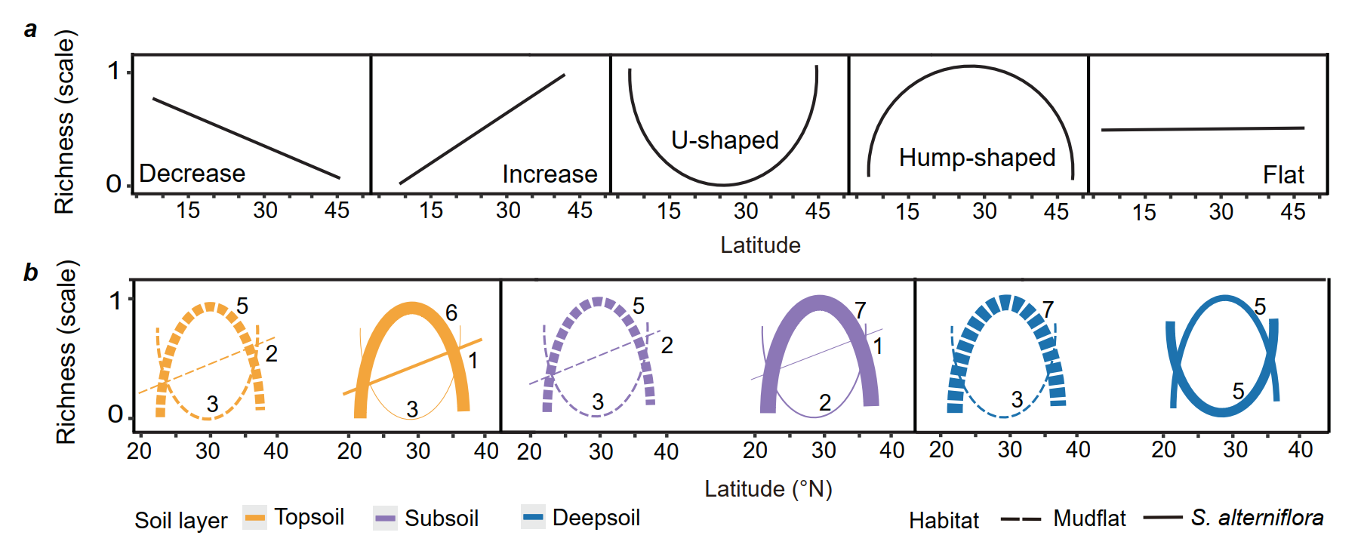
Figure S4. (a) A conceptual diagram illustrating the latitudinal gradient of species richness in biogeography; These figures serve as reference frameworks for pattern classification; (b) Based on the conceptual diagram species distribution patterns, the actual latitudinal distribution patterns of the top 10 most abundant bacteria in mudflats and S. alterniflora-invaded habitats were classified. Dashed lines represent mudflat habitats; solid lines represent S. alterniflora-invaded habitats. Line thickness indicates the actual distribution of bacteria corresponding to each model (in the top 10 bacterial phyla). Colors denote different soil layers.

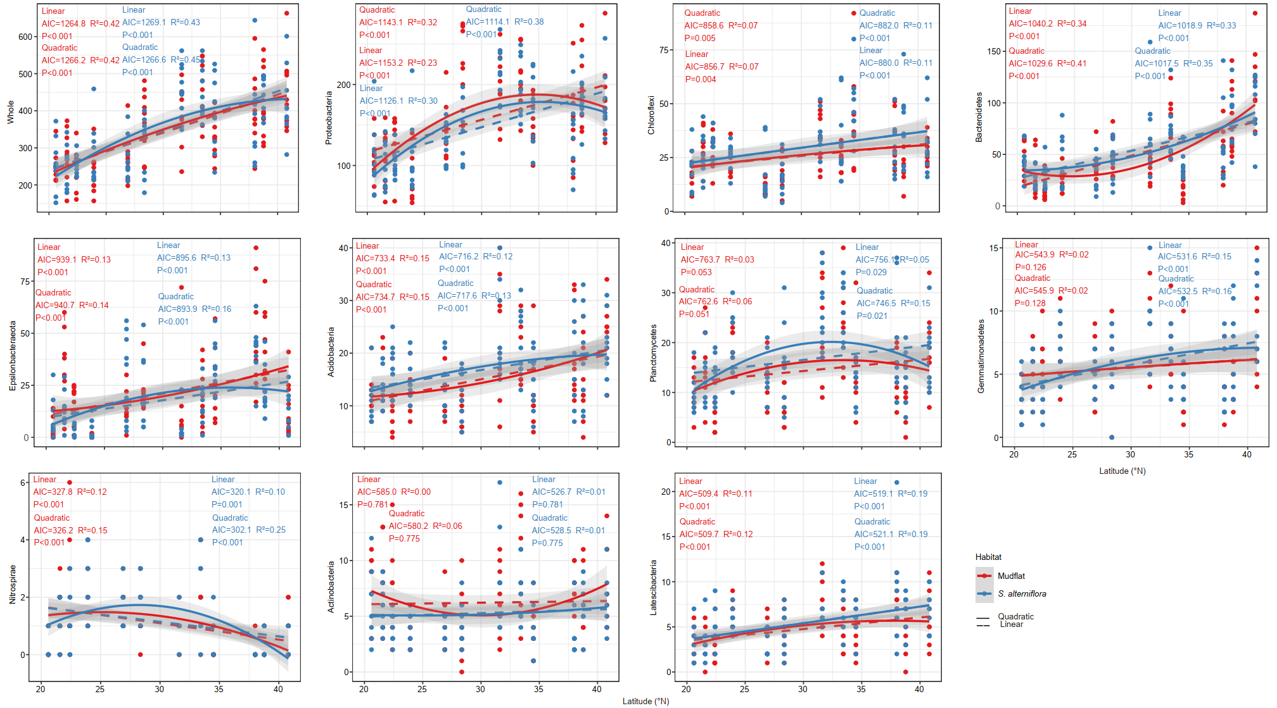
Figure S5. Latitudinal richness pattern of the whole bacterial community and the top 10 phyla. Data were fitted using linear and quadratic regressions. Quadratic relationships were shown as solid lines; linear relationships are shown in dashed lines. Shaded area indicates 95% confidence intervals. Each dot represents one composite sample.

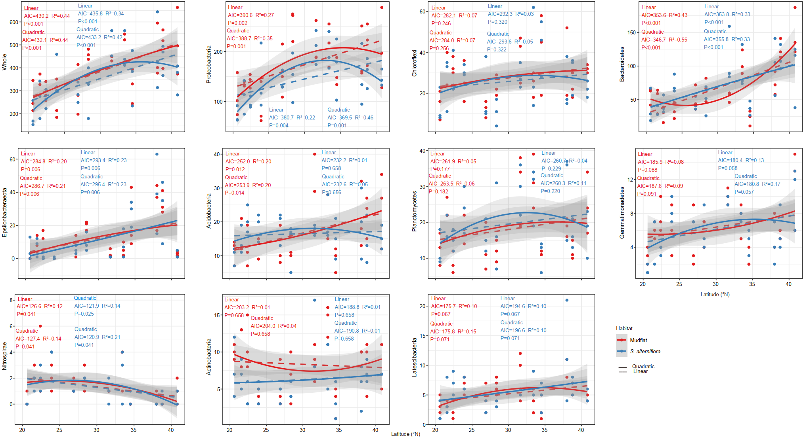
Figure S6. The latitudinal pattern of topsoil richness in the whole community and the top 10 phyla. For annotations, please see the legend of Figure S5.

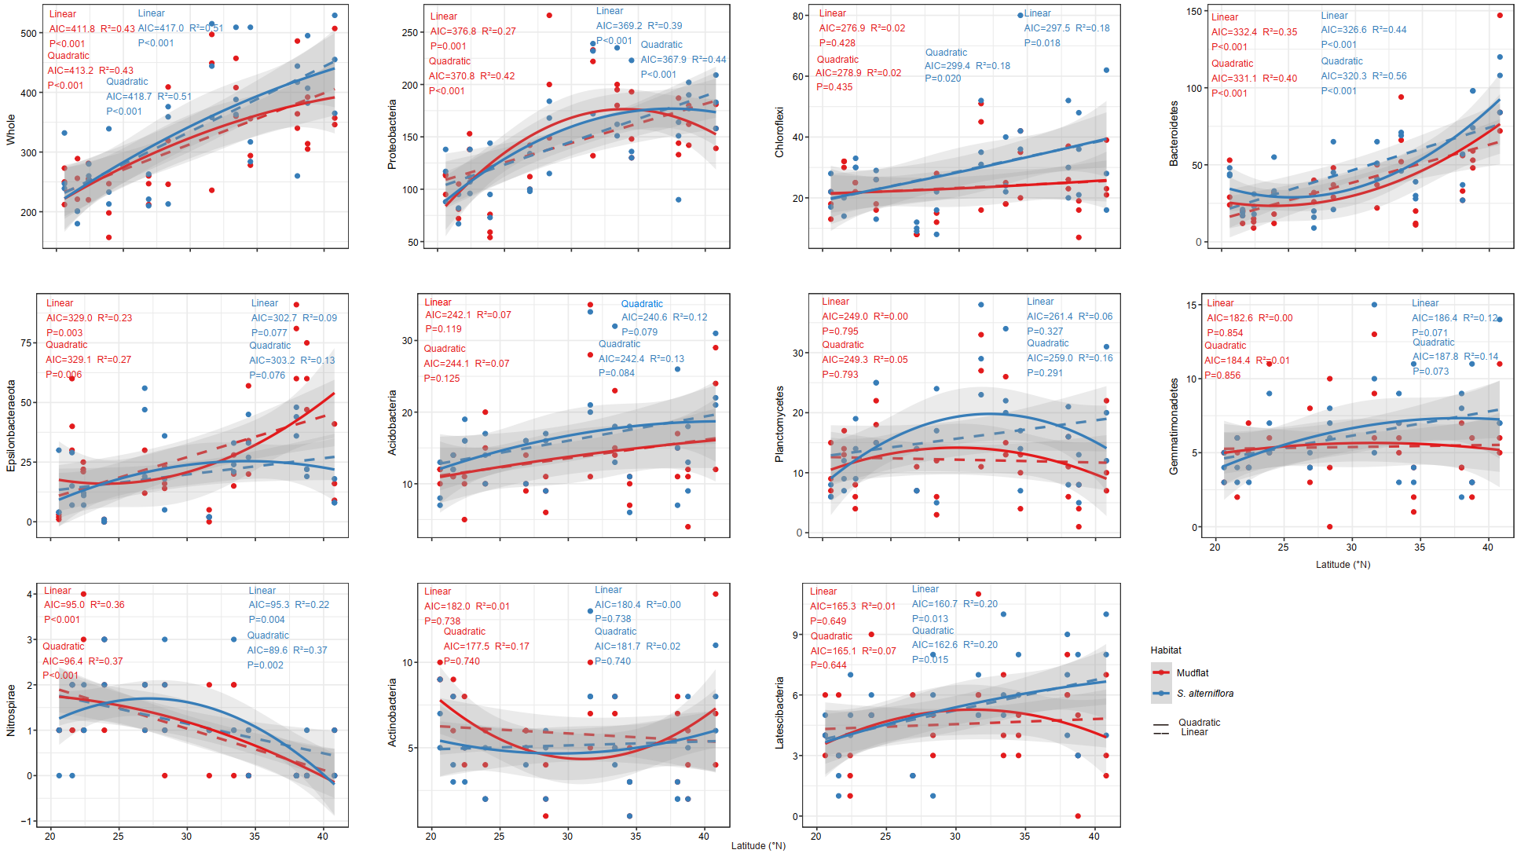
Figure S7. The latitudinal pattern of subsoil richness in the whole community and the top 10 phyla. For annotations, please see the legend of Figure S5.

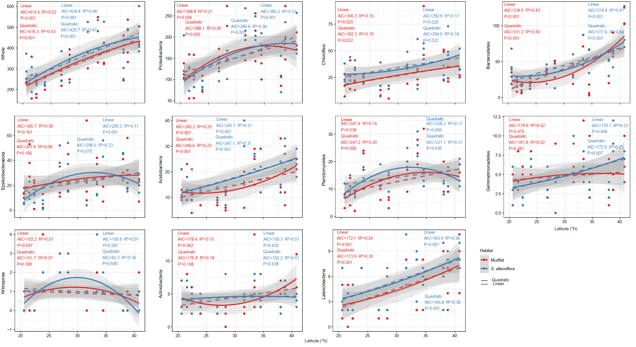
Figure S8. The latitudinal pattern of deep soil richness in the whole community and the top 10 phyla. For annotations, please see the legend of Figure S5.

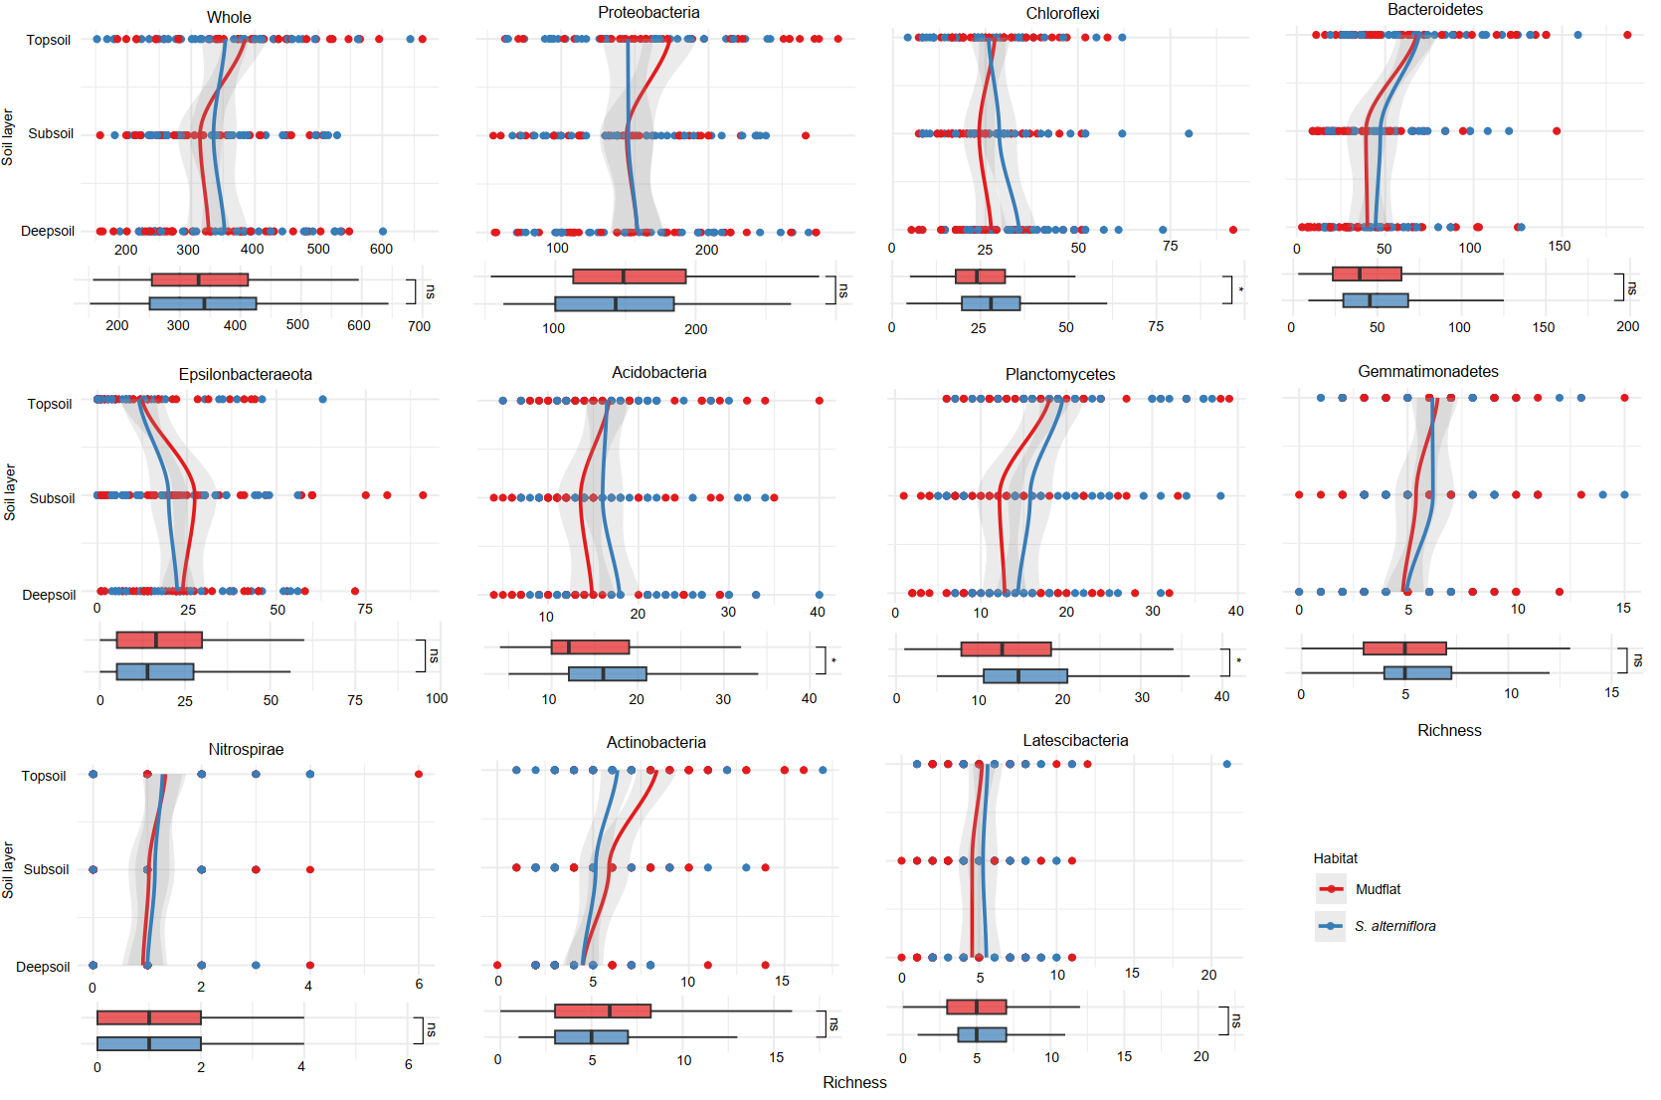
Figure S9. Changes bacterial richness across soil layers for the whole community and the top 10 phyla in mudflat and S. alterniflora habitats. Difference in richness between habitats were assessed using the Wilcoxon rank sum test *p < 0.05. Colors indicate habitat type. Shaded area indicates 95% confidence intervals. Each dot represents bacteria in a sample Richness.

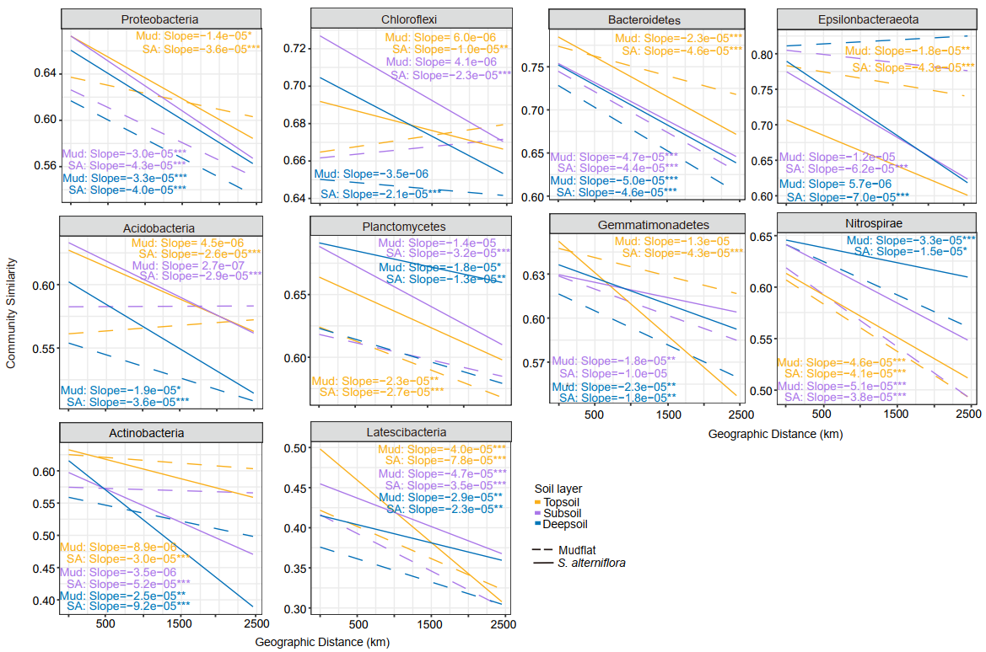
Figure S10. Distance-decay relationships showing the decline in community similarity with increasing geographical distance for the top 10 bacterial genera across different soil layers and habitats. The slope and p were calculated through linear regression. *p < 0.05; **p < 0.01; ***p < 0.001. Colors represent different soil layers.

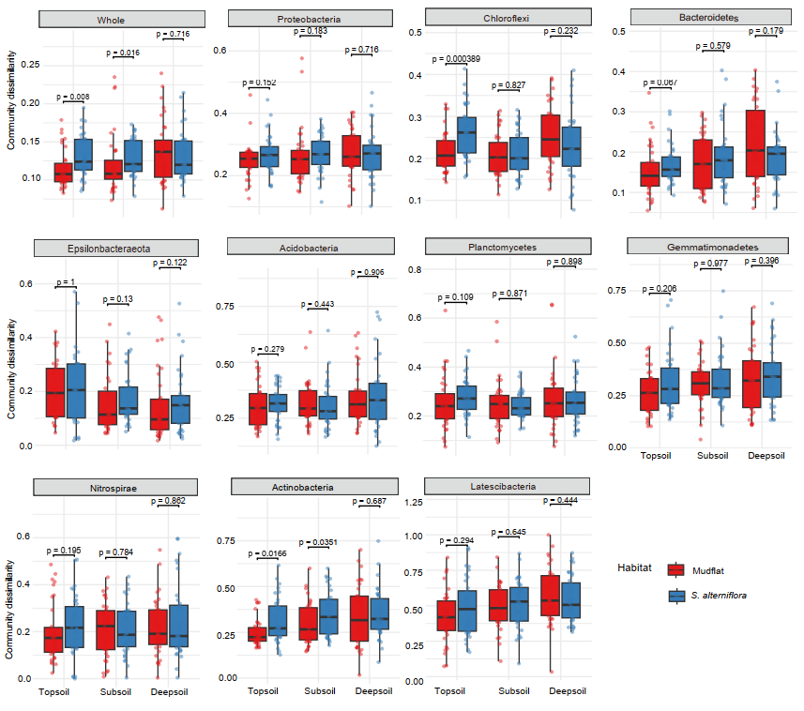
Figure S11. Comparison of community stability across soil layers and habitats based on Weighted Unifrac distance for the whole and the top 10 bacterial phyla.

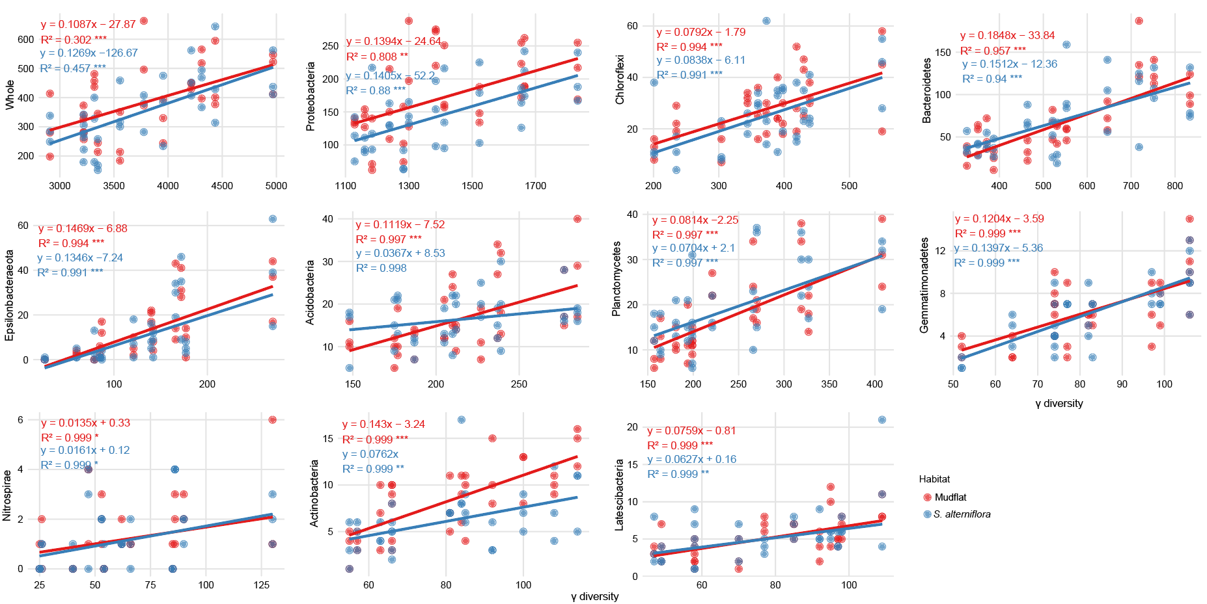
Figure S12. Huber robust regression analysis of bacterial species richness against γ-diversity, comparing the whole community with the top 10 bacterial phyla across topsoil samples from different habitats. *p < 0.05; **p < 0.01; ***p < 0.001.
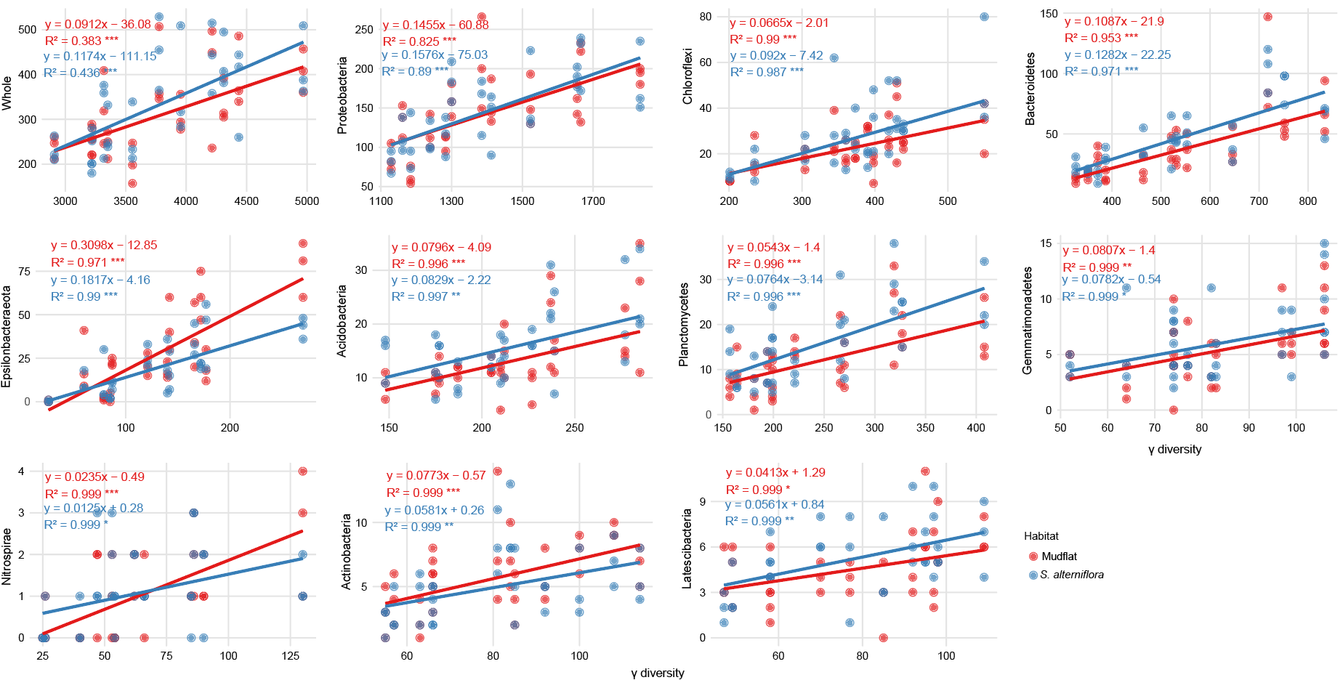
Figure S13. Huber robust regression analysis of bacterial species richness against γ-diversity, comparing the whole community with the top 10 bacterial phyla across subsoil samples from different habitats. *p < 0.05; **p < 0.01; ***p < 0.001.

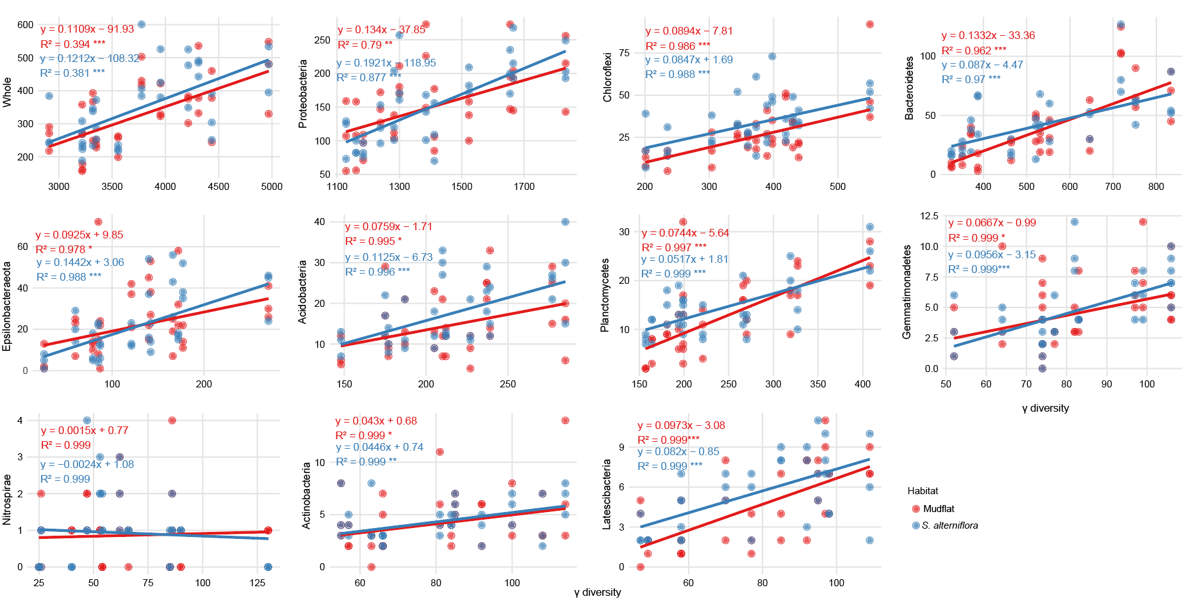
Figure S14. Huber robust regression analysis of bacterial species richness against γ-diversity, comparing the whole community with the top 10 bacterial phyla across deep soil samples from different habitats. *p < 0.05; **p < 0.01; ***p < 0.001.
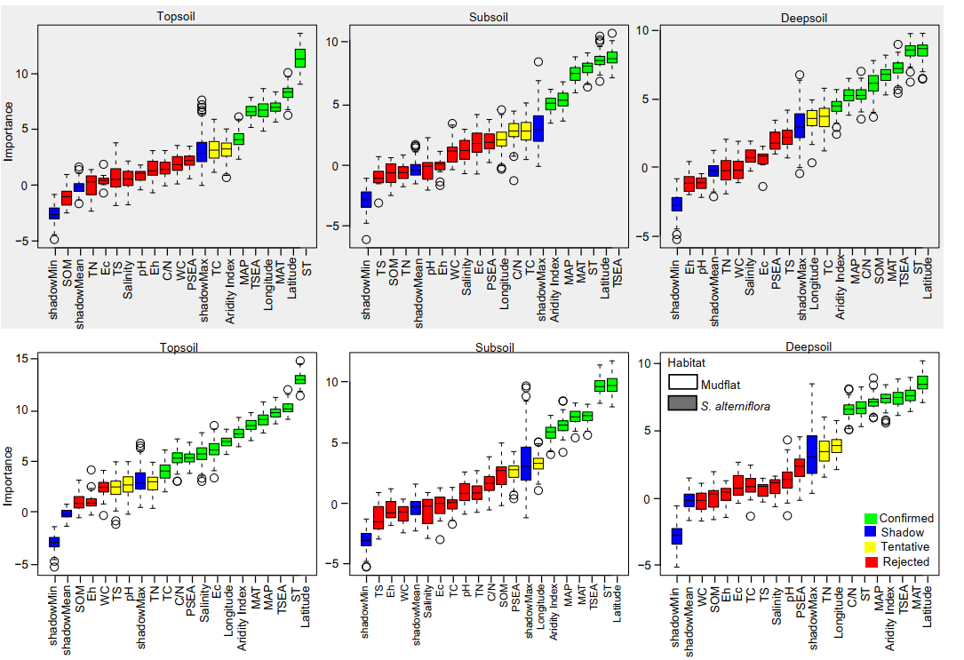
Figure S15. Random forest variable importance analysis identifying key environmental factors influencing bacterial richness across different habitats and soil layers. Different colors represent the importance of variables. SOM: soil organic matter; TN: total nitrogen; TS: total sulfur; Eh: redox potential; WC: water content; PSEA: precipitation seasonality; TC: total carbon; MAP: mean annual precipitation; MAT: mean annual temperature; TSEA: temperature seasonality; ST: soil temperature.

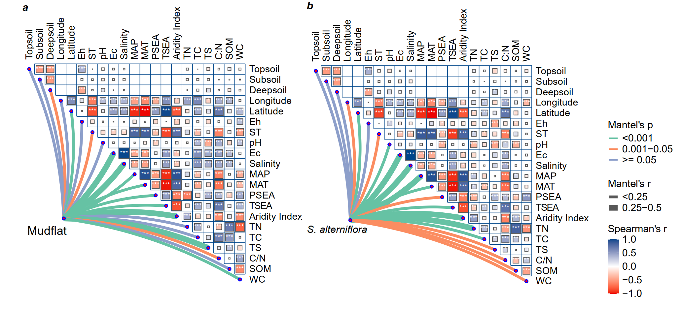
Figure S16. Spearman correlations among environmental factors and Mantel correlations between bacterial community composition and soil properties in mudflat and S. alterniflora-invaded habitats respectively. Line thickness and color indicate the magnitude of Mantel’s r and p-values, respectively. For abbreviations, see the caption of Fig. S15. Spearman correlation: *p < 0.05; **p < 0.01; ***p < 0.001.

