Carbon accumulation efficiency of granulated straw incorporation and its response to nutrient supplement in infertile agricultural soils: Evidence from biomarkers

Xun Duan^{a,b}, Xiangbi Chen^{a, *} Wenju Zhang^{c}, Jun Wangª, Ling Xieª, Yijun Xuª, Shiyou Hu^{d}, GuangXu Zhu^{e}, Wei Gaoª, Jinshui Wu^{a, *}

ª CAS Key Laboratory of Agro-ecological Processes in Subtropical Region, Institute of Subtropical Agriculture,410125, Changsha, PR China;
^{b} University of Chinese Academy of Sciences, 100049, Beijing, PR China;
^{c} National Engineering Laboratory for Improving Quality of Arable Land, Institute of Agricultural Resources and Regional Planning, Chinese Academy of Agricultural Sciences, Beijing 100081, China
^{d} Institute of Plant Protection and Soil Science, Hubei Academy of Agricultural Sciences, Wuhan, 430064, China
^{e} College of Biology and Environment Engineering, Guiyang University, Guiyang 550005, China

* Corresponding Author:
Xiangbi Chen
E-mail: xbchen@isa.ac.cn Tel: +86-731-84619722 Fax: +86-731-84612685
Jinshui Wu
E-mail: jswu@isa.ac.cn Tel: +86-731-84619722 Fax: +86-731-84612685

2.1 C use efficiency analysis
Microbial CUE was determined based on measuring the incorporation of ¹⁸O from ¹⁸O-labeled H₂O into microbial DNA and C losses by respiration (Spohn et al., 2016). Briefly, four replicates of 500 mg soil pre-incubated for 3 weeks were added in 2 mL vials. ¹⁸O-labeled H₂O (97.0 atom% ¹⁸O; Shanghai Research Institute of Chemical Industry Co., Ltd.) was added to half of the replicates to adjust 20.0 atom% ¹⁸O in the final soil water and the other half of replicates was added the same volume of non-labeled H₂O as natural abundance control. In parallel, 10 g of the pre-incubated soil was added into 100 mL containers, and the same procedure of adding non-labeled H₂O was also conducted to determine basal microbial respiration. Then, the open vials were transferred into 50 mL incubation containers and sealed, and incubated at 25 °C. After 24 hours of incubation, the 20 mL gas was taken from each 100 mL container and transferred to a pre-evacuated 12 mL vacuum bottle. The CO₂ concentration was analyzed by gas chromatography (Agilent 7890A; Agilent Technologies, USA). When the gas samples were collected, the vials were sealed and put into liquid N₂ to freeze the soils, and then stored at –80 ℃ until DNA extraction.
DNA was extracted from soils with ¹⁸O-labeled and non-labeled H₂O addition using a DNA extraction kit (FastDNA™ Spin kit for soil; MP). The DNA concentration was determined by a NanoDrop 1000 spectrophotometer (Thermo Scientific, USA). 50 μL of DNA extracts were weighed and dried in silver capsules at 60 ℃. Then, the ¹⁸O abundance was quantified by an isotope ratio mass spectrometer (MAT253) coupled with an elemental analyzer (FLASH 2000, Thermo Fisher Scientific, USA).
The newly produced DNA amount was calculated as follows:
$${DNA}_{produced}=C_{DNA}×(δ^{18}O_{sample}-δ^{18}O_{control})/(δ^{18}O_{H2O}-δ^{18}O_{control})$$
Where C_{DNA} represents the concentration of DNA extracted from soil (μg g⁻¹ dry soil); δ¹⁸O_{sample} represents ¹⁸O abundance of DNA in a labeled sample; δ¹⁸O_{control} represents ¹⁸O abundance of DNA in an unlabeled sample; δ¹⁸O_{H2O} represents ¹⁸O abundance in the final soil water (20.0 atom%).
The newly produced MBC amount (MBC_{produced}) was calculated as follows:
$${MBC}_{produced}={DNA}_{produced}/C_{DNA}×{MBC}_{total}$$
Where MBC_{total} represents the microbial biomass C of the soil sample.
The microbial growth rate (C_{Growth}; ng C g⁻¹ h⁻¹) was calculated using the following equation:
$$C_{Growth}=\frac{{MBC}_{prodcued}×1000}{M×24}$$
Where M represents the mass of the soil as the equivalent of dry weight; 24 represents the incubation time in hours.
The microbial respiration rate (C_{Respiration}, ng C g⁻¹ h⁻¹) was calculated as follows:
$$C_{Respiration}=\frac{(C-C_{0})×M×V×298}{V_{m}×DW×273×t}$$
Where C and C₀ represent the CO₂ concentrations (ppm) of the treated and control samples, respectively. M represents the molecular mass of C (12 g mol⁻¹); V represents the volume of the head-space in a vial (mL); V_{m} represents the standard molar volume of an ideal gas (L mol⁻¹); DW represents the dry mass of soil (g); 273 represents the absolute temperature (K) at the standard atmospheric pressure; 298 represents the incubation temperature (K); and t represents the incubation time (h).
The microbial CUE was calculated by the following equation:
$$CUE=\frac{C_{Growth}}{C_{Uptake}}$$
2.2 Soil chemical properties analysis
Soil pH was measured at the soil-to-distilled water ratio of 1:2.5 (w/v) using a pH meter (YSI Inc., USA). SOC were determined using an elemental analyzer (Vario EL III, Elementer, Germany). At the end of the SOC analysis, the undecomposed straw was removed by the sodium polytungstate (SPT) extraction of 1.65 g cm^{–3}, and measured SOC content. Fe_{d}, Fe_{o} and Fe_{p} were extracted using a solution of dithionite-citrate-bicarbonate, a solution of ammonium oxalate-oxalic acid, and a solution of sodium-pyrophosphate solution, respectively (Weiss et al., 2003, 2005).

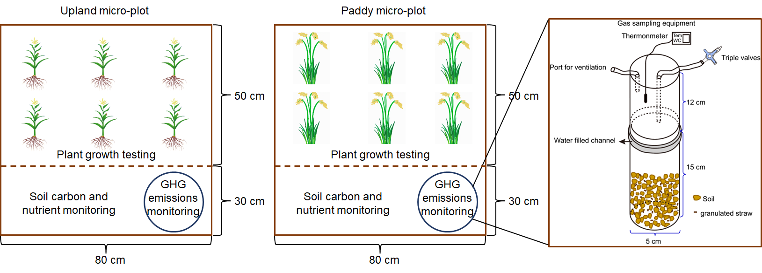
Fig. S1 Schematic distribution of micro-plot field

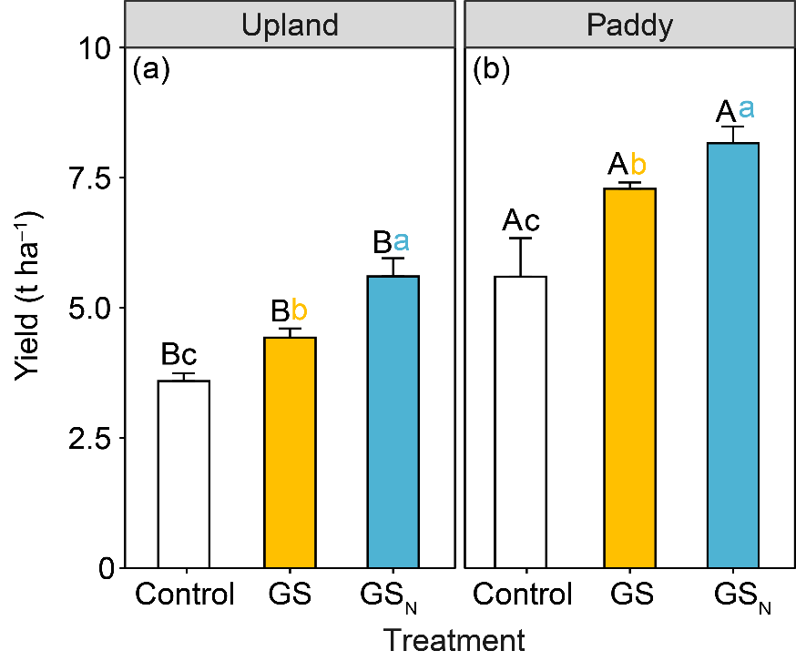
Fig. S2 The yield of corn in upland and rice in paddy soils under granulated straw incorporation with or without nutrients supplement. Different color lowercase letters indicate differences across treatments within one land-use type (p < 0.05), while different black uppercase letters indicate differences between upland and paddy soil within one certain treatment (p < 0.05).

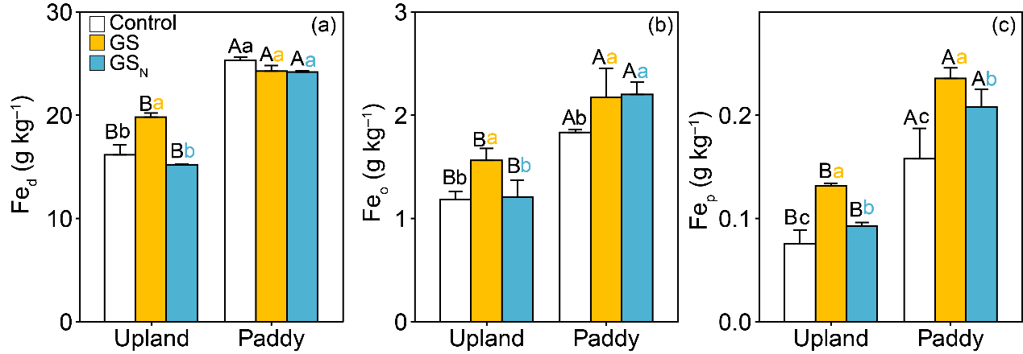
Fig. S3 Free (a), amorphous (b), and complexed (c) Fe oxides in infertile upland and paddy under granulated straw incorporation with or without nutrients supplement. Different color lowercase letters indicate differences across treatments within one land-use type (p < 0.05), while different black uppercase letters indicate differences between upland and paddy soil within one certain treatment (p < 0.05).

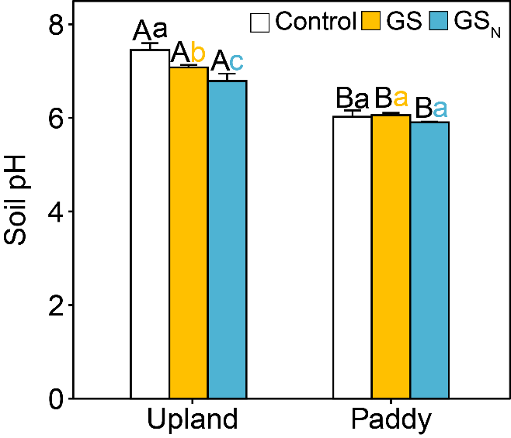
Fig. S4 Soil pH in infertile upland and paddy under granulated straw incorporation with or without nutrients supplement. Different color lowercase letters indicate differences across treatments within one land-use type (p < 0.05), while different black uppercase letters indicate differences between upland and paddy soil within one certain treatment (p < 0.05).

