Ecological Facilitation: Terrestrial Isopods indirectly Modulate Collembolan Behaviour in Biochar-Amended Soils

Lorenzo Federico¹, Asia Rosatelli¹, Niccolò Lamanna¹, Veronica Termopoli¹, Heiko Lange¹, Andrea Franzetti¹, Isabella Gandolfi¹, Sara Villa¹

¹DISAT, Department of Earth and Environmental Sciences, University of Milano-Bicocca, Piazza della Scienza 20126, Milan, Italy
Supplementary material

Table of Content

Figure S1 Overlay of the GC–MS chromatograms obtained for the four biochar extracts: black, B. juncea 400 °C; pink, B. juncea 600 °C; blue, R. communis 400 °C; dark-orange, R. communis 600 °C. The chromatograms show a region between approximately 7 and 17 min mainly characterized by alkanes (both linear and branched) for all samples. Free fatty acids were detected only in B. juncea biochar pyrolyzed at 400 °C, while B. juncea biochar at 600 °C showed only esterified fatty acids. In contrast, the GC–MS profiles of R. communis biochar extracts were predominantly characterized by alkanes, with no evident other contributions. In B. juncea 400 °C were additionally detected traces of steroid derivatives.

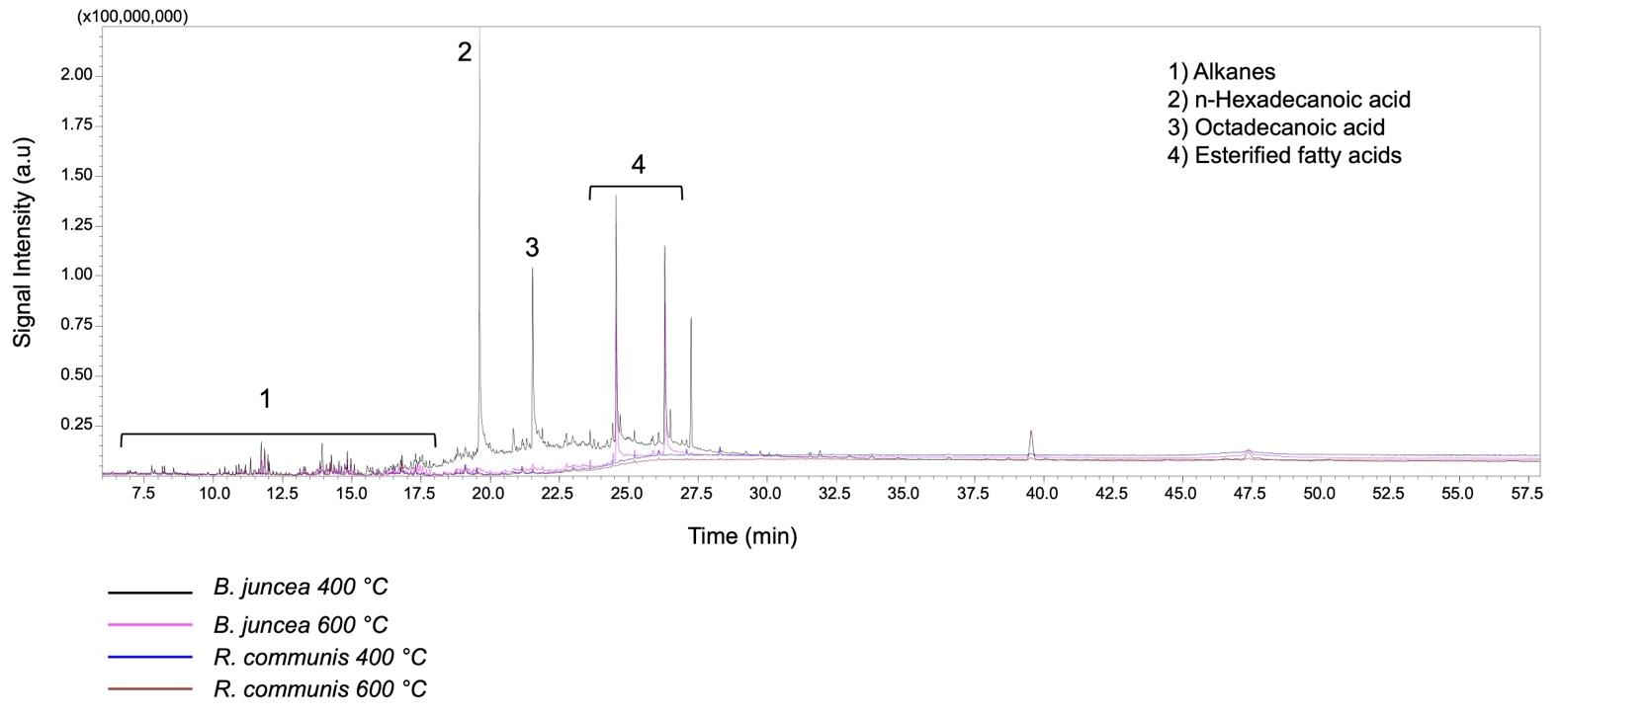

7.5
10.0
12.5
15.0
17.5
20.0
22.5
25.0
27.5
30.0
32.5
35.0
37.5
40.0
42.5
45.0
47.5
50.0
52.5
55.0
57.5
0.25
0.50
0.75
1.00
1.25
1.50
1.75
2.00
(x100,000,000)

B. juncea 400 °C
B. juncea 600 °C
R. communis 400 °C
R. communis 600 °C

1
2
3
1) Aliphatic hydrocarbons
2) n-Hexadecanoic acid
3) Octadecanoic acid
4) Esterified fatty acids

4
Time (min)
Signal Intensity (a.u)

