Effects of polypropylene microplastics addition on particulate organic carbon and mineral-associated organic carbon in urban soil
Hengkang Xuª, Zhuo Pangª, Chao Chenª, Weiwei Zhangª, Guofang Zhangª, John Scullion^{b}, Mike J Wilkinson^{b}, and Haiming Kanª*
ªInstitute of Grassland, Flowers and Ecology, Beijing Academy of Agriculture and Forestry Sciences (BAAFS), Beijing, China, No. 9 Shuguang Garden Middle Road, Haidian District
^{b}Department of Life Sciences, Penglais Campus, Aberystwyth University, Wales SY23 3DA, UK
* Correspondence: Haiming Kan: kanhaiming@hotmail.com

Fig. S1. Surface morphology and size of initial MPs (a, SEM images of 500 nm and 300nm PP. b, FTIR spectra of PP). The growth of three plants (c). Surface morphology and size of MPs after growth of three plant (d, SEM images of 300 nm PP in Carex breviculmis; SEM images of 500 nm PP in Festuca arundinacea; SEM images of 300 nm PP in Poa pratensis L.).

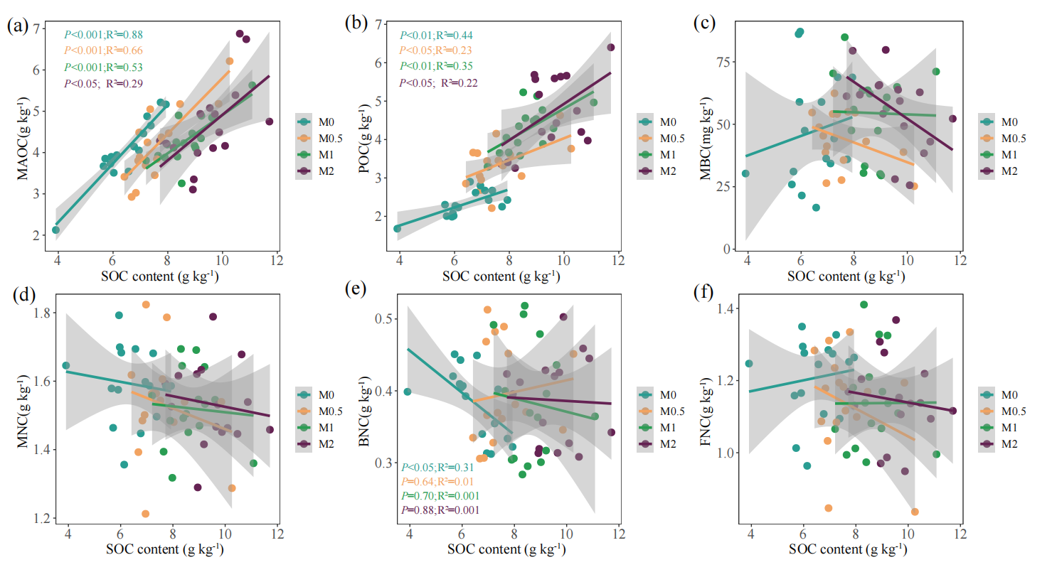
Fig. S2. Regressions of SOC with MAOC, POC, MBC, MNC, BNC and FNC at different concentrations of microplastics (a-f). SOC: soil organic carbon; MAOC: mineral-associated organic carbon. POC: soil particulate organic carbon; MBC: microbial biomass carbon; MNC: microbial necromass carbon; BNC: bacterial necromass carbon; FNC: fungal necromass carbon; M0: (0%, 0g), M0.5: (0.5%, 5g), M1: (1%, 10g), M2: (2%, 20g).

Fig. S3. Effects of 2% microplastics on observed species (a) and Shannon-Wiener index (b) of bacteria and observed species (c) and Shannon-Wiener index (d) of fungi. Different letters above bars indicate significant differences among treatments (data are mean ± SD; n=4). M0: no MPs; M2: 2% MPs; N: unplanted soil; P: P. pratensis L.; F: F. arundinacea; C: C. breviculmis. M: microplastics.

Fig. S4. Non-metric multidimensional scaling (NMDS) of bacterial community composition (e) and fungal community composition (f) at the OTU level based on Bray-Curtis distances (n=4). Adonis analysis was used to examine the differences in different treatments. Significant differences between treatments are indicated with * for P < 0.05, ** for P < 0.01 and *** for P < 0.001. NM0: unplanted soil + no MPs; NM2: unplanted soil + 2% MPs; PM0: Poa pratensis L. + no MPs; PM2: Poa pratensis L. + 2% MPs; FM0: Festuca arundinacea + no MPs; FM2: Festuca arundinacea + 2% MPs; CM0: Carex breviculmis + no MPs; CM2: Carex breviculmis + 2% MPs.

Table S1 The characteristic peaks and related structures of PP

Wavenumber (cm⁻¹) | Related structure
2961 | CH₃ asymmetric stretching vibrations
2919 | CH₂ asymmetric stretching vibrations
2867 | CH₃ symmetric stretching vibrations
2839 | CH₂ symmetric stretching vibrations
1457 | CH₂ bending vibrations
1375 | CH₃ symmetric distortion vibrations
1166, 972 | CH₃ rocking vibrations

DNA extraction, PCR amplification, and Illumina MiSeq sequencing
Microbial community genomic DNA was extracted from 0.25 g of moist soil using the PowerSoil DNA Isolation Kit (MO BIO laboratories, Carlsbad, CA, USA) following a standardized protocol. Soil DNA of each sample was extracted in triplicate and then pooled to decrease extraction bias. The DNA extract was checked on 1% agarose gel, and DNA concentration and purity were determined with NanoDrop 2000 UV-vis spectrophotometer (Thermo Scientific, Wilmington, USA). The bacterial 16S rRNA gene was amplified with the primers 338F_806R and the fugal ITS region was amplified with the primers ITS1F_ITS2 by an ABI GeneAmp® 9700 PCR thermocycler (ABI, CA, USA). To profile soil bacterial communities, we amplified the V3–V4 hypervariable region of 16S rRNA gene with the primer sets 338F (5′-ACTCCTACGGGAGGCAGCAG- 3′) and 806R (5′-GGACTACHVGGGTWTCTAAT- 3′) (Caporaso et al., 2012; Xu et al., 2022). For fungal communities, we amplified the ITS region with the primers sets ITS1-F (5′-CTTGGTCATTTAGAGGAAGTAA-3′) and ITS2 (5′- TGCGTTCTTCATCGATGC- 3′) (McGuire et al., 2013; Xu et al., 2022). PCR reactions for both communities are detailed in the Supplementary Methods. Purified amplicons were pooled in equimolar and paired-end sequences (2 ×300) on an Illumina MiSeq platform according to standard protocols of Majorbio Bio-Pharm Technology Co., Ltd. (Shanghai, China).
After demultiplexing and quality-filtering, the acquired raw 16S rRNA and internal transcribed spacer (ITS) sequence data were sorted into valid reads using the Quantitative Insights into Microbial Ecology (QIIME; version 1.9.1) pipeline with the criteria detailed in the Supplementary Methods. The ribosomal database project (RDP) classifier was used to assign 16S rRNA and ITS gene sequences to taxonomic groups based on the SILVA database (version 132) and the UNITE fungal ITS database (version 7.2), respectively, at an identity threshold of 75%.

Caporaso JG, Lauber CL, Walters WA, Berg-Lyons D, Huntley J, Fierer N, et al. Ultra-high-throughput microbial community analysis on the Illumina HiSeq and MiSeq platforms. The ISME Journal 2012; 6: 1621-1624.
McGuire KL, Payne SG, Palmer MI, Gillikin CM, Keefe D, Kim SJ, et al. Digging the New York City Skyline: Soil Fungal Communities in Green Roofs and City Parks. Plos One 2013; 8.
Xu H, Liu N, Zhang Y. Short-Term Snow Removal Alters Fungal but Not Bacterial Beta Diversity and Structure during the Spring Snowmelt Period in a Meadow Steppe of China. journal of Fungi 2022; 8: 234.

