Supplementary Material
Mediation of soil aggregate stability and carbon sequestration by meadow steppe soil microorganisms under long-term nitrogen and phosphorus nutrient additions
Zhendan Wuª, Renheng Wuª, Siyuan Baoª, He Yeª, Meijun Shengª, Dianlin Yang^{d}, Hong Mei^{a b c*}
ª College of Resources and Environment Sciences, Inner Mongolia Agricultural University, Hohhot, Inner Mongolia, 010018, China
^{b} Inner Mongolia Key Laboratory of Soil Quality and Nutrient Resources, Hohhot, Inner Mongolia, 010018, China
^{c} Key Laboratory of Agricultural Ecological Security and Green Development at Universities of Inner Mongolia Autonomous Region, Hohhot, Inner Mongolia, 010018, China
^{d} Agro-Environmental Protection Institute, Ministry of Agriculture and Rural Affairs, Tianjin, 300191, China
*Correspondence: Email: nmczhm1970@126.com

2 Materials and methods
Study site description
Fig. S1 Annual precipitation and temperature in the test area in sampling years.
Statistical analysis
Differential analysis of soil microbial communities was performed using the vegan package in R 4.5.0 via non-metric multidimensional scaling (NMDS) based on Bray-Curtis distance. Differences in microbial community composition were further examined using permutational analysis of variance (PERMANOVA).

3 Results
Soil aggregate composition characteristics
Under long-term N and P application, the distribution of soil aggregates showed consistent patterns across months: macro-aggregates constituted the predominant category in all treatments, accounting for over 40.03% of the total aggregates. The macro-aggregate proportions ranged from 40.0% to 51.1% in October, from 51.9% to 66.1% in May, and from 41.6% to 57.6% in August (Fig. S2). Significant variations in soil aggregate distribution were observed across months: macro-aggregates constituted a markedly higher proportion in May than in other months, while the proportion of mega-aggregates was significantly lower in May than in other months (P<0.05) (Fig. S2B). Micro-aggregates showed no significant variation among months.
Compared to the control, the distribution of soil aggregates in all months were significantly affected by N and NP treatments. Specifically, the proportions of mega-aggregates and macro-aggregates significantly increased, while the proportion of micro - aggregates significantly decreased due to N and NP additions (Fig. S2). Furthermore, the proportion of mega-aggregates significantly increased in the P treatment, while the proportion of macro-aggregates significantly reduced in the P treatment compared to the control in October (Fig. S2C). The soil aggregate distribution of the P treatment showed no significant changes for other months.
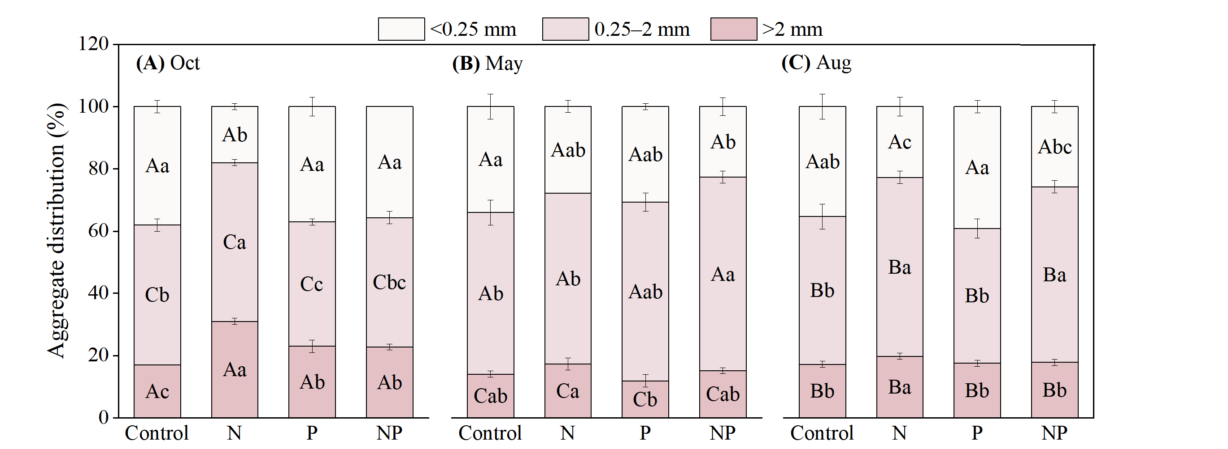
Fig. S2 Soil aggregate size distribution under long-term N and P application and at different growth stages. Data represent the mean (n=4) ± standard deviation. Control, N, P, and NP denote the N application, P application, and combined N and P application, respectively. Different lowercase letters indicate that there is a significant difference between different treatments of the same index in the same month (P<0.05), and different uppercase letters mean that there is a significant difference between different months of the same index (P<0.05).
Microbial communities in soil and aggregates
Soil bacteria abundance was significantly influenced by month, treatment, aggregate size, and their interactions (Table S2). Compared to other months, soil bacterial abundance exhibited relatively consistent variation, peaking in May and bottomed in October (Table S3) The biomass of bacteria (Bact.), Gram-positive (GP), Gram-negative (GN), and actinobacteria (Actino.) in the bulk soil was significantly lower than the control forin both N and NP treatments (P<0.05). Additionally, the Bact. (August) and GN (May, August) biomass was significantly lower in the P treatment (P<0.05). Bact. and GP biomass in mega-aggregates was significantly increased by P treatment (May) (P<0.05). Bact., GP, GN, and Actino. biomass (October, May, August) significantly decreased under N treatment, while Bact. (May), GN (October, May, August), and Achino. (May, August) were significantly decreased by NP treatment (P<0.05) (Fig. S3). In macro-aggregates, the Bact., GP, GN, and Actino. biomass was significantly reduced in the NP treatment across all months; and the Bact. (May, August), GP (May, August), and Actino. (May) biomass was significantly reduced in the P treatment (P<0.05) (Fig. S3). Within micro-aggregates, the Bact., GN, and Actino. biomass were significantly reduced by both N and NP treatments across all months; the GP biomass decreased significantly in the N (October) and NP treatments (October, May, August) (P<0.05); and the Bact. (May), GN (October, May, August), GP (August), and Actino. (October, May, August) biomass increased significantly in the P treatments (P<0.05) (Fig.S3). Regarding aggregate size, the Bact. (October, May, August), GP (May, August), GN (October, May, August), and Actino. (May) biomass was significantly reduced in mega-aggregates, and all biomass was significantly reduced in micro-aggregates across all months (P<0.05) compared to the bulk soil.

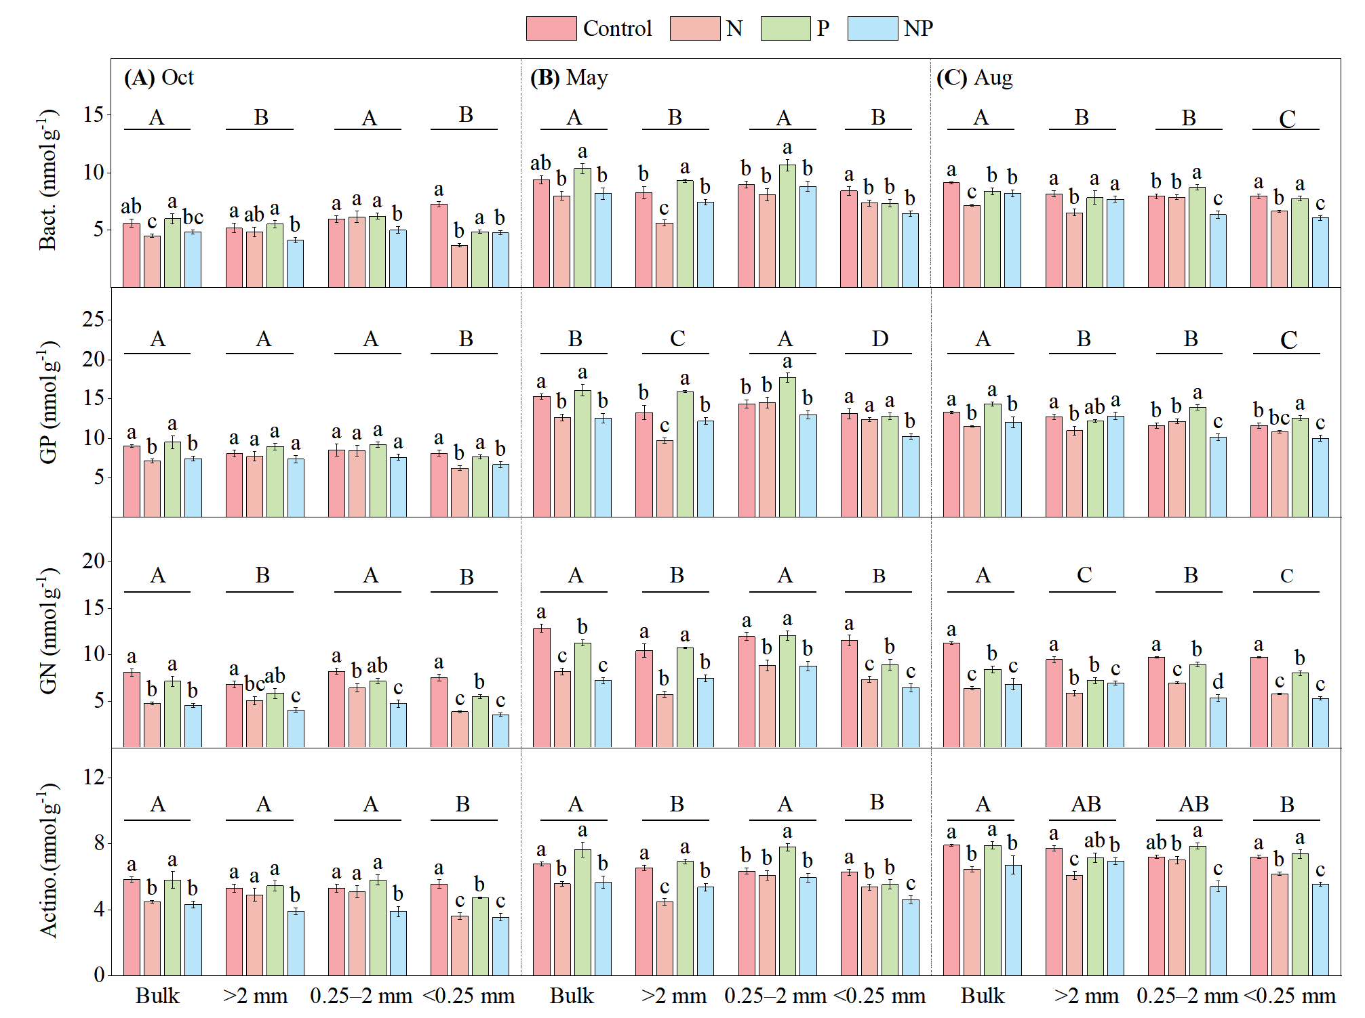
Fig. S3 Bacterial PLFAs biomass in the bulk soil and aggregate size fractions under long-term N and P application at different growth stages. Bact.: Bacteria; GP: Gram-positive bacteria; GN: Gram-negative bacteria; Actino.: actinobacteria
The soil saprophytic fungi (SF) and arbuscular mycorrhizal fungi (AMF) were significantly influenced by month, treatment, aggregate size, and their interactions (Table S2). The SF and AMF biomass exhibited relatively consistent variation across months, peaking in May and reaching their lowest levels in October (Table S3). Compared to the control, the SF and AMF biomass in the bulk soil was significantly reduced in both N and NP treatments across all months (P<0.05) (Fig. S4). Additionally, the SF biomass (August) and the AMF biomass (May, August) were significantly reduced in the P treatment (P<0.05). In mega-aggregates, the SF and AMF biomass was significantly reduced in N and NP treatments across all months, while the SF biomasst (May) was significantly increased in the P treatment (P<0.05) (Fig. S4). The SF and AMF biomass in macro-aggregates was significantly reduced in N and NP treatments across all months (P<0.05). The SF and AMF biomass in micro-aggregates was significantly reduced in N, P, and NP treatments across all months (Fig. S4). Compared to the bulk soil, the SF (May, August) and AMF (May) biomass was significantly lower in mega-aggregates, while the SF and AMF biomass in micro-aggregates was also significantly reduced in all months (Fig. S4).
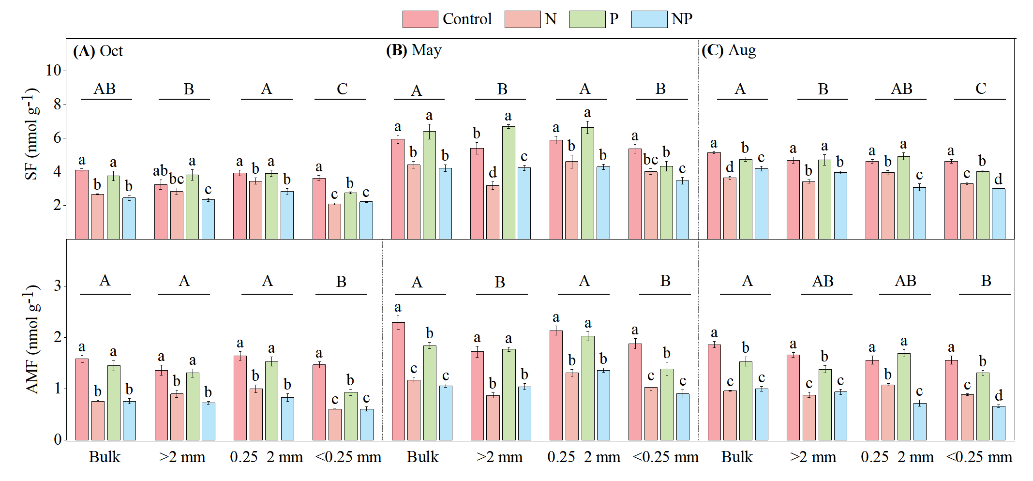
Fig. S4 Fungal PLFAs in the bulk soil and different size aggregates as affected by long-term N and P applications and sampling time. SF: saprophytic fungi; AMF: arbuscular mycorrhizal fungi

Microbial community structure in the bulk soil and aggregates
Under long-term N and P application, soil microbial community structure exhibited similar distribution patterns across months. Specifically, microbial communities in N and NP treated soils showed higher separation from the control treatment, with distinct distributions observed in mega-aggregates and micro-aggregates compared to the bulk soil (Fig. S3). Furthermore, PERMANOVA indicated that soil microbial community structure was significantly influenced by treatment, aggregate size, and their interaction. Nutrient treatment (October R² = 0.91, P<0.001; May R² = 0.76, P<0.001; August R² = 0.84, P<0.001) exerted a greater effect on microbial community structure than aggregate size (October R² = 0.58, P<0.001; May R² = 0.12, P = 0.108; August R² = 0.58, P<0.001) (Fig. S3).
Fig. S5 Microbial community structure in the bulk soil and aggregates under long-term N and P application at different time of the year. The ellipses in the analysis represent 95% confidence intervals.

Main pathways driving the stability of aggregates and changes in SOC
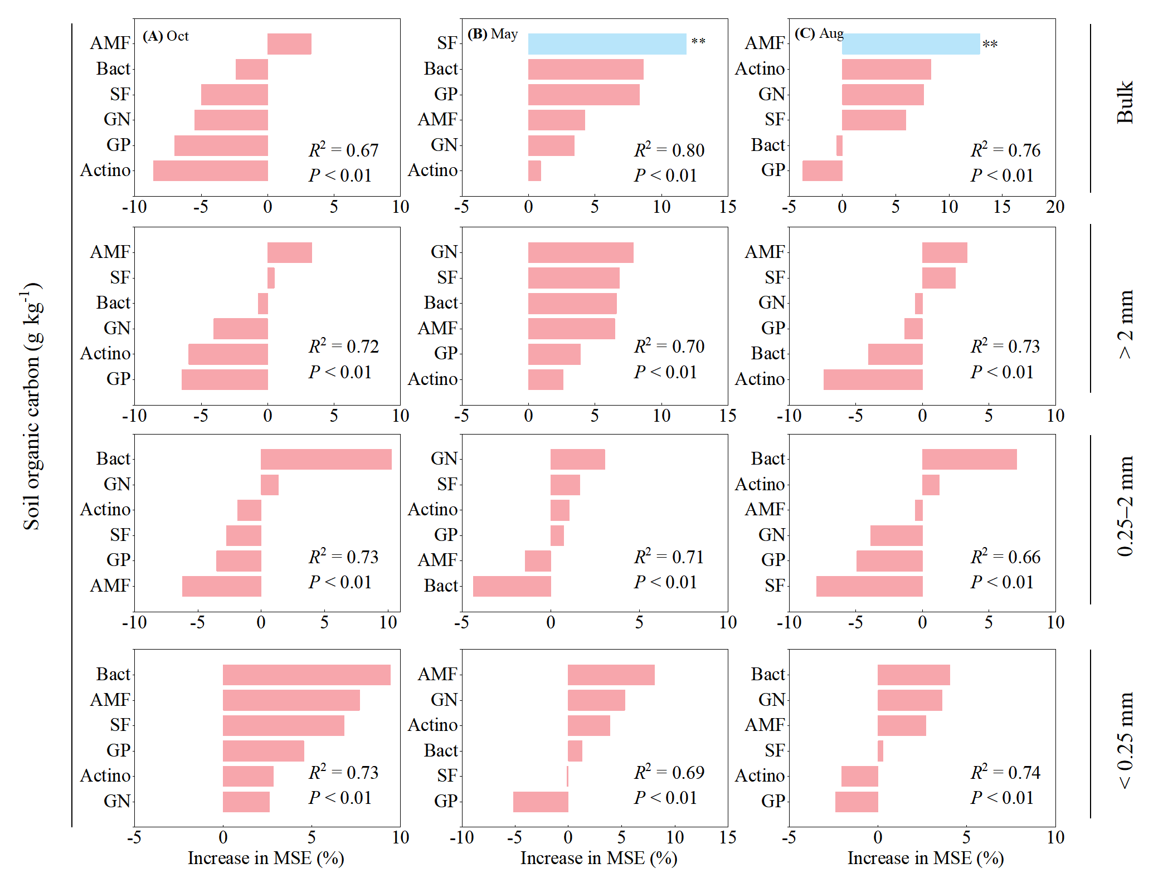
Fig. S6 Importance ranking of soil microorganisms influencing SOC under N and P application in bulk soil and aggregates. The random forest algorithm was used to calculate the MSE (mean squared error) for each predictor. The percentage increase in MSE among variables characterises the importance of factor prediction, with higher MSE% values indicating greater predictor importance.

Fig. S7 Relationship between MWD in bulk soil and aggregates and soil microorganisms.
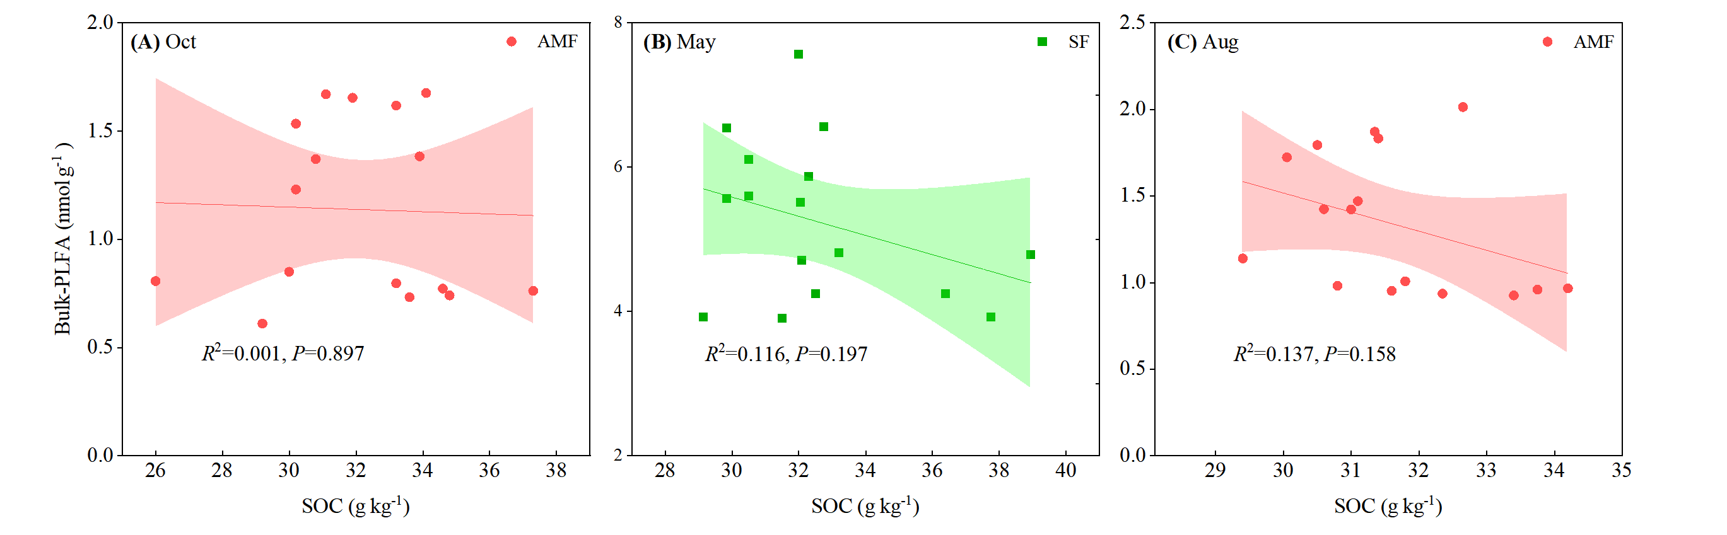

Table S1 Multivariate variance analysis of SOC in soil and aggregates by long-term N and P application，*P < 0.05；**P < 0.01；***P < 0.001.
 | Month | Size | Treatment | Month*Size | Month*Treatment | Size*Treatment | Month*Size*Treatment
SOC | 1.126 | 14.911*** | 3.68** | 0.405 | 1.558 | 3.267*** | 0.932

Table S2 Multivariate analysis of variance of soil and aggregate soil microorganisms under long-term N and P application, *P < 0.05；**P < 0.01；***P < 0.001.
Source of variation | PLFAs | Bact | GP | GN | SF | AMF | Actino
Month | 354.493*** | 165.005*** | 640.645*** | 200.062*** | 319.602*** | 133.103*** | 265.379***
Size | 36.635*** | 14.007*** | 32.696*** | 20.8*** | 37.187*** | 47.084*** | 22.701***
Treatment | 88.626*** | 27.515*** | 74.491*** | 162.166*** | 165.141*** | 428.086*** | 103.403***
Month*Size | 3.664*** | 2.494*** | 6.145*** | 1.972*** | 2.768** | 4.546*** | 2.459**
Month*Treatment | 2.111 | 1.429*** | 4.801*** | 3.298*** | 7.3*** | 2.434** | 1.881
Size*Treatment | 5.615*** | 2.761*** | 6.097*** | 2.748*** | 7.511*** | 5.596*** | 5.012***
Month*Size*Treatment | 2.165*** | 1.649*** | 2.909*** | 1.483*** | 2.826*** | 2.225*** | 2.625***
Bact: Bacteria; GP: Gram-positive bacteria; GN: Gram-negative bacteria; Actino: Actinomycetes; SF: Saprophytic fungi; AMF: Arbuscular mycorrhizal fungi

Table S3 Seasonal variations of soil microorganisms in long-term N and P application soils and aggregates，*P < 0.05；**P < 0.01；***P < 0.001.
Size | Month | PLFAs | Bact | GP | GN | SF | AMF | Actino
Bulk | 10 | 29.12±0.81C | 5.24±0.12C | 8.28±0.17C | 6.11±0.25C | 3.25±0.1C | 1.14±0.05C | 5.11±0.15C
Bulk | 5 | 46.25±0.39A | 8.98±0.17A | 14.16±0.11A | 9.87±0.07A | 5.24±0.11A | 1.59±0.03A | 6.42±0.19A
Bulk | 8 | 42.27±0.37B | 8.22±0.14B | 12.83±0.16B | 8.21±0.14B | 4.43±0.08B | 1.34±0.04B | 7.25±0.22B
> 2 mm | 10 | 26.97±0.52B | 4.92±0.08B | 8.05±0.14C | 5.42±0.06C | 3.05±0.19C | 1.07±0.02C | 4.89±0.11C
> 2 mm | 5 | 40.35±0.39A | 7.66±0.14A | 12.79±0.22A | 8.57±0.29A | 4.88±0.15A | 1.35±0.05A | 5.83±0.07A
> 2 mm | 8 | 38.64±1.31A | 7.56±0.21A | 12.2±0.13B | 7.35±0.06B | 4.2±0.16B | 1.21±0.03B | 6.99±0.15B
0.25–2 mm | 10 | 30.31±0.76C | 5.84±0.09C | 8.45±0.31C | 6.6±0.1C | 3.53±0.12C | 1.25±0.06B | 5.02±0.11B
0.25–2 mm | 5 | 47.19±1.25A | 9.14±0.23A | 14.9±0.14A | 10.38±0.22A | 5.36±0.13A | 1.7±0.02A | 6.54±0.11A
0.25–2 mm | 8 | 38.99±0.53B | 7.73±0.03B | 11.98±0.08B | 7.71±0.1B | 4.14±0.11B | 1.26±0.01B | 6.87±0.11A
< 0.25 mm | 10 | 24.21±0.66C | 4.99±0.19B | 7.18±0.11C | 5.08±0.09C | 2.67±0.05C | 0.91±0.01C | 4.36±0.07C
< 0.25 mm | 5 | 38.5±0.32A | 7.39±0.27A | 12.16±0.08A | 8.53±0.2A | 4.3±0.08A | 1.3±0.06A | 5.45±0.1A
< 0.25 mm | 8 | 36.27±0.71B | 7.1±0.07A | 11.26±0.1B | 7.18±0.08B | 3.73±0.02B | 1.11±0.04B | 6.58±0.09B
Different uppercase letters stated that there was a considerable difference between different months of the same index (P<0.05). Bact: Bacteria; GP: Gram-positive bacteria; GN: Gram-negative bacteria; Actino: Actinomycetes; SF: Saprophytic fungi; AMF: Arbuscular mycorrhizal fungi

