Supporting Information for
Soil Macrofauna Mucus Bacterial Community: Insights from Cultured Earthworms and Snails
Jia-Jia Gu¹, Ming-Xin Li¹, Shuai-Fei Ye¹, Qiu-Yu Gan¹, Si-Si Chen¹, Cheng-Wei Tao¹, Jing Wen¹, Xin-Li An^{1,2}, Yu-Ling Jiang³, Hong-Tao Wang^{1,2*}

¹ College of Geographical Sciences, Faculty of Geographical Science and Engineering, Henan University, Zhengzhou, 450046, China
² Key Laboratory of Geospatial Technology for the Middle and Lower Yellow River Regions, Ministry of Education; Henan Engineering Research Center for Control and Remediation of Soil Heavy Metal Pollution, Henan University, Kaifeng 475004, China
³ School of Geographic Sciences, Xinyang Normal University, Xinyang, 464000, China

* Corresponding author. Email: htwang@henu.edu.cn

Contents
Texts
Text S1 Preparation of soil and soil fauna.
Text S2 Mucus extraction method.

Tables
Table S1 The ASV numbers of earthworm, snail mucus, gut and soil samples.
Table S2 Network properties across mucus, gut, and soil samples.

Figures
Figure S1. Heat map of community composition at the family level.
Figure S2. Shannon index in different mucus methods.
Figure S3. Volcano plot in different mucus methods.
Figure S4. Weighted UniFrac principal coordinate analysis (PCoA) plots describe differences between samples.
Figure S5. Analysis of mucus, intestinal, and soil bacterial community composition at the phylum level.
Figure S6 Heatmap profile of the core microbiome across four host species.

Total:
Number of Texts：2
Number of tables: 2
Number of figures: 6
Number of pages: 12

Material and methods

Text S1 Preparation of Soil and Soil fauna
Soil samples were collected from the topsoil (0 - 20 cm) of an uncontaminated organic vegetable farm in Kaifeng City, Henan Province, China (34°51'34" N, 114°18'45 " E). The soil texture was sandy loam. After natural drying for 72 hours at 20 ± 2 ºC (relative humidity 45-60%), visible impurities were removed. The samples were ground and sieved through a 2-millimeter stainless steel sieve. Soil moisture content was adjusted to 75% field capacity (determined using the pressure plate method) and incubated in a ventilated container at 22 ± 2 ºC in the dark for 21 days. Commercially purchased soil fauna (Eisenia fetida, Metaphire guillelmi, Cathaica fasciola, Lissachatina fulica; GreenBio Agricultural Supply Company, Nanjing) were washed three times with sterile water and pre-cultured for 14 days in screened farmland soil (75% field capacity) under controlled conditions (22 ± 2 ºC, 70 ± 5% humidity, 12 - hour light-dark cycle) using a perforated incubator. Earthworms were supplemented with oatmeal weekly; snails were allowed to freely consume fresh lettuce. Vitality was confirmed after the adaptation period (survival rate > 95%; no behavioral abnormalities).

Text S2 Mucus Extraction Method
Mucus sampling from snails and earthworms was performed using two distinct methods. Prior to sampling, all soil fauna were thoroughly rinsed with sterile distilled water (3 rinses) and briefly blotted on sterile filter paper to remove excess surface moisture. Method 1 (Direct Swabbing Method, Mucus 1): Induce mucus secretion through mechanical stimulation. Gently secure the individual fauna, then use a sterile cotton swab to gently rub back and forth on the foot of a snail and the surface of an earthworm. Immediately use the same cotton swab to wipe the surface of the fauna secreting mucus to collect the secreted mucus. The tip of the swab containing mucus is aseptically cut off using sterile scissors and immediately placed into a pre-labeled 2.0 mL sterile microcentrifuge tube.
Method 2 (Aquatic Stimulation Method, Mucus 2): Each fauna is placed individually in a sterile polystyrene container. Snails are added to 1 mL of sterile phosphate-buffered saline (PBS, pH 7.4; Thermo Fisher Scientific). Earthworms are immersed in 1 mL of sterile distilled water (due to sensitivity to salt). Fauna are incubated at room temperature (22 ± 2 ºC) for a standardized duration of 30 minutes to allow mucus secretion into the surrounding liquid; The fauna are carefully removed using sterile forceps, and the supernatant containing mucus (approximately 900 µL, to compensate for volume displacement) is carefully aspirated into sterile pre-labeled 2.0 mL microcentrifuge tubes, avoiding aspiration of sediment or feces. The centrifuge tubes are immediately rapidly frozen in liquid nitrogen after sampling and stored at -80 ºC until subsequent analysis. For mucus collection, individuals were pooled to generate one composite sample per culture box, ensuring a sufficient volume of approximately 1.0-1.5 mL. Consequently, four independent biological replicates were established for each treatment.

Table S1 The ASV numbers of earthworm, snail mucus, gut and soil samples
Treatment | Mucus | Gut | Soil | All
Earthworm | 4861 | 8160 | 9352 | 11,615
Snail | 6749 | 7576 | 10181 | 12317

Table S2 Network properties across mucus, gut, and soil samples
Treatment | Group | positive edges | negative edges | all  edges | nodes | average degree | modularity
E. fetida | Mucus1 | 132 | 53 | 185 | 63 | 5.87 | 0.832
E. fetida | Mucus2 | 510 | 112 | 622 | 79 | 15.75 | 0.276
E. fetida | Gut | 2989 | 1016 | 4005 | 283 | 28.30 | 0.847
E. fetida | Soil | 3215 | 1262 | 4477 | 336 | 26.65 | 0.876
M. guillelmi | Mucus1 | 188 | 95 | 283 | 58 | 9.76 | 0.732
M. guillelmi | Mucus2 | 886 | 99 | 985 | 74 | 26.62 | 0.288
M. guillelmi | Gut | 4134 | 3475 | 7509 | 373 | 40.80 | 0.769
M. guillelmi | Soil | 3619 | 2537 | 6156 | 369 | 33.37 | 0.800
C. fasciola | Mucus1 | 1282 | 928 | 2210 | 148 | 29.87 | 0.580
C. fasciola | Mucus2 | 829 | 225 | 1054 | 127 | 16.60 | 0.817
C. fasciola | Gut | 1158 | 8 | 1166 | 119 | 19.60 | 0.611
C. fasciola | Soil | 13404 | 4765 | 18169 | 542 | 67.04 | 0.782
L. fulica | Mucus1 | 663 | 453 | 1116 | 99 | 22.55 | 0.433
L. fulica | Mucus2 | 188 | 52 | 240 | 63 | 7.62 | 0.803
L. fulica | Gut | 323 | 171 | 494 | 108 | 9.15 | 0.845
L. fulica | Soil | 10052 | 3615 | 13667 | 511 | 53.49 | 0.807

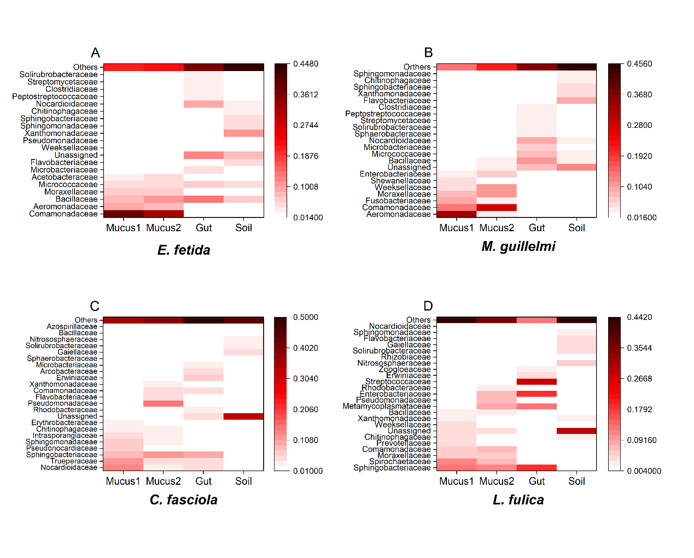
Fig.S1 Heat map of community composition at the family level was created by selecting the top 20 most abundant bacterial communities at the family level to obtain the community composition distribution heat maps for earthworms (A, B) and snails (C, D). Mucus1 represents the cotton swab stimulation extraction method; Mucus2 represents the sterile water extraction method.

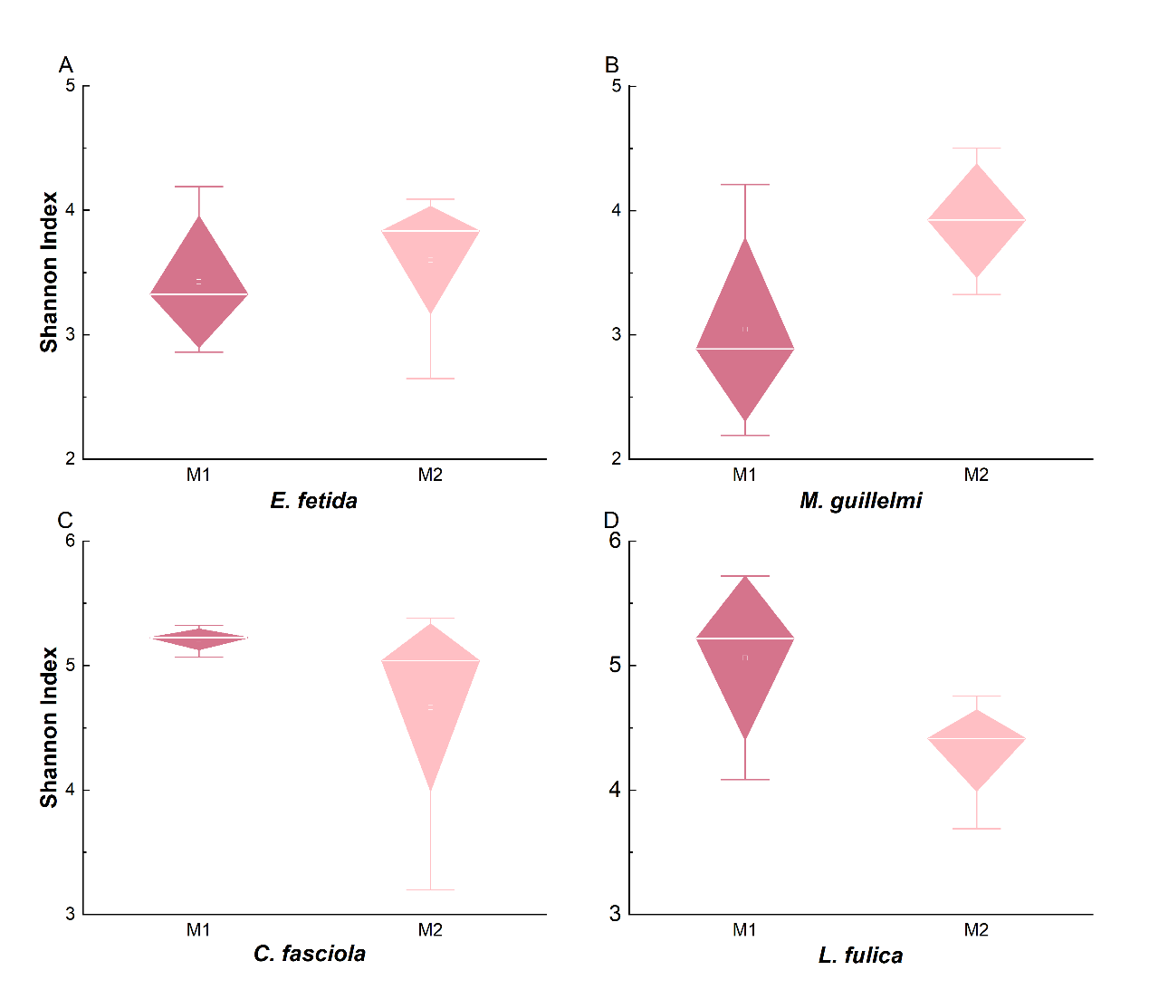
Fig.S2. The Shannon index in different mucus methods from earthworm (A, B) and snail (C, D). M1 represents the cotton swab stimulation extraction method; M2 represents the sterile water extraction method.

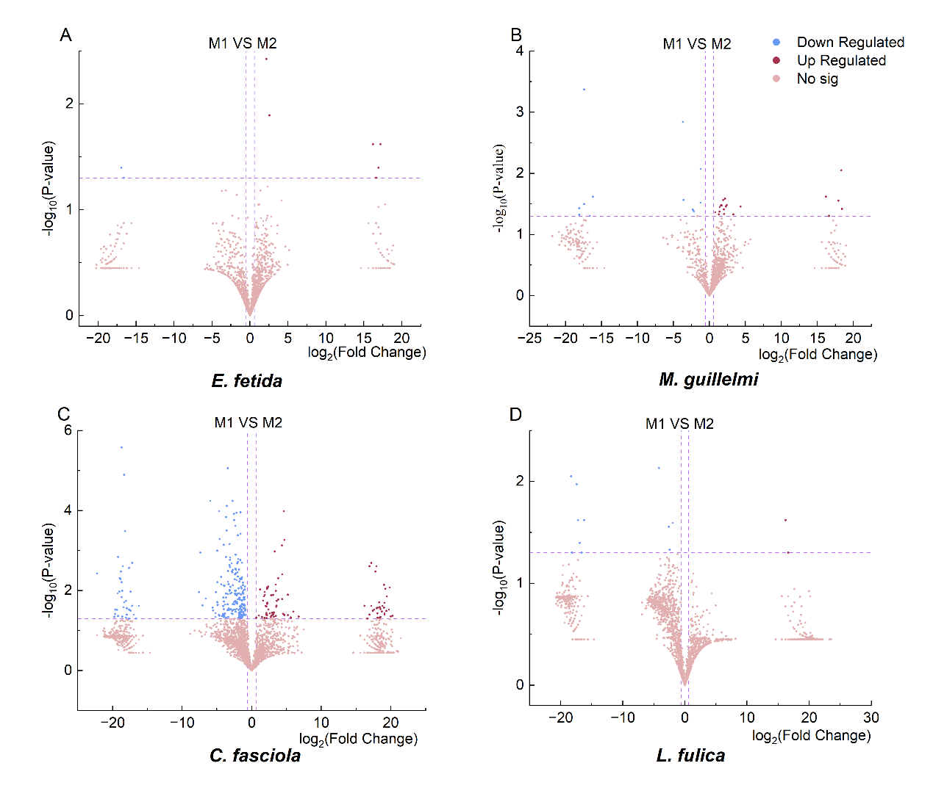
Fig.S3. Volcano plot in different mucus methods. Volcano plot of earthworm (A, B) and snail (C, D) in different mucus methods (P=0.05). M1 represents the cotton swab stimulation extraction method; M2 represents the sterile water extraction method.

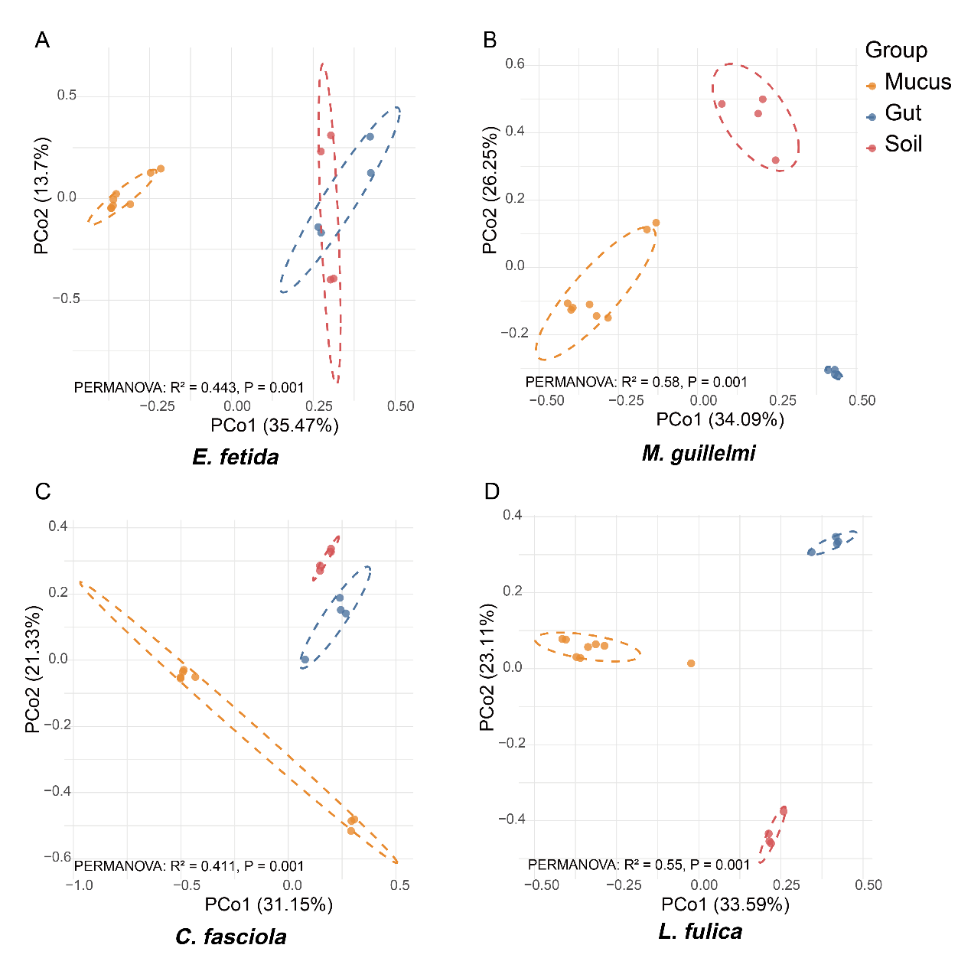
Fig.S4 Bray-Curtis principal coordinate analysis (PCoA) plots illustrating differences in bacterial communities among mucus (n=8), gut (n=4), and soil (n=4) of four soil fauna.

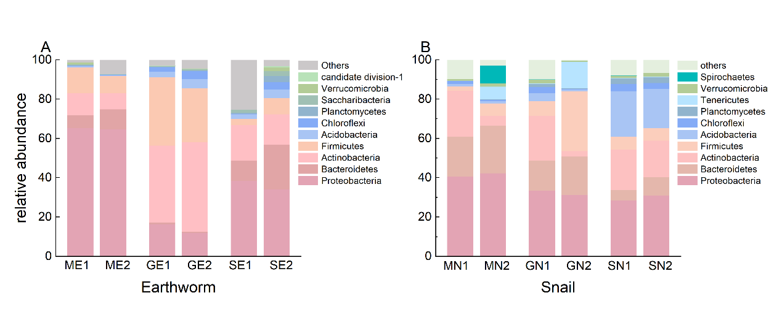
Fig.S5 Relative abundance of earthworm (A) and snail (B) mucus, intestinal, and soil bacteria at the phylum level. M represents mucus, G : gut, S : soil. E1 represents E. fetida, E2: M. guillelmi, N1: C. fasciola, N2: L. fulica. For example, ME1 represents the mucus of E. fetida.

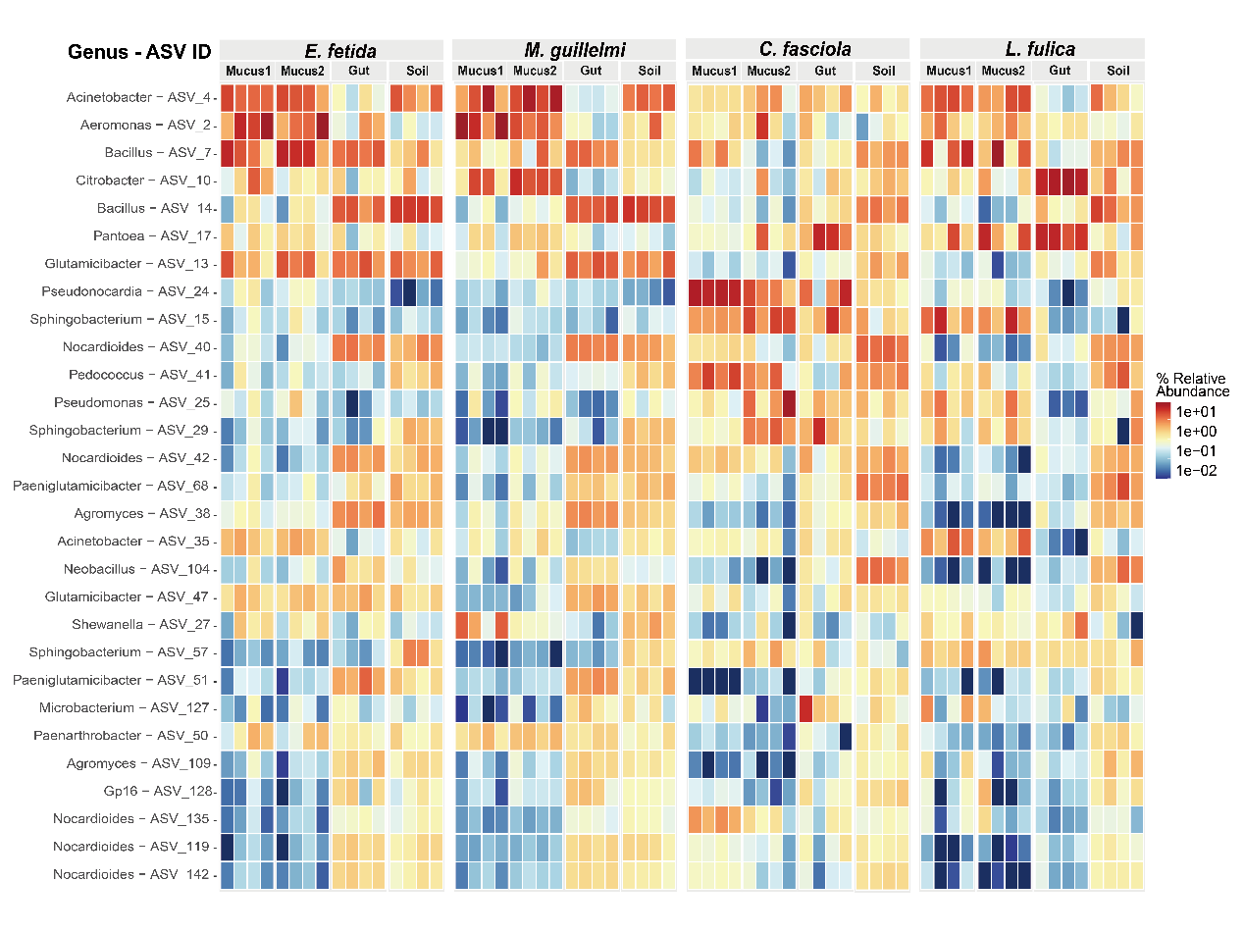
Fig.S6 Heatmap profile of the core microbiome across four host species. Core taxa were defined as ASVs present in more than 80% of all samples with a relative abundance greater than 0.0001 (0.01%). Rows represent the taxonomic assignment (at the genus level) of these core ASVs. The color gradient indicates the relative abundance of each taxon, ranging from blue (low abundance) to red (high abundance). Mucus1 represents the cotton swab stimulation extraction method; Mucus2 represents the sterile water extraction method.

