Table S1 Twelve treatments of the experiment.
Treatments | Temperatures | Addition of NP fertilizer
1 | 5ºC | CK+S (N-16.2 mg kg⁻¹, P-30 mg kg⁻¹)
2 | 5ºC | N+S (N-150 mg kg⁻¹, P-30 mg kg⁻¹)
3 | 5ºC | P+S (N-16.2 mg kg⁻¹, P-100 mg kg⁻¹)
4 | 5ºC | NP+S (N-150 mg kg⁻¹, P-100 mg kg⁻¹)
5 | 10ºC | CK+S (N-16.2 mg kg⁻¹, P-30 mg kg⁻¹)
6 | 10ºC | N+S (N-150 mg kg⁻¹, P-30 mg kg⁻¹)
7 | 10ºC | P+S (N-16.2 mg kg⁻¹, P-100 mg kg⁻¹)
8 | 10ºC | NP+S (N-150 mg kg⁻¹, P-100 mg kg⁻¹)
9 | 15ºC | CK+S (N-16.2 mg kg⁻¹, P-30 mg kg⁻¹)
10 | 15ºC | N+S (N-150 mg kg⁻¹, P-30 mg kg⁻¹)
11 | 15ºC | P+S (N-16.2 mg kg⁻¹, P-100 mg kg⁻¹)
12 | 15ºC | NP+S (N-150 mg kg⁻¹, P-100 mg kg⁻¹)

Fig. S1 Straw decomposition rates under different temperatures and fertilizer additions.
Fig. S2 Soil DOC and MBC under different temperatures and fertilizer additions.
Fig. S3 Soil NH₄⁺-N, NO₃⁻-N and pH under different temperatures and fertilizer additions.
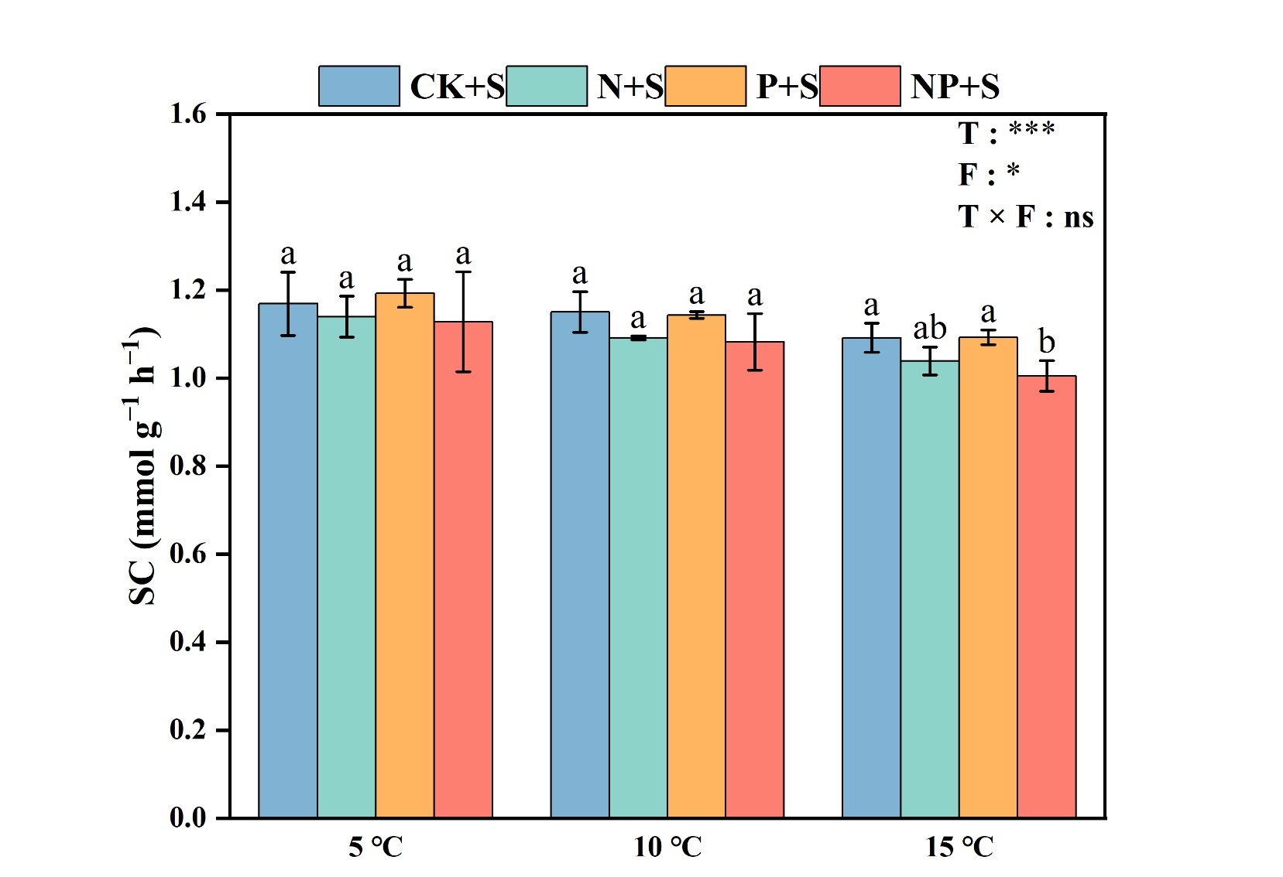
Fig. S4 Soil sucrase (SC) activity under different temperatures and fertilizer additions.

