Supporting Information

Table S1 Results of principal components analysis of variables in categories of soil environment, nematode diversity, ecological indices, metabolic traits, and plant diversity for Piecewise SEM.
Variables | Principal component 1
Soil environments
Soil bulk density | -0.577
Soil pH | -0.561
Soil moisture | 0.594
Cumulative (%) | 71.8
Nematode diversity
Nematode alpha diversity | 0.707
Nematode beta diversity | -0.707
Cumulative (%) | 78.3
Ecological induces
Enrichment index | 0.378
Structure index | 0.482
Maturity index | 0.477
Channel index | 0.455
Plant parasite Index | 0.435
Cumulative (%) | 39.5
Metabolic traits
Energy flux | 0.707
Metabolic footprint | 0.707
Cumulative (%) | 98.4
Plant diversity
Plant Alpha diversity | 0.707
Plant Beta diversity | -0.707
Cumulative (%) | 57.9

Table S2. The correlations between the composite variables (PC1 scores) and their respective original indicators. Values represent Pearson correlation coefficients; asterisks indicate statistical significance (*P < 0.05, **P < 0.01, ***P < 0.001). Sample size n = 220.
Variables | Correlation index | Significance
Soil environment
Soil bulk density | 0.83 | ***
Soil pH | 1 | ***
Soil moisture | 0.87 | ***
Nematode diversity
Nematode alpha diversity | 0.88 | ***
Nematode beta diversity | -0.88 | ***
Ecological induces
Enrichment index | 0.53 | ***
Channel index | 0.64 | ***
Structure index | 0.68 | ***
Maturity index | 0.67 | ***
Plant parasite Index | 0.49 | ***
Metabolic traits
Energy flux | 0.99 | ***
Metabolic footprint | 0.19 | **
Plant diversity
Plant alpha diversity | 0.25 | ***
Plant beta diversity | -0.57 | ***

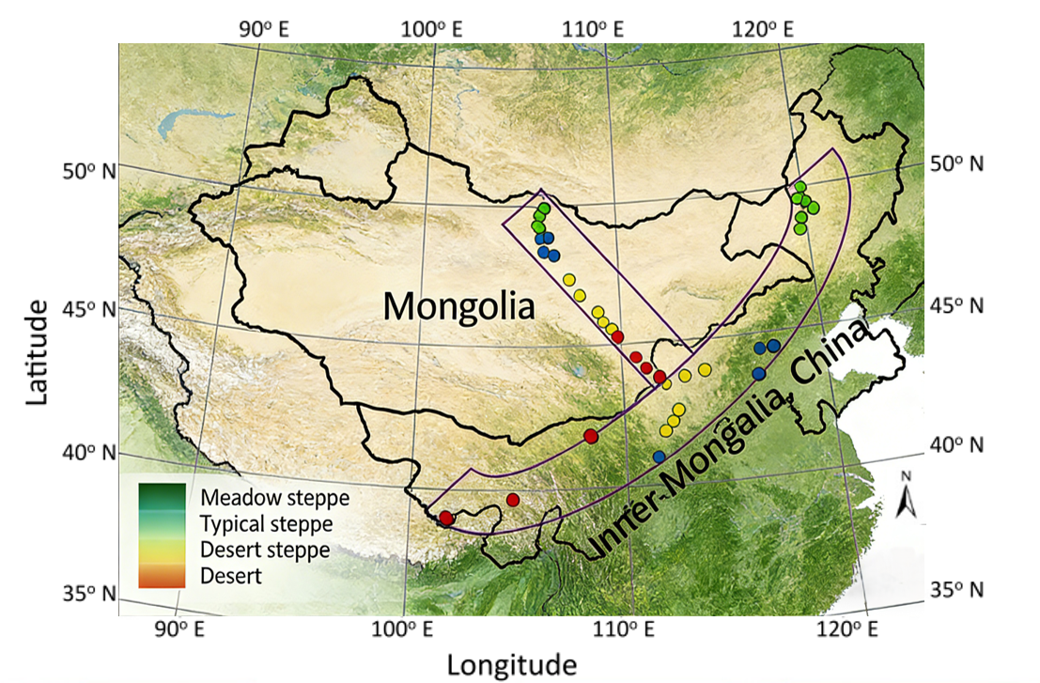
Figure S1 Locations of the 44 study sites along the east–west transect across Inner Mongolia, China (~2000 km), and the north–south transect across Mongolia (~900 km) on the Mongolian Plateau.

Figure S2 Strong autocorrelation between α- and γ-diversity in plants and nematode. Scatterplots with linear fits; R² and P-values (*** P < 0.001) shown in upper-left corners. Due to high correlations, subsequent analyses prioritized α- and β-diversity.
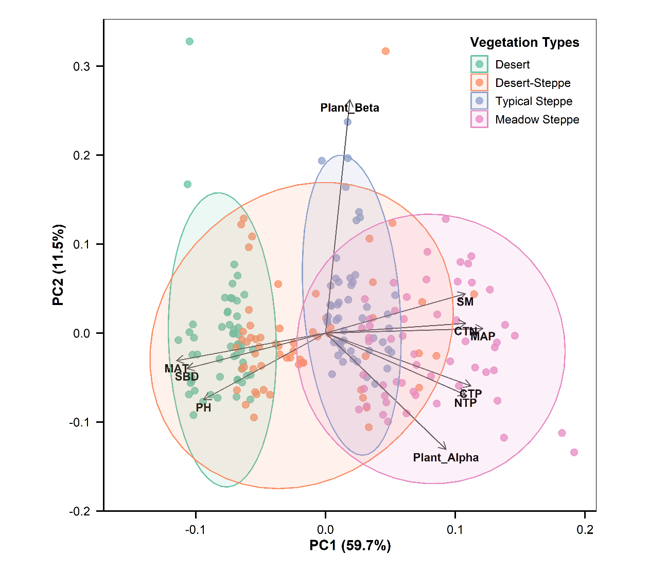
Figure S3 PCA biplot of environmental variables and plant diversity across vegetation types. Sites (n = 44) are ordinated by PC1 and PC2 (cumulative variance: 71.2%). Symbols and colors denote vegetation types Desert (D), Desert Steppe (DS), Typical Steppe (TS), and Meadow Steppe (MS)). Vectors show loadings of mean annual precipitation (MAP), mean annual temperature (MAT), soil moisture (SM), soil pH, soil bulk density (SBD), ratio of SOC to TSN (CTN), ratio of SOC to TSP (CTP), ratio of TSN to TSP (NTP), plant alpha diversity (Plant_α), and plant alpha diversity (Plant_β). Ellipses represent 95% confidence intervals.
Figure S4 Variation in individual ecosystem functions across four grassland vegetation types. Vegetation types: desert (D), desert steppe (DS), typical steppe (TS), and meadow steppe (MS). Values are means ± SE. Different letters denote significant differences (P < 0.05, Tukey HSD). Eleven key ecosystem functions encompassing aboveground functions—including aboveground net primary productivity (ANPP), belowground biomass (BB), and plant carbon (C) and nitrogen (N) content (PC and PN)—and belowground functions—including soil organic carbon (SOC), total soil nitrogen (TSN), total soil phosphorus (TSP), soil C and N mineralization rates (Cmin and Nmin), soil microbial biomass (TPLFA), and soil nematode abundance (TNA).
Figure S5 Pearson correlation heatmap showing relationships between abiotic and biotic variables and ecosystem multifunctionality (EMF) and its aboveground and belowground components across four vegetation types. Panels display correlation coefficients for desert, desert steppe, typical steppe, and meadow steppe. Predictors include climatic (MAT, MAP), soil environment (soil moisture, pH, bulk density), plant diversity (α- and β-diversity), nematode taxonomic diversity (α- and β-diversity), ecological indices (MI, SI, EI, CI, PPI), and metabolic traits (energy flux, metabolic footprint). Color intensity reflects the strength of Pearson's r, with red indicating positive and blue indicating negative correlations; asterisks indicate significance (* P < 0.05, ** P < 0.01, *** P < 0.001).

