Figure S1. Geographic location map of a) soil collection site (Irauçuba) and b) greenhouse experiment setup (Fortaleza) in Ceará state, Brazil. Source: Barbosa et al., 2024.

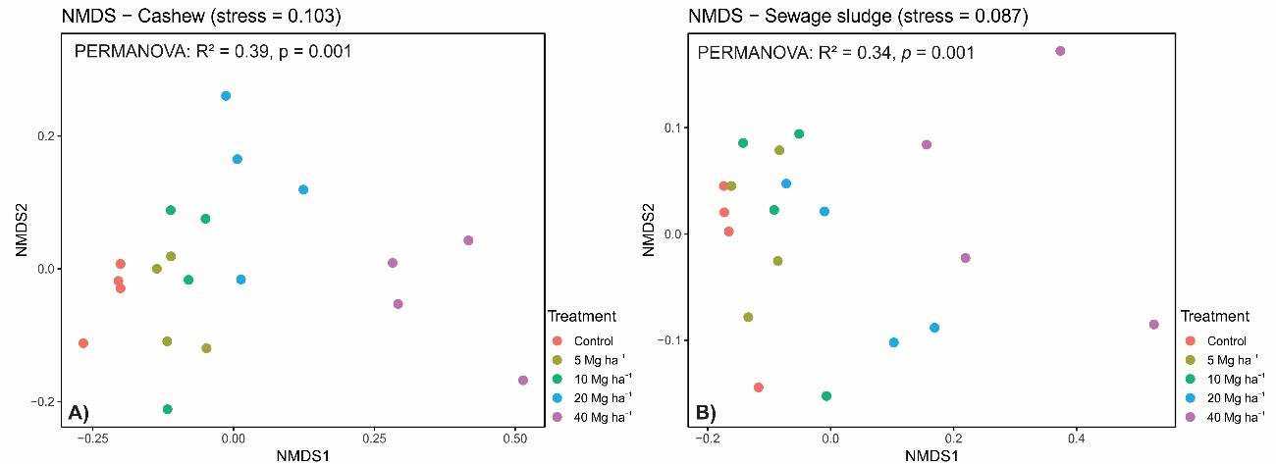
Figure S2. Non-metric multidimensional scaling (NMDS) ordination based on Bray–Curtis dissimilarity showing bacterial community structure under (A) cashew biochar and (B) sewage sludge biochar across application rates, including the control. Points represent individual samples. Differences among treatments were significant in both cases (PERMANOVA, p = 0.001), with a stronger effect observed for cashew biochar (R² = 0.39) compared to sewage sludge biochar (R² = 0.34). Stress values are indicated in each panel.

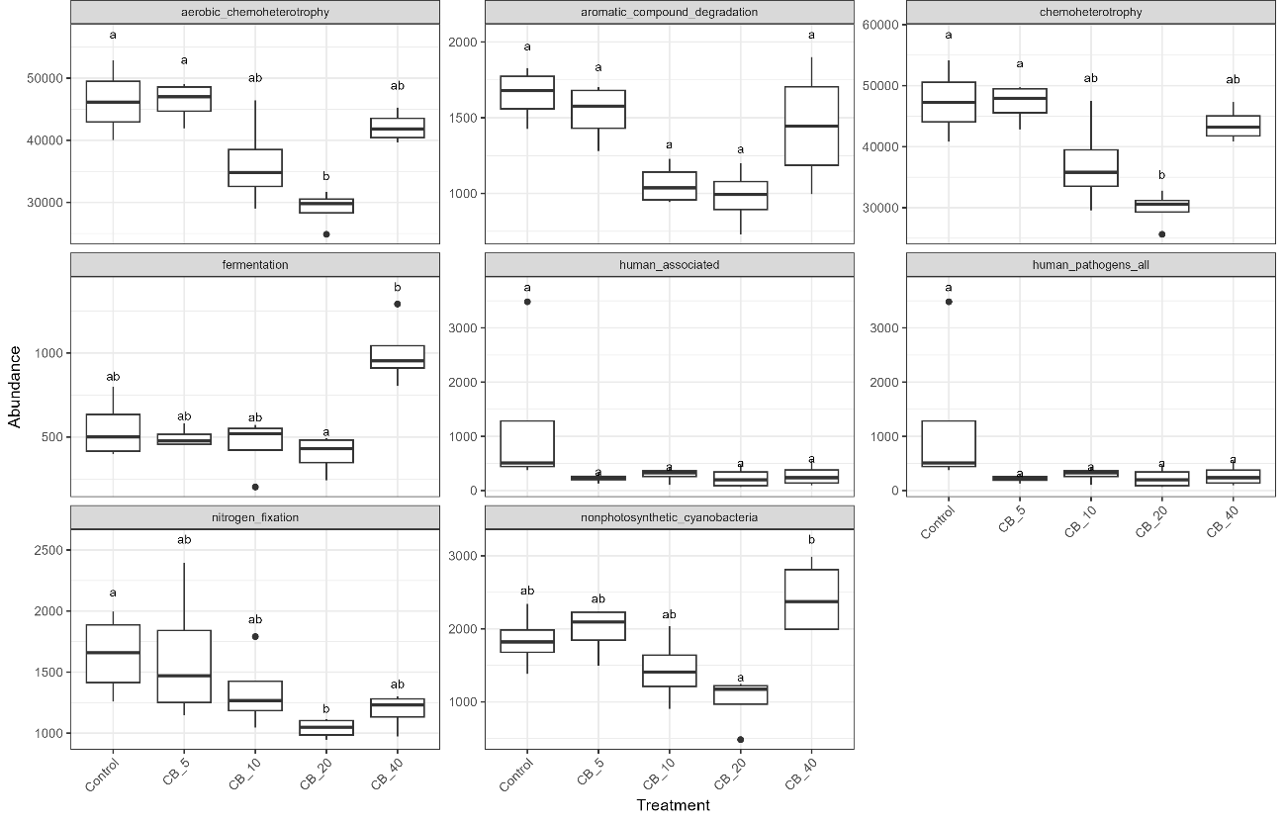
Figure S3. Predicted functional profiles of soil bacterial communities under cashew bagasse biochar application at different doses. Boxplots represent the distribution of functional group abundances across treatments (Control, 5, 10, 20, and 40 Mg ha⁻¹). Functions shown were selected based on statistical significance or lowest p-values when no significant differences were detected. Different letters above boxplots indicate significant differences among treatments according to Dunn’s post hoc test (p < 0.05). Boxes represent the interquartile range, horizontal lines indicate medians, and whiskers represent the range of the data.

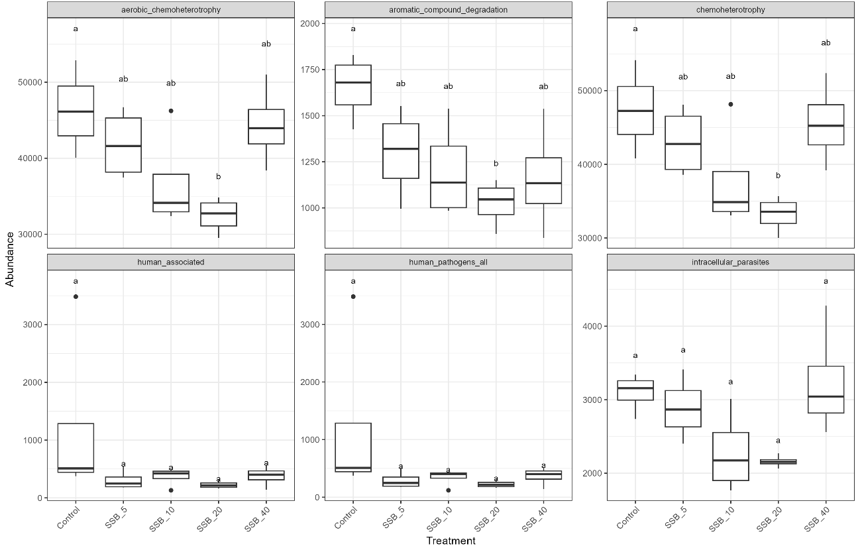
Figure S4. Predicted functional profiles of soil bacterial communities under sewage sludge biochar application at different doses. Boxplots represent the distribution of functional group abundances across treatments (Control, 5, 10, 20, and 40 Mg ha⁻¹). Functions shown were selected based on statistical significance or lowest p-values when no significant differences were detected. Different letters above boxplots indicate significant differences among treatments according to Dunn’s post hoc test (p < 0.05). Boxes represent the interquartile range, horizontal lines indicate medians, and whiskers represent the range of the data.

