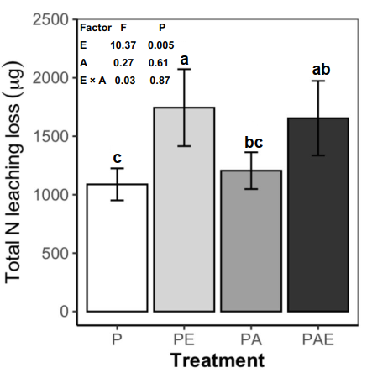
Fig. S1 The total amount of leaching N of the three sampling days. Means ± SE. The significant differences (P < 0.05) between treatments were indicated by different letters. Results of the two-way ANOVA (earthworm, E; AMF, A and their interaction, E × A) are shown within the graph. Abbreviations: P, plant only (control); PE, plant with earthworm (E); PA, plant with arbuscular mycorrhizal fungi (AMF); PAE, plant with both E and AMF

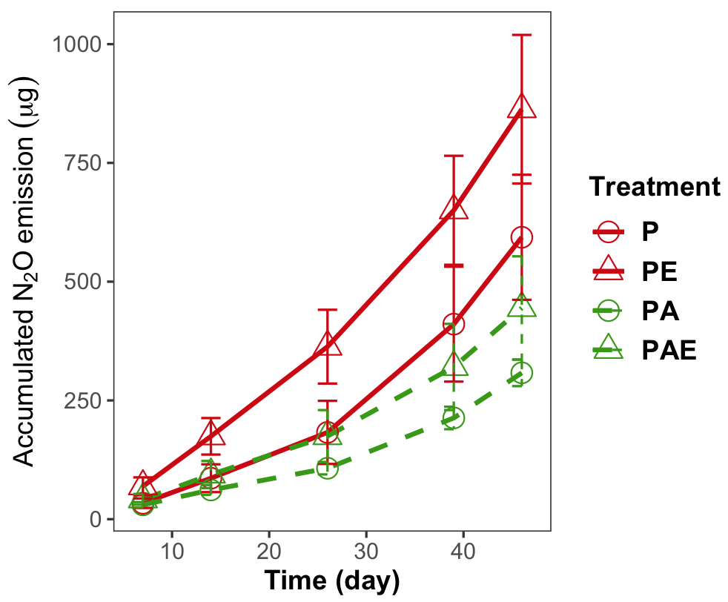
Fig. S2 Cumulative soil N₂O emissions over the sampling period. Data are presented as means ± SE.

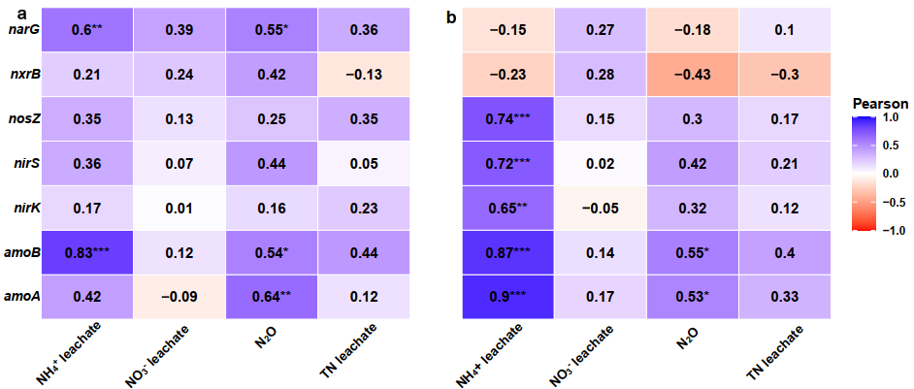
Fig. S3 Pearson correlation analysis between nitrogen-cycle gene abundances and soil NH₄⁺ leachate, NO₃⁻ leachate, N₂O emissions and total nitrogen (TN) leachate in bulk soil (a) and rhizosphere (b). Color intensity indicates the strength and direction of correlations (red = negative, blue = positive), with values representing Pearson correlation coefficients. Asterisks denote statistical significance (* p < 0.05, ** p < 0.01, *** p < 0.001).

Table S1 The target genes, primer sets and thermocycle conditions used for real-time qPCR reactions.

Target gene | Sequence (5’–3’) | Function | Elongation temperature, time | Reference
amoA | F: GGGGTTTCTACTGGTGGT  R: CCCCTCKGSAAAGCCTTCTTC | NH₄⁺→NO₂ | 95℃ 5 min; 95℃ 30 s, 55℃ 30 s, 72℃ 30s, 35 cycles | Li et al. (2016)
amoB | F: GGG GTT TCT ACT GGT GGT  R: CCC CTC KGS AAA GCC TTC TTC | NH₄⁺→NO₂ | 95℃ 5 min; 95℃ 30 s, 56℃ 30 s, 72℃ 30s, 35 cycles | Rotthauwe et al. (1997)
nxrB | F: TACATGTGGTGGAACA  R: CGGTTCTGGTCRATCA | NO₂⁻→NO₃⁻ | 95℃ 5 min; 95℃ 30 s, 58℃ 30 s, 72℃ 30s, 35 cycles | Giller et al. (1998)
narG | F: TAYGTSGGGCAGGARAAACTG  R: CGTAGAAGAAGCTGGTGCTGTT | NO₃⁻→NO₂⁻ | 95℃ 5 min; 95℃ 30 s, 59°C 30 s, 72℃ 30s, 35 cycles | Wang et al. (2013)
nirS | F: GTSAACGTSAAGGARACSGG  R: GASTTCGGRTGSGTCTTGA | NO₂⁻→NO | 95℃ 5 min; 95℃ 30 s, 59℃ 30 s, 72℃ 30s, 35 cycles | Wang et al. (2013)
nirK | F: ATCATGGTSCTGCCGCG  R: GCCTCGATCAGRTTGTGGTT | NO₂⁻→NO | 95℃ 5 min; 95℃ 30 s, 63℃ 30 s, 72℃ 30s, 35 cycles | Throbäck et al. (2004)
nosZ | F: CCCGCTGCACACCRCCTTCGA  R: CGTCGCCSGAGATGTCGATCA | N₂O→N₂ | 95℃ 5 min; 95℃ 30 s, 66℃ 30 s, 72℃ 30s, 35 cycles | Wang et al. (2013)

Table S2 Effects of earthworms (E), AMF (A), and their interaction on soil NH₄⁺ and NO₃⁻ concentrations on Day 14.
Factors | NH₄⁺ |  | NO₃⁻
Factors | Wald Chi-Square | P | Wald Chi-Square | P
E | 46.383 | < 0.001 | 7.496 | 0.006
A | 5.621 | 0.018 | 1.306 | 0.253
E × A | 2.61 | 0.106 | 0.64 | 0.424

Table S3 The effects of the earthworm (E), AMF (A) and their interaction (E×A) on soil N₂O emission rate in each sampling day (daytime, nighttime and daily average). Two-way ANOVA results indicate the effects at each time point, while repeated-measures ANOVA indicates the effects of E, A, and E×A over time.
 | Daytime |  |  |  |  |  | Night |  |  |  |  |  |  | Daily average
 | day-7 | day-14 | day-26 | day-39 | day-46 |  | day-7 | day-14 | day-26 | day-39 | day-46 |  | day-7 | day-14 | day-26 | day-39 | day-46
E | 0.074 | 0.036 | 0.078 | 0.069 | 0.684 |  | 0.033 | 0.14 | 0.004 | 0.805 | 0.438 |  | 0.045 | 0.05 | 0.04 | 0.383 | 0.48
A | 0.312 | 0.026 | 0.002 | 0.005 | 0.164 |  | 0.198 | 0.01 | 0.01 | 0.003 | 0.285 |  | 0.242 | 0.018 | 0.003 | 0.003 | 0.114
E×A | 0.492 | 0.998 | 0.725 | 0.561 | 0.786 |  | 0.452 | 0.878 | 0.443 | 0.993 | 0.557 |  | 0.446 | 0.974 | 0.653 | 0.711 | 0.933
Repeated-measures ANOVA: E (P = 0.114), A (P = 0.008), E×A (P = 0.631)

Table S4 The effects of earthworms (E), AMF (A), and their interaction (E × A) on accumulated N₂O emissions
measured on days 7, 14, 26, 39, and 46.

Factors | Day_7 |  | Day_14 |  | Day_26 |  | Day_39 |  | Day_46
Factors | Wald χ² | Sig. | Wald χ² | Sig | Wald χ² | Sig. | Wald χ² | Sig. | Wald χ² | Sig.
E | 5.007 | 0.025 | 5.589 | 0.018 | 5.94 | 0.015 | 4.47 | 0.034 | 4.576 | 0.032
A | 1.714 | 0.19 | 4.024 | 0.045 | 6.866 | 0.009 | 11.039 | 0.001 | 14.483 | < 0.001
E × A | 0.726 | 0.394 | 0.348 | 0.555 | 0.169 | 0.681 | 0.016 | 0.899 | 0 | 0.982

Table S5 Results of repeated-measures ANOVA showing between-subject effects of earthworm (E) and AMF (A) treatments and within-subject effects of time and its interactions with E and A on cumulative N₂O emissions. Bold values indicate significant effects (P < 0.05).
Between-subject effects | df | F | Sig.
E | 1, 16 | 3.704 | 0.072
A | 1, 16 | 7.211 | 0.016
E * A | 1, 16 | 0.569 | 0.462
Within-subjects effects (time)
Time | 4, 64 | 82.36 | < 0.001
Time × E | 4, 64 | 2.61 | 0.123
Time × A | 4, 64 | 9.34 | 0.006
Time × E × A | 4, 64 | 0.28 | 0.62

Table S6 Pearson correlations between total N₂O and derived N₂O for daytime and nighttime measurements at three sampling times (26, 39, and 46). The table shows correlation coefficients (estimate, r), and P-values.
Collection date | Period | Correlation (r) | P-value
26 | day | 0.86 | < 0.001
26 | night | 0.82 | < 0.001
39 | day | 0.88 | < 0.001
39 | night | 0.96 | < 0.001
46 | day | 0.97 | < 0.001
46 | night | 0.96 | < 0.001

References
Giller, K.E., Witter, E., McGrath, S.P., 1998. Toxicity of heavy metals to microorganisms and microbial processes in agricultural soils: a review. Soil Biology and Biochemistry 30, 1389-1414. https://doi.org/https://doi.org/10.1016/S0038-0717(97)00270-8
Li, Q., Guo, X., Lu, Y., Shan, G., Huang, J., 2016. Impacts of adding FGDG on the abundance of nitrification and denitrification functional genes during dairy manure and sugarcane pressmud co-composting. Waste Management 56, 63-70. https://doi.org/https://doi.org/10.1016/j.wasman.2016.07.007
Rotthauwe, J.H., Witzel, K.P., Liesack, W., 1997. The ammonia monooxygenase structural gene amoA as a functional marker: molecular fine-scale analysis of natural ammonia-oxidizing populations. Applied and environmental microbiology 63, 4704-4712. https://doi.org/10.1128/aem.63.12.4704-4712.1997
Throbäck, I.N., Enwall, K., Jarvis, Å., Hallin, S., 2004. Reassessing PCR primers targeting nirS, nirK and nosZ genes for community surveys of denitrifying bacteria with DGGE. FEMS Microbiology Ecology 49, 401-417. https://doi.org/https://doi.org/10.1016/j.femsec.2004.04.011
Wang, C., Lu, H., Dong, D., Deng, H., Strong, P.J., Wang, H., Wu, W., 2013. Insight into the Effects of Biochar on Manure Composting: Evidence Supporting the Relationship between N₂O Emission and Denitrifying Community. Environmental Science & Technology 47, 7341-7349. https://doi.org/10.1021/es305293h

