Supplementary Files
Agropedogenesis Alters Microbial Communities and Antibiotic Resistomes in Tundra Soils: A Comparison of Modern and Ancient Cryogenic Ecosystems in West Siberia
Alexey S. Vasilchenko¹*, Darya V. Poshvina¹, Аrtyom A. Stepanov¹, Alexander V. Balkin², Diana S. Dilbaryan¹, Alexander V. Yashnikov¹, Elya Shmidt¹, Olga Domanskaya¹, Andrey V. Soromotin³, Timur Nizamutdinov ⁴, Andrey V. Lisitsa ^{1,5} , Anastasia V. Teslya¹
¹Laboratory of Antimicrobial Resistance, Institute of Environmental and Agricultural Biology (X-BIO), University of Tyumen, Tyumen, Russian Federation
² Laboratory of Biomedical Technologies, Institute for Cellular and Intracellular Symbiosis of the Ural Branch of the Russian Academy of Sciences, Orenburg, Russian Federation
³ Institute of Ecology and Natural Resource Management Research, University of Tyumen, Russia
⁴Department of Applied Ecology, Saint-Petersburg State University, St. Petersburg, Russian Federation
⁵V.N. Orekhovich Institute of Biomedical Chemistry, 10, Pogodinskaya St., 119121 Moscow, Russia
* Corresponding author. E-mail: avasilchenko@gmail.com (ASV).

Table S1. Description of sample locations
Type | Coordinates | Soil type, WRB 2022 | Code
Arable land | 65.503376, 72.647211 | Hortic Podzol (Arenic) | FA
Arable land (abandoned 17 y.o.) | 65.336806, 72.982361 | Plaggic Podzol (Arenic) | FAa
Arable land (abandoned 17 y.o.) | 65.336545, 72.981920 | Plaggic Podzol (Arenic) | FAa
Arable land (abandoned 29 y.o.) | 65.508750, 72.634000 | Plaggic Podzol (Arenic) | FAa
Arable land (abandoned 17 y.o.) | 65.503419, 72.647971 | Plaggic Podzol (Arenic) | FAa
Natural landscape (5-10 cm) | 65.525604, 72.477900 | Fibric Histosols | NLt
Natural landscape (5-10 cm) | 65.525572,72.478333 | Fibric Histosols | NLt
Natural landscape (5-10 cm) | 65.550354, 72.550645 | Fibric Histosols | NLt
Natural landscape (5-10 cm) | 65.647094, 71.858232 | Fibric Histosols | NLt
Natural landscape (5-10 cm) | 65.525568, 72.478061 | Fibric Histosols | NLt
Natural landscape (>30 cm) | 65.525604, 72.477900 | Fibric Histosols | PNLt
Natural landscape (>30 cm) | 65.525568, 72.478061 | Fibric Histosols | PNLt
Natural landscape (>30 cm) | 65.550354, 72.550645 | Fibric Histosols | PNLt
Natural landscape (>30 cm) | 65.647094, 71.858232 | Fibric Histosols | PNLt
Natural landscape | 65.702361, 71.781035 | Albic Podzol | NLр
Natural landscape | 65.702646, 71.779710 | Albic Podzol | NLр

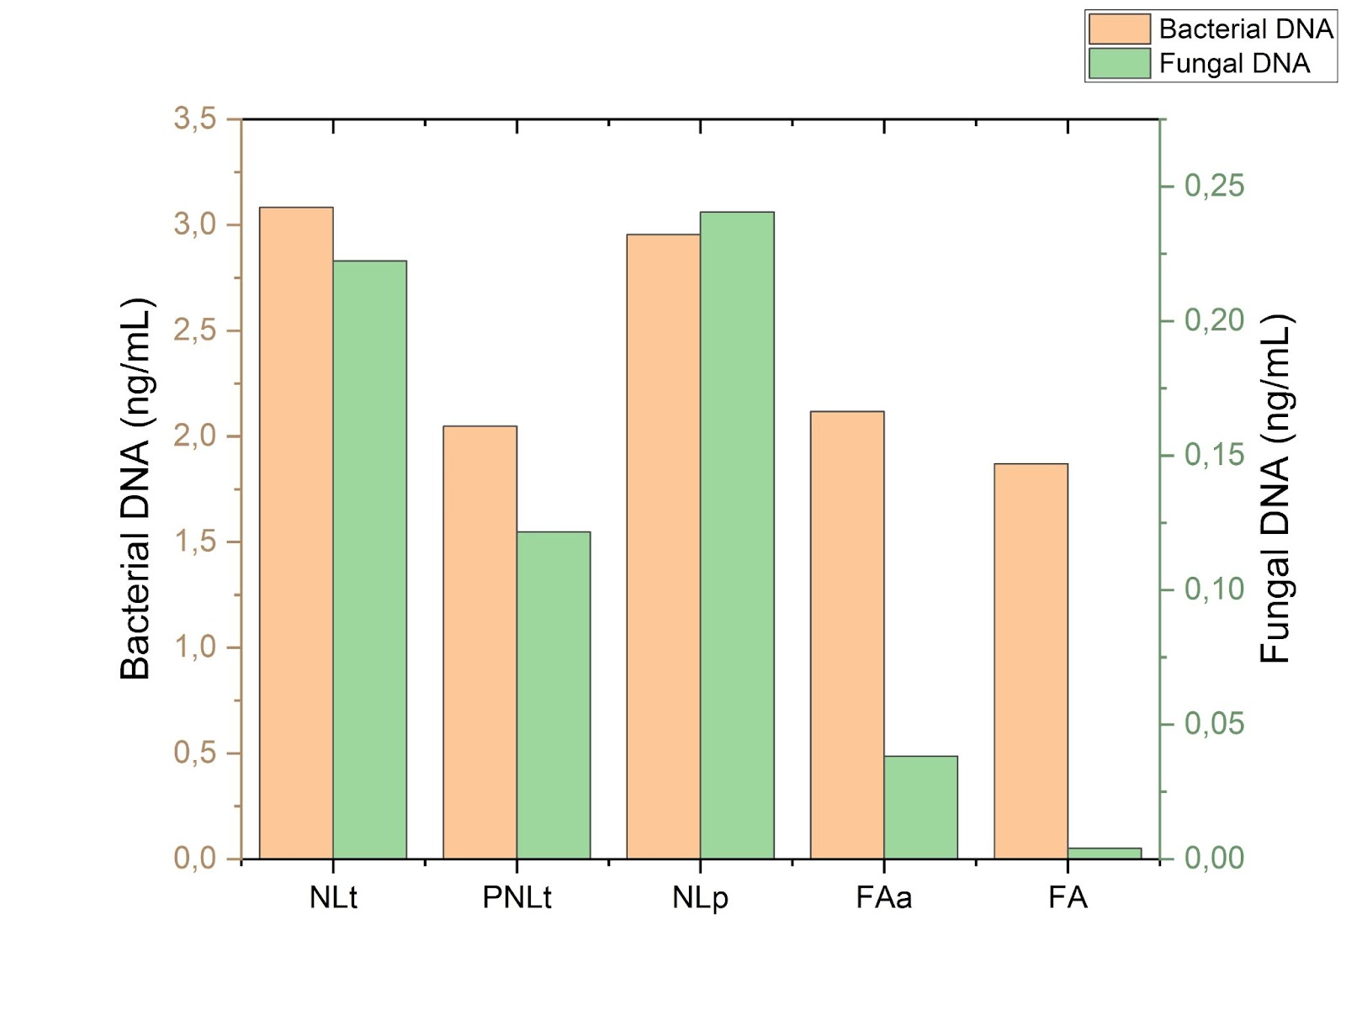
Figure S1. The amount of DNA corresponding to fungi and bacteria determined by RT-PCR.
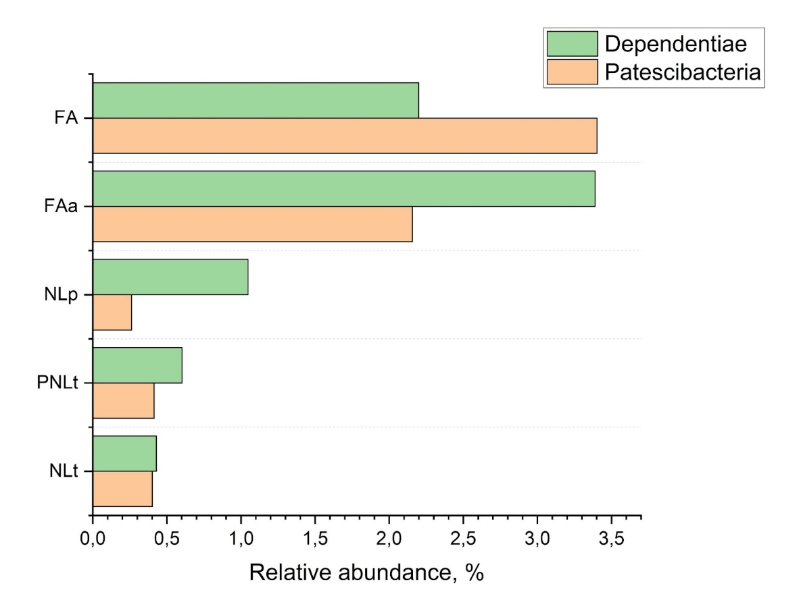
Figure S2. The relative abundance of bacterial phyla that make up the so-called "microbial dark matter", which certain genera are known as intracellular symbionts of eukaryotes (protists).
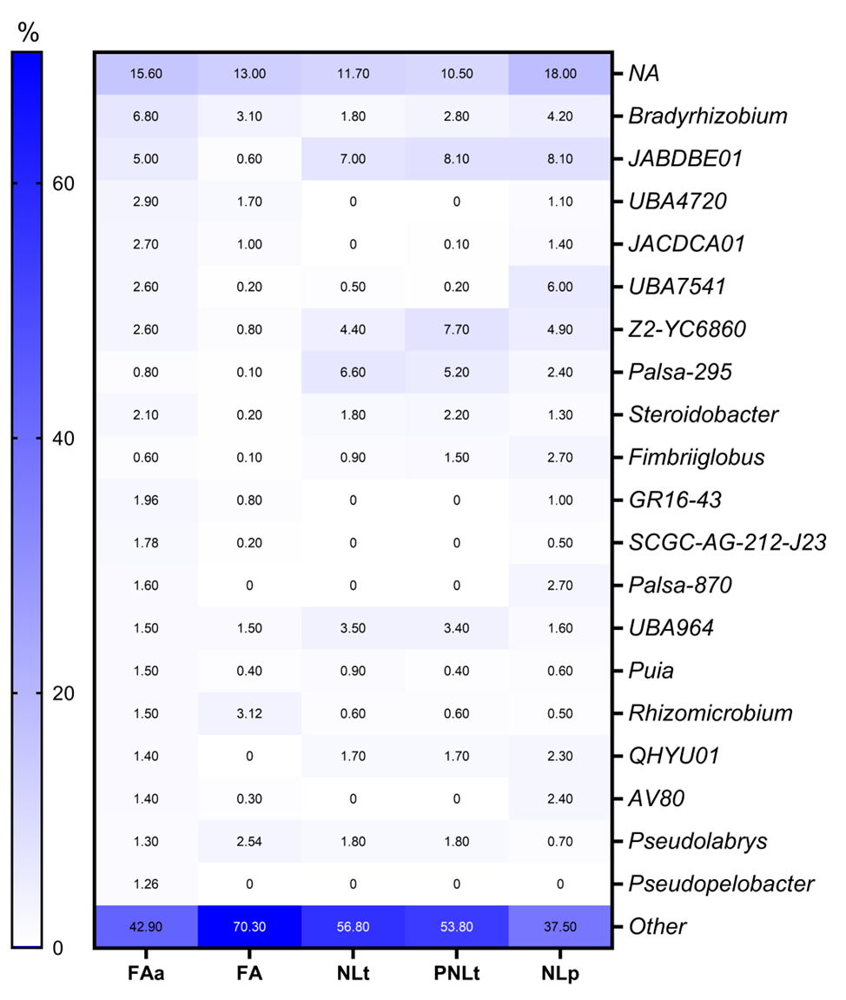
Figure S3. The relative abundance of bacterial taxa at the genus level. The top 20 genera are shown; the rest are grouped into other genera.

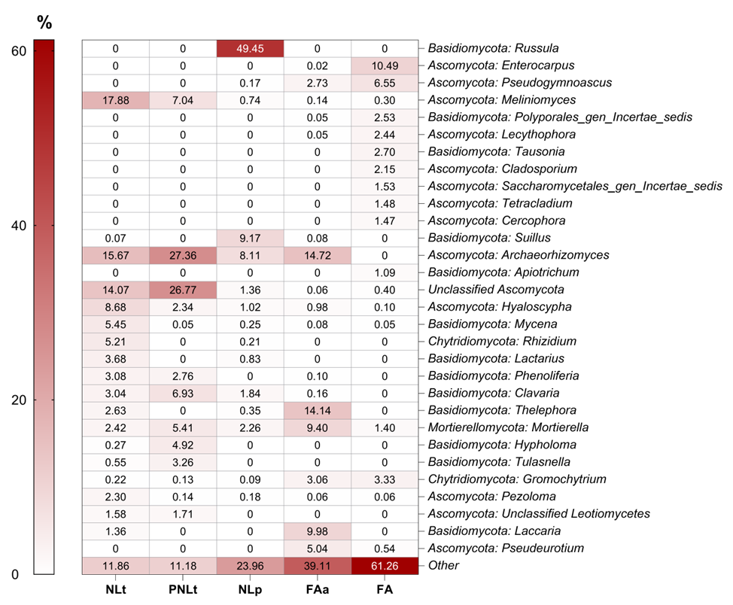
Figure S4. The relative abundance of fungal taxa at the genus level. The top 20 genera are shown, the rest are grouped into other genera.

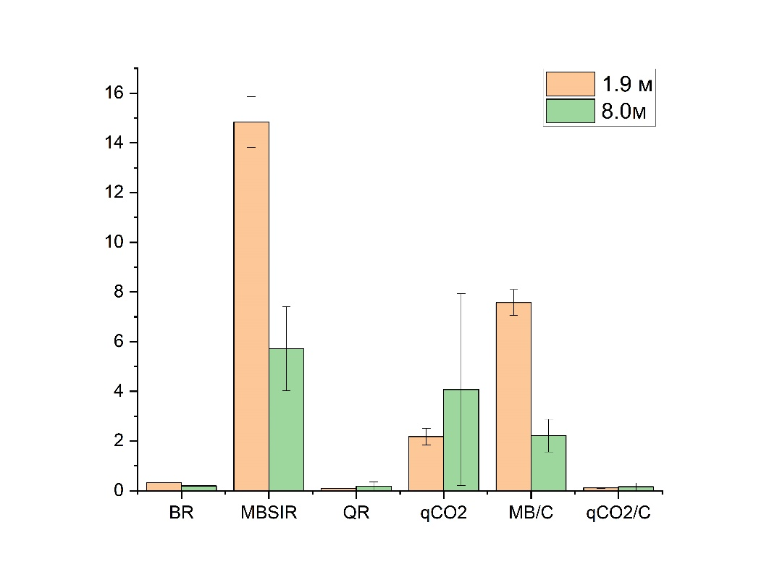
Figure S5. The metabolic activity of microbial communities in borehole sediments at different depths

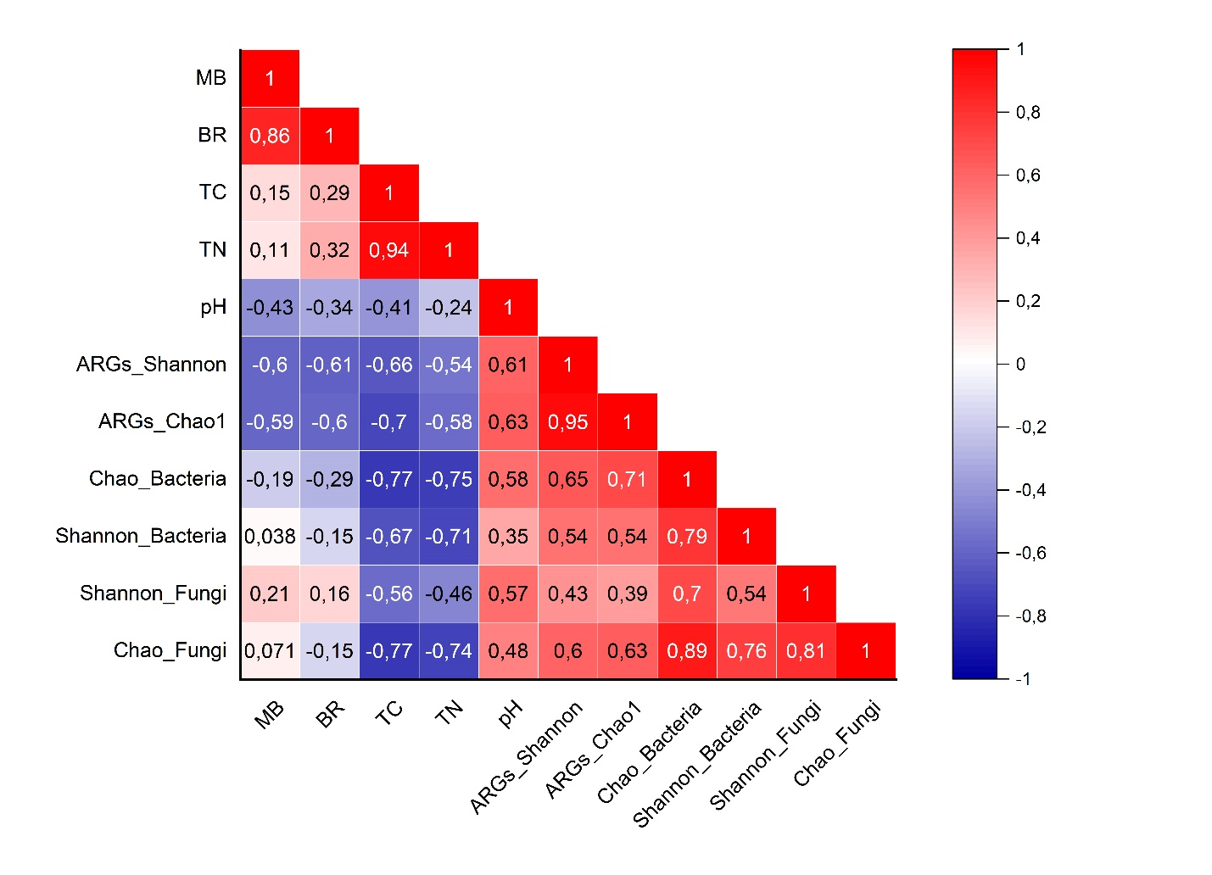
Figure S6. Spearman correlation analysis relationships between chemical, microbiological parameters of soils and microbial diversity and ARGs diversity

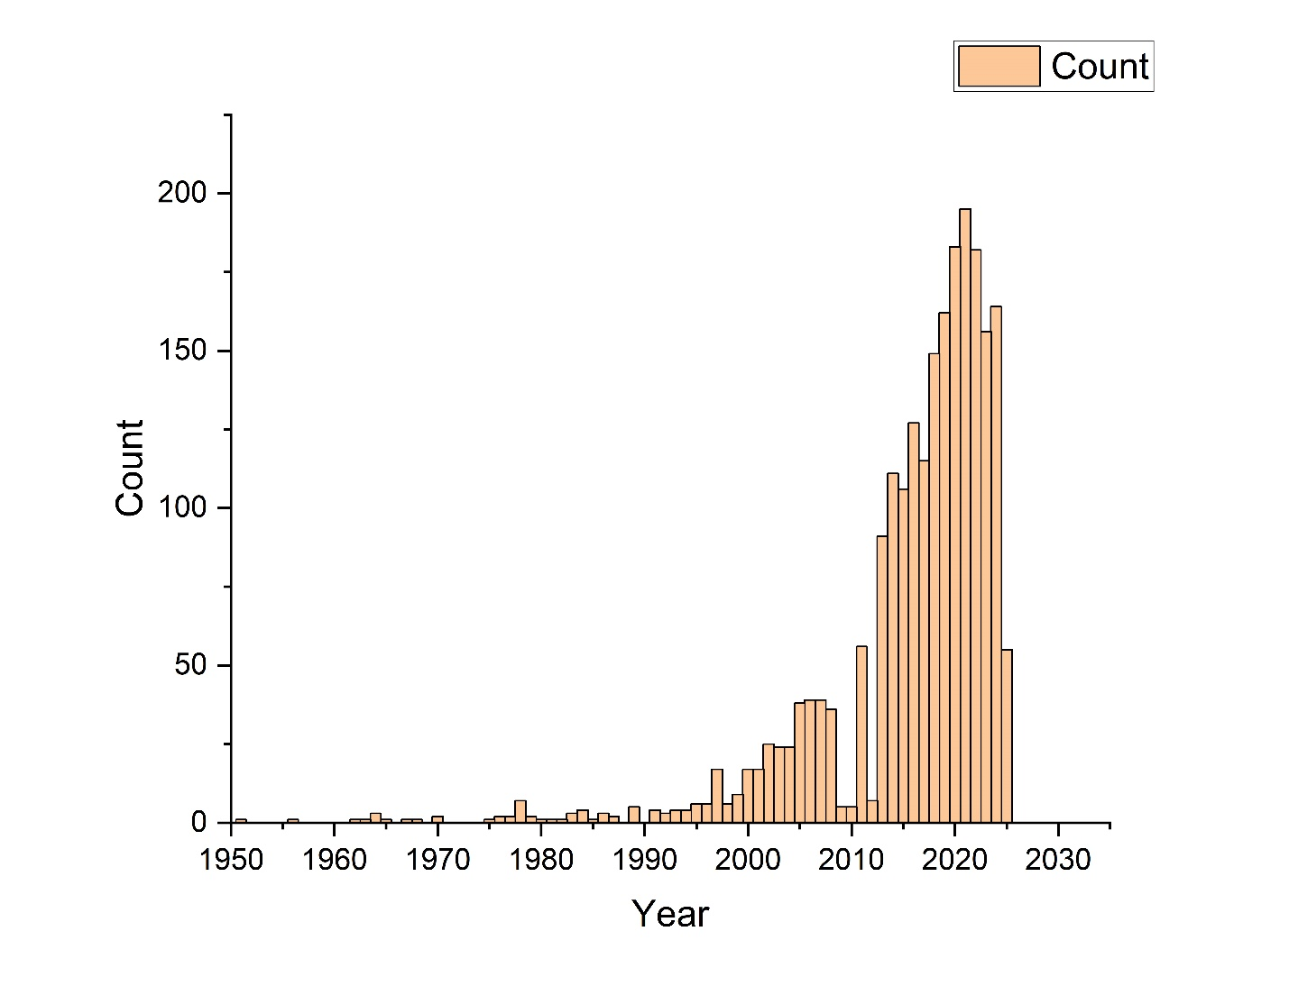

Figure S7. Publication trends for Arctic soil research in PubMed.
Number of publications retrieved using the combined keywords "Soil" AND "Arctic" in the PubMed database (1990-2023).

