SUPPLEMENTARY INFORMATION
Linking rhizosphere bacterial life-history strategies with wheat growth under drought stress
Yanshuo Pan^{1,2,3} ˙ Binhui Liu⁴ ˙ Shan Zhuang² ˙ Hongzhe Wang² ˙ Yanjie Qi¹ ˙ Jieyin Chen^{5,6} ˙ Didier Lesueur^{7,8,9,10,11} ˙ Liang Xiao^{12,13,14,15,16,17} ˙ Yuzhong Li^{2*} ˙ Dongfei Han^{1*}
¹ School of Environmental Science and Engineering, Suzhou University of Science and Technology, Suzhou 215009, China
² Institute of Environment and Sustainable Development in Agriculture, Chinese Academy of Agricultural Sciences, Beijing 100081, China.
³ College of Natural Resources and Environment, Northwest A&F University, Yangling, Shaanxi 712100, China.
⁴ Key Laboratory of Crop Drought Resistance Research of Hebei Province / Institute of Dryland Farming, Hebei Academy of Agriculture and Forestry Sciences, Hengshui 053000, Hebei, China
⁵ State Key Laboratory for Biology of Plant Diseases and Insect Pests, Institute of Plant Protection, Chinese Academy of Agricultural Sciences, Beijing 100193, China
⁶ Western Agricultural Research Center, Chinese Academy of Agricultural Sciences, Changji 831100, China
⁷ Centre de Coopération Internationale en Recherche Agronomique pour le Développement (CIRAD), UMR Eco&Sols, Hanoi, Vietnam
⁸ Eco&Sols, University de Montpellier (UMR), CIRAD, Institut National de la Recherche pour l’Agriculture, l’Alimentation et l’Environnement (INRAE), Institut de Recherche pour le Développement (IRD), Montpellier SupAgro, 34060 Montpellier, France
⁹ Alliance of Biodiversity International and International Center for Tropical Agriculture (CIAT), Asia hub, Common Microbial Biotechnology Platform (CMBP), Hanoi, Vietnam
¹⁰ School of Life and Environmental Sciences, Faculty of Science, Engineering and Built Environment–Deakin University, Geelong, Victoria, Australia
¹¹ Chinese Academy of Tropical Agricultural Sciences, Rubber Research Institute, Haikou, China
¹² BGI-Shenzhen, Shenzhen 518083, China
¹³ College of Life Sciences, University of Chinese Academy of Sciences, Beijing 100049, China
¹⁴ Qingdao-Europe Advanced Institute for Life Sciences, BGI-Shenzhen, Qingdao 266555, China
¹⁵ China National GeneBank, BGI-Shenzhen, Shenzhen 518120, China
¹⁶ Shenzhen Engineering Laboratory of Detection and Intervention of the human intestinal microbiome, BGI-Shenzhen, Shenzhen 518120, China
¹⁷ BGI College & Henan Institute of Medical and Pharmaceutical Sciences, Zhengzhou University, Zhengzhou 450000, China

* To whom correspondence may be addressed. Email: dongfeihan@usts.edu.cn and liyuzhong@caas.cn
Table S1 Effects of drought and dilution on the composition of bacterial communities in root and rhizosphere (RS)
PEAMANOVA |  | R² | p
Compartment  (RS vs Root) |  | 0.67 | p < 0.001
RS | Dilution | 0.72 | p < 0.001
RS | Drought | 0.16 | p < 0.01
Root | Dilution | 0.11 | p < 0.05
Root | Drought | 0.17 | p < 0.01

Table S2 Parameter of rhizosphere and root bacterial community networks
Parameter | RS | Root
Number of nodes | 189 | 67
Number of edges | 2186 | 147
Average degree | 23.132 | 4.388
Graph density | 0.123 | 0.066
Average path length | 3.178 | 4.481
Modularity | 0.258 | 0.725
Average cluster coefficient | 0.641 | 0.688

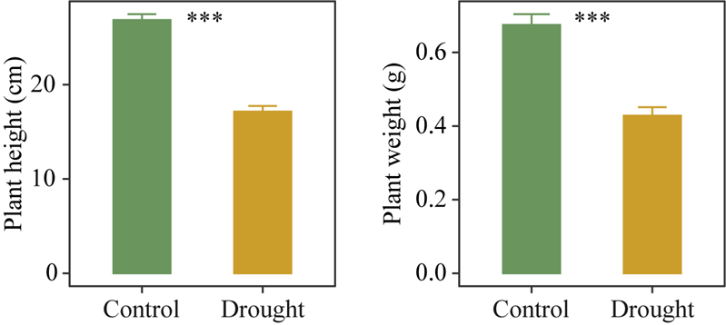
Fig.S1 Wheat height and weight under control and drought conditions. Asterisks indicate significance: ***P value < 0.001.

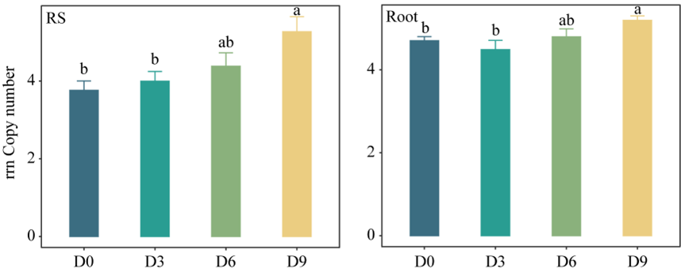
Fig.S2 Community-level rrn copy numbers across dilution levels. Different letters indicate significant differences among different dilution level at P < 0.05.

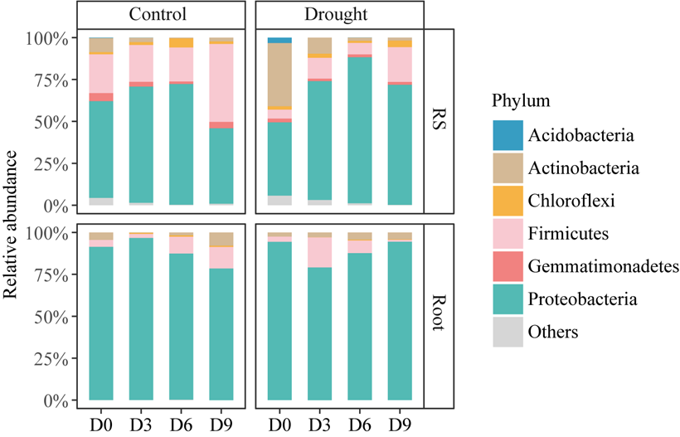
Fig.S3 Composition of rhizosphere and root bacterial communities at phylum level.

Fig.S4 Alpha diversities of bacterial communities (Shannon) across dilution levels. Different letters indicate significant differences among different dilution level at P < 0.05.

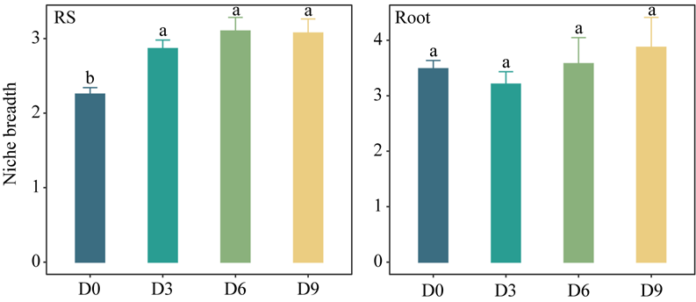
Fig.S5 Community niche breadth across dilution levels. Different letters indicate significant differences among different dilution level at P < 0.05.

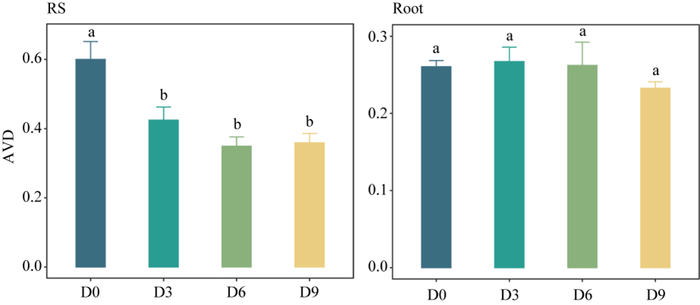
Fig.S6 Average variation degree (AVD) of communities across dilution levels. Different letters indicate significant differences among different dilution level at P < 0.05.

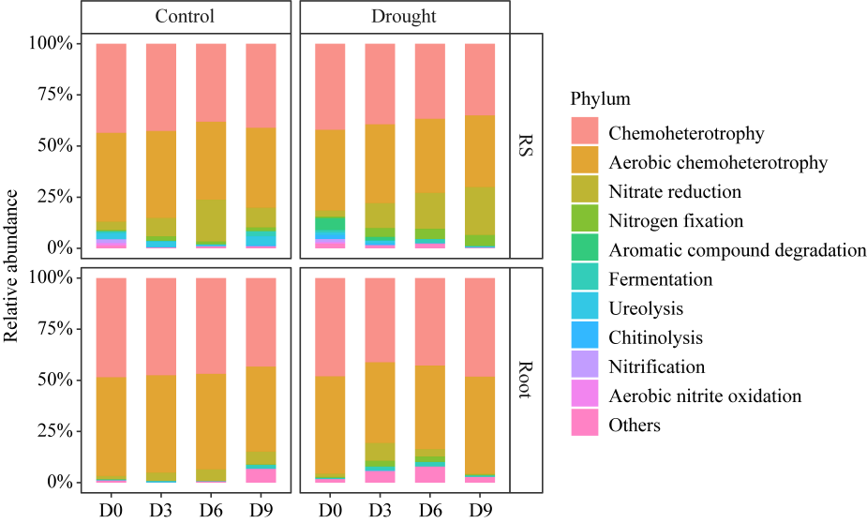
Fig.S7 Composition of rhizosphere and root bacterial community function.

