Appendix 1.The schematic diagram of plot cultivation, from top to bottom, is as follows:MP: moldboard plow, RT: ridge tillage, NT: no-tillage. The diagram on the right shows the specific cultivation zoning.1: no-tillage,2: strip cropping, 3: ridge tillage,4: fall ploughing.
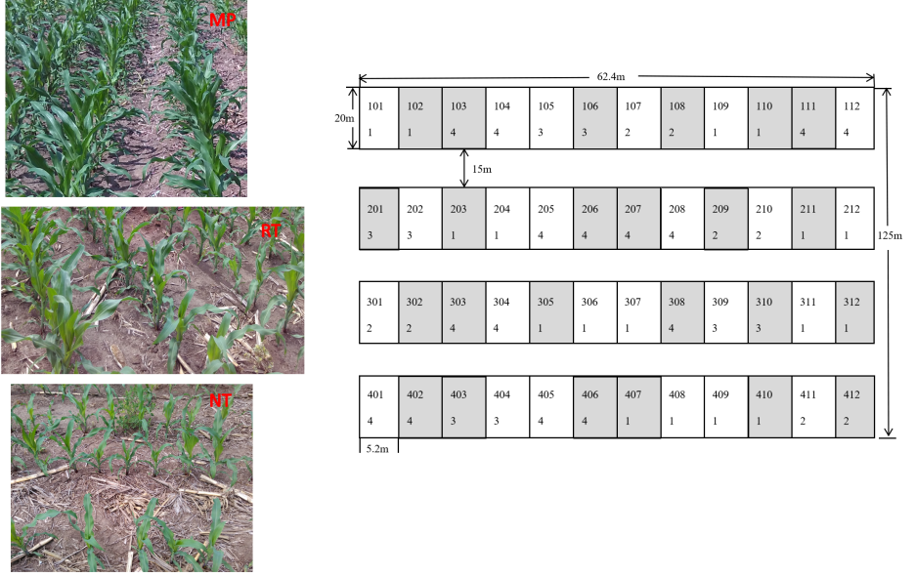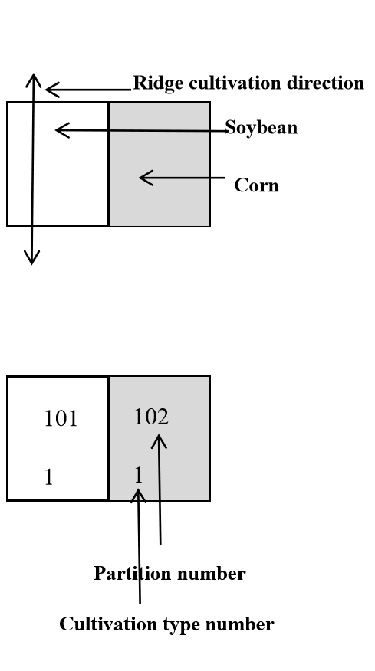

Appendix 2. The total dry weight (g) of three earthworms before and after adding earthworms during the two cultivation stages. The data in the table is mean ± SE.
Tillage treatment | Initial earthworm (Eisenia fetida) weight (gram,3 earthworms in total) | After 15 days of cultivation earthworm (Eisenia fetida) weight (gram,3 earthworms in total)
MP | 0.92±0.17 | 0.63±0.09
NT | 0.95±0.05 | 0.75±0.04
RT | 1±0.20 | 0.65±0.10 (One earthworm escaped from RT1 PVC frame and died in the incubator)

Tillage treatment | Initial earthworm (Eisenia fetida) weight (gram,3 earthworms in total) | After 30 days of cultivation earthworm (Eisenia fetida) weight (gram,3 earthworms in total)
MP | 0.95±0.06 | 0.40±0.14 (Two earthworms escaped from MP2 PVC frame and died in the incubator)
NT | 0.95±0.26 | 0.45±0.10 (One earthworm escaped from NT2 PVC frame and died in the incubator)
RT | 0.96±0.15 | 0.57±0.10

Appendix 3.The effect of different tillage (A) and earthworms treatment (B) on the composition of Collembola is shown in the PcoA diagram. The table on the right shows the results of Permannova analysis based on Bray Curtis distance, including the addition of earthworms (a), cultivation method (b), and the combination of earthworms and cultivation method (c).

A
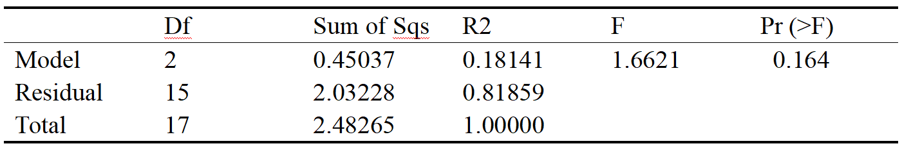
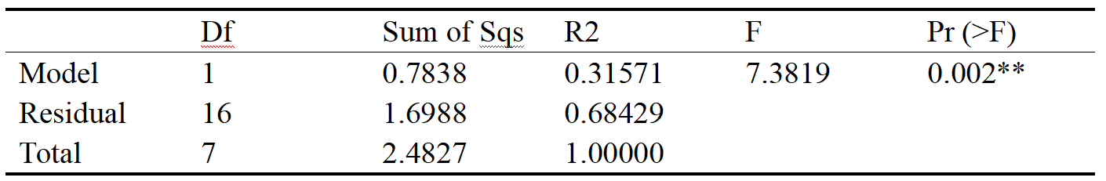
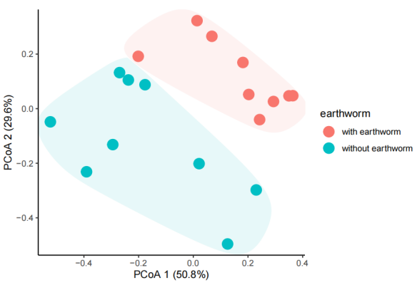
b
a
B
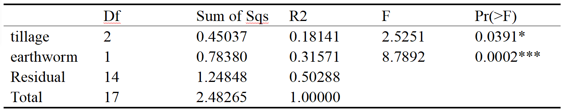
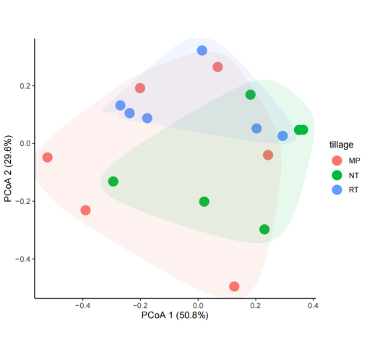
c
Appendix 4.Two-way ANOVA for the impact of different tillage and earthworm treatment on soil environmental factors on 30 June 2015 (15 days after incubation) and 16 July 2015 (30 days after incubation). The data in the table is P-value, bold font indicates significance at p < 0.05.
Soil environmental factors | 30th of June 2015 |  |  | 16th of July 2015
Soil environmental factors | Earthworm | Tillage | Earthworm×Tillage | Earthworm | Tillage | Earthworm×Tillage
pH | 0.06328 | 0.66421 | 0.54251 | 0.17066 | 0.03914 | 0.81775
Soil organic matter（%） | 0.69095 | 0.15657 | 0.36589 | 0.62703 | 0.08033 | 0.70347
Total nitrogen (g/kg) | 0.40081 | 0.47265 | 0.42446 | 0.82528 | 0.25008 | 0.70270

Appendix 5. Standardized modified model fitting index.
Indicator name | Results of model fitting 15 days after incubation | Results of model fitting 30 days after incubation | Acceptance criteria
Chi-square | 0.503 | 0.496 | P＞0.05
Goodness of Fit Index | 0.991 | 0.993 | ＞0.90
Comparative Fit Index | 1.000 | 1.000 | ＞0.95
Root Mean Square Residual | 0.207 | 0.525 | The smaller the better
Standardized Root Mean Square Residual | 0.032 | 0.054 | ＜0.08
Root Mean Square of Error Approximation | 0.000 | 0.000 | ＜0.05

