Supporting information

Environmental drivers shape soil mite communities along succession, with limited links to litter decomposition in upper Andean tropical forests

Dennis Castillo-Figueroa¹*, Camilo Castillo-Avila²

¹ School of Sciences and Engineering, Universidad del Rosario, Kr 26 # 63B-48, Bogotá, Colombia.
²Universidad Distrital Francisco José de Caldas, Grupo de Investigación en Artrópodos KUMANGUI, Bogotá, Colombia.
*Corresponding author: dennis.castillof@gmail.com

Fig. S1. Rarefaction curves for total Acari (pink), Mesostigmata (blue), Sarcoptiformes (orange), and Trombidiformes (purple) in upper Andean tropical forests of Colombia for (a) q = 0, (b) q = 1, and (c) q = 2. Shaded areas represent 95% confidence intervals.
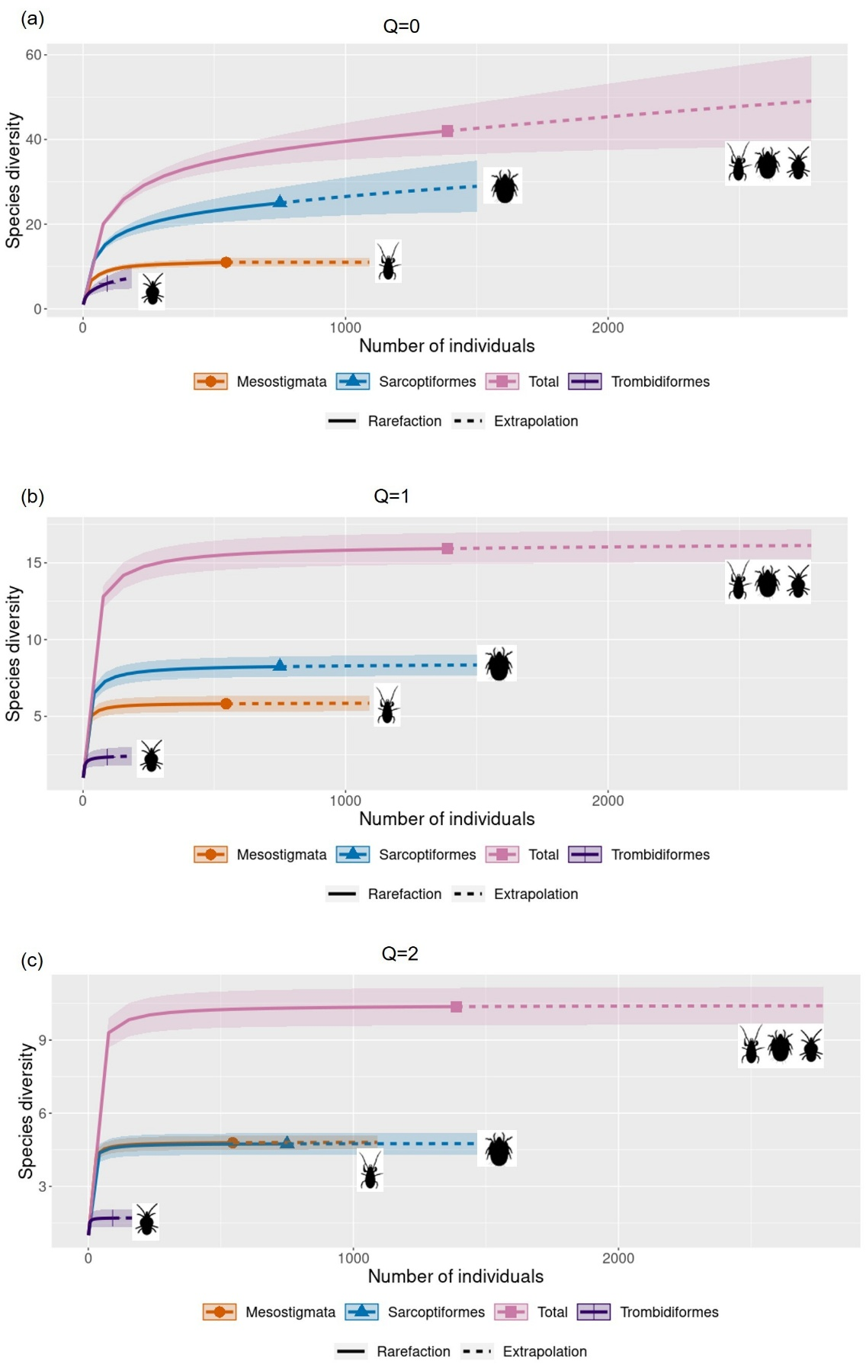
Fig. S2. Variation in abundance and richness across the four sampled months for (a–b) total Acari, (c–d) Mesostigmata, (e–f) Sarcoptiformes and (g–h) Trombidiformes. Plots show 95% confidence intervals. Climatic seasons are indicated by icons: blue clouds represent the wet season, and yellow suns denote the dry season.
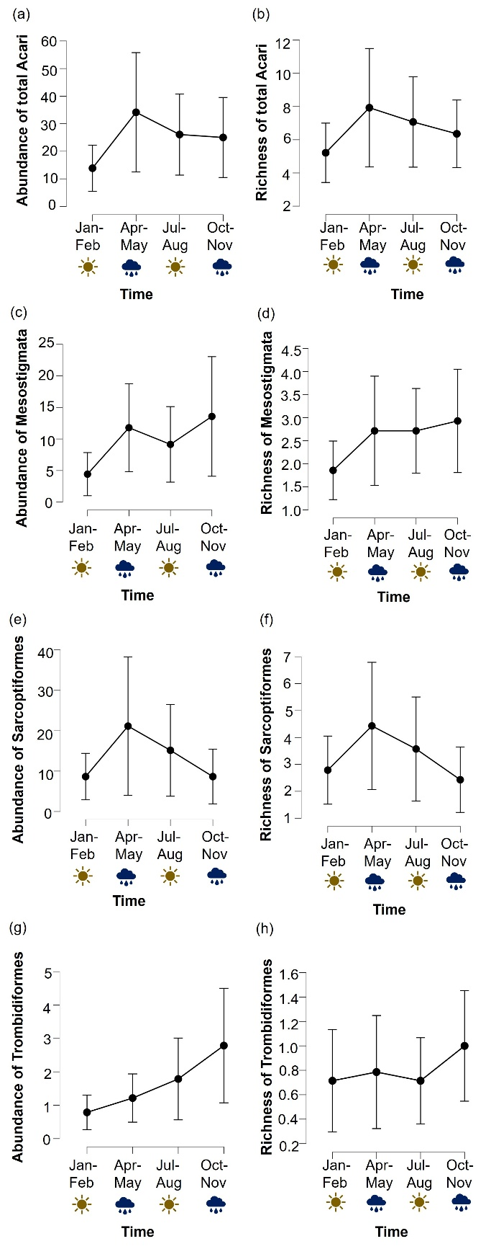
Fig. S3. Relative abundance of total Acari, Mesostigmata, Sarcoptiformes, and Trombidiformes in upper Andean tropical forests of Colombia.

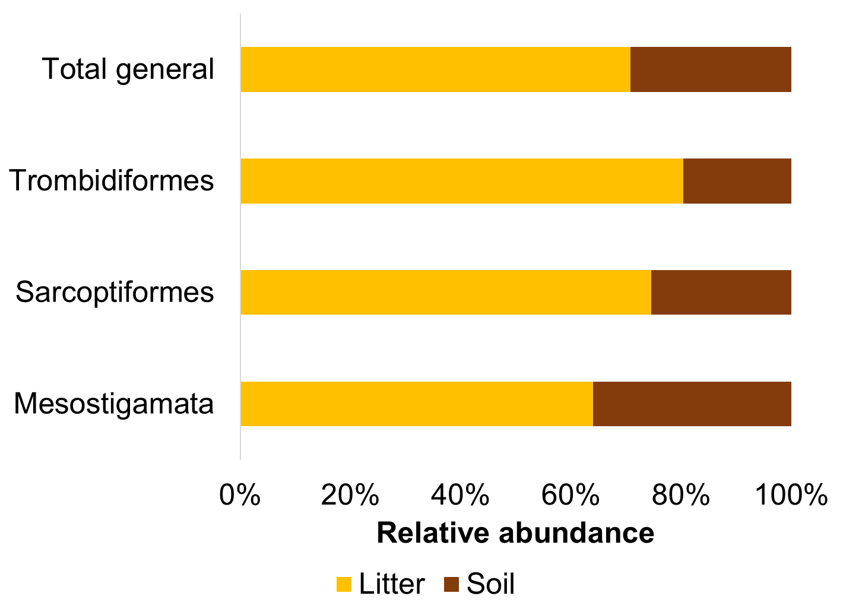

Fig. S4. Reduced major axis regressions between forest, soil, and environmental variables and total Acari richness. Significant variables include: (a) mean soil temperature, (b) minimum soil temperature, (c) maximum soil temperature, (d) mean surface temperature, (e) minimum surface temperature, (f) mean air temperature, (g) minimum air temperature, and (h) Na. The shaded red areas represent bootstrap 95% confidence intervals. Green asterisks indicate mature forest plots, while grey asterisks indicate secondary forest plots. The coefficient of determination (R²) is shown in the upper left corner of each panel.

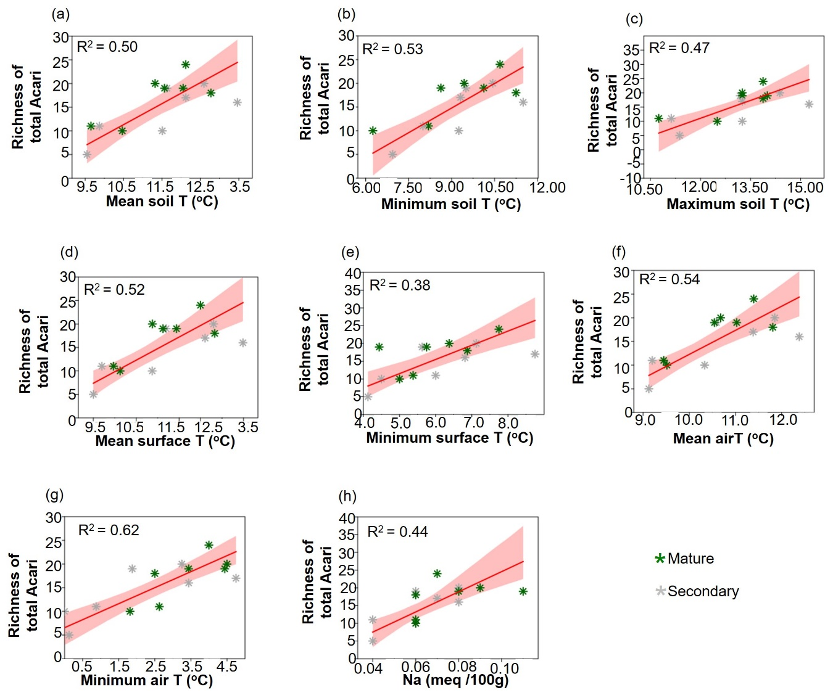

Fig. S5. Reduced major axis regressions between forest, soil, and environmental variables and Mesostigmata abundance and richness. Significant variables associated with Mesostigmata abundance include: (a) standard deviation of soil moisture and (b) organic carbon. Significant variables associated with Mesostigmata richness include: (c) minimum surface temperature, (d) mean surface temperature, (e) mean soil temperature, (f) mean air temperature, (g) soil pH, (h) Ca, (i) K, (j) Mg, (k) soil temperature range, and (l) Al. The shaded red areas represent bootstrap 95% confidence intervals. Green asterisks indicate mature forest plots, while grey asterisks indicate secondary forest plots. The coefficient of determination (R²) is shown in the upper left corner of each panel.
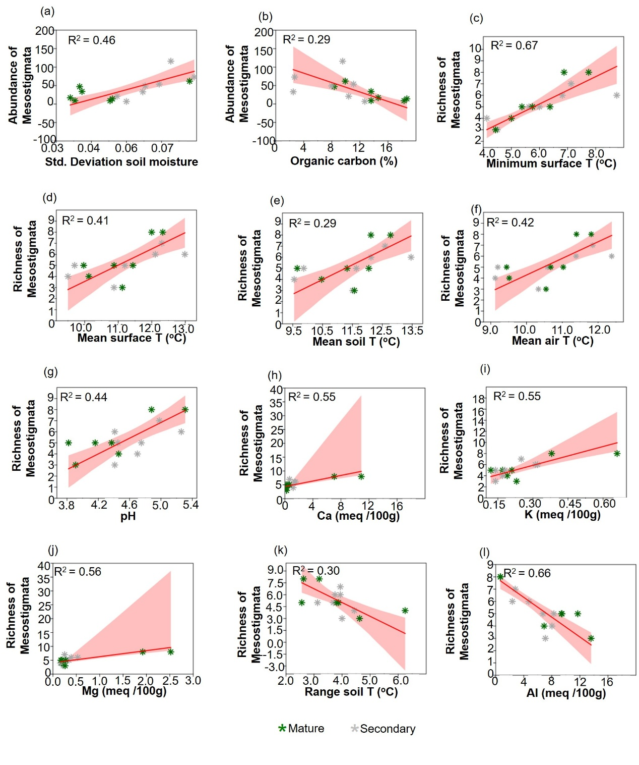
Fig. S6. Reduced major axis regressions between forest, soil, and environmental variables and Sarcoptiformes abundance and richness. Significant variables associated with Sarcoptiformes abundance include: (a) Na, (b) litter depth, and (c) minimum air temperature. Significant variables associated with Sarcoptiformes richness include: (d) Na and (e) minimum air temperature. The shaded red areas represent bootstrap 95% confidence intervals. Green asterisks indicate mature forest plots, while grey asterisks indicate secondary forest plots. The coefficient of determination (R²) is shown in the upper left corner of each panel.

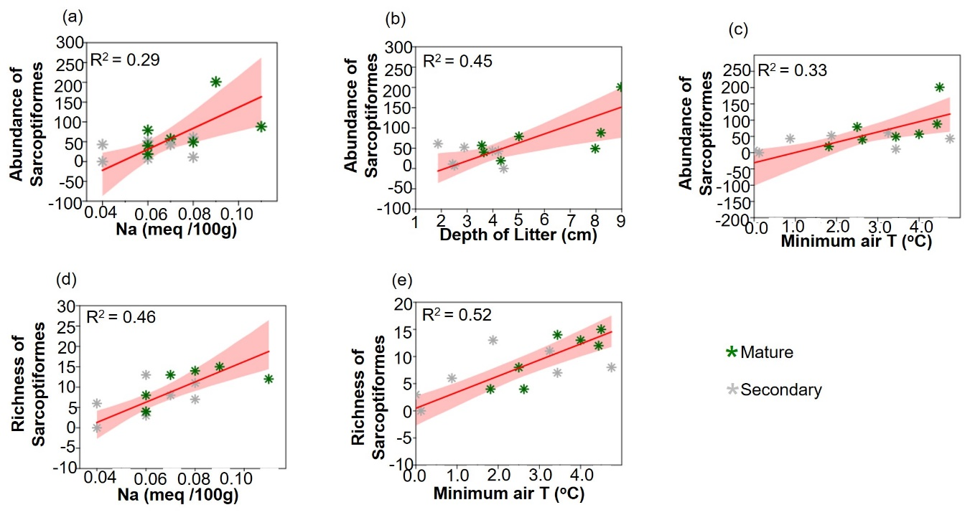

Fig. S7. Reduced major axis regressions between forest, soil, and environmental variables and Trombidiformes abundance and richness. Significant variables associated with Trombidiformes abundance include: (a) Mg, (b) soil moisture range. Significant variables associated with Trombidiformes richness include: (c) nitrogen content (d) slope and (e) clays. The shaded red areas represent bootstrap 95% confidence intervals. Green asterisks indicate mature forest plots, while grey asterisks indicate secondary forest plots. The coefficient of determination (R²) is shown in the upper left corner of each panel.

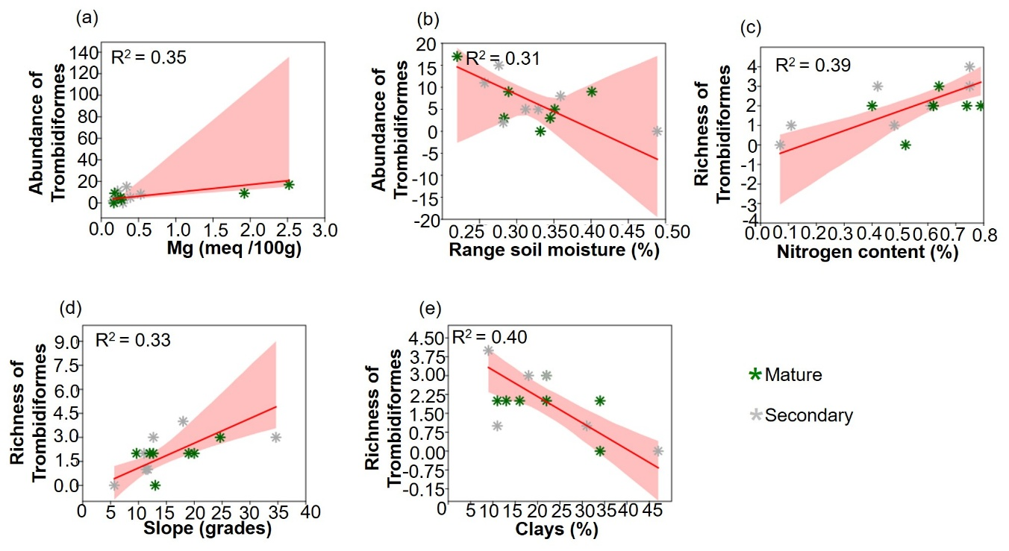

Table S1. List of morphospecies for each of the three soil mite groups found in upper Andean tropical forests of Colombia.

Taxa | Abundance
MESOSTIGMATA | 545
- | 9
Mesostigmata sp. 1 | 1
Uropodoidea sp. 1 | 8
Ascidae | 26
Ascidae sp. 1 | 26
Laelapidae | 11
Oloopticus sp. 1 | 11
Macrochelidae | 134
Macrocheles sp. 1 | 134
Ologamasidae | 4
Ologamasidae sp. 1 | 4
Parasitidae | 66
Pergamasus sp. 1 | 66
Trachytidae | 9
Trachytidae sp. 1 | 9
Trematuridae | 144
Trematuridae sp. 1 | 8
Trematuridae sp. 2 | 136
Uropodidae | 142
Uropodidae sp. 1 | 142
SARCOPTIFORMES | 750
- | 58
Oribatida sp. 1 | 37
Oribatida sp. 2 | 12
Oribatida sp. 3 | 8
Oribatida sp. 4 | 1
Acaridae | 21
Acaridae sp. 1 | 21
Aleurodamaeidae | 1
Aleurodamaeus sp. 1 | 1
Anderemaeidae | 3
Anderemaeus sp. 1 | 3
Ceratozetidae | 28
Edwardzetes s. str. sp. 1 | 28
Crotoniidae | 42
Crotoniidae sp. 1 | 41
Heminothrus sp. 1 | 1
Damaeidae | 15
Damaeidae sp. 1 | 15
Dampfiellidae | 4
Beckiella sp. 1 | 4
Galumnidae | 283
Allogalumna sp. 1 | 283
Hermanniellidae | 7
Hermannobates sp. 1 | 7
Liacaridae | 11
Liacarus (Rhaphidosus) sp. 1 | 11
Mochlozetidae | 52
Unguizetes (Calugarella) sp. 2 | 34
Unguizetes sp. 1 | 18
Nothridae | 4
Nothrus sp. 1 | 3
Nothrus sp. 2 | 1
Oppiidae | 3
Octoppia sp. 1 | 3
Oribotritiidae | 14
Oribotritia s. str. sp. 1 | 14
Phthiracaridae | 177
Hoplophorella sp. 1 | 177
Plateremaeidae | 23
Paralopheremaeus sp. 1 | 23
Rhynchoribatidae | 3
Rhynchoribates sp. 1 | 3
Xenillidae | 1
Xenillus sp. 1 | 1
TROMBIDIFORMES | 92
- | 1
Trombidiformes sp. 1 | 1
Anystidae | 2
Anystis sp. 1 | 2
Bdellidae | 1
Bdellidae sp. 1 | 1
Erythraeidae | 13
Erythraeidae sp. 1 | 13
Smarididae | 6
Smarididae sp. 1 | 6
Trombidiidae | 69
Trombidiinae sp. 1 | 69
Total | 1387

Table S2. PERMANOVA results for total Acari community composition, evaluating the effects of site, climatic season, and their interaction (H1). Statistical significance is denoted with asterisks: * p < 0.05, ** p < 0.01, *** p < 0.001.

Source | Sum of sqrs | df | Mean square | F | p
Season | 0.382108 | 1 | 0.38211 | 1.5391 | 0.1244
Site | 1.62732 | 3 | 0.54244 | 2.1849 | 0.0041**
Interaction | 0.588193 | 3 | 0.19606 | 0.78973 | 0.7452
Residual | 4.96532 | 20 | 0.24827
Total | 7.5629 | 27

Table S3. PERMANOVA results for total Mesostigmata community composition, evaluating the effects of site, climatic season, and their interaction (H1). Statistical significance is denoted with asterisks: * p < 0.05, ** p < 0.01, *** p < 0.001.

Source | Sum of sqrs | df | Mean square | F | p
Season | 0.375858 | 1 | 0.37586 | 1.7836 | 0.105
Site | 1.21969 | 3 | 0.40656 | 1.9293 | 0.0242*
Interaction | 0.491027 | 3 | 0.16368 | 0.77671 | 0.7142
Residual | 4.21458 | 20
Total | 6.3012

Table S4. PERMANOVA results for total Sarcoptiformes community composition, evaluating the effects of site, climatic season, and their interaction (H1). Statistical significance is denoted with asterisks: * p < 0.05, ** p < 0.01, *** p < 0.001.

Source | Sum of sqrs | df | Mean square | F | p
Season | 0.273786 | 1 | 0.27379 | 0.9442 | 0.4865
Site | 2.05958 | 3 | 0.68653 | 2.3676 | 0.0006***
Interaction | 0.723737 | 3 | 0.24125 | 0.83198 | 0.7322
Residual | 5.79934 | 20 | 0.28997
Total | 8.8564

Table S5. PERMANOVA results for total Trombidiformes community composition, evaluating the effects of site, climatic season, and their interaction (H1). Statistical significance is denoted with asterisks: * p < 0.05, ** p < 0.01, *** p < 0.001.

Source | Sum of sqrs | df | Mean square | F | p
Season | 0.178323 | 1 | 0.17832 | 0.5755 | 0.7056
Site | 1.61316 | 3 | 0.53772 | 1.7354 | 0.064
Interaction | 0.327097 | 3 | 0.10903 | 0.35188 | 0.9844
Residual | 6.19714 | 20 | 0.30986
Total | 8.3157 | 27

Table S6. Mann-Whitney U test comparing dry and wet seasons for total acari, Mesostigmata, Sarcoptiformes and Trombidiformes. Effect size is represented by the rank biserial correlation. Statistical significance is denoted with asterisks: * p < 0.05, ** p < 0.01, *** p < 0.001.

Response variable | P value | Statistic | Rank-Biserial Correlation
Abundance total Acari | 0.141 | 65.5 | -0.332
Richness total Acari | 0.406 | 79.5 | -0.189
Abundance Mesostigmata | 0.089 | 60.5 | -0.383
Richness Mesostigmata | 0.301 | 75.5 | -0.230
Abundance Sarcoptiformes | 0.045* | 54.0 | -0.449
Richness Sarcoptiformes | 0.693 | 89.0 | -0.092
Abundance Trombidiformes | 0.255 | 73.0 | -0.255
Richness Trombidiformes | 0.291 | 76.0 | -0.224

Table S7. Multiple linear regression with stepwise method for total Acari richness (p = 0.026, r = 0.872, R² = 0.76, Adjusted R² = 0.71). In this model, the following covariates were considered but not included: Na, Mean Soil T, Maximum Soil T, Mean Surface T, Minimum Surface T, Mean Air T.
Coefficients
 |  |  |  |  |  |  |  |  |  |  |  |  |  | Collinearity Statistics
Model |  |  |  | Unstandardized |  | Standard Error |  | Standardized |  | t |  | p |  | Tolerance |  | VIF
1 |  | (Intercept) |  | 15.643 |  | 1.424 |  |  |  | 10.983 |  | < .001
2 |  | (Intercept) |  | 8.514 |  | 1.868 |  |  |  | 4.558 |  | < .001
 |  | Minimum Air T |  | 2.652 |  | 0.605 |  | 0.785 |  | 4.383 |  | < .001 |  | 1.000 |  | 1.000
3 |  | (Intercept) |  | -3.586 |  | 4.944 |  |  |  | -0.725 |  | 0.483
 |  | Minimum Air T |  | 1.891 |  | 0.580 |  | 0.559 |  | 3.260 |  | 0.008 |  | 0.740 |  | 1.351
 |  | Minimum Soil T |  | 1.529 |  | 0.594 |  | 0.442 |  | 2.576 |  | 0.026 |  | 0.740 |  | 1.351

Table S8. Multiple linear regression with stepwise method for Mesostigmata abundance (p = 0.007, r = 0.68, R² = 0.46, Adjusted R² = 0.42). In this model, the following covariate was considered but not included: % organic carbon.

Coefficients
 |  |  |  |  |  |  |  |  |  |  |  |  |  | Collinearity Statistics
Model |  |  |  | Unstandardized |  | Standard Error |  | Standardized |  | t |  | p |  | Tolerance |  | VIF
1 |  | (Intercept) |  | 38.929 |  | 8.228 |  |  |  | 4.731 |  | < .001
2 |  | (Intercept) |  | -31.495 |  | 22.770 |  |  |  | -1.383 |  | 0.192
 |  | Std. Deviation soil moisture |  | 1170.946 |  | 363.940 |  | 0.681 |  | 3.217 |  | 0.007 |  | 1.000 |  | 1.000

Table S9. Multiple linear regression with stepwise method for Mesostigmata richness (p = 0.003, r = 0.93, R² = 0.86, Adjusted R² = 0.83). In this model, the following covariates were considered but not included: pH, K, Mg, Al, Mean Soil T, Minimum Soil T, Range Soil T, Mean Surface T, Mean Air T.

Coefficients
 |  |  |  |  |  |  |  |  |  |  |  |  |  | Collinearity Statistics
Model |  |  |  | Unstandardized |  | Standard Error |  | Standardized |  | t |  | p |  | Tolerance |  | VIF
1 |  | (Intercept) |  | 5.286 |  | 0.425 |  |  |  | 12.440 |  | < .001
2 |  | (Intercept) |  | -0.569 |  | 1.225 |  |  |  | -0.465 |  | 0.650
 |  | Minimum Surface T |  | 0.970 |  | 0.198 |  | 0.816 |  | 4.887 |  | < .001 |  | 1.000 |  | 1.000
3 |  | (Intercept) |  | 0.461 |  | 0.880 |  |  |  | 0.524 |  | 0.611
 |  | Minimum Surface T |  | 0.726 |  | 0.150 |  | 0.611 |  | 4.838 |  | < .001 |  | 0.819 |  | 1.221
 |  | Ca |  | 0.243 |  | 0.064 |  | 0.483 |  | 3.825 |  | 0.003 |  | 0.819 |  | 1.221

Table S10. Multiple linear regression with stepwise method for Sarcoptiformes abundance (p = 0.009, r = 0.67, R² = 0.45, Adjusted R² = 0.41). In this model, the following covariates were considered but not included: Na, Minimum Air T.
Coefficients
 |  |  |  |  |  |  |  |  |  |  |  |  |  | Collinearity Statistics
Model |  |  |  | Unstandardized |  | Standard Error |  | Standardized |  | t |  | p |  | Tolerance |  | VIF
1 |  | (Intercept) |  | 53.571 |  | 13.283 |  |  |  | 4.033 |  | 0.001
2 |  | (Intercept) |  | -14.390 |  | 23.941 |  |  |  | -0.601 |  | 0.559
 |  | Depth of litter |  | 14.869 |  | 4.734 |  | 0.672 |  | 3.141 |  | 0.009 |  | 1.000 |  | 1.000

Table S11. Multiple linear regression with stepwise method for Sarcoptiformes richness (p = 0.004, r = 0.72, R² = 0.52, Adjusted R² = 0.48). In this model, the following covariate was considered but not included: Na.

Coefficients
 |  |  |  |  |  |  |  |  |  |  |  |  |  | Collinearity Statistics
Model |  |  |  | Unstandardized |  | Standard Error |  | Standardized |  | t |  | p |  | Tolerance |  | VIF
1 |  | (Intercept) |  | 8.429 |  | 1.248 |  |  |  | 6.754 |  | < .001
2 |  | (Intercept) |  | 2.693 |  | 1.831 |  |  |  | 1.471 |  | 0.167
 |  | Minimum Air T |  | 2.134 |  | 0.593 |  | 0.720 |  | 3.599 |  | 0.004 |  | 1.000 |  | 1.000

Table S12. Multiple linear regression with stepwise method for Trombidiformes abundance (p = 0.025, r = 0.59, R² = 0.35, Adjusted R² = 0.30). In this model, the following covariate was considered but not included: Range Soil T.
Coefficients
 |  |  |  |  |  |  |  |  |  |  |  |  |  | Collinearity Statistics
Model |  |  |  | Unstandardized |  | Standard Error |  | Standardized |  | t |  | p |  | Tolerance |  | VIF
1 |  | (Intercept) |  | 6.571 |  | 1.394 |  |  |  | 4.716 |  | < .001
2 |  | (Intercept) |  | 4.222 |  | 1.485 |  |  |  | 2.844 |  | 0.015
 |  | Mg |  | 4.277 |  | 1.672 |  | 0.594 |  | 2.558 |  | 0.025 |  | 1.000 |  | 1.000

Table S13. Multiple linear regression with stepwise method for Trombidiformes richness (p = 0.016, r = 0.81, R² = 0.65, Adjusted R² = 0.59). In this model, the following covariate was considered but not included: %N

Coefficients
 |  |  |  |  |  |  |  |  |  |  |  |  |  |  | Collinearity Statistics
Model |  |  |  | Unstandardized |  |  | Standard Error |  | Standardized |  | t |  | p |  | Tolerance |  | VIF
1 |  | (Intercept) |  |  | 1.929 |  | 0.305 |  |  |  | 6.324 |  | < .001
2 |  | (Intercept) |  |  | 3.404 |  | 0.579 |  |  |  | 5.878 |  | < .001
 |  | % Clays |  |  | -0.066 |  | 0.024 |  | -0.631 |  | -2.815 |  | 0.016 |  | 1.000 |  | 1.000
3 |  | (Intercept) |  |  | 2.049 |  | 0.664 |  |  |  | 3.084 |  | 0.010
 |  | % Clays |  |  | -0.060 |  | 0.019 |  | -0.569 |  | -3.172 |  | 0.009 |  | 0.985 |  | 1.015
 |  | Slope |  |  | 0.078 |  | 0.028 |  | 0.507 |  | 2.829 |  | 0.016 |  | 0.985 |  | 1.015

