Supplementary Materials for

Divergent effects of contemporary grazing on grassland litter decay are associated with site-specific legacies

The PDF file includes:

Figure S1 to S2
Tables S1 to S5

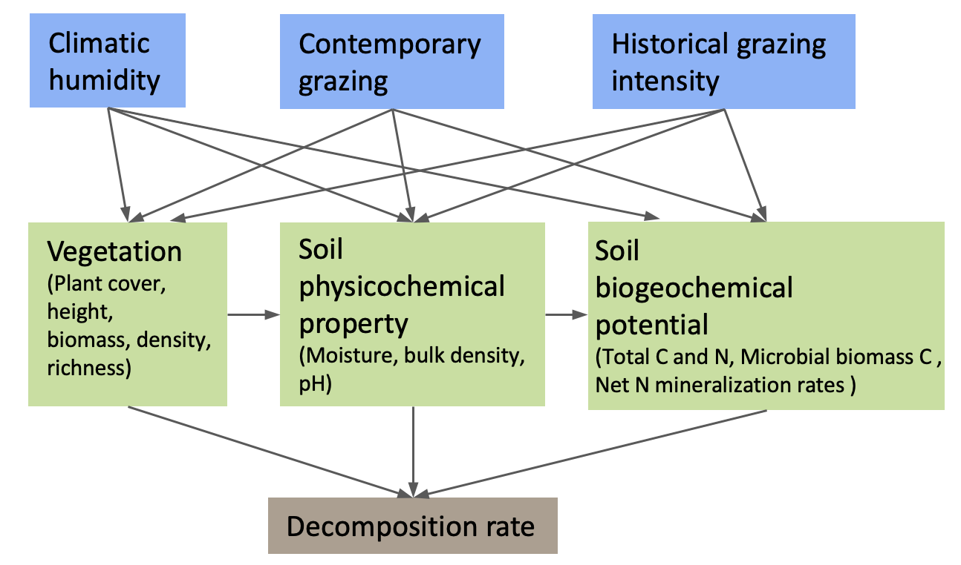
Fig. S1. The a priori conceptual model of hypothesized structural relationships. This path diagram illustrates the comprehensive initial model used to evaluate pathways linking exogenous drivers (humidity, contemporary grazing, and historical grazing intensity) to the final decomposition rate. The model posited that these drivers were associated with three mediating microhabitat components—vegetation structure, soil physicochemical properties, and soil biogeochemical potential—which were further linked through cascading pathways to decomposition. Indicators for each multi-indicator component are listed within the corresponding boxes. This initial model was subsequently simplified based on statistical diagnostics and model parsimony to produce the final model presented in the main text (Fig. 5).

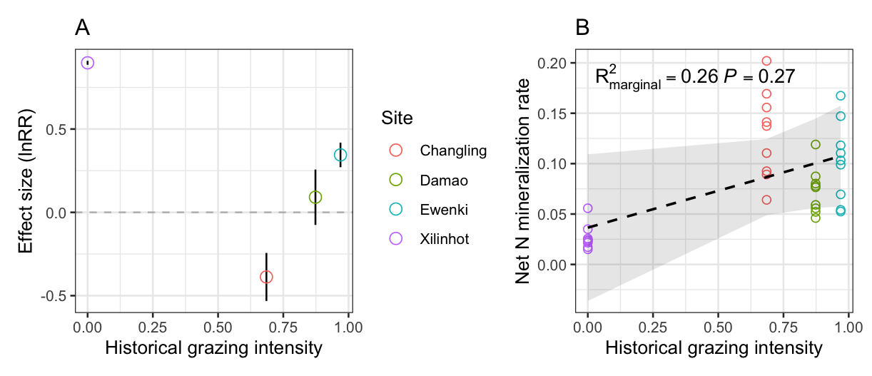
Fig. S2. The relationship between historical grazing intensity and soil net N mineralization, and its response to contemporary grazing. (A) Effect of contemporary grazing on net N mineralization across the historical grazing gradient. The log response ratio (lnRR) was calculated separately for each experimental block. Positive values indicate promotion by contemporary grazing, whereas negative values indicate inhibition. Points show the mean lnRR for each site (± s.e.m. across three blocks, n = 3). The horizontal dashed line indicates no effect. (B) Relationship between historical grazing intensity and the baseline net N mineralization rate in the ungrazed control plots. Each point represents an individual subplot. The dashed line and shaded area show the fitted relationship and 95% confidence interval from a linear mixed-effects model.
Table S1. Characteristics of the experimental sites in 20 years (1994-2013). Changling, at the Jilin Songnen Grassland Ecosystem National Observation and Research Station in Songyuan; Ewenki, at Bayan-Ula in Ewenki Autonomous Banner of Hulunbuir; Xilinhot, at the field observation station of National Climate Observatory in Xilingol League; Damao, at Xilamuren in Darhan Muminggan United Banner of Baotou; Data are Mean ± Standard Error.

Site | Xilinhot | Changling | Damao | Ewenki
Grazing  history | Ungrazed | Moderately grazed | Heavily grazed | Overgrazed
Habitat type | Typical steppe | Plain meadow | Desert steppe | Meadow steppe
Geographic  position | 44°09' N, 116°20' E | 44°35' N,  123°30' E | 41°47' N, 111°53' E | 48°43' N, 119°55' E
Elevation (m) | 1100 | 140 | 1450 | 740
Mean annual precipitation (mm) | 262.64 ± 21.86 | 405.22 ± 26.05 | 255.78 ± 14.00 | 346.33 ± 20.63
Mean annual temperature (°C) | 3.33 ± 0.15 | 6.21 ± 0.15 | 5.08 ± 0.14 | -0.28 ± 0.21
Mean annual sunshine duration (hour) | 2966.42 ± 21.42 | 2700.40 ± 47.41 | 2918.87 ± 33.55 | 2519.90 ± 48.58
Soil type | Typical chestnut soil | Mixed saline-alkalized meadow soil | Light chestnut soil | Dark chestnut soil

Table S2. Selection of variables indicating decomposition environment and data conversion.

Microhabitat variables | Related with decomposition
Plant diversity | An original indicator for reflecting plant diversity, and could mediate litter breakdown by changing decomposition micro-environment (1-3).
Above-ground biomass | An indicator reflecting plant community and micro-environment, has a strong relationship with decomposition (1, 4).
Soil moisture | Important abiotic indicators for evaluating soil environment, soil moisture is the main driver of decomposition dynamics (5-7).
Soil C and N | Build-up of nutrient pools that to support the plant and microbial communities in grassland ecosystems, be strongly related with decomposition (5-8).
Soil microbial biomass carbon | Basic indicator reflecting soil microbial communities, be related to plant communities and soil micro-environment, and decomposition (5, 6, 9).
and net N mineralization rate

References
- Bardgett RD & Wardle DA (2010) Aboveground-belowground linkages: biotic interactions, ecosystem processes, and global change. Oxford University Press.
- Hector A et al. (2000) Consequences of the reduction of plant diversity for litter decomposition: effects through litter quality and microenvironment. Oikos, 90, 357-371.
- Song XX et al. (2017) Sheep grazing and local community diversity interact to control litter decomposition of dominant species in grassland ecosystem. Soil Biology and Biochemistry, 115, 364-370.
- Mueller P et al. (2016) Plants mediate soil organic matter decomposition in response to sea level rise. Global change biology, 22, 404-414.
- Wang ZN et al. (2018) Large herbivores influence plant litter decomposition by altering soil properties and plant quality in a meadow steppe. Scientific reports, 8, 9089.
- Coleman DC et al. (2017) Fundamentals of soil ecology. Academic press.
- Risch AC et al. (2007) Effects of grazing and soil micro-climate on decomposition rates in a spatio-temporally heterogeneous grassland. Plant and Soil, 298, 191-201.
- Lamb EG (2008) Direct and indirect control of grassland community structure by litter, resources, and biomass. Ecology, 89, 216-225.
- Van Der Heijden et al. (2008) The unseen majority: soil microbes as drivers of plant diversity and productivity in terrestrial ecosystems. Ecology letters, 11, 296-310.

Table S3 Summary of linear mixed-effects models testing for interaction effects on microhabitat variables. We fitted a separate LMM for each of the 12 response variables. Each model included climatic humidity, historical grazing intensity, and contemporary grazing as fixed effects, along with their two-way interaction terms: Humidity × Contemporary Grazing and Historical Grazing × Contemporary Grazing. Values shown in cells are the model Estimate ± Standard Error (P-value).

Variable | Humidity | Historical grazing | Contemporary grazing | Humidity × Contemporary grazing | Historical grazing × Contemporary grazing
Aboveground biomass (g/m²) | 29.14 ± 14.72 (0.063) | -51.45 ± 14.72 (0.003) | -14.54 ± 12.85 (0.273) | 2.78 ± 14.83 (0.853) | -12.85 ± 14.83 (0.398)
Plant height (cm) | 4.29 ± 2.36 (0.086) | -9.31 ± 2.36 (< 0.001) | -2.24 ± 2.06 (0.292) | 0.03 ± 2.38 (0.989) | -0.61 ± 2.38 (0.801)
Plant cover (%) | 15.16 ± 0.88 (< 0.001) | -15.62 ± 0.88 (< 0.001) | -0.5 ± 0.77 (0.521) | -0.88 ± 0.88 (0.332) | 0.18 ± 0.88 (0.844)
Plant density (stems/m²) | 51.58 ± 25.83 (0.061) | 40.94 ± 25.83 (0.13) | -16.85 ± 22.54 (0.464) | -1.46 ± 26.01 (0.956) | 8.62 ± 26.01 (0.744)
Plant richness | 5.01 ± 1.15 (< 0.001) | 9.87 ± 1.15 (< 0.001) | -0.04 ± 1 (0.967) | -0.87 ± 1.16 (0.461) | 0.72 ± 1.16 (0.543)
Soil moisture (%) | 2.87 ± 0.15 (< 0.001) | -2.96 ± 0.15 (< 0.001) | -0.2 ± 0.13 (0.121) | -0.15 ± 0.15 (0.308) | 0.23 ± 0.15 (0.127)
Bulk density (g/cm³) | -0.12 ± 0.02 (< 0.001) | 0.1 ± 0.02 (< 0.001) | 0.04 ± 0.02 (0.023) | -0.01 ± 0.02 (0.465) | 0.03 ± 0.02 (0.143)
Soil pH | -0.64 ± 0.08 (< 0.001) | 0.03 ± 0.08 (0.739) | 0.12 ± 0.07 (0.117) | -0.04 ± 0.08 (0.649) | 0.04 ± 0.08 (0.674)
Soil C (g/100g) | 0.48 ± 0.07 (< 0.001) | -0.51 ± 0.07 (< 0.001) | 0.05 ± 0.06 (0.457) | 0.02 ± 0.07 (0.745) | -0.02 ± 0.07 (0.774)
Soil N (g/100g) | 0.03 ± 0.01 (< 0.001) | -0.02 ± 0.01 (0.005) | 0 ± 0.01 (0.619) | 0 ± 0.01 (0.827) | 0.01 ± 0.01 (0.405)
Microbial biomass Carbon (mg/100g) | 4.08 ± 1.07 (< 0.001) | -15.25 ± 1.07 (< 0.001) | -0.01 ± 0.93 (0.996) | -0.76 ± 1.08 (0.484) | -0.82 ± 1.08 (0.45)
Net N mineralization (mg/100g per day) | 0.01 ± 0.01 (0.008) | 0.02 ± 0.01 (0.001) | 0.01 ± 0 (0.208) | 0.01 ± 0.01 (0.06) | -0.01 ± 0.01 (0.091)

Table S4 Summary for all measured microhabitat variables and the litter decomposition rate under grazed and ungrazed control treatments across the study sites. Values shown in cells are Mean ± Standard Error (n=3 blocks). Different letters indicate statistically significant differences between sites (P < 0.05).

Variable | Treatment | Xilinhot  (Ungrazed) | Changling (Moderately  grazed) | Damao (Heavily grazed) | Ewenki (Overgrazed)
Aboveground biomass (g/m²) | Ungrazed | 208.55 ± 5.17 b | 282.36 ± 10.15 a | 83.37 ± 1.47 d | 171.26 ± 7.45 c
 | Grazed | 227.48 ± 4.83 a | 211.67 ± 10.71 a | 53.12 ± 2.34 c | 137.77 ± 10.28 b
Plant height (cm) | Ungrazed | 32.38 ± 0.75 b | 40.64 ± 0.72 a | 6.37 ± 0.19 d | 20.12 ± 0.44 c
 | Grazed | 31.74 ± 1.14 a | 28.42 ± 1.91 a | 5.09 ± 0.37 c | 16.5 ± 1.11 b
Plant cover (%) | Ungrazed | 55.69 ± 2.79 a | 30.14 ± 1.64 b | 16.57 ± 0.59 c | 52.22 ± 1.41 a
 | Grazed | 54.03 ± 3.37 a | 34.4 ± 2.9 b | 14.74 ± 0.29 c | 47.47 ± 0.49 a
Plant density (stems/m²) | Ungrazed | 122.56 ± 12.15 c | 423.52 ± 22.39 a | 133.41 ± 2.67 c | 327.22 ± 30.83 b
 | Grazed | 74.78 ± 12.08 a | 342.12 ± 13.44 b | 139.97 ± 11.8 c | 316 ± 26.98 a
Plant richness | Ungrazed | 8.67 ± 0.33 d | 18.33 ± 0.88 c | 30.33 ± 1.2 b | 45.33 ± 1.45 a
 | Grazed | 7 ± 0.58 d | 20 ± 0.58 c | 32 ± 0.58 b | 43.33 ± 0.88 a
Soil moisture (%) | Ungrazed | 13.93 ± 0.16 a | 8.09 ± 0.21 b | 6.21 ± 0.08 c | 12.72 ± 0.61 a
 | Grazed | 13.03 ± 0.16 a | 7.45 ± 0.2 b | 6.54 ± 0.04 b | 12.29 ± 0.44 a
Bulk density (g/cm³) | Ungrazed | 1.15 ± 0.02 ab | 1.19 ± 0.04 ab | 1.34 ± 0.05 a | 1.08 ± 0.08 b
 | Grazed | 1.12 ± 0.03 b | 1.37 ± 0.1 ab | 1.41 ± 0.06 a | 1.13 ± 0.03 ab
Soil pH | Ungrazed | 8.25 ± 0.01 b | 8.74 ± 0.06 a | 8.21 ± 0.04 b | 6.85 ± 0.03 c
 | Grazed | 8.27 ± 0.01 b | 9.59 ± 0.02 a | 8.23 ± 0.01 b | 6.88 ± 0.02 c
Soil C (g/100g) | Ungrazed | 2.37 ± 0.14 a | 0.95 ± 0.01 c | 1.3 ± 0.04 b | 2.15 ± 0.04 a
 | Grazed | 2.56 ± 0.04 a | 0.75 ± 0.07 c | 1.47 ± 0.1 b | 2.35 ± 0.11 a
Soil N (g/100g) | Ungrazed | 0.21 ± 0.01 a | 0.09 ± 0.00 c | 0.16 ± 0.00 b | 0.2 ± 0.00 a
 | Grazed | 0.19 ± 0.00 b | 0.07 ± 0.01 c | 0.17 ± 0.00 b | 0.22 ± 0.01 a
Microbial biomass Carbon (mg/100g) | Ungrazed | 52.51 ± 2.49 a | 19.14 ± 0.34 c | 20.47 ± 0.49 c | 26.85 ± 0.51 b
 | Grazed | 56.98 ± 3.98 a | 15.63 ± 1.87 b | 22.59 ± 1.29 b | 23.72 ± 0.78 b
Net N mineralization (mg/100g per day) | Ungrazed | 0.03 ± 0 c | 0.13 ± 0.01 a | 0.07 ± 0.01 bc | 0.1 ± 0.02 ab
 | Grazed | 0.07 ± 0.01 b | 0.09 ± 0.01 ab | 0.08 ± 0.01 b | 0.14 ± 0.02 a
Decomposition rate (yr-¹) | Ungrazed | 0.26 ± 0.01 b | 0.25 ± 0.01 bc | 0.22 ± 0.01 c | 0.35 ± 0.01 a
 | Grazed | 0.18 ± 0 c | 0.36 ± 0.01 a | 0.19 ± 0.01 c | 0.3 ± 0.02 b

Table S5. Summary of quality metrics for the partial least squares path model (PLS-PM) constructs. The table displays the validation metrics for each construct's measurement model and the explanatory power of the structural model. MVs is the number of manifest variables (indicators) per construct. Cronbach’s Alpha (α) and Dillon-Goldstein’s Rho (ρ) assess internal consistency reliability (acceptable > 0.70). The Average Variance Extracted (AVE) measures convergent validity (acceptable > 0.50). R² indicates the proportion of variance explained for each endogenous construct. For single-indicator constructs, reliability and validity metrics are assumed to be perfect (1.000).

Construct | MVs | Cronbach’s α | Dillon-Goldstein’s ρ | AVE | R²
Humidity | 1 | 1 | 1 | 1.000 | 0.000
Historical grazing | 1 | 1 | 1 | 1.000 | 0.000
Contemporary grazing | 1 | 1 | 1 | 1.000 | 0.000
Vegetation | 3 | 0.864 | 0.920 | 0.772 | 0.800
Soil moisture | 1 | 1 | 1 | 1.000 | 0.585
Soil biogeochemical potential | 3 | 0.875 | 0.924 | 0.801 | 0.748
Decomposition rate | 1 | 1 | 1 | 1.000 | 0.368

