Supplementary Materials
Title: Distinct effects of abundant and rare microbial communities on ecosystem multifunctionality across the soil profiles in agricultural Isohumosols

This file includes:
Text S1 and S2
Fig. S1 to S6

Text S1: Soil samples collection
A pit of 2 m wide, 3 m long, and 1-2 m deep at each site was excavated to expose different diagnostic horizons of each soil profile. The soil samples were collected from each soil profile based on soil diagnostic horizons. In each pit, four soil profile walls were sampled (i.e., four spatial replicates at each diagnostic horizon). Approximately 200 g of soils were randomly collected from the middle section of each diagnostic horizon. To avoid cross-contamination during sampling, the soils were collected from the bottom to the top diagnostic horizons using sterilized shovels. The collected soils (about 40 g of each sample) were placed in 50 mL centrifuge tubes, and the tubes were kept in an ice box, transferred to the laboratory.

Text S2: Soil property analysis
The gravimetric soil moisture content was determined by oven drying 10 g of fresh soil for 8 h at 105 °C. Soil pH was assayed in a 1:5 soil solution (0.01 mol L⁻¹ CaCl₂) using a pH meter (Mettler-Toledo FE28, Switzerland). Soil samples were pretreated with 0.5 mol L⁻¹ HCl to remove inorganic carbonates, the soil organic carbon (SOC) and total nitrogen (TN) were quantified with an elemental analyzer (VarioELIII, Elementar, Germany). Soil NH₄⁺-N and NO₃⁻-N were extracted via a 1:10 soil solution (2 mol L⁻¹ KCl) and then were determined using a continuous flow analyzer (SAN⁺⁺, SKALAR, Netherlands). Soil total phosphorus (TP) and available phosphorus (AP) were extracted by HClO₄-H₂SO₄ digestion and 0.5 mol L⁻¹ NaHCO₃ solution, respectively, and then were measured using a continuous flow analyzer (SAN⁺⁺, SKALAR, Netherlands). Soil total potassium (TK) and available potassium (AK) were extracted with 1.0 mol L⁻¹ CH₃COONH₄ solution, and then were determined using a flame atomic absorption spectrophotometer (ICPS-7500, Shimadzu, Japan). In addition, the soil textures, including particle size distribution (clay, silt, and sand) were analyzed using a Laser-Particle-Sizer (Mastersizer 3000, England).
The hydrolytic enzyme activities, including including P-acquiring enzymes (alkaline phosphatase [ALP] and acid phosphatase [ACP]), N-acquiring enzymes (β-1,4-N-acetyl-glucosaminidase [NAG] and L-leucine aminopeptidase [LAP]), labile C-acquiring enzymes (β-xylosidase [BX] and β-1,4-glucosidase [BG]), were determined using standard fluorometric techniques with highly fluorescent compounds 7-amino-4-methyl-coumarin (MUC) and 4-methylumbelliferone (MUB). Fluorescence was measured at wavelengths of 365 nm excitation and 450 nm emission using a microplate reader (BMG LABTECH, Germany). Additionally, two oxidative enzymes (recalcitrant C-acquiring enzymes) of phenol oxidase [POX] and peroxidase [POD] were measured with the substrate of L-3,4-dihydroxy -phenylalanine (LDOPA) in 96-well microplates, and the absorbance was read at 450 nm. All EEAs were calculated and converted to μmol d-1 g-1 soil. The carbon quality index (CQI) was calculated by ln POX:(ln BG + ln POX).

Text S3: PCR conditions and systems
To distinguish different soil samples, each forward primer was modified with a sample-specific barcode at the 5′ end. The PCR was conducted in a 25 μL volume containing 2 µL of 4 × FastPfu Buffer, 2 µL of 2.5 mmol L⁻¹ dNTPs, 0.5 µL of FastPfu Polymerase, 0.2 µL of BSA, 0.5 µL of forward and reverse primers (10 µmol L⁻¹), 1 µL of extracted DNA, and 18.3 µL of sterile deionized water. The PCR conditions were as follows: 95 °C for 3 min, followed by 30 cycles of 95 °C for 30 s, 58 °C for 30 s for bacterial and archaeal communities, and 50 °C for 30 s for fungal communities, then 72 °C for 30 s, followed by 72 °C for 10 min.
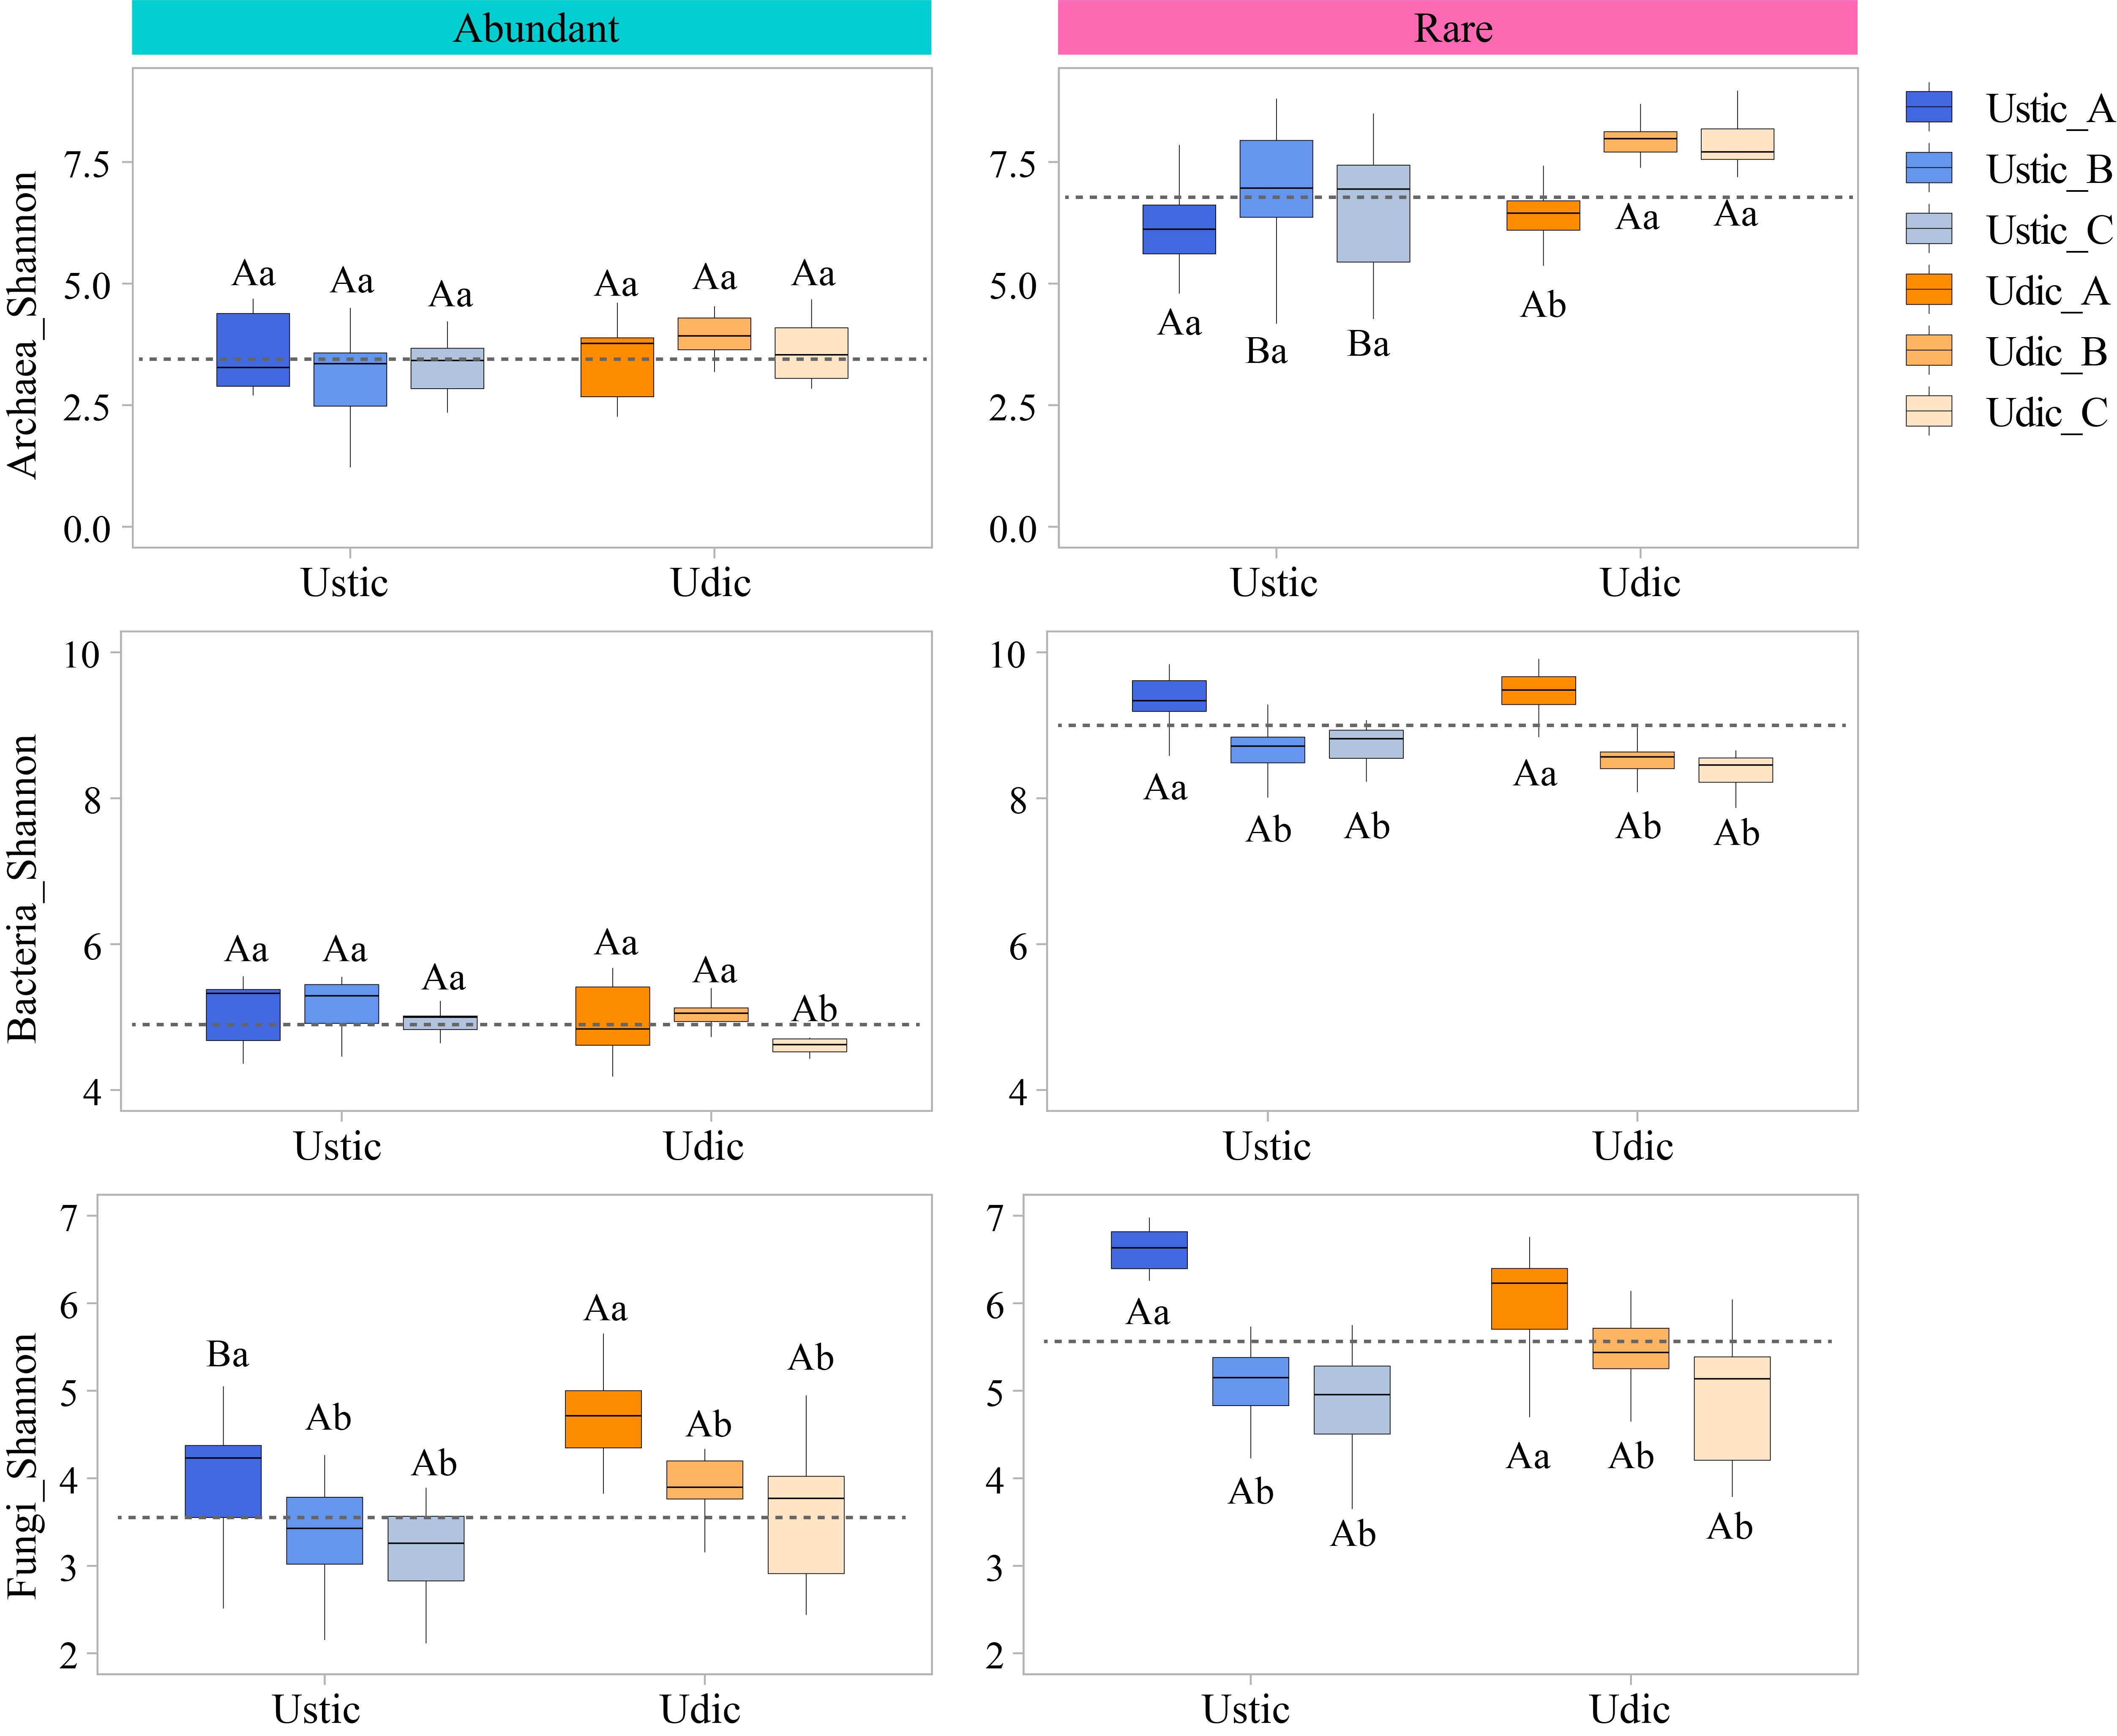
Fig. S1 Variations of abundant and rare microbial alpha diversity in the profiles of Ustic and Udic Isohumosols. Different lowercase letters represent significant differences at P < 0.05 among three soil horizons within the same soil type, and different uppercase letters represent significant differences at P < 0.05 between two suborders of Isohumosols within the same soil horizon.

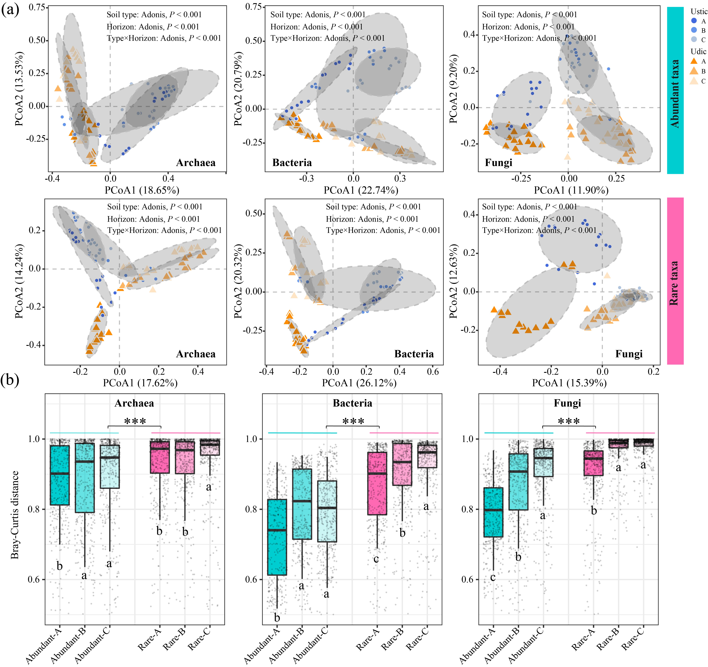
Fig. S2 Principal co-ordinate analysis (a) and Bray-Curtis distance (b) showing the variations of abundant and rare microbial community structures in the profiles of Isohumosols. Different lowercase letters represent significant differences at P < 0.05 among three soil horizons.

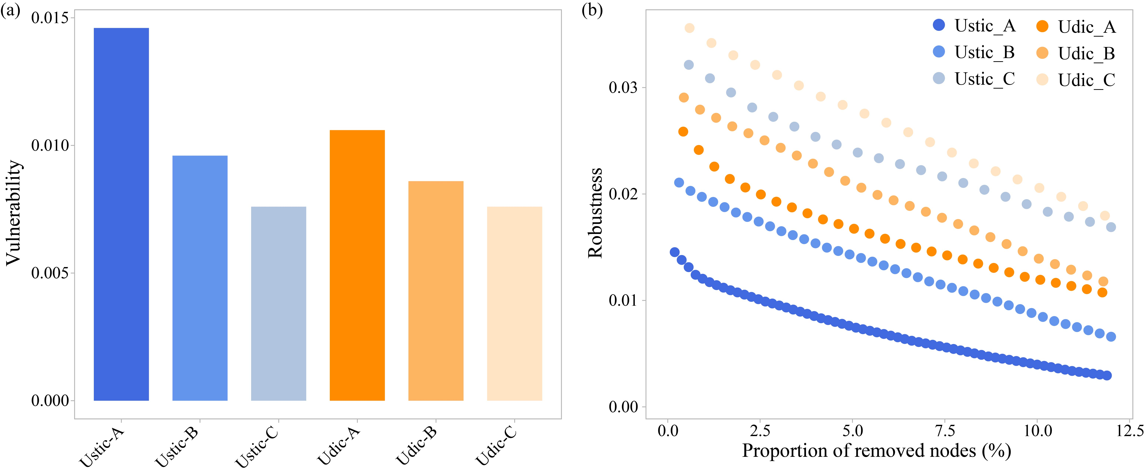
Fig. S3 Network vulnerability and robustness in the profiles of Ustic and Udic Isohumosols.

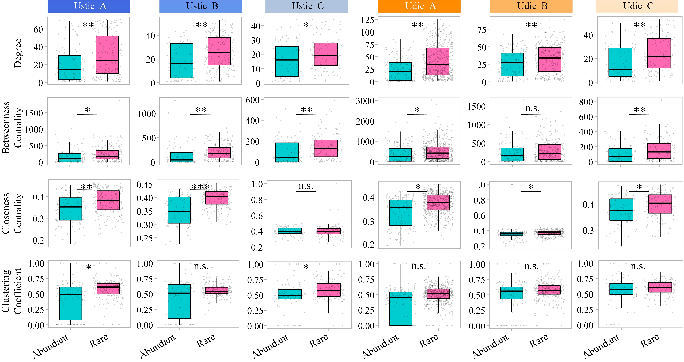
Fig. S4 Differences in network topological properties of abundant and rare microbial taxa in the profiles of Ustic and Udic Isohumosols. “n.s.”, “*” and “**” indicate P > 0.05, P < 0.05 and P < 0.01, respectively.

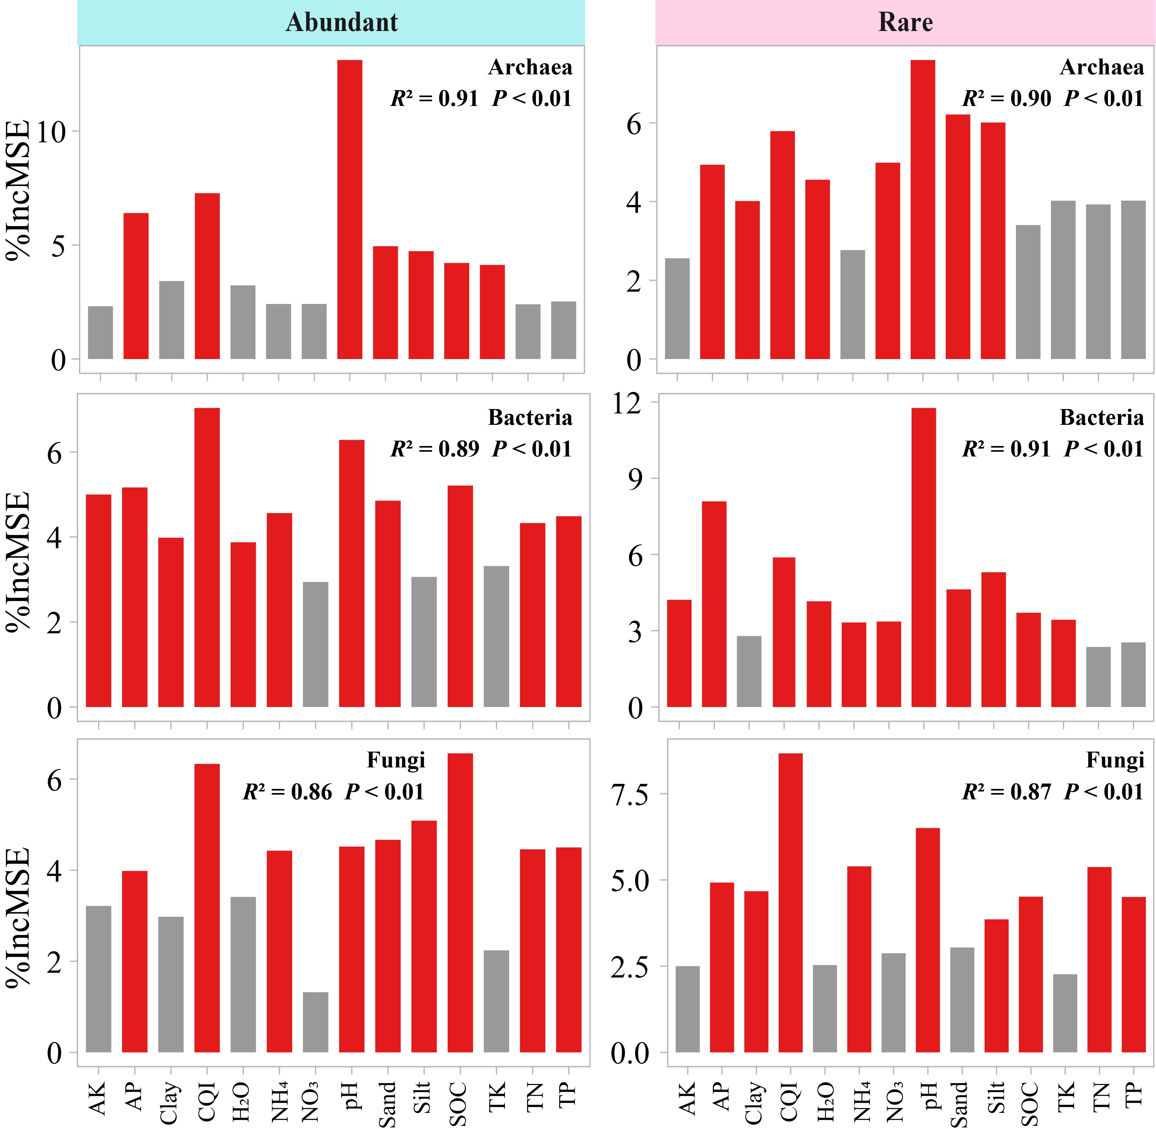
Fig. S5 The influences of edaphic variables on abundant and rare microbial communities were estimated based on random forest analysis. %IncMSE indicates the percentage increase in the mean square error.

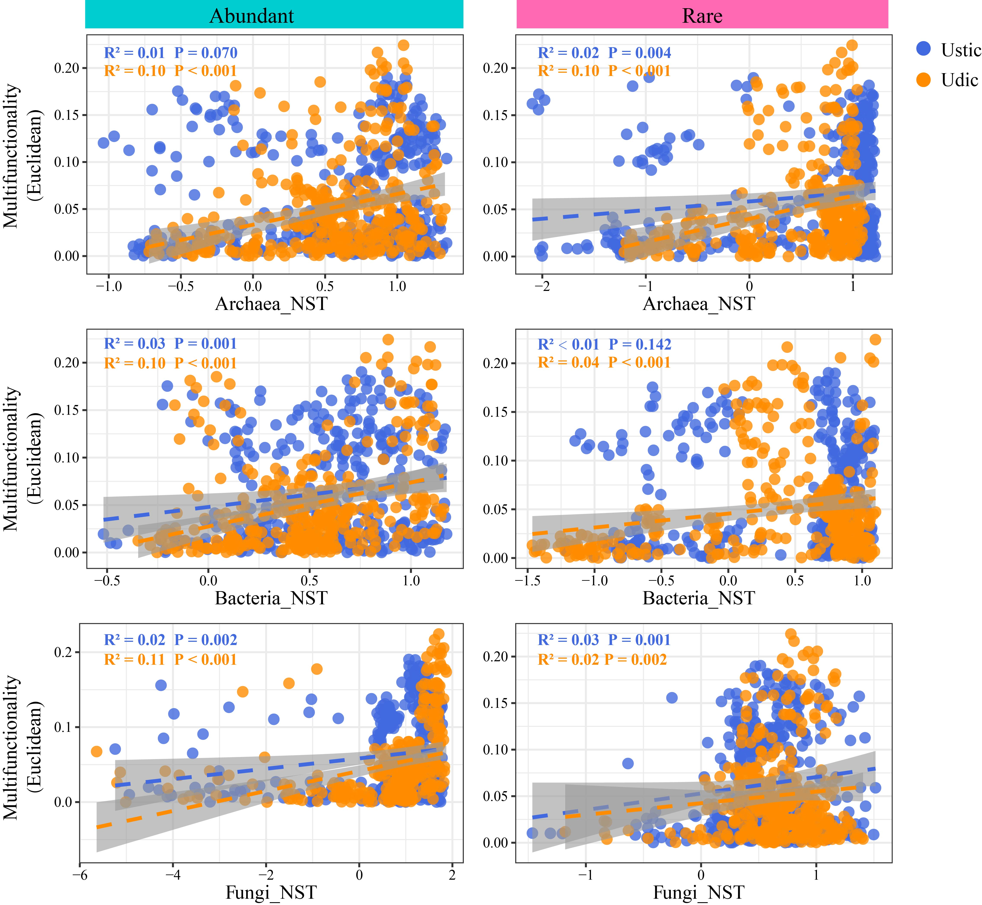
Fig. S6 Pearson correlation analyses of the community assemblies of abundant and rare microbial taxa (based on Bray-curtis distance) and soil ecosystem multifunctionality (based on Euclidean distance) in the profiles of Ustic and Udic Isohumosols. NST indicates the normalized stochasticity ratio.

