Supporting Information
Journal: Soil Ecology Letters
Soil Salinity Alters Acemannan Content and Sodium Uptake in Aloe barbadensis Miller plants. A Role for Root-Associated Microbial Communities?
Christina N. Nikolaou, Myrto Tsiknia*, Dionisios Gasparatos, Constantinos Ehaliotis*.
Laboratory of Soil Science and Agricultural Chemistry, Department of Natural Resources and Agricultural Engineering, Agricultural University of Athens, Iera Odos 75, Athens, GREECE
*Corresponding authors
ehaliotis@aua.gr and
mtsiknia@aua.gr
Running title: Coordinated responses of A. vera and root-associated microbes to soil salinity

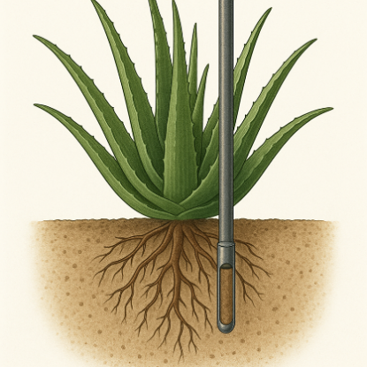
Fig. S1 Schematic representation of the rhizosphere and root sampling procedure in Aloe vera plants. Each sample consisted of three co-homogenized subsamples per plant. The illustration was generated with the assistance of AI-based software (OpenAI, DALL·E).

Table S1 Biometric characteristics of Aloe vera plants in the low vs high salinity area. Average values are presented ± standard errors (n = 6). Significance is indicated with ns for p > 0.05, * p < 0.05, ** p < 0.01, *** p < 0.001, based on t-Tests.
Plant Growth | Salinity level |  | t-Test
Plant Growth | Low | High | t-Test
Height (cm) | 57.3 ± 3.8 | 55.5 ± 3.9 | ns
Leaves | 16.0 ± 0.9 | 14.8 ± 0.6 | ns
Offshoots | 4.8 ± 0.6 | 5.7 ± 1.2 | ns

Table S2 Correlation of acemannan concentration (AC (%)) with leaf minerals, based on Spearman Rank correlation test. Significance is indicated by ns for p > 0.05, * p < 0.05, ** p < 0.01, *** p < 0.001. Only significant correlations are presented.
AC (%) | Leaf  compartment | Correlation in each salinity level
AC (%) | Leaf  compartment | Low | High
P | Rind | -0.10^{ns} | 0.85*
Na | Gel | -0.40^{ns} | 0.96**
Fe | Gel | 0.88^{ns} | 0.88*

Table S3 Correlations between the concentrations of the nutrients that are correlated with acemannan concentration, based on Spearman Rank correlation test. Significance is indicated by ns for p > 0.05, * p < 0.05, ** p < 0.01, *** p < 0.001.
Nutrient 1 | Leaf  compartment | Nutrient 2 | Leaf  compartment | Correlation in each salinity level
 |  |  |  | Low | High
P | Rind | Na | Gel | 0.01^{ns} | -0.03^{ns}
P | Rind | Fe | Gel | 0.15^{ns} | 0.25^{ns}
Na | Gel | Fe | Gel | 0.33^{ns} | 0.86*

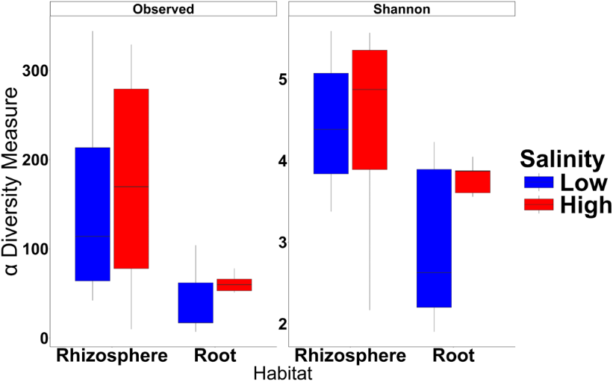
Fig. S2 The “Observed” richness and the Shannon alpha diversity indices for the ASVs-based proxies of prokaryotic communities in the rhizosphere and Aloe vera roots.

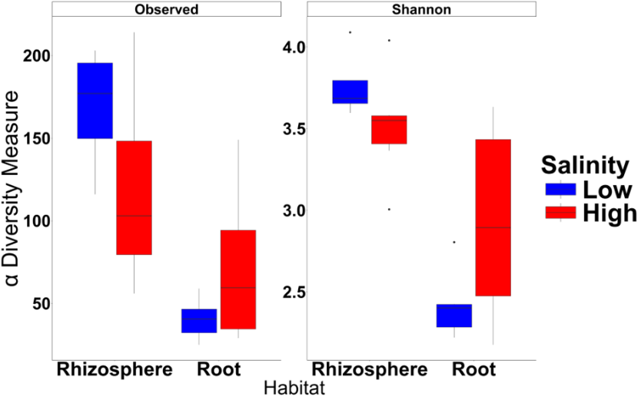
Fig. S3 The “Observed” (richness) and the Shannon alpha diversity indices for the ASVs-based proxies of fungal communities in the rhizosphere and Aloe vera roots.

Table S4 Summary of statistically significant correlations between prokaryotic community (Bray–Curtis distances) and Euclidean distances of soil and plant variables for each salinity level. Only significant associations are shown and are indicated by ns for p > 0.05, * p < 0.05, ** p < 0.01, *** p < 0.001.
Habitat | Variable | Salinity | R | p-value | Significance
Rhizosphere | AC | High | +0.73 | 0.002 | **
Rhizosphere | AC | Low | -0.27 | 0.34 | ns
Rhizosphere | Gel Na | High | +0.47 | 0.005 | **
Rhizosphere | Gel Na | Low | -0.08 | 0.79 | ns
Rhizosphere | ECe | High | -0.03 | 0.91 | ns
Rhizosphere | ECe | Low | +0.80 | 0.000 | *
Root | ECe | High | +0.71 | 0.003 | **
Root | ECe | Low | -0.68 | 0.03 | *

Abbreviations: R, Pearson correlation coefficient; AC, acemannan; ECe, electrical conductivity of the saturation paste extract.

Table S5 Summary of statistically significant correlations between fungal community (Bray–Curtis distances) and Euclidean distances of soil and plant variables for each salinity level. Only significant associations are shown and are indicated by ns for p > 0.05, * p < 0.05, ** p < 0.01, *** p < 0.001.
Habitat | Variable | Salinity | R | p-value | Significance
Rhizosphere | Soil K | High | +0.55 | 0.002 | **
Rhizosphere | Soil K | Low | +0.52 | 0.002 | **
Root | AC | High | +0.77 | 0.001 | **
Root | AC | Low | -0.16 | 0.06 | ns
Root | Gel Na | High | +0.73 | 0.002 | **
Root | Gel Na | Low | +0.22 | 0.43 | ns
Root | ECe | High | +0.02 | 0.94 | ns
Root | ECe | Low | +0.57 | 0.03 | *
Abbreviations: R, Pearson correlation coefficient; AC, acemannan; ECe, electrical conductivity of the saturation paste extract.

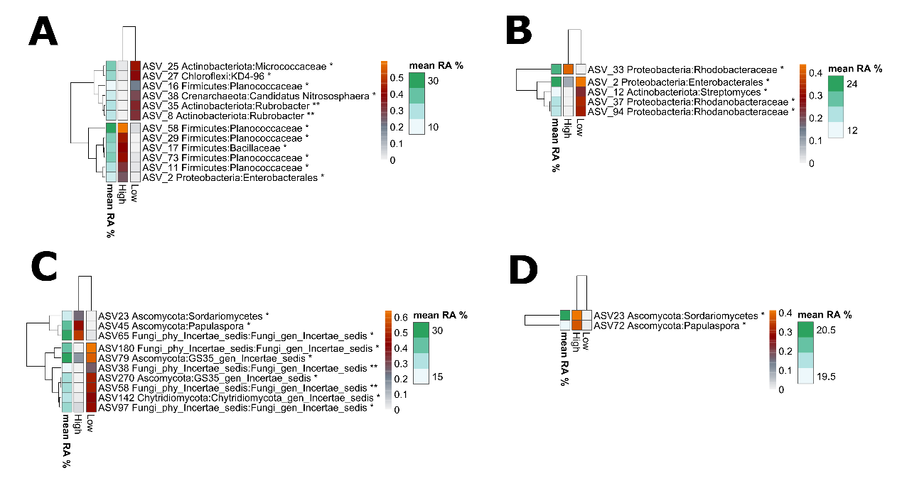 Fig. S4 Bacterial (A, B) and fungal (C, D) community members (amplicon sequence variants -ASVs), and their differential abundance between the two salinity levels in the rhizosphere (A, C) and the roots (B, D). Heatmaps display normalized counts (row z-scores) between the two salinity levels for significant ASVs only. Next to each ASV the assigned Phylum and the lower available taxonomic level (Family or Order or Genus) is reported.

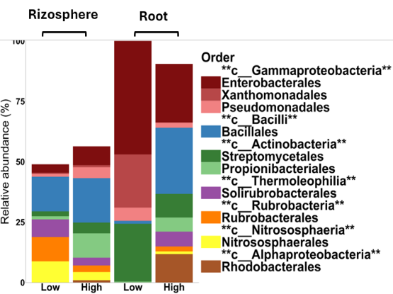
Fig. S5 Taxonomic composition of the prokaryotic community at the Order level. The most abundant orders within each class (c__) are being shown across the two salinity areas for each examined habitat.

Fig. S6 Correlation analysis performed using the Pearson R correlation coefficient, between the root prokaryotic community or rhizospheric fungal community Bray-Curtis distances with the Euclidean distances of plant variables (Acemannan and Na in leaf gel) for each salinity level. The scatterplots show linear correlation curves for Acemannan (AC) (Panels a/c) and Na in the leaf gel (Na_G) (Panels b/d). Values of R and P displayed in each panel correspond to the Pearson correlation coefficient and the associated p-value, respectively. Asterisks indicate significance (p < 0.05, *p < 0.01, **p < 0.001).

