Supporting information for
Land-use types impact soil ecosystem functions by altering the soil multitrophic biodiversity and interactions

Tian-Lun Zhang^{1,2,3}, Shao-Yang Zhang^{1,2,3}, Lu Wang^{1,3}, Da Lin^{1,2,3}, Bang Ni^{1,3}, Tian-Gui Cai^{1,3}, Shuai Du^{1,3,*}, Dong Zhu^{1,3}

¹Key Laboratory of Urban Environment and Health, Ningbo Observation and Research Station, Institute of Urban Environment, Chinese Academy of Sciences, Xiamen 361021, Peoples R China
²University of Chinese Academy of Sciences, Beijing 100049, Peoples R China
³Zhejiang Key Laboratory of Urban Environmental Processes and Pollution Control, CAS Haixi Industrial Technology Innovation Center in Beilun, Ningbo 315830, Peoples R China

*Corresponding author: Shuai Du, Email: sdu@iue.ac.cn
Key Laboratory of Urban Environment and Health, Ningbo Observation and Research Station, Institute of Urban Environment, Chinese Academy of Sciences, Xiamen 361021, Peoples R China

S1. Supplementary Methods
Soil microbial activities
The methods for measuring soil enzyme activity and soil respiration are consistent with previous studies (Fei et al. 2020; Liu et al. 2018).

S2. Supplementary Figures

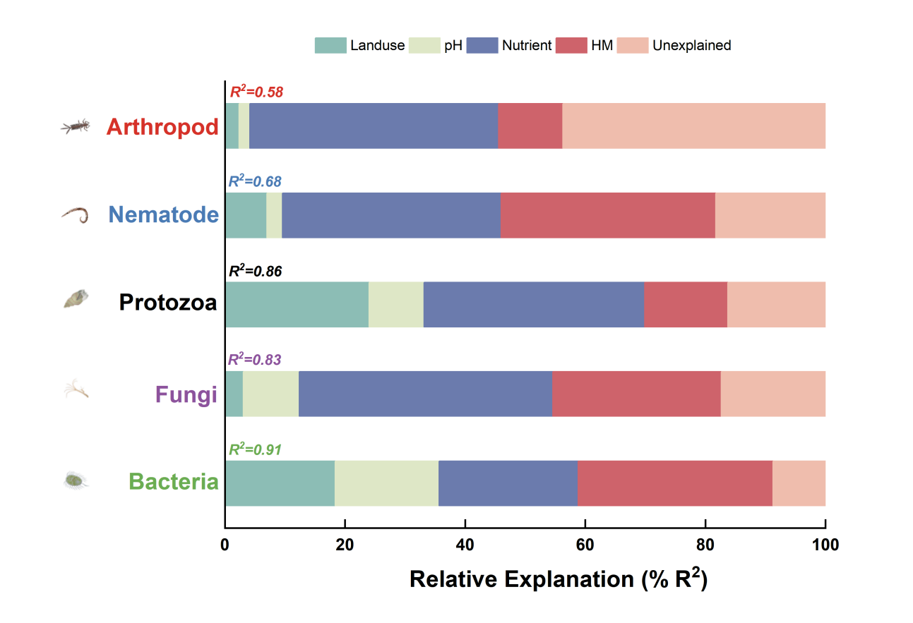

Figure S1. Relative explanation of different types of variables to the variation of soil multitrophic community. Relative effects (% R²) are resulting from partial redundancy analysis.

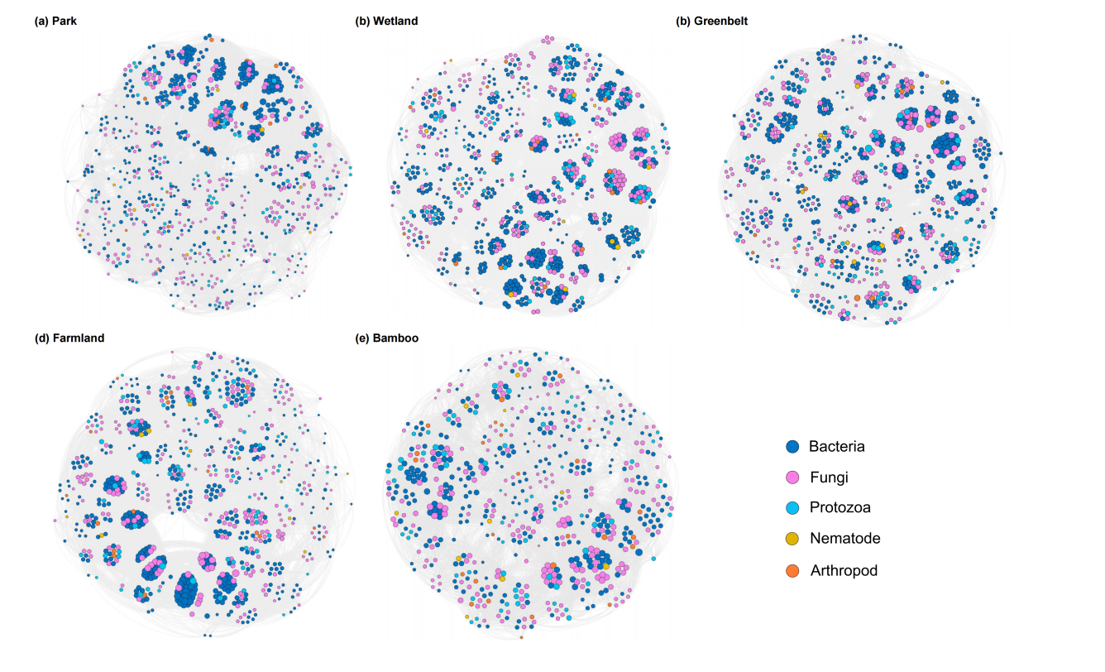

Figure S2. The cooccurrence networks of soil multitrophic communities from five land-use types. The size of node is proportional to the link number of each node. The line between each pair of nodes represents positive (in orange) and negative (in blue) interaction with P < 0.05 and |r| > 0.6.

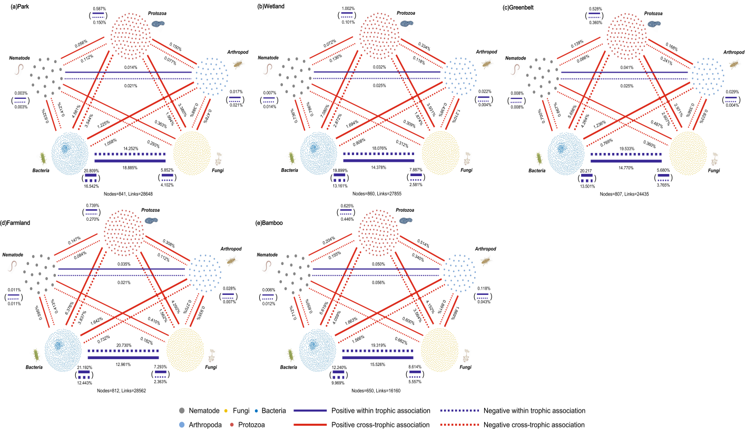

Figure S3. The co-occurrence networks of five land-use types revealing soil potential multitrophic community interactions. Each node represents an ASV. The nodes are clustered according to the category of kingdom and marked with grey (nematode), wathet (arthropod), red (protozoa), yellow (fungi), and blue (bacteria). Each link between the same and different kingdom represents a significant pairwise association between them (P < 0.05). Purple links represent within trophic associations (potential within trophic interactions), while red links represent cross trophic association (potential cross trophic interactions). The solid and dashed lines represent positive and negative associations between nodes, respectively. The thickness of links represents the proportion of a certain type of association.
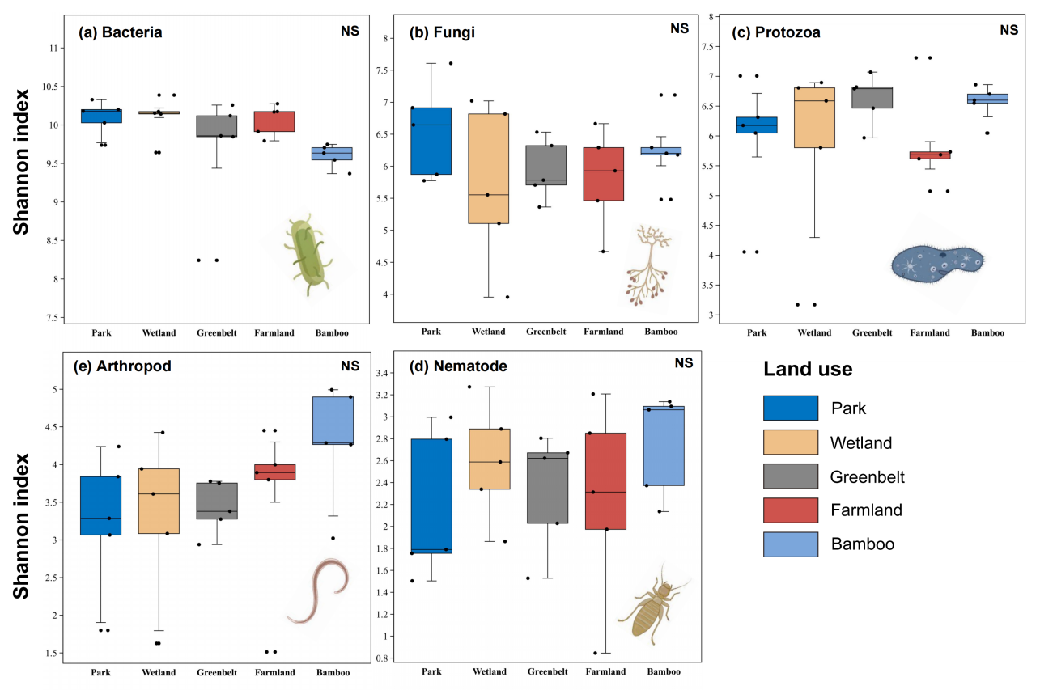

Figure S4. Variation in the Shannon index of soil multitrophic communities across the five land-use types.

References
Fei, Y., Huang, S., Zhang, H., Tong, Y., Wen, D., Xia, X., Wang, H., Luo, Y., Barcelo, D., 2020. Response of soil enzyme activities and bacterial communities to the accumulation of microplastics in an acid cropped soil. Sci. Total Environ. 707, 135634.
Liu, Y.-R., Delgado-Baquerizo, M., Wang, J.-T., Hu, H.-W., Yang, Z., He, J.-Z., 2018. New insights into the role of microbial community composition in driving soil respiration rates. Soil Biol. Biochem. 118, 35-41.

