Supporting information:

Title: Soil micro-food web composition determines soil fertility and crop growth
Yaping Lin ^{a, b}, Qing Yi ^{b}, Dandan Gao ^{a, b *}, Jiangnan Li ^{b, d}, Wei Zhang ^{b, c, d}, Kelin Wang ^{b, d}, Dan Xiao ^{b, d}, Peilei Hu ^{b, d}, Jie Zhao ^{b, c, d}
ª College of Life and Environmental Science, National Engineering Laboratory for Applied Technology in Forestry & Ecology in South China, Central South University of Forestry and Technology, Changsha 410004, Hunan, China
^{b} Key Laboratory of Agro-ecological Processes in Subtropical Region, Institute of Subtropical Agriculture, Chinese Academy of Sciences, Changsha 410125, China
^{c} Guangxi Industrial Technology Research Institute for Karst Rocky Desertification Control, Nanning, 530012, PR China
^{d} Huanjiang Agriculture Ecosystem Observation and Research Station of Guangxi, Guangxi Key Laboratory of Karst Ecological Processes and Services, Huanjiang Observation and Research Station for Karst Ecosystems, Chinese Academy of Sciences, Huanjiang, 547100, Guangxi, PR China

* Corresponding author and reprint request: Dr. Dandan Gao
Email for Dandan Gao: gaodandan2004@126.com

Supporting information:
Table 1. Topological properties of the co-occurrence network between soil microbe and nematodes communities in original soil.
Network topological parameter | Soil type
Network topological parameter | Lowland red soil | Highland red soil | Lowland calcareous soil | Highland calcareous soil
Number of nodes | 167 | 193 | 278 | 266
Number of edges | 5650 | 6275 | 12211 | 12585
Positive correlation | (55.29) | (51.89) | (50.59) | (50.92)
Negative correlation | (44.71) | (48.11) | (49.41) | (49.08)
Average degree | 67.665 | 64.691 | 87.534 | 94.27
Average weighting degree | 12.323 | 2.897 | 0.065 | 1.468
Graph density | 0.408 | 0.335 | 0.315 | 0.354
Modularization | 0.337 | 0.608 | 0.642 | 0.551
Connecting parts | 4 | 7 | 8 | 7
Average clustering coefficient | 0.997 | 0.997 | 0.998 | 0.998
Notes: The percentage of the positive or negative correlation is in parentheses (%).

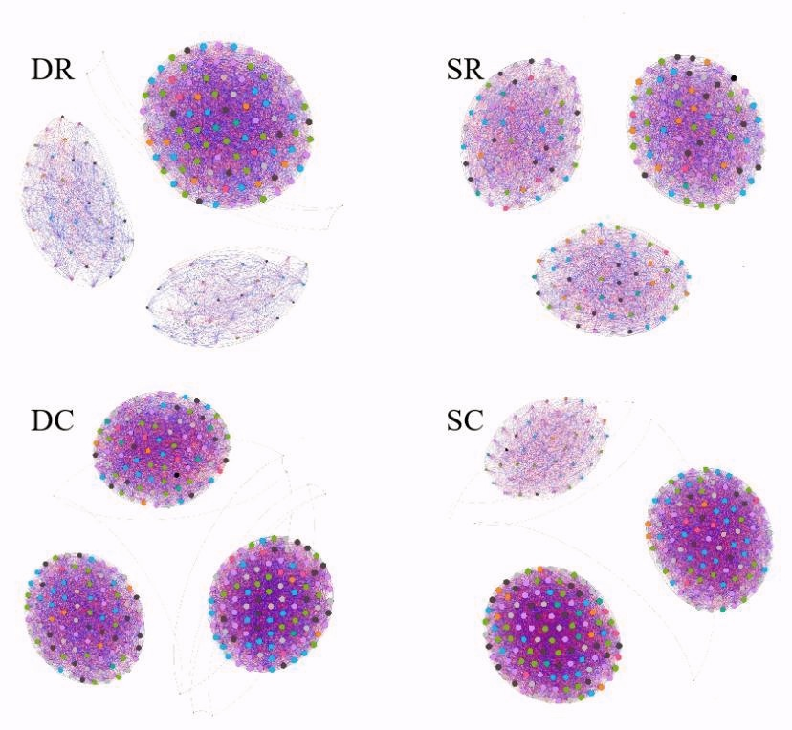
Fig. S1 Co-occurrence network between soil microbe and nematodes communities in original soil. DR, lowland red soil; SR, highland red soil; DC, lowland calcareous soil; SC, highland calcareous soil. The networks were constructed using the relative abundance tables of bacteria, fungi and nematodes. In order to reduce the complexity of the network, the relative abundance was 0.8, the significant p value was p < 0.001, and Gephi 9.2 was used for network visualization. The number of nodes and edges, positive correlation number and negative correlation number, graph density and module number of each network are calculated. The number of nodes and edges and graph density are used to evaluate the complexity of the network. These values are standardized and averaged. The higher the value, the more complex the network is.

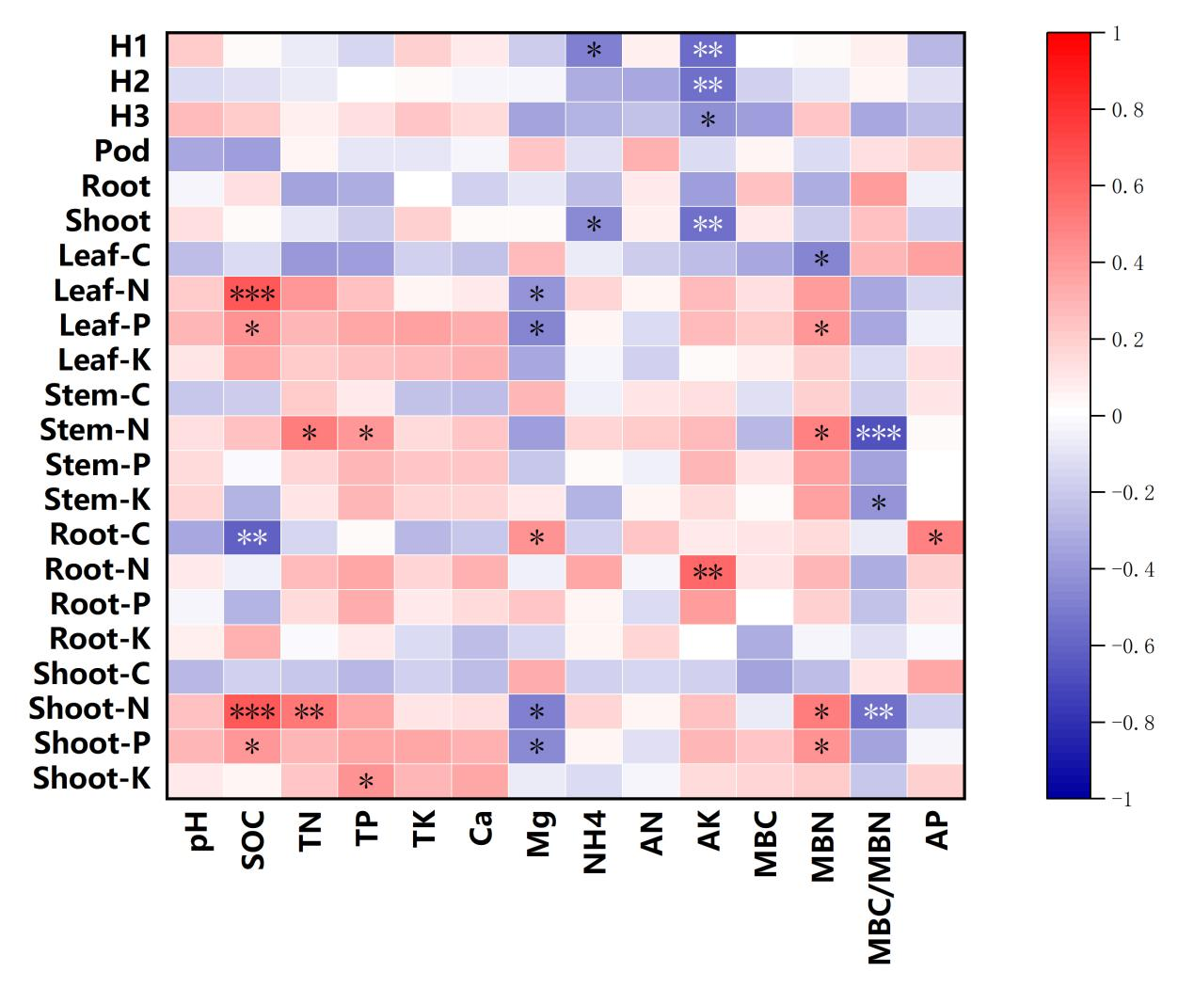
Fig. S2. Correlation between soil biophysical-chemical properties and plant agronomic traits and nutrient content. Significance levels at * p <0.05, **p < 0.01, ***p < 0.001. H1, plant height at seeding stage; H2, plant height at flowering stage; H3, plant height at podding stage; Pod, fresh pod weight; Shoot, shoot dry weight; Root, root dry weight.

