Fig. S1 Field layout of the injection of different forms of labelled ¹⁵N

Figure S2 Root length density (RLD,), specific root length, root surface, total root length, fine root length, above-, below-ground and total biomass per individual of sedges and forbs.Sedges species are K. humilis and K. pgymaea and forbs are A. flaccidus, S. japonica and L. nanum
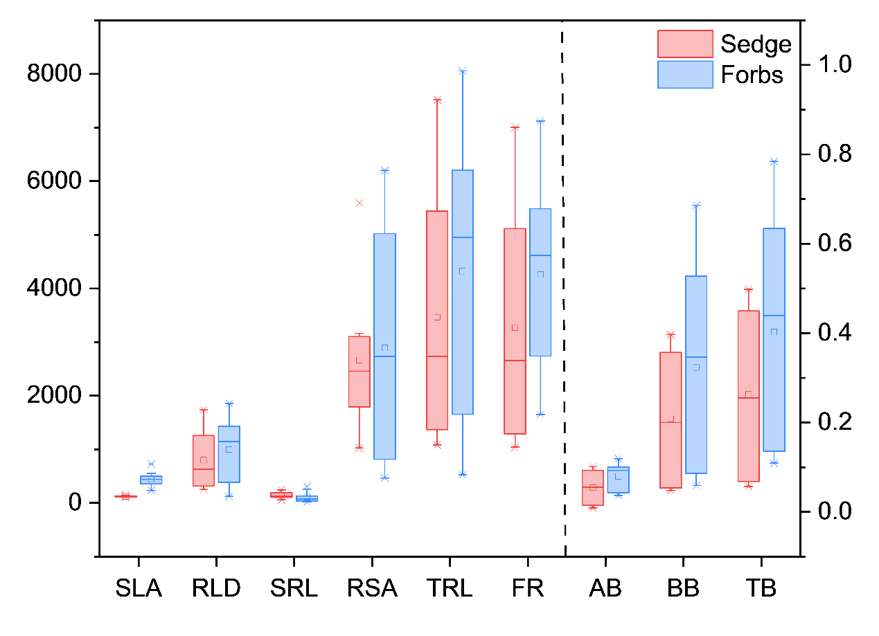

Figure S3 The principal component analysis of root traits among the five species.
See Fig.3 for abbreviations
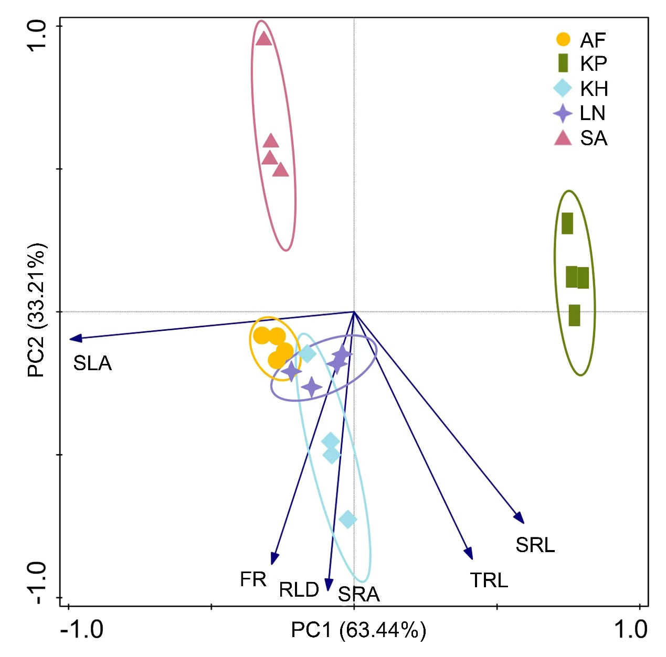

Table S1 Relative coverage of the studied species in the plant community of undegraded alpine meadow

Species | Kobresia humilis | Kobresia pygmaea | Leontopodium nanum | Aster flaccidus | Saussurea japonica
Coverage (%) | 20.63±3.65 | 25.94±6.94 | 12.00±2.78 | 3.65±1.80 | 4.58±3.44

