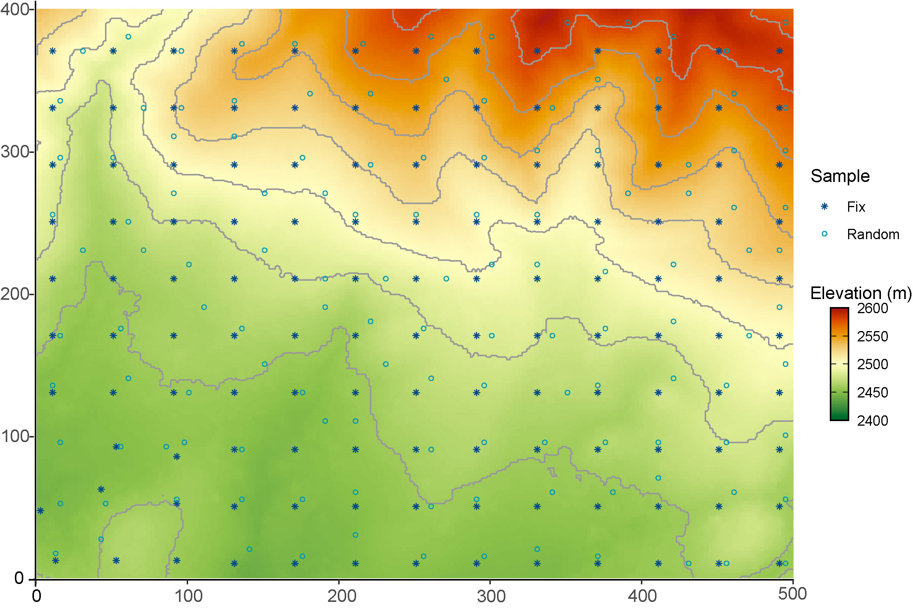
Fig. S1 Sampling design and elevation of the 20-ha plot. Fixed samples (Fix) were located at the intersections of a 40 × 40 m grid, and random points were matched at distances of 5, 10, and 20 m in any direction from each fixed point.
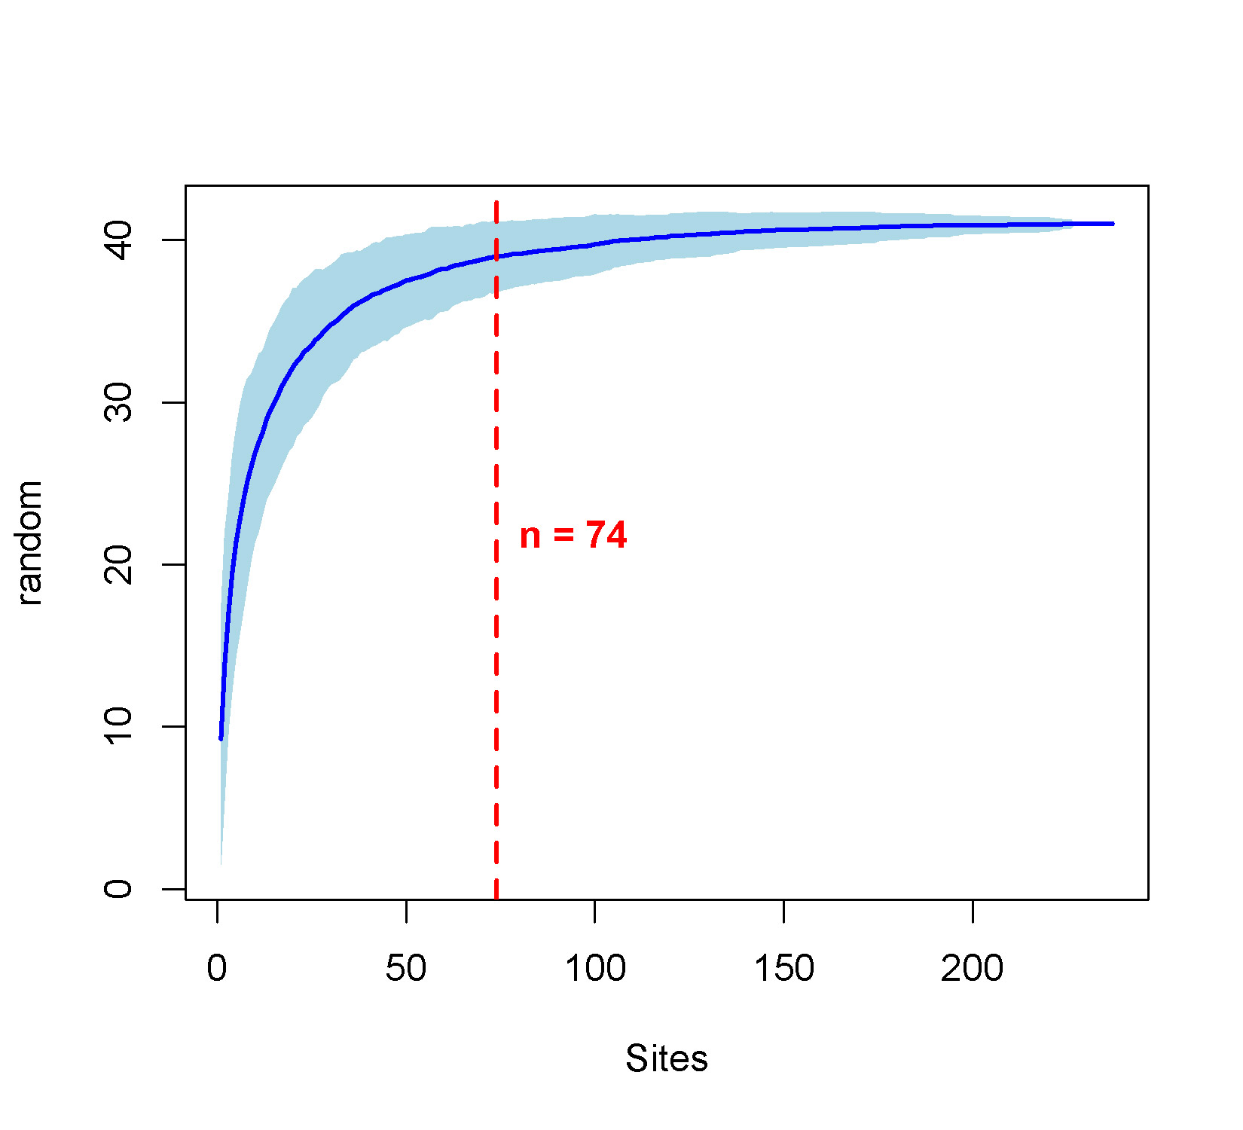
Fig. S2 Collembola species accumulation curve: The red line indicates the number of samples required to reach 95% of the total species richness (n = 74).

Fig. S3 Trait diversity indices in Collembola along the vertical stratification gradient (Epe = epedaphic; Hemie = hemiedaphic; Eue = euedaphic).

Table S1 List of sampled Collembola at the genus level and their abundance
Order | Family | Genus | Abundance
Entomobryomorpha | Entomobryidae | Entomobrya | 132
 |  | Homidia | 305
 |  | Lepidocyrtus | 180
 |  | Pseudosinella | 34
 |  | Sinella | 178
 |  | Willowsia | 23
 | Isotomidae | Cryptopygus | 724
 |  | Desoria | 958
 |  | Folsomia | 10048
 |  | Folsomides | 224
 |  | Isotoma | 169
 |  | Proisotoma | 44
 |  | Pseudanurophorus | 115
 | Paronellidae | Paronella | 3
 | Tomoceridae | Tomocerus | 345
Poduromorpha | Hypogastruridae | Hypogastruridae | 1447
 | Neanuridae | Neanuridae | 469
 | Onychiuridae | Onychiurus | 1622
 |  | Tullbergia | 28
Symphypleona | Neelidae | Megolothorax | 55
 |  | Nelides | 14
 | Sminthuridae | Bourletiella | 13
 |  | Dicyrtoma | 21
 |  | Heterosminthurus | 59
 |  | Papirinus | 7

