APPENDIX
Interactive effects of warming, antibiotics and nanoplastics on the gut microbiome of the collembolan Folsomia candida
Miquel Ferrín, Laura Márquez, Xavier Domene, Dong Zhu, Yong-Guan Zhu, Josep Peñuelas, Guille Peguero
Figure A1
Rarefaction curves for each treatment using replicates (a) and mean reads per replicate (b). Dashed lines correspond to the extrapolated portions of the curves, which were mean-rarefied.
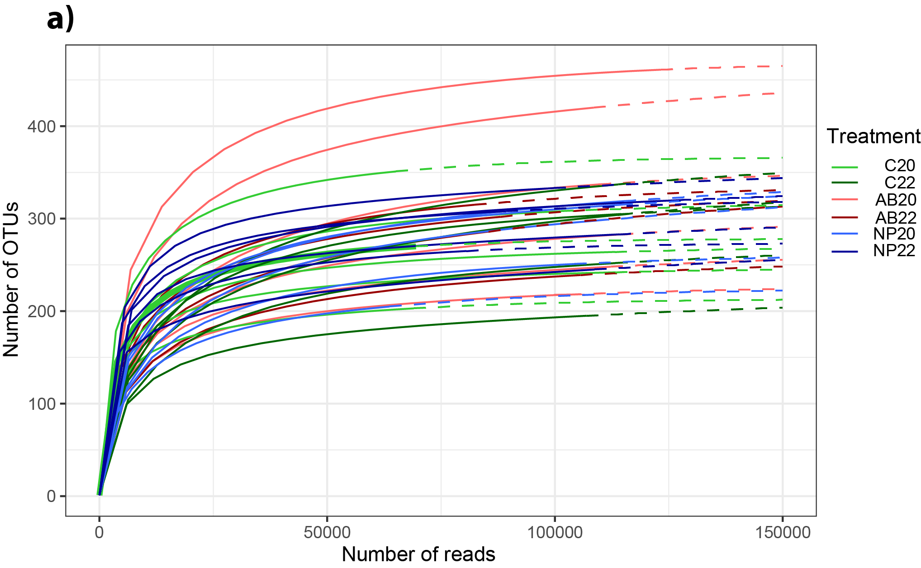
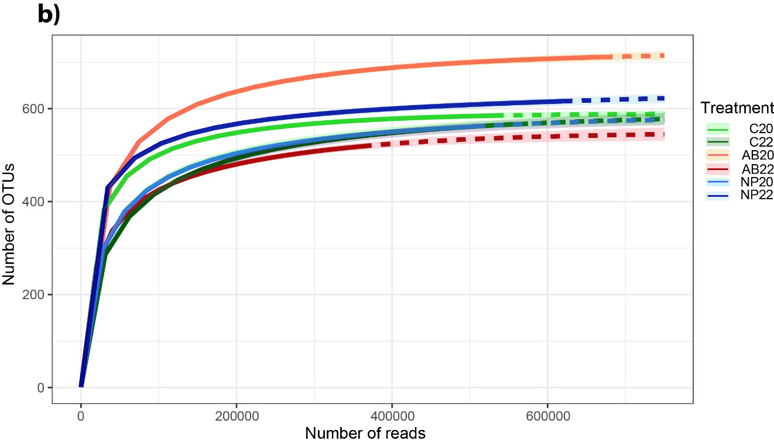

Table A1
Table A1. Linear models of species abundances for the main phyla and families against each treatment.
Phyla
Actinobacteria | Response  variable | Antibiotic |  | Nanoplastics
Actinobacteria | Response  variable | Estimate ± SE | R² | Estimate ± SE | R²
Actinobacteria | Intercept | 2.22 ± 0.88* | 0.55 | 5.03 ± 0.72** | 0.86
Actinobacteria | 22 °C | -0.06 ± 0.04 | 0.55 | -0.20 ± 0.03** | 0.86
Actinobacteria | Xenobiotic | 2.80 ± 1.21* | 0.55 | -10.8 ± 1.02** | 0.86
Actinobacteria | Interaction | -0.13 ± 0.05* | 0.55 | 0.52 ± 0.04** | 0.86
Firmicutes | Intercept | 0.03 ± 0.71 | 0.37 | 2.29 ± 1.07* | 0.36
Firmicutes | 22 °C | 0.06 ± 0.03 | 0.37 | -0.04 ± 0.05 | 0.36
Firmicutes | Xenobiotic | 2.26 ± 0.97* | 0.37 | -4.67 ± 1.52** | 0.36
Firmicutes | Interaction | -0.11 ± 0.04* | 0.37 | 0.22 ± 0.07** | 0.36
Proteobacteria | Intercept | 5.01 ± 2.09* | 0.46 | 11.6 ± 1.25** | 0.76
Proteobacteria | 22 °C | -0.08 ± 0.10 | 0.46 | -0.39 ± 0.06** | 0.76
Proteobacteria | Xenobiotic | 6.64 ± 2.87* | 0.46 | -14.4 ± 1.78** | 0.76
Proteobacteria | Interaction | -0.30 ± 0.13* | 0.46 | 0.69 ± 0.08** | 0.76
Families
Bacillaceae | Response  variable | Antibiotic |  | Nanoplastics
Bacillaceae | Response  variable | Estimate ± SE | R² | Estimate ± SE | R²
Bacillaceae | Intercept | 0.55 ± 0.22* | 0.00 | 0.84 ± 0.29* | 0.00
Bacillaceae | 22 °C | 0.01 ± 0.01 | 0.00 | 0.00 ± 0.01 | 0.00
Bacillaceae | Xenobiotic | 0.29 ± 0.31 | 0.00 | -0.60 ± 0.41 | 0.00
Bacillaceae | Interaction | -0.01 ± 0.01 | 0.00 | 0.02 ± 0.01 | 0.00
Rickettsiaceae | Intercept | 1.29 ± 0.35** | 0.76 | 2.47 ± 0.45** | 0.72
Rickettsiaceae | 22 °C | -0.05 ± 0.01** | 0.76 | -0.10 ± 0.02** | 0.72
Rickettsiaceae | Xenobiotic | 1.17 ± 0.48* | 0.76 | -4.87 ± 0.64** | 0.72
Rickettsiaceae | Interaction | -0.05 ± 0.02* | 0.76 | 0.23 ± 0.03** | 0.72
Sphingomonadaceae | Intercept | 1.14 ± 0.17** | 0.58 | -0.22 ± 0.22 | 0.60
Sphingomonadaceae | 22 °C | -0.03 ± 0.00** | 0.58 | 0.03 ± 0.01** | 0.60
Sphingomonadaceae | Xenobiotic | -1.37 ± 0.24** | 0.58 | 1.83 ± 0.31** | 0.60
Sphingomonadaceae | Interaction | 0.06 ± 0.01** | 0.58 | -0.08 ± 0.01** | 0.60
LMs where intercept group are controls incubated at 20 °C. Linear models for abundances were done with Gaussian family. SE, standard error; **, P < 0.01. Degrees of freedom = 18 and 17 for the nanoplastics and antibiotic models, respectively.

Table A2
Table A2. Similarity percentage analyses under paired treatments.
Paired variables | Taxon | Contribution ± SD | Contribution to all taxa contribution
C20-NP20 | Wolbachia sp. | 2.14e-02 ± 5.56e-03 ** | 5.7e-02
Discriminating taxon between pairs of treatments using Bray-Curtis dissimilarities with 999 permutations. Taxa are those with P < 0.05 and contributions >5%, if none is shown means that none met the criteria. “Contribution” corresponds to taxa contribution to average between-group dissimilarity, and “Contribution to all taxa contribution” corresponds to the contribution of a given taxon to the overall taxa contribution totaling 1. SD, standard deviation; *, P < 0.05; **, P < 0.01.

Table A3
Table A3. Linear model for the abundance of Gram-negative species
Response variable | Estimate ± SE | Adjusted-R²
Intercept | 747 ± 265 ** | 0.00
22 °C | 506 ± 371 | 0.00
Colistin | 674 ± 397 · | 0.00
Interaction | -1.09e+3 ± 570 · | 0.00
Linear model with Gaussian family for Gram-negative taxa at the temperature treatments and colistin. Intercepts are at control 20 º°C. SE, standard error; ·, P < 0.10; **, P < 0.01. Degrees of freedom = 415.

Table A4
Table A4. Linear model for Wolbachia sp. abundance with nanoplastic addition and warming.
Response variable | Estimate ± SE | Adjusted-R²
Intercept | 0.35 ± 0.01** | 0.89
Nanoplastics | -0.27 ± 0.02 ** | 0.89
Linear model with Gaussian family for Wolbachia sp. in the temperature and nanoplastic treatments. The intercept is at the control. We found no interaction and no impact from warming, limiting the model to the impact of nanoplastics. **, P < 0.01. Degrees of freedom = 9.

